# LDR

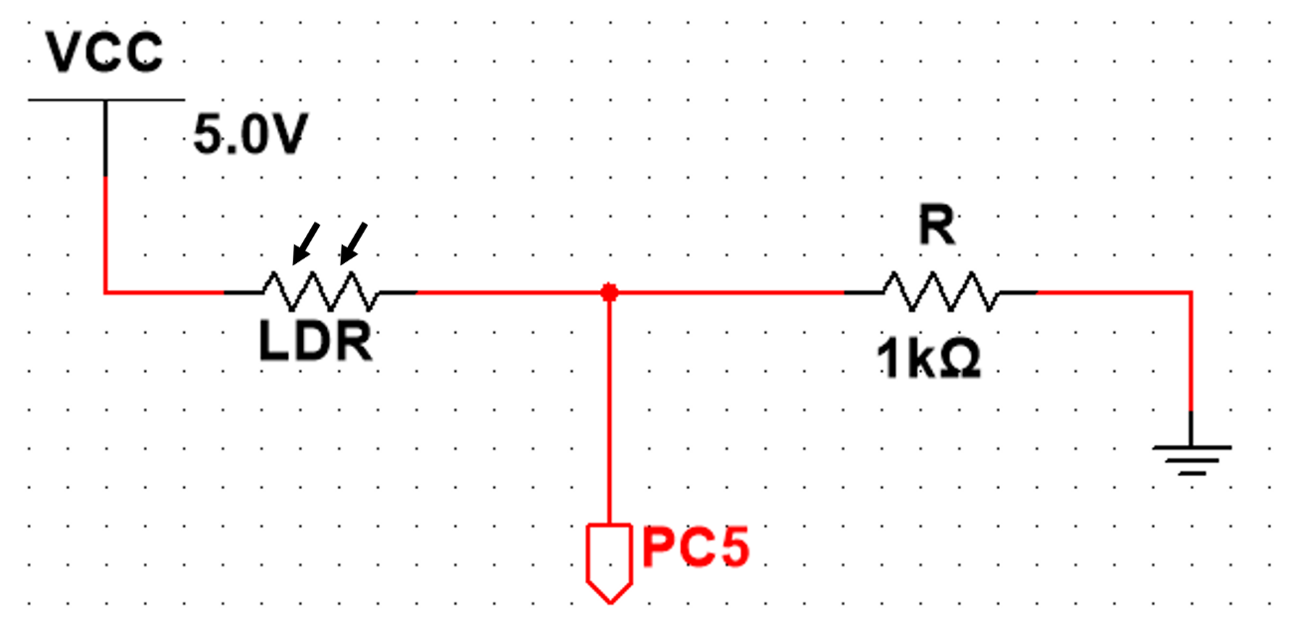

Specifications

|  |  |
| --- | --- |
| **Bright Resistance (100 lux)** | 5k Ω |
| **Dark Resistance (10 lux)** | 10k Ω |
| **Very Bright Resistance (100 lux)** | 400 Ω |
| **Max Voltage** | 150 V |
| **Max Power** | 100 mW |
| **Ambient Temperature Range** | -30 ~ +70 °C |
|  |  |

Interface

|  |  |  |
| --- | --- | --- |
|  | **Pin Name** | **Pin Function** |
| **LDR OUT** | PC5 | ADC12_IN15 |

Test Cases

$Vo=VCC-VCC\frac{LDR}{LDR+R}$ $Vo=5-5\frac{LDR}{LDR+1K}$

Best ambient light (250 lux) -> 2.5k Ω

|  |  |  |
| --- | --- | --- |
| Light Level | Expected Circuit Output | Real output |
| Bright (100 lux) | 0.83 V |  |
| Dark (10 lux) | 0.45 V |  |
| Good Lighting (250 lux) | 1.43 V |  |