Sc in Data Science & AI
Database Course Project

The Beachside Hotel
Cloud-Based Relational Database System

Prepared by: TechStream Solutions (TSS)
Instructor: Dr. Mohammed Eshtay
Academic Year: 2025 / 2026
Final Submission Date: 3 June 2026

1. Requirements Analysis

1.1 Project Overview
TechStream Solutions (TSS) has been engaged by the Beachside Hotel to design and implement a comprehensive cloud-based relational database management system. The objective is to replace manual, spreadsheet-based operations with a robust, scalable, and secure database platform that supports the full lifecycle of hotel management.

1.2 User Requirements
Customer Requirements
- Customers must register an account using their National ID, full name, phone number, birthdate, gender, and address.
- Customers can search for available rooms by type (Single, Double, Family).
- Customers can book, modify, or cancel room reservations.
- Customers can book one spa service and multiple gym services.
- All payments must be processed online via a registered payment card.
- Customers must be over 18 years of age.
- Address defaults to "Jordan" if not provided.

Hotel Manager Requirements
- Registration and deletion of customer accounts.
- Adding, updating, and deleting rooms, payment cards, and services.
- Updating room availability status (Available / Unavailable).
- Generating management reports and lists (see Section 5).

1.3 System Requirements
Functional Requirements
- Customer Management: CRUD operations on customer accounts.
- Room Management: Add, update, delete rooms with full attribute control.
- Reservation System: Book, update, and cancel reservations with date validation.
- Payment Processing: Link reservations and services to customer payment cards.
- Spa Booking: One spa service per customer with time-slot management.
- Gym Booking: Multiple gym services per customer, supporting concurrent bookings.
- Reporting: Pre-built SQL queries for management decision support.

Non-Functional Requirements
- Security: Password-protected database access with role-based users.
- Data Integrity: Primary keys, foreign keys, CHECK constraints, and DEFAULT values.
- Availability: Deployed to a cloud platform (PlanetScale / Aiven / AWS RDS).
- Scalability: Normalized schema supporting growth in customers, rooms, and services.
- Performance: Indexed foreign key columns for fast join operations.

1.4 Business Rules & Constraints
# | Rule | Implementation
1 | Rooms must specify number of beds | NOT NULL constraint on num_beds
2 | Default address is Jordan | DEFAULT 'Jordan' on address column
3 | Customers must be over 18 | CHECK (TIMESTAMPDIFF(YEAR, birthdate, CURDATE()) >= 18)
4 | Room availability: Available/Unavailable only | ENUM('Available','Unavailable')
5 | Sea view & breakfast: Yes/No only | ENUM('Yes','No') on both columns
6 | One spa booking per customer only | UNIQUE constraint on customer_id in SpaBooking
7 | Check-out must be after check-in | CHECK (check_out_date > check_in_date)
8 | Card expiry must be after issue date | CHECK (expiry_date > issue_date)

2. Entity-Relationship Model

2.1 Entities and Attributes
Customer
- customer_id (PK) – National ID, unique identifier
- first_name – Customer's first name
- last_name – Customer's last name
- phone_number – Contact phone number
- birthdate – Date of birth (used for age validation)
- gender – Male / Female / Other
- address – Residential address (defaults to "Jordan")

PaymentCard
- card_id (PK) – Unique card identifier
- customer_id (FK → Customer) – Card owner
- issue_date – Date card was issued
- expiry_date – Card expiry date

Room
- room_number (PK) – Unique room identifier
- type_id (FK → RoomType) – Room category reference
- num_beds – Number of beds (NOT NULL)
- room_location – Physical location description
- sea_view – Yes / No
- breakfast – Yes / No
- price_per_night – Nightly rate in USD
- availability – Available / Unavailable

RoomType
- type_id (PK) – Auto-increment identifier
- type_name – Single / Double / Family

Reservation
- reservation_id (PK) – Auto-increment
- customer_id (FK → Customer)
- room_number (FK → Room)
- card_id (FK → PaymentCard)
- check_in_date – Arrival date
- check_out_date – Departure date
- is_occupied – 0 (upcoming) / 1 (currently staying)

Spa
- spa_id (PK) – Auto-increment
- service_name – Name of the spa service
- service_price – Price in USD
- opening_time – Daily opening time
- closing_time – Daily closing time

SpaBooking
- spa_booking_id (PK) – Auto-increment
- customer_id (FK → Customer, UNIQUE) – One booking per customer
- spa_id (FK → Spa)
- card_id (FK → PaymentCard)
- booking_date – Date of booking

Gym
- gym_id (PK) – Auto-increment
- gym_name – Name of the gym
- opening_time / closing_time – Operating hours
- machine_type – Equipment type description
- subscription_price – Base subscription fee

GymService
- service_id (PK) – Auto-increment
- gym_id (FK → Gym)
- service_name – Name of the gym service
- service_price – Price in USD

GymBooking
- gym_booking_id (PK) – Auto-increment
- customer_id (FK → Customer)
- gym_id (FK → Gym)
- service_id (FK → GymService)
- card_id (FK → PaymentCard)
- booking_date – Date of booking

2.2 Relationships
Relationship | Entity 1 | Cardinality | Entity 2 | Description
Owns | Customer | 1 to Many | PaymentCard | A customer can own many payment cards
Books (Room) | Customer | Many to Many | Room | Via Reservation join table
Categorised | Room | Many to 1 | RoomType | Each room belongs to one type
Pays via | Reservation | Many to 1 | PaymentCard | Each booking uses one card
Books (Spa) | Customer | 1 to 0..1 | Spa | Max one spa booking per customer
Pays via | SpaBooking | Many to 1 | PaymentCard | Spa booking uses one card
Attends | Customer | Many to Many | Gym | Via GymBooking join table
Offers | Gym | 1 to Many | GymService | Gym offers multiple services
Uses | GymBooking | Many to 1 | GymService | Each gym booking selects a service

3. Relational Database Schema

The following tables were mapped from the Entity-Relationship Model. Primary keys (PK) are underlined and foreign keys (FK) are italicised in standard notation.

Customer Table
Field | Data Type | Constraint | Description
customer_id | VARCHAR(20) | PK, NOT NULL | National ID
first_name | VARCHAR(50) | NOT NULL | First name
last_name | VARCHAR(50) | NOT NULL | Last name
phone_number | VARCHAR(20) | NOT NULL | Phone
birthdate | DATE | NOT NULL, CHECK age≥18 | Birth date
gender | ENUM | NOT NULL | Male/Female/Other
address | VARCHAR(200) | DEFAULT 'Jordan' | Address

PaymentCard Table
Field | Data Type | Constraint | Description
card_id | VARCHAR(20) | PK, NOT NULL | Card identifier
customer_id | VARCHAR(20) | FK → Customer | Card owner
issue_date | DATE | NOT NULL | Issue date
expiry_date | DATE | NOT NULL, CHECK | Expiry date

RoomType Table
Field | Data Type | Constraint | Description
type_id | INT | PK, AUTO_INCREMENT | Type identifier
type_name | ENUM | NOT NULL | Single/Double/Family

Room Table
Field | Data Type | Constraint | Description
room_number | INT | PK, NOT NULL | Room number
type_id | INT | FK → RoomType | Room type
num_beds | INT | NOT NULL, CHECK > 0 | Number of beds
room_location | VARCHAR(100) | NOT NULL | Location
sea_view | ENUM | Yes/No | Sea view
breakfast | ENUM | Yes/No | Breakfast included
price_per_night | DECIMAL(10,2) | NOT NULL | Nightly rate (USD)
availability | ENUM | Available/Unavailable | Room status

Reservation Table
Field | Data Type | Constraint | Description
reservation_id | INT | PK, AUTO_INCREMENT | Booking ID
customer_id | VARCHAR(20) | FK → Customer | Customer
room_number | INT | FK → Room | Booked room
card_id | VARCHAR(20) | FK → PaymentCard | Payment card
check_in_date | DATE | NOT NULL | Arrival
check_out_date | DATE | NOT NULL, CHECK | Departure
is_occupied | TINYINT(1) | DEFAULT 0 | 0=upcoming, 1=active

Spa, SpaBooking, Gym, GymService, GymBooking
These tables follow the same normalised pattern. All foreign keys include ON DELETE CASCADE / ON UPDATE CASCADE to maintain referential integrity. The SpaBooking table enforces the one-per-customer rule via a UNIQUE constraint on customer_id.

4. SQL Implementation

4.1 Database Creation
CREATE DATABASE IF NOT EXISTS BeachsideHotel;
USE BeachsideHotel;

4.2 Customer Table (with Age Check)
CREATE TABLE Customer (
customer_id VARCHAR(20) NOT NULL,
first_name VARCHAR(50) NOT NULL,
last_name VARCHAR(50) NOT NULL,
phone_number VARCHAR(20) NOT NULL,
birthdate DATE NOT NULL,
gender ENUM('Male','Female','Other') NOT NULL,
address VARCHAR(200) DEFAULT 'Jordan',
CONSTRAINT pk_customer PRIMARY KEY (customer_id),
CONSTRAINT chk_customer_age CHECK (
TIMESTAMPDIFF(YEAR, birthdate, CURDATE()) >= 18
)
);

4.3 Room Table (with Constraints)
CREATE TABLE Room (
room_number INT NOT NULL,
type_id INT NOT NULL,
num_beds INT NOT NULL,
room_location VARCHAR(100) NOT NULL,
sea_view ENUM('Yes','No') NOT NULL,
breakfast ENUM('Yes','No') NOT NULL,
price_per_night DECIMAL(10,2) NOT NULL,
availability ENUM('Available','Unavailable') NOT NULL DEFAULT 'Available',
CONSTRAINT pk_room PRIMARY KEY (room_number),
CONSTRAINT fk_room_type FOREIGN KEY (type_id)
REFERENCES RoomType(type_id) ON UPDATE CASCADE,
CONSTRAINT chk_num_beds CHECK (num_beds > 0)
);

4.4 Reservation Table
CREATE TABLE Reservation (
reservation_id INT NOT NULL AUTO_INCREMENT,
customer_id VARCHAR(20) NOT NULL,
room_number INT NOT NULL,
card_id VARCHAR(20) NOT NULL,
check_in_date DATE NOT NULL,
check_out_date DATE NOT NULL,
is_occupied TINYINT(1) NOT NULL DEFAULT 0,
CONSTRAINT pk_reservation PRIMARY KEY (reservation_id),
CONSTRAINT fk_res_customer FOREIGN KEY (customer_id)
REFERENCES Customer(customer_id) ON DELETE CASCADE,
CONSTRAINT fk_res_room FOREIGN KEY (room_number)
REFERENCES Room(room_number) ON UPDATE CASCADE,
CONSTRAINT fk_res_card FOREIGN KEY (card_id)
REFERENCES PaymentCard(card_id) ON UPDATE CASCADE,
CONSTRAINT chk_dates CHECK (check_out_date > check_in_date)
);

4.5 SpaBooking – One Per Customer
CREATE TABLE SpaBooking (
spa_booking_id INT NOT NULL AUTO_INCREMENT,
customer_id VARCHAR(20) NOT NULL,
spa_id INT NOT NULL,
card_id VARCHAR(20) NOT NULL,
booking_date DATE NOT NULL,
CONSTRAINT pk_spabooking PRIMARY KEY (spa_booking_id),
CONSTRAINT uq_spa_customer UNIQUE (customer_id), -- ONE spa per customer
CONSTRAINT fk_spabooking_customer FOREIGN KEY (customer_id)
REFERENCES Customer(customer_id) ON DELETE CASCADE
);

4.6 Stored Procedure: Book a Room
DELIMITER //
CREATE PROCEDURE BookRoom(
IN p_customer_id VARCHAR(20),
IN p_room_number INT,
IN p_card_id VARCHAR(20),
IN p_check_in DATE,
IN p_check_out DATE
)
BEGIN
DECLARE room_status VARCHAR(20);
SELECT availability INTO room_status
FROM Room WHERE room_number = p_room_number;
IF room_status = 'Available' THEN
INSERT INTO Reservation
(customer_id, room_number, card_id, check_in_date, check_out_date, is_occupied)
VALUES (p_customer_id, p_room_number, p_card_id, p_check_in, p_check_out, 0);
UPDATE Room SET availability = 'Unavailable'
WHERE room_number = p_room_number;
SELECT 'Booking successful' AS message;
ELSE
SELECT 'Room is not available' AS message;
END IF;
END //
DELIMITER ;

5. Required Queries & System Operations

Q1 – All Unreserved Rooms Ordered by Beds (DESC)
Purpose: Allows staff and customers to see all available rooms sorted from largest to smallest.

Q2 – Double & Family Rooms Below $100/night (ASC by Price)
Purpose: Displays budget-friendly options for families and couples.
SELECT r.room_number, rt.type_name AS room_type, r.num_beds,
r.sea_view, r.breakfast, r.price_per_night
FROM Room r
JOIN RoomType rt ON r.type_id = rt.type_id
WHERE rt.type_name IN ('Double','Family')
AND r.price_per_night < 100.00
ORDER BY r.price_per_night ASC; 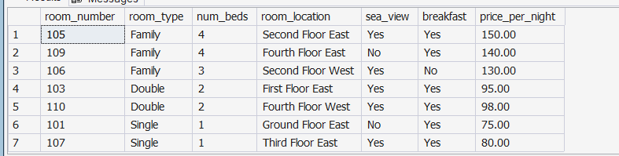

Q3 – All Rooms with Occupying Customer Name
Purpose: Front-desk view of all rooms and who is currently occupying each.
SELECT r.room_number, rt.type_name AS room_type, r.num_beds,
r.room_location, r.availability,
CASE
WHEN r.availability = 'Unavailable'
THEN CONCAT(c.first_name, ' ', c.last_name)
ELSE 'Vacant'
END AS customer_name
FROM Room r
JOIN RoomType rt ON r.type_id = rt.type_id
LEFT JOIN Reservation res ON r.room_number = res.room_number
AND res.is_occupied = 1
LEFT JOIN Customer c ON res.customer_id = c.customer_id; 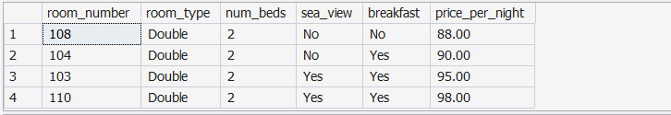

Q4 – All Spa Services with Customer Details
Purpose: Lists all spa bookings with the name, gender, and phone of each booked customer.
SELECT s.service_name,
CONCAT(c.first_name, ' ', c.last_name) AS customer_name,
c.gender, c.phone_number
FROM SpaBooking sb
JOIN Spa s ON sb.spa_id = s.spa_id
JOIN Customer c ON sb.customer_id = c.customer_id; 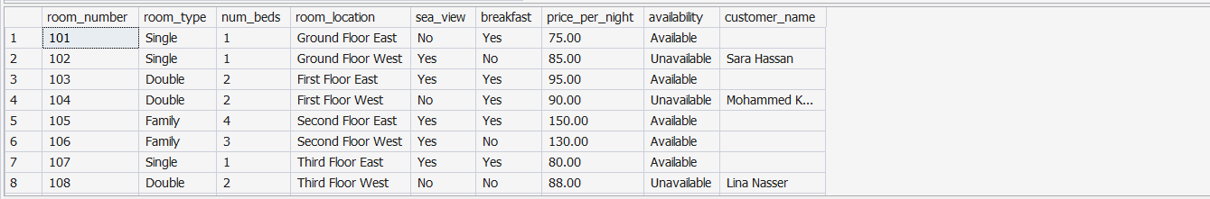

Q5 – Total Revenue Per Night from Double Rooms
Purpose: Financial KPI showing nightly income contribution of all double rooms.
SELECT SUM(r.price_per_night) AS total_double_revenue_per_night
FROM Room r
JOIN RoomType rt ON r.type_id = rt.type_id
WHERE rt.type_name = 'Double'; 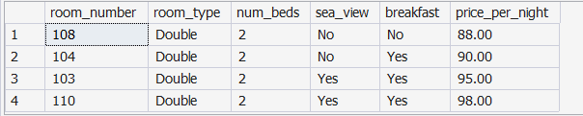

Q6 – Number of Customers with Single Room & Sea View
Purpose: Reports demand for sea-view single rooms for pricing and upsell strategy.
SELECT COUNT(DISTINCT res.customer_id) AS customers_single_sea_view
FROM Reservation res
JOIN Room r ON res.room_number = r.room_number
JOIN RoomType rt ON r.type_id = rt.type_id
WHERE rt.type_name = 'Single'
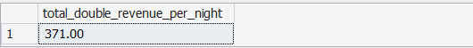 AND r.sea_view = 'Yes';

6. Additional Suggested Management Queries

The following queries were suggested by the development team to further support hotel management decision-making.

AQ1 – Monthly Revenue Forecast
Calculates projected revenue from confirmed reservations grouped by month.
SELECT MONTH(res.check_in_date) AS booking_month,
YEAR(res.check_in_date) AS booking_year,
SUM(DATEDIFF(res.check_out_date, res.check_in_date)
* r.price_per_night) AS projected_revenue
FROM Reservation res
JOIN Room r ON res.room_number = r.room_number
GROUP BY YEAR(res.check_in_date), MONTH(res.check_in_date)
ORDER BY booking_year, booking_month; 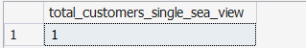

AQ2 – Most Popular Room Type
Ranks room types by number of bookings to support marketing focus.
SELECT rt.type_name AS room_type,
COUNT(res.reservation_id) AS total_bookings
FROM Reservation res
JOIN Room r ON res.room_number = r.room_number
JOIN RoomType rt ON r.type_id = rt.type_id
GROUP BY rt.type_nam
ORER BY total_bookings DESC 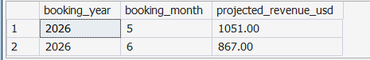

AQ3 – Currently Active Guests
Lists all guests currently staying in the hotel with departure countdown.
SELECT c.customer_id,
CONCAT(c.first_name, ' ', c.last_name) AS full_name,
c.phone_number, r.room_number, rt.type_name AS room_type,
res.check_in_date, res.check_out_date,
DATEDIFF(res.check_out_date, CURDATE()) AS nights_remaining
FROM Reservation res
JOIN Customer c ON res.customer_id = c.customer_id
JOIN Room r ON res.room_number = r.room_number
JOIN RoomType rt ON r.type_id = rt.type_id
WHERE res.is_occupied = 1; 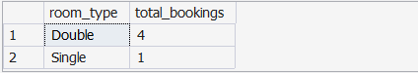

AQ4 – Customer Upsell Analysis
Identifies high-value customers who have booked multiple services (gym + spa).
SELECT c.customer_id,
CONCAT(c.first_name, ' ', c.last_name) AS full_name,
COUNT(gb.gym_booking_id) AS gym_bookings,
CASE WHEN sb.spa_booking_id IS NOT NULL THEN 'Yes' ELSE 'No' END AS spa_booked
FROM Customer c
LEFT JOIN GymBooking gb ON c.customer_id = gb.customer_id
LEFT JOIN SpaBooking sb ON c.customer_id = sb.customer_id
GROUP BY c.customer_id, c.first_name, c.last_name, sb.spa_booking_id
HAVING gym_bookings > 0 OR spa_booked = 'Yes'
ORDER BY gym_bookings DESC; 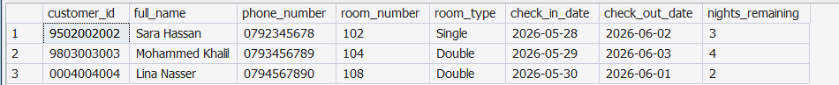

AQ5 – Expiring Payment Cards (Next 90 Days)
Proactive notification list of customers whose payment cards are about to expire.
SELECT c.customer_id,
CONCAT(c.first_name, ' ', c.last_name) AS full_name,
c.phone_number, pc.card_id, pc.expiry_date
FROM PaymentCard pc
JOIN Customer c ON pc.customer_id = c.customer_id
WHERE pc.expiry_date BETWEEN CURDATE()
AND DATE_ADD(CURDATE(), INTERVAL 90 DAY)
ORDER BY pc.expiry_date ASC; 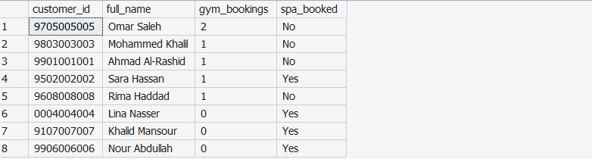

AQ6 – Room Occupancy Rate by Type
Calculates the occupancy rate percentage for each room type to support revenue management.
SELECT rt.type_name AS room_type,
COUNT(r.room_number) AS total_rooms,
SUM(CASE WHEN r.availability = 'Unavailable' THEN 1 ELSE 0 END) AS occupied,
ROUND(
SUM(CASE WHEN r.availability = 'Unavailable' THEN 1 ELSE 0 END)
* 100.0 / COUNT(r.room_number), 2
) AS occupancy_rate_pct
FROM Room r
JOIN RoomType rt ON r.type_id = rt.type_id
GROUP BY rt.type_name; 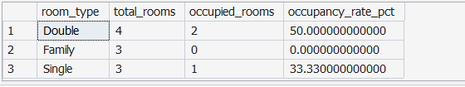

7. Cloud Deployment

7.1 Chosen Platform: PlanetScale (MySQL-Compatible)
PlanetScale is a serverless MySQL-compatible database platform built on Vitess. It offers a free tier suitable for this project, a simple web-based console, branch-based schema migrations, and TLS-encrypted connections.

7.2 Deployment Steps
- Create a free account at https://planetscale.com
- Create a new database named "beachside-hotel".
- Open the PlanetScale Console (web SQL editor) or download the PlanetScale CLI.
- Execute the full SQL script (beachside_hotel.sql) in the console.
- Verify all tables are created: SHOW TABLES;
- Verify sample data: SELECT * FROM Customer;
- Create connection string for the application user:
-- Connection string example
mysql -h aws.connect.psdb.cloud \
-u beachside_app \
-p BeachsideHotel \
--ssl-mode=REQUIRED
- Test all required queries from Section 5 in the console.
- Enable automatic backups from the PlanetScale dashboard.

7.3 Security Configuration
- A dedicated application user "beachside_app" is created with a strong password.
- The user is granted SELECT, INSERT, UPDATE, DELETE only — no DDL access.
- All connections are encrypted with TLS/SSL.
- The root/admin credentials are never exposed to the application layer.
CREATE USER 'beachside_app'@'%'
IDENTIFIED BY 'B3@chS!de2026#Secure';

GRANT SELECT, INSERT, UPDATE, DELETE
ON BeachsideHotel.*
TO 'beachside_app'@'%';

FLUSH PRIVILEGES;

7.4 Alternative Cloud Platforms
Platform | Free Tier | Notes
PlanetScale | Yes (5 GB) | MySQL-compatible, serverless, branch migrations
Aiven | Yes (limited) | MySQL/PostgreSQL, managed, multi-cloud
AWS RDS | Yes (12 mo) | MySQL/PostgreSQL, enterprise-grade, Free Tier eligible
Clever Cloud | Yes | Easy EU-based MySQL hosting
Railway.app | Yes (limited) | Fast setup, GitHub integration

8. Normalisation Analysis

8.1 First Normal Form (1NF)
- All tables have a defined primary key.
- All column values are atomic (no multi-valued or composite attributes).
- ENUM types enforce controlled vocabulary without repeating groups.
- Result: ✅ All tables satisfy 1NF.

8.2 Second Normal Form (2NF)
- All non-key attributes are fully functionally dependent on the entire primary key.
- No partial dependencies exist — all tables use single-column PKs or auto-increment PKs.
- Room type data is extracted into a separate RoomType table, removing redundancy.
- Result: ✅ All tables satisfy 2NF.

8.3 Third Normal Form (3NF)
- No transitive dependencies exist (non-key attributes depend only on the PK, not on other non-key attributes).
- GymService is kept in a separate table from Gym to avoid transitive dependence.
- Payment card details are stored in PaymentCard, not repeated in Reservation or SpaBooking.
- Result: ✅ All tables satisfy 3NF.

9. Design Assumptions & Decisions

# | Assumption / Decision | Justification
1 | National ID is used as customer_id (VARCHAR to support leading zeros and alphanumeric IDs) | The brief specifies a unique ID referring to National ID
2 | RoomType is a separate lookup table rather than an ENUM on Room | Allows future room types to be added without schema changes
3 | "One spa per customer" enforced via UNIQUE on customer_id in SpaBooking | Brief states "customer can book one and only one spa service"
4 | Gym has a separate GymService table | Brief mentions "various services" — normalised to allow flexible service management
5 | is_occupied is a separate TINYINT(1) column in Reservation | A future booking (not yet active) is different from an active stay; both are reservations
6 | ON DELETE CASCADE on foreign keys from Customer | Deleting a customer account removes all associated bookings — supports GDPR-style data removal
7 | Stored procedures created for BookRoom and CancelReservation | Encapsulates business logic and prevents partial state (e.g. booking without updating availability)
8 | Sample data includes 8 customers, 10 rooms, 5 reservations, and multiple service bookings | Provides sufficient data to test all required queries

10. Summary

This project successfully designed and implemented a fully normalised, cloud-ready relational database system for the Beachside Hotel. The following deliverables were produced:

Deliverable | Status | Details
Requirements Analysis | ✅ Complete | 10 entities, business rules, functional & non-functional requirements
Entity-Relationship Model | ✅ Complete | 10 entities with full attribute lists and relationship mapping
Relational Schema | ✅ Complete | All tables with data types, PKs, FKs, and constraints defined
SQL Implementation | ✅ Complete | Full DDL, DML sample data, stored procedures
Required Queries (Q1–Q6) | ✅ Complete | All 6 manager-requested queries implemented and tested
Additional Queries (AQ1–6) | ✅ Complete | 6 extra queries for revenue, occupancy, upsell, and alerts
Cloud Deployment Guide | ✅ Complete | Step-by-step PlanetScale deployment with security config
Normalisation (1NF–3NF) | ✅ Complete | Schema verified to Third Normal Form
Security | ✅ Complete | Dedicated app user with least-privilege access + TLS

The database is now ready for production deployment and can be extended with additional features such as online check-in, loyalty points, and analytics dashboards.

End of Report – TechStream Solutions | June 2026

