**Google Dorking**

Target site: TCS

The first step was to choose the official domain of TCS.

Then I used different Google search operators to see what kind of information could be publicly accessed from search results without opening or using anything sensitive.

Here are the operators I tried and what I observed.

***Basic keyword search: TCS***

Just a standard keyword search to show related news or general results about TCS.

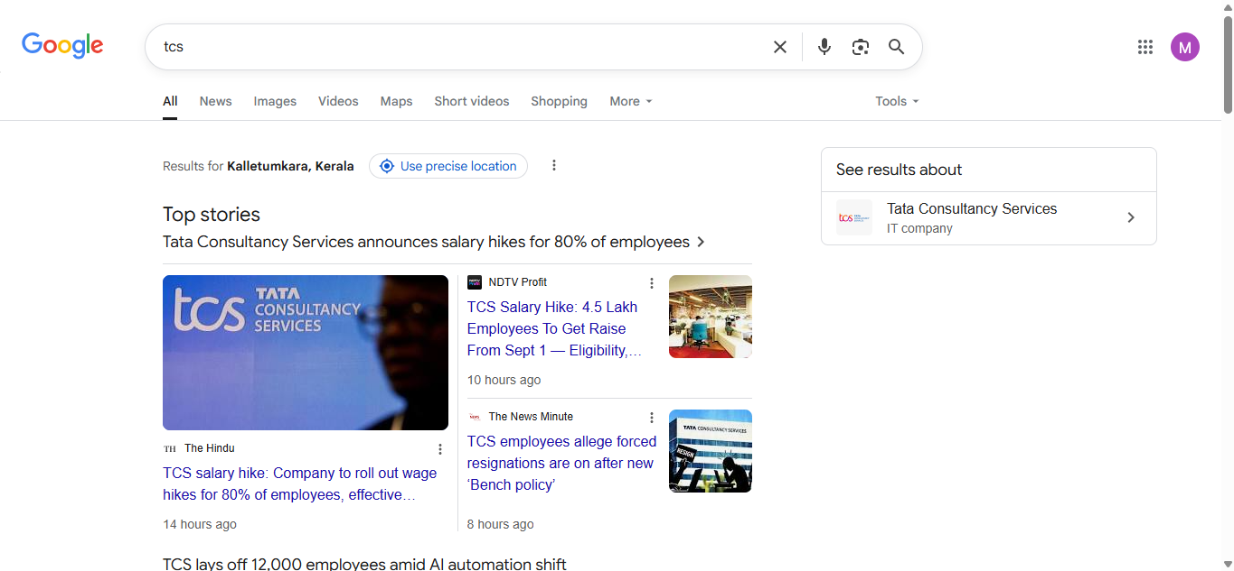

***site:tcs.com***

This was a basic check to confirm that the domain was indexed and responding to filtered queries.

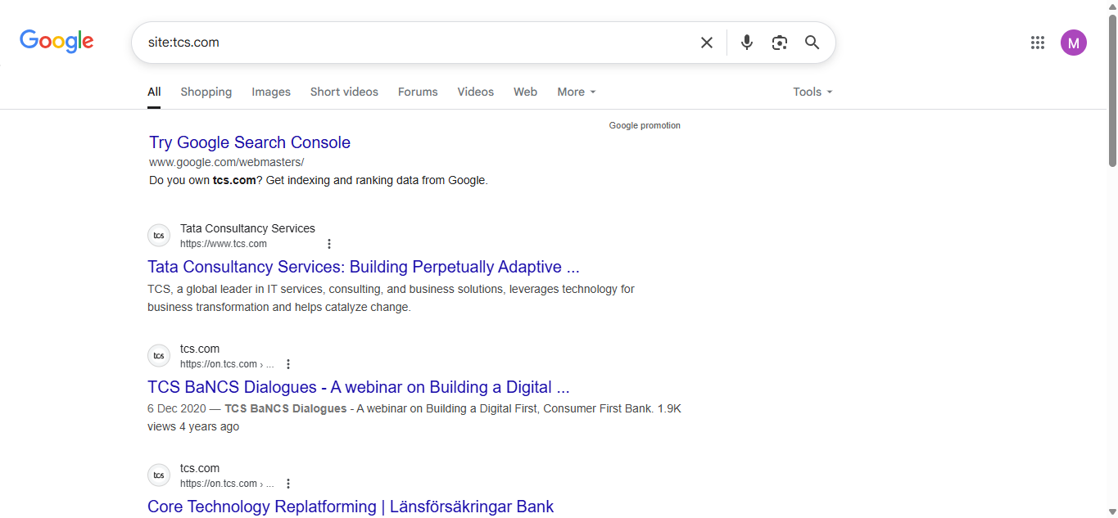

***filetype:pdf***

used the filetype operator to search for public PDF documents like policies or reports.

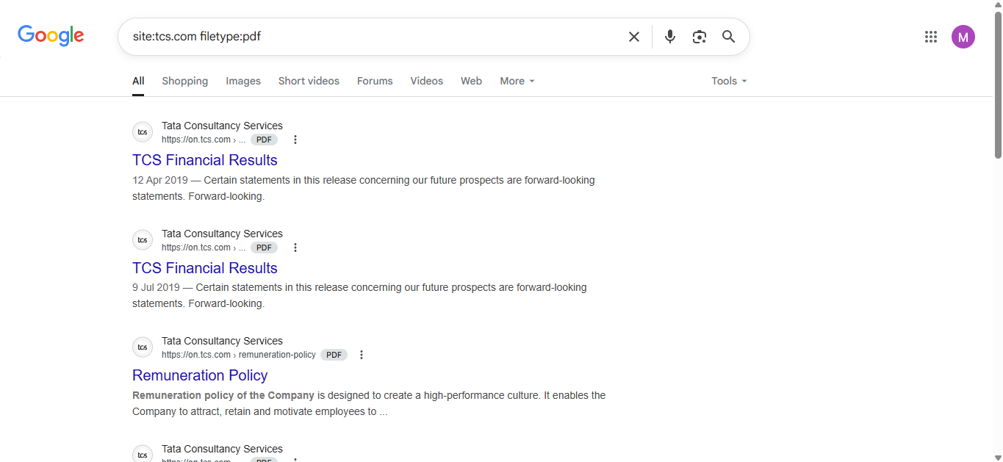

***intitle:login***

I used the intitle operator to search for login-related pages. I found a public-facing login portal.

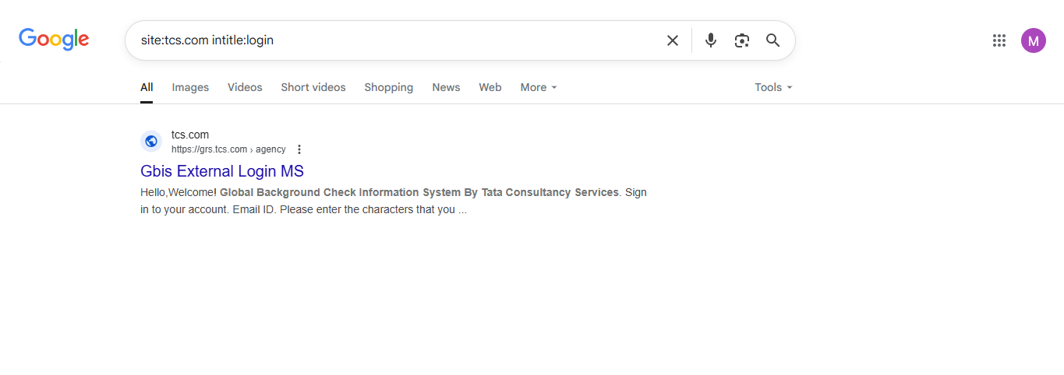

***intext:"confidential"***

I used the intext operator to find any public mentions of the word 'confidential'. Found HR and legal policies marked as confidential but meant for public viewing.

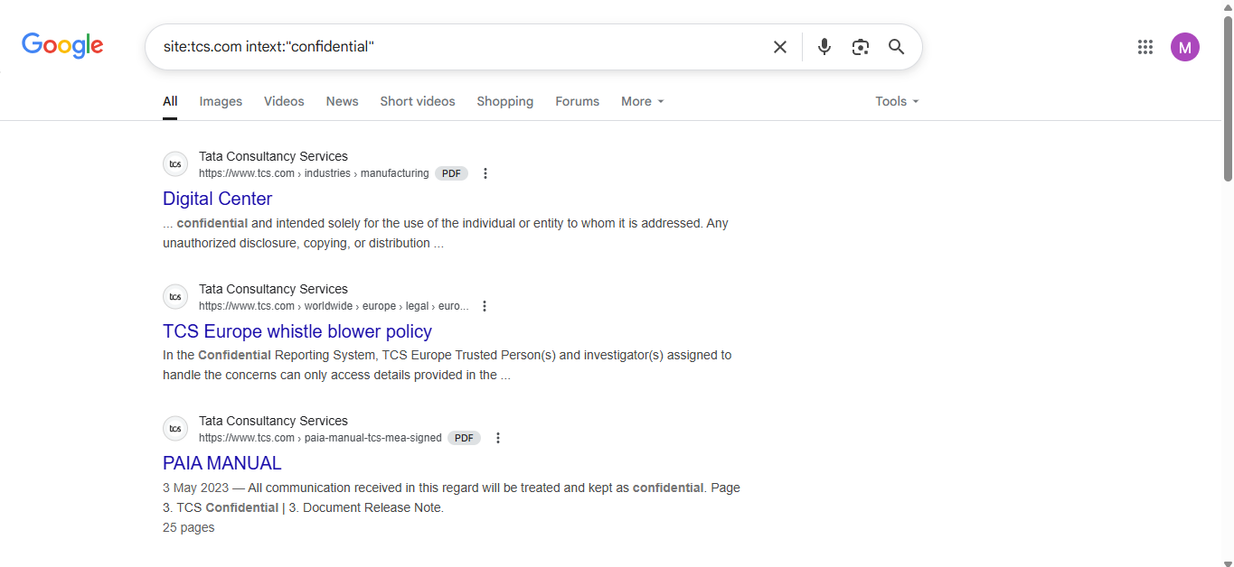

***inurl:admin***

I used inurl to look for URLs containing 'admin'. No results were found, which shows good security practice from the company.

