Week 1 - PL/SQL Programming
Student Name: Aaradhy Soni
Exercise 1: Control Structures

Scenario 1: Loan Interest Rate Discount for Senior Citizens
Problem Statement
The bank wants to apply a discount to loan interest rates for customers above 60 years old.
Objective
Write a PL/SQL block that loops through all customers, checks their age, and if they are above 60, applies a 1% discount to their current loan interest rates.
Approach
- Used a FOR LOOP to iterate through eligible customers.
- Used MONTHS_BETWEEN() function to calculate age.
- Applied a 1% reduction to loan interest rates.
- Used UPDATE statement to modify loan records.
- Used COMMIT to save changes permanently.
Output
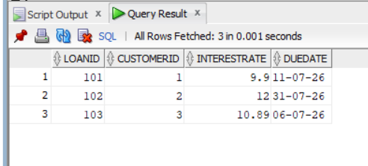

Result
Loan interest rates were successfully reduced by 1% for customers above 60 years of age.

Scenario 2: VIP Customer Promotion
Problem Statement
A customer can be promoted to VIP status based on their account balance.
Objective
Write a PL/SQL block that iterates through all customers and sets the IsVIP flag to TRUE for customers having a balance greater than 10000.
Approach
- Used a FOR LOOP to iterate through customer records.
- Checked whether the account balance exceeds 10000.
- Updated the IsVIP field to TRUE.
- Used COMMIT to save the updates.

Output
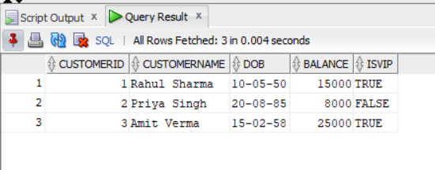Result
Customers with account balances greater than 10000 were successfully promoted to VIP status.

Scenario 3: Loan Due Reminder System
Problem Statement
The bank wants to send reminders to customers whose loans are due within the next 30 days.
Objective
Write a PL/SQL block that fetches all loans due within the next 30 days and prints reminder messages for customers.
Approach
- Used a FOR LOOP to iterate through loan records.
- Selected loans whose DueDate falls within the next 30 days.
- Used DBMS_OUTPUT.PUT_LINE() to display reminder messages.
- Displayed customer name, loan ID, and due date.
Output
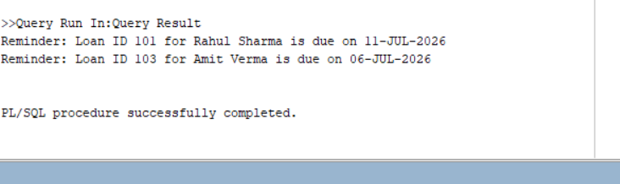
Result
Reminder messages were successfully generated for customers whose loan due dates fall within the next 30 days.

