Week 1 - PL/SQL Programming
Student Name: Aaradhy Soni
Exercise 3: Stored Procedures

Scenario 1: Process Monthly Interest
Problem Statement
The bank needs to process monthly interest for all savings accounts.
Objective
Write a stored procedure ProcessMonthlyInterest that calculates and updates the balance of all savings accounts by applying an interest rate of 1% to the current balance.

Output Before Execution
Accounts Table Before Applying Interest
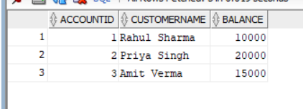

Output After Execution
Accounts Table After Applying Interest
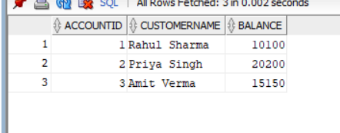
Result
The stored procedure was executed successfully and 1% interest was applied to all account balances.

Scenario 2: Update Employee Bonus
Problem Statement
The bank wants to implement a bonus scheme for employees based on their performance.
Objective
Write a stored procedure UpdateEmployeeBonus that updates the salary of employees in a given department by adding a bonus percentage passed as a parameter.

Output Before Execution
Employee Details Before Bonus Update
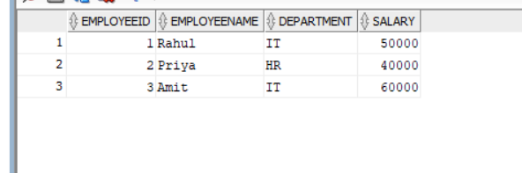
Output After Execution
Employee Details After Bonus Update
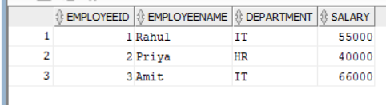
Result
The stored procedure was executed successfully and employee salaries were updated according to the specified bonus percentage.

Scenario 3: Transfer Funds
Problem Statement
Customers should be able to transfer funds between their accounts.
Objective
Write a stored procedure TransferFunds that transfers a specified amount from one account to another, checking that the source account has sufficient balance before making the transfer.

Output Before Execution
Account Details Before Fund Transfer

Output After Execution
Account Details After Fund Transfer


Conclusion
This exercise demonstrated the implementation of PL/SQL Stored Procedures for various banking operations. The following procedures were successfully created and executed:
- ProcessMonthlyInterest
- UpdateEmployeeBonus
- TransferFunds
All procedures produced the expected results and validated the use of stored procedures in Oracle PL/SQL for performing business operations efficiently.

