PORTFOLIO PROJECT REPORT | ARTIFICIAL INTELLIGENCE & DATA SCIENCE
Insights of Business
Online Retail Sales Analysis & Revenue Trend Modelling
Prepared by: Data Analytics Portfolio Candidate | Program: BCA (Artificial Intelligence & Data Science)
Dataset: Online Retail.xlsx | Core Tools: Python, Pandas, Matplotlib, Microsoft Excel
EXECUTIVE SUMMARY
Executive Summary: This report delivers an end-to-end commercial analysis of transactional sales data from December 2010 through December 2011. By examining monthly and quarterly trajectories, identifying peak commercial cycles, and evaluating significant month-over-month shifts, this study transforms raw records into actionable insights for retail inventory, marketing allocation, and cash flow governance.

1. Project Overview
Modern commercial enterprises generate thousands of customer transaction logs daily. However, transaction data creates business value only when systematically transformed into clear, actionable intelligence. This project examines an international online retail dataset to uncover underlying revenue patterns, assess seasonal growth velocity, and provide data-backed strategic recommendations.
Project Title | Insights of Business – Online Retail Sales Analysis
Primary Dataset | Online Retail.xlsx (Multi-national transactional records)
Technical Stack | Python (Pandas, NumPy, Matplotlib, Seaborn) & Microsoft Excel
Analytical Domain | Retail Business Analytics & Revenue Performance Management
Core Objective | Analyze online retail transactions to understand revenue trends, monthly and quarterly performance, sales growth, and potential business opportunities.
Target Audience | Retail Commercial Executives, Inventory Planners, and BI Decision Makers

By identifying chronological revenue fluctuations and evaluating sales momentum across quarters, this report provides a structured framework to evaluate customer buying patterns, optimize procurement timelines, and mitigate sudden downturns in trading volume.
2. Dataset Preparation & Cleaning Methodology
Data cleaning is a critical prerequisite for credible business analysis. Raw transaction datasets often contain missing identifiers, inconsistent timestamp structures, and cancelled transactions. In this project, a disciplined data pipeline was constructed using Python and Pandas to ensure statistical rigor.
Data Preparation Steps
- 1. Ingestion: Load the raw transactional records from Online Retail.xlsx into a Pandas DataFrame using pd.read_excel().
- 2. Handling Missing Attributes: Filter out records containing missing product Description or CustomerID when executing customer-level and item-level cleaning protocols.
- 3. Datetime Standardization: Convert the InvoiceDate field into a native pandas datetime64 format using pd.to_datetime().
- 4. Revenue Computation: Derive line-item gross revenue by multiplying quantity by item unit price: Revenue = Quantity × UnitPrice.
- 5. Temporal Attribute Extraction: Extract temporal features (year, month, quarter) directly from the datetime object without prematurely transforming timestamps into static text strings.
- 6. Aggregation & Sorting: Group derived revenue chronologically by calendar year, month, and quarter, followed by explicit sorting before computing delta metrics.
TECHNICAL BEST PRACTICE
Critical Analytical Principle (Datetime Integrity): InvoiceDate must remain a genuine datetime column throughout the analytical manipulation phase. Converting timestamps permanently to strings using strftime() prior to temporal extraction restricts subsequent chronological sorting, dynamic windowing, and quarterly grouping.

Distinction Between Revenue and Profit
In financial and commercial analytics, Revenue (Top-Line Turnover) must never be conflated with Profit (Net Earnings):
- Revenue (Top Line): Represents the total gross monetary value realized from customer transactions (Quantity × UnitPrice) prior to any cost deductions.
- Operating Expenses & COGS: Cost of Goods Sold (procurement/manufacturing costs), shipping fees, warehousing, payment gateway commissions, and marketing overhead are not captured in transaction unit prices.
- Analytical Caution: A high-revenue period does not guarantee commercial profitability if operating costs, expedited logistics, or heavy discounting compress operating margins.
3. Monthly Revenue Analysis
To track business growth, transactional revenue was aggregated across all available periods from December 2010 through December 2011. December 2010 serves as the foundational baseline against which early 2011 trajectory is assessed.
REPORTING CONVENTION
Currency Unit Clarification: All reported figures represent dataset currency units. In accordance with rigorous data science reporting standards, figures are not assigned arbitrary currency symbols (such as INR ₹ or USD $) without explicit transactional confirmation in the dataset metadata.

Mathematical Formulations for Month-over-Month (MoM) Growth
Month-over-month performance was evaluated using two standardized mathematical formulas applied in chronological sequence:
- Absolute Change: Absolute Change = Current Month Revenue − Previous Month Revenue
- Percentage Change: Percentage Change (%) = (Absolute Change ÷ Previous Month Revenue) × 100
Because December 2010 serves as the initial baseline, its absolute and percentage shifts are designated as N/A. January 2011 is strictly compared against December 2010, preventing multi-year month mixing.
Chronological Monthly Performance Table (Dec 2010 – Dec 2011)
Month and Year | Revenue | Absolute Change | % Change (MoM)
December 2010 (Baseline) | 748,957.020 | N/A | N/A
January 2011 | 560,000.260 | -188,956.760 | -25.23%
February 2011 | 498,062.650 | -61,937.610 | -11.06%
March 2011 | 683,267.080 | +185,204.430 | +37.18%
April 2011 | 493,207.121 | -190,059.959 | -27.82%
May 2011 | 723,333.510 | +230,126.389 | +46.66%
June 2011 | 691,123.120 | -32,210.390 | -4.45%
July 2011 | 681,300.111 | -9,823.009 | -1.42%
August 2011 | 682,680.510 | +1,380.399 | +0.20%
September 2011 | 1,019,687.622 | +337,007.112 | +49.37%
October 2011 | 1,070,704.670 | +51,017.048 | +5.00%
November 2011 | 1,461,756.250 | +391,051.580 | +36.52%
December 2011 | 433,668.010 | -1,028,088.240 | -70.33%

4. Visual Analytics: Monthly Revenue Charts
Data visualization allows analysts and business stakeholders to rapidly diagnose cyclical trends, isolate structural breaks, and identify periods requiring deeper diagnostic inquiry.
Chart 1: Monthly Revenue Trend (Dec 2010 – Dec 2011)
Figure 1 illustrates the 13-month continuous revenue trajectory, clearly establishing the initial baseline, mid-year stabilization, autumn acceleration, and sharp year-end collapse.
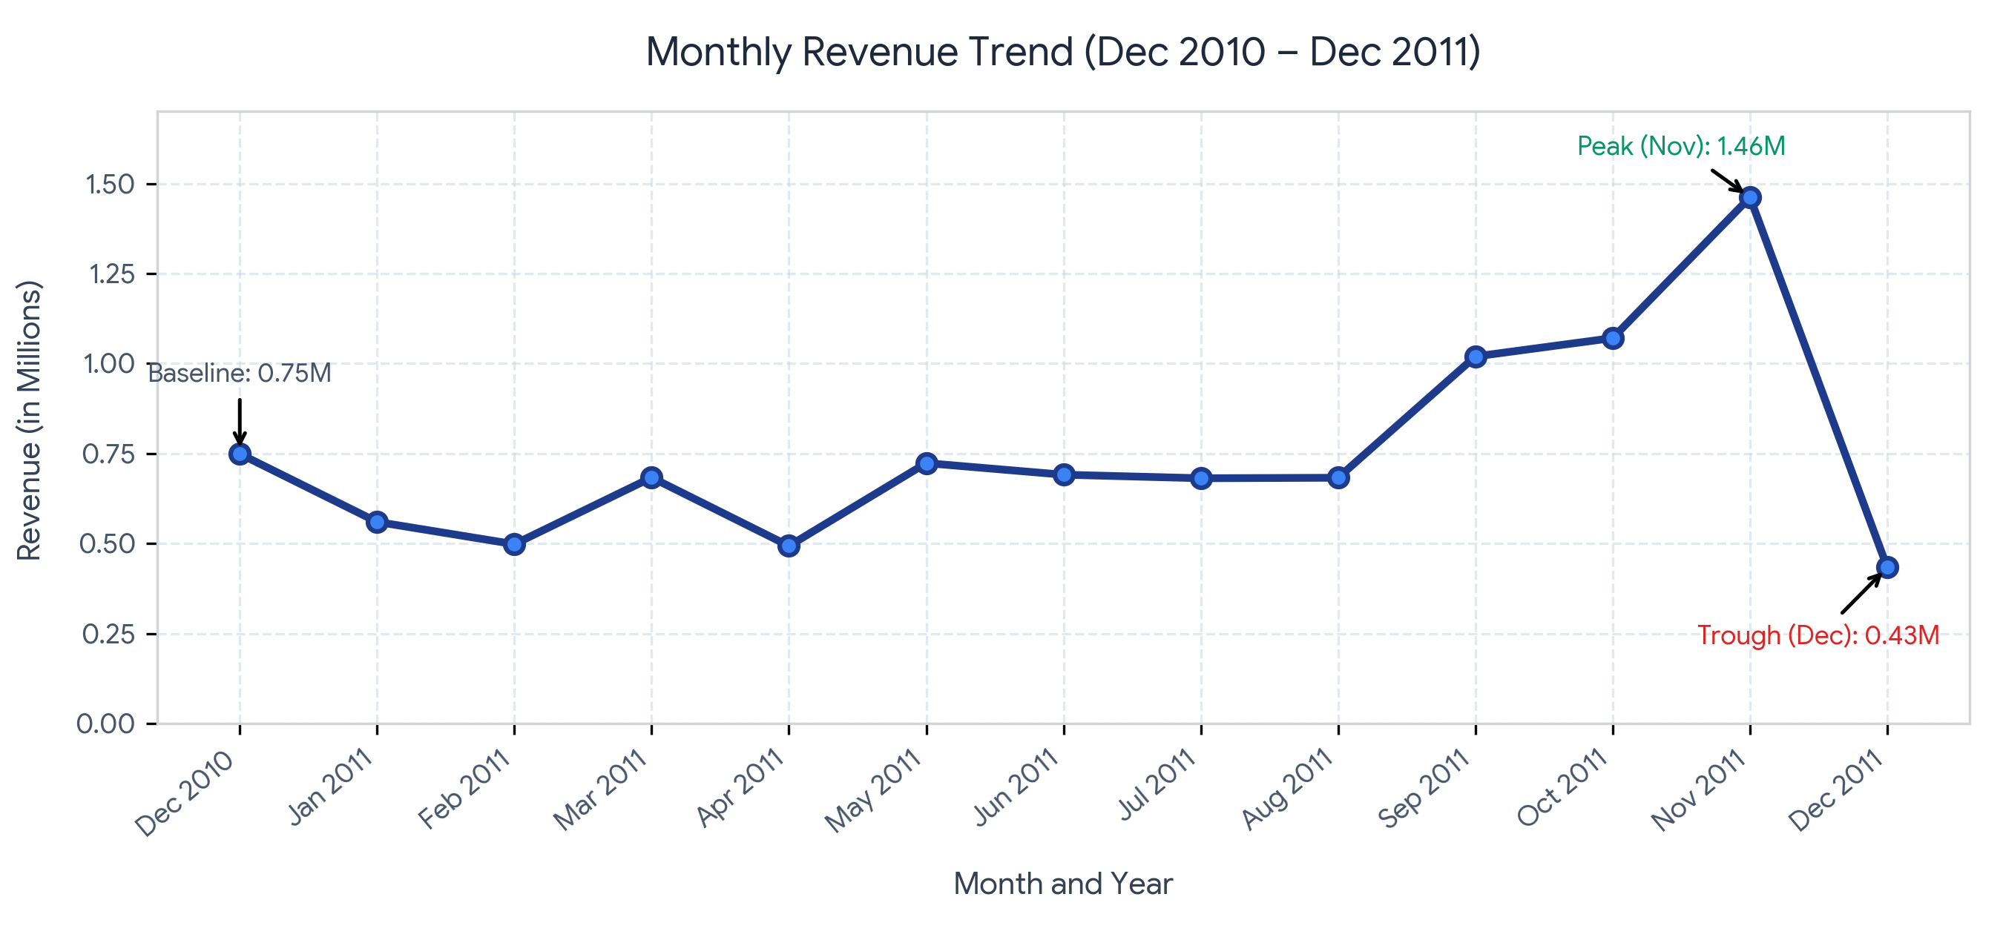
Figure 1: Full-period chronological monthly revenue line trend (Dec 2010 to Dec 2011).
Chart 2: Monthly Revenue Comparison (2011 Only)
Figure 2 isolates the 12 calendar months of 2011, providing visual contrast between average trading months and extreme operational outliers (November peak versus December trough).
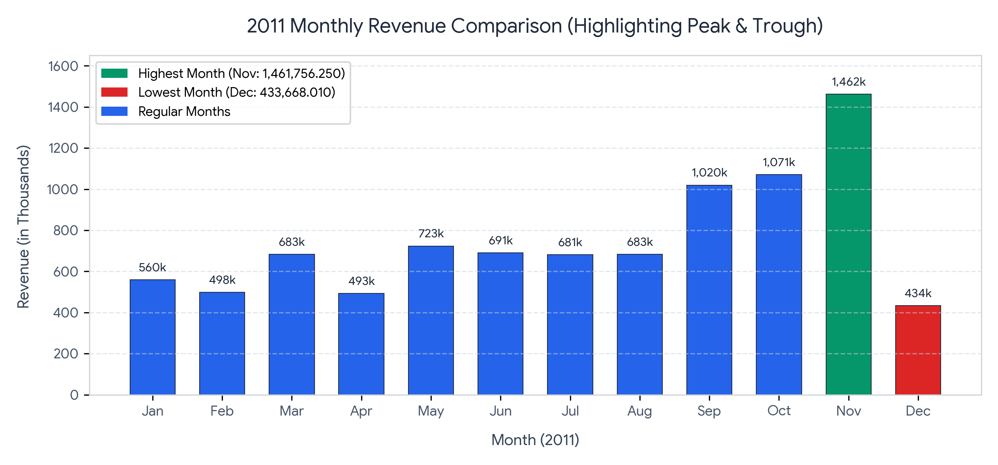
Figure 2: 2011 monthly revenue bar comparison with peak (green) and trough (red) highlights.
Chart 3: Month-over-Month Percentage Change
Figure 3 captures the rate of change relative to the preceding chronological month, anchored by a solid zero baseline to clearly segregate expansionary periods from contractionary cycles.
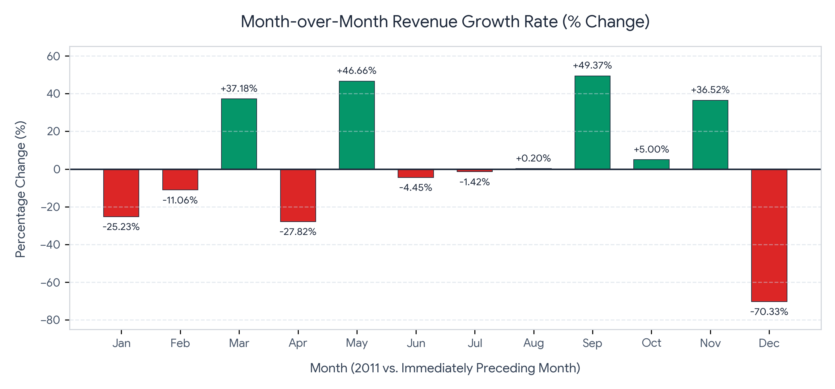
Figure 3: Month-over-month revenue growth rate (%) across 2011 with zero-reference baseline.
5. Monthly Business Insights & Commercial Implications
Careful examination of monthly figures reveals six distinct commercial dynamics. As professional data analysts, we identify empirical patterns while framing explanations as hypotheses that require validation rather than unsubstantiated claims.
Key Empirical Observations
- 1. Highest-Revenue Month (November 2011): Generated peak turnover of 1,461,756.250, outperforming all other recorded periods.
- 2. Lowest-Revenue Month (December 2011): Recorded the annual low of 433,668.010, dropping significantly below baseline figures.
- 3. Late-Summer Breakout (September 2011): Revenue surged from 682,680.510 in August to 1,019,687.622 in September, marking a +49.37% (+337,007.112) breakout above the one-million unit threshold.
- 4. Strong November Momentum: Revenues grew by +36.52% (+391,051.580) over October 2011, establishing a dramatic acceleration heading into late Q4.
- 5. Precipitous December Drop: Revenues plummeted by -70.33% (-1,028,088.240) between November and December 2011.
- 6. Post-Baseline January Rebound Deficit: January 2011 revenue contracted by -25.23% (-188,956.760) relative to December 2010.
Business Implications & Hypotheses
The observed monthly volatility carries strategic implications across core retail operational domains:
- Seasonal Demand & Promotion Windows: The surge from September through November strongly suggests heightened pre-holiday wholesale ordering or consumer retail purchasing. However, absent campaign tagging or marketing logs, this cannot be definitively credited to holiday marketing without verifying customer invoice categories.
- December Abrupt Contraction: A -70.33% contraction within an active holiday shopping month is highly unusual in retail operations. Commercial possibilities include: (a) dataset truncation (data collection ending mid-month in December 2011), (b) massive post-November order returns or invoice cancellations, or (c) warehouse stockouts resulting from November fulfillment exhaustion.
- Supply Chain and Inventory Risk: Maintaining static safety stock across this retail environment creates extreme vulnerability. Operating inventory based on November volume would cause massive deadstock in December, while ordering based on Q1 volume would trigger stockouts in September.
6. Quarterly Revenue Analysis
Quarterly aggregation aggregates high-frequency monthly fluctuations into macroeconomic business cycles, enabling senior managers to evaluate corporate quarterly targets and capacity planning.
2011 Quarterly Summary Table
Quarter | Included Months | Revenue | % Change (QoQ)
Q1 2011 | January – March | 1,741,329.990 | N/A
Q2 2011 | April – June | 1,907,663.751 | +9.55%
Q3 2011 | July – September | 2,383,668.243 | +24.95%
Q4 2011 | October – December | 2,966,128.930 | +24.44%

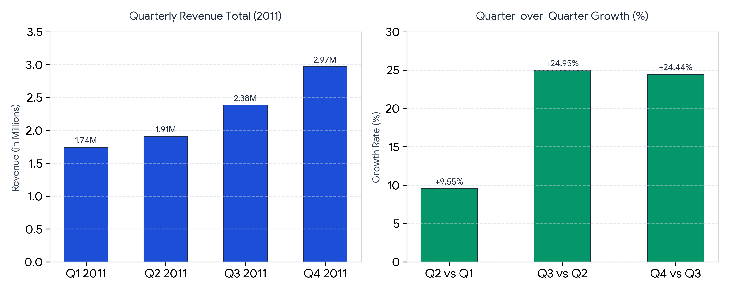
Figure 4: Quarterly performance breakdown — Total Revenue (left) and QoQ Growth Velocity (right).
Analytical Caveat: The Aggregation Masking Effect
KEY ANALYTICAL TAKEAWAY
The Quarter 4 Aggregation Paradox: At first glance, Q4 2011 stands as the most successful trading quarter with record revenue of 2,966,128.930 (+24.44% growth over Q3). However, closer monthly inspection reveals that this total was generated almost entirely by October (1.07M) and November (1.46M), while December experienced an unprecedented collapse down to 433,668.010. High quarterly revenue can easily mask critical monthly operational breakdowns.

7. Annual Revenue Summary & Data Comparability
A summary of annual aggregates reveals the following figures across the recorded calendar periods:
Calendar Year | Total Recorded Revenue | Available Time Coverage
2010 | 748,957.020 | 1 Month Only (December 2010 Baseline)
2011 | 8,998,790.914 | 12 Months Full (January through December)

Methodological Prohibition on Annual Growth Comparisons
A common novice data error is computing a year-over-year annual growth percentage between 2010 (748k) and 2011 (8.99M). Doing so would yield an artificial, misleading '+1,101.5%' growth metric.
- Asymmetry in Time Horizons: The 2010 dataset encapsulates merely 31 calendar days, whereas 2011 reflects an entire calendar year.
- Data Integrity Standard: True Year-over-Year (YoY) annual growth requires two equivalent 12-month observation windows. Analysts must rigorously avoid presenting partial-period totals against full-year totals as commercial growth rates.
8. Actionable Business Recommendations
Based on the empirical revenue trajectories, the business should execute nine concrete analytical and operational investigations:
- 1. Deep-Dive Q3/Q4 Surge Drivers: Conduct item-level and client-segment audits on the September–November expansion to establish whether wholesale client acquisition, consumer seasonal shopping, or specific marketing pushes drove the surge.
- 2. Audit December Transaction Logs: Examine December invoices for cut-off anomalies, negative line adjustments, abnormal return ratios, or incomplete logging before assuming a genuine demand collapse.
- 3. Analyze Underlying Transaction Mechanics: Disaggregate revenue into its underlying drivers across months: Transaction Volume, Average Order Value (AOV), and Items per Basket.
- 4. Conduct SKU Pareto Analysis (80/20 Rule): Identify top-performing product categories to verify if revenue growth is diversified or dangerously concentrated in a few high-risk SKUs.
- 5. Correlate Promotional Campaigns: Map marketing campaigns and price discounting schedules to monthly sales to determine promotional ROI and price sensitivity.
- 6. Synchronize Inventory & Fulfillment Planning: Establish dynamic re-order thresholds that anticipate Q3/Q4 volume spikes, preventing both expensive Q4 stockouts and Q1 overstock holding costs.
- 7. Customer Cohort & Retention Analysis: Track monthly customer acquisition versus repeat order rates to determine if revenue expansion is driven by customer retention or costly one-off acquisitions.
- 8. Multi-Year Longitudinal Validation: Ingest multi-year transaction logs (e.g., 2012–2013) to validate whether November spikes and December declines are structural retail season trends.
- 9. Incorporate Unit Margin & Profitability Metrics: Integrate Cost of Goods Sold (COGS), freight, and overhead into analysis to prevent expanding sales of margin-dilutive or loss-making merchandise.
9. Limitations of the Analysis
Transparent acknowledgment of analytical limitations ensures business leaders interpret findings with appropriate commercial nuance:
- Absence of Cost & Margin Data: This analysis evaluates gross revenue only. A commercial business may generate record turnover while incurring operational losses if promotions, return overhead, or logistics expenses exceed gross margins.
- Transaction Adjustments & Negative Values: Datasets of this nature frequently contain cancelled invoices (e.g., invoice codes starting with 'C') and negative quantities representing product returns. Complete return netting requires specialized customer-level reconciliation.
- Partial Baseline Year: Having only December 2010 prevents full annualized comparison and restricts seasonality modeling across the first three quarters of 2011.
- Correlation vs. Causation: Observing that November is the highest-revenue month does not establish what business factors caused it. External market factors, consumer sentiment, and promotional execution require supplementary data sources.
- Lack of Geographical & Channel Granularity: Aggregating all domestic and export transactions obscures market-specific currency fluctuations, regional seasonality, and shipping bottlenecks.
10. Conclusion
This report demonstrates the strategic value of rigorous descriptive analytics in retail operations. By cleaning and structuring transaction data chronologically, we established clear benchmarks across 13 months of commercial activity.
The analysis confirms November 2011 as the peak trading period (1,461,756.250) and December 2011 as the lowest recorded period (433,668.010). It highlights steady quarter-over-quarter expansion throughout 2011, while demonstrating how quarterly aggregates can conceal severe monthly downturns. Most importantly, it reinforces the analytical principle that month-over-month growth rates must be computed in strict chronological order from standardized datetime records.
ANALYST PORTFOLIO SUMMARY
Portfolio Summary: By bridging Python data engineering, statistical validation, and executive-ready communication, this study provides an actionable blueprint for retail decision-makers to optimize inventory planning, investigate operational anomalies, and drive profitable, data-backed commercial growth.

