Problem 1: Social Network Friend Suggestion
Graph Algorithm: BFS / DFS
Real-World Application: Facebook, LinkedIn
Objective: Suggest new connections based on mutual friends.
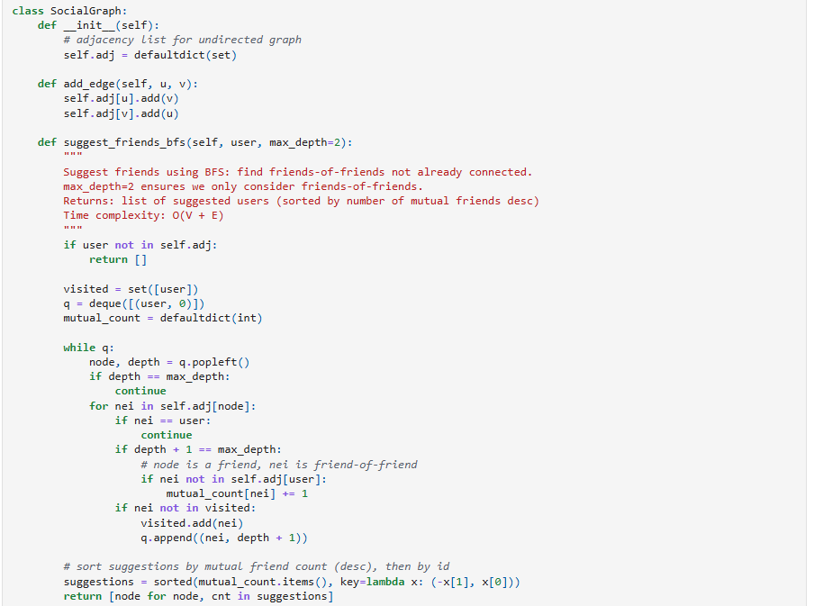
Observations and Analysis:
Time Complexity Analysis:
Execution time increases linearly with the number of vertices and edges, following the theoretical O(V + E) complexity. These algorithms perform efficiently for sparse and moderately dense graphs, making them practical for exploring social connections or friend suggestions.
Space Complexity Analysis:
Memory consumption is O(V), as visited nodes and recursion or queue structures need to be stored. The space usage remains efficient for medium-sized graphs, though very large networks may require careful memory management.

Problem 2: Route Finding on Google Maps
Graph Algorithm: Bellman-Ford
Real-World Application: Navigation systems
Objective: Find shortest path from source to all nodes, even if some edge weights are negative.
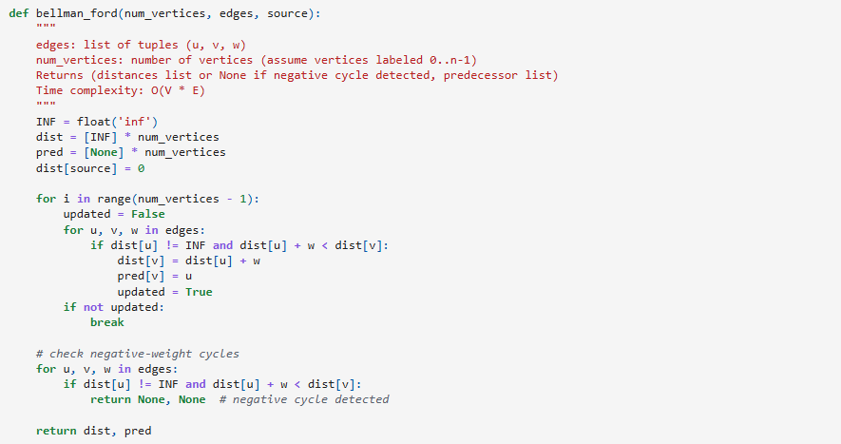
Observations and Analysis:
Time Complexity Analysis:
The algorithm’s runtime scales as O(V × E), since it relaxes all edges repeatedly for each vertex. Execution time increases sharply with graph size, making it less suitable for very large networks but effective for small to medium-sized routing problems.
Space Complexity Analysis:
Space usage is O(V), needed to store distance and predecessor arrays. Memory demand is moderate and remains manageable even for larger graphs, as only vertex-level information is maintained.

Problem 3: Emergency Response System
Graph Algorithm: Dijkstra’s Algorithm
Real-World Application: Disaster Management
Objective: Identify the fastest route for emergency vehicles in a weighted city map (all weights positive).
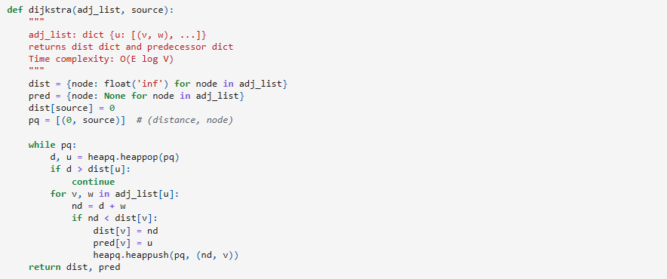

Observations and Analysis:
Time Complexity Analysis:
With a priority queue, Dijkstra’s algorithm achieves O(E log V) time complexity. Execution time grows logarithmically with graph size, maintaining good performance for large, positive-weighted networks such as city maps or disaster routes.
Space Complexity Analysis:
Memory requirements are O(V + E), as both distance arrays and adjacency lists are stored. Although space use grows with network size, it remains acceptable for most real-world applications.

Problem 4: Network Cable Installation
Graph Algorithm: Minimum Spanning Tree (Prim’s Algorithm or Kruskal’s)
Real-World Application: Telecom & IT Infrastructure
Objective: Connect all offices/nodes with the minimum total length of cable.
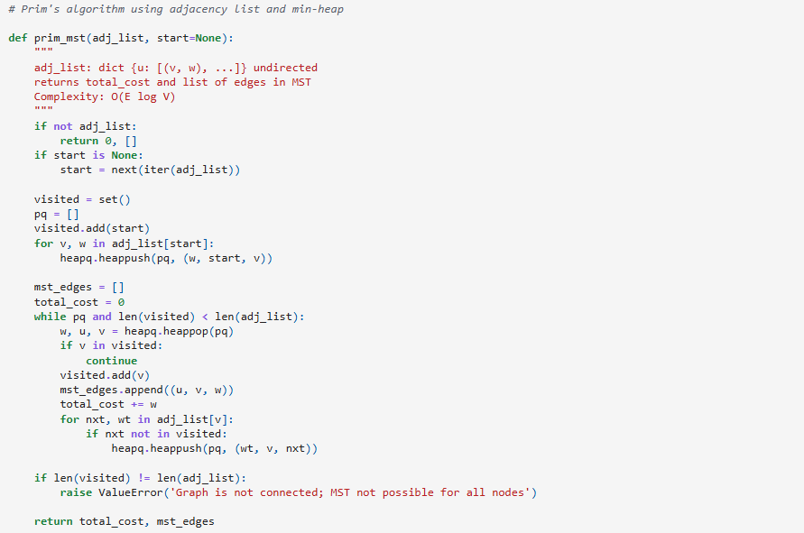
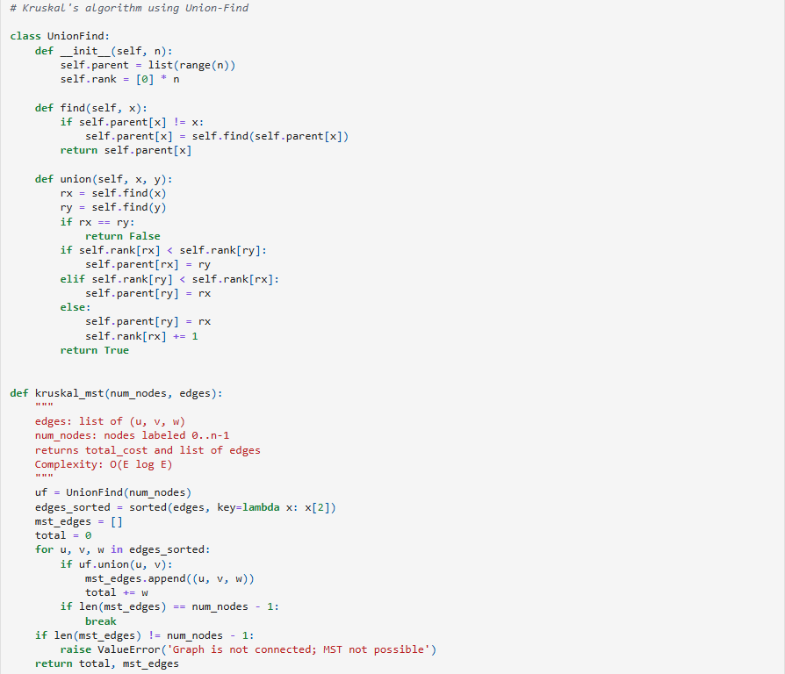

Observations and Analysis:
Time Complexity Analysis:
Prim’s and Kruskal’s algorithms operate in O(E log V) time using efficient data structures. Execution time scales smoothly with the number of edges, providing reliable performance for network or cable design problems.
Space Complexity Analysis:
Space complexity is O(V + E), used to store all edges and subsets. Memory usage remains proportional to the input size, and space-efficient implementations can further reduce overhead in large infrastructure graphs.
