NNA WEEKLY BRIEF
3Q26 Wealth Flow Review: record quarter, normal underlying growth
Prepared by Aaradhya Acharya · October 15, 2026 · Data through 3Q26 (LPL through 2Q26)
Bottom line. Morgan Stanley Wealth Management posted a record $232B of net new assets (NNA) in 3Q26, but about half was IPO-related. The underlying run-rate is ~$114B, or ~5.7% annualized organic growth, at the midpoint of the firm's 5–7% target.
Recommendation. Report NNA as underlying + attributed events in the senior-management pack, so repeatable growth is not confused with one-offs. 4Q26 base case: ~$140B (80% band $126B–$190B), before any new events.
KEY FINDINGS
- The record is real, but episodic. Excluding ~$118B of estimated IPO-related flows, 3Q26 NNA was still up ~41% on 3Q25 ($81B).
- MS leads peers on a like-for-like basis in 2026. Ex-event organic growth averaged ~6.6% annualized vs ~5.1% for Schwab and ~3.7% for LPL; in 3Q26 alone MS (5.7%) and Schwab (~5.8–6.1%) were level.
- Two strong quarters lack a public explanation. 4Q25 ($122B) and 2Q26 ($148B) sit >2 standard deviations above trend with no event disclosed; confirm drivers before treating them as run-rate.
KEY FIGURES, LATEST QUARTER
Firm (NNA definition) | Latest quarter | NNA ($B) | vs year ago | Ex-events ($B) | Organic growth, annualized | 2026 YTD ($B)
Morgan Stanley WM (net new assets) | 3Q26 | 232.4 | +187% | ~114 | 11.5% headline; ~5.7% ex-IPO | 498.9
Schwab (core NNA) | 3Q26 | 190.4 | +38% | 190.4 | 5.8% (reported) | 450.2
LPL Financial (organic NNA) | 2Q26* | 23.1 | +13% | 23.1 | 4.0% (reported) | 44.5 (1H)
*LPL reports 3Q26 on Oct 30. Firms define NNA differently, so growth rates compare better than dollars. MS ex-IPO estimated from release wording ("just over half"); MS growth uses beginning client assets interpolated between disclosed anchors.
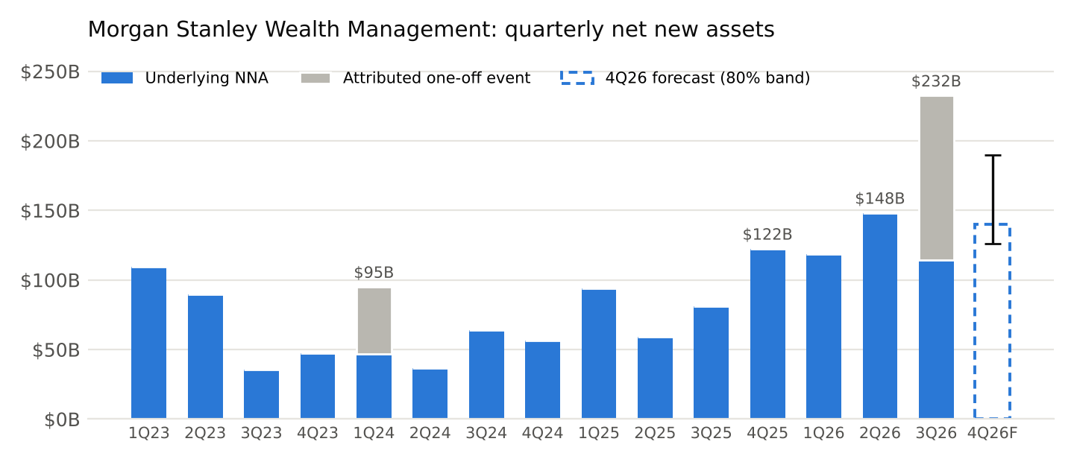
Gray = flows the firm attributed to a specific event (1Q24 family office; 3Q26 IPO-related). Dashed bar = 4Q26 base case with 80% band.
PEER COMPARISON
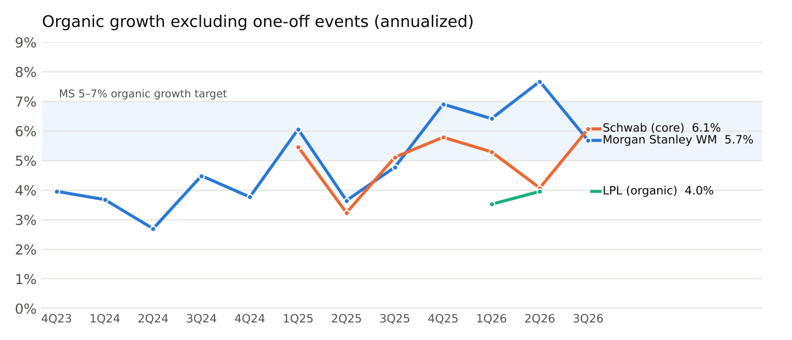
Annualized NNA ÷ beginning-period client assets, after removing attributed one-offs. Schwab's 3Q26 computes at 6.1% vs its reported 5.8% because its beginning asset base is interpolated.
WHAT TO WATCH IN 4Q26
- IPO lock-ups and fund distributions: management flagged further asset-retention opportunities; the main upside to the base case.
- Workplace-to-advisor funnel: ~$99B moved from Workplace and E*TRADE into advisor-led accounts in 2025; equity-compensation events convert directly into NNA.
- No seasonal uplift assumed: 4Q was the strongest quarter in 2025 ($122B) but weaker than 3Q in 2024 ($57B vs $64B).
- Competitor pressure: Schwab core NNA hit a record $190B (+38%); it remains the largest gatherer in dollars once MS one-offs are removed.
FORECAST AND DATA QUALITY
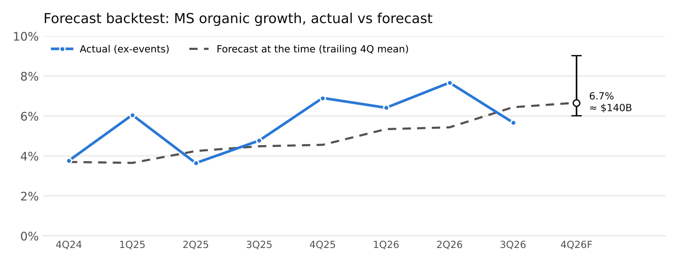
- Method: trailing-four-quarter mean of ex-event growth, chosen over last-quarter and seasonal methods in an 8-quarter rolling backtest (mean absolute error 1.22pp vs 1.55pp and 1.36pp). It has run ~0.9pp low as growth accelerated, so the band leans upward.
- Validation: 76 automated checks, 61 pass. Quarters tie exactly to full-year totals (MS 2023–25, Schwab 2025); computed growth matches firms' own disclosed rates within 0.1pp.
- Caught: a third-party data site lists LPL 2Q26 organic NNA as $23.6B vs $23.1B in LPL's release; the filing is used.
- Open questions: drivers of MS 4Q25 and 2Q26; retention of 3Q26 IPO assets through lock-up expiry.
Sources: MS 3Q26 release · MS 2025 10-K · MS 3Q26 call · Schwab 3Q26 release · Schwab 2025 10-K · LPL 2Q26 results · Code & data

