A
Project Report
On
Sales Data Analysis
Submitted to
IBM SkillsBuild Data Analytics
with AI Academic Internship Program
conducted by BharatCares
in association with AICTE

By
Aaradhya

ABSTRACT

This project presents a comprehensive analysis of Zomato data to derive valuable insights related to restaurant locations, ratings, pricing, and customer preferences. The dataset used in this project includes information such as restaurant names, locations, cuisines, average costs, ratings, and votes from customers.
The purpose of this analysis is to understand customer behavior and restaurant performance, identify popular cuisines and cost-effective eateries, and examine the relationship between different factors such as location and restaurant ratings. Data preprocessing techniques like cleaning null values, removing duplicates, and formatting inconsistent entries are performed. Exploratory Data Analysis (EDA) is then applied using visualization tools such as bar charts, histograms, and heatmaps to uncover hidden patterns and correlations in the data.
The project further discusses the design and implementation of the analytical system, supported by diagrams and Python code. The results of the study can help restaurant owners and marketing teams to make informed business decisions. The report concludes with limitations of the current work and future directions for enhancement, such as the integration of customer review sentiment analysis or real-time data streaming. This project is helpful for future model buildings and for predictive analysis. Overall, this project illustrates the powerful role of data analytics in the modern food tech industry.

KEYWORDS: Data Preprocessing , EDA ,Visualization tool, Hidden
Patterns, Correlation, Future Model Buildings , Predictive Analysis

CHAPTER-1

INTRODUCTION
The food delivery industry in India has seen tremendous growth in the past decade, with platforms like Zomato . Zomato started primarily as a restaurant review platform and has evolved into a full-scale food aggregator and delivery service. As the platform grew, so did the amount of data it accumulated—from restaurant details and menu information to customer ratings and preferences.
With the rise of data science, businesses now rely heavily on data-driven insights to understand consumer behavior and optimize their services. In this context, Zomato’s publicly available data offers an excellent opportunity to apply data analysis techniques and extract valuable information. This project focuses on analyzing Zomato data to understand food trends, pricing structures, restaurant ratings, and geographical distribution of eateries.
The dataset analyzed in this project contains key information including restaurant names, locations, types of cuisine offered, average cost for two, ratings, and number of votes. By cleaning and exploring this data, we aim to answer important business questions like: Which locations have the highest-rated restaurants? What cuisines are most popular in different cities? Is there a correlation between price and rating?
This analysis is especially useful for restaurant owners, entrepreneurs entering the food business, and even Zomato itself to enhance user experience. It demonstrates how businesses can use data not just for reporting, but also for making strategic decisions. Moreover, the project aims to showcase how tools like Python, Pandas, Matplotlib, and Seaborn can be used effectively to turn raw data into actionable insights.

CHAPTER:2

LITERATURE REVIEW /EXISTING WORK

Data analytics in the food delivery industry has become a growing area of research and business interest. Various studies have been conducted that utilize data mining, machine learning, and business intelligence to analyze customer behavior and optimize services on platforms like Zomato, Uber Eats, and Swiggy. This chapter reviews existing works related to restaurant analytics and food preference modeling.
Previous research has often focused on customer review analysis using Natural Language Processing (NLP). For instance, sentiment analysis techniques are applied to Zomato reviews to evaluate public opinion on restaurants. Additionally, clustering techniques such as K-Means have been used to group restaurants based on cuisine, price range, and popularity.
Machine learning models have also been implemented to predict restaurant ratings using features such as cuisine, location, and average cost. Another important area of work is recommendation systems. Collaborative filtering and content-based filtering have been employed to suggest restaurants to users based on past preferences and behavior of similar users.
Despite this, many works are either focused solely on one aspect—such as rating prediction or reviews—or rely on limited data. The present project aims to offer a holistic analysis of multiple variables using structured Zomato data. By combining traditional EDA with visualizations and integrating multiple variables (like cuisine, cost, ratings, and location), this work provides a comprehensive view of the restaurant landscape.

CHAPTER-3

PROBLEM STATEMENT

Despite having access to vast amounts of restaurant data, businesses in the food industry often struggle to convert this raw data into actionable insights. Zomato dataset have information such as restaurant names, locations, ratings, cuisines, cost estimates, and customer votes.
The key problem is the lack of clarity in understanding what influences customer choices and restaurant popularity. For instance, do customers prefer expensive restaurants, or is affordability more critical? Does the cuisine type play a major role in determining ratings? How important is location when it comes to customer engagement? These are crucial questions that can be answered through in-depth data analysis.
Another significant challenge is data quality. Public datasets often contain null values, duplicates, or inconsistent formatting. Without proper cleaning, these anomalies can lead to misleading results. Furthermore, analyzing multidimensional data involving numerical and categorical variables requires advanced techniques for effective visualization and interpretation.
Therefore, the primary objective of this project is to bridge this gap by:
- Preprocessing and cleaning Zomato’s dataset for analysis.
- Conducting exploratory data analysis (EDA) for finding hidden patterns and correlation between data points.
- Visualizing trends in cost, cuisine, and ratings using charts and plots.
- Helping stakeholders make data-driven decisions for marketing, expansion, and service improvements.
Ultimately, the project aims to transform raw Zomato data into a clear, interactive, and insightful report that helps various stakeholders—from restaurant managers to data analysts—understand the dynamics of the food industry more effectively.

CHAPTER-4

PROPOSED WORK

The proposed work follows a structured data analysis pipeline starting from raw data collection to the generation of insights through visualization and interpretation. The key steps involved are Importing dataset and libraries , data preprocessing, Handling Missing values , exploratory data analysis (EDA), visualization.
- DATA COLLECTION AND PREPROCESSING:
The dataset is taken from the Kaggle. It contains fields such as restaurant name, location, cuisines, city , rating, Online Delivery Available , table booking and number of votes. The first step is to clean this data by removing null values, duplicate entries, and converting data types for consistency.
- EXPLORATORY DATA ANALYSIS (EDA):
EDA helps uncover hidden trends and correlations in the dataset. Important questions are asked:
What are the most popular cuisines in each city?
Is there a correlation between restaurant pricing and customer ratings?
Which areas have the highest concentration of top-rated restaurants?
Visualizations such as histograms, bar plots, heatmaps, pie charts, and scatter plots are used to answer these questions.
- TOOLS AND TECHNOLOGIES:
Python is the primary language used, with Jupyter Notebook as the development environment. Libraries such as Pandas and NumPy handle data manipulation, while Matplotlib and Seaborn generate visualizations. Optional tools like Tableau and Power BI can be used to create interactive dashboards.
- OUTCOME:
The final outcome includes a well-documented report containing visual insights and business conclusions. These insights help in customer segmentation, pricing strategies, and regional food trend analysis, thereby supporting strategic planning for restaurant businesses. These insights are also helpful for predictive analysis and building machine learning model

CHAPTER-5

SYSTEM DESIGN

FLOWCHART

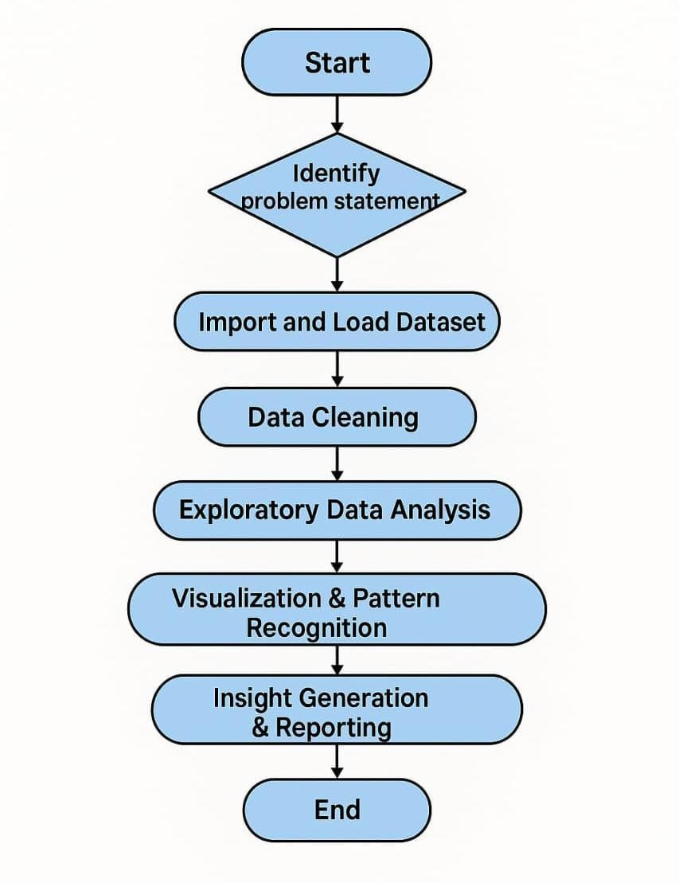
Figure:1: Flowchart for Zomato sales data analysis

1. Identify and define the problem clearly.
2. Import and load the required dataset.
3. Clean the data by fixing errors and handling missing values.
4. Analyze the data to explore trends and patterns.
5. Create visualizations to understand the data better.
6. Generate insights and prepare a summary report.
End the process after completing all steps.

2. DATA FLOW DIAGRAM (DFD )

user
Store clean
Clean Dataframe
Load data
Data preprocessing

dataset
access clean data
Country.xlsx
Zomato.csv
EDA

summery and
visuals

Generate Reports

perform
EDA
Analyst

Insights

Figure:2: DFD Diagram for zomato sales analysis

Description:

The Level-0 DFD illustrates data movement in the Zomato Data Analysis process.

Entities:

User, Analyst

Processes:

1. Load Data (User uploads files)

2. Data Preprocessing (Cleaning and merging datasets)

3. EDA (Exploratory Data Analysis) (Performing statistical analysis and generating visuals)

4. Generate Reports (Creating dashboards and insights)

Data Flows:

User → Load Data: Uploads Zomato.csv and Country.xlsx

Load Data → Data Preprocessing: Sends raw data for cleaning and merging

Data Preprocessing → Clean DataFrame: Stores cleaned dataset

Clean DataFrame → EDA: Accesses processed data for analysis

EDA → Generate Reports: Passes analysis results

Generate Reports → Analyst: Delivers dashboards and reports

3. ENTITY-RELATIONSHIP DIAGRAM (ERD)
Entities:
- Restaurant (restaurant_id, name, rating, cost)
- Location (location_id, city, locality)
- Cuisine (cuisine_id, cuisine_name)

Relationships:
- A restaurant belongs to one location
- A restaurant can offer multiple cuisines
- A restaurant has one or more ratings
Restaurant_id
name

RESTAURANT

cost
Belongs to
rating

offers
LOCATION
CUISINE
Location_id
Cuisine id
Cuisine_name
city

4. USE CASE DIAGRAM
- Analyst
- Business Owner Use Cases:
- Upload data
- Clean data
- Perform EDA
- Generate visualizations
This design ensures a clear understanding of how the system operates and helps in implementing the workflow effectively.

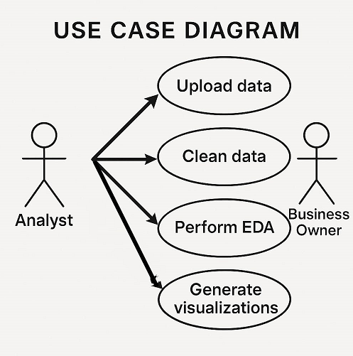
Description:-
1. Analyst – Responsible for the technical tasks involving data handling and analysis.
2. Business Owner – Stakeholder who is primarily interested in insights derived from the data.
Use Cases:
1. Upload Data – The Analyst uploads raw data into the system.
2. Clean Data – The Analyst processes the data to remove errors, missing values, and inconsistencies.
3. Perform EDA (Exploratory Data Analysis
4. Generate Visualizations
Relationships:
The Analyst is connected to all four use cases.
The Business Owner is linked to Clean Data and Perform EDA, indicating interest or involvement in those processes.
An arrow from Generate Visualizations to Perform EDA indicates that visualizations are derived from or depend on the results of EDA.

CHAPTER-6
IMPLEMENTATION

The implementation involves executing the planned steps using Python and its associated libraries. The dataset is loaded into a Jupyter Notebook environment where the following steps are performed.

1.Importing the Libraries

import pandas as pd import numpy as np import matplotlib.pyplot as plt import seaborn as sns
%matplotlib inline

2.Impoting Datasets

import warnings warnings.filterwarnings('ignore') df = pd.read_csv("C:/Users/admin/Downloads/zomato.csv",encoding='latin-
1') df.head()

3.Data Cleaning

null_columns = df.columns[df.isnull().any()].tolist() null_columns df["Cuisines"].isnull().sum()
df["Cuisines"]= df["Cuisines"].fillna(df['Cuisines'].mode()[0]) df["Cuisines"].isnull().sum()

4.Exploratory Data Analysis (EDA)

ratings=final_df.groupby(['Aggregate rating','Rating color','Rating text']).size().reset_index().rename(columns={0:'Rating Count'}) ratings final_df[['Country','Currency']].groupby(['Country','Currency']).size().r eset_index()
final_df[final_df['Has Online delivery'] == "Yes"].Country.value_counts()
final_df[['Has Online delivery','Country']].groupby(['Has Online delivery','Country']).size().reset_index() final_df[final_df["Has Table booking"] == "Yes"].Country.value_counts()
final_df[["Has Table booking",'Country']].groupby(['Has Table booking','Country']).size().reset_index()

5.Data Visualization

pie chart for top 3 countries that uses zomato

colors = ['#ff9999','#66b3ff','#99ff99',"#c2f0c2","#a3a3c2"]
plt.pie(country_val[:3],labels=country_names[:3],autopct="%1.2f%%",colors
=colors) plt.show()

Rating bargraph

import matplotlib plt.figure(figsize=(12, 6))
sns.barplot(x="Aggregate rating",y="Rating Count",data=ratings,color="teal") plt.show()

plt.figure(figsize=(12,6)) sns.barplot(x="Aggregate rating",y="Rating Count",hue='Rating color',data=ratings,palette=["White","Red","Orange","Yellow","Green","pur ple"]) plt.show()

## COUNT PLOT sns.countplot(x="Rating color",data=ratings,palette="Greens") plt.show()

Top cities: New Delhi , Gurgaon , Noida , Faridabad and Ghaziabad are the top 5 cities by orders.

plt.figure(figsize=(8,6))
city_values=final_df.City.value_counts().values city_labels=final_df.City.value_counts().index
colors = ['#ff9999','#66b3ff','#99ff99',"#c2f0c2","#a3a3c2"] plt.pie(city_values[:5],labels=city_labels[:5],autopct='%1.2f%%',colors=c olors) plt.show()

plt.figure(figsize=(8,6))
Cuisines_values=final_df.Cuisines.value_counts().values Cuisines_labels=final_df.Cuisines.value_counts().index plt.pie(Cuisines_values[:10],labels=Cuisines_labels[:10],autopct='%1.2f%%
') plt.show()

Top 10 Restaurant by Rating

# Sort top_10 DataFrame by rating top_10_sorted = top_10.sort_values(by='Votes', ascending=True)
# Create a bar plot P lt.figure(figsize=(8,6)) sns.barplot( x="Restaurant Name", y="Votes", data=top_10_sorted, color="teal",alpha=0.8
) plt.xticks(rotation=45, ha='right') plt.title("Top 10 Restaurants by Rating") plt.xlabel("Restaurant Name") plt.ylabel("Votes") plt.tight_layout() plt.show()

Heatmap for correlation

corr_matrix = df[["Aggregate rating", "Votes"]].corr() sns.heatmap(corr_matrix,annot=True,cmap="Greens",alpha=0.8)

6.Interface Screenshots

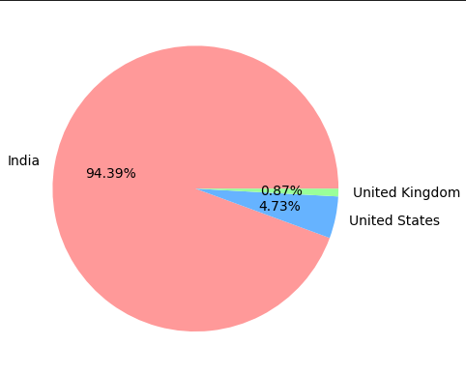
Figure:1: Zomato maximum records or transaction are from India .After that USA and then United Kingdoms.

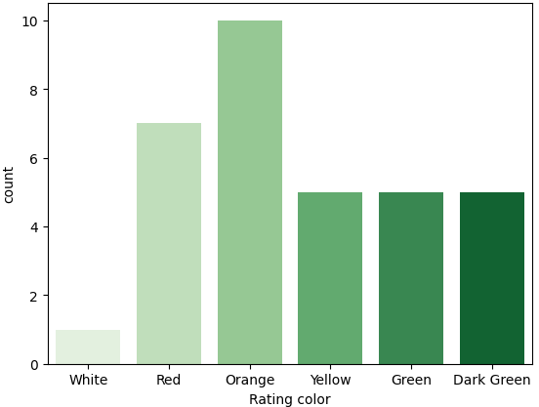
Figure:2: New Delhi , Gurgaon , Noida , Faridabad and Ghaziabad are the top 5 cities by orders.

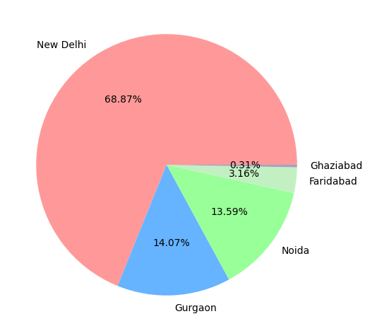
Figure:3:New Delhi , Gurgaon , Noida , Faridabad and Ghaziabad are the top 5 cities by orders.
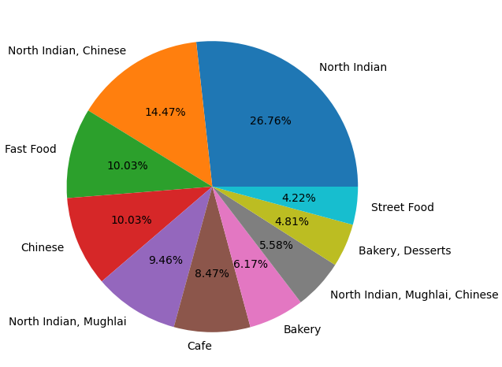
Figure:4:Mostly North Indian and Chinese food are ordered by Customers.

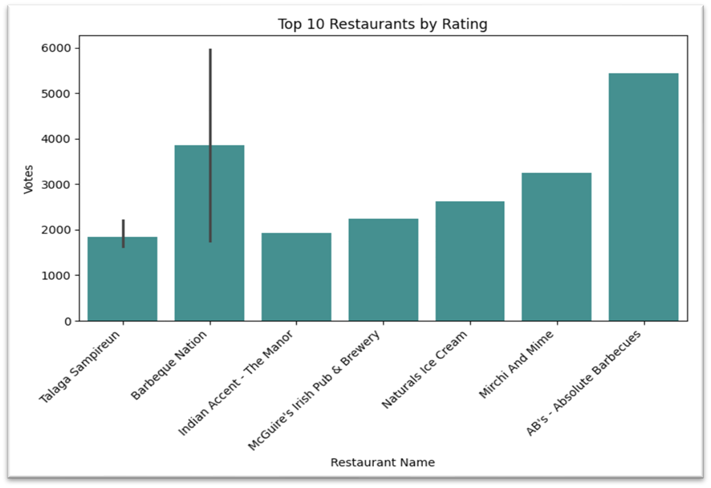

Figure:5: List of top 10 restaurants by ratings

CONCLUSION, LIMITATION, AND FUTURE SCOPE

CONCLUSION:
This project successfully performed an end-to-end analysis of the Zomato dataset. The insights derived include the identification of most preferred cuisines, toprated restaurants, pricing distributions, and customer preferences across locations. Python-based data analysis and visualization provided an effective and scalable way to understand complex restaurant data.
The results show that:
- Location and cuisine significantly influence restaurant ratings.
- Higher cost does not always equate to higher ratings.
- North Indian and Chinese cuisines are the most popular.
LIMITATIONS:
- The dataset is static and may not reflect real-time trends.
- Text-based reviews and sentiments are not included.
- Geographical data is limited, restricting detailed location-based analysis.
FUTURE SCOPE:
- This sales analysis is used for building future Machine Learning Models and Predictive Analysis.
- Zomato dataset can enhance targeted marketing campaigns, offering personalized recommendation and promotion.
- Implementing real time dashboards for sales and user activities.
- Sales trends can identify areas for reducing deliveries time, optimizing delivery routes and improving restaurants partnerships.
- Insights from sales data can guide Zomato in identifying high performing regions.

REFERENCE
- Zomato Dataset – Kaggle and GitHub
- Seaborn and Matplotlib Official Documentation
- Research Papers on Food Delivery Analytics and Customer Segmentation

