Assembly Language – I and II

Guide to x84_64: https://web.stanford.edu/class/cs107/guide/x86-64.html
Hello World Program

section .data
text db "Hello, World!",10

section .text
global _start

_start:
mov rax, 1
mov rdi, 1
mov rsi, text
mov rdx, 14
syscall

mov rax, 60
mov rdi, 0
syscall

Overview of the Code:

text – variable with data bytes assigned, stores the memory location of the data stored
db – data bytes to be assigned to the previously said variable “text”
"Hello, World!" - text data to be stored in variable “text”
10 – new line character in assembly

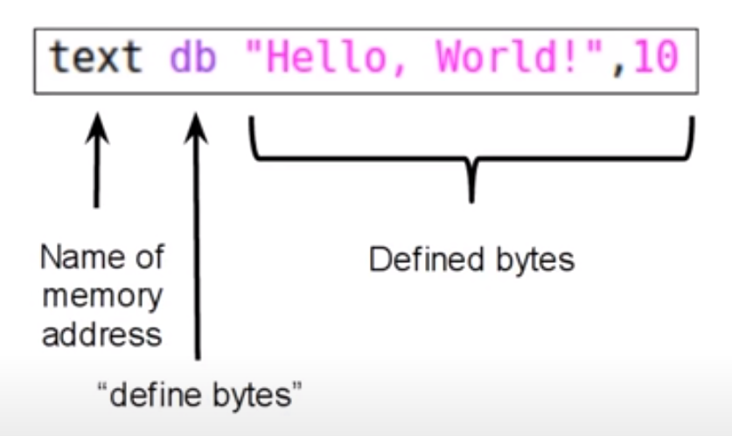

Registers: Part of processor that temporarily hold the memory
In x86_64, registers hold 64 bits
Each Register can hold values:

Unsigned: 0 18,446,744,073,709,551,616
Signed: -9,223,372,036,854,775,808 9,223,372,036,854,775,807

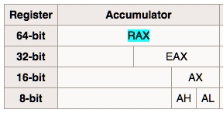

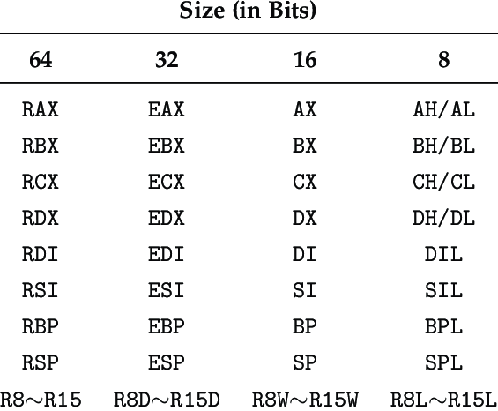
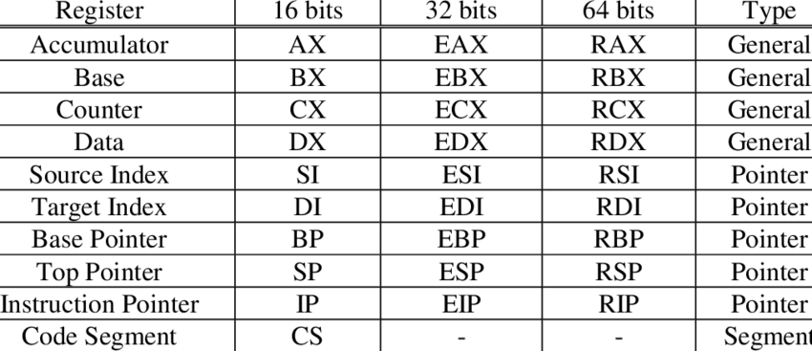

System Call (syscall):

A system call, or syscall, is used when a program requests a service from a kernel.
System calls differ by OS as different OS’s use different system calls
All syscall have an associated ID to themselves
syscall also take arguments, i.e., a list of inputs

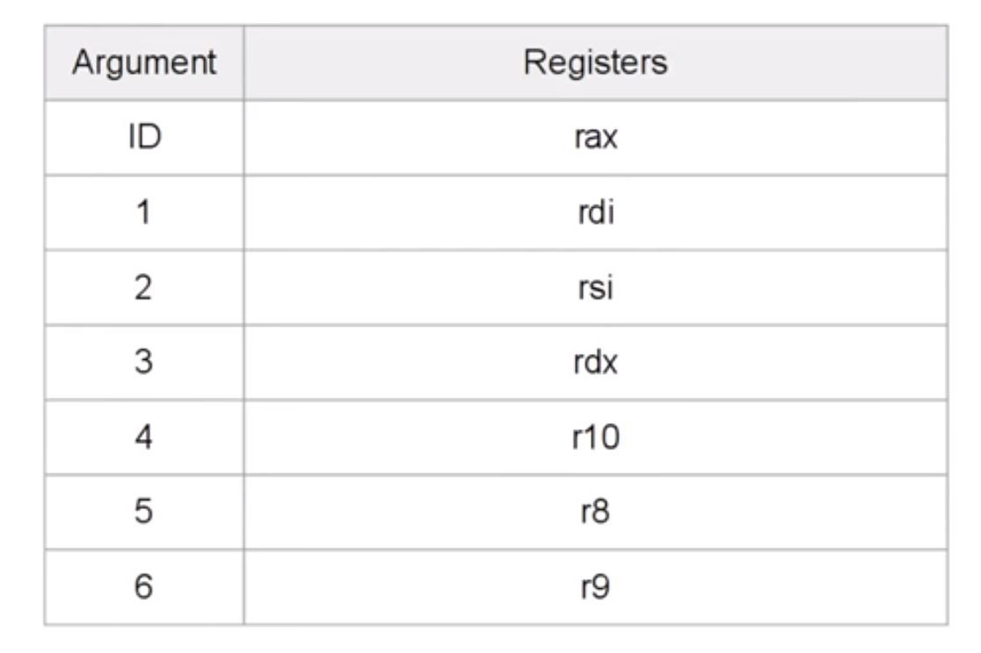

Syscall Syntax:

Syscall List for Different Systems:

x86_64 Architecture: https://syscalls.mebeim.net/?table=x86/64/x64/latest

ARM64, Aarch64: https://syscalls.mebeim.net/?table=arm64/64/aarch64/latest
These syscalls are for Raspberry Pi 5 and whichever supports ARM64.

Syscalls Used:

mov rax, 1 : Tells the system to sys_write
mov rax, 60 : Tells the system to sys_exit

Simple Language Conversion:

- Define Bytes
- sys_write(1, text 14)
- sys_exit(0)

Sections:

All x86_64 assembly files have three sections-
- “.data” section: data defined before compilation
- “.bss” section: data allocated for future use
- “.text” section: actual code
Label:

A “label” is used to label a part of code.
Upon compilation, compiler will calculate location in which the label will sit in the memory
Whenever label is used, in code, it is replaced by the location in the memory by compiler
It is like a Function in C++

_start label:

Essential for all type of code
Any program will first look for the start program first
If linker cannot find the “_start” program, it will throw an error
It is like “main()” function in C++

Global:

“Global” is used when you want the linker to know the address of some label
The object file generated will contain link to ever label declared “global”
In this case, we declared “_start” as global since it is required for code to be properly executed

Assembly Language – III

Flags:

Like registers, hold Data
Only holds 1 bit, either True or False
Individual Flags are part of larger registers

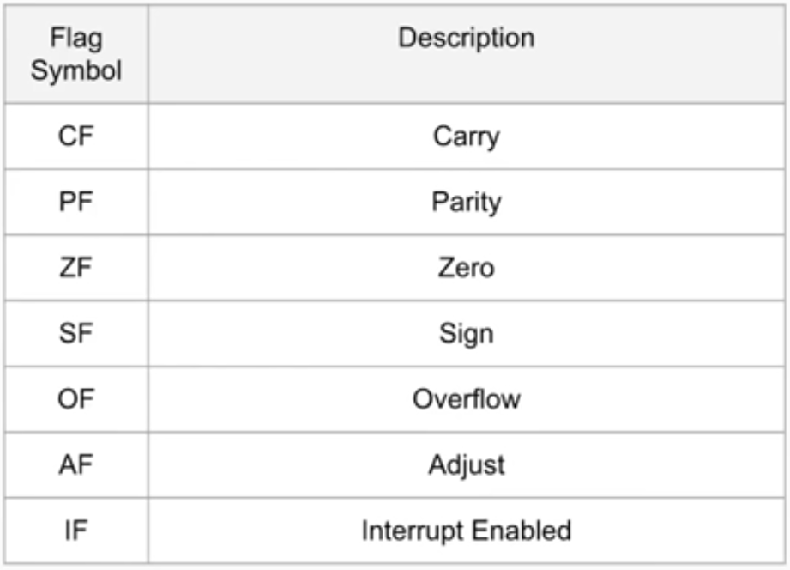

Pointers:

Registers that hold data
Point to data, meaning, holds its memory address

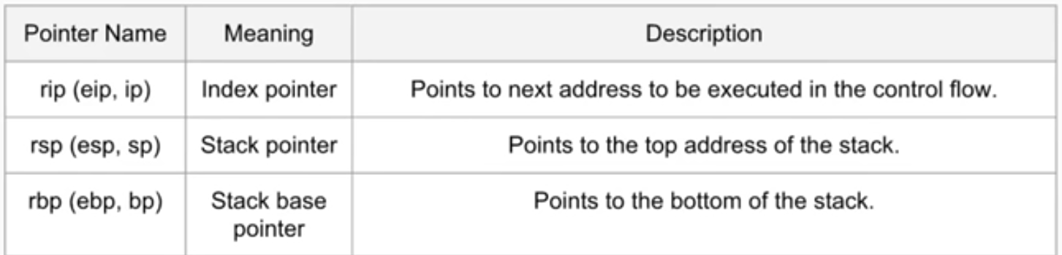

Control Flow:

All code runs from top to bottom by default
Direction the program flows in is called Control Flow

The rip register holds address of next instuction to execute
Increments after each instruction, making control flow naturally flow from top to bottom

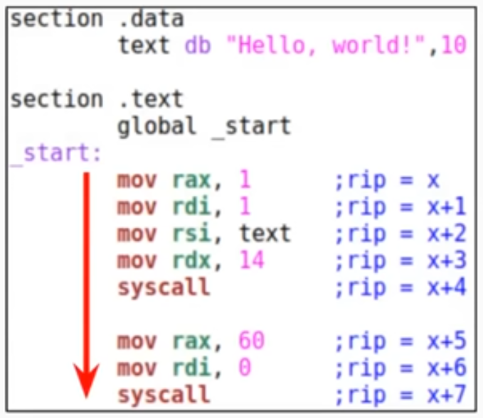

Jumps:

Can be used to jump to different parts of code based on labels
Used to divert program flow
General Flow:
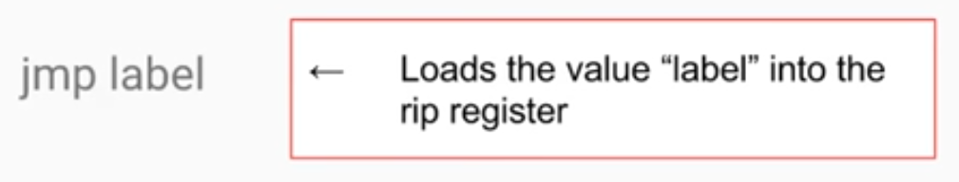
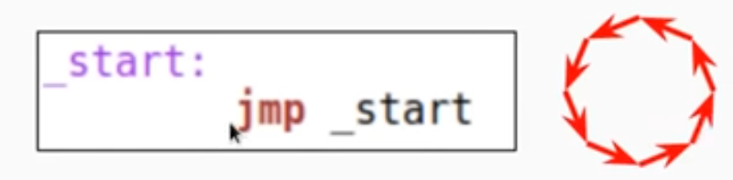
Comparisons:

Allow programs to take different paths based on certain conditions
Comparisons are done on registers
General Format:
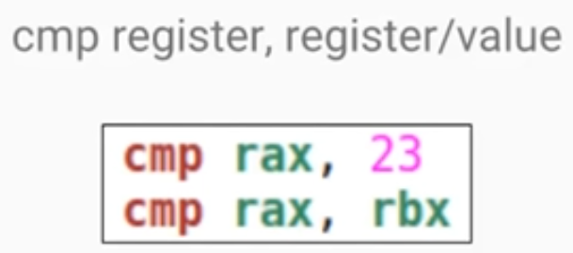
After making a comparison, certain flags are set
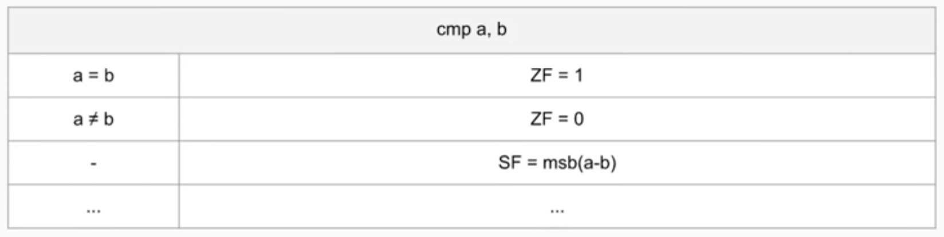
Conditional Jump:

Can be made after a comparison
Based on Status of the Flags
Written like jumps, except the symbol for conditional jump is used instead of “jmp”

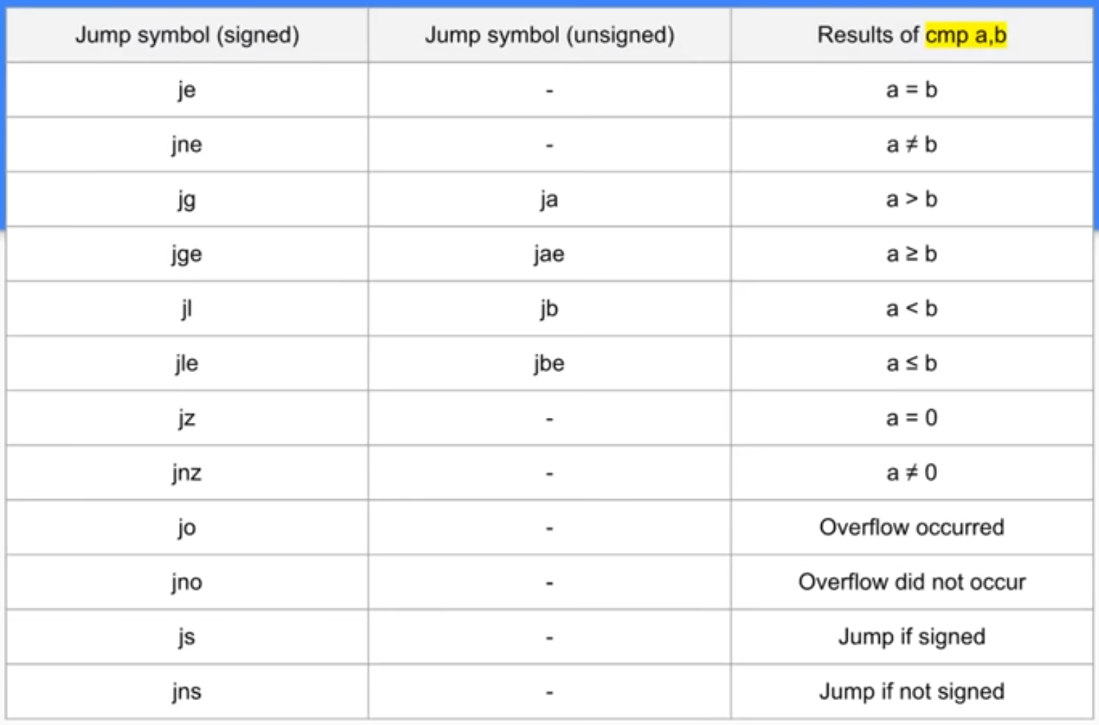

Registers as Pointers:

Default registers can be treated as pointers
To treat a register as a pointer, surround the register name with a square bracket, such as “rax” becoming “[rax]”

Calls:

Same as jumps
When using call, can return to original position where call was made using the return “ret”

This is called subroutine

Assembly Language – IV
User Input

section .data
text1 db "What is your Name?", 10
text2 db "Hello, "
section .bss
name resb 16
section .text
global _start
_start:
call _printText1
call _getName
call _printText2
call _printName

mov rax, 60
mov rdi, 0
syscall
_printText1:
mov rax, 1
mov rdi, 1
mov rsi, text1
mov rdx, 19
syscall
ret
_printText2:
mov rax, 1
mov rdi, 1
mov rsi, text2
mov rdx, 7
syscall
ret
_getName:
mov rax, 0
mov rdi, 0
mov rsi, name
mov rdx, 16
syscall
ret
_printName:
mov rax, 1
mov rdi, 1
mov rsi, name
mov rdx, 16
syscall
ret

Assembly Language – V
Math and Stack Operations

Math Operations:

Used to mathematically manipulate registers
Form of math operation is:
operation, register, value/register
First register is subject of operation
For example,
add rax, 5
sub rdx, rax

Math Operation List:
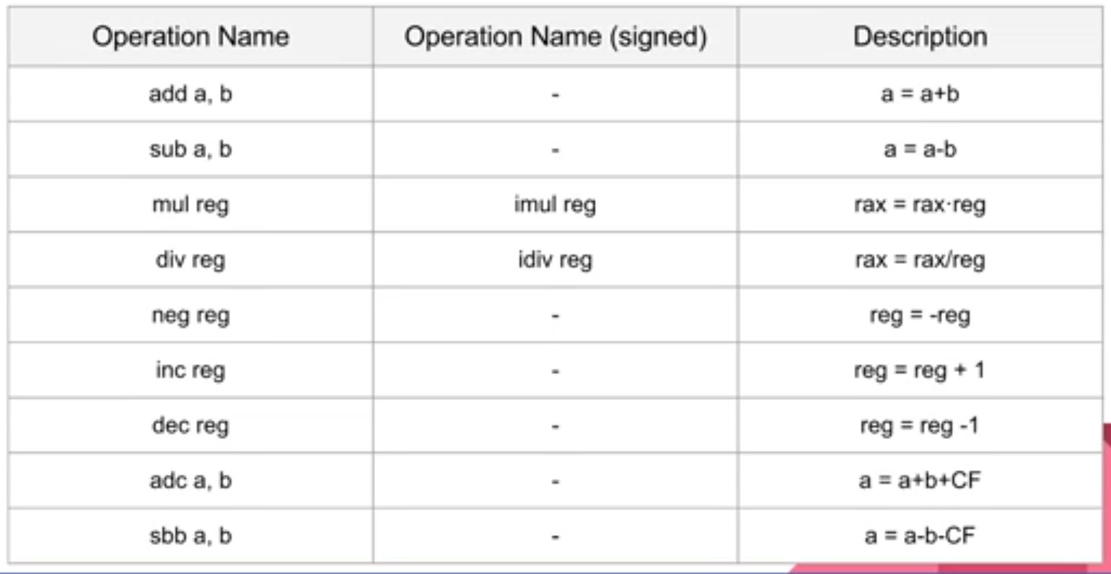

ASCII(American Standard Code for Information Interchange):

Method of modern computers to represent strings of text
Computers only store numbers, so ASCII maps numbers to specific characters
Usually supports 7-bit binary codes to represent characters
As byte is 8-bit, and is primary unit of information, modern computers usually support extended ASCII, which is 8-bit coded
Useful to reference as ASCII table

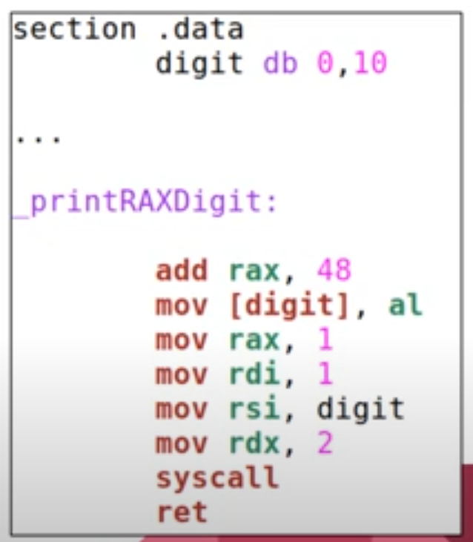
Display a digit:

Subroutine to display digit between 0 to 9
The displayed digit comes from rax register
The lower byte of rax register is moved to memory address digit
Digit is defined with 2 bytes, being 0 and 10, a new line character
Since we are loading lower byte of rax into digit, it only overwrites the first byte and does not affect newline character

Note: When division is performed on rax, it merges with the rdx register giving a 128-bit register, which if contains value, will give error in calculation, which is why its better to store 0 value in the rdx register to avoid errors. Following this the rdx register stores the remainder of the division.

The Stack:

Like registers, another way to temporarily store data
Called as “stack” because you stack data onto it
Just like paper stack, can see contents of only the top paper
Page in middle cannot be removed, before the pages above are cleared

Terminology in Stack:

When you add data onto top of Stack, you push data onto the stack
When you remove data from top of Stack, you pop data from the stack
Looking at the top of data, without changes, is known as peeking

Stack Operations:

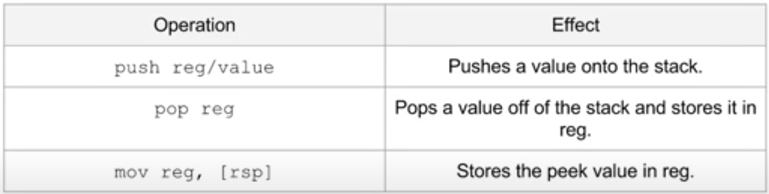

Assembly Language – VI
Subroutine to Print Strings

Macros:

Single instruction that expands into predefined set of instructions to perform a particular task

Defining Macros:

<name>
Name of Macro
<argc>
The number of arguments the macro will take
<macro body>
The definition of macro

“Exit” Macro:

%macro exit 0
mov rax, 60
mov rdi, 0
syscall
%endmacro

Arguments for a Macro:

<argc> is the number of arguments the macro takes
Arguments are inputs that can be passed through the macro
Within macro, these inputs are referenced using “%1” for first input, “%2” for second and so on
For “printDigit” macro, argc is 1 because it takes 1 argument(the digit)
For the “exit” macro, argc is 0 because it takes no arguments
When we use “printDigit” in code under_start, we specify a number after it, that is our first argument
When we use “exit” we specify no numbers after it because it takes no arguments
If args > 1, then a comma is used between inputs
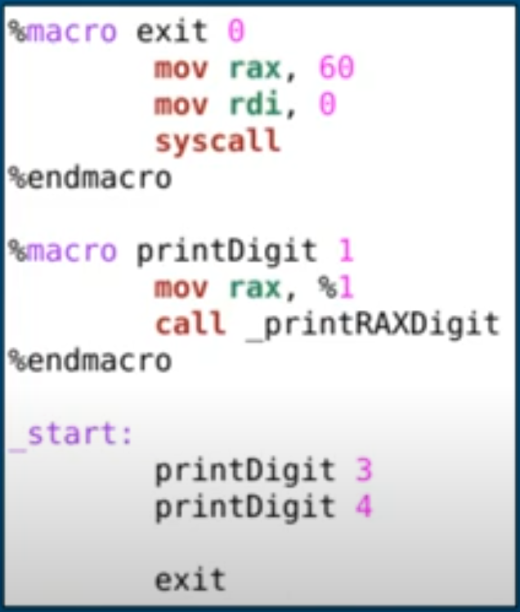
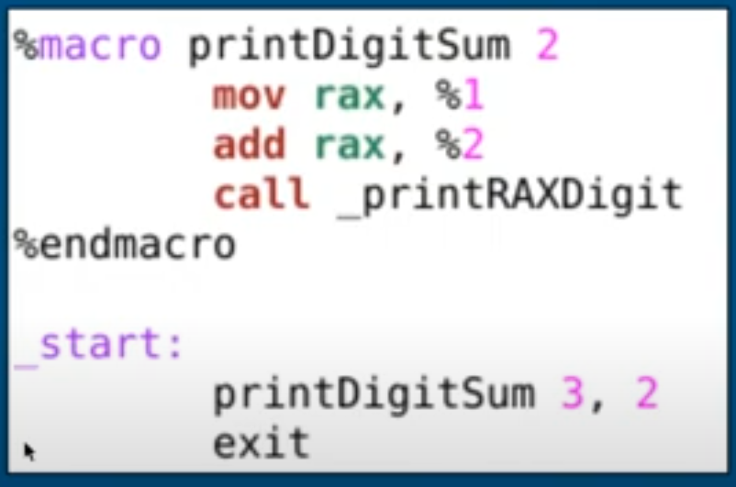

Local Labels in Macros:

Macros are expanded upon compilation into predefined code
If code contains label, can cause duplicate label error if macro is used more than once

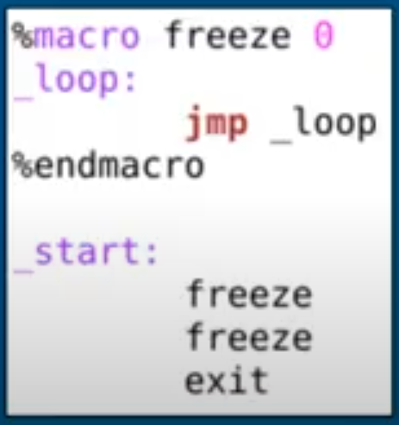

This problem can be solved using “%%” before label names with macro
This will make label unique every time it is expanded

%macro freeze 0
%%loop:
jmp %%loop
%endmacro

Defining Values with EQU:
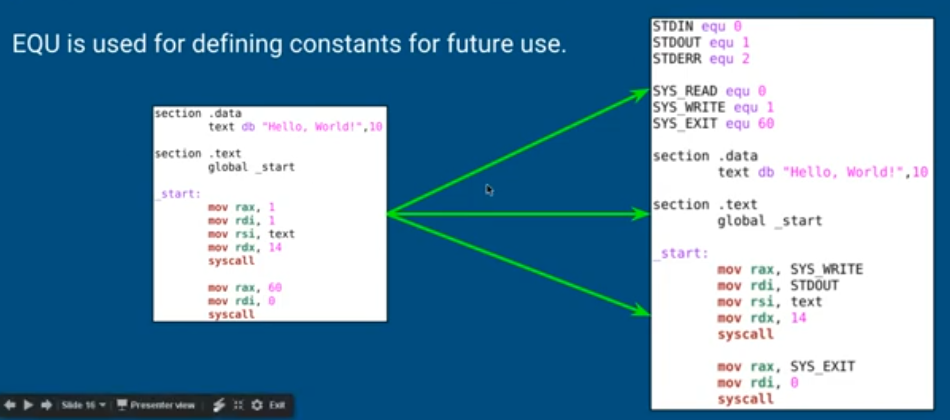
Including External Files:

Single assembly program can be broken up into multiple files using “include”
“include” loads an external file’s code and insert it into the position in which it is included in compilation
Macros and EQU definitions are often defined inside of included files

%include “filename.asm”

This “Hello, World!” code works because the “print” and “exit” macro are already defined in the “linux64.inc” file

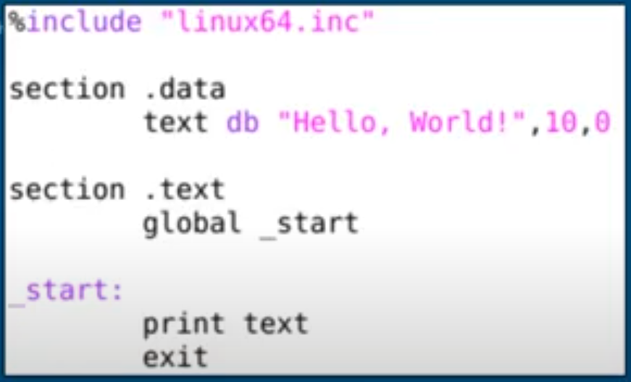

Assembly Language – IX
Command Line Arguments

Command Line Arguments:

While executing from command line, arguments can be passed into it
After program name, args are seperated by space
All args are strings not ints

Arguments on the Stack:

When program is executed, arguments are automatically loaded into stack
Top item is number of arguments
This number is at least 1
The next items in stack are pointers to zero-terminated strings starting with path then of each individual argument

The path is the first argument, arg[1] is second, arg[2] is third and so on
However, the OS provides *path, so *arg[1] is first user defined argument
Therefore, argc is 1 without specifying any argument

argc here defines the number of arguments
path is by default the first argument

Displaying Argument Count:

Code will display argument count
Pops the top item of the stack then prints to the screen
The top item is always the argument count

argtest:

The program will display an argument count followed by all the argument count followed by all arguments inputted into the program
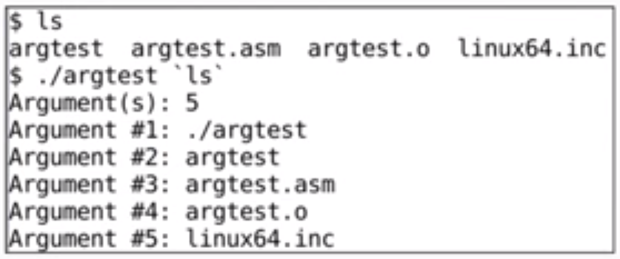
Arguments allow user to input data into program without program requiring interface
Can be used to link output of one cmd application to input of another cmd app

“ls” command can also be fed as argument list

Assembly Language – X
Introduction to Files

File Permissions:

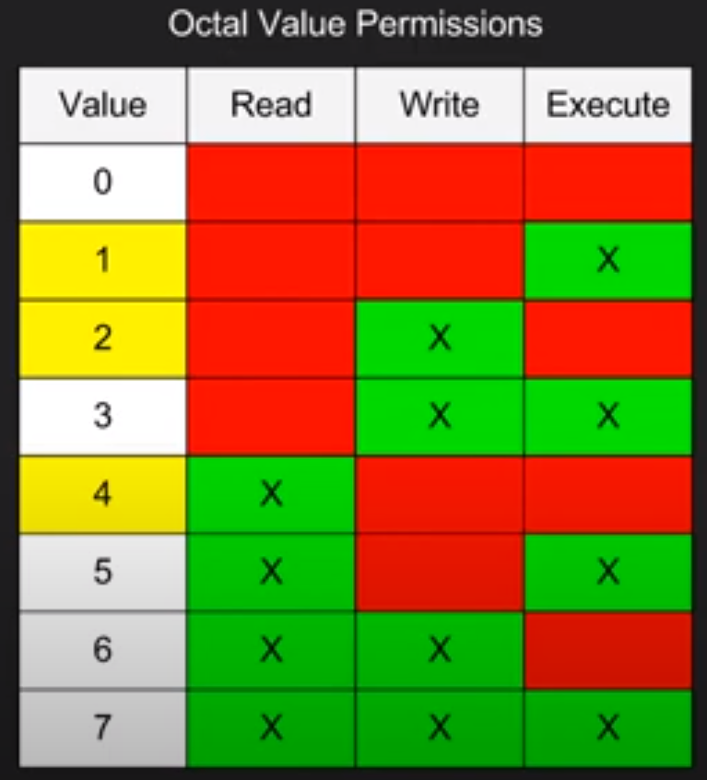
Files modes specify permissions for files

Essentially, they specify who is allowed to read, write and/or execute the file
Modes are stored as 3 digit octal values

File permissions in Linux are set with four octal values. The least significant three octal are for the file owner’s permissions, group’s permissions and others’ permission
(those outside the group and not file owners)

The most significant octal value is reserved for special permissions
We usually do not use these

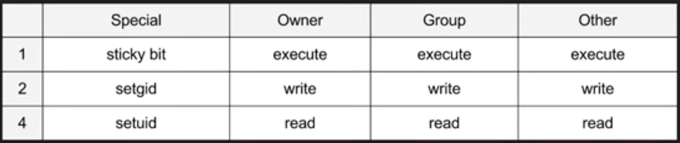

setuid bit: Present for files with executable permission. Sets file permissions when being run to that of user (owner) rather than the executer.

setgid: Affects file and directories, executes with permissions of user (owner) group rather than executer group permissions.

stickybit: File can be deleted or renamed only by file, directory user (owner)

It is an Octal Value for a given instance of file for any type of file

Assembly Language – XI
Writing Files

sys_open:

First argument, sys_open, takes in pointer to filename (zero terminated)
Second argument are the flags
Third argument is file mode, being 4-digit octal
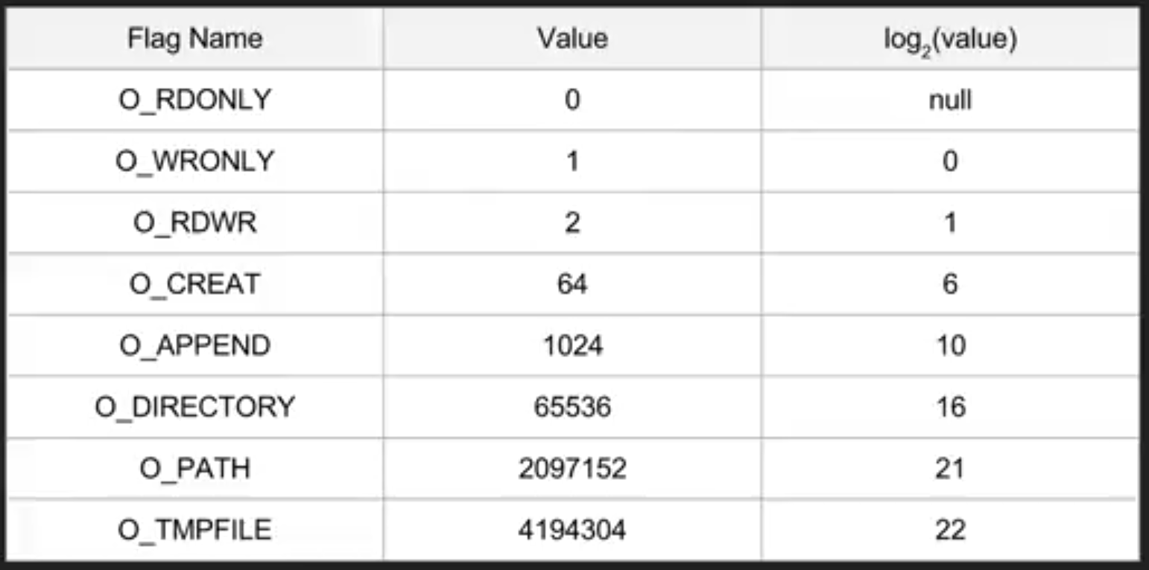
Code to open a file with “create” and “write” flag
“create” flag creates a non-existent file

mov rax, SYS_OPEN
mov rdi, filename
mov rsi, 0_CREATE+0_WRONLY
mov rdx, 0644o (o denoted Octal)
syscall

The system call returns file descriptor of opened file, within rax register
If there is error, error is returned in rax register

sys_write:

System call used to write text to a file
Exactly how we used in “Hello World” to display text on screen
The only difference is first argument is changed to file descriptor returned from sys_open system call

Example:

mov rdi, rax
mov rax, SYS_WRITE
mov rsi, text
mov rdx, 17
syscall

sys_close:

Takes only file descriptor as argument

Example:

mov rax, SYS_CLOSE
pop rdi
syscall

Assembly Language – XII
Reading Files

sys_open:

First argument, sys_open, takes in pointer to filename (zero terminated)
Second argument are the flags
Third argument is file mode, being 4-digit octal
Code to open a file with “create” and “write” flag
“create” flag creates a non-existent file

mov rax, SYS_OPEN
mov rdi, filename
mov rsi, 0_RDONLY
mov rdx, 0644o (o denoted Octal)
syscall

The system call returns file descriptor of opened file, within rax register
If there is error, error is returned in rax register

sys_read:

System call used to read text from a file
Exactly how we used in user input program
The only difference is first argument is changed to file descriptor returned from sys_open system call

Example:

mov rdi, rax
mov rax, SYS_READ
mov rsi, text
mov rdx, 17
syscall

sys_close:

Takes only file descriptor as argument

Example:

mov rax, SYS_CLOSE
pop rdi
syscall

Assembly Language – XIII
Pausing with Nanosleep

db dw dd dq:

We learned “db” or “define bytes” and how it can be used to define bytes of data
A “byte” is always 8 bit, ranging from 0 to 255 (-128 to 127)

section .data
somedata db 5

db | Define Bytes
dw | Define Word
dd | Define Double Word
dq | Define Quadraple Word

Certain number of bytes arising from processor’s design
For x86_64, “word” is equal to 2 bytes or 16 bits
“double-word” is equal to 4 bytes or 32 bits
“qword” is equal to 8 bytes or 64 bits

Timespec:

Structure that holds 2 values: tv_sec and tv_nsec
tv_sec and tv_nsec are both 64-bit values, in other words, they are q-words
The max value for:

tv_nsec is 999,999,999

because:

1 second = 1,000,000,000 nanoseconds

sys_nanosleep:

Syscall used to suspend a program for a certain amount of time
Called “nanosleep” because its precision is down to nanoseconds
The two arguments are both pointers to timespec values
First arg is length of delay, second is often left blank (rsi set to 0)

Example:

section .data
delay dq 5, 500000000
section .text
delay global _start
_start:
mov rax, 35
mov rdi, delay
mov rsi, 0
syscall

mov rax, 60
mov rdi, 0
syscall

