OS and Programming platforms – Basics

**AM.BT.P2BIF20001**

**AARATHI NARAYANAN K**

1. Linux mint

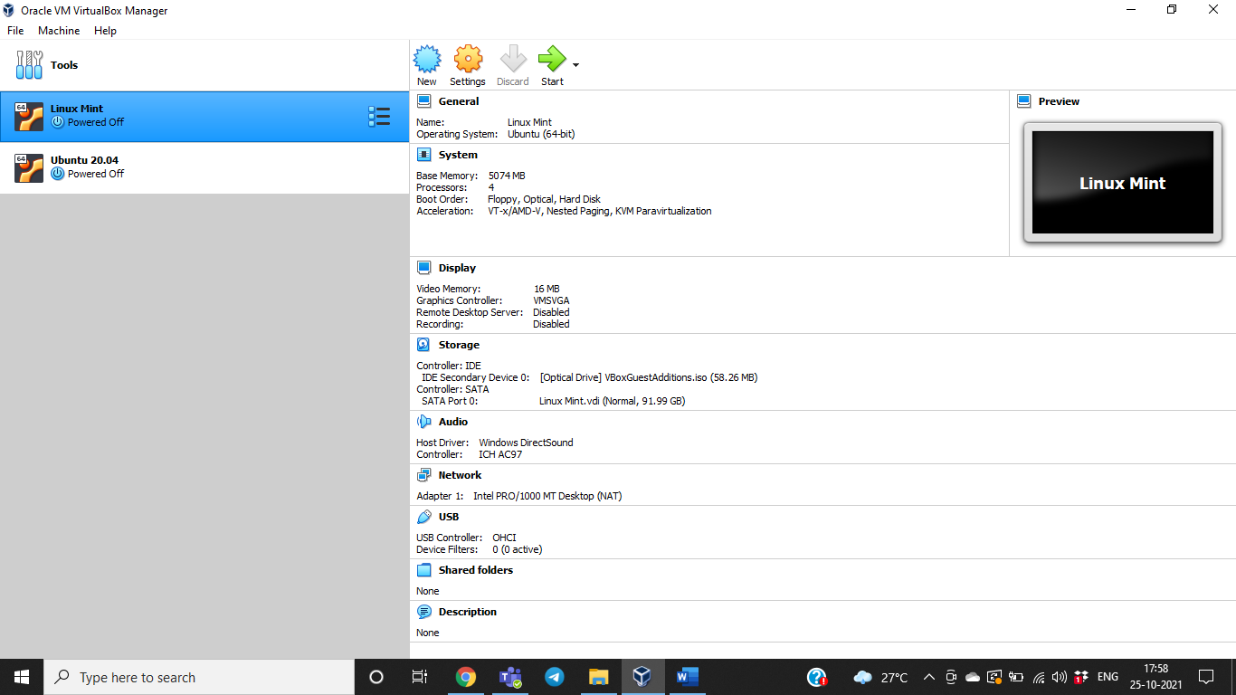

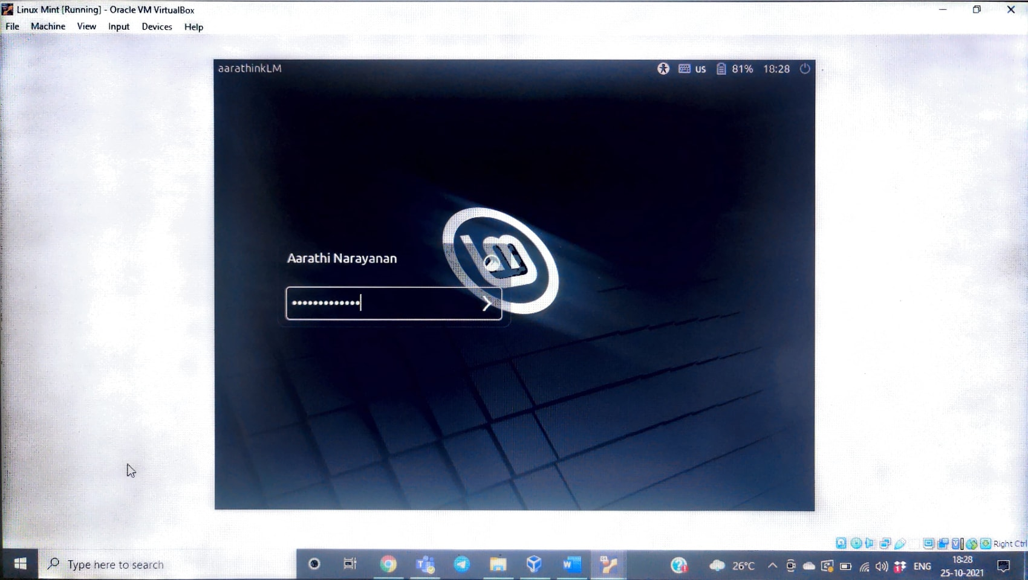

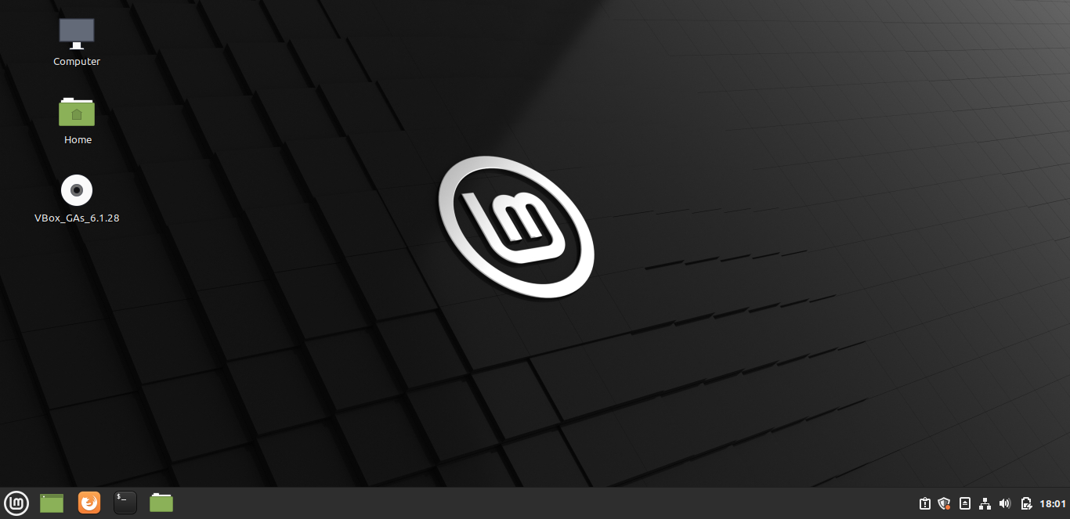

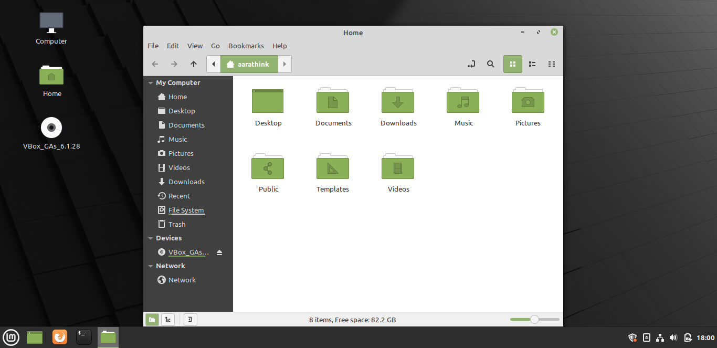

Kernel version – Linux kernel 5.4

Shell - bash

1. Ubuntu

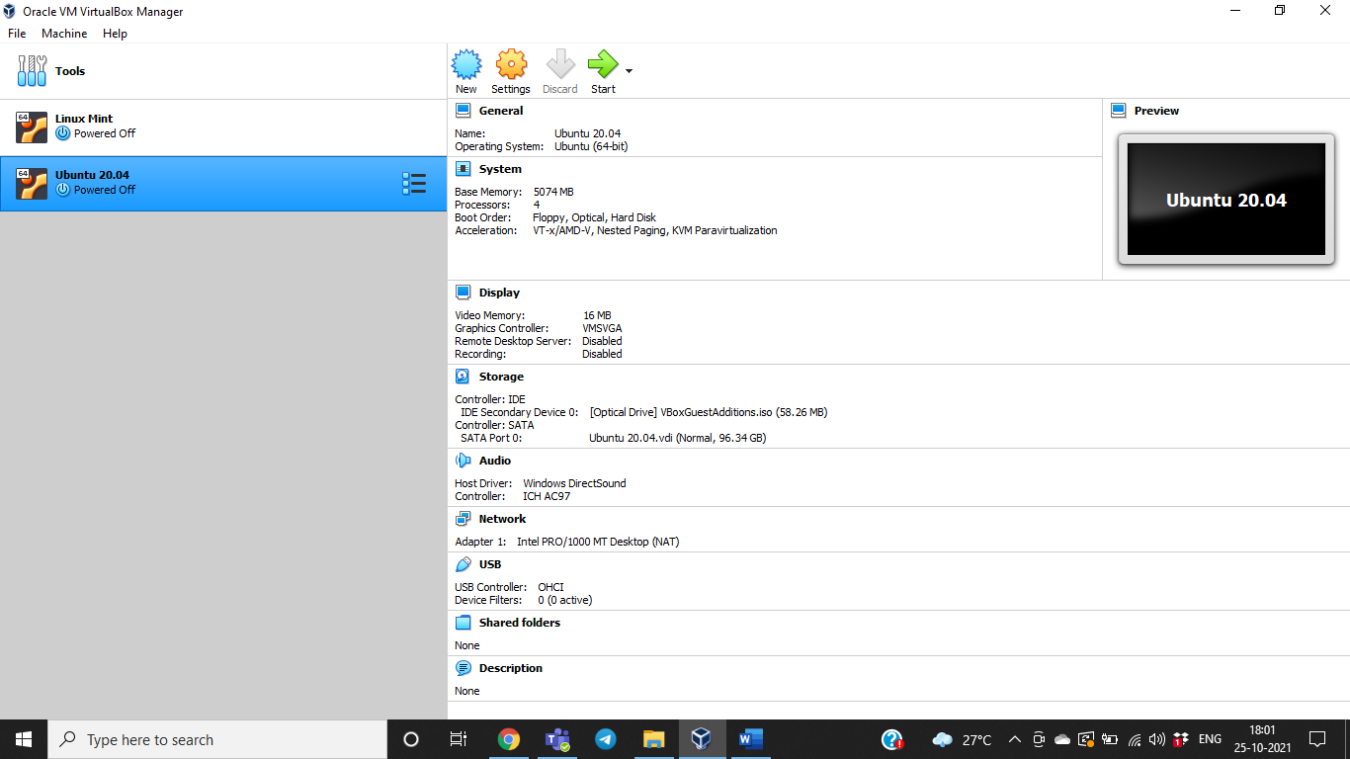

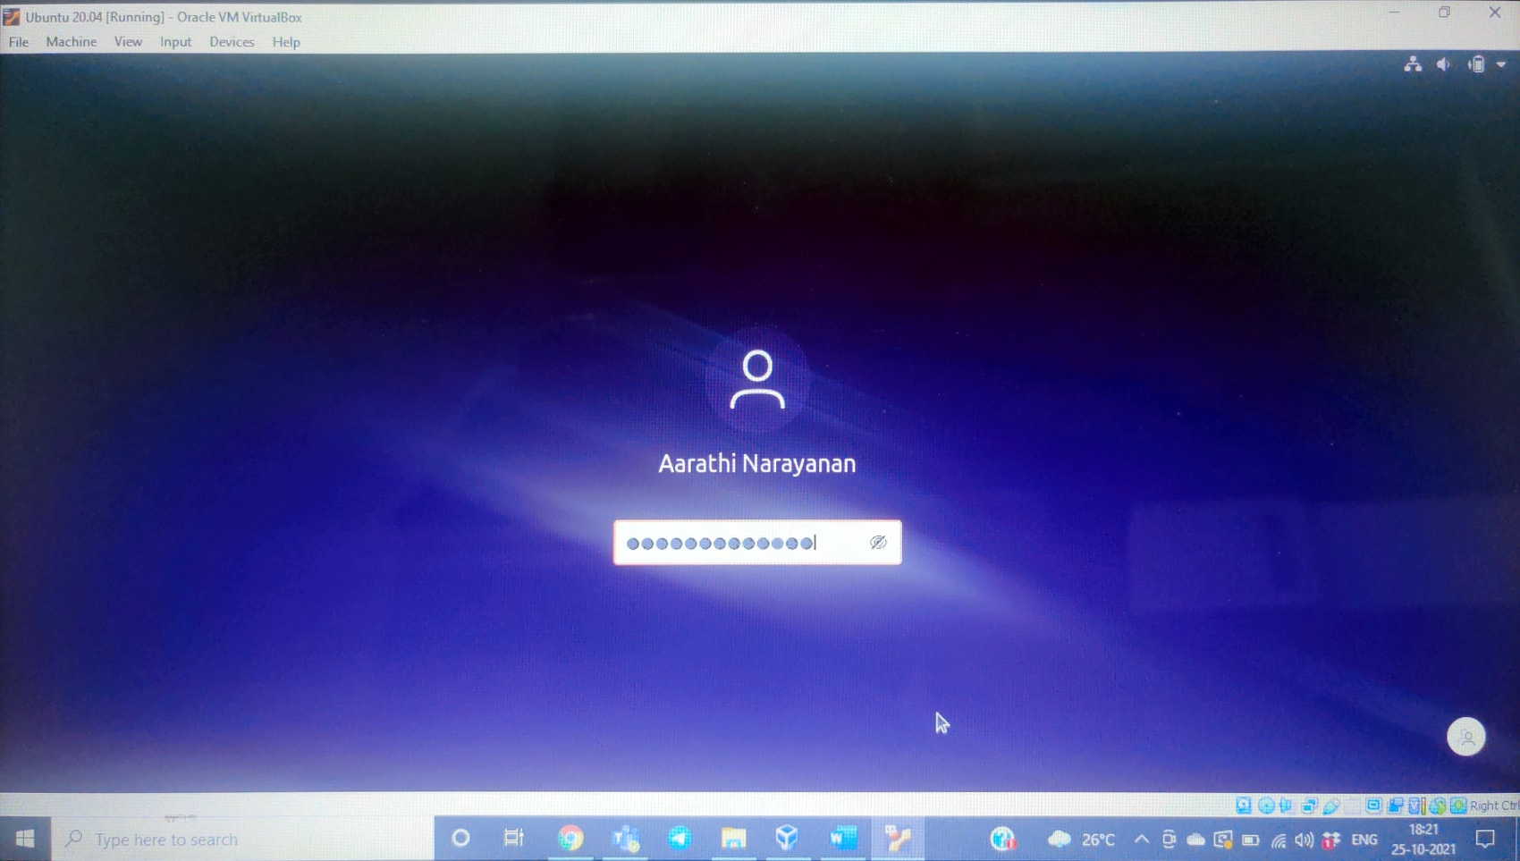

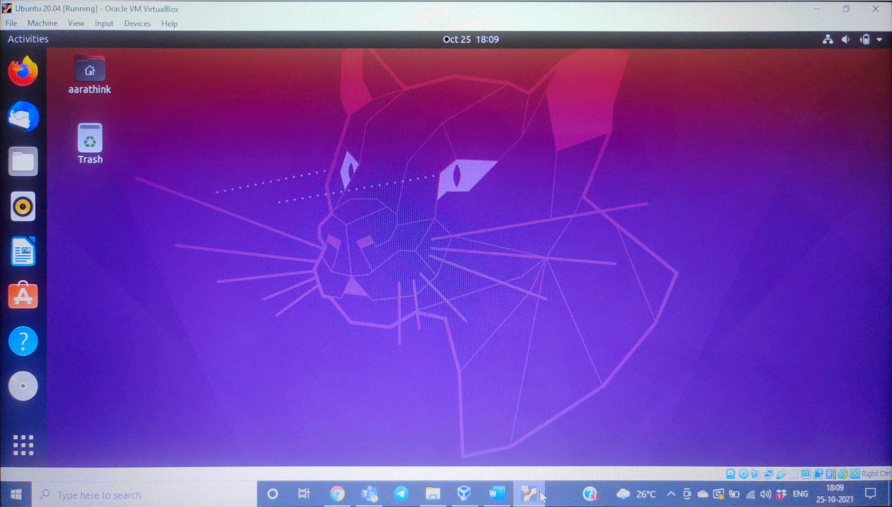

Kernel version – 5.4

Shell – GNU bash

Q. What is kernel and shell?’

A. [Kernel](https://www.geeksforgeeks.org/kernel-i-o-subsystem-in-operating-system/) is central component of an operating system that manages operations of computer and hardware. It basically manages operations of memory and CPU time. Kernel loads first into memory when an operating system is loaded and remains into memory until operating system is shut down again. It is responsible for various tasks such as disk management, task management, and memory management. It decides which process should be allocated to processor to execute and which process should be kept in main memory to execute. It basically acts as an interface between user applications and hardware.

Shell is the interface to the operating system. It is the outermost layer of the operating system. Shells incorporate a programming language to control processes and files, as well as to start and control other programs.

Q. What does OS mean?

A. An **Operating System (OS)** is a software that acts as an interface between computer hardware components and the user. Every computer system must have at least one operating system to run other programs. Applications like Browsers, MS Office, Notepad Games, etc., need some environment to run and perform its tasks.

The OS helps you to communicate with the computer without knowing how to speak the computer’s language. It is not possible for the user to use any computer or mobile device without having an operating system.