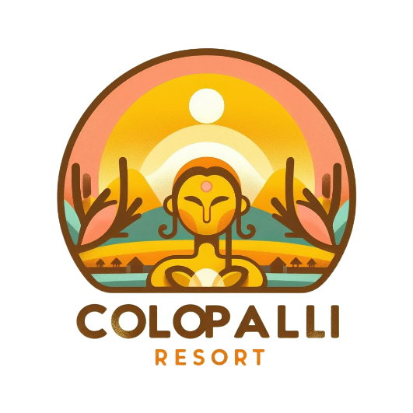



Colopalli Resort & SPa

Website Desing & Development

November 19, 2023

Group-3

CSD-1103 Section 1

Table of Contents

1. Purpose of the Website 1

2. Target Audience 2

3. Website Desing 2

3.1 Site Map 3

3.2 Wireframes 4

4 Graphics 4

4.1 Hotel Logo 4

4.2 Banner 4

4.3 Services Images. 5

4.4 Amenities Images 5

4.5 Contact Map 5

5 Color Palette 5

6 Typography 6

7 Features 6

# Purpose of the Website

This website will present the services of **Colopalli Resort & Spa**. This place is the merge of two diverse worlds: Nepal and Colombia. Located in the city with beautiful views of the lake and various facilities such as pools, spas, restaurants and different types of rooms.

As the main goals for the Website, we have defined the following:

1. Present Hotel history and business justification.
2. Provide an overview of all accommodation types and advantages.
3. Offer to the future guest a summary of all the amenities (gastronomic offer, spa and wellness) that made **Colopalli Resort & Spa** a very different experience from any other hotel.
4. Finally, it will serve as a contact point and booking tool between future guests and the hotel.

The website should have an intuitive design, easy to follow, full of colour, and high-quality graphics.

# Target Audience

The primary target audience for the **Colopalli Resort & Spa** website is Nepali and Colombian tourists and family groups who want to remember and experience their roots while being in a different country and for all people around the globe who feel engaged about knowing other cultures and flavours.

Besides, **Colopalli Resort & Spa** is intended to be a place for the whole family, so the website has to show the different environments and events for kids, teenagers, adults and seniors, basically showing why this place is a complete cultural experience more than a hotel.

# Website Desing

According to the two previous sections, the website will contain the next webpages:

1. Home Page: It will contain an overview of all the services and other webpages of the hotel.
2. About Us Page: It will contain the hotel's history, followed by a brief description of the services, and will give future guests some essential reasons why **Colopalli Resort & Spa** is the best option for them and their families.
3. Services Page: This webpage will present to future guests all the accommodation offers and descriptions and will provide appealing, high-quality room pictures showing the beautiful spaces and environments in each one.
4. Amenities and Hotel Environments Page: Here, all extra hotel environments will be posted as pool, restaurants, spa and wellness and children's play areas. This webpage will show why **Colopalli Resort & Spa** is considered a family place.
5. Events Page: This webpage will contain the justification of the Hotel in terms of cultural exchange. Here, the main events will be posted weekly, events such as Nepal and Colombia night festivals and food experiences for the whole family. Other more common events such as Children's entertainment and Activities for seniors and adults will also be shared on this webpage.
6. Contact Us Page: This one will present the location for the hotel and forms for contact purposes.
7. Booking Page: Will contain booking form with validation.

## 3.1 Site Map

The **Colopalli Resort & Spa** website for intuitive and easy navigation will be designed as a webbed website where each webpage is linked with the other five webpages, the site map is presented in the following schema:

Figure - Website Site Map

## Wireframes

For the **Colopalli Resort & Spa** website design, a mobile-first strategy was followed, and it will include mobile, tablet and desktop wireframes. Look attached documents.

# Graphics

Due to the importance of pictures and graphics to show and invite future guests to know the hotel, the following section will describe the images included on each one of the web pages and some examples of them.

## 4.1 Hotel Logo

The **Colopalli Resort & Spa** Logo will be included on all webpages of the website and will also be used as a Fav Icon for all of them.

## 4.2 Banner

Different banners will be included on the webpages; each one of them should be related to the primary purpose of its corresponding web page. For instance:

Figure 2 - Home Page Banner

## 4.3 Services Images.

It will present three different types of rooms and their main characteristics in a slider image container for each one of them; some examples:

Figure 4 - Standard Room Picture

## 4.4 Amenities Images

It will present pictures of the restaurant, children play areas and spa and wellness sections:

Figure 5 – Amenities Restaurant Picture

## 4.5 Contact Map

It will give a map with the hotel's location.

# Color Palette

The colour palette for the website was chosen according to the message **Colopalli Resort & Spa** wants to send to future guests; the colour palette should reflect joy, excitement and a warm welcoming to out target audience, which is why a variety of yellow colours combined with gray on the bottom also to transmit professionalism and formality on the hotel brand.

#EDE597 #F4CF15 #495F58

# Typography

As font-family, the “Monserrat” font was selected for its tidy and readability characteristics.

The previous properties with the good printable characteristics of this font are fundamental to website design.

# Features

**Colopalli Resort & Spa** website design will include among other features like:

* Box Model
* Flexible Images
* Icons
* Forms with validation
* Tables
* Sliders
* Links
* Buttons
* Videos