Reminder App

Aadit Wadhwa; email id: [*aadit2.be22@chitkara.edu.in*](mailto:aadit2.be22@chitkara.edu.in)

Aarav Shourie; email id: [aarav10.be22@chitkara.edu.in](mailto:aarav10.be22@chitkara.edu.in)

# **Abstract**

Reminder app can help you organise your whole day and make it productive by suggesting you things you like to do in your free time, it will help you give warranty reminders, subscription alerts and motivate you to complete the task assigned. This desktop application is very user-friendly and easy to use. User has wide range of choices to select a category and set reminder such as groceries list, water drinking alert, medicine reminder, workout schedule, birthday/anniversary reminder and much more. App sends notification with daily dose of motivation. The future scope of our project will be to suggest you a complete roadmap for anything you want to do, be it related to health-fitness, gaming, studies or any personal skill development.

# **Implementation**

**Label**: Reminder app starts with multiple labels where user can select any of these categories and set reminder accordingly.

**Title**: Input title is taken which is to be displayed at the time of notification.

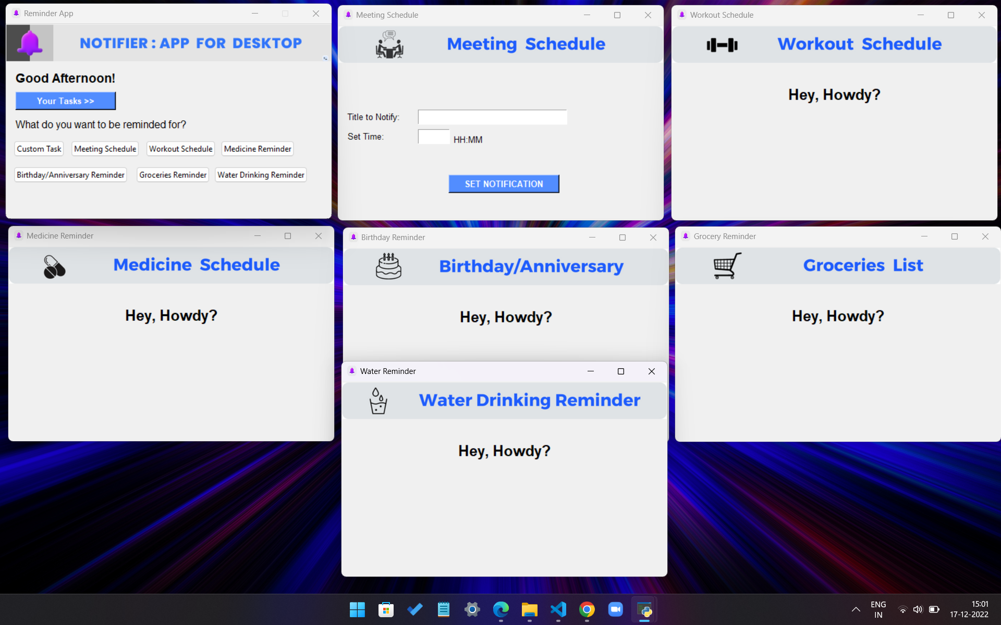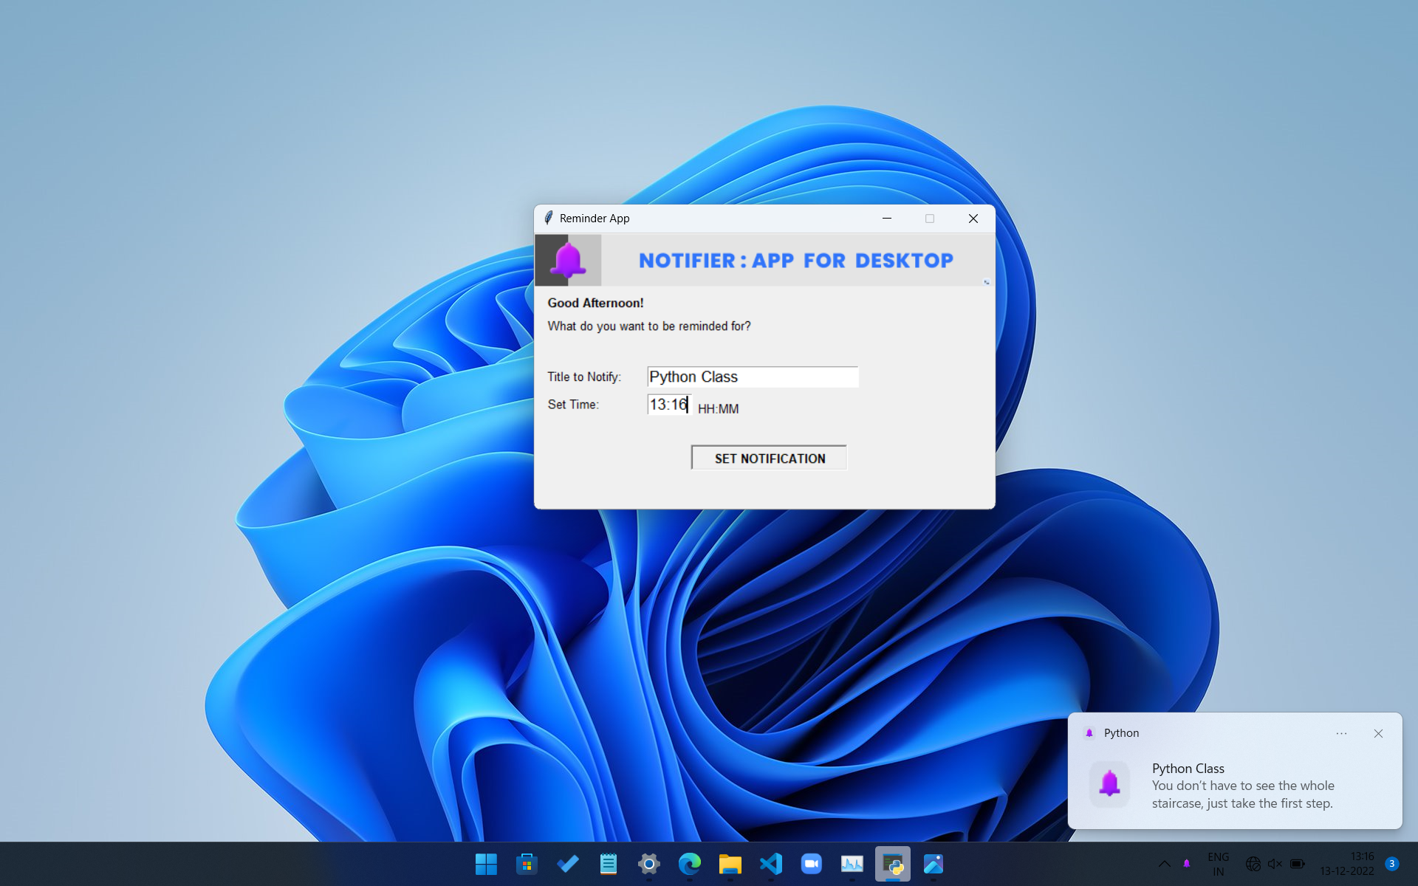**Time**: Input time is taken to receive notification at the desired time.

Main Screen

Water Drinking Reminder

Birthday /Anniversary Reminder

Medicine Reminder

Workout Schedule

Custom Task

Meeting Schedule

**Tools/Technique**: Python GUI, tkinter library, datetime function, notifier module

**Mentor Name: Ms. Neha Sharma**