class4.R
aaravprasad
2026-04-14
x <- 1:50
plot(x)
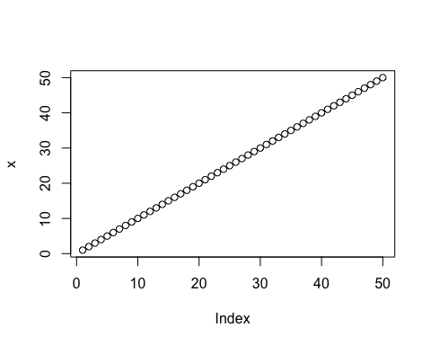
plot(x,sin(x),typ="l", col= "red", lwd= 2)
