Paradigm Assignment:
- Aarav Singh, 24116003

Semantic Priming Paradigm:

Procedure:
A word (called the primer word, or clue) is flashed to the participant, and he has to find a related word in the grid that follows. The participant’s reaction speed is measured by recording his keystrokes.

Hypothesis 1: The participant is expected to find the related word much faster when he is shown the primer compared to when he isn’t. The related clue gives the brain a head start, hence his reaction time should decrease.

My twist: I am also introducing a “distraction” word, which is completely opposite to the actual word in the grid.

Hypothesis 2: When the “distraction” is introduced, the participant’s reaction speed will decrease. This is because even though he/she knows that it is a distraction, the brain will not be able to forget the word. Subconsciously, the participant is searching for a word similar to the distraction word.

Things that I understood: In most of these paradigms, we introduce a distraction that slows the reaction speed. And the purpose of the whole paradigm is to measure how much effect the distraction has.

Results from dummy test:
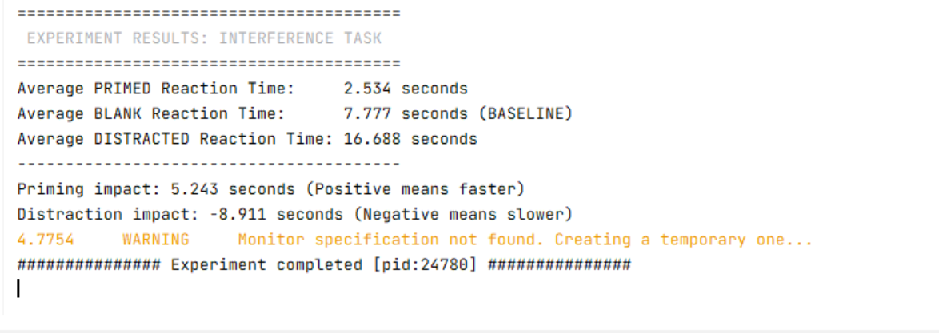

As seen by this, average time taken for distracted words is more than the baseline (blank), and primed words takes less than the baseline. This supports both the hypothesis.

Related Research Paper:
- Fernandino, L., & Conant, L. L. (2024/2026). The Primacy of Experience in Language Processing.
- Ball, L. V., et al. (2024/2025). Revisiting Novel Word Semantic Priming: The Role of Strategic Mechanisms

Code: (written in psychopy code runner, but uploading through google collab link)

https://colab.research.google.com/drive/1tLA4-svLziw3wFMPH7-BYgoAGm98X68b?usp=sharing

