 | Bombay International School  Practice Assessment 2026

NAME | Aarav Patodia

CENTRE  NUMBER | I | N | 6 | 5 | 7 |  | ASSET  NUMBER

Subject: ICT - Practical Date: Wednesday 23rd September 2026
Grade 7 Duration: 45 minutes
You must answer on the question paper

INSTRUCTIONS
- Write your name in the space provided above.
- Answer all questions.
- Use Visual Studio Code to write your code and Google Chrome to view your output.
- Paste all screenshots and code in the evidence boxes provided.
INFORMATION
- The total marks for this paper is 30.
- The number of marks for each question or part question is shown in brackets [ ]
- This is a practice assessment for the Time Bound Test on 30th September 2026.

HTML Practical [Use Visual Studio Code]
You are going to create a web page for the BIS Diwali Mela.
1. Create a new project folder called: DiwaliMela
Inside it, complete the following:
- Create a folder called assets
- Locate the files rangoli.jpg and diya.jpg in the ICT Grade 7 ICT Test 1 folder and store them inside your assets folder
- Create a file called index.html inside the DiwaliMela folder (not inside assets)
- Open the DiwaliMela folder in VS Code using File → Open Folder [2]

EVIDENCE 1
Take a screenshot of your DiwaliMela project folder showing index.html and the assets folder. Place it here. 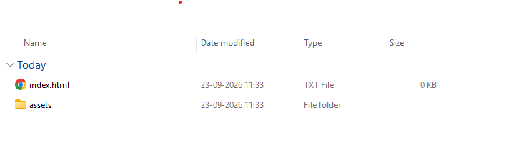

EVIDENCE 2
Take a screenshot of the assets folder open, showing both images. Place it here. 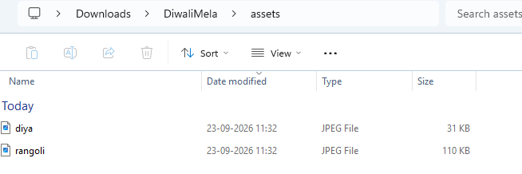

2. Edit index.html to create the table structure as shown below:
A
B | C | D
B | E | F
G |  | H

Each table cell is identified with a letter. The letters shown in the table must not appear on your final web page. You must use colspan and rowspan to build this structure. [4]
Complete steps 3 to 11 given below.
3. Set the title shown on the browser tab to Diwali Mela 2026. Enter in cell A the text:
BIS Diwali Mela – 6th November 2026
Set this text to style h1. The letters “th” must appear as superscript. [2]
4. Place in cell B the image rangoli.jpg from your assets folder. Set it to 200 pixels wide and 260 pixels high, with the alternate text Rangoli design.
The image must be a hyperlink that opens https://en.wikipedia.org/wiki/Rangoli in a new tab. [3]
5. Enter in cell C the text Stalls in style h3, followed by an unordered list with square bullets:
Food Court, Diya Painting, Lantern Making, Games Corner [2]
6. Enter in cell D the text Programme in style h3, followed by an ordered list numbered with capital Roman numerals (I, II, III):
I. Opening Ceremony – 10:00 am
II. Rangoli Competition – 11:30 am
III. Cultural Show – 2:00 pm [2]
7. Place in cell E the image diya.jpg from your assets folder. Set only the width to 150 pixels so the image does not distort. Using CSS, give all images on the page a border that is 3 pixels, dotted, colour #FF9933, with a border-radius of 20 pixels. [3]
8. Enter in cell F the text below as a paragraph. Did you know? must be bold and underlined, and the numbers in the formulas must be subscript:
Did you know? A burning diya releases CO₂ and H₂O into the air.
Place a horizontal rule below the paragraph. [2]
9. Place in cell G a registration form with the following:
- A label Name with a text box showing the placeholder Enter your full name
- A label Email with an email box, and a label Tickets with a number box
- A label Date of visit with a date picker
- A label Favourite stall with two radio buttons labelled Food and Games
- A text area 4 rows high and 30 columns wide containing the text Any suggestions?
- A Reset button and a Submit button, each on the same line [4]
Each label and its box must be on its own line.
10. Place in cell H a hyperlink with the text Visit the BIS website that opens https://bis.edu.in/ in the same tab. Below it, in style paragraph, enter:
Name: (your name)
Asset Number: (your asset number) [2]
11. Using CSS inside the <style> tag, apply the following:
- Web page background colour: Red = 255, Green = 243, Blue = 224
- Font for the whole page: Verdana as first priority, Arial as second priority
- h1: centre aligned, colour #800000, in small-caps
- Table: maximum width of 900 pixels, with collapsed borders
- Every table cell: 2 pixel solid border in colour #8B0000 and 12 pixels of inside spacing on all sides
- When you hover over a table cell, its background colour changes to #FFE0B2 [4]

EVIDENCE 3
Place a screenshot showing the whole web page in your browser. Hover over one table cell while taking the screenshot.

EVIDENCE 4
Copy the full HTML source code (including the CSS inside <style>) and place it here.

[End of practice assessment]

