ScamShield AI Fraud and Scam Awareness Assistant
  - Summative assessment documentation and Dialogflow test evidence
Student Name: Aarav Motwani | Program/Year: IBCP Year 1
CRS Name: Artificial Intelligence | Course Name: Artificial Intelligence: Real-World Applications and Implications
Candidate Registration Number: ____________________ | School Name: Ryan Global
Project Repository:  https://github.com/aarav343/scam-shield-ai-sa | Dialogflow ES agent (Google access required):  https://dialogflow.cloud.google.com/#/editAgent/scamshieldai-k9we/

1 Executive summary and problem
ScamShield AI helps people respond safely to suspicious payment requests, phishing links, impersonation, fake jobs, and related fraud. It gives short warnings, asks for the action requested by the sender, and points people toward an official bank or reporting route when needed. It is an advisory chatbot: it does not verify whether a message is genuine or collect real account credentials.
The Dialogflow ES agent is documented as containing 21 intents and 10 custom entities. In the recorded console tests, 13 English scenarios matched the intended intents, and an additional English greeting matched Default Welcome Intent. Hindi can be selected in the console, but the recorded Hindi scam requests did not reliably match the relevant intents. Reliable Hindi support has not been demonstrated in these tests.

2 Intended users and design decisions
The prototype is intended for digital payment customers, students and job seekers, older adults, and people who may already have sent money or shared a credential. I focused the scenarios on urgent payment requests, unfamiliar links, advance fees, and requests for OTPs or UPI PINs. These groups and scenarios define the intended use of the prototype; they are not presented as findings from interviews or surveys.
The assistant asks users to describe warning signs without pasting OTPs, PINs, passwords, CVV, or full account details. It gives immediate caution before requesting more detail, and it uses follow-up context for scam details and the safety quiz.

3 Dialogflow implementation
The English agent uses 19 custom intents plus the default Welcome and Fallback intents. Each custom intent has 12 example phrases in the prepared import. The 10 custom entities standardise terms such as payment method, contact channel, requested action, and loss status. The prototype uses built-in responses and short-lived Dialogflow contexts; it does not need a webhook or external data store for these responses.

Custom entity catalogue
Entity | Example values
@scam-type | UPI fraud, phishing, job scam, investment scam, loan scam, impersonation
@contact-channel | WhatsApp, SMS, email, phone call, social media, website
@requested-action | share OTP, send money, open link, install app, scan QR, share PIN
@credential-type | OTP, UPI PIN, password, CVV, card number
@payment-method | UPI, QR code, bank transfer, card, wallet
@impersonated-identity | bank, government, employer, courier, support
@urgency-cue | immediately, today, within ten minutes, account will close
@link-feature | shortened link, misspelled domain, unknown website, unexpected attachment
@job-fee | registration fee, training fee, security deposit, equipment fee
@loss-status | money sent, credentials shared, app installed, no action taken

Intent and entity mapping
Intent | Action or purpose | Custom entities
Default Welcome Intent | Greeting and entry point | —
ScamCheckIntent | scam.check | @contact-channel, @scam-type, @urgency-cue
ScamDetailsIntent | scam.details | @requested-action
OTPIntent | scam.otp | @credential-type, @impersonated-identity, @urgency-cue
UPICollectIntent | scam.upi_collect | @payment-method, @credential-type
QRCodeIntent | scam.qr | @payment-method, @contact-channel
PhishingLinkIntent | scam.phishing | @link-feature, @contact-channel, @urgency-cue
FakeJobIntent | scam.job | @job-fee, @contact-channel, @urgency-cue
ImpersonationIntent | scam.impersonation | @impersonated-identity, @contact-channel, @urgency-cue
InvestmentIntent | scam.investment | @scam-type, @contact-channel, @urgency-cue
LoanAppIntent | scam.loan | @scam-type, @contact-channel, @credential-type
RemoteAccessIntent | scam.remote_access | @requested-action, @impersonated-identity, @loss-status
AccountCompromisedIntent | scam.compromised | @loss-status, @credential-type, @payment-method
ReportFraudIntent | scam.report | @scam-type, @payment-method, @loss-status
PreserveEvidenceIntent | scam.evidence | @contact-channel, @link-feature
SafePaymentTipsIntent | scam.tips | @payment-method, @scam-type
QuizStartIntent | quiz.start | —
QuizSafeAnswerIntent | quiz.correct | —
QuizUnsafeAnswerIntent | quiz.incorrect | —
GoodbyeIntent | input.goodbye | —
Default Fallback Intent | Safe recovery from an unmatched input | —

4 Training examples and responses
The table gives one example training phrase and an excerpt from the configured English response for each custom intent. The prepared import is described as containing the complete training phrases and response texts; the excerpts below are shortened for readability.
Intent | Sample phrase | Configured response excerpt
ScamCheckIntent | Can you check if this message is a scam? | I cannot verify a message as safe from a description alone. Do not click links, pay, or share codes. Tell me what the sender asked you to do, without pasting any OTP, PIN, password, or full account…
ScamDetailsIntent | They asked me to share my OTP | That request is a warning sign. Pause contact and independently check the organisation through its official app or website. Do not share a PIN, OTP, password, or CVV. If you already lost money, contact…
OTPIntent | Should I share my OTP with someone? | Never share an OTP, UPI PIN, password, or CVV with another person, even if they claim to be from your bank. Stop the conversation and contact your bank using a number from its official app or card.
UPICollectIntent | They sent me a UPI collect request | Be careful with unexpected UPI collect requests. Entering your UPI PIN authorises a payment; it is not needed to receive money. Decline the request and verify the sender through an official channel.
QRCodeIntent | They sent a QR code for my refund | Do not scan an unknown QR code or enter your UPI PIN to receive a refund or prize. Scanning and approving with a PIN can make a payment. Verify through the official app instead.
PhishingLinkIntent | I received a shortened link in SMS | Do not open an unexpected link or attachment. A shortened URL, misspelled domain, or urgent login demand is a warning sign. Visit the organisation's official website by typing the address yourself.
FakeJobIntent | A job offer asks for a registration fee | A job offer asking for an upfront registration, training, or equipment fee is a warning sign. Do not pay or share sensitive documents. Verify the employer on its official website and contact the…
ImpersonationIntent | Someone claiming to be my bank called me | A name, logo, or caller ID does not prove identity. End the conversation and contact the bank, government office, employer, courier, or support team through an independently found official channel. Do…
InvestmentIntent | This investment promises guaranteed returns | Guaranteed high returns and pressure to invest quickly are warning signs. Do not send money based on a chat group or influencer claim. Independently verify the provider and its regulator details before…
LoanAppIntent | A loan app wants an advance fee | Be cautious with loan apps that demand an advance fee, unnecessary phone permissions, or payment outside the official app. Verify the lender independently and do not share an OTP or install unknown…
RemoteAccessIntent | Support asked me to install an app | Do not install a remote-control app for an unsolicited caller. It may let them view your screen or operate your device. If you already installed one, disconnect the device, remove the app, contact your…
AccountCompromisedIntent | I shared my OTP already | Act quickly: contact your bank or payment provider using its official app, website, or card number. Block affected access, change passwords from a trusted device, and review transactions. For financial…
ReportFraudIntent | How do I report online fraud? | If money was lost in India, contact your bank immediately and call the national financial cyber fraud helpline 1930. You can also report at https://cybercrime.gov.in/. Use official sites only. Keep…
PreserveEvidenceIntent | What evidence should I save? | Save screenshots of the message, sender details, links, transaction IDs, dates, and times. Do not delete the chat before reporting. Do not paste private credentials into this chatbot. Share evidence…
SafePaymentTipsIntent | Give me safe payment tips | Before paying, verify the recipient independently, check the amount in your payment app, and avoid links from strangers. Never enter a UPI PIN to receive money and never share OTPs, PINs, passwords, or…
QuizStartIntent | Start a safety quiz | Quick quiz: a caller claims to be your bank and asks for your OTP to stop fraud. Should you share it? Reply yes or no.
QuizSafeAnswerIntent | No | Correct. Never share an OTP with a caller, even if they claim to be from your bank. For help, end the call and use the bank's official contact details.
QuizUnsafeAnswerIntent | Yes | The safe answer is no. A caller asking for your OTP is a warning sign. Never share it; end the call and contact your bank through an official number.
GoodbyeIntent | Goodbye | Stay safe. If you have lost money or shared credentials, contact your bank promptly and report financial cyber fraud through official channels.

5 Live test results in Dialogflow
I marked a recorded English test as passed when Dialogflow matched the intended intent and returned safety-aligned advice for that input. These results show how the agent behaved for the recorded examples; they do not prove that it will recognise every possible wording.
Scenario | Observed match | Result
UPI collect request | UPICollectIntent | Pass
OTP impersonation | OTPIntent | Pass
Fake job fee | FakeJobIntent | Pass
Phishing link | PhishingLinkIntent | Pass
Remote access | RemoteAccessIntent | Pass
Money already lost | AccountCompromisedIntent | Pass
Scam detail slot filling | ScamCheckIntent → ScamDetailsIntent | Pass
Quiz, correct answer | QuizStartIntent → QuizSafeAnswerIntent | Pass
Quiz, unsafe answer | QuizStartIntent → QuizUnsafeAnswerIntent | Pass
Fallback | Default Fallback Intent | Pass
UPI refund PIN request | UPICollectIntent | Pass
Misspelled suspicious SMS link | PhishingLinkIntent | Pass
Quiz answer out of context | Default Fallback Intent | Pass
English greeting with en selected | Default Welcome Intent | Pass

Figure 3 shows the input “hi” matching Default Welcome Intent and returning the configured English welcome response when English was selected in Dialogflow.

Hindi-language checks (limitations observed in the console)
Input | Observed match | Observation
नमस्ते | Default Welcome Intent | Generic Hindi greeting
बैंक वाला मेरा ओटीपी मांग रहा है | Default Fallback Intent | Scam warning did not match
मुझे पैसे लेने के लिए यूपीआई पिन डालने को कह रहे हैं | Default Fallback Intent | UPI warning did not match
मुझे एसएमएस में संदिग्ध लिंक मिला है | Default Welcome Intent | Misrouted to greeting
सुरक्षा क्विज़ शुरू करो | Default Fallback Intent | Quiz did not start
मैंने ठग को पैसे भेज दिए | Default Fallback Intent | Loss guidance did not match

6 Evidence from the live agent
The screenshots below show selected views and test results from the ScamShieldAI Dialogflow ES console. They show the custom entity list, the intent list, an English welcome response, and a Hindi money-loss input that reached the fallback intent. They are examples of console evidence, not screenshots of every test listed in Section 5.
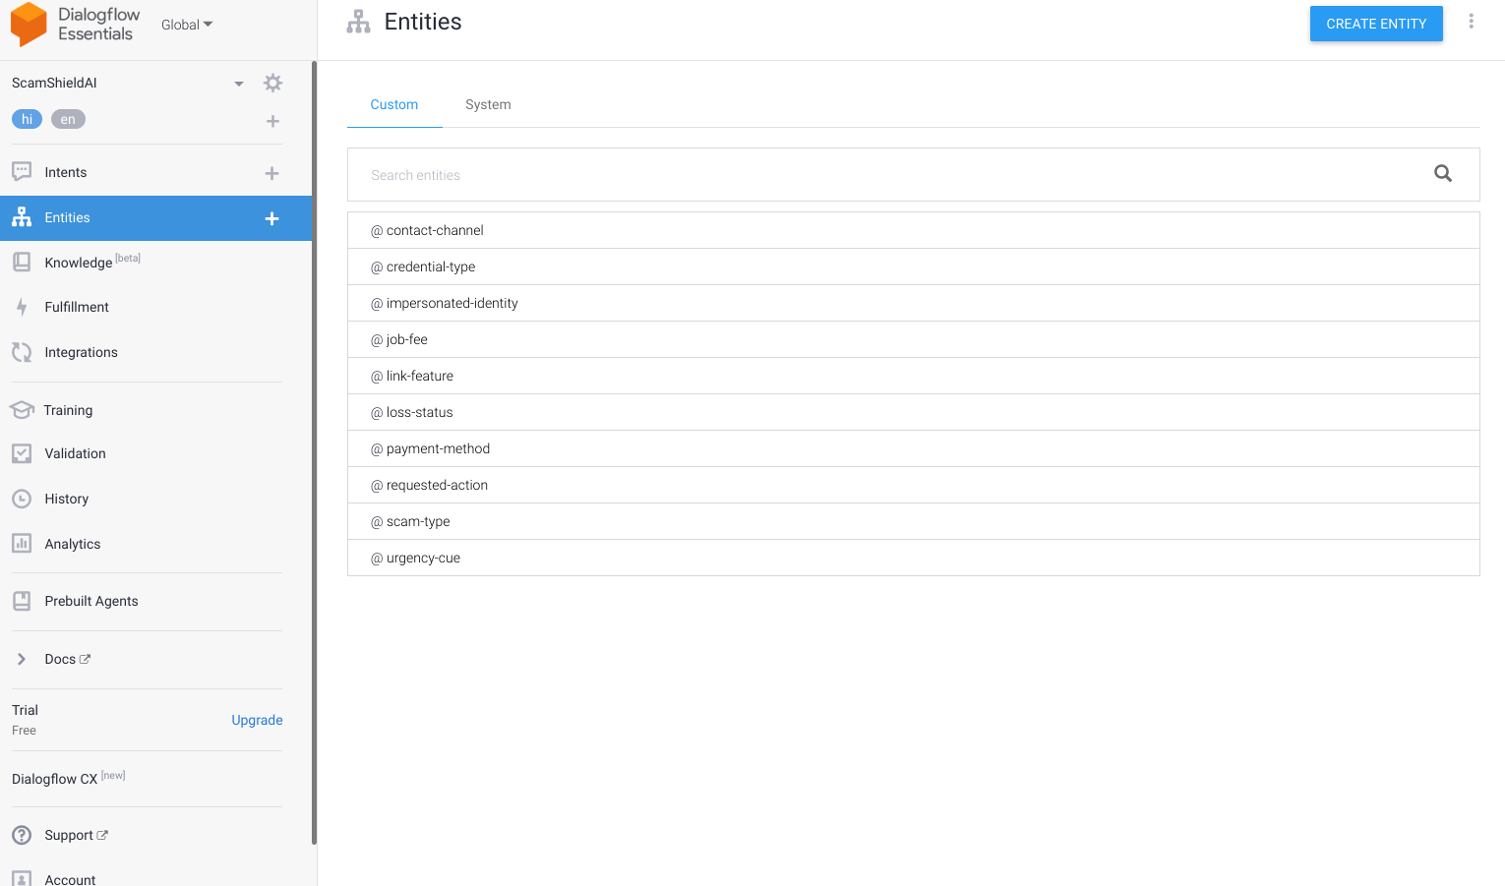
Figure 1 Ten custom entities
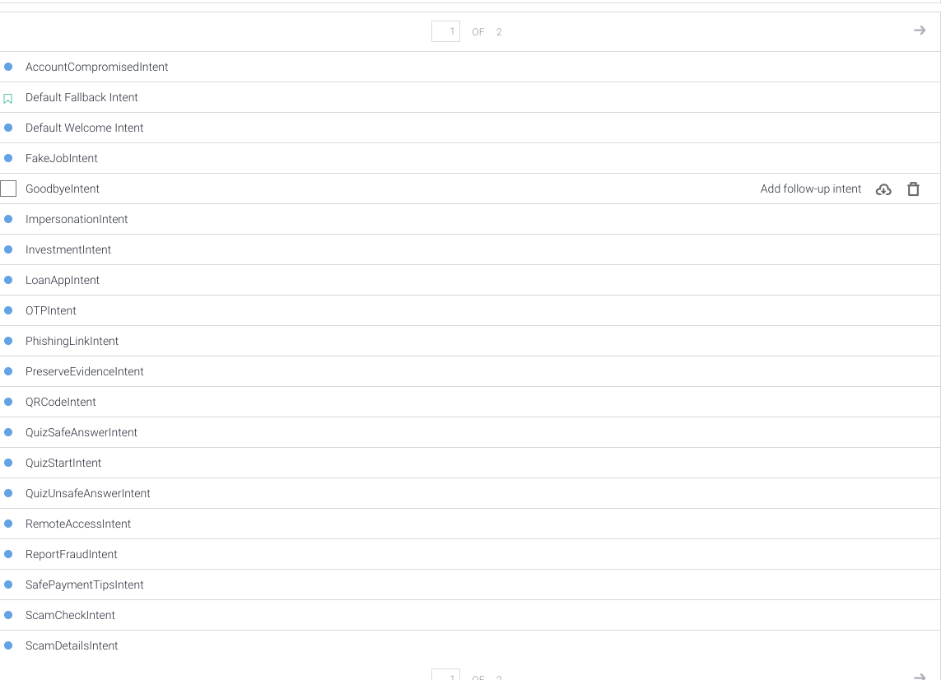
Figure 2 First page of the intent list

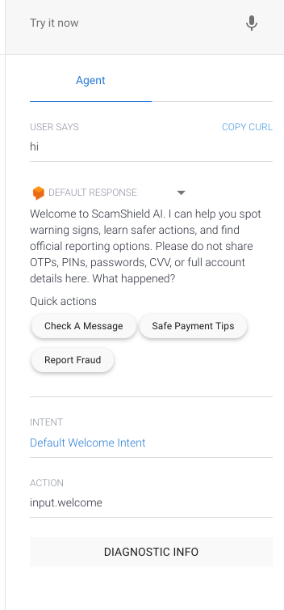  Figure 3 English greeting matched Welcome | 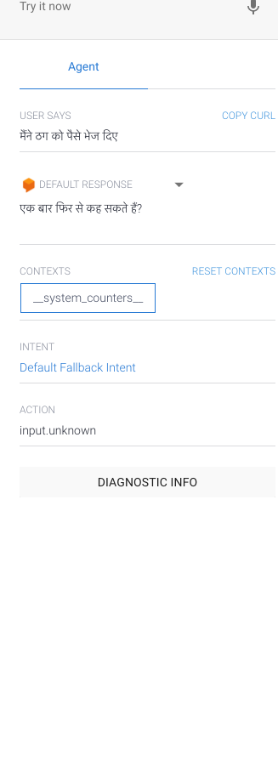  Figure 4 Hindi money-loss input reached Fallback

