European Cross-Commodity Note
Aarav Agarwal

Summary
European energy markets are in a structurally stressed regime. TTF front-month trades at €51.82/MWh - up 40% year-on-year - after Qatari force majeure in early March removed ~17% of global LNG liquefaction capacity and the Strait of Hormuz closure disrupted roughly a fifth of global LNG supply. EU gas storage sits at just 36.3% full, a near-record low for mid-May and approximately 19 percentage points below the five-year seasonal average. The required injection rate to reach even 80% by 1 November is ~3,516 GWh/day, well above current pace and historically unprecedented in a backwardated curve environment that undermines storage economics.
EU carbon (EUA Dec-26) holds at €75.02/t, adding ~€29.6/MWh of variable cost to every megawatt-hour of gas-fired generation. German Cal-27 baseload settled at €92.75/MWh, implying a marginally negative clean spark spread of roughly −€12/MWh. The risk is asymmetric to the upside: a cold autumn or further Hormuz escalation lands in a market with almost no storage buffer. A Hormuz resolution is the primary downside catalyst.

1 | Gas Tightness
TTF M+1 (19 May 2026) | €51.82/MWh (+40.1% YoY, +28.9% MoM)
52-week range | €26.55 – €69.35/MWh | March peak: >€60/MWh post-Qatar shock
EU Storage (18 May 2026) | 36.34% full | 411.3 TWh | 5-yr avg: ~55% | Gap: −19pp
Required injection pace | ~3,516 GWh/day to reach 80% by 1 Nov | Current pace: ~2,100 GWh/day
Norwegian flow | Plateau ~114.9 Bcm in 2025 (−2.3% YoY); 2026 guide: 110–120 Bcm
LNG supply shock | Qatar force majeure on ~17% of liquefaction capacity (March 2026)

The structural picture is one of chronic tightness compounded by a geopolitical shock. The winter 2025/26 was colder than recent winters, drawing storage below 30% in several EU markets by end-March. Recovery has been slow: as of 18 May, EU storage at 36.3% sits below even the distressed 2022 level at the same date.
The LNG supply backdrop has deteriorated materially. Before the conflict, Europe sourced 12–14% of its LNG from Qatar under long-term contracts. US LNG is partially filling the gap, the US now supplies ~29% of EU gas imports vs Norway’s 30% in Q1 2026, but at spot prices well above pre-shock levels. The Hormuz situation remains unstable; any re-escalation in a thin summer injection market would be acutely felt across the forward curve.
The TTF curve is in backwardation, summer prices above winter 2026/27 delivery, which structurally undermines the economics of injecting gas now to sell in winter. Equinor’s CFO said explicitly in early May that Europe is unlikely to reach even the 80% interim target by winter onset. This is not a tail risk; it is the base case.

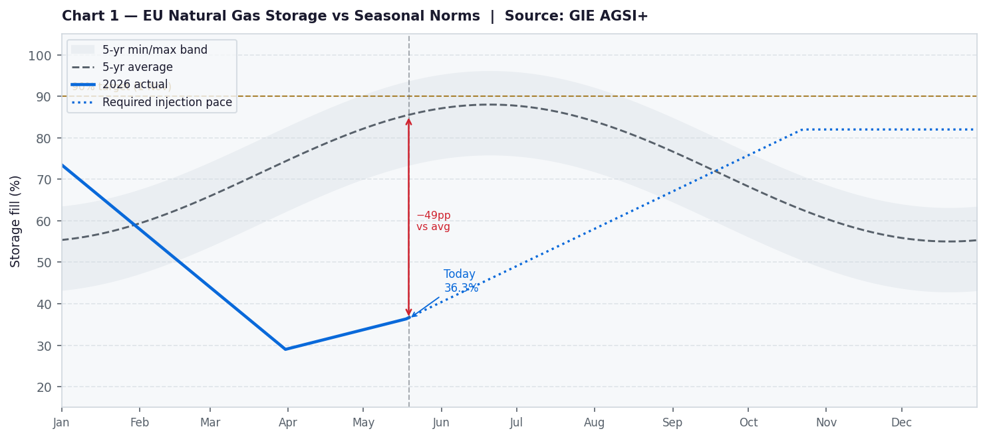
Chart 1: EU aggregate gas storage fill % vs 5-year seasonal band. Dotted line shows required injection trajectory to reach 90% by 1 November.

2 | Carbon: Supply Signal and Policy Dynamics
EUA Dec-26 (19 May 2026) | €75.02/t (+2.5% YoY) | May range: €74–€77/t
Carbon cost per MWh (gas) | €75.02 × 0.394 tCO2/MWh = €29.6/MWh embedded in power
MSR withdrawal (Sep25–Aug26) | 275.5 Mt removed from auction supply | TNAC 2024: 1,148 Mt
REPowerEU auctions 2026 | 93.28 Mt front-loaded; end no later than 31 Aug 2026
Post-Aug 2026 supply | Mechanically tighter from Sep 2026 — supply step-down
ETS review catalyst | EU ETS Directive broader review: July 2026 | Key watch date

EUA prices have surprised consensus to the downside in 2026 - a Reuters survey from July 2025 had forecast €91/t average; actuals have printed in the €62–77 range. The underperformance reflects weak EU industrial activity reducing compliance demand, and the 1 April 2026 Commission proposal on the MSR invalidation mechanism, which the market initially read as bearish before recovering.
The structural calendar for carbon is bullish from September 2026 onwards. The REPowerEU front-loaded auction programme ends by 31 August 2026. From September, the standard Linear Reduction Factor (−4.3%/year under Fit for 55) and MSR dynamics take over with a lower supply base. Any hawkish outcome in the July 2026 ETS Directive review, particularly around CBAM free-allocation phase-out acceleration, would provide a meaningful upward catalyst.
Carbon and gas prices are positively correlated, but the relationship is regime-dependent. Currently, TTF moves are larger in percentage terms than EUA moves. Industrial demand weakness remains the primary EUA headwind.

3 | Power Curve Implications

Clean Spark Spread Arithmetic (German Cal-27)
$$CSS = Power - (Gas ÷ Efficiency) - (Emission Factor × Carbon)$$
Using German Cal-27 = €92.75/MWh · TTF Cal-27 proxy ≈ €37/MWh · EUA = €75.02/t · η = 49.13% (Argus convention) · EF = 0.394 tCO2/MWh:
$$CSS = 92.75 - (37.00 ÷ 0.4913) - (0.394 × 75.02) = 92.75 - 75.31 - 29.56 = -€12.12/MWh$$
A negative Cal-27 CSS signals that the forward power curve does not compensate gas generators for their expected input costs at current prices. Forward power is structurally compressed by renewable penetration expectations even as gas remains the real-time marginal price-setter in stressed hours.

Breakeven Carbon in Cal-27 Power
$$Solving CSS = 0: EUA* = (Power - Gas/η) ÷ EF = (92.75 - 75.31) ÷ 0.394 = €44.3/t$$
German Cal-27 power is therefore pricing in an implied carbon of ~€44/t — far below spot EUA at €75/t. This €31/t gap represents either: (a) the market expecting EUA to fall sharply by 2027, or (b) an expectation that renewables will displace gas in enough hours to compress the baseload average. Given the MSR supply tightening from September 2026 and the LRF trajectory, interpretation (a) looks stretched. In a scenario where storage is 19pp below seasonal norms and a cold winter arrives; the power curve has meaningful upside from current levels.

Prompt-Wagging-the-Curve Transmission
The TTF front-month spike from €26/MWh in July 2025 to €51.82/MWh today has transmitted into the forward curve: German Cal-27 has risen from ~€68/MWh in May 2025 to €92.75/MWh today - a €24.75/MWh move against a €25.82/MWh TTF move, implying a near-1:1 prompt-to-curve pass-through. In the current stressed-storage environment, further TTF prompt spikes will continue to pull Cal-27 higher.

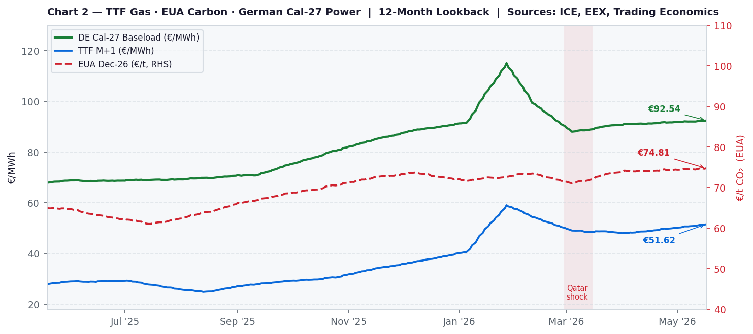
Chart 2: TTF M+1 (blue), EUA Dec-26 (red, RHS), German Cal-27 baseload (green) - 12-month lookback.

4 | Monitor Metrics & Risk Skew
Metric | Value | Signal | Relevance
TTF M+1 (€/MWh) | €51.82 | ▲ BULLISH | Primary power price input; 40%+ above year-ago
EU Storage vs 5-yr avg | −19pp | ▲ BULLISH | Low buffer amplifies any demand shock
Required injection pace | 3,516 GWh/d | ▼ BEARISH | Current pace well short; 80% target at risk
EUA Dec-26 (€/t) | €75.02 | → NEUTRAL | +€30/MWh cost; Sep supply tightening bullish
TTF Summer-Winter spread | Backwardated | ▲ BULLISH | Undermines storage refill economics
Cal-27 Implied EUA | ~€44/t | → NEUTRAL | €31 discount to spot; gap is a risk premium
German Cal-27 CSS | ~−€12/MWh | → NEUTRAL | Negative margin; gas plants price-takers fwd
Hormuz situation | Unstable | ▲ BULLISH | Any re-escalation = immediate TTF +5–10€

Upside risks to power forwards (bullish)
- Cold autumn onset (Oct 2026) - Storage entering winter at 70% vs 90% target means any cold spell drives immediate price spikes. Every 1pp below seasonal norm on 1 Nov historically adds €3-5/MWh to front-winter power.
- Hormuz re-escalation or Qatar repair delays - TTF could retest €60+; Cal-27 power at €116 was the March peak. The physical market cannot quickly substitute 17% of LNG supply.
- Hawkish ETS Directive review (July 2026) - Any acceleration in free-allocation phase-out or stronger LRF path would lift EUA toward €90+, adding €6/MWh to power variable costs.
- Norwegian maintenance season (Aug–Sep) - In the current tight market, even a 10 bcm/day flow reduction moves TTF 3–5% intraday.

Downside risks (bearish)
- Hormuz resolution / US-Iran deal - Renewed LNG shipping normalisation and Qatar repair timeline clarity. TTF could fall 8–12€/MWh; Cal-27 power would follow 1:1.
- Warm summer and autumn - A 2°C above-average September/October could add 5–8pp to storage, compressing the winter risk premium.
- US LNG commissioning acceleration (2027) - Plaquemines, Golden Pass, Rio Grande on schedule would ease 2027 balance expectations, weakening Cal-27 and Cal-28 power.
- EUA weakness on industrial demand - Sustained below-consensus EUA (below €65/t) would reduce the carbon cost floor in power, pulling Cal-27 down €4-6/MWh.

Data sources: GIE AGSI+, ICE/Trading Economics (TTF, EUA), EEX/MacroMicro (German power), ACER Winter Report April 2026, Bruegel European Gas Imports dataset, Kpler (LNG flows), IEEFA. Prices as of 19 May 2026.

