AgriSmart: Low-Cost Sensor-Driven Crop Recommendation Using Temporal Consensus over a Relational Farm Database

Aarav Gupta
School of Computer Science and Engineering
Vellore Institute of Technology
Vellore, India
Reg. No. 25BAI0131
Chirag Saxena
School of Computer Science and Engineering
Vellore Institute of Technology
Vellore, India
Reg. No. 25BCE0223
Suyash Agarwal
School of Computer Science and Engineering
Vellore Institute of Technology
Vellore, India
Reg. No. 25BBS0088

Abstract— Most literature crop recommenders consider just a single soil sample including N-P-K values which are difficult for a small farmer to determine at low cost. In this paper, we design AgriSmart – a crop recommendation system based on a normalised MySQL 8 database powered by an Arduino Uno node with just a soil moisture sensor, air temperature/humidity sensor and soil temperature probe, with soil pH being optional. Every measurement, cultivation cycle and fertiliser used are stored in the database and a recommendation is made using this history and not a single measurement. We suggest (i) quality-weighted 7-day Temporal Consensus (QW-TC) of measurements, (ii) automatically switch to a model based solely on sensors when pH is not known, (iii) isotonic calibration with Isolation-Forest Abstention, (iv) Virtual Nitrogen Balance Index calculated from crop history and fertilisers used and implemented as an SQL function, and (v) explainable per-crop fit card. The models are trained on a publicly available 22-crop dataset where soil moisture, soil temperature and soil type are calculated using formulas. Calibrated soft voting achieves 0.902 hold-out accuracy for pH and a Random Forest achieves 0.814 without pH. For simulated faulty sensors between 0 and 30%, QW-TC maintains its top-1 accuracy between 0.857 and 0.902, whereas for just using the latest value, it is 0.539–0.614.
Keywords—crop recommendation, relational database, Internet of Things, soil sensors, temporal consensus, model calibration, precision agriculture

Introduction
Currently, Indian farming cooperatives maintain separate registers and spreadsheets to record land, soil test, planting and fertilizer data. The result is that there is no way to connect the history of a plot to its eventual yield. According to surveys done on agriculture IoT, the biggest issue facing the implementation of these systems is heterogeneity of the data and lack of a unified schema [1]. Further, agricultural data remains siloed [2].
Existing crop recommenders cause another concern in the form of the classification of one soil sample with N, P and K [3]. The RS485 N-P-K/pH probe constituted INR 2,500 of the total approximate INR 3,900 cost of the node in our initial design. A single sample from a noisy and temperature fluctuating low-cost sensor can be faulty at times; for instance, a disconnected DS18B20 gives −127 °C [4]. Existing crop recommenders give an answer regardless of whether the inputs are similar to the training data and without regard to previous crops grown on the plot.
AgriSmart addresses these problems by making the relational database the centre of the system. A low-cost node without an N-P-K sensor writes readings into MySQL, and every recommendation is computed from the plot’s stored history. The contributions are:
- QW-TC: a quality-weighted, day-blocked 7-day consensus of readings instead of a single snapshot;
- adaptive model selection: a separately trained sensor-only model when no valid pH exists;
- calibrated, abstention-aware output: isotonic calibration, an Isolation-Forest out-of-distribution check and a confidence threshold;
- Virtual Nitrogen Balance Index (VNBI): soil nitrogen estimated from crop and fertiliser history, implemented identically in SQL and Python, with season, rotation and nitrogen re-ranking;
- explainable fit card: each crop’s learned P5–P95 range per measurement, stored in the database and shown with every recommendation.
Section II reviews related work, Section III describes the system and database, Section IV the dataset and models, Section V the proposed methods and Section VI the experiments. Sections VII and VIII discuss limitations and conclude.

Related Work

IoT Sensing Architectures
Ayaz et al. [5] considered a number of sensors through the life cycle of crops and observed that the highest decision value per rupee is associated with soil moisture, pH, and N-P-K but have not mentioned any issues related to data storage. Elijah et al. [1] suggested an architectural model with four layers in which the analytics layer relies on the cloud, which is expensive for co-operatives. Tzounis et al. [6] indicated that a low-power microcontroller with duty-cycled sampling is enough for monitoring the slow-changing soil parameters, and according to Khanna and Kaur [7], the cost of a soil-sensing node has reduced to an extent which makes it possible for co-operatives. Farooq et al. [8] have suggested validating the readings at the edge before storing them. LoRaFarM [9] is cost-effective and modular but stores its data in time series.

Farm Data Management
It was shown by Kamilaris et al. [11] that the majority of agriculture big data applications do not have a normalized and queryable core, and data integration is identified by Bhat and Huang [12] as the top open problem in this field. Input-to-output traceability was indicated by Sharma et al. [13] as one of the prerequisites for conducting supply chain analysis. In addition, Zhang et al. [14] demonstrated that in-field heterogeneity calls for plot-scale management, while Dhanaraju et al. [15] found that fertilizer usage can be minimized through sensor-based input control.

Machine Learning in Agriculture
According to Liakos et al. [16], soil management is the least researched area in agricultural machine learning. While deep learning works better than classical approaches, it requires large labeled datasets which are lacking in the cooperative [17]. A review of studies on yield prediction [18] found that farm-level historical data is infrequently utilized as an input feature. Random Forest algorithm has provided significantly smaller errors compared to linear regression for predicting yield [19]; a small number of soil and climate variables can explain most of the yield variability [20]; and deep reinforcement learning has confirmed the presence of predictive power in previous seasons at the expense of interpretability [21].

Irrigation, Crop Recommendation and Rotation
The sensor network for irrigation systems [22]–[24] employed moisture sensing in threshold and closed-loop control modes, whereas Muangprathub et al. [25] obtained moisture bands from recorded history. Pudumalar et al. [3] suggested the crops by a voting ensemble, which gave better results than individual classifiers, however, based on sporadic soil sampling without any historical information. Fenz [26] proposed crop rotations according to multi-year field records, yet the planner operates offline without any constraints during data input.

Research Gaps
From this review we identified five gaps: (1) sensed soil data is not linked in a normalised schema to the plot, crop cycle and yield; (2) crop recommendation ignores soil history; (3) crop rotation is planned but never enforced; (4) fertiliser and pesticide use is not traceable to output; and (5) results are reported as model accuracy without simple metrics that a clerk can verify by hand. AgriSmart closes gaps 1, 3, 4 and 5 with schema objects (tables, a trigger, views and a stored procedure) and gap 2 with QW-TC.

System Design
Fig. 1 shows the architecture. Readings travel from the sensor node over USB to a Python serial bridge, which inserts them into MySQL. A Flask website reads the database and calls the recommendation engine.
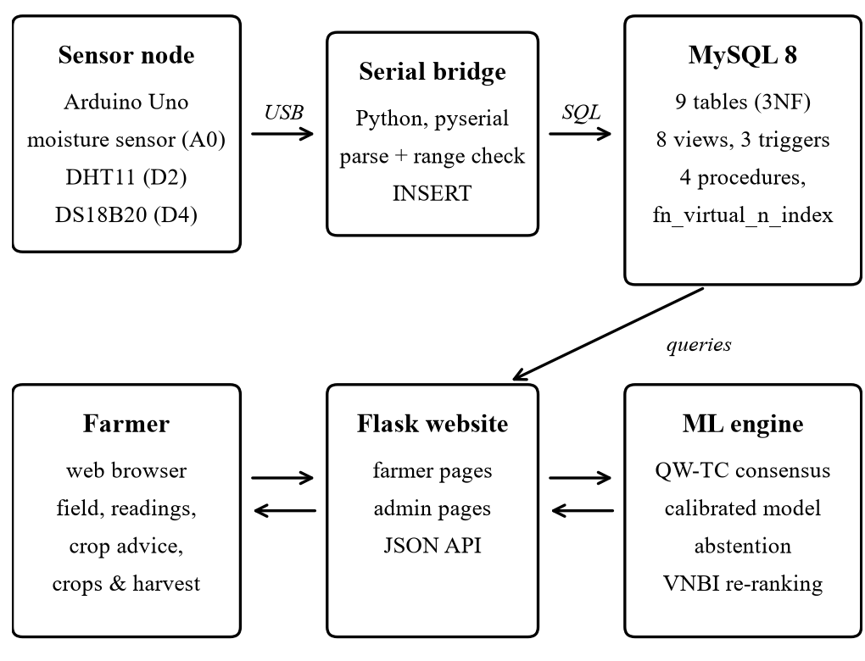
- AgriSmart architecture.

Sensor Node
The node is an Arduino Uno with a capacitive soil-Serial Bridge moisture sensor connected to A0, a DHT11 air temperature and humidity sensor connected to D2 [27], and a DS18B20 waterproof soil-temperature sensor connected to D4 with a 4.7 kΩ pull-up resistor [4]. An optional PH-4502C pH sensor connected to A1 can be added to the system or pH input manually using the Soil Health Card of the farmer. The code outputs a header line followed by each sample (node_id, moisture, soil temperature, air temperature, humidity, pH) in one CSV line with a “nan” value if no reading exists. Moisture is calibrated based on a two-point method between a dry and saturated water content (default 45%). Removing the N-P-K sensor and its MAX485 interface from the Review-1 component list results in about INR 1,380.
The bridge reads the column order from the sketch’s header line and accepts 6-field or 4-field frames. It maps “nan” to NULL, sets values outside the physical range (moisture 0–60 %, soil temperature −5–60 °C, air temperature 0–50 °C, humidity 5–100 %, pH 3–10) to NULL, and rejects frames from unknown or inactive nodes. DS18B20 fault codes (−127 and 85 °C) are passed through so that a database trigger can clean them. For sensor modules that report moisture on a 0–100 % dry-to-wet scale, the bridge can rescale the value to volumetric water content.

Relational Database
The Review-1 entity-relationship design had seven tables; the final schema has the nine 3NF tables of Table I [28]. It uses primary and foreign keys with ON DELETE rules, UNIQUE constraints and CHECK constraints for value ranges, phone format and status/date consistency [29].
- Database Tables
Table | Stores
farmers | farmer identity and contact
plots | field area, soil type, location
crops | season, family, N demand, learned P5–P95 ranges
sensor_nodes | node, plot, fitted sensors, last seen
soil_health_logs | every reading with source and quality score
cultivation_cycles | sowing, harvest, status, yield
treatments | fertiliser/pesticide, N applied, cost
recommendation_runs | model used, window, VNBI, season
recommendation_items | ranked crops of each run
There are eight views for the most recent reading and pH per plot, 7-day conditions, last grown crop, cycle performance, node health, plot overview and v_recommended_crops which is a rule-based recommender that matches each plot’s conditions with the range of crops. There are three triggers for the rotation rule (which states that an annual crop cannot be followed by itself and a plot cannot have two growing cycles), for preventing invalid fault codes in DS18B20 when inserting, and updating the last-seen time of a node. Four stored procedures initiate a cycle, insert a harvest in a transaction that can roll back, retrieve the history of a plot, and create a yield report (yield total, actual vs catalogue maturing times and yield per acre). The function fn_virtual_n_index calculates the VNBI of Section V. The generated demonstration data consists of 10 farmers, 16 plots, 22 crops, 6 sensor nodes, 2,942 soil logs (10 days with readings every 30 minutes for each node), 62 cultivation cycles and 151 treatments.

Web Application
The Flask website guides a farmer through four steps: the field and its live readings, optional manual soil data, plain-language crop advice, and the crops grown and harvested. Choosing a recommended crop saves the run and starts a cultivation cycle through sp_start_cycle. Registering a farmer, field, sensor node and first reading happens in one transaction. Administrative pages and a JSON API expose the same data.

Dataset and Models

Sensor-Oriented Dataset
The models are trained on the public Crop Recommendation dataset [30]: 2,200 rows, 22 crops, 100 rows per crop, with N, P, K, temperature, humidity, pH and rainfall. Because the node has no N-P-K sensor, N, P, K and rainfall were dropped, and three columns the node does measure were derived. Soil type is sampled per crop from Indian crop–soil associations based on NCERT geography [31]; this mapping is a team assumption. Volumetric moisture is
θ = WP + (FC − WP)(1 − exp(−R/R₀)) + ε, (1)
where FC and WP are the mid-points of field capacity and wilting point from FAO-56 Table 19 [32] for the texture of each soil type (e.g., alluvial 27/12 %, black 36/22 %), R is rainfall, R₀ = 120 mm and ε ~ N(0, 1.2). Soil temperature is
T_{soil} = T_{air} + 1.5 − 0.08(θ − 20) + ε, (2)
with ε ~ N(0, 0.8). Values are rounded to the sensor resolution (DHT11 1 °C and 1 %RH, DS18B20 0.0625 °C). The features are moisture, soil temperature, air temperature, humidity, soil type and, optionally, pH. All experiments use a stratified 80/20 split with seed 42 (440 test rows) and stratified 5-fold cross-validation (CV).
Table II (Exp 1) measures the cost of having no N-P-K sensor with a Random Forest on the original dataset. Accuracy falls from 0.996 to 0.742 when N, P, K and rainfall are removed, so the sensor-only problem is substantially harder.
- Effect of Removing N-P-K (Exp 1, Random Forest)
Features | CV accuracy
N, P, K, temperature, humidity, pH, rainfall | 0.996
temperature, humidity, pH, rainfall | 0.962
temperature, humidity, rainfall | 0.920
temperature, humidity, pH | 0.742

Model Selection
Nine classifiers from scikit-learn [33] were compared on both feature sets (Exp 2, Table III). The soft-voting ensemble of Random Forest, Histogram Gradient Boosting and an RBF SVM had the highest CV accuracy with pH, and the Random Forest was the strongest single model without pH.
- CV Accuracy of the Compared Models (Exp 2)
Model | With pH | Without pH
Soft Voting (RF+HGB+SVM) | 0.895 | 0.833
Hist Gradient Boosting | 0.888 | 0.818
Random Forest | 0.878 | 0.831
SVM (RBF) | 0.872 | 0.819
Extra Trees | 0.870 | 0.817
Decision Tree | 0.820 | 0.772
K-Nearest Neighbours | 0.811 | 0.795
Logistic Regression | 0.732 | 0.671
Gaussian Naive Bayes | 0.595 | 0.546

An extensive comparison of 16 models (Experiment 7, including MLP, LDA, QDA, AdaBoost, Bagging, Gradient Boosting and Stacking) confirmed the models to be used for deployment. In case of pH, Soft Voting showed maximum cross-validation accuracy and surpassed Histogram Gradient Boosting in 4 out of 5 folds; Stacking achieved 0.892. In absence of pH, Stacking (0.834) and Soft Voting (0.833) were better than the Random Forest in only 2 out of 5 folds; therefore, the simpler Random Forest remained. Nested-cross-validation regularisation (Experiment 8) improved Logistic Regression by 0.064 in case of pH and 0.054 in absence of pH (5 out of 5 folds), and Histogram Gradient Boosting and SVM by 0.011 and 0.010 respectively in absence of pH (5 out of 5 folds), while having no effect on Random Forest and having slight adverse impact on Histogram Gradient Boosting in presence of pH by 0.005.
Both selected models have been calibrated using isotonic regression [34], with 5-fold cross-validation. The calibrated models, applied to the hold-out set, attain an accuracy of 0.902 and top-3 accuracy of 0.993 with pH, and 0.814 and 0.986 without pH; thus, the website will always display the top three. Using permutation importance on the hold-out set, humidity is found to be most important (0.639 with pH), followed by moisture (0.247), pH (0.200), soil (0.148), air temperature (0.113) and soil temperature (0.060). Soil temperature is of minor importance, since it has been derived from air temperature by (2).

Proposed Methods

Quality-Weighted Temporal Consensus (QW-TC)
Instead of classifying the latest reading, the engine classifies a consensus feature vector over the last 7 days of readings x_{i}:
x̄ = Σ q_{i} w_{i} x_{i} / Σ q_{i} w_{i}. (3)
The quality score q_{i} starts at 1 and is set to 0 for a missing, out-of-range or fault-code value. A robust spike test compares each value with the window median using the median absolute deviation; a z-score above 3.5 multiplies q_{i} by max(0, 1 − (z − 3.5)/3.5). Moisture below 1 % (probe out of soil) multiplies q_{i} by 0.1, and a soil–air temperature difference above 15 °C by 0.5. The recency weight is day-blocked, w_{i} = exp(−24 d_{i}/τ) with d_{i} the whole days before the latest reading and τ = 168 h, so all readings of one day share a weight and the day/night balance is kept. Quality scores are written back to soil_health_logs, and the 7-day view excludes rejected readings. If no reading in the window has a soil temperature (no probe fitted), it is estimated with (2) without noise.

Adaptive Model Selection
If the plot has a valid pH (between 3 and 10, at most 180 days old, from the probe or typed in), the with-pH model is used; otherwise the sensor-only model is used instead of imputing pH.

Calibration and Abstention
An Isolation Forest [35] (300 trees, contamination 0.01) trained on the training features marks inputs unlike any training condition as out-of-distribution. If the top calibrated probability is below 0.50, the run is marked low-confidence and the website advises a laboratory soil test.

Virtual Nitrogen Balance Index and Re-Ranking
Without an N-P-K sensor, soil nitrogen is estimated from the plot’s last three cycles k = 0, 1, 2 (most recent first):
VNBI = Σ 0.6^{k} (e(c_{k}) + min(1, N_{k}/40)), (4)
where e(c) is +1 for a nitrogen-fixing legume, 0 for a low, −0.5 for a medium and −1 for a high nitrogen-demand crop, and N_{k} is the nitrogen applied in cycle k in kg per acre, taken from the treatments table. The same formula is implemented in Python and as fn_virtual_n_index with a window function. The final score is
S = p × f_{season} × f_{rotation} × f_{N}, (5)
where p is the calibrated probability. f_{season} = 0.6 for an off-season annual crop. f_{rotation} is 0 for the same annual crop as last cycle (also enforced by the trigger), 0.8 for the same family and 1.15 for a legume after a cereal or fibre crop. When VNBI < −0.75, f_{N} is 0.85 for high-N crops and 1.15 for legumes; when VNBI > 0.75, it is 1.1 for high-N crops. These factors are rule-based.

Explainable Fit Card
For each crop, the P5–P95 range of every measurement is learned from the training rows and stored in the crops table. The website shows whether each consensus value lies inside, below or above the range, and v_recommended_crops uses the same ranges as a transparent SQL baseline.

Experiments and Results

Robustness to Sensor Faults (Exp 3)
Each test row was taken as a plot’s daily-mean condition, and a 7-day window of 42 readings (one every 4 h) was simulated around it with diurnal cycles (air temperature ±4 °C, humidity ±8 %, soil temperature ±1.5 °C), slow moisture drift and datasheet-level noise. Each reading became faulty with probability f, chosen from DS18B20 disconnected (−127 °C), DS18B20 power-on reset (85 °C), probe out of soil (0 %), a humidity spike (±30 %) and a moisture spike (±15 %).
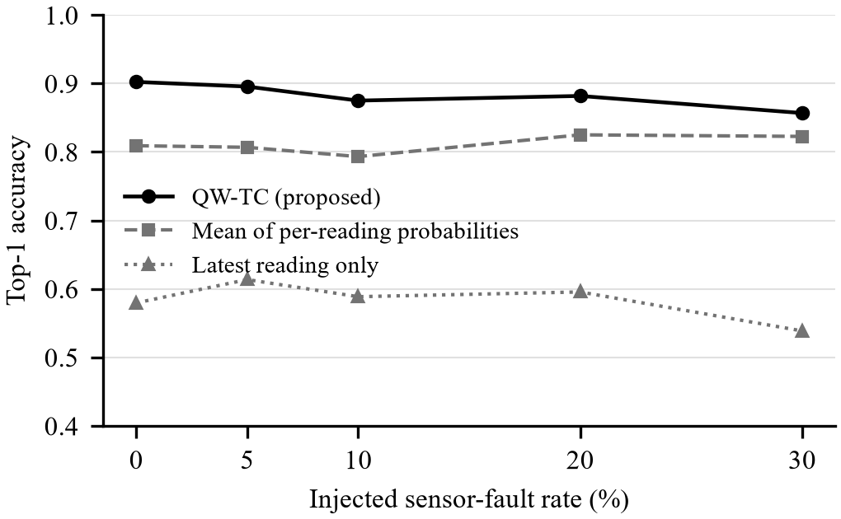
- Top-1 accuracy versus injected fault rate (Exp 3, with-pH model, 440 test rows).
Fig. 2 shows that classifying the latest reading gives 0.539–0.614, whereas QW-TC gives 0.857–0.902 for fault rates of 0–30 %. Averaging per-reading class probabilities gives only 0.793–0.825, because single readings carry the day/night swing while crop requirements describe daily-mean conditions. An hourly recency decay (τ = 72 h) gave 0.843–0.884, lower than day-blocked weighting at every fault level. With 440 test rows the standard error is about ±0.017, so differences below about 3 points between the consensus variants are within noise; the large gain is from snapshot to consensus.

Missing pH (Exp 4)
- Strategies When pH Is Missing (Exp 4)
Strategy | Accuracy
With-pH model, pH = 7.0 | 0.677
With-pH model, pH = training median | 0.791
Sensor-only model (proposed) | 0.814
Reference: pH measured | 0.902

Table IV shows that switching to the sensor-only model is more accurate than either imputation.

Calibration and Abstention (Exp 2 and Exp 5)
- Effect of Isotonic Calibration (Hold-Out Set)
Model | ECE before | ECE after | Accuracy after
Soft Voting (with pH) | 0.086 | 0.022 | 0.902
Random Forest (no pH) | 0.074 | 0.051 | 0.814

Calibration lowered the expected calibration error (ECE; 15 bins) in both cases (Table V). Figure 3 illustrates the risk–coverage chart; based on the selected threshold of 0.50, 97.0% of the predictions are replied to with 91.8% accuracy, while the abstained 3.0% are correct with 38.5% accuracy. Isolation Forest detected 0.45% of true test samples but 70.1% of 1,000 random in-range samples.
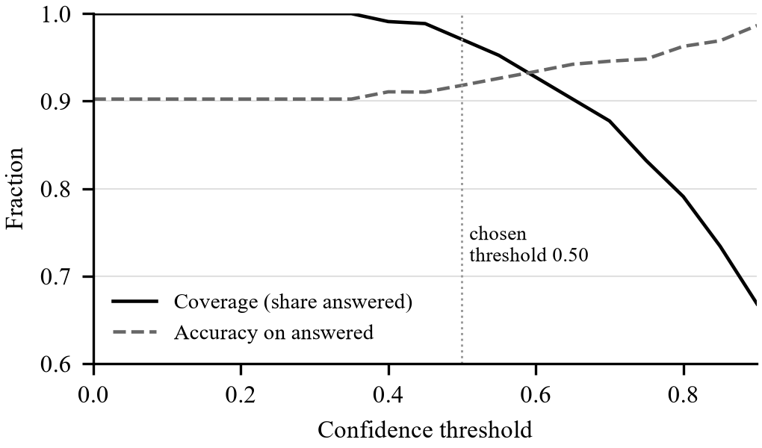
- Coverage and accuracy versus confidence threshold (Exp 5, with-pH model).

Context-Aware Re-Ranking (Exp 6)
One real test reading (row 150: moisture 17.4 %, soil temperature 23.1 °C, air temperature 21 °C, humidity 65 %, pH 6.67, alluvial soil) was ranked under five plot histories. The model alone ranks maize (0.62) above lentil (0.38). Table VI gives the context-aware top two.
- Re-Ranking of One Reading Under Five Histories (Exp 6)
Scenario | VNBI | Top two (score)
No history, July | – | maize 0.62, lentil 0.23
Last crop maize, July | −1.00 | lentil 0.30, apple 0.00
Rice, maize, cotton, no fertiliser, July | −1.96 | maize 0.52, lentil 0.30
Same, 50 kg N/acre each cycle, July | 0.00 | maize 0.62, lentil 0.26
No history, November | – | lentil 0.38, maize 0.37

Repeating maize is blocked, a depleted nitrogen history lowers maize from 0.62 to 0.52, recorded urea removes that penalty, and in November (Rabi) lentil overtakes the Kharif crop maize. This is a case study; whether the re-ranking improves yield needs multi-season field data.

Prototype Test
The data path was verified on 13 October 2026 using an Arduino Uno with a soil moisture sensor and a DHT type air sensor; the DS18B20 was not installed yet. The sensor output was moisture content between 0% (completely dry soil) and 100% (completely wet soil), while the bridge was transforming it to volumetric content, assuming 100% corresponds to 45%. The new value appeared on average once per 10 seconds: 0% when the probe was in the air and 96–100% (stored as 43–45%) in newly watered soil. When the probe was pulled away from the soil, 0% values had zero importance in QW-TC, thus the total consensus value remained 44.2% and the recommendation was not changed. With pH value manually set to 5.6 and 55 readings available, the model with pH predicted pigeon peas as the first option (probability 0.611, final score 0.367 taking into account the off-season factor 0.6 in October) and marked moisture as higher than the range for all top crops.

Limitations
The parameters moisture content, soil temperature, and soil type in the training data are calculated from a public data source using formulae and do not correspond to field observations. The method of collection of this data source is not detailed in the author’s work. The Exp 3 sensor windows are simulated on the rows of the data source. The weights and re-ranking factors in VNBI algorithm are heuristic and have been assessed based on case study and not from yield data. The agronomic constants (number of seasons, days to maturation, typical yield) should be cross-checked with the ICAR and Government of India sources.

Conclusion and Future Work
AgriSmart reveals that a relational database with data input from a low-cost node without an N-P-K sensor is able to provide reliable and explainable crop recommendations based on plot history. The QW-TC approach increased top-1 accuracy under simulated faults from 0.539–0.614 to 0.857–0.902, the adaptive model switch outperformed pH imputation (0.814 vs. 0.677–0.791), and calibration with abstention provided meaningful confidence measure. Agro-nomic rules such as crop rotation are implemented in the database through a trigger, nitrogen state is estimated in SQL based on history records. Further research will include fitting the soil-temperature probe, collecting real field data and multi-year harvests to validate the models and VNBI, and verifying the agro-constants from official sources.

References
- O. Elijah, T. A. Rahman, I. Orikumhi, C. Y. Leow, and M. N. Hindia, “An overview of Internet of Things (IoT) and data analytics in agriculture: Benefits and challenges,” IEEE Internet of Things Journal, vol. 5, no. 5, pp. 3758–3773, Oct. 2018.
- S. Wolfert, L. Ge, C. Verdouw, and M.-J. Bogaardt, “Big data in smart farming – A review,” Agricultural Systems, vol. 153, pp. 69–80, 2017.
- S. Pudumalar, E. Ramanujam, R. H. Rajashree, C. Kavya, T. Kiruthika, and J. Nisha, “Crop recommendation system for precision agriculture,” in Proc. IEEE 8th Int. Conf. Advanced Computing (ICoAC), Chennai, India, 2016, pp. 32–36.
- Maxim Integrated, DS18B20 Programmable Resolution 1-Wire Digital Thermometer, datasheet.
- M. Ayaz, M. Ammad-Uddin, Z. Sharif, A. Mansour, and E.-H. M. Aggoune, “Internet-of-Things (IoT)-based smart agriculture: Toward making the fields talk,” IEEE Access, vol. 7, pp. 129551–129583, 2019.
- C. Tzounis, N. Katsoulas, T. Bartzanas, and C. Kittas, “Internet of Things in agriculture, recent advances and future challenges,” Biosystems Engineering, vol. 164, pp. 31–48, 2017.
- A. Khanna and S. Kaur, “Evolution of Internet of Things (IoT) and its significant impact in the field of precision agriculture,” Computers and Electronics in Agriculture, vol. 157, pp. 218–231, 2019.
- M. S. Farooq, S. Riaz, A. Abid, K. Abid, and M. A. Naeem, “A survey on the role of IoT in agriculture for the implementation of smart farming,” IEEE Access, vol. 7, pp. 156237–156271, 2019.
- G. Codeluppi, A. Cilfone, L. Davoli, and G. Ferrari, “LoRaFarM: A LoRaWAN-based smart farming modular IoT architecture,” Sensors, vol. 20, no. 7, p. 2028, 2020.
- A. Villa-Henriksen, G. T. C. Edwards, L. A. Pesonen, O. Green, and C. A. G. Sørensen, “Internet of Things in arable farming: Implementation, applications, challenges and potential,” Biosystems Engineering, vol. 191, pp. 60–84, 2020.
- A. Kamilaris, A. Kartakoullis, and F. X. Prenafeta-Boldú, “A review on the practice of big data analysis in agriculture,” Computers and Electronics in Agriculture, vol. 143, pp. 23–37, 2017.
- S. A. Bhat and N.-F. Huang, “Big data and AI revolution in precision agriculture: Survey and challenges,” IEEE Access, vol. 9, pp. 110209–110222, 2021.
- R. Sharma, S. S. Kamble, A. Gunasekaran, V. Kumar, and A. Kumar, “A systematic literature review on machine learning applications for sustainable agriculture supply chain performance,” Computers & Operations Research, vol. 119, p. 104926, 2020.
- Q. Zhang, M. Wang, and N. Wang, “Precision agriculture – A worldwide overview,” Computers and Electronics in Agriculture, vol. 36, no. 2–3, pp. 113–132, 2002.
- M. Dhanaraju, P. Chenniappan, K. Ramalingam, S. Pazhanivelan, and R. Kaliaperumal, “Smart farming: Internet of Things (IoT)-based sustainable agriculture,” Agriculture, vol. 12, no. 10, p. 1745, 2022.
- K. G. Liakos, P. Busato, D. Moshou, S. Pearson, and D. Bochtis, “Machine learning in agriculture: A review,” Sensors, vol. 18, no. 8, p. 2674, 2018.
- A. Kamilaris and F. X. Prenafeta-Boldú, “Deep learning in agriculture: A survey,” Computers and Electronics in Agriculture, vol. 147, pp. 70–90, 2018.
- T. van Klompenburg, A. Kassahun, and C. Catal, “Crop yield prediction using machine learning: A systematic literature review,” Computers and Electronics in Agriculture, vol. 177, p. 105709, 2020.
- J. H. Jeong et al., “Random forests for global and regional crop yield predictions,” PLoS ONE, vol. 11, no. 6, p. e0156571, 2016.
- P. S. Maya Gopal and R. Bhargavi, “A novel approach for efficient crop yield prediction,” Computers and Electronics in Agriculture, vol. 165, p. 104968, 2019.
- D. Elavarasan and P. M. D. Vincent, “Crop yield prediction using deep reinforcement learning model for sustainable agrarian applications,” IEEE Access, vol. 8, pp. 86886–86901, 2020.
- C. Kamienski et al., “Smart water management platform: IoT-based precision irrigation for agriculture,” Sensors, vol. 19, no. 2, p. 276, 2019.
- S. R. Nandurkar, V. R. Thool, and R. C. Thool, “Design and development of precision agriculture system using wireless sensor network,” in Proc. IEEE Int. Conf. Automation, Control, Energy and Systems (ICAETR), 2014, pp. 1–6.
- Y. Kim, R. G. Evans, and W. M. Iversen, “Remote sensing and control of an irrigation system using a distributed wireless sensor network,” IEEE Transactions on Instrumentation and Measurement, vol. 57, no. 7, pp. 1379–1387, Jul. 2008.
- J. Muangprathub, N. Boonnam, S. Kajornkasirat, N. Lekbangpong, A. Wanichsombat, and P. Nillaor, “IoT and agriculture data analysis for smart farm,” Computers and Electronics in Agriculture, vol. 156, pp. 467–474, 2019.
- S. Fenz, “AI- and data-driven crop rotation planning,” Computers and Electronics in Agriculture, vol. 212, p. 108160, 2023.
- Aosong Electronics, DHT11 Humidity & Temperature Sensor, datasheet.
- R. Elmasri and S. B. Navathe, Fundamentals of Database Systems, 7th ed. Hoboken, NJ, USA: Pearson, 2016.
- Oracle Corporation, “MySQL 8.0 Reference Manual: Stored Programs and Views,” MySQL Documentation, 2024. [Online]. Available: https://dev.mysql.com/doc/refman/8.0/en/
- A. Ingle, “Crop Recommendation Dataset,” Kaggle, 2020. [Online]. Available: https://www.kaggle.com/datasets/atharvaingle/crop-recommendation-dataset
- NCERT, Contemporary India II: Textbook in Geography for Class X, Ch. 1 “Resources and Development” and Ch. 4 “Agriculture.” New Delhi, India: NCERT.
- R. G. Allen, L. S. Pereira, D. Raes, and M. Smith, Crop Evapotranspiration: Guidelines for Computing Crop Water Requirements, FAO Irrigation and Drainage Paper 56. Rome, Italy: FAO, 1998.
- F. Pedregosa et al., “Scikit-learn: Machine learning in Python,” Journal of Machine Learning Research, vol. 12, pp. 2825–2830, 2011.
- B. Zadrozny and C. Elkan, “Transforming classifier scores into accurate multiclass probability estimates,” in Proc. 8th ACM SIGKDD Int. Conf. Knowledge Discovery and Data Mining, 2002, pp. 694–699.
- F. T. Liu, K. M. Ting, and Z.-H. Zhou, “Isolation forest,” in Proc. 8th IEEE Int. Conf. Data Mining (ICDM), 2008, pp. 413–422.

