BACSE202 – DATABASE SYSTEMS
Project Details
on
AgriSmart: Smart Farm & Crop Recommendation System
Prepared by
Aarav Gupta - 25BAI0131
Chirag Saxena - 25BCE0223
Suyash Agarwal - 25BBS0088
Project Description
AgriSmart recommends the most suitable crop for a farmer’s plot using low-cost soil sensors instead of a laboratory N-P-K test. An Arduino Uno node with a capacitive soil-moisture sensor, a DHT11 air temperature/humidity sensor and a DS18B20 soil-temperature probe sends readings over USB to a Python serial bridge, which validates them and stores them in a MySQL 8 database. Soil pH is optional and can be typed in from the Soil Health Card. The database has 9 tables in 3NF (farmers, plots, crops, sensor_nodes, soil_health_logs, cultivation_cycles, treatments, recommendation_runs, recommendation_items), 8 views, 3 triggers (crop-rotation rule, DS18B20 fault cleaning, node last-seen), 4 stored procedures (sp_start_cycle, sp_record_harvest, sp_plot_history, sp_yield_report) and the function fn_virtual_n_index. A Flask application allows a farmer to register his field, view live readings, get straightforward crop recommendation and keep track of what was sown, fertilized and harvested. The crop prediction model was trained on the publicly available Kaggle Crop Recommendation dataset (2,200 records, 22 crops) where N, P, K, rainfall data was removed and the other variables soil moisture, soil temperature and soil type were calculated using the formulas mentioned in the documentations. The deployed isotonic calibrated models consist of a Soft Voting ensemble for known pH (Random Forest + Hist Gradient Boosting + SVM) and Random Forest for unknown pH (Table 1).
Feature set | Deployed model | 5-fold CV accuracy | Hold-out accuracy | Hold-out top-3
Sensors + pH | Soft Voting (RF+HGB+SVM) | 0.895 | 0.902 | 0.993
Sensors only (no pH) | Random Forest | 0.831 | 0.814 | 0.986
Table 1. Deployed models (seed 42; hold-out = 440 test rows, after isotonic calibration).
Novelty of the Idea
The first novel aspect of this research is the idea to base the recommendation on the historical record
of the plot kept in the database rather than on one measurement done by the sensor, which allows for a
relatively inexpensive node without an N-P-K sensor to provide credible and comprehensible
recommendations. Current crop recommenders make their decision based on one measurement,
require N-P-K readings, always provide some response regardless of uncertainty, and do not take into
account what had been planted before. The AgriSmart solution makes the following improvements:

- N1 – Quality-Weighted Temporal Consensus (QW-TC): instead of the latest reading, the engine averages the last 7 days of readings, weighting each by a quality score (range check, DS18B20 fault codes −127/85 °C, a median-based spike test and soil-air temperature consistency) and a day-blocked recency weight. Under 0–30 % injected sensor faults it keeps top-1 accuracy at 0.857–0.902, against 0.539–0.614 for the latest reading alone (Figure 1).
- N2 – Adaptive model switch when pH is missing: if no valid pH (at most 180 days old) exists, a separately trained sensor-only model is used instead of guessing the pH. This gives 0.814 accuracy, compared with 0.791 when pH is filled with the training median and 0.677 when pH is assumed to be 7.0.
- N3 – Calibrated, abstention-aware advice: isotonic calibration lowered the expected calibration error from 0.086 to 0.022 (with pH) and from 0.074 to 0.051 (without pH). An Isolation-Forest detector flags 70.1 % of random in-range inputs but only 0.45 % of real test readings, and a 0.50 confidence threshold keeps 97.0 % of recommendations at 91.8 % accuracy, asking for a lab test for the rest.
- N4 – Virtual Nitrogen Balance Index (VNBI) and context re-ranking: with no N-P-K sensor, soil nitrogen is estimated from the plot’s last three crops and the fertiliser recorded in the database (decay 0.6 per cycle), implemented both as the SQL function fn_virtual_n_index and in Python. The final score multiplies the model probability by season, rotation and nitrogen factors; a trigger blocks an annual crop from following itself.
- N5 – Explainable fit card: for every crop, the P5–P95 range of each measurement is learned from the training data and stored in the crops table. The website shows whether each measured value is inside, below or above that range, and the view v_recommended_crops uses the same ranges as a rule-based baseline that can be checked by hand.

Contribution | Experiment | Result
N1 QW-TC | Exp 3: 42 simulated readings over 7 days per test row, 0–30 % faults | Top-1: 0.902 / 0.875 / 0.857 at 0 / 10 / 30 % faults (latest reading only: 0.580 / 0.589 / 0.539)
N2 Model switch | Exp 4: test rows with pH removed | Sensor-only model 0.814; pH = median 0.791; pH = 7.0 0.677; pH measured 0.902
N3 Calibration + abstention | Exp 2 calibration; Exp 5 risk-coverage and OOD test | ECE 0.086 → 0.022; OOD flags 70.1 % random vs 0.45 % real; threshold 0.50 keeps 97.0 % at 91.8 %
N4 VNBI re-ranking | Exp 6: one soil reading, five plot histories | Last crop maize → maize blocked, lentil #1 (0.30); VNBI −1.96 → maize 0.62 → 0.52; November → lentil 0.38 above maize 0.37
N5 Fit card | Implemented for all 22 crops | Ranges stored in the crops table and shown per recommendation
Table 2. Evidence for each contribution (experiments/EXPERIMENTS_SUMMARY.md).
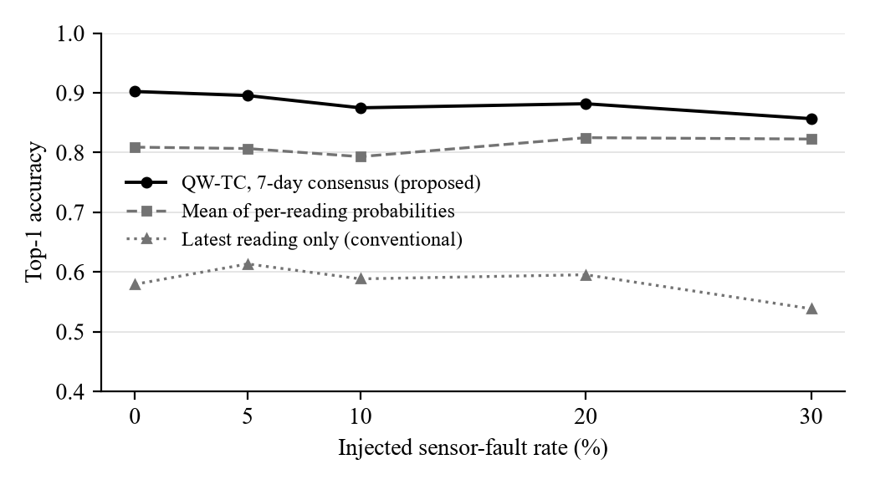
Figure 1. Top-1 accuracy versus injected sensor-fault rate (Exp 3, with-pH model, 440 test rows).
Limitations. The moisture, soil temperature, and soil type features in the training data set are obtained from a public dataset which uses certain formulas, not obtained from field measurements, while the sensor window for Exp 3 are simulated. The weights in VNBI as well as re-ranking factors are rule-based and demonstrated through case studies instead of being extracted from the yield data. At the present moment, in the prototype DS18B20 probe has not been installed and thus the soil temperature is estimated based on the air temperature and moisture.
Proposed Outcome: Conference

