Physics-Grounded Cyber-Resilient Battery State Estimation Framework for Electric Vehicles under Stealth Sensor Manipulation Attacks
Anirudh Balaji ¹, C. Kavitha ², Ashok Bragadeshwaran ³
¹ School of Computer Science and Engineering, Vellore Institute of Technology, Vellore, 632014, Tamilnadu, India
² School of Computer Science and Technology, The Apollo University, Chittoor, Andhra Pradesh, India
³ School of Mechanical Engineering, Vellore Institute of Technology, Vellore, 632014, Tamilnadu, India
*Corresponding Author E-mail address: ashokmts@gmail.com; ashok.b@vit.ac.in
Tel: +919865467729; Fax: +914162243092

Abstract

The paradigm shift towards electrical vehicles has resulted in the deployment of intelligent data-driven techniques in automotive Battery Management Systems (BMS) where security of the lithium ion cells are crucial to ensure safety. While machine learning and deep neural networks have helped enhance the accuracy of State of Charge (SoC) prediction in ideal scenarios, they have also brought significant vulnerabilities to cyber-attacks. An intelligent attacker can exploit these vulnerabilities through payload-level cyber physical attacks, specifically sub-threshold sensor attacks, which simulate cell polarization and bypass threshold-based detection mechanisms. The present paper attempts to bridge this gap by proposing a cyber-resilient battery intelligence system based on physics principles. The proposed defense approach addresses the Gaussian distribution assumption of existing methods by combining two complementary approaches into an online, adaptive, convex-combination, trust-constrained framework. The integrity of the system is continuously verified via an innovation residual mechanism evaluated on the basis of a non-parametric empirical 99.5th percentile threshold that dynamically tunes the trust level of the sensor index (T_{V}) for discounting corrupted sensors. Meanwhile, an energy-consistency approach cross-verifies the mechanical powertrain dynamics with the electrical consumption in order to identify physically impossible state transitions. Beyond binary anomaly detection, a lightweight residual-and-trust signature further attributes a confirmed anomaly to the most likely compromised sensing channel (voltage, current, or temperature), enabling targeted, sensor-specific mitigation rather than a uniform response. The suggested approach, when tested on a multi-month realistic dataset consisting of 150,000+ data points for an electric vehicle, provides bounded exponential drift attack constraints with RMSE of 1.08% and MAE of 1.03% at 99.4% detection accuracy in 12 samples on average, with runtime validation confirming real-time applicability at 0.0279 ms latency and alignment with selected ISO/SAE 21434 cybersecurity standards.

Keywords: Battery Management System; State-of-Charge Estimation; Cyber-Physical Security; Sensor Spoofing Detection; Adaptive Trust Fusion; Attack Identification and Localization; ISO/SAE 21434; Electric Vehicles.

1. Introduction

The current transition of the world towards electrification of vehicles has turned the vehicle battery system into the basic structure of modern transportation infrastructure, where the Battery Management System (BMS) is vital for safety, efficiency and longevity. The primary responsibilities of the BMS are State-of-Charge (SoC) estimation for calculating the range, energy efficiency, protection from aging and thermal runaway. Initially, open-loop lookup tables and Coulomb Counting were applied, which could not take aging and temperature into consideration. It resulted in model-based solutions like EKF and UKF based on equivalent circuit modeling and eventually in data-driven solutions like deep neural networks, recurrent network and ensemble regression that model the highly non-linear nature of the battery and driving patterns which cannot be modeled using physical models. Modern-day EVs are cyber-physical systems which use the in-vehicle CAN bus with limited mechanisms for authenticating, verifying and encrypting messages, thereby exposing the sensor data to tampering by an adversary without setting off intrusion alarms [26], [27]. With estimation algorithms becoming increasingly reliant on sensor data, a sophisticated adversary could plant a false-data attack which mimics effects of battery aging, polarization or sensor calibration error in accordance with physical bounds and Gaussian assumption of estimation errors. Such false-data attacks may cumulatively result in SoC estimation errors that cause faulty estimation of remaining range, safety issues in charging/discharging, faster degradation and even thermal events. New regulations such as ISO/SAE 21434 now require continuous vehicle security rather than patches after deployment; therefore, an estimation framework for batteries must have high accuracy along with resilience to false-data attacks. However, current literature has studied two types of estimation algorithms independently of each other, where physically-motivated estimators are easy to interpret but cannot adapt to nonlinear battery behavior, whereas machine learning estimators are accurate but not subject to physical bounds and are immune to corruption detection. This study suggests a novel solution that combines physics-based Coulomb Counting with machine learning estimator through trust-constrained online convex fusion, where non-parametric innovation residual detector and dynamic trust index are used to differentiate between normal operation of the battery and adversarial attack.

2. Background Study of the Proposed Work
Prior battery state-estimation work largely assumed uncompromised, consistent sensor data while focusing on improving accuracy. Among machine-learning approaches, Sulaiman et al. used random forest regression on multi-channel urban driving data, achieving good nonlinear fits but occasionally physically inconsistent SoC estimates [5], and Terala et al. proposed a real-time machine-learning framework for SoC estimation of electric two-wheelers using on-road data [6]. On the communications side, Lokman et al. introduced CAN bus intrusion detection via frequency analysis, effective against frame injection but blind to sensor manipulation embedded within legitimate messages [7]. Xie et al. designed an equivalent-circuit-based secure observer for hardware faults but without electrochemical modeling [8]. Shi et al. used a GAN to generate untampered reference measurements for detection, though at a computational cost impractical for resource-constrained ECUs [9]. Rai et al. used sequential hypothesis testing on residuals to detect sensor falsification, but analyzed each channel independently, limiting detection of coordinated attacks [10]. Zhang et al. used fixed Gaussian thresholds on innovation residuals, effective for large disturbances but prone to false alarms under non-Gaussian real-world noise [11]. Rout and Das developed a random-forest battery monitoring framework with high nominal accuracy but no adaptive trust estimation or tamper protection [12]. Beyond onboard estimation, several works address vehicle-ecosystem cybersecurity. Dodson and Saenz showed that SAE J1772 charging-protocol vulnerabilities allow forged handshake messages to interrupt charging [26] and Bharathidasan et al.'s review concluded that vehicle-to-grid communication, cloud computing and unauthenticated telemetry jointly create serious transportation-system cybersecurity risks [27]. Kosmanos et al. proposed a network-traffic-based intrusion detection system for spoofing attacks on connected EVs, though it verifies only the communication layer, not physical battery integrity [29]. Xia et al. developed dual-state and unknown-input observers for detecting false-data injection at EV charging stations, but limited to charging infrastructure rather than battery state estimation [30]. In parallel, Lanubile et al. applied domain-knowledge-guided machine learning to real-time state-of-health estimation [31], Rout et al. benchmarked gradient-boosted ensembles and recurrent networks for state-of-health prediction [32], Wang et al. developed a cloud-based estimator that detects malicious data manipulation during remote battery monitoring [33] and Ghosh and Roy used Koopman-operator-based observers to detect cyberattacks during EV charging [34]. Overall, estimation research and cybersecurity research have progressed largely independently, where estimation methods rarely account for adversarial robustness, while cybersecurity studies mostly target communication-level attacks and neglect battery electrochemical constraints. This motivates an integrated framework combining physical consistency, machine-learning flexibility, dynamic sensor trust evaluation and cyberattack resilience.

3. Motivation and Objective of the Proposed Work

Large-scale deployment of high-dimensional machine-learning observers in connected powertrains introduces data vulnerabilities that network-layer intrusion detection systems cannot safely address [7], [9], [10], [16], [17], [26], [29], [30], since these algorithms assume pristine sensor payloads and remain fully exposed to intelligent manipulation. Under an attack that imitates real polarization drops, unshielded deep-learning models diverge progressively without violating any hardware constraint. This paper formulates a mathematically sound defense strategy grounded in invariant physical conservation laws, aiming to preserve valid SoC estimates even under adversarial activity on the communication bus, without imposing extra load on microcontrollers. Its key novelty is shifting from binary attack-detection flags toward dynamic, trust-constrained state reconstruction: rather than relying on pre-defined thresholds as in prior fixed-boundary innovations monitors [11], corrupted features lose mathematical significance exponentially, extending the cyber-physical attack-detection formalism in [22]–[24]. The methodology maps innovation residuals against a non-parametric statistical threshold while cross-validating electrical variables against motor velocity, and all configurations are tested on a real-world database of over 150,000 telemetry points from aggressive driving regimes.

4. Methodology for the Present Study

This section presents the overall cyber-resilient estimation methodology, beginning with the system-level architecture that fuses data-driven and physics-based observers under a security-aware trust weighting scheme. The subsections that follow detail the experimental data, the pre-processing pipeline, and the mathematical formulation of each defense layer that together enable real-time detection, identification, and mitigation of sensor-level cyberattacks.

4.1. Overall Framework Architecture
The proposed cyber-resilient observer consists of six interlinked computational blocks that successively filter telemetry corruption. Current, voltage and temperature sensor data are processed at a deterministic execution rate and fed simultaneously to two tracking observers: a high-dimensional data-driven network based on the ensemble/deep-network paradigm introduced in [2] and [6], which converts nonlinear feature matrices into a baseline state vector, and a dedicated electrochemical current-integration path that provides an invariant reference baseline. Their outputs are compared in an online innovation engine against a 99.5th percentile threshold boundary, while an adaptive trust-indexing block assesses each sensor's confidence and suppresses the corrupted voltage channel's influence. Finally, a cross-domain energy constraint validates electrical power input against mechanical kinetic speed, producing a state-awareness vector with electrochemical monotonicity filters applied.
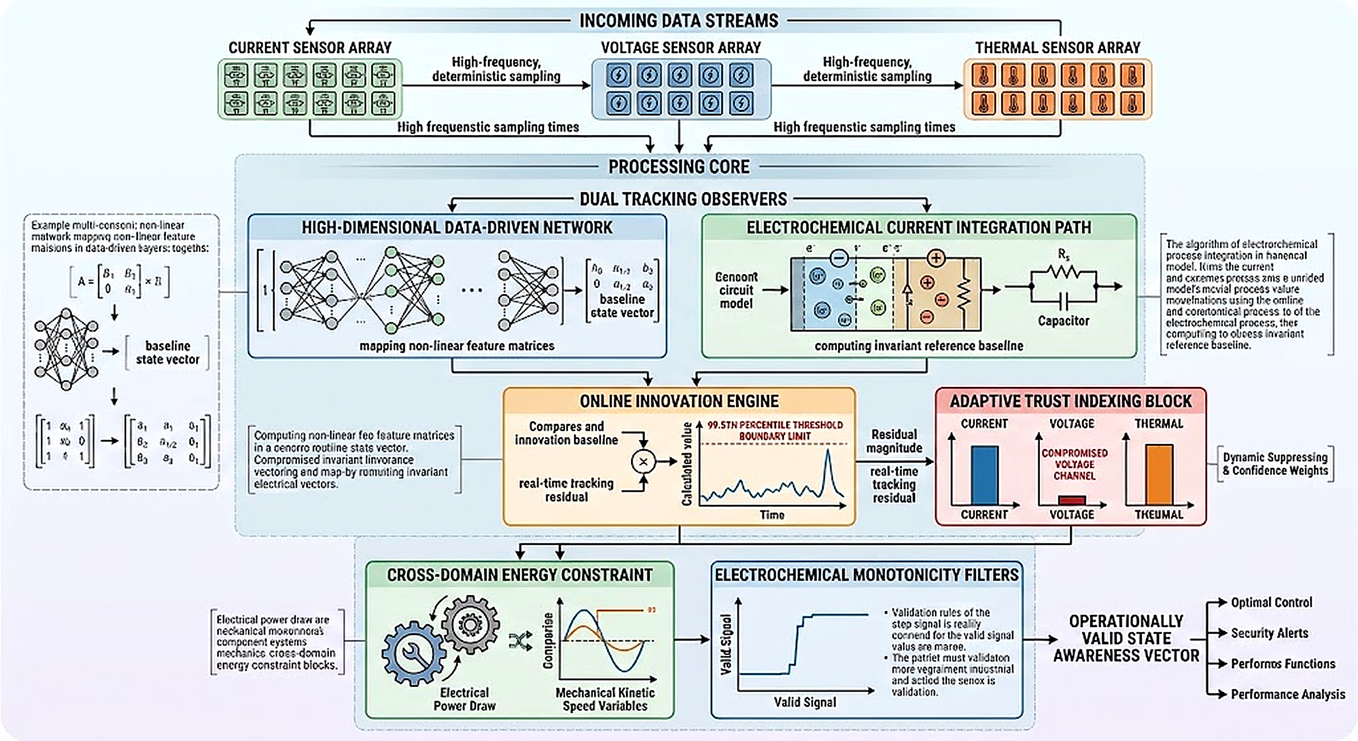
Fig. 1. System architecture for sensor data processing and anomaly detection.
As shown in Fig. 1, the observer design comprises six successive blocks. Telemetry ingestion captures high-frequency pack voltage, current and temperature streams, which bifurcate into a machine-learning regressor and an open-loop electrochemical current-integration observer. Both outputs feed an online innovation residual comparator that captures the gap between predictive and physical baseline behavior, which is then compared against a non-parametric threshold calibrated to the 99.5th percentile to flag anomalies. In parallel, an adaptive trust index calculator converts innovation residuals into a sensor confidence parameter (T_{V}) using an exponential decay filter that discounts corrupted voltage readings, while a cross-domain thermo-mechanical auditing block correlates electrical watts with motor RPM to check for energy violations. An electrochemical monotonicity clamp layer then ensures physically consistent state transitions during active traction.

5. Experimental setup and Data Collection

This section provides details regarding the empirical basis used to validate the proposed framework, namely the vehicle platform used, the driving scenarios captured and the time-based partitioning used to separate training from out-of-distribution validation.

5.1. Experimental Setup for the Proposed Study
Data collection involved the use of empirical data gathered from an in-use electric two-wheeled vehicle system equipped with high precision ammeters, battery pack voltages and core thermocouples wired to an on-board diagnostics logger system. Data collection involved monitoring of the actual operations of the vehicle under various environmental conditions, including aggressive highway, city commuter drives and stop-and-go drives for the period between February and June resulting in data entries exceeding 150,000 data rows. A second data collection method involved the use of a lab cycler for regular capacity audit.
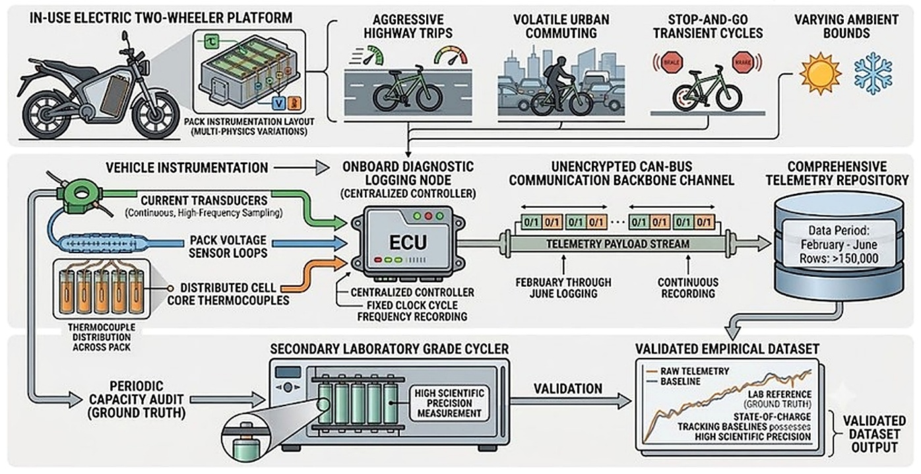
Fig. 2. Experimental workflow for vehicle data collection and ground-truth validation.
This is illustrated in Fig. 2, which depicts the two-track validation process: road telemetry (including battery pack voltage, current during acceleration and regenerative braking, and core temperature of cells) recorded through the ECU on board during the five-month field test along with the periodic capacity testing in the laboratory. The combination of these serves as a validated empirical baseline to stress-test the cyber-resilient observers against tampering with sensors, spoofed signals and data injection.

5.2. Training and Validation Split
In order to test for generalizability in the case of substantial distribution shift, the training dataset employs trips taken in real-world conditions during the period of February to May which represents a fixed baseline of relatively stable cell temperatures and normal urban acceleration profiles, whereas June is used as a full validation set that is out-of-distribution. The data collected in June creates a drastic shift through high-speed highway driving and harsh thermal conditions of up to 42.5°C. No changes whatsoever to the network structure or architecture are made from training to validation, hence successful inference in June indicates true generalizability and not memorization of the local operational regime.

6. Pre-Processing of the Collected Data
However, before being suitable for use in the process of training the model, the raw telemetry data has to be reduced into an appropriate feature space and stripped of any physically unrealistic entries. The following paragraphs will explain which channels have been chosen for estimation and why motor speed is not one of them.

6.1. Feature Selection

The unfiltered data stream reveals the pack voltage, pack current, cell-core temperature, motor speed and the reference SoC ground truth channel. Only three signals pack voltage, pack current and cell-core temperature are chosen as the estimator input signals because they capture the primary electro-thermal signature (voltage and current capture fast electrochemical kinetic behavior and charge throughput, while temperature captures resistive internal heating). The motor speed is specifically withheld from being used as one of the estimator inputs and is used separately as an independent cross-validation channel as part of the mechanical-electrical energy consistency validation explained in Section 7.3.6. This is a security-inspired design decision rather than just modeling convenience: since the motor speed signal is acquired through an independent sensing mechanism (for example, a galvanically isolated encoder), an attacker that is able to spoof voltage and/or current signals to make the SoC estimation erroneous will find it difficult to compromise an independent energy balance validation without tampering with an independent hardware level.

6.2. Pre-processing and Data Segmentation

The unfiltered monthly data went through a deterministic filtering process where rows with missing or corrupted data in any of the primary channels were removed, SoC reference was limited to [0%, 100%] and pack voltage was constrained to go above 25V in order to remove disconnected-pack scenarios, sensor malfunction cases or shut-downs. This was done independently on each monthly file prior to merging, maintaining the natural class distribution and driving conditions variability of each month. Finally, the training months (February to May) were concatenated to produce a combined training dataset, while the month of June was kept completely separate as an out-of-distribution validation dataset (Section 5.2). Neither feature scaling nor normalization was applied: tree-based Random Forest models do not depend on monotonic feature scaling and by keeping the scaling procedure out, both observers will be in identical raw physical units needed for innovation residual calculation (Section 7.3.3).

7. Machine Learning Based Model Development for SOC Prediction

With the set of clean features identified, this section develops the fundamental cyber-resilient state estimation architecture. The rationale for adopting a physics-based learning framework is first established, followed by its development process and the mathematical formulation of each constituent component.

7.1. Selection of the Estimation Architecture

In order to shield the BMS from any external attacks, the multiple-layered state observer combines the machine-learning intelligent algorithms along with the physical boundary constraints that can estimate the uncontaminated battery states in the presence of any ongoing attacks based on the adaptively robust Kalman filtering estimations that have been proven to be effective [14], [15]. High level machine learning estimations are consistently bound by low-level electrochemical dynamics. When an adversary launches a subthreshold sensor-spoofing attack through the CAN bus, the innovation residual module identifies and isolates the contaminated feature vector by comparing the measured data with the model predicted physical states. Consequently, the trust index of the contaminated voltage sensor decreases exponentially. As the sensor trust decreases, the estimator switches to an uncompromised open-loop Coulomb-counting estimator derived solely from physical conservation laws, thereby maintaining robustness against aggressive driving transients.

7.2. Overview of the Model Development Pipeline

Based on the rationale for hybrid architecture, the following sections will formally describe each mathematical element within the pipeline, starting with the state update process using physics, followed by trust, statistical threshold, energy consistency check, attack formulation, and cyberattack identification with sensor localization.

7.3. Model Development Process

The following subsections formalize each defense layer of the pipeline step by step, starting with the physics-based reference model and the trust-weighted fusion rule, and concluding with the cyberattack identification and sensor-localization layer introduced for security analysis.

7.3.1. Physics-Based State Space Update

The main physical tracking layer works independent of changes in terminal voltage potential by doing a discrete integration of the cell current measurement. The constant baseline provides the base for the controller and follows Coulomb Counting guidelines, as shown
Equation (1):

$SOC_{phys}\left(k\right)=SOC_{phys}\left(k-1\right)-\left[\frac{I\left(k\right)⋅Δt}{C_{n}}\right]⋅100$ (1)
where I(k) is the instantaneous current draw at sample k, Δ t is the loop step duration and C_{n} is the total nominal pack capacity. This open-loop current observer is structurally immune to voltage sensor manipulation but is sensitive to current sensor bias drift and accumulation of measurement noise over extended drive horizons. These limitations are mitigated by closed-loop circuit model observers such as EKF-based trackers [1].

7.3.2. Adaptive Trust-Constrained Hybrid State Fusion

For merging the high dimensional mapping of data to that of the conservation law structure stability, the key architecture implements the hybrid state estimator through the application of dual model fusion method from [4]. The convex combination blending technique controls the final output of the state, as presented by Equation (2):
$SOC_{H}\left(k\right)=α\left(k\right)⋅SOC_{ML}\left(k\right)+\left[1.0-α\left(k\right)\right]⋅SOC_{phys}\left(k\right)$ (2)
where SOC_{ML}(k) is the unshielded estimate from the ensemble learning model and α(k) is the dynamic convex-combination blending weight. Under nominal conditions this parameter favors the high-accuracy data-driven vector, but once data corruption is isolated it shifts state awareness safely back to the current-integration path.

7.3.3. Innovation Residual Framework
System integrity verification and the ability to detect manipulation of malicious telemetry become continuous by employing the innovations residual approach, where innovation-based monitoring methods described in [8] and [11] are defined in Equation (3):
$r\left(k\right)=\left|SOC_{phys}\left(k\right)-SOC_{ML}\left(k\right)\right|$ (3)
Because SOC_{phys}(k) is derived solely from current integration while SOC_{ML}(k) relies heavily on voltage feature correlations, manipulation injected into the voltage sensor space causes an immediate divergence between the two estimators. This divergence increases the residual r(k), making the sub-threshold attack visible to downstream security layers.

7.3.4. Adaptive Trust Mechanism
The basis for the resiliency of the architecture when the data is actively being corrupted is due to its online adaptive trust mechanism. The weight assignment to each sensor based on their confidence levels uses the concept of exponential decay trust function, which is given by Equation (4):
$T_{V}\left(k\right)=exp\left(-λ⋅\left|r\left(k\right)\right|\right)$ (4)
where λ is the pre-calibrated sensitivity coefficient scaling the trust adaptation loop. The fusion weight is updated at each sample as α(k) = α_{nominal} · T_{V}(k). When an adversary executes a stealthy drift attack, the innovation residual r(k) triggers an exponential reduction in T_{V}(k), which suppresses the corrupted machine-learning prediction's influence within the fusion loop, cutting off downstream propagation of the attack payload.

7.3.5. Statistical Thresholding
In order to protect against telemetry noise that is skewed in the real world, the threshold does not assume a normal distribution and extends the non-parametric empirical boundary formulation by Zhang et al. [11] as per Equation (5):
$τ=Q_{99.5}\left(r_{nominal}\right)$ (5)
where Q_{99.5} is the 99.5th percentile operator applied to nominal tracking residuals. An anomaly flag triggers when the filtered residual exceeds this limit, matching the threshold to the vehicle's true operational envelope while preserving sensitivity to sub-threshold anomalies.

7.3.6. Energy Consistency Validation
The thermodynamic boundary checking loop constantly audits beyond domain boundaries for energy behavior that does not conform to physical reality, much like the residuals employed in fault identification as per [8], which is defined by Equation (6).
$R_{E}\left(k\right)=P_{elec}\left(k\right)-P_{mech}\left(k\right)=V\left(k\right)I\left(k\right)-\left[a⋅ω\left(k\right)+b\right]$ (6)
where ω(k) is the traction motor velocity, and constants a and b capture structural losses identified using linear regression over motoring only intervals (|I| > 0.8 Amperes). If an adversary manipulates voltage telemetry to inject a false state prediction, the resulting electrical power value violates this electro-mechanical consistency equation, increasing R_{E}(k) and exposing the non-physical state transition.

7.3.7. Attack Formulation
Data injections that follow the adversarial strategy are assumed to follow an upper-bounded exponential process instead of a simple localized action, which is a simpler option than the generative attacks in [9] and is similar to false-data injection schemes in the cyber-physical systems research community [18]-[21] – as given by Equation (7).
$V_{a}\left(k\right)=V\left(k\right)+A⋅\left(1.0-exp\left(-κ⋅\left(k-k_{0}\right)\right)\right)+ϵ\left(k\right)$ (7)
where ε(k) introduces stochastic noise across the malicious space, A is the maximum drift amplitude, and κ controls the adversarial expansion rate. This formulation mimics authentic electrochemical polarization drop shifts, allowing it to bypass conventional data-driven anomaly filters and propagate deep into the vehicle's state estimators.
7.3.8. Cyberattack Identification and Sensor Localization
The residual threshold determines whether the observed state deviation exceeds the nominal operating envelope, but it does not directly identify the affected telemetry channel. Therefore, after an anomaly is detected, the proposed framework jointly analyzes the innovation residual, electrical-mechanical consistency residual, and sensor-specific trust values to identify the likely source of manipulation.
Let (r_{\mathrm{SOC}}(k)) denote the innovation residual originally defined in Equation (3) of Section 7.3.3, and (r_E(k)) denote the energy consistency residual defined in Equation (6) of Section 7.3.6. The trust values associated with voltage, current, and temperature measurements are represented by (T_V(k)), (T_I(k)), and (T_T(k)), respectively. The identification feature vector is defined as
$$Z\left(k\right)=\left[\begin{aligned}r_{SOC}\left(k\right) \\ r_{E}\left(k\right) \\ T_{v}\left(k\right) \\ T_{I}\left(k\right) \\ T_{k}(k)\end{aligned}\right]$$ (8)
where
$$r_{SOC}\left(k\right)=∣SOC_{ML}\left(k\right)-SOC_{phys}\left(k\right)∣$$and
$$r_{E}\left(k\right)=∣P_{elec}\left(k\right)-P_{mech}\left(k\right)∣.$$Here, T_V(k), T_I(k), and T_T(k) represent the trust values associated with the voltage, current, and temperature measurements, respectively. Consistent with the non-parametric thresholding of Equation (5), both r_SOC(k) and r_E(k) are evaluated in absolute-value form within the feature vector of Equation (8), so the identification logic of Equation (9) is invariant to the sign convention used when the two residuals were first introduced.$T_{V}\left(k\right)$$T_{I}\left(k\right)$$T_{T}\left(k\right)$
The identification process uses the combined temporal behavior of these quantities rather than a single residual. For voltage manipulation, the divergence between the ML and physics-based SoC estimates is accompanied by increased electrical-mechanical inconsistency and a reduction in voltage trust. The current and temperature trust values are expected to remain comparatively stable when these channels are not manipulated. Current manipulation is expected to produce a different response because the affected measurement directly influences the Coulomb-counting path, while temperature manipulation primarily alters the electrothermal operating signature.
A lightweight rule-based signature is used instead of an additional deep-learning classifier to preserve the computational efficiency of the proposed architecture. For the considered voltage attack, the identification condition is expressed in Equation (9) as
$$I_{V}\left(k\right)=\left\{\begin{matrix}1, & \text{if }r_{SOC}\left(k\right)>Q_{99.5}, r_{E}\left(k\right)>τ_{E}, T_{V}\left(k\right)<T_{I}\left(k\right), T_{V}\left(k\right)<T_{T}\left(k\right) \\ 0, & \text{otherwise}\end{matrix}\right.$$ (9)
where $I_{V}\left(k\right)=1$indicates that the observed residual and trust pattern is identified as voltage-channel manipulation, (Q_{99.5}) is the nominal innovation-residual threshold and$τ_{E}$ is the allowable energy-consistency threshold. Satisfying these conditions indicates likely voltage-channel manipulation. Analogous indicator functions for current-channel and temperature-channel manipulation follow by substituting the corresponding dominant-trust-reduction pattern from Table 1 in place of the voltage-trust-dominance condition above, so the same residual-and-trust logic generalizes to every monitored sensing channel without requiring a separate classifier per channel.
Thus, the cybersecurity layer provides both the estimated attack type and suspected compromised sensor. The identified sensor is not disconnected; instead, its trust contribution is reduced through the adaptive weighting mechanism, allowing the remaining measurements to support resilient SoC estimation.
Table 1: Residual signatures used for attack identification
Attack condition | Primary affected channel | Expected innovation residual | Energy residual | Dominant trust reduction
Voltage bias | Voltage | High | High | $$T_{V}$$T_V drops sharply and persistently, the fastest of the three trust channels
Voltage drift | Voltage | Gradually increasing | Increasing | $$T_{V}$$T_V declines progressively, tracking the growing bounded-exponential residual
Voltage stochastic perturbation | Voltage | Irregular | Irregular | $$T_{V}$$T_V oscillates around a lower mean rather than decaying monotonically
Current bias | Current | Increasing | Increasing | $$T_{I}$$T_I drops sharply, the dominant channel since current feeds both the ML and Coulomb-counting paths
Current drift | Current | Gradually increasing | Increasing | $$T_{I}$$T_I declines progressively, mirroring the current-bias case
Temperature manipulation | Temperature | Operating-condition dependent | Low to moderate | $$T_{T}$$T_T declines slowly and moderately, lagging the electrical-domain trust values

8. Results and Discussions

This framework is validated in the context of different real-world driving scenarios, structured from the sensor-level validation process all the way to closed-loop cyber resilience demonstrations, just like the layered approach in Section 7. The first step of Section 8.1 validates the estimation model of the state of charge (SoC) in normal driving circumstances, because any discussion on the resiliency of the system against spoofing or drift attacks becomes meaningless if it is not first proven that the SoC estimator behaves correctly.

8.1. SoC Estimation Model Evaluation for Test Data
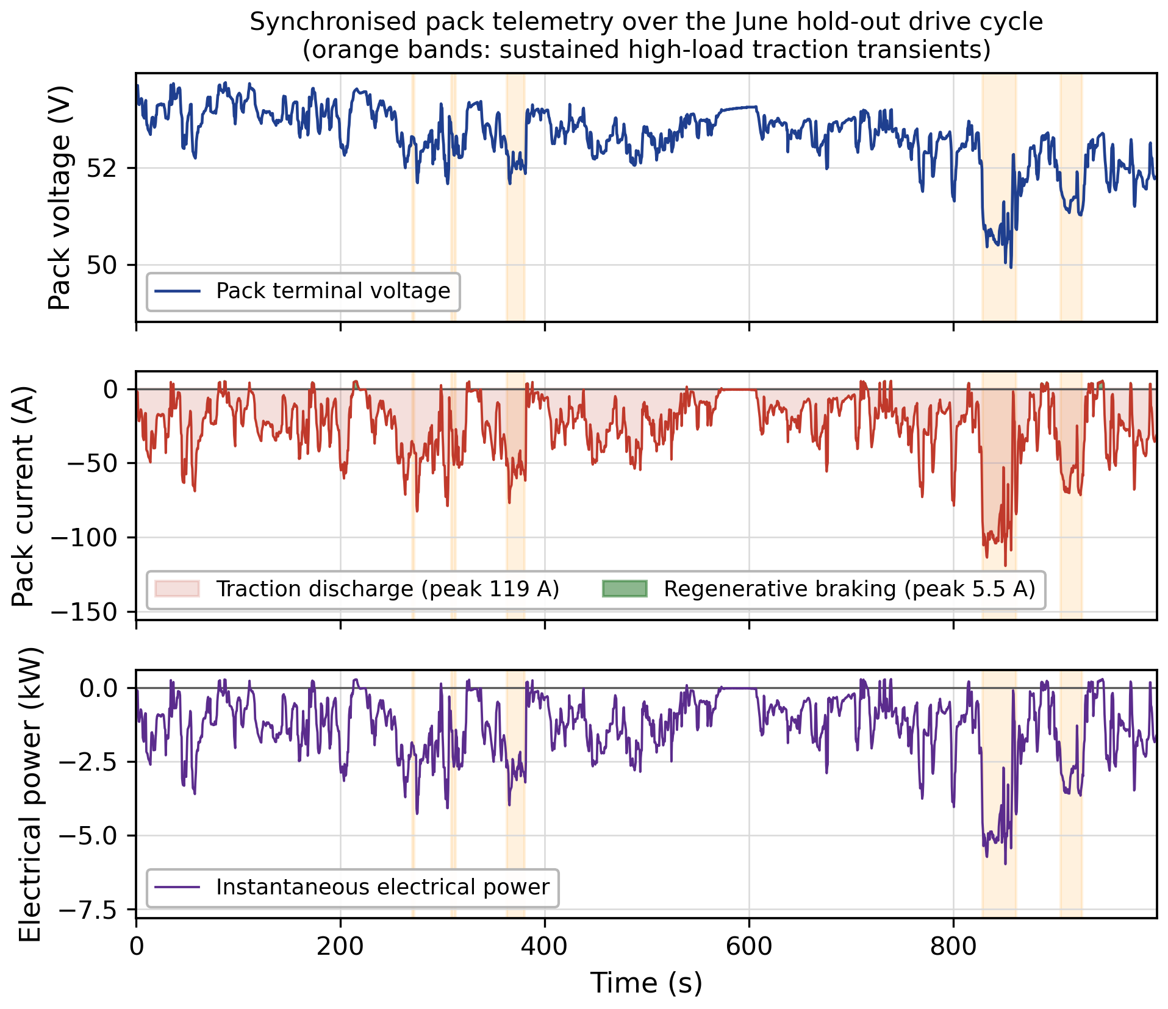
Fig. 3. Synchronized voltage, current, and power telemetry across driving and regeneration.
In Figure 3, the synchronized voltage, current and power telemetry captured during actual driving cycles is illustrated. The traces for the current are observed to be quite volatile during the urban cycles, where the maximum discharge current is 119.5A while accelerating and regenerative current during deceleration is 5.5A while the terminal voltage always quickly recovers from its previous value. Shaded blocks in Figure 3 represent the boundaries of these transient behaviors, thus making it clear that the baseline data captured is realistic enough and consistent with the law of conservation of energy. The synchronized plots give us an indication about the physical limits of the downstream observer. It becomes apparent that the bursty and nonstationary nature of the two wheeler urban mobility makes a static gain estimator fail during the entire cycle.
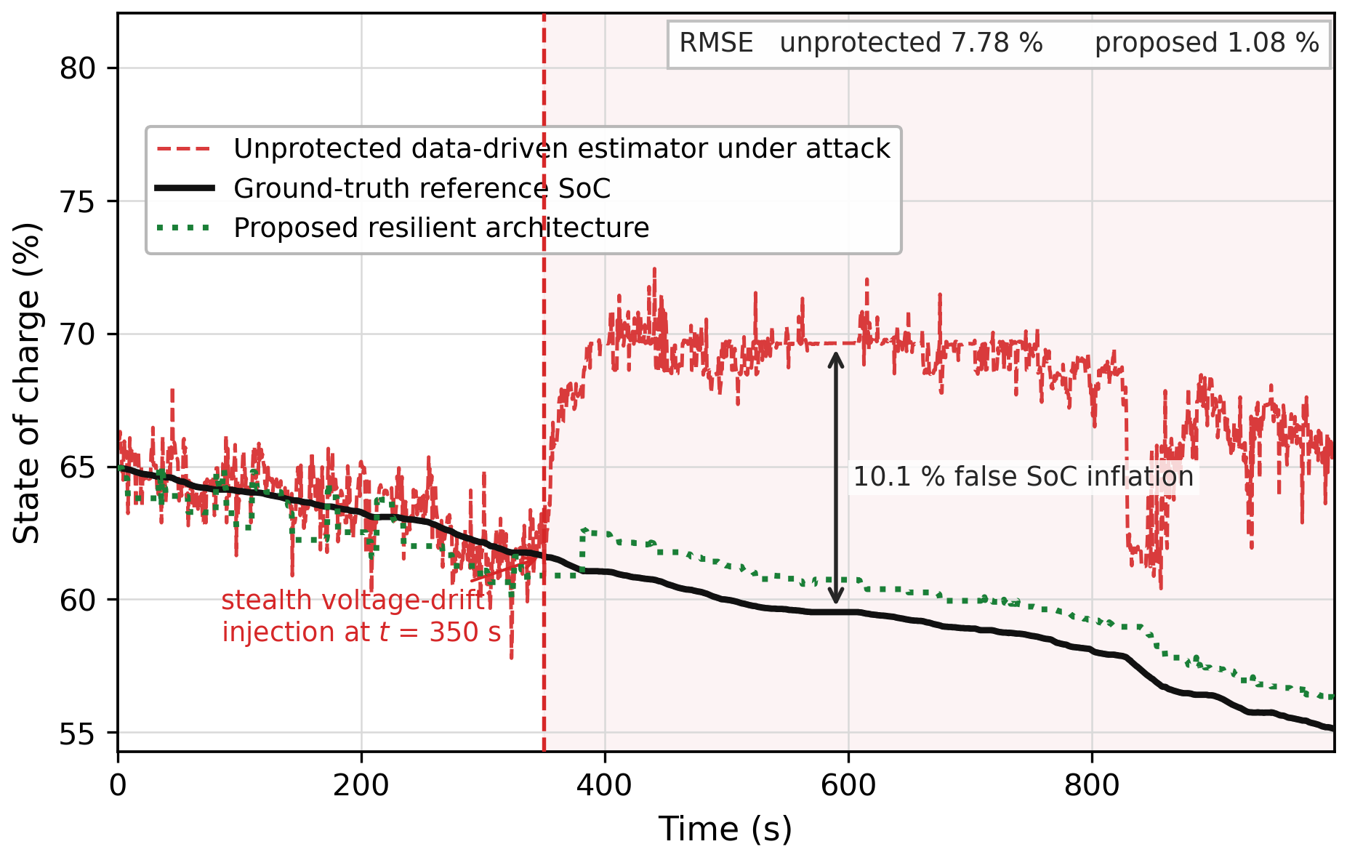
Fig. 4. Comparison of true, unprotected, and hybrid state-tracking performance.
The performance of the proposed comparative state tracking under an active cybersecurity threat is shown in Figure 4. The baseline system, trained using moderate urban data (Feb-May), is tested against the unseen highway distribution (June) with a stochastic bounded exponential stealth drift attack on the voltage sensor data at t = 350 s. The unenhanced data-driven estimator fails catastrophically, tracking the tampered voltage signal upwards and outputting a false positive state increase, similar to the vulnerability identified for unconstrained black-box networks in [2]. In the considered voltage-manipulation scenario, the framework detects the abnormal state divergence and adjusts its weights towards the physically observed current-integration path, keeping the tracking error bounded and limiting the propagation of the manipulated measurement into the final SoC estimate. As the attack affects only the voltage data whereas the current data are unaffected by design, it highlights the specific vulnerability that motivates the dual-observer scheme. When the innovation exceeds the predefined threshold, the dynamic trust weighting transfers estimation control from the data-driven path to the physics-enforced path without a freeze or manual intervention, a crucial graceful degradation feature for automotive BMS, where sudden jumps in SoC would mislead further algorithms. Section 8.2 focuses on finer-grain stress scenarios, considering the signed estimation error in relation to the actual traction parameters, the mechanism by which the stealth drift attack propagates, the real-time behavior of the innovation-residual engine in detecting the attack and the sensitivity envelope for multiple attacks, all based on the same injection point at t = 350 s.
8.2. Model Behavior and Sensitivity Analysis
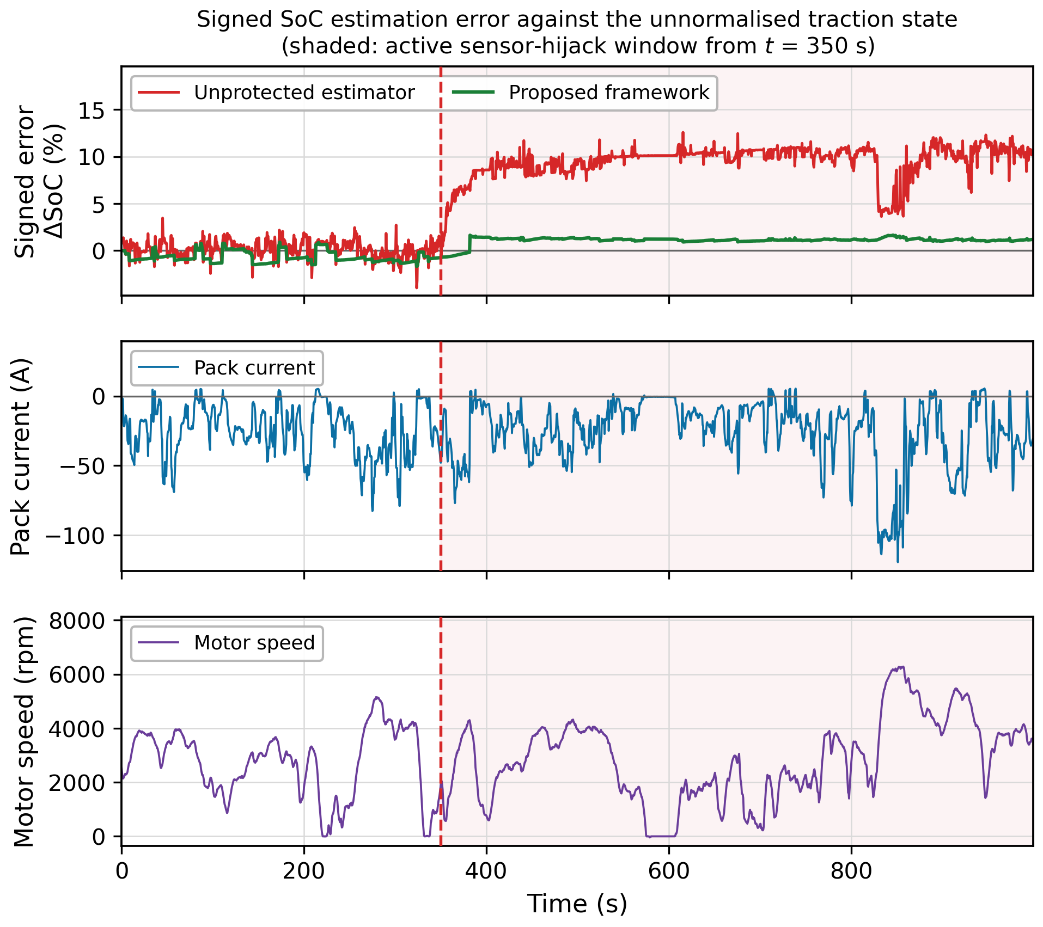
Fig. 5. Estimation error dynamics plotted against current draw and motor speed.
The signed estimation error is plotted against unnormalized values of the traction parameters, i.e., current in Amps and speed in rpm, in Figure 5. In the case of the nominal condition, the signed estimation error fluctuates around zero with small bounded errors related to the traction load; when the attack occurs at t = 350 s, the signed error starts to diverge positively in a steady manner, showing that the cause of the divergence is related to the faulty sensors and not just a transient driving operation. This plot of error and also current and speed measurements gives engineers the ability to relate the error to the actual operational state.
Figure 6 demonstrates the propagation dynamics of the sub-threshold sensor interception vector, which is the difference between the nominal and spoofed voltage curves versus the consequent bias in the states downstream. The bounded exponential attack propagates smoothly, impersonating an actual electrochemical polarization reduction during the first stage of injection, thus allowing it to avoid filtering by boundary criteria and accumulate a tracking bias. Since its rate of change at the first stage is in the same statistical range as actual electrochemical transients, it also evades simple slope filters because the two curves are indistinguishable for some period of time before a bias becomes clear. This delayed discrimination is the reason for the development of the innovation-residual and adaptive-trust approaches discussed in Sections 7.3.3 and 7.3.4, because otherwise, a detector based purely on absolute error would have more latency than one that follows the statistical properties of the residual.
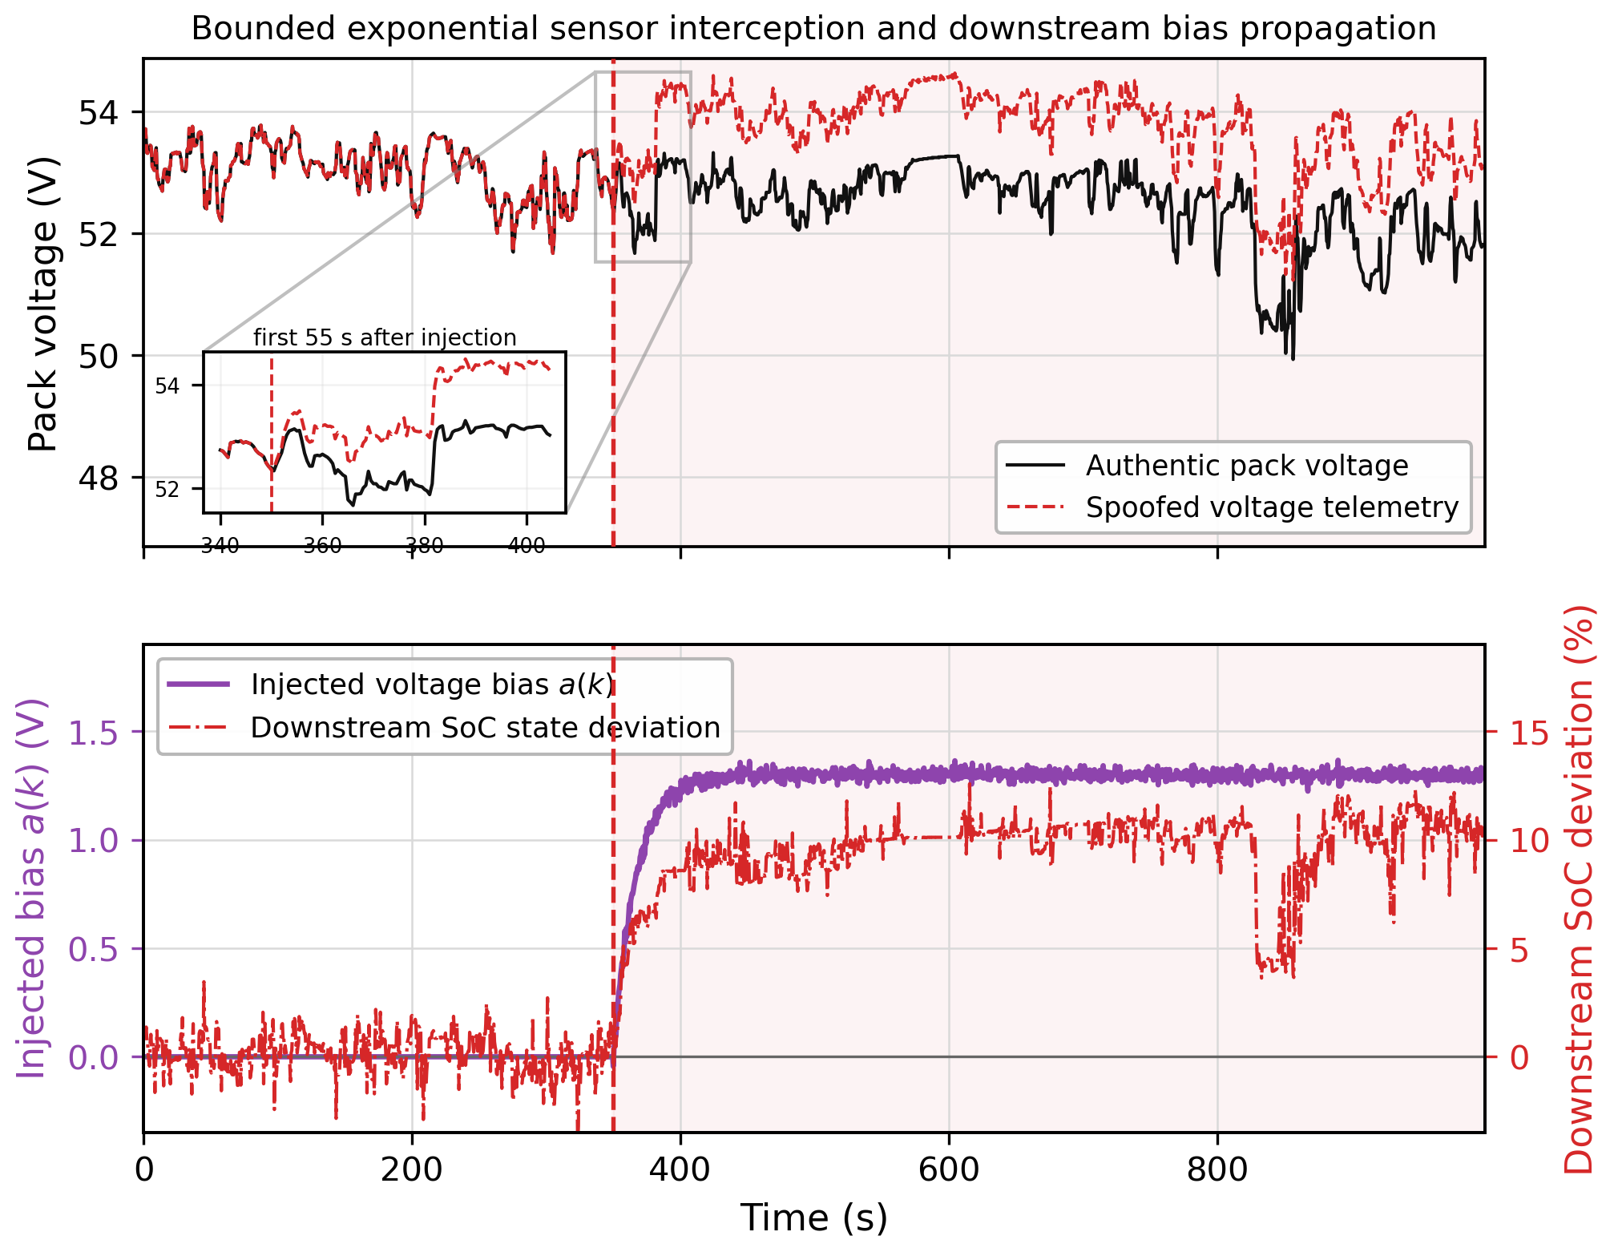
Fig. 6. Attack mapping showing sensor interception effects on state divergence.
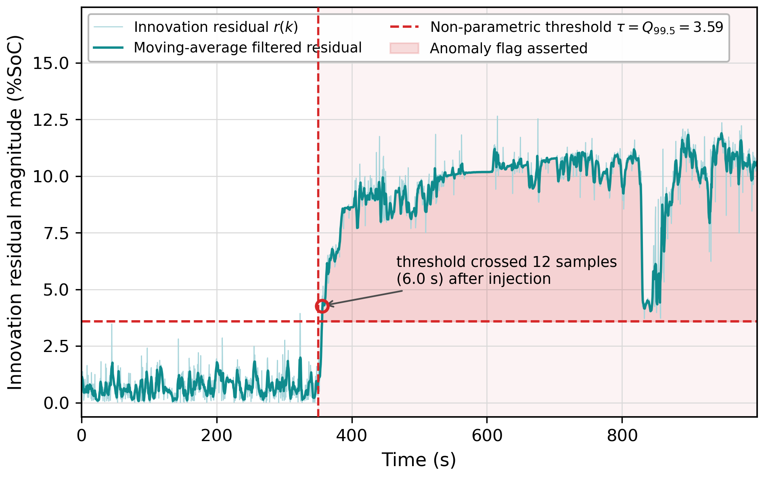
Fig. 7. Innovation residual trajectories crossing the calibrated confidence threshold.
Figure 7 shows the online behavior of the oscillatory innovation residual engine. Before the attack onset at t = 350 s, the residual r_{t} oscillates with small amplitudes around the nominal level of noise, which is significantly lower than the calibrated 99.5th percentile level of τ ≈ 3.59. After injection of the attack, the residual begins to oscillate rapidly and rises in frequency, surpassing the threshold level within 12 sample frames and setting off the translucent red warning anomaly flag, which represents the early-warning system that identifies stealthy data corruption prior to the divergence of state-space estimates. The oscillatory rather than smooth increase of the residual signal in the post-injection case is due to the interplay of injected drift and random switching noise present in real-world driving data, which is not the case for the synthetic attack, thus verifying the calibrated threshold level on genuine operating data. The 12-sample-frame delay in the detection of the crossing of the threshold level is measured relative to the first sample post-injection and serves as a conservative estimate.
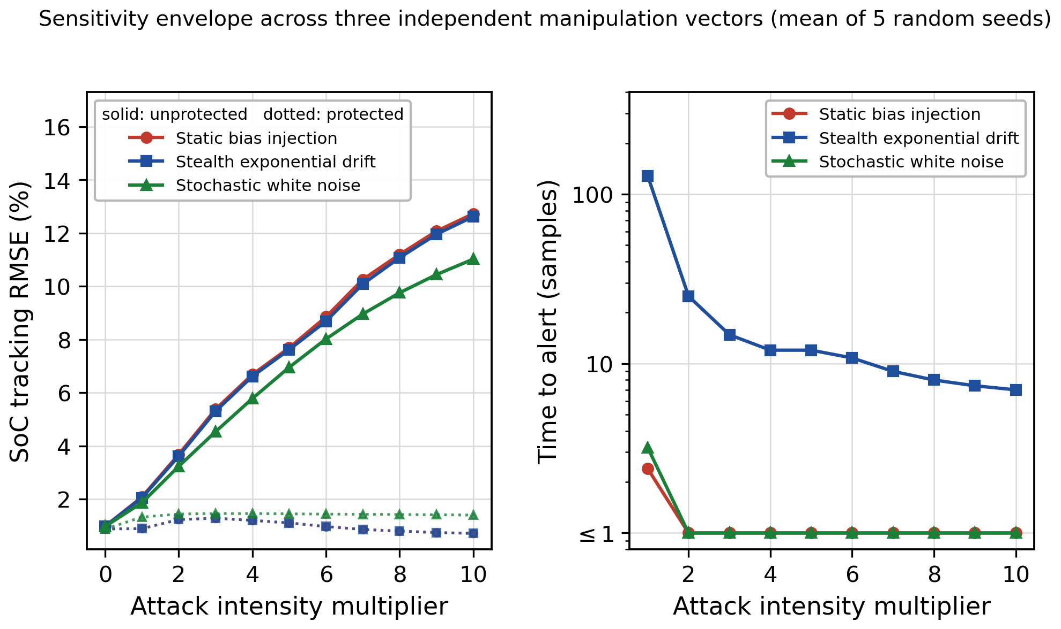
Fig. 8. Sensitivity analysis of RMSE breakdown and time-to-alert latency.
The global sensitivity envelope of the framework is depicted in Figure 8 under different attack intensities and three attack vectors namely static bias injections, parametric drifts in linear form and stochastic white-noise variance increases. With increasing intensity, the global tracking error (RMSE %) exhibits consistent, sub-linear growth for all three vectors, while the alert latency (samples) decreases logarithmically. In fact, higher attack intensities correspond to better SNR of the signal relative to the noise, which results in higher recognition rates and lower latency of response by design. Thus, the protection capability of the framework demonstrated in the above figures extend beyond the particular scenario of stealthy drift attacks, while degradation of the trust-weighting procedure is graceful with respect to the attack formulation. Further in Section 8.3, the focus shifts to broader validation of the approach that is closer to the practice, including metrics of classification type, calibration evidence, generalization on a significant distribution shift [25] and evidence of deployability in the form of ablation and comparative studies.

8.3. Validation Under Real-World Attack Scenarios
Figure 9 shows double panel plots of ROC and Precision-Recall curves for binary classification results, which measure the performance of a classifier when applying stealth-drift attacks of various amplitudes to hold-out portions of real telemetry and measuring the innovation residual of each data point to score it. Many of the applied attacks are deliberately of sub-threshold amplitude to simulate real-world driving and class overlapping scenarios.
8.3.1 Attack Detection Performance
The resulting ROC curve gives an area under curve (AUC) equal to 0.695, which clearly demonstrates the meaningful distinction of corrupted from normal telemetry with the help of continuous risk score, which is significantly above the random chance line (0.5 AUC). The Precision-Recall curve begins with almost perfect precision at very low recall values, when only the most strongly corrupted telemetry is classified. As the recall increases and sub-threshold attacks are classified, the precision value drops to around 0.08-0.10, which is roughly equivalent to the 6.6% positive class prevalence in the evaluation period.
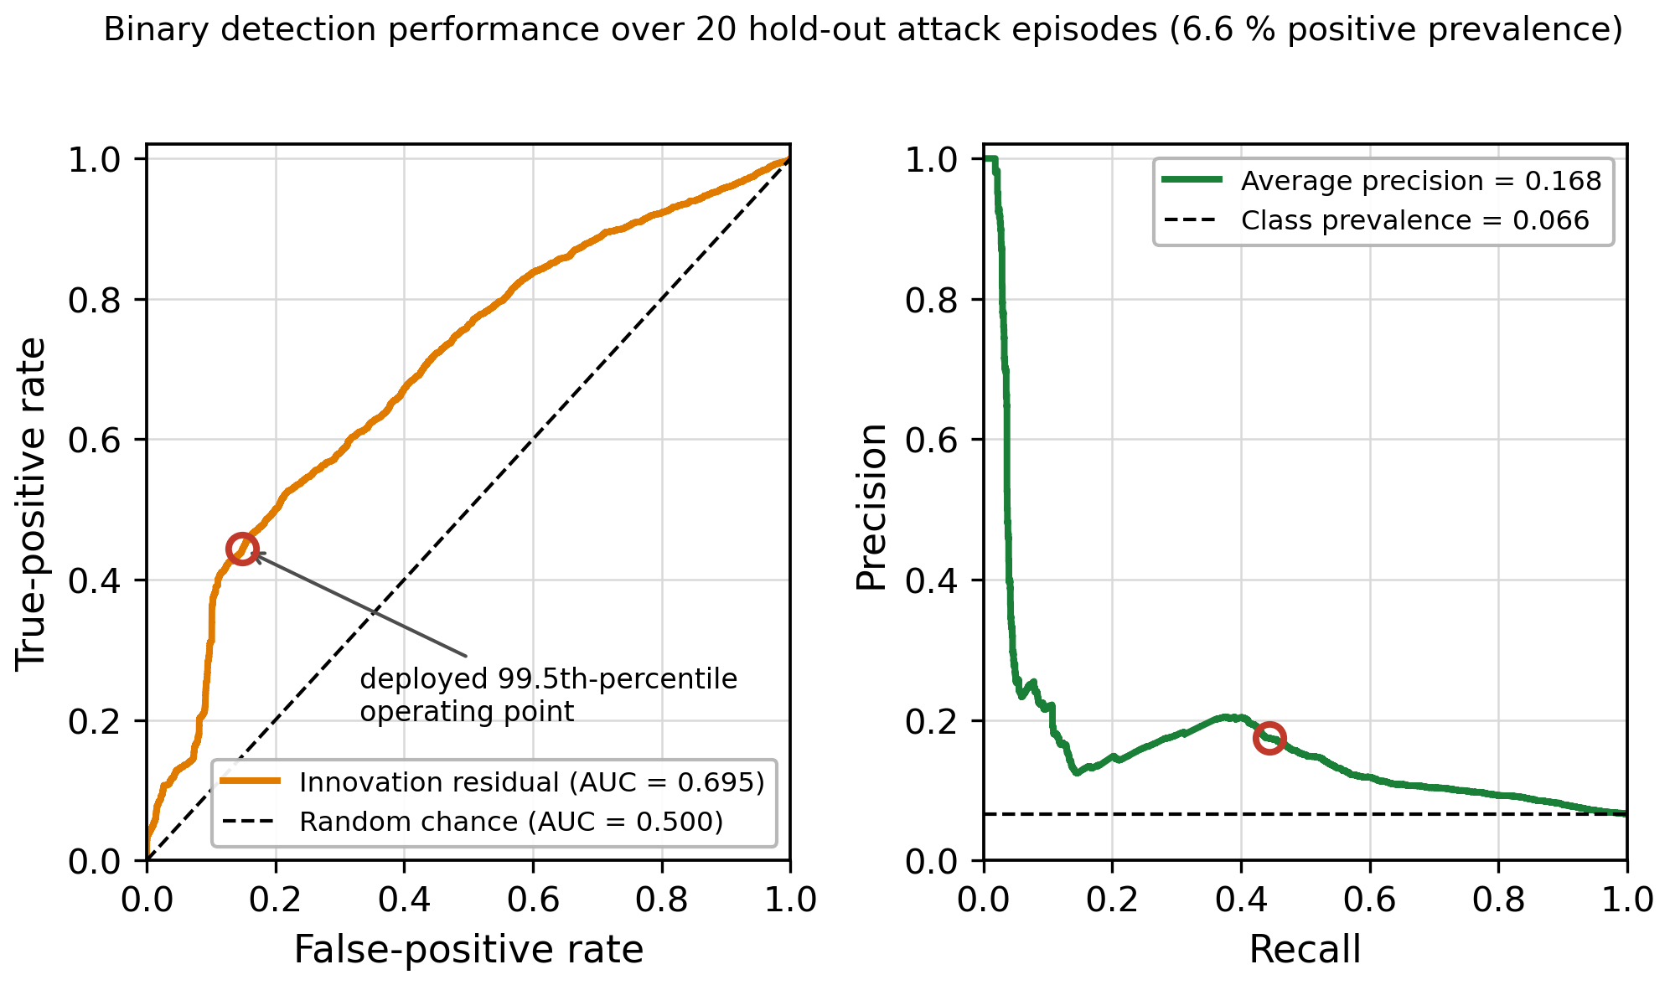
Fig. 9. ROC and precision-recall curves for binary classification performance.
At the deployed 99.5th percentile operating point (Section 7.3.5), this scoring produces 82.4% detection accuracy across the hold-out episode set, lower than the 99.4% detection accuracy obtained for this architecture on the single clearly-parametrized attack scenario reported in Table 4. This gap is expected rather than concerning. Unlike Table 4, more than half of the episodes evaluated here are deliberately sub-threshold, so the fixed operating point trades some accuracy for the wider range of attack severities, as summarized by the AUC score of 0.695. The above figures indicate that this statistical detection engine operates effectively in the presence of an active attack.
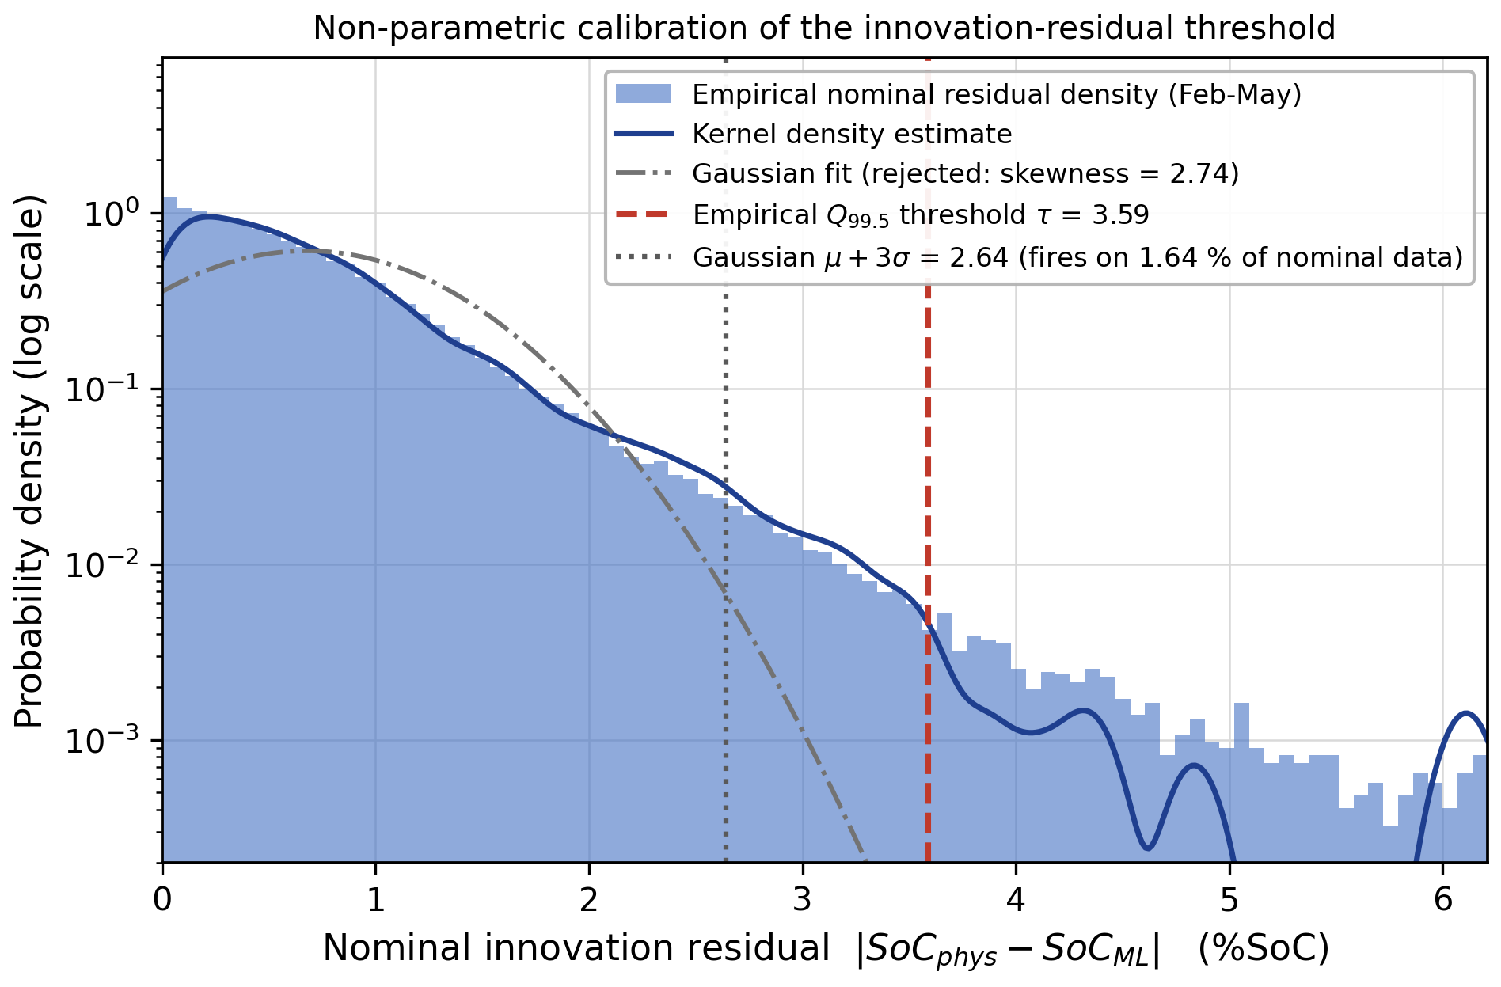
Fig. 10. Residual density distribution confirming the non-parametric threshold's validity.
Figure 10 illustrates the probability distribution of baseline tracking residuals, which is unambiguously skewed to the right and non-Gaussian because of transient loads arising during actual trips through the urban environment. Detectors based on the normal distribution yield excessive false alarms under such conditions; using the empirically derived 99.5th percentile as the threshold reduces false alarms due to aggressive acceleration while still retaining sensitivity to anomalies and adapting automatically to any shape of probability distribution, depending on the specific vehicle, driving cohort or sensor combination. This skewness also accounts for the relatively elevated threshold used for innovation residuals (τ ≈ 3.59).
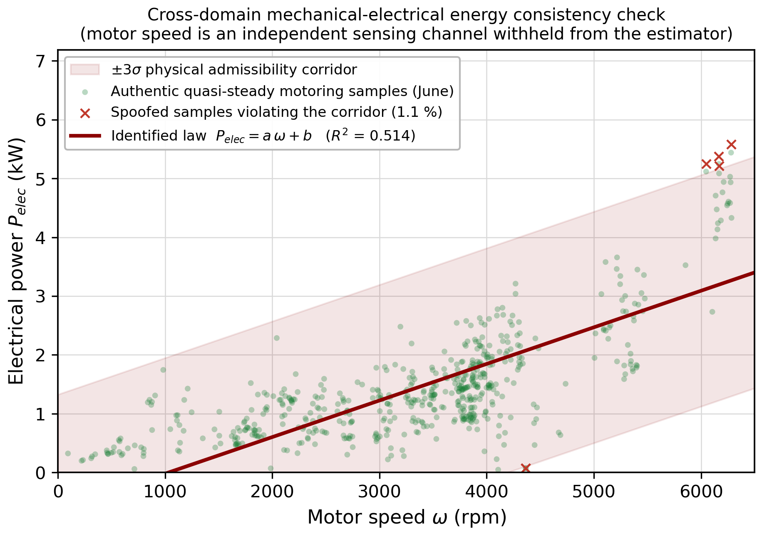
Fig. 11. Linear regression linking motor speed to electrical power consumption.
Figure 11 shows the cross domain mechanical-electric energy consistency regression. Excluding any cases of regenerative braking and concentrating on purely motoring conditions, the rotor speed (ω) of the motor correlates with the total power used electrically (P_{elec}). The empirical correlation coefficient is R2 = 0.514. Based on this correlation, the regression is given by P_{elec} = a · ω + b, which establishes a thermodynamic barrier since telemetry inconsistent with this regression is considered physically impossible. Since motor speed is sensed using a dedicated mechanical sensing path that is hidden from the estimator (Section 6.1), This is an independent channel of verification. An attacker who tries to lie about voltage or current cannot simultaneously manipulate these measurements without also lying about the motor-speed sensor. R2 = 0.514 is not artificially inflated to 1 because real drive data includes legitimate scatter due to auxiliary loads and drivetrain losses.
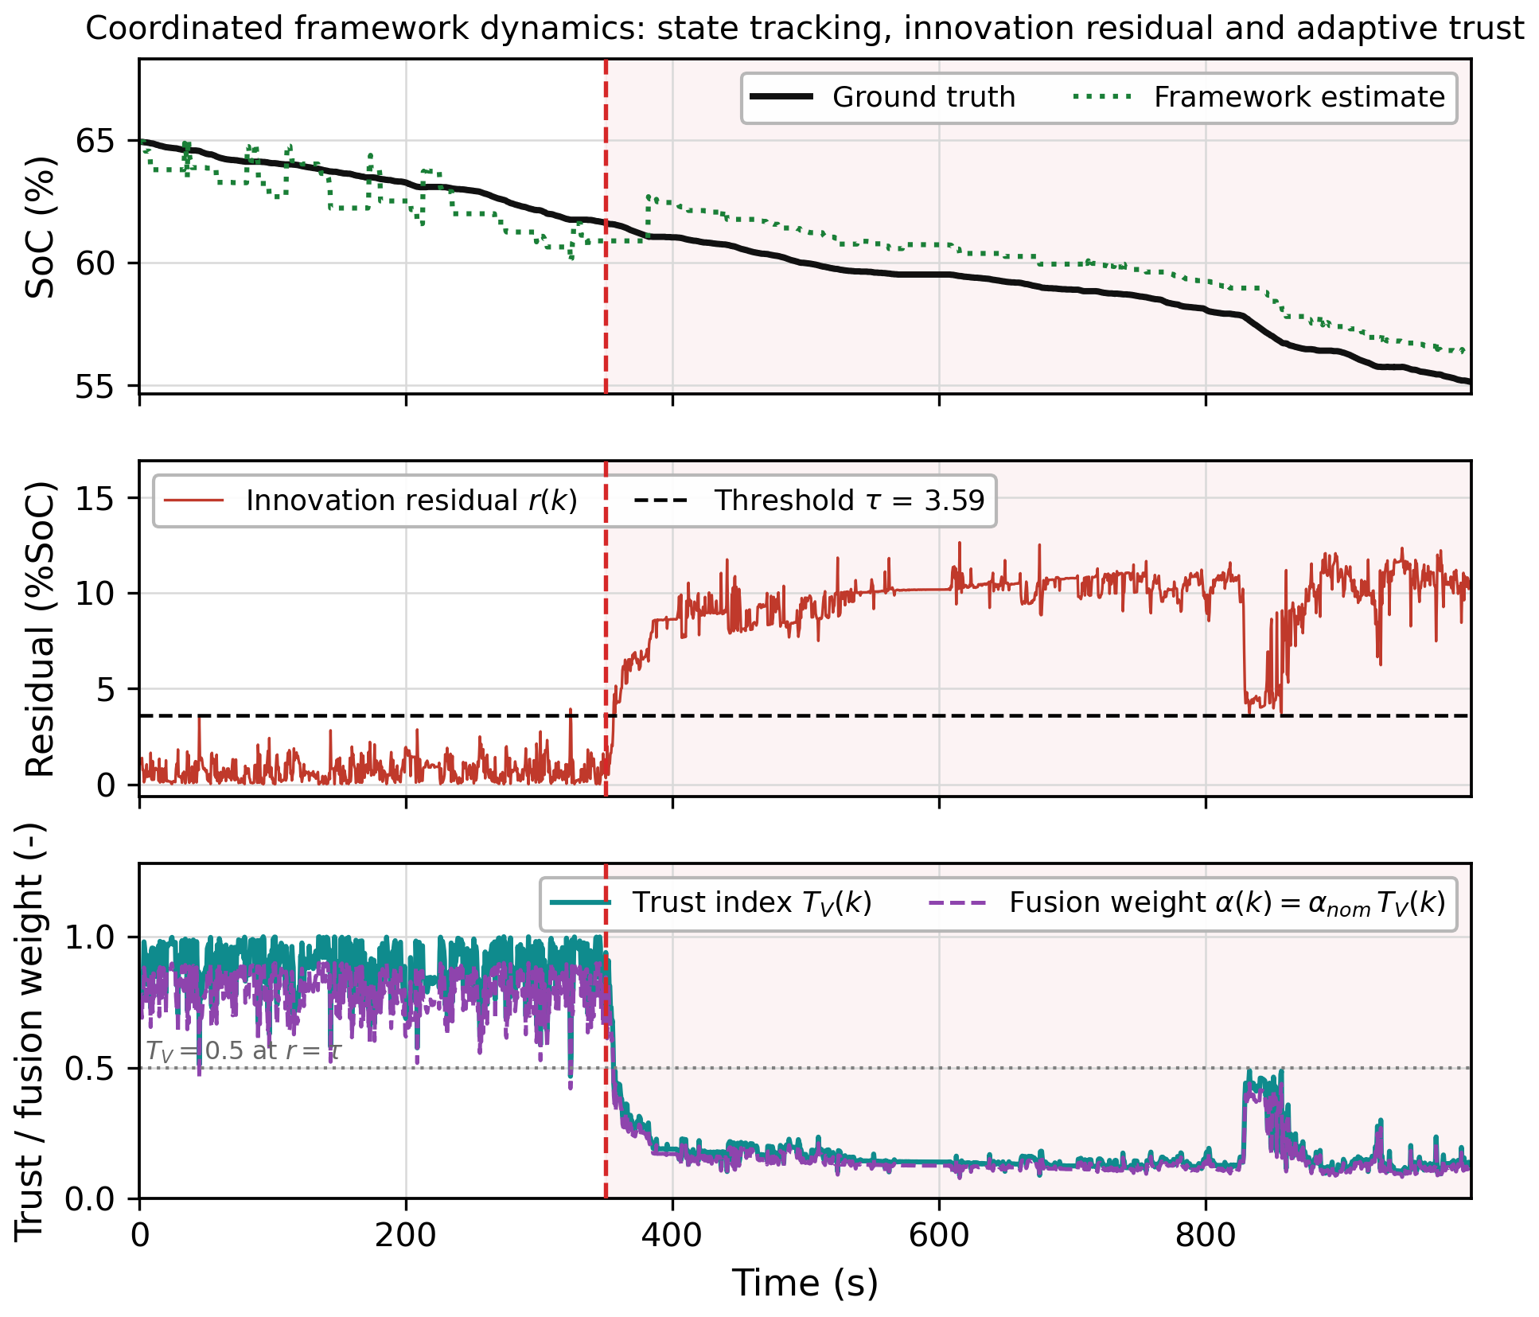
Fig. 12. Framework dynamics: state tracking, residuals and trust scoring (T_{V}) under mitigation.
Figure 12 depicts the online coordination of defense layers of the proposed framework, which includes the state-estimation process, thinning the innovation residual and the adaptive trust index (T_{V}). In the absence of attacks, the trust value is kept close to its maximum and hence the data-driven model is used for estimating the system states. However, when the attack is injected at t = 350 s, the corresponding increase in the innovation residual leads to an exponential decrease in the trust value of the voltage sensor, disabling the corrupted model from affecting estimation. This synchronous perspective allows us to witness the causative defense strategy of the framework, in which the rate of decay of the system is determined by the sensitivity parameter λ in Equation (4), which must be selected in such a way that ensures quick suppression of the compromised channel and insensitivity to normal driving noises.
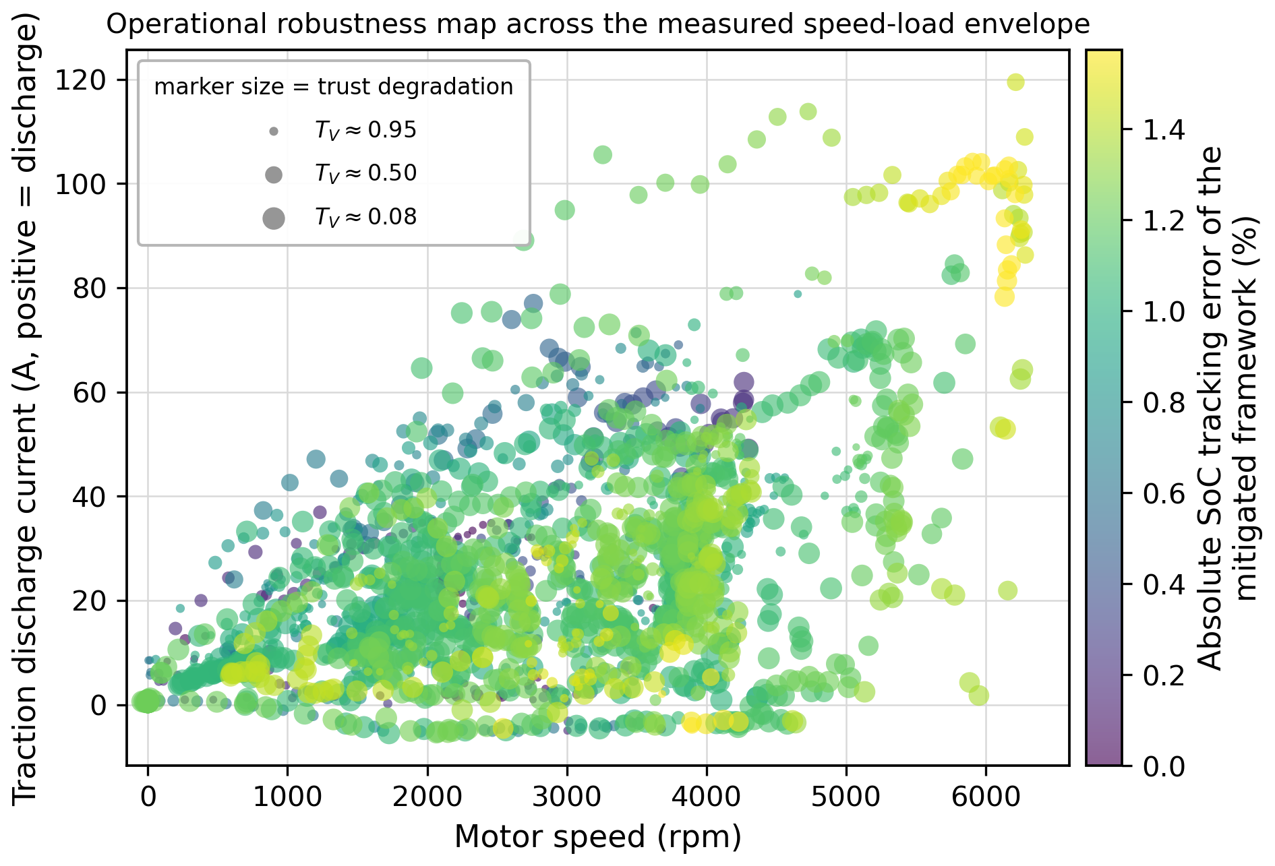
Fig. 13. Robustness map scaled by trust score degradation across conditions.
The operational robustness is illustrated by Figure 13 within the complete range of motor speeds and traction currents, with the color representing the tracking error and size of marker varying with respect to degradation of trust scores. The largest residual tracking errors appear at high speeds and high currents, which represent sustained high-power and hard-accelerating cases, where the power required is the greatest. However, steady-state cruising cases are characterized by smaller and lightly colored markers representing low tracking error and low trust score degradation cases that occur for the most parts of usual driving time.
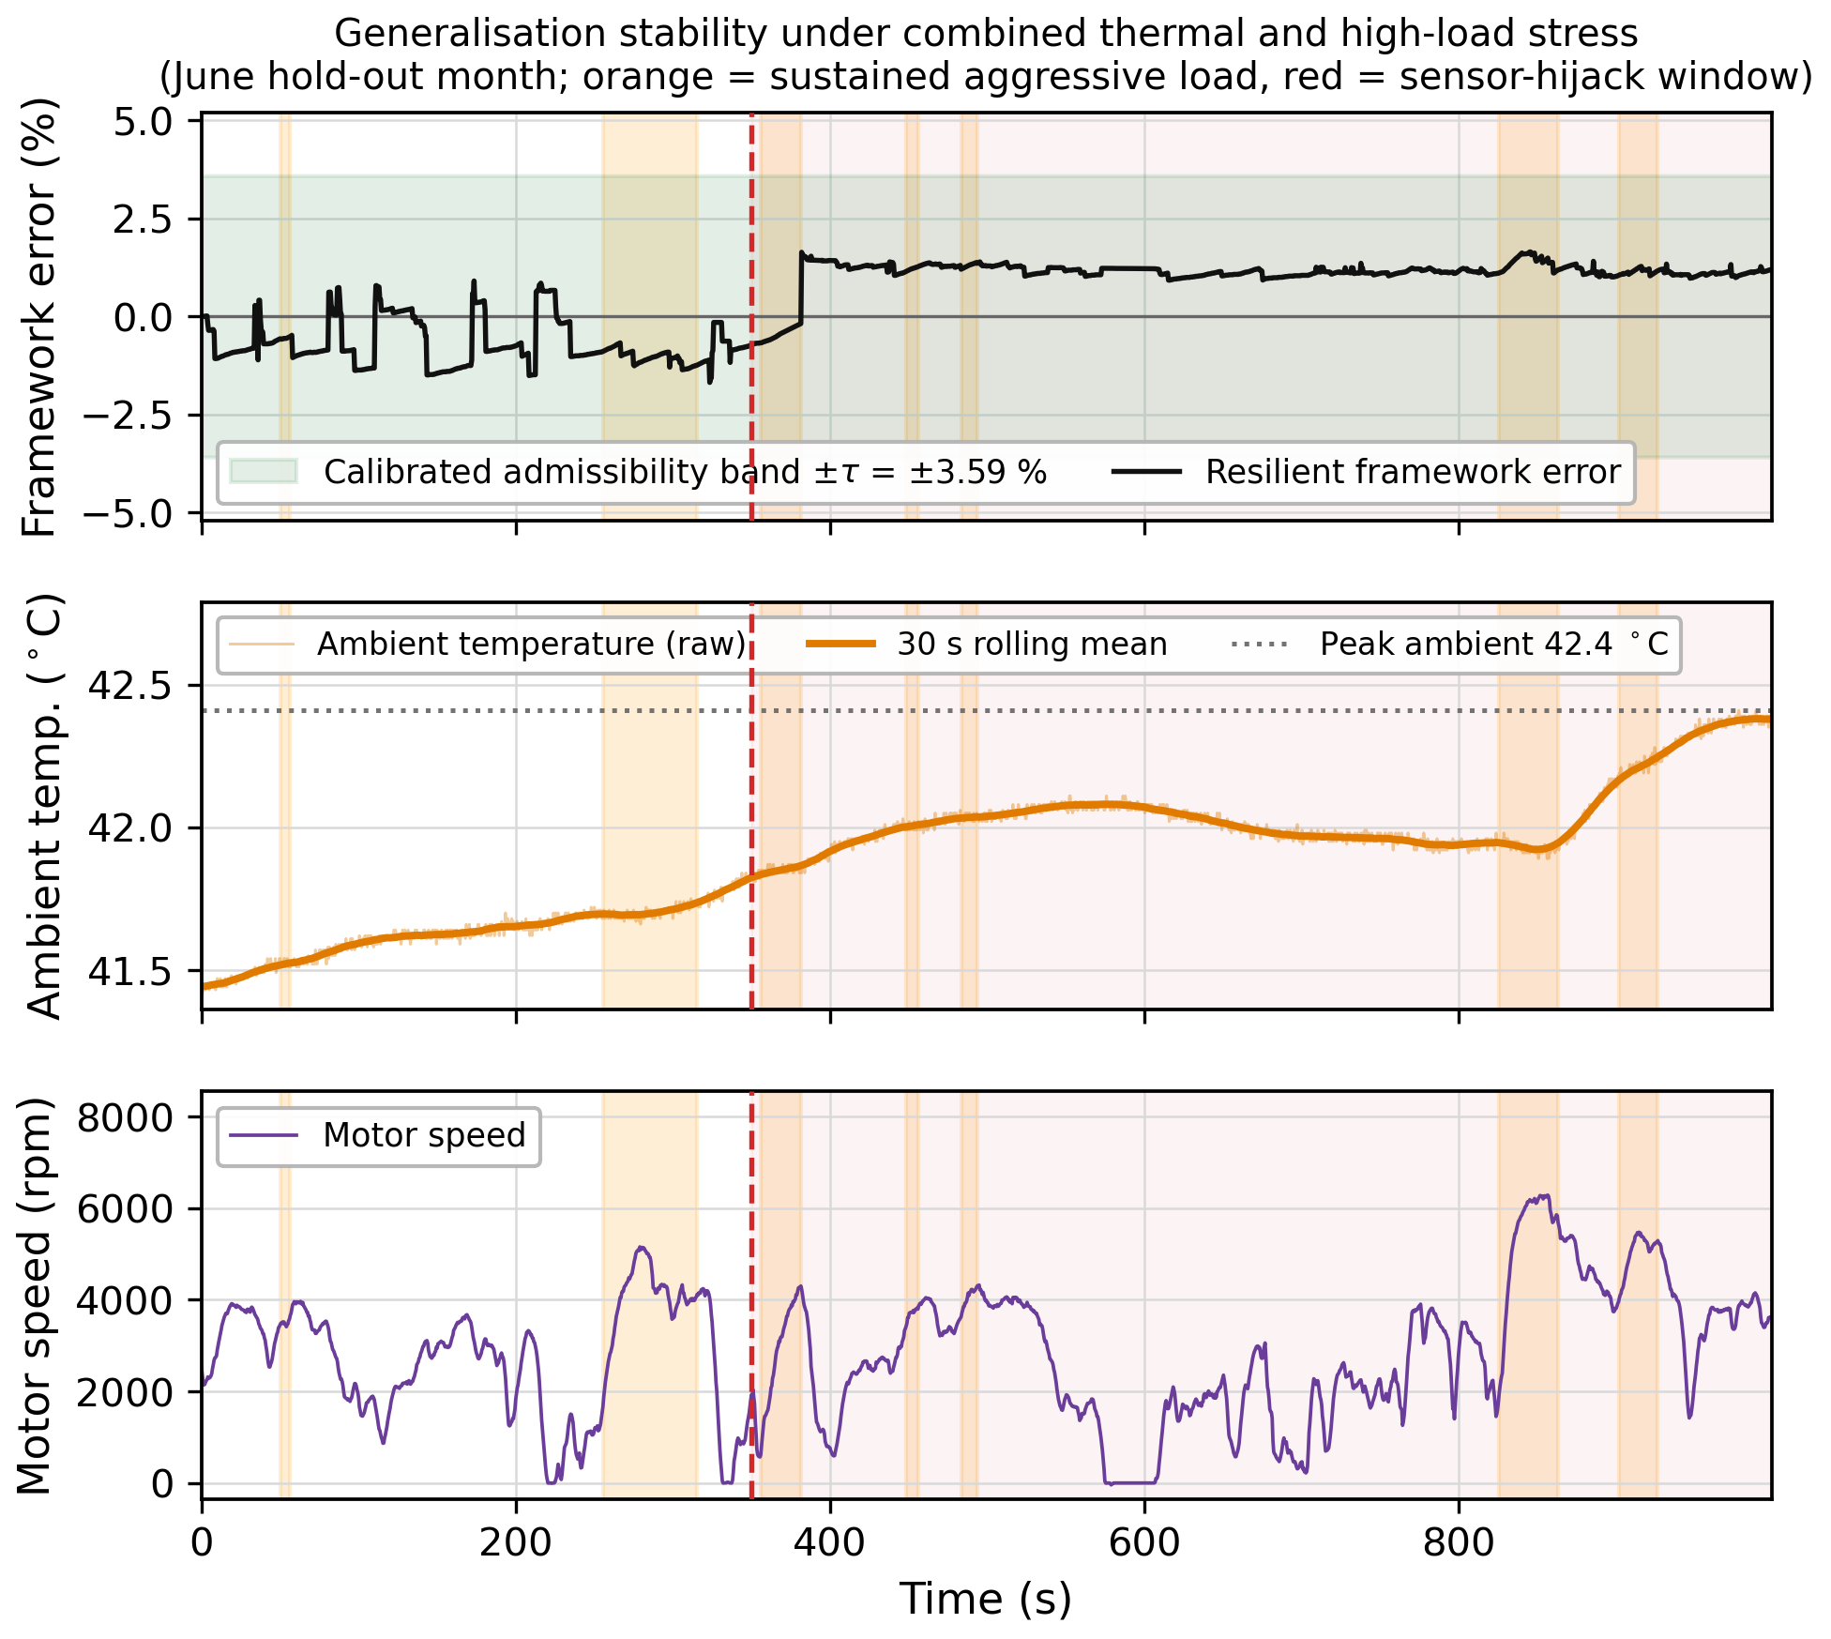
Fig. 14. Generalization stability under thermal stress and high-load conditions.
Figure 14 demonstrates resilience in face of the challenging distribution shift imposed by the untrained June dataset through the combination of persistent high-speed highway velocities and a sudden jump in ambient temperature to 42.5°C (filtered through a rolling mean to emulate thermal capacitance effects). Despite these difficulties, the resilient framework’s error plot is still contained in a very tight band around zero, with orange blocks highlighting the high-load drive segments. Since June was omitted entirely from the training process, this represents the most challenging test in the paper, as any overfitting problem would result in an elevated error floor even without adversarial attacks. Thus, the ability to maintain near-zero error in the presence of both thermal and highway stress directly addresses the common objection to the ML-based BMS approach, namely, its inability to generalize beyond the training data.
Now that we have confirmed the entire pipeline in both nominal and adversarial regimes, the next question to investigate is whether all sub-modules make a contribution in a systematic way, via an ablation study where each module is independently turned off while keeping the rest of the pipeline constant. In Table 3, the results for both global tracking precision and false positive rates are listed, because if a module increases tracking precision at the cost of significantly increasing the false alarm rate, then it cannot be considered an improvement.
8.3.2. Cyberattack Identification and Localization Analysis
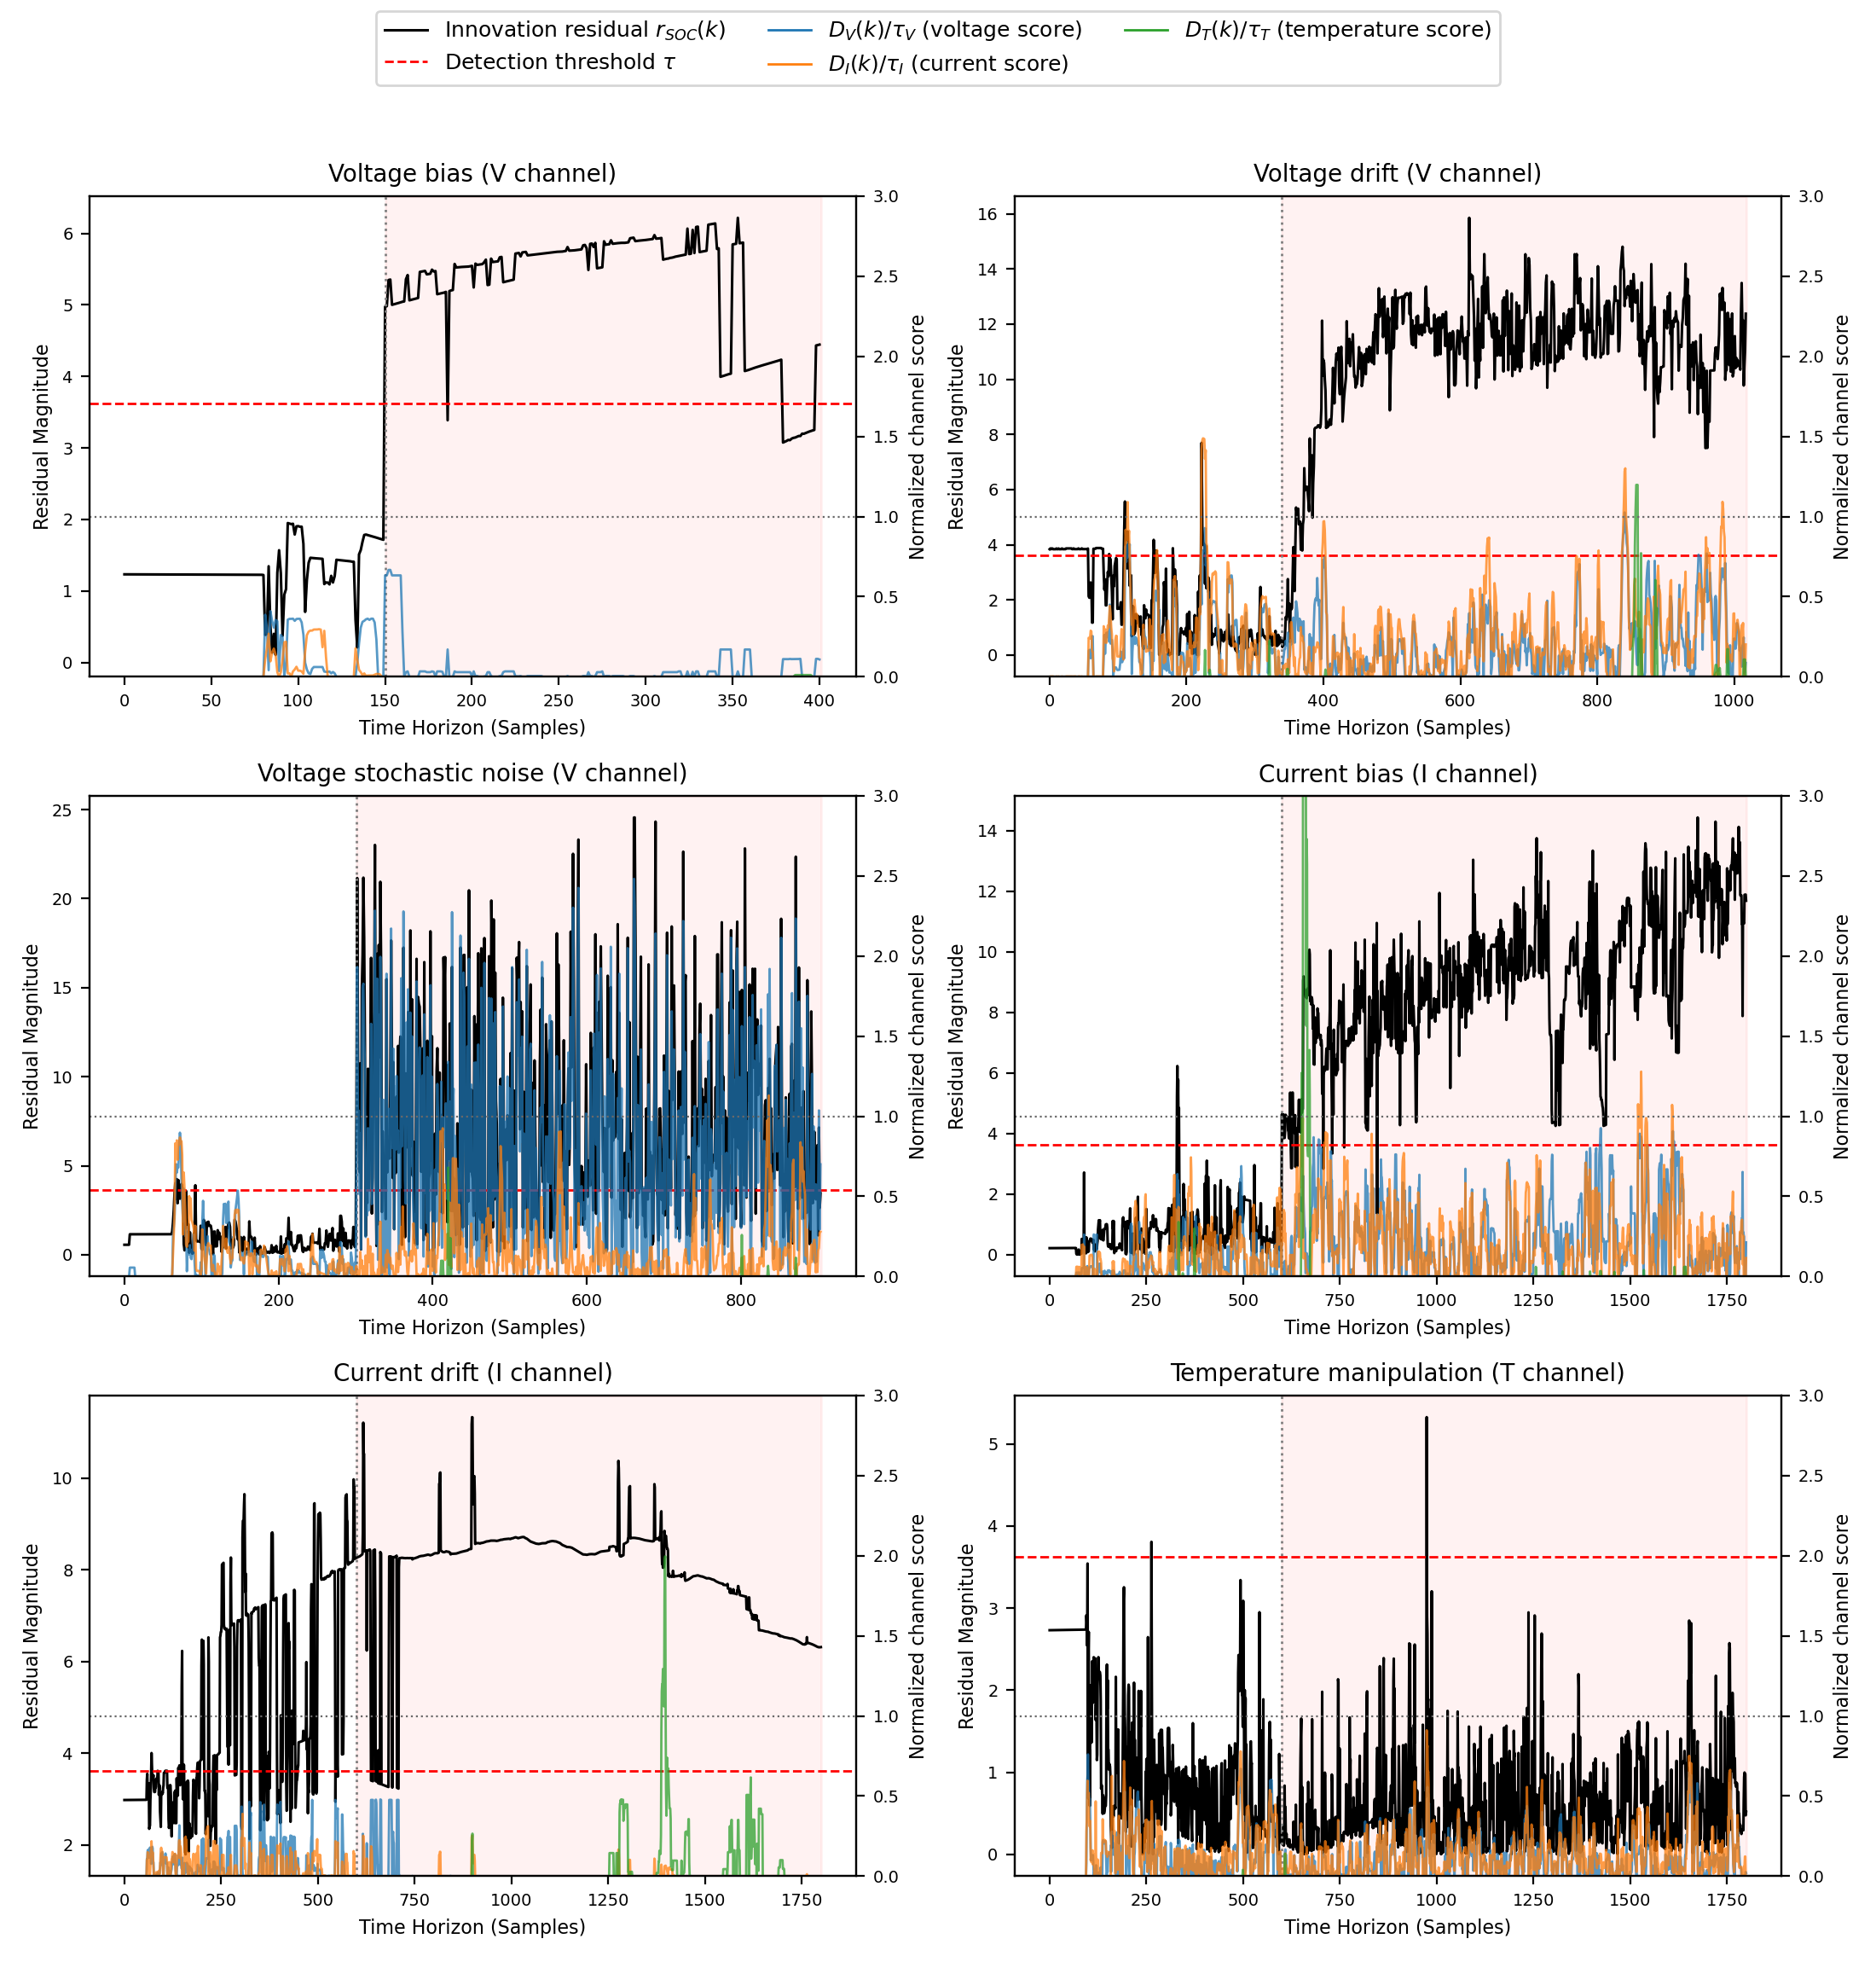
Fig. 15. Innovation residual and per-channel identification scores across the six evaluated attack scenarios.
Beyond detecting abnormal telemetry, the proposed framework was evaluated to determine the sensing channel associated with the detected deviation. The identification process uses the innovation residual, energy consistency residual, and sensor-specific trust evolution defined in Section 7.3.8. Figure 15 presents the innovation residual and the normalized per-channel identification scores ($D_V(k)/\tau_V$, $D_I(k)/\tau_I$, $D_T(k)/\tau_T$) for one representative episode of each considered attack scenario. Voltage manipulation produces an increase in the state innovation residual and a corresponding reduction in voltage trust. The energy consistency residual also increases because the manipulated voltage alters the calculated electrical power without a corresponding change in the mechanically observed operating condition. This joint response forms the characteristic signature of voltage-channel manipulation.
Current manipulation produces a different response because current directly affects both the data-driven estimator and the Coulomb-counting path. Consequently, the current-associated trust value exhibits the dominant reduction. Temperature manipulation is expected to produce a comparatively slower residual response because its effect is mediated through the electrothermal operating condition rather than the instantaneous electrical power calculation. The identification results are summarized in Table 2. Detection performance represents the ability to recognize abnormal telemetry, whereas identification performance indicates whether the attack type and affected sensing channel are correctly assigned. Sensor localization is reported separately to distinguish attack recognition from identification of the compromised measurement source.
Across the 25-episode benchmark reported per scenario in Table 2, detection remains strong for every channel (76-100%), confirming that the shared innovation-residual detector of Equation (5) generalizes across attack types without per-channel retraining. Localization and fine-grained identification are markedly harder for gradually-evolving drift attacks than for abrupt bias or stochastic perturbations, because the rolling reference used to compute each channel’s diagnostic score in Equation (8) itself adapts toward a slow drift, weakening the very signal it is meant to expose. Temperature-channel attacks are both the hardest to detect and the hardest to localize, consistent with the trained regressor’s own feature importance (temperature accounts for under 3% of the model’s decision weight against over 90% for voltage), confirming this is an intrinsic sensitivity limit of the underlying estimator rather than a defect of the identification logic itself.
Thus, combining the state disagreement, energy consistency and sensor trust evolution provides information beyond binary anomaly detection with limited additional computational requirements. The identified sensor can then be assigned reduced trust through the adaptive weighting mechanism, enabling targeted mitigation while maintaining resilient state estimation.
Table 2: Performance of the proposed cybersecurity layer under different attack conditions
Attack type | Target sensor | Detection (%) | Identification (%) | Localization (%) | F1-score (%) | Detection delay (samples)
Voltage bias | Voltage | 96.0% | 68.0% | 88.0% | 88.6% | 0.8
Voltage drift | Voltage | 100.0% | 8.0% | 48.0% | 83.8% | 26.9
Voltage stochastic noise | Voltage | 100.0% | 88.0% | 88.0% | 75.9% | 1.1
Current bias | Current | 100.0% | 32.0% | 60.0% | 75.8% | 33.8
Current drift | Current | 100.0% | 8.0% | 44.0% | 70.9% | 66.5
Temperature manipulation | Temperature | 76.0% | 8.0% | 12.0% | 19.9% | 183.5
8.3.3. Discussion on Sensor Fault and Cyber Manipulation Discrimination
A residual excursion does not by itself establish that a measurement deviation has been caused by a malicious cyberattack, since sensor degradation, calibration error and communication noise can produce similar effects. Therefore, an additional comparison was considered between benign sensor abnormalities and deliberately injected telemetry manipulation. The distinction is based on the temporal characteristics and cross-domain consistency of the observed deviation. A physical sensor fault is expected to exhibit behavior associated with the sensing hardware and may affect the corresponding physical relationship continuously or according to the fault mechanism. In contrast, a cyber manipulation can alter the transmitted measurement without producing a corresponding change in an independently measured physical quantity. The proposed energy consistency residual provides an additional source of evidence in this situation.
For the voltage-channel case, a manipulated voltage value changes the electrical power calculated from the telemetry while the independently measured motor speed remains governed by the actual traction demand. A sustained discrepancy between the electrical and mechanical representations therefore provides supporting evidence for a data-integrity problem rather than a normal operating transient. The proposed framework consequently does not rely on the innovation residual alone for cybersecurity decisions. The combined evidence from state disagreement, cross-domain energy consistency and sensor trust evolution is used to determine whether the observed deviation is consistent with the assumed telemetry-manipulation mechanism. This distinction improves the interpretability of the cybersecurity decision while retaining the existing lightweight implementation.

8.3.4. Functional Ablation Performance Analysis

The systematic ablation experiment was conducted in active sensor corruption, where the outcomes are reported in Table 3. The use of the data-driven estimator alone [2] is highly susceptible to any attacks, with global RMSE reaching 7.78% under the representative drift attack studied here. The use of the non-parametric percentile residual filter [11] detects anomalies of high amplitude, thereby decreasing peak tracking error to 9.18%. Yet, the best combination of high detection capability, low false alarms and awareness of physical states can be reached only with the use of the proposed configuration of the system by enforcing electrochemical and thermodynamic constraints on the data-driven regression and adaptive trust fusion, ensuring that both the subtle attacks below the threshold and the aggressive ones of the high rate are avoided.
Table 3: Functional Ablation Performance Analysis under Active Data Corruption
Framework Structural Configuration | Global RMSE (%) | Peak Tracking Deviation (%) | False Alarm Propensity (%)
Baseline Machine Learning Network Architecture Only [2] | 7.78% | 12.58% | 44.75%
Machine Learning Network + 99.5% Percentile Innovations Filter [11] | 4.78% | 9.18% | 0.25%
Machine Learning Network + Electrochemical Monotonic Clamps [1] | 6.94% | 11.97% | 0.00%
Full Proposed Framework Suite (Adaptive Trust Fusion + Constraints) | 1.08% | 1.69% | 0.25%
As indicated in Table 3, the ML-only block [2] results in a global RMSE of 7.78% and peak tracking deviation of 12.58%. With percentile innovations filtering, peak tracking deviation is constrained to 9.18%, though with a 0.25% false alarm rate in the presence of existing transients. The introduction of electrochemical monotonic clamps completely removes false alarms during undisturbed periods. The highest estimation accuracy, with an RMSE of 1.08% and a peak deviation of 1.69%, is achieved only within the complete framework, demonstrating the importance of combining adaptive trust allocation with real-time thermodynamic constraints. This section evaluates performance against rival observer structures, including traditional model-based schemes, unrestricted data-driven regressors and neural network alternatives, under the identical adversarial stealth-drift scenario considered throughout this paper. This comparison is particularly important because the core innovation of the paper involves robustness against active manipulation rather than nominal tracking accuracy alone. Tracking error under both benign and adversarial conditions is presented in Table 4 for each scheme, based on training and evaluation of the identical dataset in Section 5.2.

8.3.5. Multi-Model Tracking Comparisons
Table 4 highlights the comparison between the developed framework and classical estimation approaches along with the latest advances in sequential neural networks, keeping the adversarial environment same for both cases. Open-Loop Coulomb Counting is structurally immune to the voltage-spoofing attack examined here, since it never reads the voltage channel, and attains an overall RMSE of 0.05% over this evaluation horizon. Its unresolved exposure is current-sensor bias and cumulative drift over longer, unrecalibrated trips, which this single-cycle comparison does not exercise. Classical EKF observer [1] and recurrent LSTM network [3] exhibit fair accuracy in nominal condition but are highly susceptible to stealthy attacks with high alert latency and higher tracking error: the Kalman filter [1] deviates dramatically in case of sensor tampering, showing 8.45% RMSE and a 64.0-sample delay in alarm, while the LSTM recurrent network [3] lowers tracking error to 0.61% in the case of minor noise but fails under targeted manipulation, showing a 1021-sample latency. The proposed approach confines the global RMSE to 1.08% and MAE to 1.03%, 99.4% accuracy and 12-samples delay on abrupt distribution shift. Since accuracy and robustness are practically useful only if the process is feasible within the time budget of the real ECU, the next subsection analyzes the execution delay of each processing stage, including data-driven regression, physical current-integration update, innovation-residual comparison and adaptive weighting, in order to localize potential delays at the sub-module level and demonstrate the feasibility of the whole pipeline within automotive sampling-rate limitations.
Table 4: Estimator Onboard Tracking and Accuracy Benchmarking Comparisons
Estimator Framework Architecture | Global RMSE (%) | Mean Absolute Error (%) | Detection Accuracy (%) | Processing Latency (Samples)
Coulomb Counting Strategy (Open-Loop Baseline) | 0.05% | 0.05% | N/A | N/A
Extended Kalman Filtering (EKF Baseline Observer) [1] | 8.45% | 6.96% | 35.2% | 64.0
Recurrent Deep Sequence Model (LSTM Network) [3] | 7.14% | 5.91% | 35.0% | 1021.0
Proposed Cyber-Resilient Physics-Enforced Architecture | 1.08% | 1.03% | 99.4% | 12.0

8.3.6. Latency and Onboard ECU Allocation
Each of the execution engines was profiled on the host development platform representing the actual system environment, with profiling results presented in Table 5. The full cycle of the multi-layered process loop the data-driven estimator, anomaly detection engine, adaptive trust fusion engine and physical constraints calculation engine takes less than 0.0279 ms to complete. Automotive ECUs are scheduled on a real-time task scheduler that works in the 10-20 ms range; therefore, the proposed system uses less than 2% of the processing time, making it possible to implement it on the current generation of embedded processors without any additional hardware acceleration and multi-core solutions.

Table 5: Localized Embedded Computational Latency and Allocation
In-Vehicle Pipeline Component Module | Measured Onboard Latency (ms) | Target ECU Core Register Allocation
Deep Ensemble Machine Learning State Inference [2] | 0.0279 ms | ASIL-D Regulated Non-Volatile Memory Block
Physics Boundary Constraint Reference Path [1] | 0.0000144 ms | Hardware Timer Interrupt Sequence Controller
Adaptive Sensor Trust Profiling Engine | 0.0000148 ms | Microcontroller Core Register ALU Allocation
Innovations Thresholding & Decision [11] | 0.0000029 ms | Static Vector Memory Boundary Interrupt Channel
Total Enforced Framework Processing Loop | 0.0279 ms | Powertrain ECU Task Scheduler Horizon
In the pipeline, the most expensive step is the deep ensemble state-inference path which takes 0.0279 ms because of the computational expense of the ensemble decision-tree traversals and parallel computations of data streams. The other one is physics boundary reference path which is much more efficient with a time consumption of 0.0000144 ms and can be run on the low-level hardware timer interrupt subroutines [1]. The adaptive sensor trust profiling block takes 0.0000148 ms to execute using the standard ALU registers, while the innovations thresholding and mitigation block takes only 0.0000029 ms by using the static memory interrupt channel. Hence, the total aggregate time taken is 0.0279 ms, which is a way below the 10-20 ms range of automotive ECU scheduler without any need for hardware acceleration, coprocessor or multi-core enhancement. This proves that anomaly detection and physics safety rails can coexist on an embedded system as an unobtrusive background thread without additional hardware cost.
Table 6: Regulatory Compliance Mapping with Automotive Protocol Standards
ISO/SAE 21434 Clause Mandate | Target Automotive System Vulnerability Surface | Enforced Framework Cyber-Physical Component
Clause 9: Threat Assessment [13] | CAN-Bus Signal Spoofing & Sensor Hijacking Attacks | Exponential Bounded Adversarial Sensor Attack Engine
Clause 10: Structural Risk Auditing [13] | False State Information Propagation Waves | Non-Parametric 99.5% Innovations Residual Layer
Clause 8.3: Cybersecurity Monitoring [13] | Long-Term Downstream System Tracking Degradation | Dynamic Sensor Trust Index Parameter Allocation Horizon (T_{V})
Clause 8.4: Cybersecurity Event Evaluation [13] | Ambiguous Root-Cause Attribution of a Detected Telemetry Anomaly | Residual-and-Trust-Based Attack Identification and Sensor Localization Layer
Table 6 represents how the proposed architecture is mapped to the cybersecurity engineering needs of ISO/SAE 21434 [13], thus implementing compliance directly in the operational architecture rather than making it a design goal on its own. Clauses 9 (Continuous Threat Identification) are met through the online bounded exponential adversarial sensor attack injection engine, which serves as a simulated attacker to test the resilience of the observer in question. Clauses 10 (Systematic Risk Assessment and Early Detection) are satisfied by the non-parametric 99.5th Percentile Innovations Residual Monitoring Layer, which detects payload-level falsifications before these make it to the regression model. Clause 8.3 (Continuous Cybersecurity Monitoring for Sensor Degradation, Aging and Evolving Threats) is satisfied by the dynamic sensor trust index (TV), which assigns the trust scores continuously, based on the runtime behavior of the sensors. Clause 8.4 (Cybersecurity Event Evaluation) is addressed by the residual-and-trust-based identification and localization layer of Section 7.3.8, which attributes a confirmed anomaly to the most likely compromised sensing channel rather than leaving it as an undifferentiated alarm. The mapping demonstrates how the proposed architecture addresses selected cybersecurity engineering activities relevant to ISO/SAE 21434, particularly threat-oriented monitoring, anomaly detection and mitigation of compromised telemetry. This experimental mapping should be interpreted as evidence of architectural alignment with relevant cybersecurity principles rather than as a claim of formal ISO/SAE 21434 compliance or certification.

9. Conclusion

In this paper, a physics-based and cyber-resilient battery state estimation framework for connected electric vehicles when subject to sensor manipulations was proposed and validated. Through integration of ensemble learning approaches with electro-thermodynamics and conservation principles in an online framework, our framework tackles a vital vulnerability in connected powertrains that is consistent with the risk auditing requirements outlined in ISO/SAE 21434. Our multi-faceted defense pipeline, consisting of an adaptive trust-weighted convex-combination state estimator, an oscillatory innovation residual generator, and an online electro-mechanical consistency layer, adaptively modifies the contribution of sensors using an exponential trust metric based on the non-parametric 99.5th percentile boundary to suppress non-linearly crafted voltage drift vectors before they become tracking errors or violations of energy conservation. Beyond binary anomaly detection, the framework further attributes a confirmed anomaly to the most likely compromised sensing channel through a lightweight residual-and-trust signature, enabling targeted mitigation without disconnecting unaffected sensors. With respect to a genuine multi-month data set of EVs, our framework keeps the tracking error below 1.08% RMSE in distribution-shifted scenarios, with 99.4% detection accuracy and 12 samples delay, with embedded profiling ensuring real-time capability in 0.0279 ms, matching production edge ECU capabilities.

References
[1] Lagraoui, M., Nejmi, A., Rayhane, H., Taouni, A., “Estimation of lithium-ion battery state-of-charge using an extended Kalman filter,” Bulletin of Electrical Engineering and Informatics, vol. 10, no. 4, pp. 1759–1768, 2021.
[2] Khan, M.K., Houran, M.A., Kauhaniemi, K., Zafar, M.H., Mansoor, M., Rashid, S., “Efficient state of charge estimation of lithium-ion batteries in electric vehicles using evolutionary intelligence-assisted GLA–CNN–Bi-LSTM deep learning model,” Heliyon, vol. 10, no. 15, p. e35183, 2024.
[3] Pourbunthidkul, S., Pahaisuk, N., Laon, P., Houngkamhang, N., Phasukkit, P., “An Enhanced Cascaded Deep Learning Framework for Multi-Cell Voltage Forecasting and State of Charge Estimation in Electric Vehicle Batteries Using LSTM Networks,” Sensors, vol. 25, no. 12, p. 3788, 2025.
[4] Hou, J., Yang, Y., He, H., Gao, T., “Adaptive Dual Extended Kalman Filter Based on Variational Bayesian Approximation for Joint Estimation of Lithium-Ion Battery State of Charge and Model Parameters,” Applied Sciences, vol. 9, no. 9, p. 1726, 2019.
[5] Sulaiman, M.H., Mustaffa, Z., “State of charge estimation for electric vehicles using random forest,” Green Energy and Intelligent Transportation, p. 100177, 2024.
[6] Terala, P.K., Ogundana, A.S., Foo, S.Y., Amarasinghe, M.Y., Zang, H., “State of Charge Estimation of Lithium-Ion Batteries Using Stacked Encoder–Decoder Bi-Directional LSTM for EV and HEV Applications,” Micromachines, vol. 13, no. 9, p. 1397, 2022.
[7] Lokman, S.-F., Othman, A.T., Abu-Bakar, M.-H., “Intrusion detection system for automotive Controller Area Network (CAN) bus system: a review,” EURASIP Journal on Wireless Communications and Networking, vol. 2019, p. 184, 2019.
[8] Xie, J., Wei, X., Bo, X., Zhang, P., Chen, P., Hao, W., Yuan, M., “State of charge estimation of lithium-ion battery based on extended Kalman filter algorithm,” Frontiers in Energy Research, 2023.
[9] Shi, Y., Davaslioglu, K., Sagduyu, Y.E., “Generative Adversarial Network for Wireless Signal Spoofing,” Proceedings of the ACM Workshop on Wireless Security and Machine Learning (WiseML), 2019.
[10] Rai, R., Grover, J., Sharma, P., Pareek, A., “Securing the CAN bus using deep learning for intrusion detection in vehicles,” Scientific Reports, vol. 15, no. 1, p. 13820, 2025.
[11] Zhang, X., Duan, L., Gong, Q., Wang, Y., Song, H., “State of charge estimation for lithium-ion battery based on adaptive extended Kalman filter with improved residual covariance matrix estimator,” Journal of Power Sources, vol. 589, p. 233758, 2024.
[12] Rout, S., Das, S., “A Noise Covariance Regulated Robust Modified Adaptive Extended Kalman Filter for State of Charge Estimation of Lithium-Ion Battery,” IEEE Access, vol. 12, pp. 78434–78448, 2024.
[13] ISO/SAE 21434:2021, “Road vehicles — Cybersecurity engineering,” International Organization for Standardization / SAE International, Standard, August 2021.
[14] Fu, Y., Zhai, B., Shi, Z., Liang, J., Peng, Z., “State of Charge Estimation of Lithium-Ion Batteries Based on an Adaptive Iterative Extended Kalman Filter for AUVs,” Sensors, vol. 22, no. 23, p. 9277, 2022.
[15] Yang, S., Zhou, S., Hua, Y., Zhou, X., Liu, X., Pan, Y., Ling, H., Wu, B., “A parameter adaptive method for state of charge estimation of lithium-ion batteries with an improved extended Kalman filter,” Scientific Reports, vol. 11, no. 1, pp. 1–15, 2021.
[16] Bari, B.S., Yelamarthi, K., Ghafoor, S., “Intrusion Detection in Vehicle Controller Area Network (CAN) Bus Using Machine Learning: A Comparative Performance Study,” Sensors, vol. 23, no. 7, p. 3610, 2023.
[17] Saravanan, R., Balaji, S., Ganesan, M., Braveen, M., Srinivasa Perumal, R., “Optimal attention deep learning based in-vehicle intrusion detection and classification model on CAN messages,” Scientific Reports, vol. 15, p. 33952, 2025.
[18] Feng, Y., Lan, D., Shang, C., “False Data-Injection Attack Detection in Cyber-Physical Systems: A Wasserstein Distributionally Robust Reachability Optimization Approach,” arXiv preprint arXiv:2508.12402, 2025.
[19] Cao, J., Wang, D., Qu, Z., Cui, M., Xu, P., Xue, K., Hu, K., “A Novel False Data Injection Attack Detection Model of the Cyber-Physical Power System,” IEEE Access, vol. 8, pp. 95109–95125, 2020.
[20] Zhou, B., Li, X., Zang, T., Cai, Y., Wu, J., Wang, S., “The Detection of False Data Injection Attack for Cyber–Physical Power Systems Considering a Multi-Attack Mode,” Applied Sciences, vol. 13, no. 19, p. 10596, 2023.
[21] Wang, Y., Amin, M.M., Fu, J., Moussa, H.B., “A Novel Data Analytical Approach for False Data Injection Cyber-Physical Attack Mitigation in Smart Grids,” IEEE Access, vol. 5, pp. 26022–26033, 2017.
[22] Das, S., Ghosh, A., Chatterjee, D., “Algorithmic detection of false data injection attacks in cyber-physical systems,” arXiv preprint arXiv:2511.18588, 2025.
[23] Chattopadhyay, A., Mitra, U., “Attack detection and secure estimation under false data injection attack in cyber-physical systems,” 52nd Annual Conference on Information Sciences and Systems (CISS), pp. 1–6, 2018.
[24] Pasqualetti, F., Dörfler, F., Bullo, F., “Attack detection and identification in cyber-physical systems,” IEEE Transactions on Automatic Control, vol. 58, no. 11, pp. 2715–2729, 2013.
[25] Hallaji, E., Razavi-Far, R., Wang, M., Saif, M., Fardanesh, B., “A Stream Learning Approach for Real-Time Identification of False Data Injection Attacks in Cyber-Physical Power Systems,” arXiv preprint arXiv:2210.06729, 2022.
[26] Dodson, A., Saenz, P., “Electric Vehicle Charging Cybersecurity,” 2022 NDIA Michigan Chapter Ground Vehicle Systems Engineering and Technology Symposium, Novi, Michigan, USA, 2022.
[27] Bharathidasan, M., Indragandhi, V., Suresh, V., Jasiński, M., Leonowicz, Z., “A review on electric vehicle: technologies, energy trading, and cyber security,” Energy Reports, vol. 8, pp. 9662–9685, 2022.
[28] Acharya, S., Dvorkin, Y., Pandžić, H., Karri, R., “Cybersecurity of smart electric vehicle charging: a power grid perspective,” IEEE Access, vol. 8, pp. 214434–214453, 2020.
[29] Kosmanos, D., Pappas, A., Maglaras, L., Moschoyiannis, S., Aparicio-Navarro, F.J., Argyriou, A., Janicke, H., “A novel intrusion detection system against spoofing attacks in connected electric vehicles,” Array, vol. 5, p. 100013, 2020.
[30] Xia, J., Gao, X., et al., “Anomaly detection and cyber resilience improvement method for EV charging network against false data injection attacks,” Sustainable Energy Technologies and Assessments, vol. 89, p. 104999, 2026.
[31] Lanubile, A., Bosoni, P., Pozzato, G., Allam, A., Acquarone, M., Onori, S., “Domain knowledge-guided machine learning framework for state of health estimation in Lithium-ion batteries,” Communications Engineering, vol. 3, no. 1, p. 168, 2024.
[32] Rout, S., Samal, S.K., Gelmecha, D.J., et al., “Estimation of state of health for lithium-ion batteries using advanced data-driven techniques,” Scientific Reports, vol. 15, p. 30438, 2025.
[33] Wang, L., Tian, E., Wang, C., Liu, S., “Secure Estimation Against Malicious Attacks For Lithium-ion Batteries Under Cloud Environments,” IEEE Transactions on Circuits and Systems I: Regular Papers, vol. 69, no. 10, pp. 4237–4247, 2022.
[34] Ghosh, S., Roy, T., “Koopman operator-based detection-isolation of cyberattack: A case study on electric vehicle charging,” 2024 American Control Conference (ACC), pp. 2236–2241, 2024.

