INSTRUCTIONS

Step 1: choose 1 of the Matrix size:

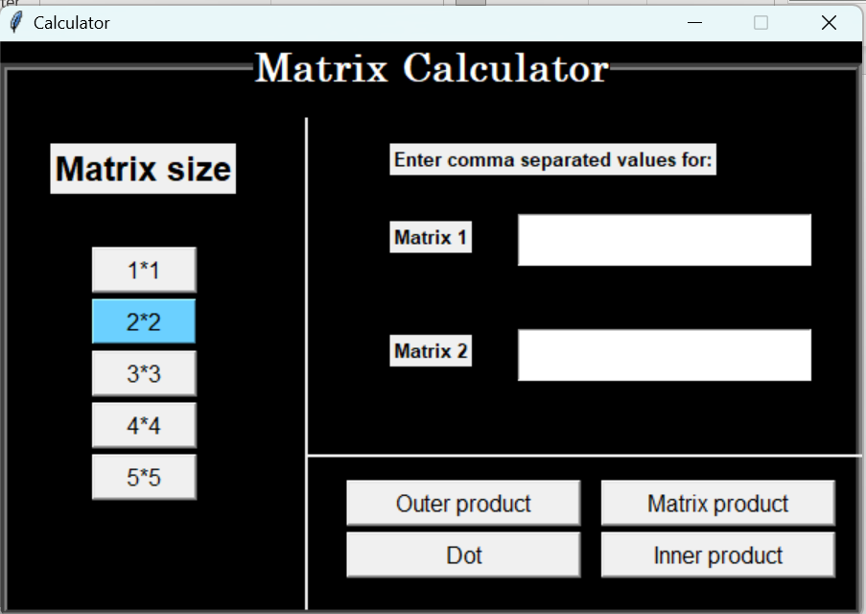

Step 2: If you have selected n\*n size matrix, enter n^2 values in each of matrix 1 and matrix 2 textbox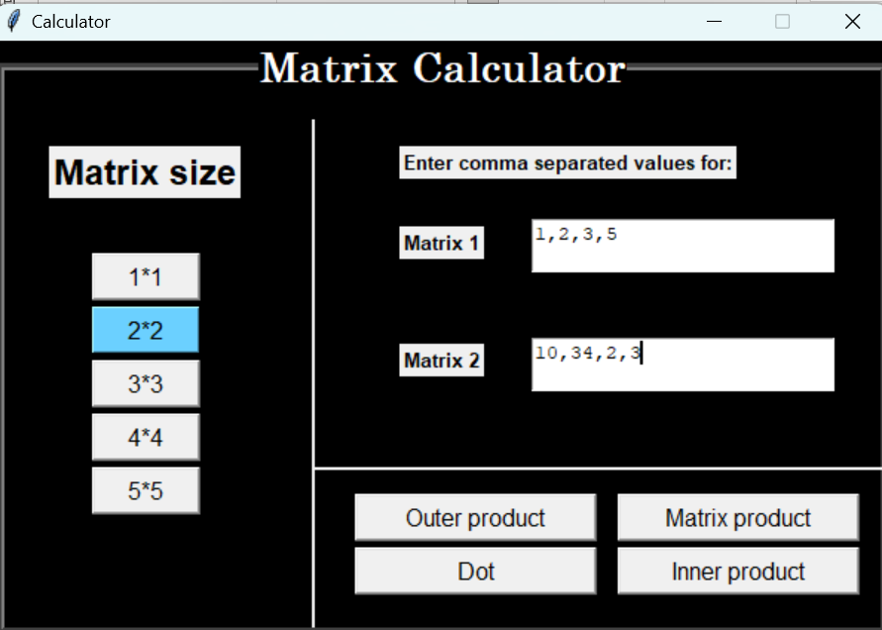

Step 3: Select the operation you want:

