Bluetooth

Bluetooth wireless technology is a short range communications technology intended to replace the cables connecting portable unit and maintaining high levels of security. Bluetooth technology is based on **Ad-hoc technology** also known as **Ad-hoc Pico nets**, which is a local area network with a very limited coverage.

History of Bluetooth

WLAN technology enables device connectivity to infrastructure based services through a wireless carrier provider. The need for personal devices to communicate wirelessly with one another without an established infrastructure has led to the emergence of **Personal Area Networks (PANs)**.

* Ericsson's Bluetooth project in 1994 defines the standard for PANs to enable communication between mobile phones using low power and low cost radio interfaces.
* In May 1988, Companies such as IBM, Intel, Nokia and Toshiba joined Ericsson to form the Bluetooth Special Interest Group (SIG) whose aim was to develop a defacto standard for PANs.
* IEEE has approved a Bluetooth based standard named IEEE 802.15.1 for Wireless Personal Area Networks (WPANs). IEEE standard covers MAC and Physical layer applications.

**Bluetooth** specification details the entire protocol stack. Bluetooth employs Radio Frequency (RF) for communication. It makes use of **frequency modulation** to generate radio waves in the **ISM** band.

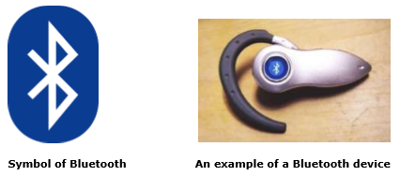

The usage of Bluetooth has widely increased for its special features.

* Bluetooth offers a uniform structure for a wide range of devices to connect and communicate with each other.
* Bluetooth technology has achieved global acceptance such that any Bluetooth enabled device, almost everywhere in the world, can be connected with Bluetooth enabled devices.
* Low power consumption of Bluetooth technology and an offered range of up to ten meters has paved the way for several usage models.
* Bluetooth offers interactive conference by establishing an adhoc network of laptops.
* Bluetooth usage model includes cordless computer, intercom, cordless phone and mobile phones.

Piconets and Scatternets

Bluetooth enabled electronic devices connect and communicate wirelessly through shortrange devices known as **Piconets**. Bluetooth devices exist in small ad-hoc configurations with the ability to act either as master or slave the specification allows a mechanism for **master** and **slave** to switch their roles. Point to point configuration with one master and one slave is the simplest configuration.

When more than two Bluetooth devices communicate with one another, this is called a **PICONET**. A Piconet can contain up to seven slaves clustered around a single master. The device that initializes establishment of the Piconet becomes the **master**.

The master is responsible for transmission control by dividing the network into a series of time slots amongst the network members, as a part of **time division multiplexing** scheme which is shown below.

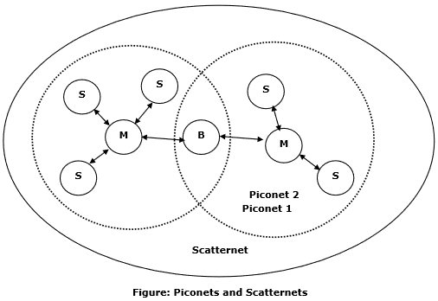

The features of Piconets are as follows −

* Within a Piconet, the timing of various devices and the frequency hopping sequence of individual devices is determined by the clock and unique **48-bit address** of master.
* Each device can communicate simultaneously with up to seven other devices within a single Piconet.
* Each device can communicate with several piconets simultaneously.
* Piconets are established dynamically and automatically as Bluetooth enabled devices enter and leave piconets.
* There is no direct connection between the slaves and all the connections are essentially master-to-slave or slave-to-master.
* Slaves are allowed to transmit once these have been polled by the master.
* Transmission starts in the slave-to-master time slot immediately following a polling packet from the master.
* A device can be a member of two or more piconets, jumping from one piconet to another by adjusting the transmission regime-timing and frequency hopping sequence dictated by the master device of the second piconet.
* It can be a slave in one piconet and master in another. It however cannot be a master in more than once piconet.
* Devices resident in adjacent piconets provide a bridge to support inner-piconet connections, allowing assemblies of linked piconets to form a physically extensible communication infrastructure known as **Scatternet**.

Spectrum

Bluetooth technology operates in the unlicensed industrial, scientific and medical (ISM) band at 2.4 to 2.485 GHZ, using a spread spectrum hopping, full-duplex signal at a nominal rate of 1600 hops/sec. the 2.4 GHZ ISM band is available and unlicensed in most countries.

Range

Bluetooth operating range depends on the device Class 3 radios have a range of up to 1 meter or 3 feet Class 2 radios are most commonly found in mobile devices have a range of 10 meters or 30 feet Class 1 radios are used primarily in industrial use cases have a range of 100 meters or 300 feet.

Data rate

Bluetooth supports 1Mbps data rate for version 1.2 and 3Mbps data rate for Version 2.0 combined with Error Data Rate.