Evaluation of Multilayer Designs for Stable Wearable Biosensors
Joel Whaling, Aarav Patel*, Mandy Hung*, Yuancheng Fang*, Leona Cai*, Zenan Li*, Advik Raja*, Nathan Xu*, Linda Shi
Institute of Engineering in Medicine, University of California San Diego, USA
9500 Gilman Drive, La Jolla, CA 92093, USA
*High school students participating in the IEM OPALS program

Abstract - Mechanical stability of a wearable biosensor depends on its component load paths, attachment, and imposed skin motion. We retained a sixteen-body CAD assembly and compared uniform, single-compliant, and graded supports at fixed thickness. The expanded three-dimensional linear-elastic study varies adhesive modulus, effective skin modulus, and extension direction. A geometric audit distinguishes the supplied contact from an explicitly gap-filled adhesive scenario. CalculiX/SPOOLES solves, independent high-contrast benchmarks, local-equilibrium checks, and direct mixed-load comparisons support numerical acceptance. The main filled-contact matrix contains 27 material configurations and 972 sampled directional responses reconstructed from tensor basis solutions; these are not 972 independent solves. Wire principal-strain demand, disturbance relative to matched bare-skin finite-element references, and adhesive distortion quantify separate tradeoffs. At nominal material inputs, the wire metric varies by up to 2.6-fold with extension direction. The sampled worst-case comparison identifies 6 nondominated material/support options. Across selected nominal and sampled-worst configurations, the largest final-refinement changes are 4.4%, 3.8%, and 1.1% for the three metrics. Results guide conditional prototype comparisons. Unidentified component properties and ideal bonding require material and experimental validation before relating mechanical demand to sensing performance.
Keywords: Wearable biosensors, three-dimensional finite elements, compliant supports, skin attachment, material uncertainty.

1. Introduction
Wearable biosensors must remain mechanically compatible with moving skin while protecting their sensing components and conductors. Epidermal and stretchable electronics demonstrate how geometry and compliant materials can accommodate deformation [1,2]. Experiments with soft interlayers show that mechanical coupling to tissue depends on the complete device stack and its interface [3]. Motion-artifact studies also establish that skin attachment can affect recorded signals [4]. A mechanical simulation can identify candidate load paths and design tradeoffs, but it cannot establish signal quality without an electrical model and measurements.
A support that reduces strain in a packaged component need not reduce strain in an adjacent routed conductor. Similarly, reducing wire loading may increase deformation of the adhesive or constraint of the skin. These competing responses matter when selecting a wearable stack for subsequent bench testing. A single stretching direction and one nominal material set provide limited guidance if a ranking changes with motion direction, tissue stiffness, or attachment geometry.
We retain the supplied sixteen-body biosensor assembly and its three equal-thickness support architectures, but expand the assessment to directional skin motion, controlled adhesive choices, and uncertain effective skin stiffness. A geometry audit distinguishes the contact present in the supplied CAD from an explicitly gap-filled adhesive scenario. Numerical acceptance includes free-DOF force residuals, constrained-reaction energy balance, independent high-contrast benchmarks, and direct checks of tensor-field superposition. The objective is a reproducible mechanical tradeoff assessment that can guide prototype testing, rather than a claim of clinical benefit or a predetermined advantage for graded supports.

2. Methods

2.1. Assembly and attachment scenarios
The original STEP geometry is in millimetres and contains skin, adhesive, PDMS support and cover, two ABS regions, five generic sensor components, a radio-transmitter body, patterned gold features, and two routed gold wires. The skin has bounding dimensions 60 × 60 × 2 mm; adhesive and support span 40 × 40 mm and 38 × 38 mm laterally, respectively. Component identities remain CAD labels rather than a verified manufactured bill of materials. The main ABS body includes a stem that passes through the support and partly enters the adhesive. Boolean fragmentation retains the stem and assigns overlapping material volume once. All remaining shared interfaces are perfectly bonded.
The original 1 mm PDMS support is partitioned into lower and middle quarters and an upper half. The uniform architecture assigns the same PDMS modulus throughout. The single compliant architecture replaces the lower half by a soft material; grading assigns soft and medium materials to the two lower quarters. Total support thickness and the electronics remain fixed. These comparisons isolate material assignment within one geometry rather than adding thickness or removing the stem.
The broad skin surface is at z=2.00 mm, whereas the broad adhesive underside is at z=2.01 mm. Thus a nominal 10 micrometre clearance remains between those planes in the supplied CAD; its textured shared interfaces provide a smaller bonded area than the projected adhesive footprint. The alternative filled scenario extrudes the broad planar adhesive underside down by 0.01 mm and fuses that extension into the adhesive; textured protrusion tips retain their original clearance. Skin, support, electronics, and wire positions remain unchanged. This is a specified attachment scenario, not an assertion that the real device has either contact condition. Shared surface area is measured from each accepted mesh, including nonplanar texture.
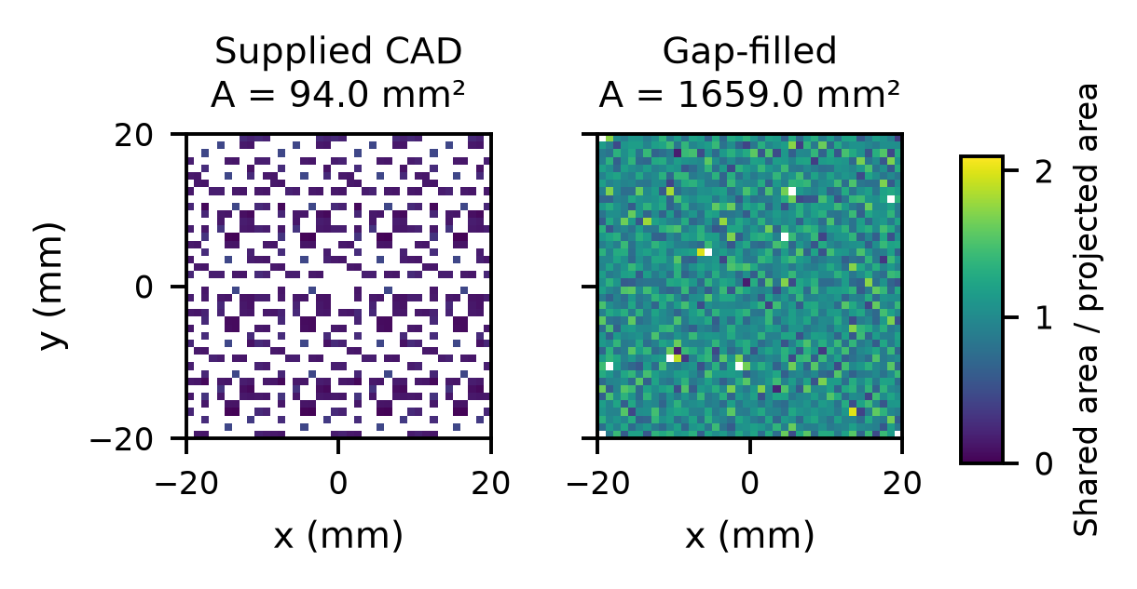
Figure 1. Actual shared skin-adhesive facets in the medium meshes, accumulated in 1 mm² projected bins. Colors show geometric surface-area density, not pressure or adhesion strength. White bins contain no shared facets. Nonplanar surface area can exceed projected area. The supplied and filled scenarios are kept separate.

2.2. Material and motion variables
All constituents use isotropic linear elasticity in the main design screen. Table 1 distinguishes fixed surrogate properties from varied inputs. PDMS and skin publications motivate the need to distinguish formulation, loading regime, and tissue response [5,6]; they do not calibrate this particular device. Effective skin modulus is varied over analyst-selected levels, while adhesive modulus is a controlled design input. Poisson ratio is 0.49 for the skin and soft polymers. The nominal ABS, sensor-package, and transmitter assignments remain mechanical surrogates. The package model does not resolve internal silicon, solder, copper traces, or a board layup absent from the CAD.
The parameter grid is deterministic. Its selected levels are sensitivity scenarios, not samples from a measured population distribution. Worst-case coordinates maximize each response over the selected skin moduli and directions without probability weights. No universal gold yield strain, adhesion strength, fatigue limit, or tissue-injury threshold is assigned. The computed responses are conditional on the stated geometry, bonding, and constitutive assumptions.
Table 1. Isotropic inputs. Unidentified fixed properties are surrogates; no manufactured grade is established.
Region | E (MPa) | ν
Skin | 0.10, 0.20, 0.50 | 0.49
Adhesive | 0.05, 0.10, 0.50 | 0.49
PDMS / cover | 1.80 | 0.49
Soft region | 0.10 | 0.49
Medium region | 0.50 | 0.49
ABS | 2,300 | 0.35
Sensor packages | 10,000 | 0.30
Transmitter | 20,000 | 0.30
Gold-labeled solids | 78,500 [7] | 0.42

The skin slab has a convex rounded footprint. Nodes projected onto its outer contour through the thickness receive prescribed in-plane displacements; filleted edge nodes projected inside the contour remain free. Three independent basis problems impose 1% normal strain along x, 1% normal strain along y, or 1% engineering shear in the xy plane. Affine in-plane displacements follow the imposed symmetric strain tensor on the same constrained nodes in all three cases. Out-of-plane motion remains free except one reference displacement. These are controlled perimeter fixtures, not a reconstruction of a specific anatomical location.
For directional extension at angle θ, the imposed in-plane strain tensor has principal values ε and −νε, with ν=0.49. At ε=0.01, the basis coefficients follow the rotation relations below. Displacement, stress, and strain tensors are combined before evaluating nonlinear metrics such as von Mises stress or a percentile. Scalar stress averages and percentiles are never superposed. The direction grid samples a half-turn; its envelopes are sampled extrema rather than certified continuous-angle bounds. Equal biaxial extension and engineering shear are additional prescribed-motion comparisons.
The directional screen samples 36 angles from 0° through 175° in 5° steps. Together with 27 material configurations, this gives 972 reconstructed directional responses; the two additional motion tensors give 54 further responses. Amplitude scaling within the linear formulation is an algebraic consequence, not an additional independent solve or evidence of finite-deformation validity. The fixed perimeter, absence of prestrain, and ideal bonding delimit what the motion comparisons represent.
$$c₁ = cos²θ - ν sin²θ$$
$$c₂ = sin²θ - ν cos²θ$$
$$c₃ = 2(1 + ν) sinθ cosθ$$

2.3. Discretization and numerical verification
Gmsh 4.15.2 imports and fragments the CAD and generates conforming ten-node tetrahedra [8]. Straight midside placement preserves straight-sided quadratic elements. CalculiX 2.17, Ubuntu package 2.17-3, uses SPOOLES for the structural solves under Ubuntu 22.04 in Windows Subsystem for Linux [9]. Python 3.12 processes the retained fields. ANSYS is not the structural solver. Input hashes, execution status, and environment are retained with each case. Backend acceptance requires assembly verification in addition to the small benchmarks.
The filled-contact medium and refined meshes contain 267,146 and 370,387 elements, respectively (412,220 and 556,536 nodes). The supplied-contact meshes contain 272,194 and 374,893 elements (436,391 and 583,486 nodes). Each mesh is connected, has positive element Jacobians, and uses the same geometry and region definitions across its material cases.
Homogeneous cubes test analytical normal and shear stress/strain tensors for Poisson ratios 0.30 and 0.49. An independent scikit-fem quadratic implementation [10] checks heterogeneous cubes at modulus ratios 10, 392,500, and 1,570,000 with Poisson ratio 0.49. The latter two ratios match nominal gold/skin and the largest gold/adhesive modulus contrasts in the selected grid; these are numerical benchmarks, not additional biosensor material cases. Direct mixed-load cube and full-assembly solves check the linear basis reconstruction. Completed assembly cases must reach final load time and satisfy free-DOF residual, prescribed-displacement, force/moment, and energy gates.
When a completed linear solve does not meet the free-DOF residual gate, a defect-correction solve applies the negative residual as nodal loads with zero prescribed displacements. Its displacement, stress, strain, and internal-force fields are scaled back and added to the initial fields. This solves the same linear equations rather than changing materials, loading, or tolerance. A labeled manufactured-error benchmark verifies recovery of known fields. Uncorrected outputs and each correction solve are retained. Every material configuration also receives a direct mixed-loading solve before its directional responses are accepted.
External work is one half of displacement dotted with reactions at prescribed DOFs only. Force output at a free DOF represents a residual and is excluded from that work. Internal strain energy is integrated as one half of sigma:epsilon, counting tensor shear terms twice. A sum over every nodal force would include residual work and could conceal an inaccurate solve. Mesh comparisons assess the new response metrics, with measured changes reported separately from numerical acceptance tolerances.

2.4. Mechanical response measures
Wire metrics include the volume-weighted mean von Mises stress and volume-weighted 95th percentile of absolute principal strain across both routed wire solids. Four integration points per straight-sided quadratic tetrahedron each receive one quarter of its undeformed volume. Local maxima are retained as diagnostics, not failure thresholds. Material boundaries are not smoothed together.
Skin disturbance is the volume-weighted RMS Frobenius norm of the difference between the device-loaded strain tensor and a device-free skin reference under the same imposed in-plane strain. The reference retains exactly the same skin elements, textured surfaces, constrained contour, and quadrature ordering. With fixed Poisson ratio, prescribed displacements, and zero body force, the homogeneous bare-skin strain field is independent of its scalar Young modulus; one reference per mesh and basis therefore serves all skin-stiffness levels. Normalization by 0.01 uses the prescribed principal extension in the directional screen as a fixed reference for all motion states. This quantifies mechanical interference, not comfort, irritation, or injury. Adhesive strain energy measures deformation demand in the bonded layer; it is not a crack energy-release rate or adhesion toughness.
The primary adhesive response is the volume-weighted RMS Frobenius norm of deviatoric strain: subtract one third of the strain trace from each normal component, square the tensor norm, average over adhesive volume, and take the square root. It measures distortion without assigning a failure threshold. Exploratory interface tractions are recovered separately from each adjacent material using quadratic displacement gradients at face centroids. Area-weighted skin-side versus adhesive-side mismatch and refinement changes are diagnostic checks. A recovered traction percentile is not used as an established detachment prediction without adequate recovery accuracy and measured interface properties. Tradeoff assessment retains the separate wire, skin, and adhesive metrics; Pareto comparisons depend on these explicit metric choices.
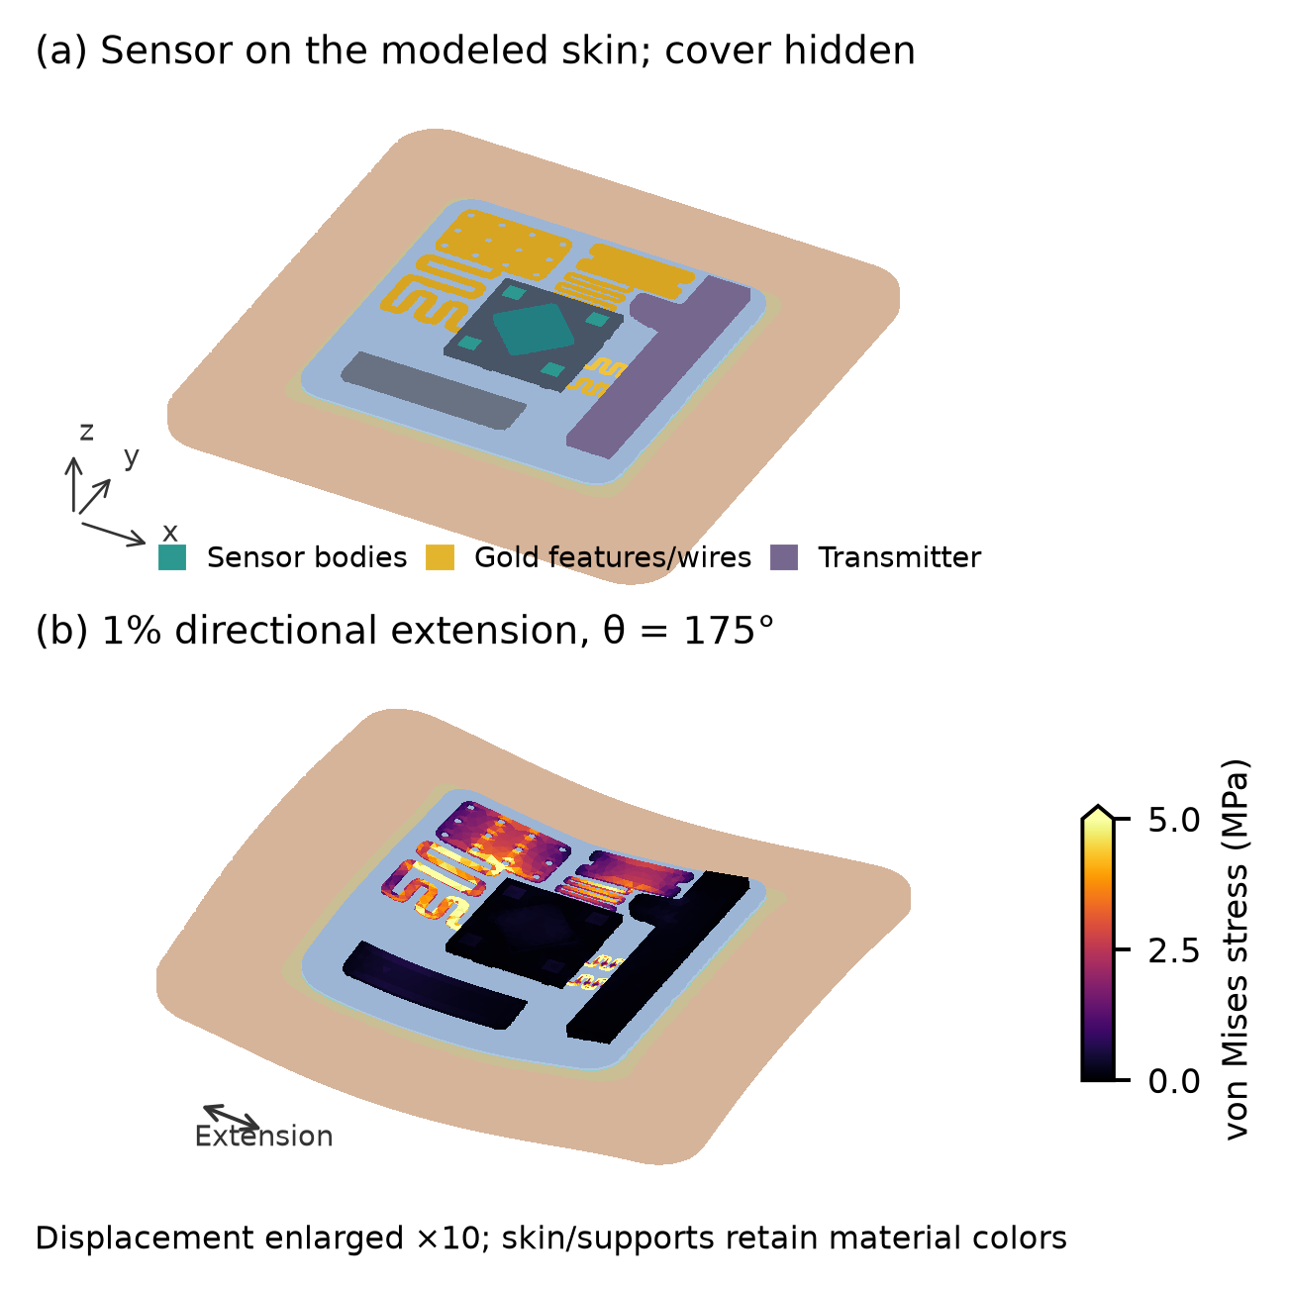
Figure 2. Refined filled-contact assembly with uniform support at nominal material inputs: (a) undeformed geometry; (b) the sampled direction maximizing its wire strain percentile. The cover is hidden. Deformation is enlarged 10 times, while stress uses the actual 1% prescribed extension. Electronic-body colors show element-mean integration-point von Mises stress, saturated above 5 MPa; skin and supports retain material colors.

3. Results

3.1. Verification and refinement
The accepted study contains 148 distinct assembly load cases and 8 auxiliary defect-correction solves. The latter improve the solution of existing cases rather than adding physical loading scenarios. Independent high-contrast displacement comparisons differ by at most 1.1×10⁻⁷ in relative norm. The manufactured-error test recovers all checked fields to within 8.6×10⁻¹⁰ relative error. Across accepted assembly cases, the maximum free-DOF relative force residual is 1.5×10⁻⁶, and the largest constrained-work energy discrepancy is 8.7×10⁻⁸. These numerical checks do not calibrate biological or manufactured materials.
Table 2 compares sampled directional maxima on the medium and refined meshes for nominal architectures, the supplied-contact control, and configurations selected from the medium grid for worst responses. These checks sample the uncertainty space; they do not refine every grid point or establish certified error bounds. A small apparent design advantage must be interpreted alongside the measured mesh dependence.
Independent element-mean stress and strain comparisons have a maximum relative discrepancy of 1.1×10⁻⁷, measured with volume-weighted Frobenius norms. Element means avoid assuming identical quadrature-point numbering between the two implementations; this is not a pointwise error bound for the biosensor assembly.
Each direct mixed-load assembly comparison must satisfy a relative field-norm discrepancy below 2×10⁻⁵ for displacement, internal force, stress, and strain. The largest observed discrepancy across these fields is 1.7×10⁻⁵. Assembly free-DOF residuals must remain below 1×10⁻⁵ and relative constrained-work energy errors below 5×10⁻⁴; a completed solver execution alone does not meet these gates.
Table 2. Relative changes (%) in sampled directional maxima after refinement. F/S denote filled/supplied contact; U/C/G denote uniform/single-compliant/graded. Moduli are skin/adhesive in MPa.
Case | Wire | Skin | Adhesive
F/G 0.2/0.1 | 0.5 | 0.7 | 0.6
F/G 0.5/0.5 | 0.4 | 0.7 | 0.4
F/C 0.2/0.1 | 0.6 | 0.7 | 0.5
F/U 0.1/0.5 | 0.7 | 0.7 | 1.1
F/U 0.2/0.1 | 0.1 | 0.8 | 1.0
F/U 0.5/0.05 | 0.3 | 0.7 | 0.9
S/U 0.2/0.1 | 4.4 | 3.8 | 0.6

3.2. Directional and material response
At nominal skin and adhesive moduli in the filled-contact geometry, the sampled wire strain percentiles span uniform: 0.00574-0.0149%; single: 0.00651-0.0172%; graded: 0.00647-0.0171%. Figure 3 shows the directional response at nominal adhesive modulus, with bands spanning the selected skin stiffnesses. The bands represent parameter dependence, not statistical confidence intervals or a patient population.
Relative to uniform support at nominal materials, the sampled maximum wire strain percentile changes by +14.9% for the single-compliant architecture and +14.6% for the graded architecture. The single-to-graded change is -0.26%; its magnitude must be judged against the refinement changes in Table 2.
The refined nominal single-to-graded wire change is -0.31%, compared with individual wire-metric refinement changes of 0.52-0.57% for those architectures. These are observed changes between two meshes, not certified error bounds.
The small nominal wire advantage of grading is below both observed refinement changes and should not be interpreted as resolved design superiority.
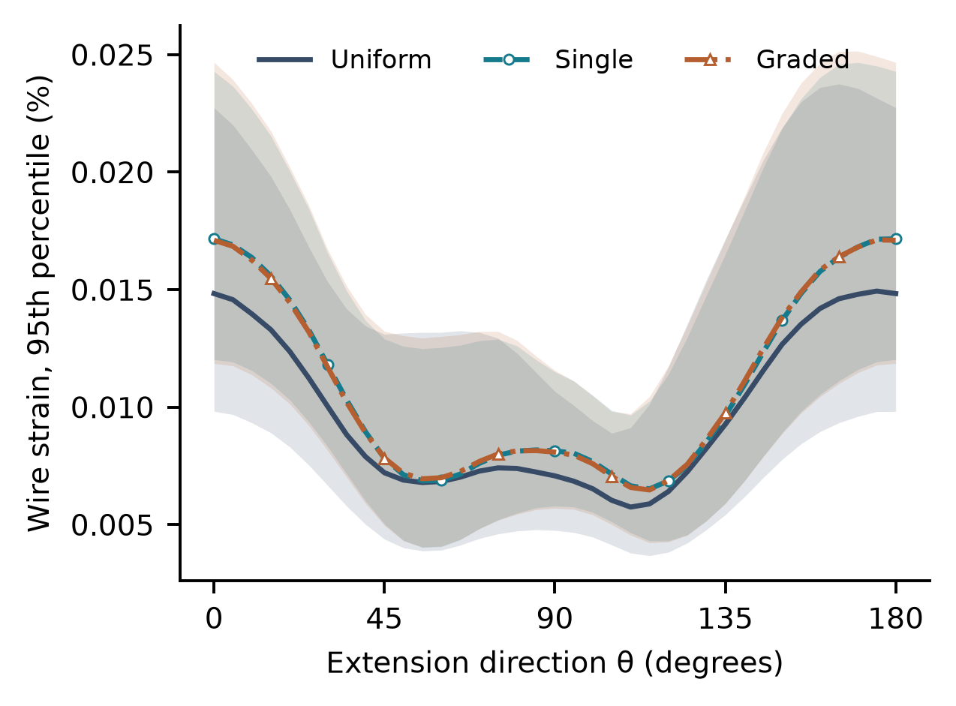
Figure 3. Wire absolute principal-strain 95th percentile versus extension direction for filled contact and adhesive modulus 0.10 MPa. Lines use skin modulus 0.20 MPa; shading encloses the three sampled skin-modulus curves at 0.10, 0.20, and 0.50 MPa. The end point repeats the equivalent 0° direction. All curves use 1% prescribed principal extension.
For nominal materials, the additional loadings give wire strain percentiles across the three support architectures of 0.5% equal biaxial extension: 0.00785-0.00908%; 1% engineering shear: 0.00495-0.00512%. Both additional tensors have maximum absolute prescribed in-plane principal strain 0.5%, versus 1% in the directional screen. They are separate motion comparisons and do not enter its directional envelopes or worst-case Pareto coordinates.

3.3. Attachment and mechanical tradeoffs
For uniform support at nominal materials, filling the specified geometric clearance changes the sampled maximum wire strain percentile from 0.00924% to 0.0149% (+61.6%). This comparison includes the explicitly added adhesive and changed shared surface; it is not a measured adhesion-strength effect.
For single support at nominal materials, filling the specified geometric clearance changes the sampled maximum wire strain percentile from 0.0114% to 0.0172% (+50.6%). This comparison includes the explicitly added adhesive and changed shared surface; it is not a measured adhesion-strength effect.
For graded support at nominal materials, filling the specified geometric clearance changes the sampled maximum wire strain percentile from 0.0112% to 0.0171% (+52.8%). This comparison includes the explicitly added adhesive and changed shared surface; it is not a measured adhesion-strength effect.
Table 3. Sampled worst responses across three skin stiffnesses and 36 extension directions for each filled-contact design option. Adhesive E is in MPa; strains are percentages; skin D is RMS perturbation divided by 0.01.
Support | Adh. E | Wire ε95 | Skin D | Adh. εdev
Uniform | 0.05 | 0.0223 | 0.989 | 4.62
Uniform | 0.1 | 0.0237 | 1.03 | 2.8
Uniform | 0.5 | 0.0249 | 1.09 | 0.995
Single | 0.05 | 0.0235 | 0.883 | 3.66
Single | 0.1 | 0.0247 | 0.914 | 2.19
Single | 0.5 | 0.0255 | 0.97 | 0.913
Graded | 0.05 | 0.0239 | 0.909 | 3.93
Graded | 0.1 | 0.0251 | 0.942 | 2.36
Graded | 0.5 | 0.0261 | 1 | 0.935

The largest sampled adhesive RMS deviatoric strain is 4.62%. This volume-averaged distortion measure is not a failure strain. Its magnitude also motivates constitutive and finite-deformation checks before using the linear screen to qualify a prototype.
The sampled worst-case Pareto set contains uniform / 0.05 MPa adhesive; uniform / 0.1 MPa adhesive; uniform / 0.5 MPa adhesive; single / 0.05 MPa adhesive; single / 0.1 MPa adhesive; single / 0.5 MPa adhesive. Each objective is maximized separately over the selected skin stiffnesses and directions, so the three worst coordinates need not occur in the same loading state. Nondominance expresses a tradeoff within these metrics; it does not identify a universally superior device or assign clinical importance to the objectives.
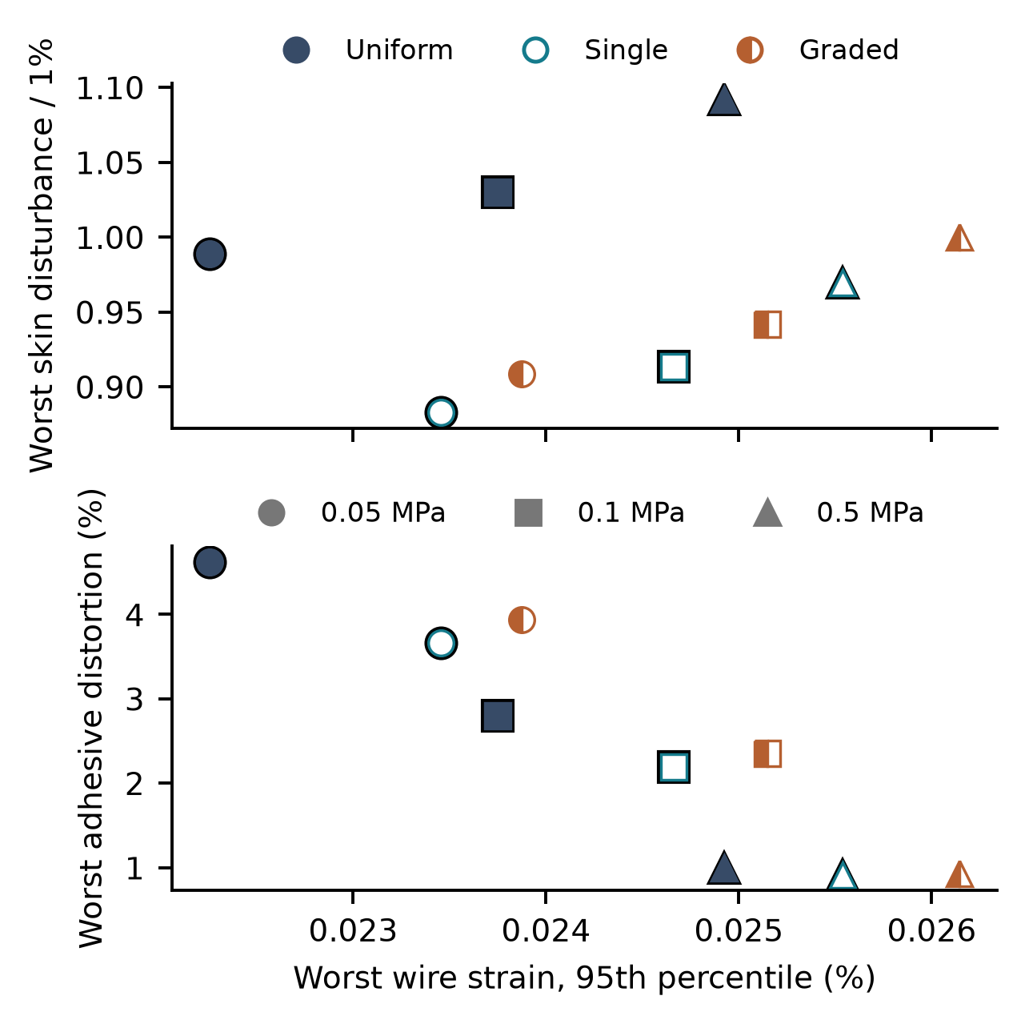
Figure 4. Filled-contact material/support options compared by sampled worst wire strain, skin disturbance, and adhesive RMS deviatoric strain. Color and marker fill identify support architecture; marker shape identifies adhesive modulus. Black outlines identify sampled nondominated options. Each coordinate is its own worst sampled value; maxima need not co-occur. Close apparent dominance must be considered with mesh sensitivity.

4. Discussion
The practical design question is how to reduce conductor deformation while preserving an acceptable mechanical interaction with skin and adhesive. The expanded comparison makes those responses explicit instead of replacing them with a whole-assembly stress average. A support or adhesive choice can move the design favorably in one coordinate while worsening another. Placement relative to motion is likewise a controlled variable whose effect should be measured before attributing improved performance solely to a graded layer.
The attachment audit also changes the interpretation of the supplied geometry. Its projected adhesive footprint and its shared bonded surface are different quantities. The filled scenario tests a specified alternative attachment construction without moving the electronics or altering support thickness. The resulting differences indicate what should be checked in manufactured specimens: actual bonding geometry, constituent properties, conductor deformation, and skin motion. They do not determine whether either construction will remain attached during use.
For prototype development, the sampled tradeoff set provides candidates for controlled comparison rather than a prescribed clinical design. Bench tests can measure full-field skin and conductor deformation at several mounting directions and compare adhesive formulations at matched geometry. Electrical measurements during those tests are necessary to connect mechanical demand to signal stability. The uncertainty grid and refinement results indicate where a favorable nominal response needs further confirmation.

5. Limitations
The largest physical uncertainties are unidentified constituent materials and the actual manufactured attachment. Both geometric contact scenarios are idealized and perfectly bonded wherever shared. Neither includes cohesive damage, frictional slip, crack growth, sweating, or removal from skin. The filled scenario adds adhesive volume and contact area explicitly; it is not silently substituted for the supplied CAD.
Skin is modeled as one effective isotropic elastic region. Layering, anisotropy, viscoelasticity, residual tension, subject variability, and anatomical curvature are not calibrated. The selected stiffness levels are sensitivity inputs rather than a patient dataset. Linear solutions do not establish validity at large local strain, under buckling, or during repeated use. Sharp features and junctions can make local maxima more mesh-sensitive than integrated measures.
The study does not simulate biomarker transport, sensing chemistry, electrical resistance changes, RF operation, fatigue, comfort, or clinical outcomes. Lower mechanical demand in one chosen metric can motivate an experiment but does not establish improved diagnostic accuracy or device safety. Authors should confirm actual materials and attachment, compare predictions with full-field deformation and component measurements, and then test electrical performance during controlled motion.

6. Conclusion
This study extends the same sixteen-body multilayer biosensor assembly to directional motion, selected skin and adhesive stiffnesses, and explicit attachment scenarios. Verified tensor-basis solutions support 972 sampled directional responses in the main material matrix. Wire strain, disturbance relative to matched bare skin, and adhesive distortion identify 6 sampled nondominated options and make component/interface tradeoffs reviewable. The result is a conditional mechanical screening framework for prototype selection, with retained inputs and numerical checks. It does not establish biomarker sensing accuracy, comfort, fatigue life, or clinical benefit.

Data and code availability
The accompanying research package retains the original CAD, specified gap-filled construction, source scripts, solver inputs and execution records, verification cases, response tables, refined comparisons, and selected field arrays. Rejected and corrected numerical outputs are distinguished. All results are computational; no human or animal experiments were performed in this study.
Source code and scalar results: project repository

References
[1] D.-H. Kim, N. Lu, R. Ma, Y.-S. Kim, R.-H. Kim, S. Wang, J. Wu, S. M. Won, H. Tao, A. Islam, K. J. Yu, T.-i. Kim, R. Chowdhury, M. Ying, L. Xu, M. Li, H.-J. Chung, H. Keum, M. McCormick, P. Liu, Y.-W. Zhang, F. G. Omenetto, Y. Huang, T. Coleman, and J. A. Rogers, "Epidermal Electronics," Science, vol. 333, no. 6044, pp. 838-843, 2011, doi: 10.1126/science.1206157.
[2] N. Lu and S. Yang, "Mechanics for stretchable sensors," Current Opinion in Solid State and Materials Science, vol. 19, no. 3, pp. 149-159, 2015, doi: 10.1016/j.cossms.2014.12.007.
[3] Y. Li, N. Li, W. Liu, A. Prominski, S. Kang, Y. Dai, Y. Liu, H. Hu, S. Wai, S. Dai, Z. Cheng, Q. Su, P. Cheng, C. Wei, L. Jin, J. A. Hubbell, B. Tian, and S. Wang, "Achieving tissue-level softness on stretchable electronics through a generalizable soft interlayer design," Nature Communications, vol. 14, no. 1, article 4488, 2023, doi: 10.1038/s41467-023-40191-3.
[4] F. Ershad, A. Thukral, J. Yue, P. Comeaux, Y. Lu, H. Shim, K. Sim, N.-I. Kim, Z. Rao, R. Guevara, L. Contreras, F. Pan, Y. Zhang, Y.-S. Guan, P. Yang, X. Wang, P. Wang, X. Wu, and C. Yu, "Ultra-conformal drawn-on-skin electronics for multifunctional motion artifact-free sensing and point-of-care treatment," Nature Communications, vol. 11, no. 1, article 3823, 2020, doi: 10.1038/s41467-020-17619-1.
[5] I. D. Johnston, D. K. McCluskey, C. K. L. Tan, and M. C. Tracey, "Mechanical characterization of bulk Sylgard 184 for microfluidics and microengineering," Journal of Micromechanics and Microengineering, vol. 24, no. 3, article 035017, 2014, doi: 10.1088/0960-1317/24/3/035017.
[6] A. Ní Annaidh, K. Bruyère, M. Destrade, M. D. Gilchrist, and M. Otténio, "Characterization of the anisotropic mechanical properties of excised human skin," Journal of the Mechanical Behavior of Biomedical Materials, vol. 5, no. 1, pp. 139-148, 2012, doi: 10.1016/j.jmbbm.2011.08.016.
[7] Goodfellow, "Gold pellets," bulk material-property data. [Online]. Available: https://www.goodfellow.com/usa/gold-pellets-group. Accessed: Oct. 18, 2026.
[8] C. Geuzaine and J.-F. Remacle, "Gmsh: A 3-D finite element mesh generator with built-in pre- and post-processing facilities," International Journal for Numerical Methods in Engineering, vol. 79, pp. 1309-1331, 2009, doi: 10.1002/nme.2579.
[9] G. Dhondt, CalculiX: A Three-Dimensional Structural Finite Element Program, version 2.17 (Ubuntu package 2.17-3). [Online]. Available: https://www.dhondt.de/. Accessed: Oct. 18, 2026.
[10] T. Gustafsson and G. D. McBain, "scikit-fem: A Python package for finite element assembly," Journal of Open Source Software, vol. 5, article 2369, 2020, doi: 10.21105/joss.02369.

