Title of the Manuscript

Ann Smith¹, John K. Jackson¹, Peter Ray²
¹Some University, Department of Some Field
100 Some Road, City, Province, Country PostalCode
smith@someuniversity.edu; jackson@someuniversity.edu
²Another University, Department of Something
99 Some Street, City, Province, Country PostalCode
ray@anotheruniversity.com

Abstract - The abstract needs to briefly describe the manuscript, including its objectives, findings, and significance. It should be formatted with 10 pt Cambria and justified. The abstract should be no more than 350 words and no less than 100 words. As much as possible, references and equations should be avoided in the abstract. Three to five keywords, separated by commas (as shown below) should follow the abstract. These are key-words that capture the essence of the manuscript. Only the first keyword should be capitalized. A Title precedes the abstract. The Title is 22 pt Cambria, bold, and centred. Author names follow the title in 12 pt bold Cambria; followed by affiliations (University name, department, address, email) in 11 pt Cambria.

Keywords: Force, Mass, Numerical models.

© Copyright 2015 Authors - This is an Open Access article published under the Creative Commons Attribution License terms (http://creativecommons.org/licenses/by/3.0). Unrestricted use, distribution, and reproduction in any medium are permitted, provided the original work is properly cited.

1. Introduction
An introduction follows the keywords. The introduction should provide a clear indication of what is put forth in the manuscript. A background on the topic should first be provided. Then the problem and importance/significance of the problem in the field should be clearly described, followed by an overview of the solution/contribution provided in the manuscript.

2. Related Work
It is preferred that the literature survey be separated from the Introduction section. Therefore, a designated section is often used. However, it is completely acceptable for the related work section to be merged with the introduction. Citation and referencing follows the IEEE style with two minor modification:
- In the References section, the IEEE style uses “et al” when three or more authors are available; we DO NOT use this rule. In other words, in the Reference section, all authors need to be mentioned for each manuscript.
- In the references section, the IEEE style abbreviates/shortens the names of journals or conferences; we DO NOT use this rule.
Otherwise our citing and referencing method is similar to the IEEE style. When citing articles in the body of the manuscript, we use numbers such as [1], [2]; in the order in which they are mentioned in the text. Following is an example of how references should be cited in the body of the manuscript: while analytical models are often used for this purpose [3]-[5]; Jones et al. [3] have illustrated that numerical models are also accurate means for approximating such systems.

3. Formatting Guidelines
The MS Word document must use Letter size pages with 2.54 cm top and bottom, and 1.2 cm left and right margins. A two column format is used with a width of 9.3 per column with a separation space of 0.59 cm. First lines of new paragraphs are indented by 1 cm. The body text is 11 pt Cambria, single-spaced, without 0 before and after paragraph spacing.

4. Headings
Major headings are 12 pt bold Cambria. DO NOT use “auto numbering” for numbering headings or sub-headings. All headings and subheadings are to be left-aligned.

4. 1. Sub-headings
Sub-headings are 11 pt bold Cambria. Similarly, auto-numbering is to be avoided. If more levels of headings are to be used (for example 4. 1. 1.), similar formatting (11 pt bold Cambria) applies.

5. Figures and Tables
Figures must be clear and high quality, preferably in EPS format. Figure axes must be labelled. Any text in the figures must be readable.
Figures must be centred and not be subject to additional indentation. Captions are placed below the figures and must be descriptive enough for readers to understand the figure just by reading the caption. Figures, for example Figure 1, can only appear after being mentioned in the text. They are referred to as “Figure” and NOT “Fig.” The caption should be in 10 pt Cambria.

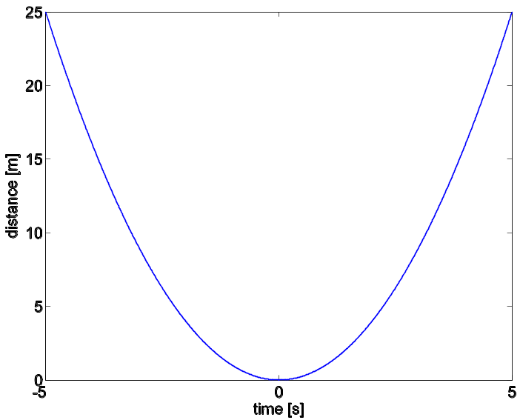
Figure 1. System output for $-5≤x≤+5$.

Tables are very similar to figures. They are centred, properly labelled, and appear only after being at least mentioned once. The only difference is that their captions appear above the table. For example, see Table 1.

Table 1. Error rates for four different trials.
Trial | X | Y | error
1 | 0.0 | 0.20 | 0.20
2 | 0.5 | 0.25 | 0.00
3 | 1.0 | 1.05 | 0.05
4 | 1.5 | 2.15 | -0.10

6. Equations
Equations are to be generated using the MS Word equation tab. They are to be numbered and all the parameters need to be described in the body. For example, the mass–energy equivalence is presented in Eq. 1 as:

$$E= mc^{2}$$ | (1)

Where E is energy, m denotes mass, and c is the speed of light.

5. Conclusion
One or more paragraphs must be provided at the end of the manuscript, which describe the general findings and conclusions of the paper.

References
[1] B. Klaus and P. Horn, Robot Vision. Cambridge, MA: MIT Press, 1986.
[2] L. Stein, “Random patterns,” in Computers and You, J. S. Brake, Ed. New York: Wiley, 1994, pp. 55-70.
[3] J. P. Wilkinson, “Nonlinear resonant circuit devices,” U.S. Patent 3 624 125, July 16, 1990.
[4] J. O. Williams, “Narrow-band analyzer,” Ph.D. dissertation, Dept. Elect. Eng., Harvard Univ., Cambridge, MA.
[5] U. V. Koc and K. R. Liu, “Discrete-cosine/sine-transform based motion estimation,” in Proceedings of the IEEE International Conference on Image Processing, Austin, TX, 1994, vol. 3, pp. 771-775.
[6] R. E. Kalman, “New results in linear filtering and prediction theory,” J. Basic Eng., vol. 83, no. 4, pp. 95-108, 1961.
[7] K. Author. (2015, May 10). Facility Greenhouse Gas Reporting (2nd ed.) [Online]. Available: http://www.ec.gc.ca/ges-ghg/default.asp?lang=En&n=040E378D-1

