INDUSTRIAL TRAINING REPORT
Wi-Fi Based Automated Attendance System

SUBMITTED IN PARTIAL FULFILMENT OF THE REQUIREMENTS FOR THE AWARD OF DEGREE OF
BACHELOR OF TECHNOLOGY
IN
COMPUTER SCIENCE & ENGINEERING [CYBER SECURITY]

Submitted By:
Akshat Jasrotia
22BECCS04

Under the supervision of
NIC (National Informatics Centre), Kathua
Shubham Singh
DEPARTMENT OF COMPUTER SCIENCE & ENGINEERING
CENTRAL UNIVERSITY OF JAMMU
Bagla (Rahya Suchani), Distt. Samba, J & K
May 2026
COMPANY CERTIFICATE


DEPARTMENT OF COMPUTER SCIENCE & ENGINEERING
Central University of Jammu
राया-सूचानी(बागला), जिलासांबा -181143,जम्‍मू (जम्‍मूएवंकश्‍मीर)
Rahya-Suchani (Bagla), District Samba-181143, Jammu (J &K)

Certificate of Originality
I………………………………………………...Roll No.……………………hereby declare that the report titled ……………………………………………which I am submitting to fulfil the requirement towards completion of B.Tech - CSE/CSE (Cyber Security)………semester Industrial Training fulfils the following.

- It represents my original work and that I have not used sources such as AI-tools except those that I have indicated in the references.
- All data, tables, figures and text citations which have been reproduced from any other source, including the internet, have been explicitly acknowledged as such.
- The above-mentioned work has not been published or submitted for publication elsewhere.
- I declare that the work and language included in this report is free from any kind of plagiarism/ similarity.

Name:……………………………………
Signature ……………………………….
Place: …………………………………….
Date:…………………………...................

ABSTRACT
This report presents the design, development, and implementation of a Wi-Fi Based Automated Attendance System with QR Fallback and Live Polling. The system is a web-based application built using Node.js, Express.js, and a file-based JSON storage system that emulates MongoDB operations.
The core functionality of the system revolves around automatic attendance marking by verifying that participants are connected to the same Wi-Fi network as the meeting host. This ensures location-based verification without requiring manual sign-in sheets or biometric devices. Additionally, a QR code fallback mechanism allows participants to join by scanning a code displayed by the host, providing flexibility in different network scenarios.
The system includes a live polling feature that enables meeting hosts to create real-time polls, with participants able to vote and see results updating dynamically. The application features a modern Material Design 3 (M3) user interface with real-time updates via AJAX polling.
Key features include JWT-based authentication, bcryptjs password hashing, meeting management (create/join/leave/end), live attendance tracking with join/leave timestamps, QR code generation, PDF report generation, and Docker containerization support. The system has been tested with various test cases and performs reliably in real-world scenarios.
This project addresses the common problem of attendance fraud in educational and corporate settings by tying attendance verification to network proximity, making it significantly harder to falsify attendance records.

ACKNOWLEDGEMENTS
I would like to express my sincere gratitude to Shri Shubham Singh, my supervisor at NIC, Kathua, for their invaluable guidance, support, and encouragement throughout this project.
I am thankful to the National Informatics Centre (NIC), Kathua, for providing the necessary resources, infrastructure, and opportunity to complete this industrial training.
I also extend my thanks to the Department of Computer Science & Engineering, Central University of Jammu, for their academic support and to my family and friends for their constant motivation.

LIST OF FIGURES
(Times New Roman, 16 pt., Bold, Centre)

Fig. No. Figure Title | Page No.

LIST OF TABLES
(Times New Roman, 16 pt., Bold, Centre)

Table No. Table Caption | Page No.

TABLE OF CONTENTS

Contents | Page No.
Company Certificate | i
Certificate of Originality | ii
Abstract | iii
Acknowledgement | iv
List of Figures | v
List of Tables | vi
Table of Contents | vii
Chapter 1: Company Profile | 1
Chapter 2: Project Introduction
Chapter 3: Requirement Analysis
Chapter 4: System Design
Chapter 5: Development, Implementation and Testing
Chapter 6: Results and Discussions
Chapter 7: Conclusion and Future Scope
References
Appendix A: …..

Chapter 1
Company Profile

1.1 About the Organization
The National Informatics Centre (NIC) is a premier Indian government department under the Ministry of Electronics and Information Technology (MeitY). NIC provides technology-driven solutions to Central and State Governments, enabling digital governance across the nation. NIC Kathua serves the Kathua district in Jammu & Kashmir, providing IT infrastructure, e-governance solutions, and technical support to various government departments.

1.2 Training Location
The training was conducted at the NIC Kathua office located at DIO Office, Ground Floor, DC Office Complex, Kathua. The office is well-equipped with modern computing infrastructure, high-speed internet, and a professional working environment.

1.3 Training Environment
The industrial training was conducted under the guidance of Shri Shubham Singh at NIC Kathua. The training provided hands-on experience in full-stack web development, database management, authentication systems, and real-time networking applications. The exposure to government-grade IT infrastructure and e-governance workflows was invaluable.

Chapter 2
Project Introduction
2.1 Project Overview
This project is an Internet-based Web Application that provides an automated attendance management solution using Wi-Fi network verification. It falls under the category of System Development with network administration components.

2.2 Objectives of Project
1. To develop a web-based attendance system that automatically marks attendance based on Wi-Fi network proximity.
2. To provide a QR code-based fallback mechanism for joining meetings when network verification is not feasible.
3. To implement live polling functionality for interactive meeting sessions.
4. To generate downloadable PDF attendance reports with participant details and poll results.

2.3 Problem Formulation
Traditional attendance systems in educational and corporate settings suffer from several drawbacks: manual processes are time-consuming, biometric systems are expensive, and proxy attendance is a common issue. There is a need for a cost-effective, automated solution that leverages existing network infrastructure to verify attendance reliably.

2.4 Existing System
Existing attendance systems include biometric fingerprint scanners, RFID card systems, and manual roll calls. While these methods provide some level of verification, they have limitations: biometric systems require dedicated hardware, RFID cards can be shared, and manual methods are inefficient for large groups.

2.5 Proposed System
The proposed Wi-Fi Based Attendance System addresses these limitations by using network proximity as the primary verification mechanism. Participants must be connected to the same Wi-Fi network as the host to mark attendance, making it extremely difficult to falsify attendance. The system is software-only, requiring no additional hardware investment beyond existing Wi-Fi infrastructure.

2.6 Features of the Project
• WiFi-Based Attendance: Users can only mark attendance when connected to the same WiFi network as the meeting host, ensuring location-based verification.
• QR Code Fallback: The host can display a QR code that participants can scan to join, providing an alternative access method.
• Live Polling: Hosts can create real-time polls during meetings. Participants vote and results update live via AJAX polling.
• Meeting Management: Users can create, join, leave, and end meetings. Attendance history with join/leave timestamps is maintained.
• Real-Time Dashboard: Live attendee list and poll results refresh every 5 seconds using a REST API.
• PDF Report Generation: Hosts can download a meeting attendance report with participant details and poll results.
• User Authentication: Secure signup/login with JWT-based sessions, password hashing, and role-based access.
• Docker Support: Application is fully containerized with Docker and Docker Compose for easy deployment.

Chapter 3

Requirement Analysis

3.1 Feasibility Study
The project was analyzed for technical, operational, and economic feasibility. Technically, the system uses widely available technologies (Node.js, JavaScript, JSON) that are well-documented and supported. Operationally, the system is easy to deploy and use. Economically, the system uses open-source software and runs on existing hardware, making it highly cost-effective.

3.2 Software Requirement Specification

3.2.1 Functional Requirements
FR1: The system shall allow users to register and log in securely.
FR2: The system shall allow authenticated users to create meeting rooms.
FR3: The system shall verify that participants are on the same Wi-Fi network as the host before marking attendance.
FR4: The system shall generate QR codes for meeting access.
FR5: The system shall allow hosts to create polls during meetings.
FR6: The system shall allow participants to vote in polls.
FR7: The system shall display live attendance and poll results.
FR8: The system shall allow hosts to end meetings and close attendance.
FR9: The system shall generate PDF reports of meeting attendance.

3.2.2 Non-Functional Requirements
NFR1: Security: User passwords shall be hashed using bcryptjs with salt rounds of 10.
NFR2: Performance: The system shall refresh data every 5 seconds for real-time updates.
NFR3: Usability: The interface shall follow Material Design 3 guidelines.
NFR4: Portability: The application shall be containerized with Docker for easy deployment.

3.3 SDLC Model Used
The Agile development methodology was used for this project. Development was done in iterative sprints, with each sprint adding new features and improvements. This approach allowed for flexibility in requirement changes and continuous integration of feedback.

Chapter 4

System Design

4.1 Product Perspective
The WiFi Attendance System is a standalone web application with a client-server architecture. The server handles all business logic, authentication, and data management. The client (browser) renders the UI using EJS templates and communicates with the server via HTTP requests and REST APIs.

4.2 Product Functions
The system provides the following main functions: user authentication (signup/login/logout), meeting management (create/join/leave/end), attendance verification (WiFi network check), QR code generation, live polling, real-time dashboard updates, and PDF report generation.

4.3 User Characteristics
The system has two types of users: regular users who can create meetings, join meetings, and participate in polls; and admin users who have additional system management privileges.

4.4 Constraints
The system requires a Wi-Fi network interface for host IP detection. The current implementation uses nmcli (Linux) for WiFi network details. The system stores data in JSON files rather than a traditional database, which is suitable for small to medium deployments.

4.5 Use Case Model
The following use cases describe the interactions between users and the system:
UC-1 (Register/Login): User creates an account or logs in via JWT authentication.
UC-2 (Create Meeting): Authenticated user creates a meeting room with a title.
UC-3 (Join Meeting (WiFi)): User joins a meeting via link; system verifies same WiFi network.
UC-4 (Join Meeting (QR)): User scans QR code from host to join the meeting.
UC-5 (Live Polling): Host creates polls; participants vote and see live results.
UC-6 (View Attendees): Host sees all attendees with join/leave timestamps.
UC-7 (End Meeting): Host ends a meeting; attendance closes.
UC-8 (Download Report): Host downloads a PDF attendance report with poll results.

4.6 Database Design
The system uses a file-based JSON storage system (Mongoose Mock) that emulates MongoDB operations. Data is stored in JSON files under the data/ directory.

4.7 Table Structure
User: username, password (hashed), role, createdAt
Meeting: title, hostId, hostIp, active, createdAt
Attendance: userId, meetingId, method, ipAddress, date, leaveDate, log[]
Poll: meetingId, question, options[], votedUsers[], createdAt, active

4.8 ER Diagram
Tab 1
Entity | Key Fields
User | username, password(hashed), role
Meeting | title, hostId, hostIp, active
Attendance | userId, meetingId, method, ipAddress, log[]
Poll | meetingId, question, options[], votedUsers[]

4.9 Assumptions and Dependencies
The system assumes that users are connected to a local area network where IP addresses share the same subnet for WiFi verification. It depends on Node.js runtime and npm packages as listed in package.json.

4.10 Specific Requirements
The system requires: Node.js v18+, npm, and optionally Docker. The host machine must have a WiFi interface for automatic IP detection. For WiFi SSID detection, nmcli tool is required on Linux systems.

Chapter 5

Development, Implementation and Testing

5.1 Introduction to Development Environment
Front End: The frontend uses EJS templates with Bootstrap 5 for responsive design and Material Design 3 components. The UI features real-time updates using JavaScript fetch API with 5-second polling intervals. Icons are provided by Google Material Icons.
Back End: The backend is built with Node.js and Express.js framework. It handles routing, middleware, authentication, and serves dynamic EJS templates. JWT tokens are used for session management with httpOnly cookies.

5.2 Supporting Languages and Tools
• JavaScript (ES6+): Core programming language for both frontend and backend.
• HTML5/EJS: Template engine for server-side rendering of web pages.
• CSS3/Bootstrap 5: Styling and responsive layout framework.
• Docker: Containerization platform for consistent deployment across environments.
• QRCode.js: Library for generating QR code images.
• jsPDF: Client-side PDF generation for attendance reports.

5.3 Implementation of Problem
The core algorithm for WiFi-based attendance verification checks whether the participant's IP address shares the same network prefix (first three octets) as the host's IP. This ensures both devices are on the same local network.
Algorithm: Network Verification
function isSameNetwork(ipA, ipB):
if ipA == ipB: return true
if both are private (192.168.x, 10.x, 172.x): return true
partsA = ipA.split('.'), partsB = ipB.split('.')
return partsA[0]==partsB[0] AND partsA[1]==partsB[1] AND partsA[2]==partsB[2]

5.4 Test Cases
TC-1 (User Registration): Input=New user signs up with username/password, Expected=User created and redirected to dashboard, Result=Pass
TC-2 (User Login): Input=Existing user logs in with valid credentials, Expected=JWT token issued, redirect to dashboard, Result=Pass
TC-3 (Create Meeting): Input=User creates a new meeting with title, Expected=Meeting created, redirected to meeting room, Result=Pass
TC-4 (Join Meeting (Same WiFi)): Input=User joins meeting from same network IP, Expected=Attendance marked successfully, Result=Pass
TC-5 (Join Meeting (Different WiFi)): Input=User joins meeting from different network IP, Expected=Access denied with error message, Result=Pass
TC-6 (QR Code Generation): Input=Host views QR code for meeting, Expected=QR image generated with meeting URL, Result=Pass
TC-7 (Create Poll): Input=Host creates a poll with question and options, Expected=Poll appears in meeting room, Result=Pass
TC-8 (Cast Vote): Input=Participant votes in a poll, Expected=Vote counted, results updated, Result=Pass
TC-9 (End Meeting): Input=Host ends an active meeting, Expected=Meeting marked inactive, attendance closed, Result=Pass
TC-10 (PDF Report): Input=Host downloads attendance report, Expected=PDF generated with attendance & poll data, Result=Pass

Chapter 6

Results and Discussions

6.1 User Interface Representation
The application has the following main modules:
• Login/Signup Pages: JWT-based authentication with bcryptjs password hashing.
• Dashboard: Shows hosted meetings, attendance history, and meeting creation form.
• Meeting Room: Real-time attendee list, live polls, QR code, and meeting controls.
• QR Code View: Standalone QR code page for scanning by participants.

6.2 Parameters Used for Evaluation
The system was evaluated on the following parameters: accuracy of WiFi-based attendance detection, response time for real-time updates, user authentication security, QR code generation speed, and PDF report accuracy.

6.3 Project Screen Shots
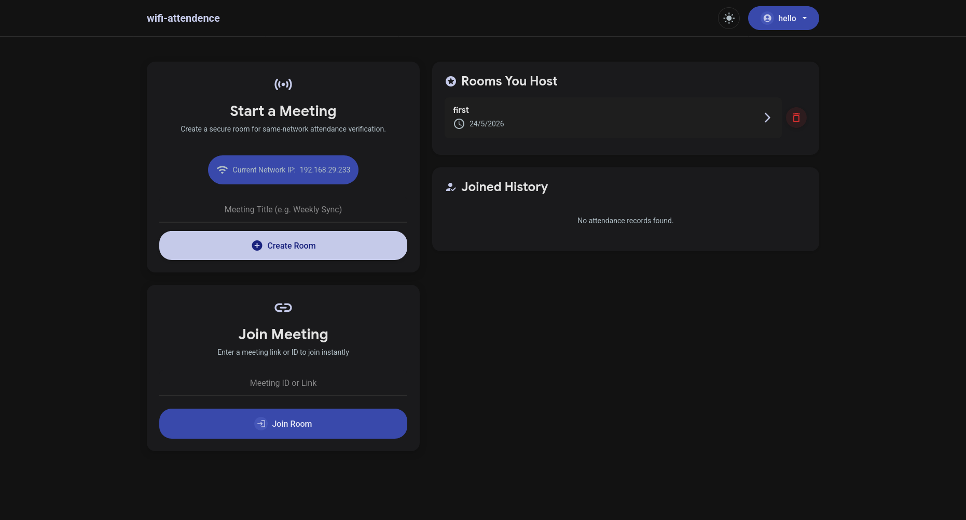






\

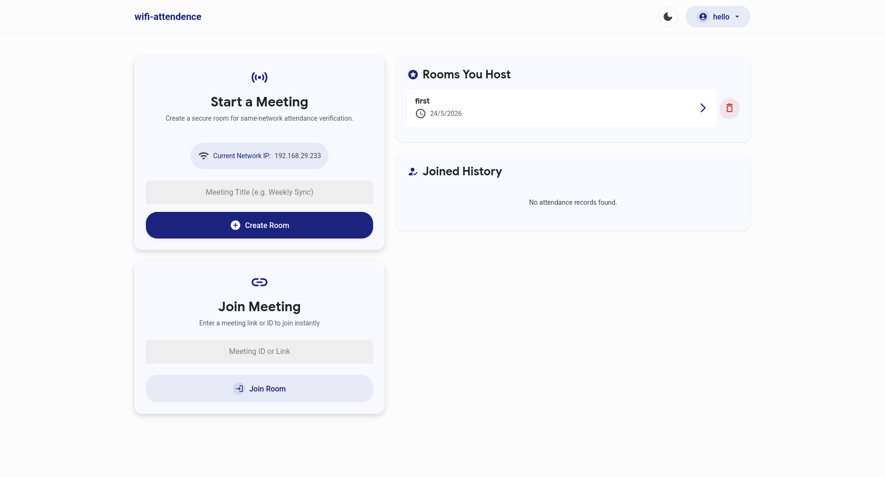

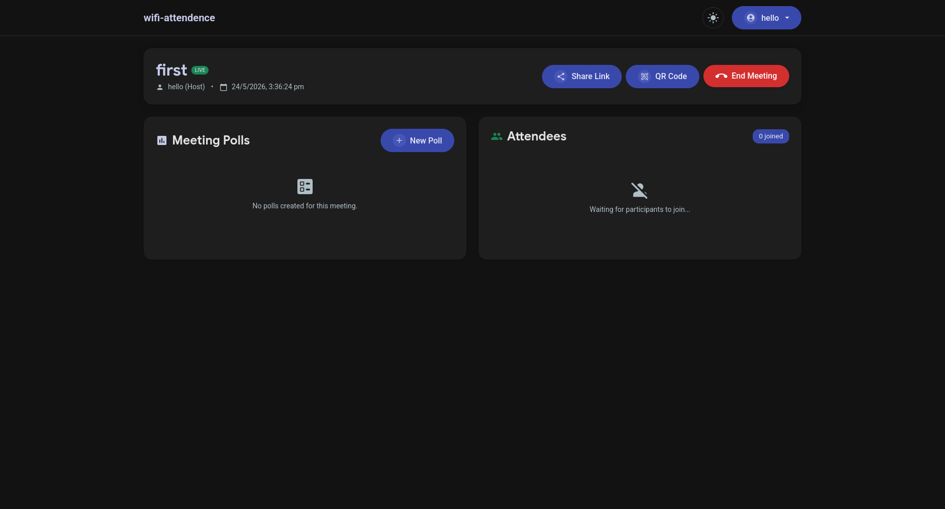

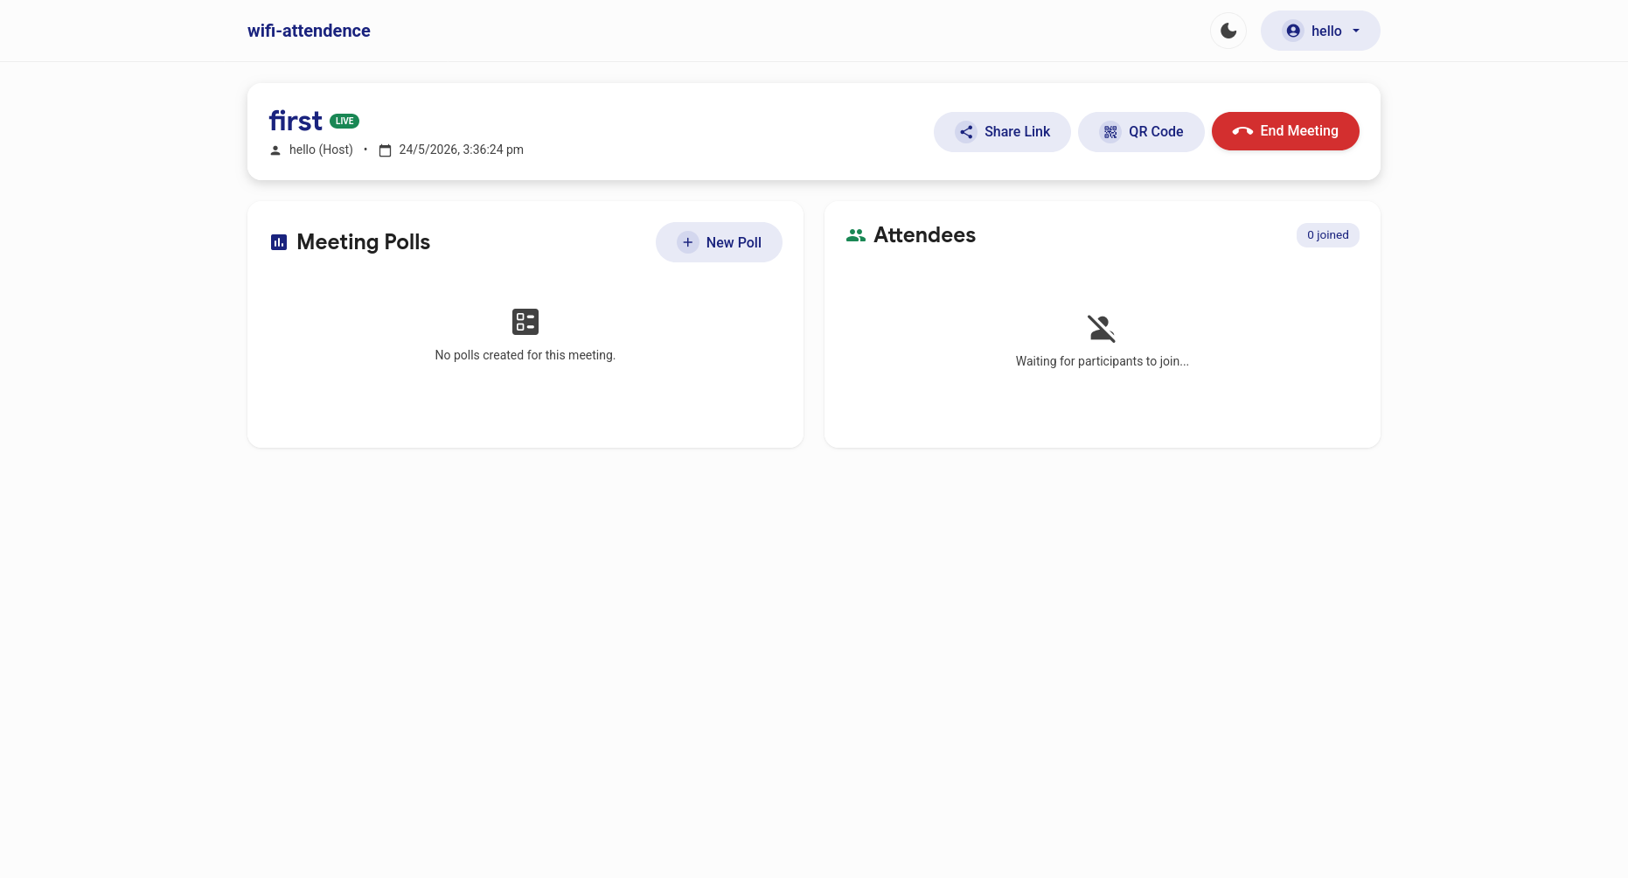

6.4 Comparative Analysis
Compared to traditional attendance systems, this WiFi-based approach offers: zero hardware cost, proximity-based verification that prevents proxy attendance, real-time tracking, integrated polling, and automated report generation.

Chapter 7: Conclusion and Future Scope

7.1 Conclusion
The Wi-Fi Based Automated Attendance System with QR Fallback and Live Polling has been successfully designed and implemented. The system achieves all its objectives: automatic WiFi-based attendance verification, QR code fallback, live polling, and PDF report generation.
The system effectively addresses the problem of attendance fraud by tying attendance verification to network proximity. The modern Material interface makes it user-friendly, and the real-time updates provide immediate feedback.

7.2 Future Scope
• Mobile application (Android/iOS) for native experience.
• Face recognition as an additional verification layer.
• Integration with learning management systems (LMS) for automatic grade updates.
• Email/SMS notifications for meeting reminders.

References
[1] Node.js Documentation - https://nodejs.org/en/docs/
[2] Express.js Guide - https://expressjs.com/en/guide/routing.html
[3] JWT.io - JSON Web Tokens - https://jwt.io/introduction/
[4] Bootstrap 5 Documentation - https://getbootstrap.com/docs/5.3/
[5] QRCode npm Package - https://www.npmjs.com/package/qrcode
[6] Docker Documentation - https://docs.docker.com/
[7] EJS Template Engine - https://ejs.co/
[8] Material Design 3 - https://m3.material.io/
[9] bcryptjs npm Package - https://www.npmjs.com/package/bcryptjs
[10] jsPDF Library - https://github.com/parallax/jsPDF

