UIUX Assignment 1
Name : Archita Jha
PRN: 1262243200
TY AI_DS Panel-F
Batch-F2
Domain: Coding Platforms
Websites Evaluated: LeetCode, HackerRank, Codeforces

LeetCode
Parameter | Justification | Rating (1-10)
Learnability | The moment you open a problem, you get a clean split screen statement on one side, editor on the other which is easy to figure out. | 9
Usability | Everything you need to actually solve a problem Run, Submit, test cases sits right where you'd expect it. You can go from reading a problem to submitting a solution in just a few clicks. | 9
Consistency | Difficulty tags are always the same three colors, problem cards look identical everywhere, and the icons don't change as you move between practice, contests, and discussions. | 8
Use of Metaphors | There isn't much metaphor here beyond color-coded tags and the occasional trophy icon for contests it leans more on standard IDE conventions than real-world imagery. | 6
Navigation Structure | The sidebar (Problems, Explore, Contest, Discuss) makes the big picture easy to follow, though once you're deep inside a topic list, there's no breadcrumb trail to show you where you are. | 7
Visual Hierarchy | Titles are bold, difficulty is color-coded, and the acceptance rate is right there it's obvious what's the problem and what's the code editor. | 8
Accessibility | Text defaults to a fairly small size, dark mode contrast isn't always great, and keyboard-only users will find the editor hard to navigate without a mouse. | 5
Responsiveness | The website is built for all screens (can check using dev tools on the website). | 9
Efficiency of Interaction | Shortcuts for running and submitting code, plus a quick language switch, mean you rarely waste a click getting to a working submission. | 8
Feedback and System Status | You know immediately whether you passed or failed, along with runtime and memory numbers, and the error messages (Wrong Answer, TLE) are clear enough to act on. | 8
Error Prevention and Recovery | Your code auto-saves as you go, so it's hard to lose progress by accident , though there's no real "undo" if you reset the editor by mistake. | 7
Aesthetic and Minimalist Design | The two-pane layout keeps things tidy, and it would feel genuinely minimal if it weren't for the occasional ad or premium banner interrupting the flow. | 8
Content Readability | Code shows up in a proper monospace font with syntax highlighting, and problem statements are formatted cleanly enough to skim quickly. | 8
Search and Discoverability | Filtering by topic, difficulty, or company is genuinely useful, though the plain search bar itself is pretty basic mostly keyword matching. | 7
Performance Perception | Pages generally load fast, but during contests the judge can get backed up and you're left staring at a spinner longer than you'd like. | 8
Trust and Credibility | It's a well-known name with tags showing which companies actually ask each question, plus official solutions , all of which make it feel trustworthy. | 10
Personalization | A streak calendar, progress tracking, and recommended problems make the platform feel like it's paying attention to your habits. There is also “my list ” in which you can add the problems that you would want to practice later on | 10
User Satisfaction | Most people rate it highly for interview prep, even with some grumbling about how much is locked behind Premium. | 9

Evidence Screenshots
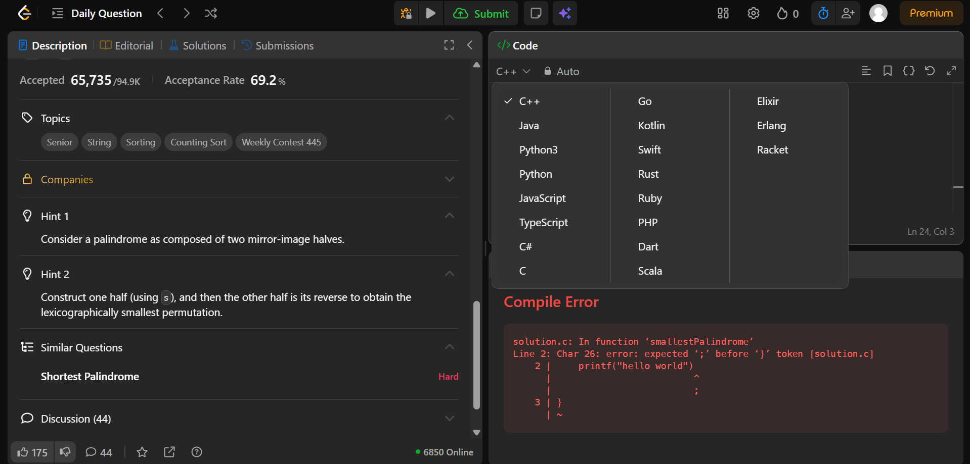
Fig. 1 — Problem view: statement panel (with hints) alongside the code editor
- Learnability: The expandable Hint 1 / Hint 2 panels ease a first-time solver into the problem without leaving the page.
- Efficiency of Interaction: A one-click language switch dropdown (C++, Java, Python, etc.) and a visible Run shortcut cut down on wasted clicks.
- Feedback and System Status: A compile error is shown directly in the editor with an inline red underline.
- Error Prevention and Recovery: The syntax error is flagged inline before the user even attempts to submit.

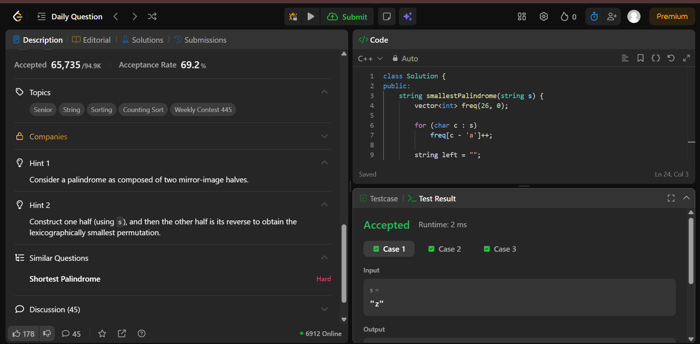
Fig. 2 — Run/Submit result: Accepted verdict with runtime
- Usability: The full Run → Submit workflow completes in the same view, ending in a clear Accepted result.
- Content Readability: Problem statement, hints, and code stay legible together thanks to monospace formatting and clear spacing.
- Performance Perception: Runtime (2 ms) is displayed immediately after submission, reinforcing a feeling of speed.
- Feedback and System Status: The Accepted banner plus runtime number gives an unambiguous pass/fail signal.

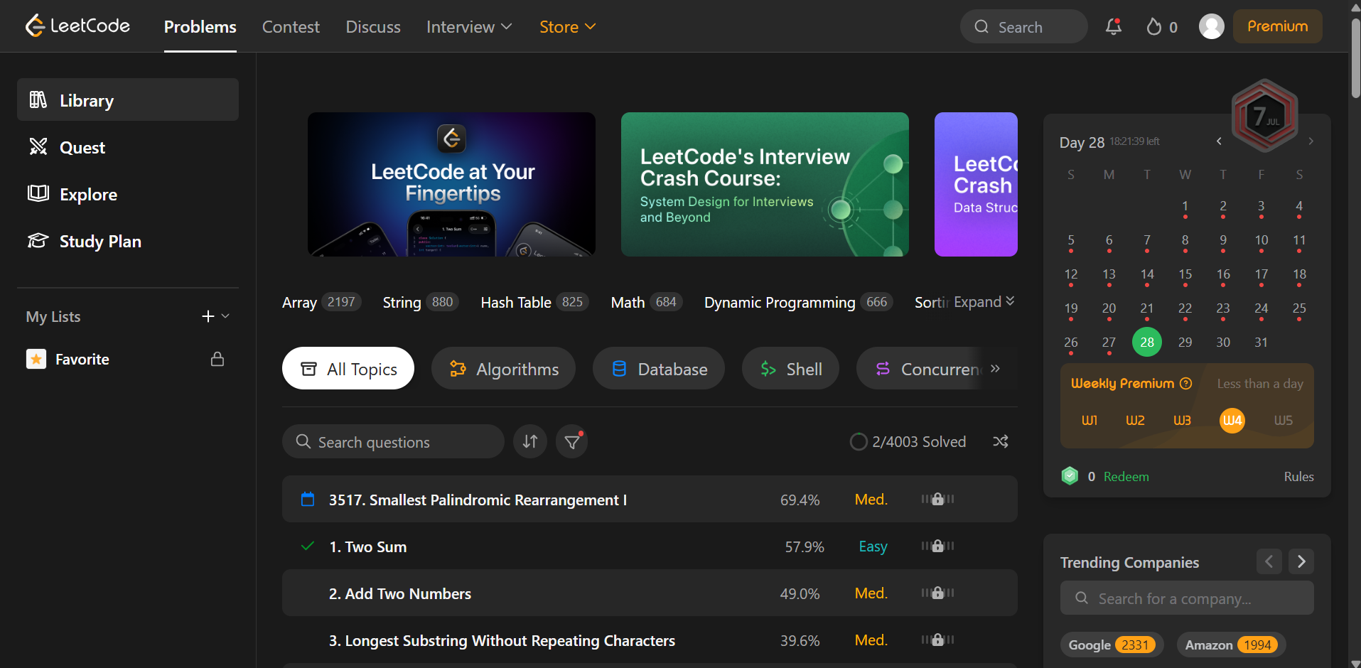
Fig. 3 — Problem list dashboard: sidebar, search bar, and difficulty tags
- Consistency: Difficulty tags use the same three colors (Easy/Medium/Hard) on every row of the problem list.
- Navigation Structure: The left sidebar (Library, Quest, Explore, Study Plan) plus the top nav bar map out the site's structure.
- Search and Discoverability: A search bar sits above topic tags (Array, String, Hash Table) for filtering problems.
- Personalization: A submission streak calendar and a Trending Companies panel are tailored to the logged-in user.
- Aesthetic and Minimalist Design: The two-column dashboard layout stays clean, aside from occasional promotional banners.

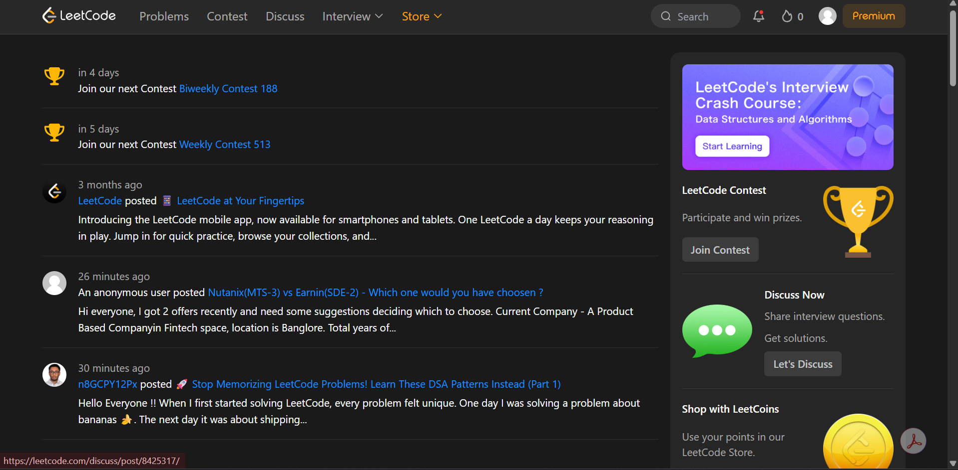
Fig. 4 — Explore/contest tile view with icon-based badges
- Use of Metaphors: A trophy icon marks contests and a streak-flame icon sits in the top bar, the two clearest metaphors on the platform.

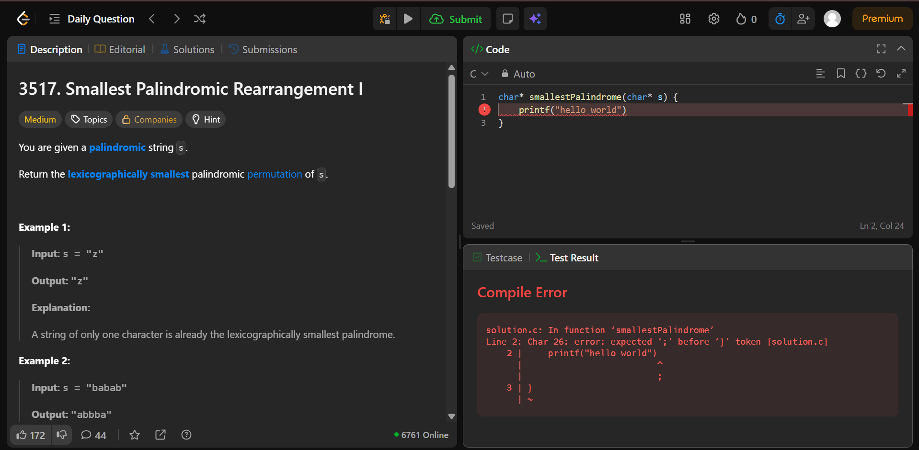
Fig. 5 — Problem statement page showing title, difficulty, and acceptance rate
- Visual Hierarchy: The problem title is bold while the description sits in normal weight, making the reading order obvious.
- Accessibility: The code editor's default font size is small and dark-mode contrast is limited, which is harder on the eyes.

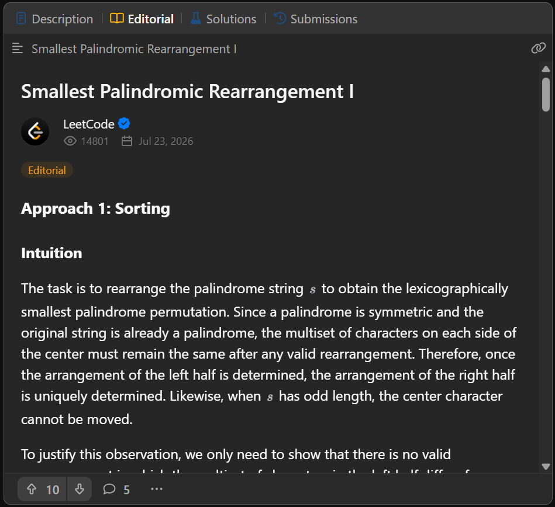
Fig. 6 — Editorial page with community engagement and verification
- User Satisfaction: Upvote and comment counts on the editorial show active community engagement with the content.
- Trust and Credibility: A verified LeetCode badge and a view count on the editorial signal that the content is official and vetted.

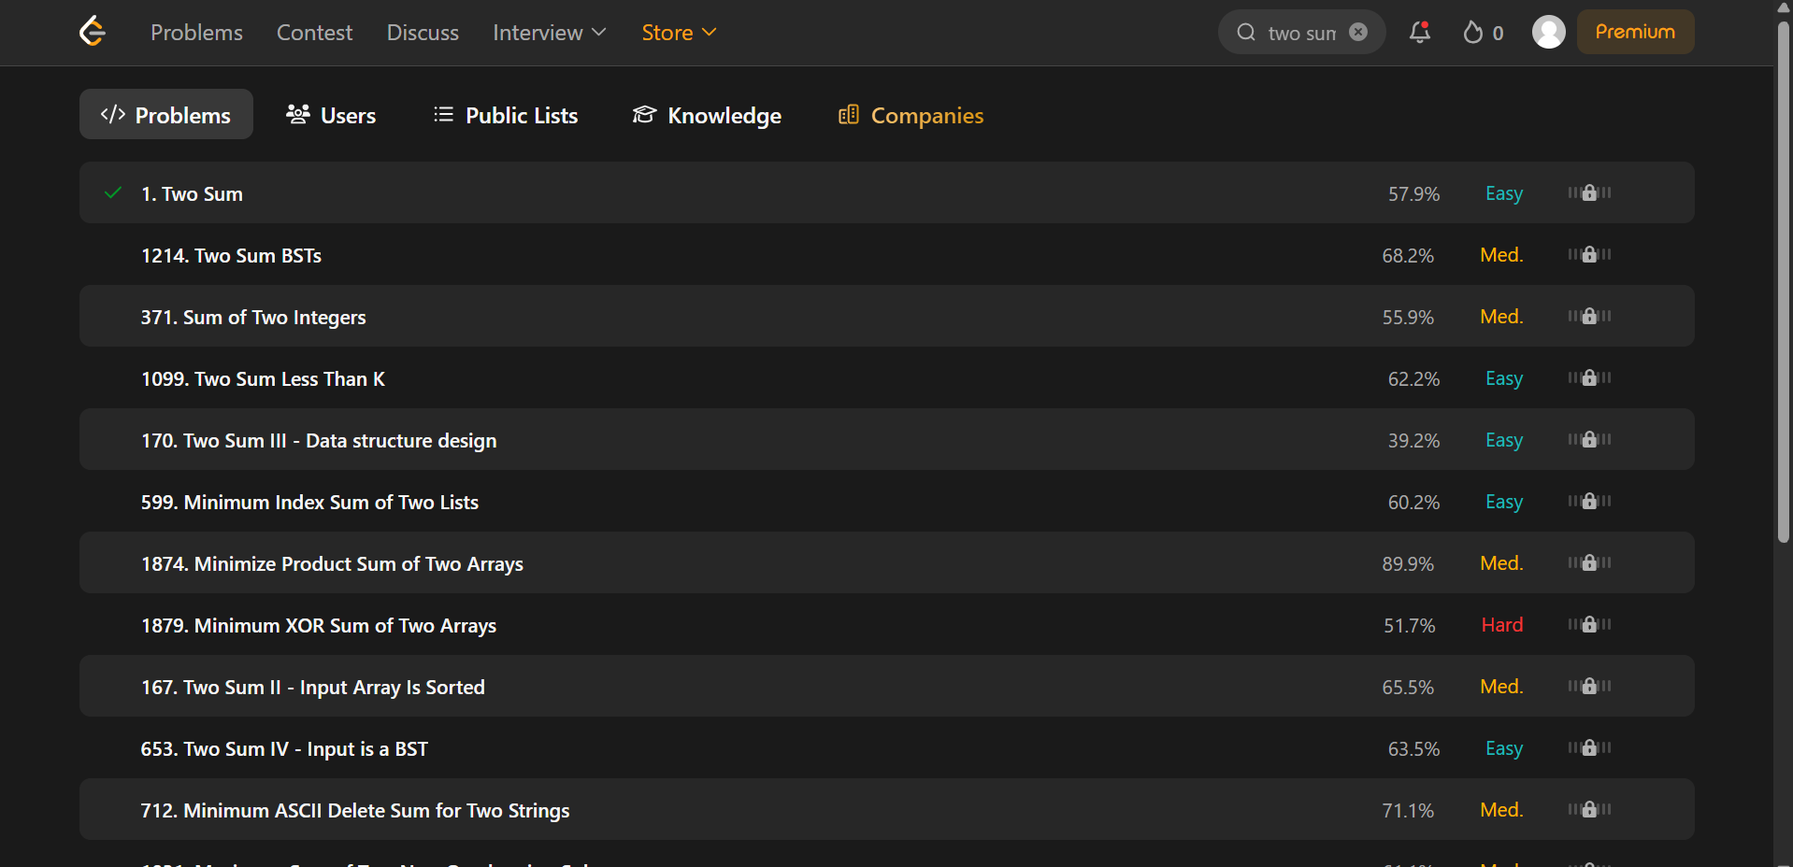
Fig. 7 — Full search results page with filters
- Search and Discoverability: The dedicated results page combines keyword search with topic and company filters side by side.

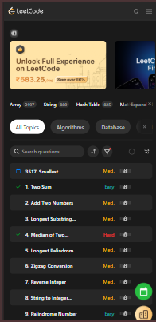
Fig. 8 — Mobile view of the platform
- Responsiveness: The layout reflows into a single usable column on a phone-sized screen instead of breaking or requiring horizontal scroll.

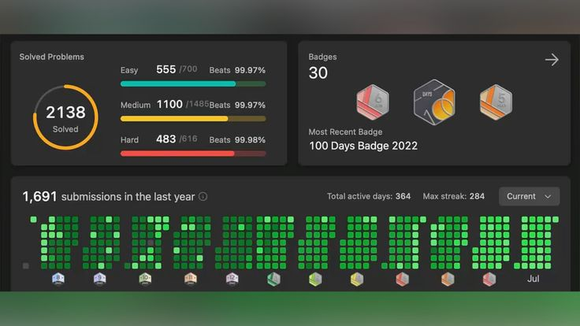
Fig. 9 — Streak page of leetcode
Personalization : You can see the number of problems you have solved, with each category and what days you have solved the problems(in green)

HackerRank
Parameter | Justification | Rating (1-10)
Learnability | First impressions can be a bit much the dashboard throws Interview Prep, Certifications, Skills, and Practice at you all at once, and it takes a minute to find your footing. | 8
Usability | The actual coding workflow works fine and feels similar to LeetCode's, but getting there involves more menu-digging than it probably needs to. | 7
Consistency | Practice, Contest, and Certification each have their own visual flavor, so it doesn't always feel like one cohesive product. | 6
Use of Metaphors | Badges and trophies for verified skills are a nice touch, but beyond that the interface sticks to fairly generic, corporate-feeling patterns. | 5
Navigation Structure | Domains lead to sub-domains lead to problems it's a deep hierarchy that asks you to remember quite a bit as you drill down. | 6
Visual Hierarchy | Pages lean text-heavy, and difficulty markers are small enough that they don't really jump out at you. | 6
Accessibility | Dense blocks of text and only moderate contrast make it harder going for anyone with visual difficulties, and nothing stands out as an accessibility feature. | 6
Responsiveness | Tablets are fine, but on a small phone screen some elements start to overflow or feel cramped. | 6
Efficiency of Interaction | Getting to a specific problem often means clicking through several layers of menus rather than just searching and going. | 7
Feedback and System Status | You get a clear score breakdown after submitting, though compiler errors can come back looking pretty raw and hard to parse. | 8
Error Prevention and Recovery | There's an autosave, but it's not the most reliable a few refreshes at the wrong moment and you can lose your work. | 6
Aesthetic and Minimalist Design | Between the certification banners and interview-prep prompts, the page feels busier than it needs to not quite as clean as it could be. | 6
Content Readability | Code is readable enough in the standard monospace font, but longer problem write-ups can turn into a wall of text. | 8
Search and Discoverability | Filters exist, but they're not especially refined search results sometimes bring back challenges that aren't really what you were looking for. | 6
Performance Perception | Domain pages occasionally take a beat to load, but overall the site performs reasonably well. | 6
Trust and Credibility | It's well respected in hiring circles, and the verified skill badges give recruiters and users a reason to trust the results. | 10
Personalization | Personalization mostly shows up as certification-track suggestions beyond that, it doesn't adapt much to you. | 8
User Satisfaction | It gets the job done for certification and hiring use cases, but people generally describe it as functional rather than delightful. | 8

Evidence Screenshots
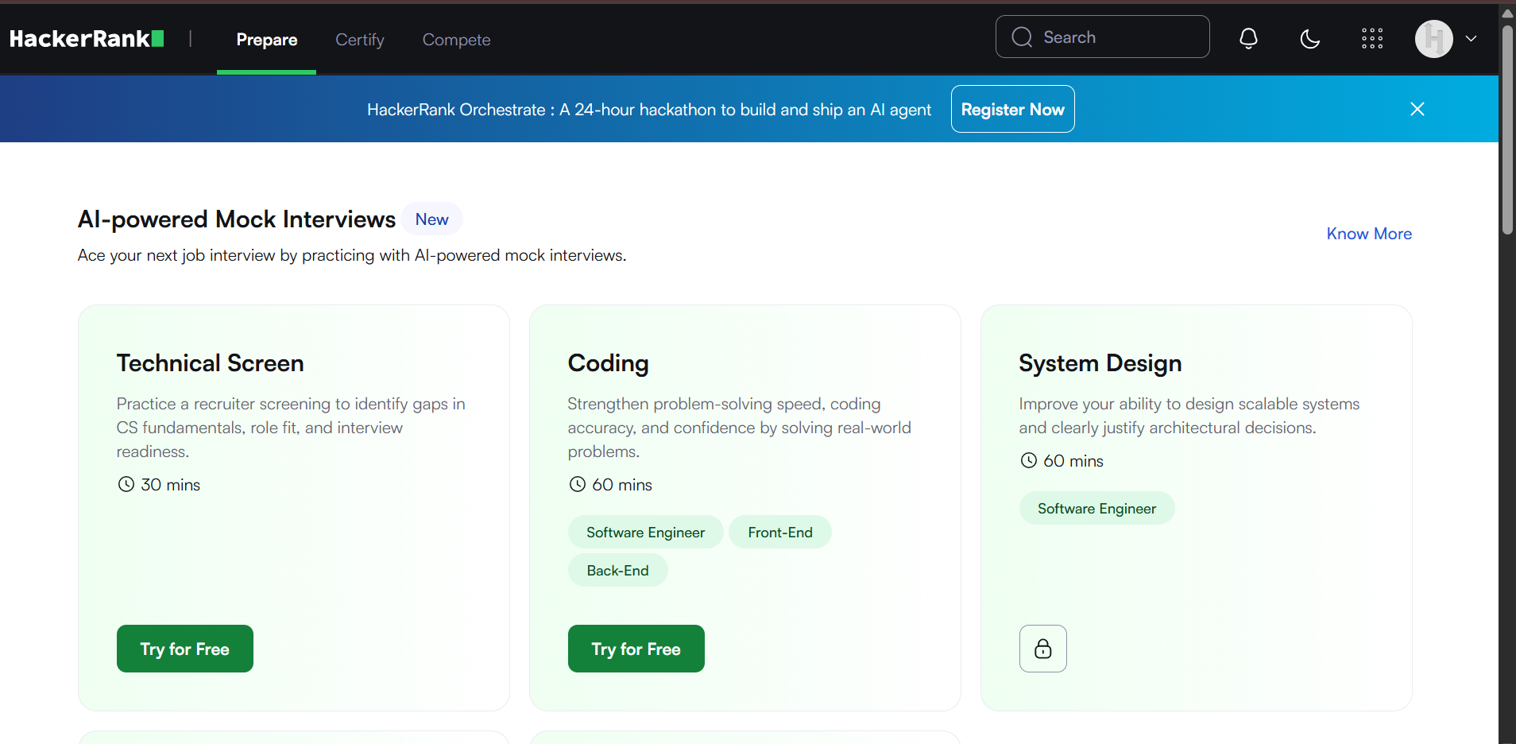
Fig. 10 — Landing dashboard with multiple entry points
- Learnability: Interview Prep, Certifications, Skills, and Practice are all presented at once on first load, giving a new user a lot to parse before finding their footing.

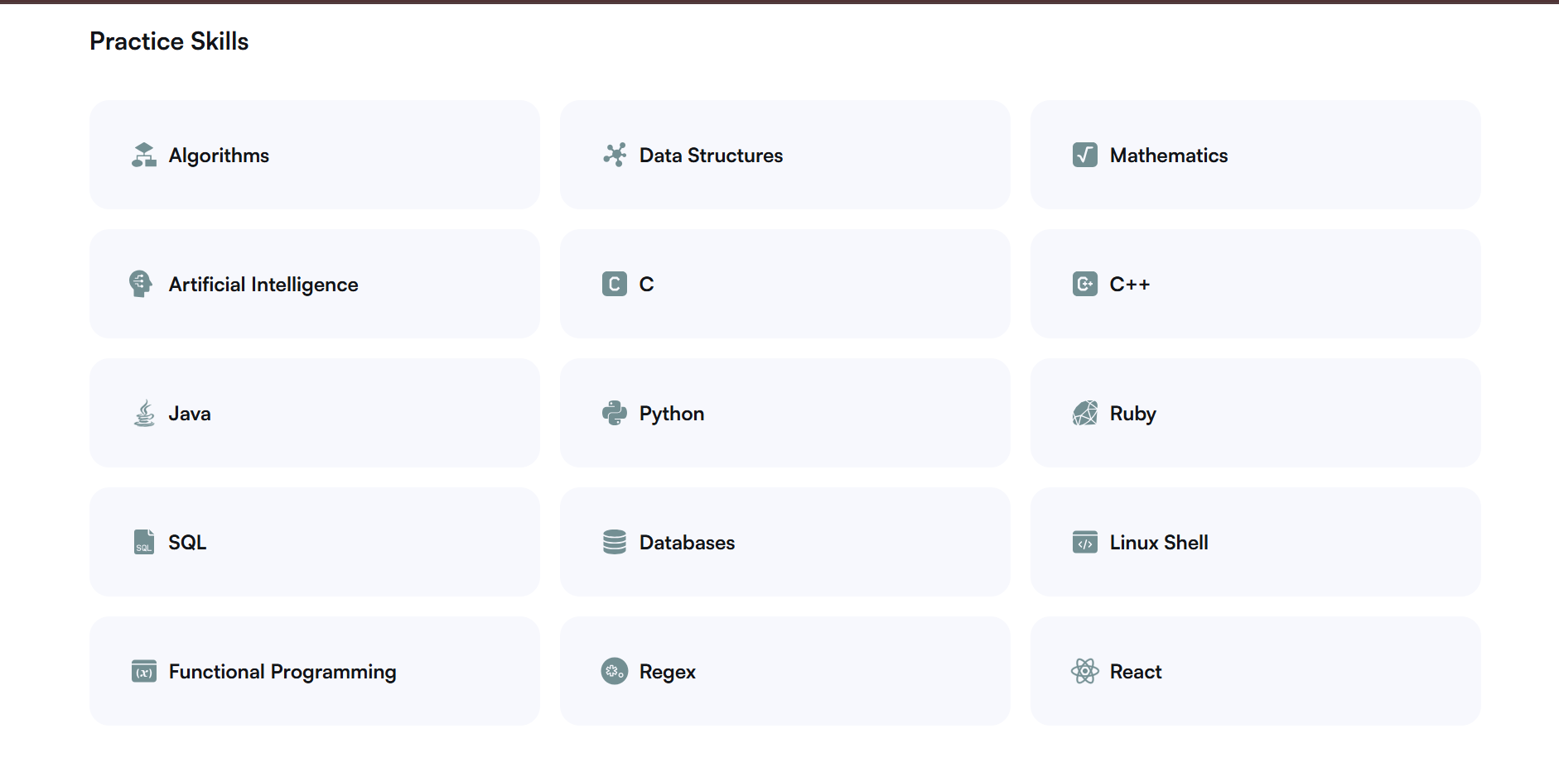
Fig. 11 — Domain/sub-domain browsing view
- Navigation Structure: Domains expand into sub-domains before reaching individual problems, illustrating the multi-level hierarchy.
- Efficiency of Interaction: Reaching a specific problem requires descending through several menu layers rather than a direct shortcut.
- Search and Discoverability: The filter controls on this page return results that are broad rather than tightly matched to the query.

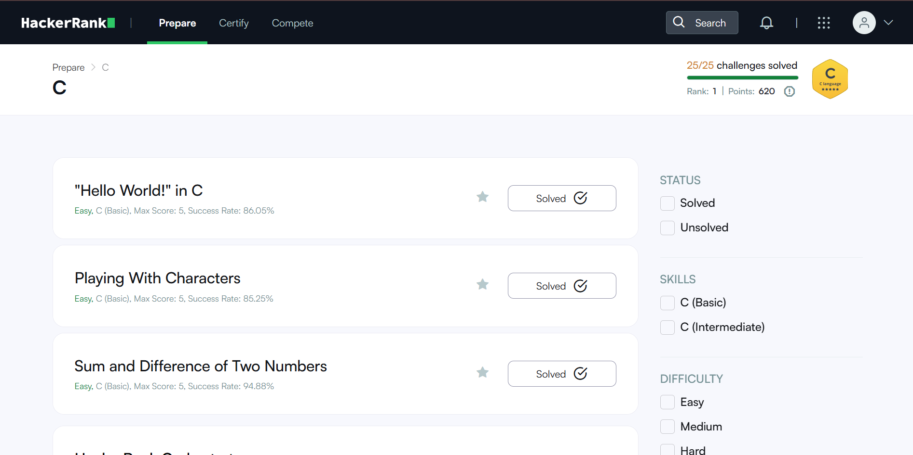
Fig. 12 — Coding workspace during a challenge
- Usability: The run/submit flow here works similarly to LeetCode's, keeping the core task straightforward once reached.
- Navigation Structure: Breadcrumb-style menu context around the editor shows how deep the current problem sits in the domain tree.

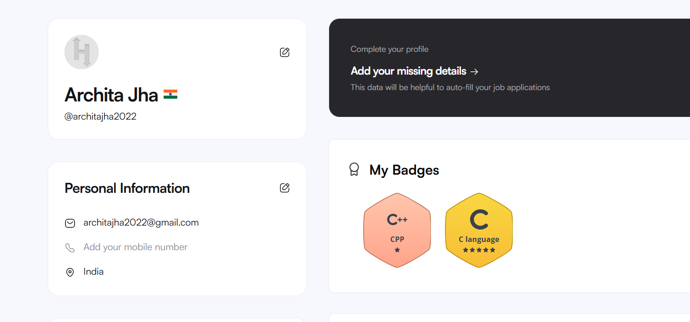
Fig. 13 — Certification/skills track panel
- Consistency: This panel's visual style (cards, colors, typography) differs noticeably from the Practice and Contest sections shown elsewhere.
- Use of Metaphors: Badges and trophies mark verified skills, one of the few metaphor-driven visuals on the platform.
- Personalization: Certification-track suggestions are surfaced based on the user's activity.

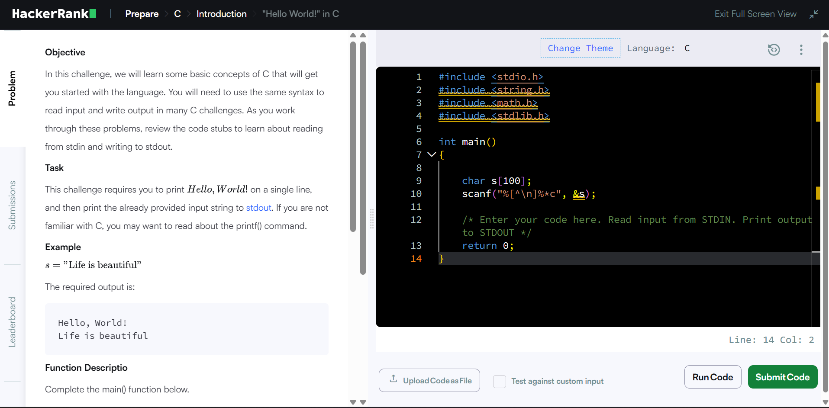
Fig. 14 — Text-dense problem/instructions page
- Accessibility: Large blocks of body text sit at only moderate contrast, with no visible accessibility controls (font scaling, high-contrast mode, etc.).

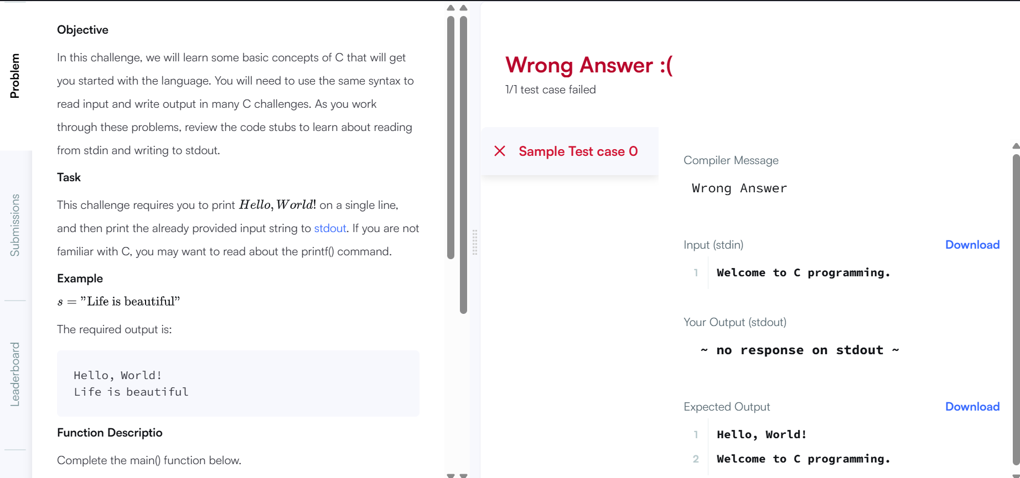
Fig. 15 — Submission result with score breakdown
- Feedback and System Status: A score breakdown appears after submission, though the raw compiler-error text beside it is harder to parse than LeetCode's equivalent.
- Error Prevention and Recovery: There is no strong safeguard against losing work the autosave here is inconsistent across refreshes.

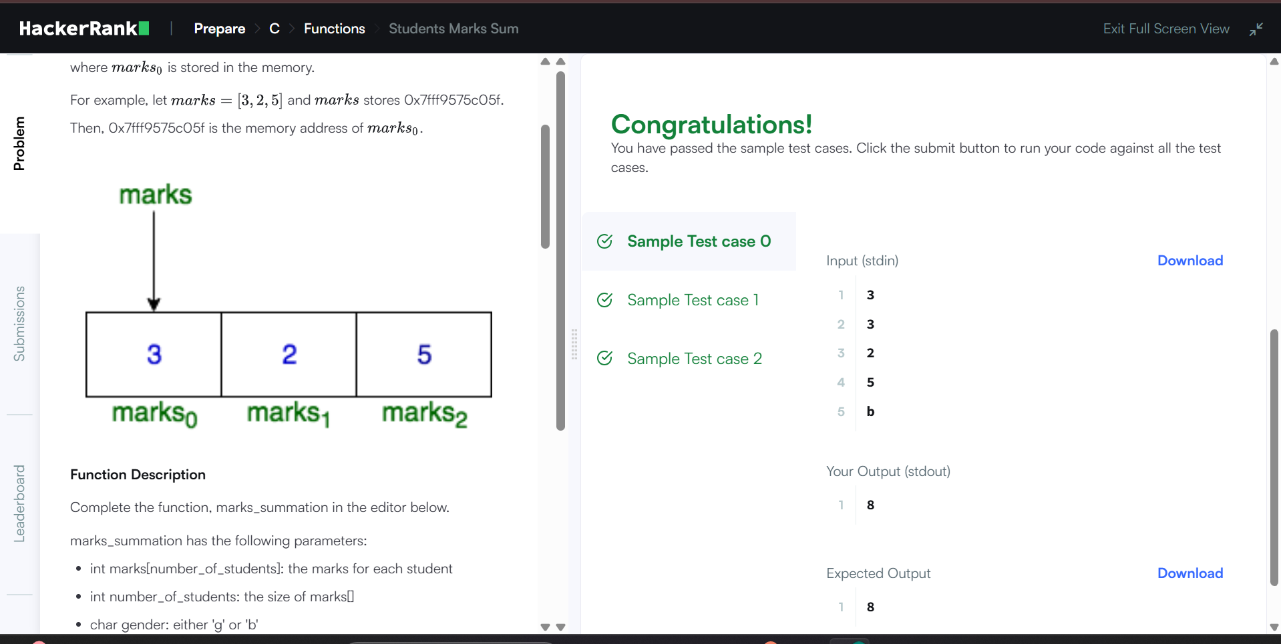
Fig. 16 — First-run practice selection screen
- Learnability: A second onboarding-style screen confirms the same pattern: several concurrent options with no guided walkthrough.

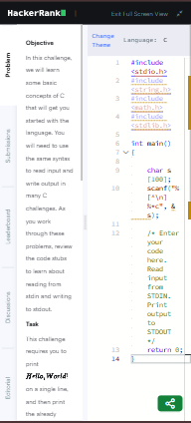
Fig. 17 — Mobile view (iPhone 14)
- Responsiveness: On a small phone screen, several elements begin to overflow or crowd together rather than adapting cleanly.

Codeforces
Parameter | Justification | Rating (1-10)
Learnability | Walking in for the first time can be rough it's dense, text-heavy, and there's no real onboarding to ease you in. | 4
Usability | Under the hood it's powerful, but the experience feels like it's stuck in an older era of web design, which makes everyday tasks less intuitive. | 5
Consistency | The upside of not changing much over the years is that everything looks the same everywhere predictable, even if a little tired-looking. | 6
Use of Metaphors | There's almost no attempt at visual metaphor just plain text, tables, and rating-colored usernames doing all the communicating. | 3
Navigation Structure | The top bar (Problemset, Gym, Blog, Contests) covers the essentials, but there's no breadcrumb trail, so you need to already know your way around. | 5
Visual Hierarchy | Nothing really pulls your eye anywhere specific the problem list and blog feed both read as one flat wall of content. | 4
Accessibility | Small fonts and low contrast make it tougher than it should be, and there's no visible nod to accessibility anywhere in the design. | 4
Responsiveness | This is very much a desktop-first site on mobile it feels cramped and clearly wasn't designed with smaller screens in mind. | 4
Efficiency of Interaction | Once you know your way around, submitting a solution is refreshingly fast it's the learning curve that's the real cost here. | 6
Feedback and System Status | Verdicts like Accepted or Wrong Answer show up clearly, just as plain text rather than anything more visually distinct. | 6
Error Prevention and Recovery | There's no autosave, so stepping away or navigating off the page at the wrong moment can cost you your unsaved code. | 4
Aesthetic and Minimalist Design | The sparse look feels more like an artifact of age than a deliberate design choice it's plain rather than intentionally simple. | 4
Content Readability | Problem statements are plain text with math rendered in LaTeX, but long paragraphs make it harder to skim than it should be. | 5
Search and Discoverability | Basic tag and rating filters exist, but most people end up relying on third-party sites to actually find good problems. | 4
Performance Perception | Ironically, the dated design pays off here pages are lightweight and load fast, which feels good even if the look doesn't. | 7
Trust and Credibility | Among competitive programmers this site's reputation speaks for itself the rating system and long track record carry a lot of weight, plain interface or not. | 10
Personalization | There's essentially none aside from your handle's rating color, everyone sees the same static site. | 3
User Satisfaction | Serious competitive programmers love it for what it does, but newcomers often find the experience more frustrating than welcoming. | 6

Evidence Screenshots
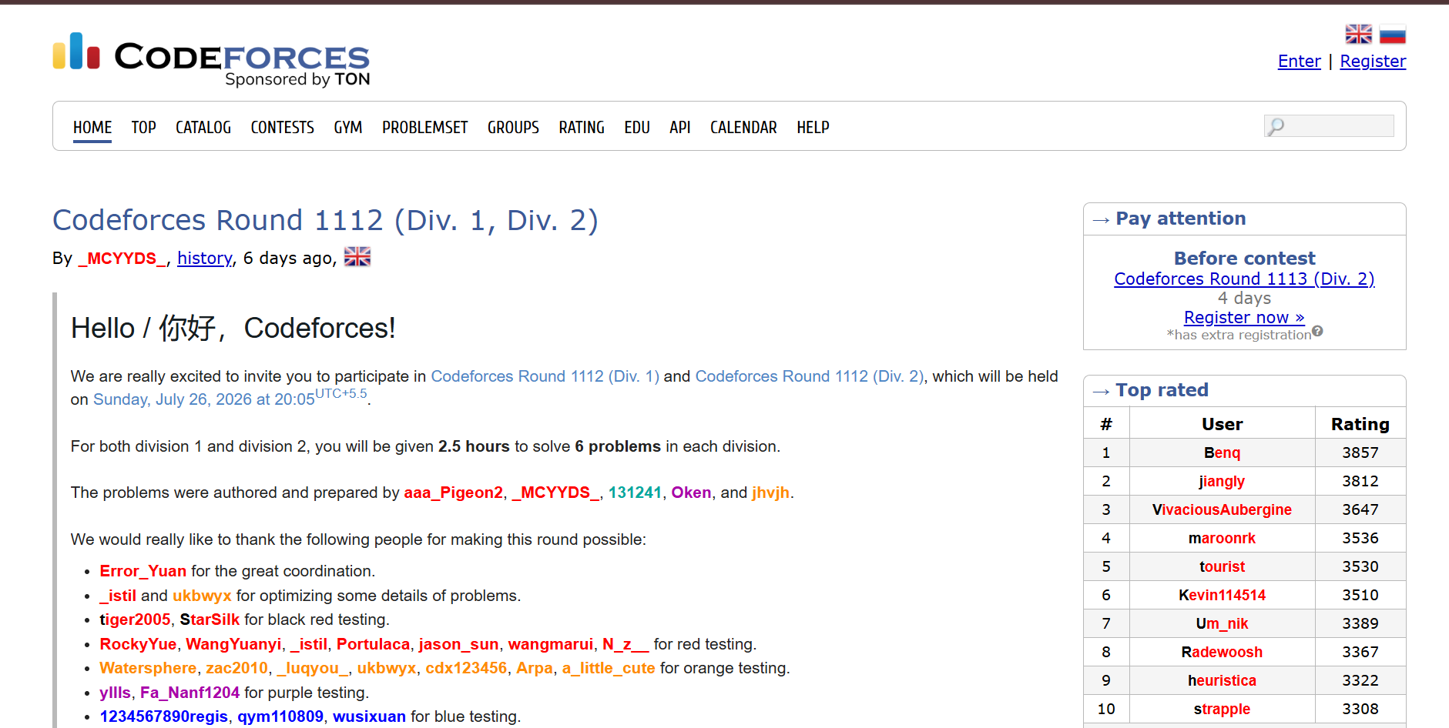
Fig. 18 — Problemset page: table of problems with tags and ratings
- Navigation Structure: The top bar (Problemset, Gym, Blog, Contests) is the only wayfinding aid there is no breadcrumb trail once inside a filtered list.
- Visual Hierarchy: Every row in the problem table carries equal visual weight, so nothing pulls the eye to a starting point.
- Use of Metaphors: Usernames and ratings are distinguished only by text color, with no icons or illustrative elements.

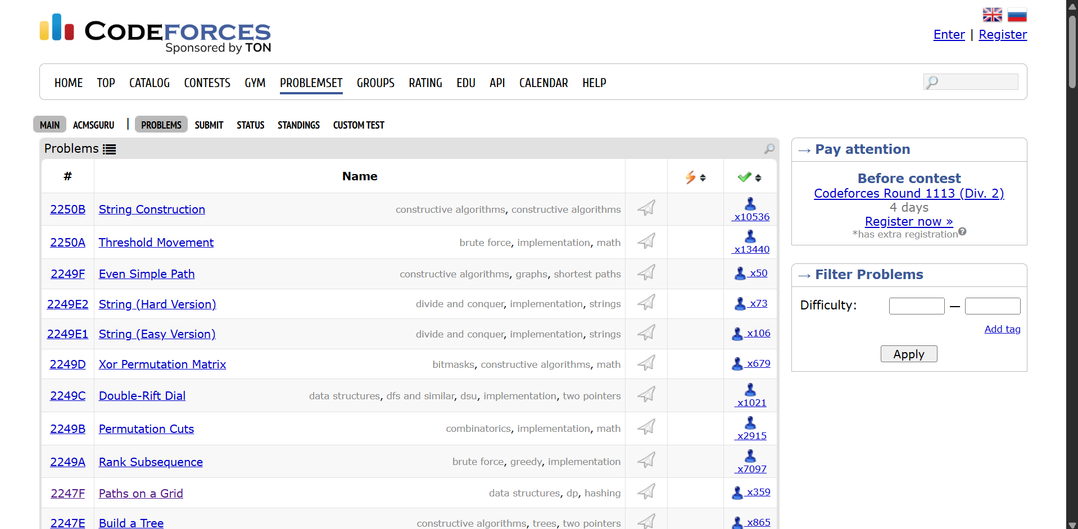
Fig. 19 — Problem statement page
- Content Readability: The statement is plain text with LaTeX-rendered math, but long unbroken paragraphs make it slower to skim.
- Aesthetic and Minimalist Design: The page uses almost no styling beyond default text and tables, reading as sparse rather than deliberately minimal.
- Learnability: There is no contextual hint or walkthrough for a first-time reader, unlike LeetCode's hint panels.

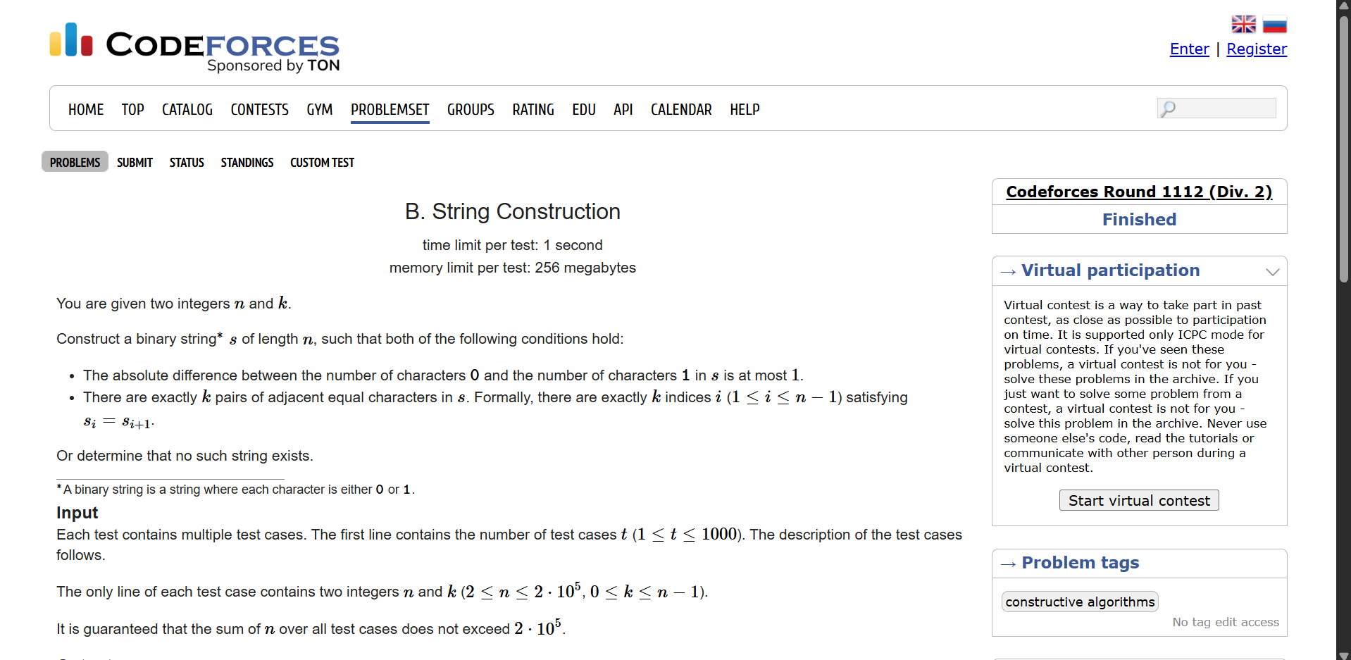
Fig. 20 — Submission status page with verdicts
- Feedback and System Status: Verdicts such as Accepted or Wrong Answer are listed as plain colored text rather than a styled banner.
- Error Prevention and Recovery: No autosave indicator is present alongside submissions, consistent with the lack of a safety net while editing.
- Efficiency of Interaction: Once a user knows the submission flow, verdicts return quickly with minimal extra steps.

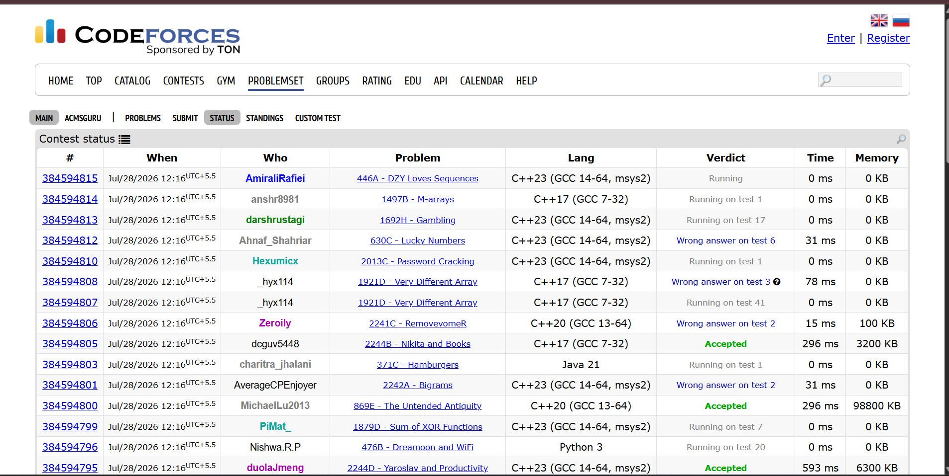
Fig. 21 — Contest/blog listing page
- Trust and Credibility: Long-running contest history and rating data are front and center, reinforcing the platform's reputation among competitive programmers.
- Personalization: The listing looks the same for every visitor, with no tailored recommendations.
- Performance Perception: The page is text-only and loads quickly, even though the visual design feels dated.

