LAB ASSIGNMENT V : HUERISTIC EVALUATION
SYSTEM EVALUATED : CODING_PLATFORM (CODE / PRACTICE, better version of LeetCode)
PART I : HUERISTIC EVALUATION BASED ON NIELSEN'S 10 GENERAL PRINCIPLES FOR INTERACTION DESIGN. (0 is lowest and 10 is highest)
S.No. | Heuristic Evaluation Parameter | Mention Violation if any | Severity 0-10 (0- minimum and 10 is maximum) | Ways to improve
1 | User Control: Interface will allow the user to perceive that they are in control | Home and problem page show no Stop, Reset code or Undo button. No way to end Mock mode. | 7/10 | Add Reset code and Stop buttons. Add an End button for Mock mode.
2 | Human Limitations: Interface will not overload the users cognitive, auditory and motor skills | Small grey text on dark grey is hard to read (Coach panel, cards, subtitles). Problem page has 3 panels and many small items. | 6/10 | Use bigger and brighter text. Let users collapse Coach sections.
3 | Accommodation: The interface will fit the way each user group works and thinks (personas) | Good for beginners (checklist, hints, analogy). Experts cannot turn the guidance off. | 8/10 | Add a Guided mode on/off switch.
4 | Linguistic Clarity: Interface will communicate as efficiently as possible | Unclear words: Skill proof, Practice later, stale? verify, Mock mode, Calm mode, Resume recap. | 6/10 | Use simple words, for example Review later and Timed practice.
5 | Aesthetic Integrity :The interface will have an attractive and appropriate design | Modern dark look. But 5 accent colours are used (pink, blue, yellow, purple, green). Pink text on dark is weak. Browse problems button is faint. | 7/10 | Use 2 accent colours. Raise contrast of text and grey buttons.
6 | Simplicity: The interface will have a simple design | Home page is clean. Problem page feels crowded. Streak and progress are shown twice on home. | 7/10 | Show Coach items only when needed. Show streak once.
7 | Predictability :The interface will behave in such a manner that the user can accurately predict what will happen next | Run, Hint and Submit look the same. Not clear what Practice pattern and Resume recap do. Feature cards look clickable but may not be. | 6/10 | Give Submit a main style, Run and Hint a lighter style. Add clear labels.
8 | Accuracy: Interface will be free from errors | On home, the text '7 days' touches 'current streak' and the progress card text is cut at the bottom. 'stale? verify' looks like a mistake. | 6/10 | Fix spacing in the progress card. Check all text for errors.
9 | Technical Clarity: Interface will have the highest possible fidelity. | Tiny text on many screens. Three coloured dots at top right have no meaning. | 7/10 | Keep text at 14px or more. Remove the dots.
10 | Fulfillment : The interface will provide a satisfying user experience | Streak, weekly goal and kind messages feel rewarding. No success screen shown after Submit. | 8/10 | Add a clear Accepted screen with a small celebration.
11 | Consistency: Interface will be consistent | Home says 'Study room', problem page says 'Study'. Streak badge is pink on home but grey on problem page. Active menu is only shown on problem page. | 6/10 | Use the same names, colours and active menu style on all pages.
12 | User Support: Interface will provide additional assistance as needed or requested | Hint button, Coach, plain analogy and checklist give lots of help. No help icon to explain what Coach and Skill proof mean. | 8/10 | Add small ? icons and a short first time tour.
13 | Precision: The interface will allow the users to perform a task exactly | Editor shows no examples, test cases or language choice. Checkboxes are small. | 6/10 | Add examples, a test case tab and a language dropdown. Make checkboxes bigger.
14 | Forgiveness: Interface will make action recoverable | Auto resume is good and Hint does not give the full answer. No Undo, no Reset and no confirm before Submit. | 7/10 | Add Undo, Reset and a Submit confirm message.
15 | Responsiveness: The interface will inform users about the results of their actions and their interface status | No visible output area, loading sign or pass/fail result for Run. Timer 00:18:42 is not explained. | 6/10 | Add an output panel with loading and pass/fail per test. Label the timer.
 | Total Score |  | 101/150

**Attach Screenshots
Screenshot 1: Home page
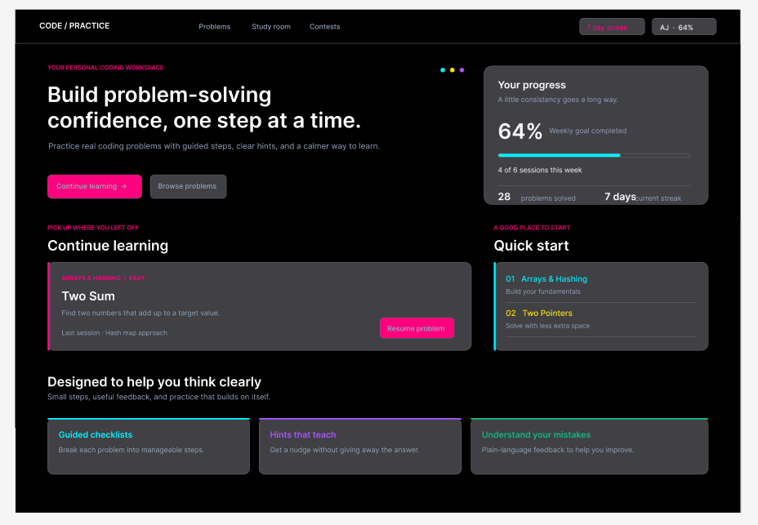
Screenshot 2: Problem page (Two Sum)
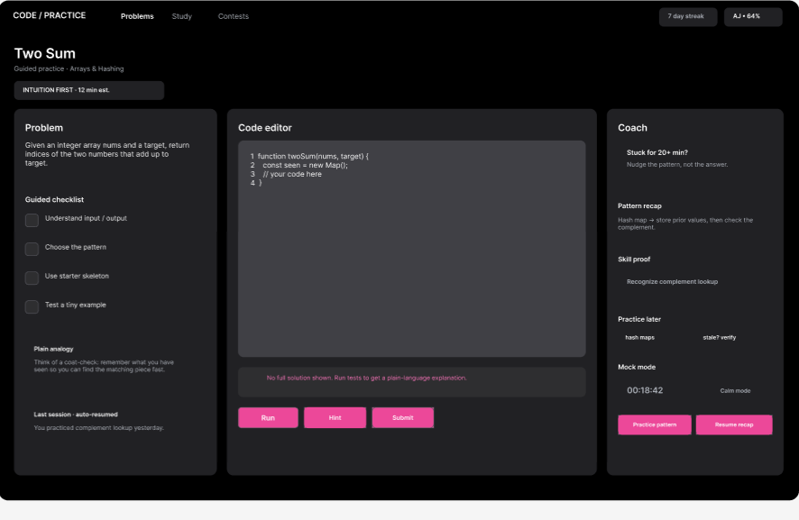

PART II : List out any other points that you may have missed out . (Other than Nielsen’s Principles)

S.NO | OBSERVATIONS | COMMENTS
1 | Colour contrast and accessibility | Grey text on dark grey and pink on black are hard to read. Add a light theme and check colours for colour blind users.
2 | Missing screens | No result screen after Submit, no problem list page and no login page are shown. Add them so the full flow can be checked.
3 | Small screens | Three panels side by side will not fit on a phone. Use tabs for Problem, Code and Coach on small screens.
4 | Good points | Continue learning card, guided checklist, plain language help and weekly progress are strong ideas. Keep them and make the text easier to read.

Students Evaluation Team : group that is evaluation ………………………………………………………………………………..

