Statistical Assumptions in Volcanic
Eruption-Probability Estimation
Synthesis, manuscript support, and an empirical test of the constant-rate assumption

Prepared for: Alberto Ardid
Context: Contribution to Kennedy et al. terminology paper; review of eruption-recurrence statistics
Date: 9 June 2026
Status: Updated working document — now includes original analysis of GVP eruption data

Contents

0. What is new in this version
Earlier versions of this document synthesised the published literature on eruption-recurrence statistics. This version adds our own empirical test of the most basic assumption in the field — that volcanic eruptions occur at a constant (or near-constant) rate, the stationarity assumption of a homogeneous Poisson process (HPP). Using a real export of the Smithsonian Global Volcanism Program (GVP) eruption catalogue, we ran a full hypothesis-testing battery on six well-recorded volcanoes (narrow-deep) and on 104–128 volcanoes globally (broad screen). Sections 5 and 6 report those results. The short answer: the constant-rate assumption is the exception, not the rule.

1. Executive summary
- The Poisson/exponential assumption is a convenience, not a validated law. It fits some volcanoes (long-quiescent closed systems; global aggregates of large eruptions) but is frequently rejected or unprovable for individual volcanoes because catalogues are short, incomplete, and non-stationary.
- Our test confirms this empirically. In the cleanest modern window (1900–2021), 55% of volcanoes with enough events reject constant rate after false-discovery-rate control. The typical volcano is mildly clustered and accelerating (median CV = 1.21, median Weibull β = 1.15 — both above the Poisson value of 1).
- Departure scales with volcano type, as theory predicts. Calderas depart most from constant rate (60% reject; median CV 1.43); basaltic shields least (45%; CV 1.07). The open- vs. closed-system contrast appears in a blind global screen.
- Under-recording is the dominant confound. Naïve analysis of the full geological record shows “non-stationary everywhere,” but that is mostly improving detection toward the present, not volcanology. Restricting to complete windows is essential.
- Implication for the terminology paper: probability-based status tiers are defensible where rates are estimable (frequent, well-monitored systems) and fragile for few-event calderas — the tiers must stay “relative,” and must state which probability (short-term conditional vs. long-term) they encode.

2. Standard practice and the distributions in use
Operational long-term forecasting estimates eruption probability from the distribution of repose (inter-eruption) times via a homogeneous Poisson process (exponential repose times), a non-homogeneous Poisson / Weibull process, or stationary renewal models (Weibull, log-normal, gamma, log-logistic, Brownian Passage Time, and — for irregular systems — the Fréchet / inverse-Weibull distribution). These sit at the temporal node of Bayesian event trees: INGV’s BET_EF/BET_VH, the CSIC HASSET tool, and USGS / GNS Science workflows (Connor, Bebbington & Marzocchi 2015).
Physical basis is thin. The exponential is memoryless (chosen for convenience); Weibull has a loose materials-failure link; Brownian Passage Time is borrowed from earthquake stress-accumulation models. The most useful taxonomy (Marzocchi & Zaccarelli 2006) is empirical: short repose → clustered, open-conduit, time-predictable; long repose → random, closed-conduit, Poissonian.

3. What the literature already found
- Global large eruptions look Poissonian. De la Cruz-Reyna (1991) for VEI≥4; Papale (2018) finds exponential return times with power-law magnitudes.
- Apparent secular increase is an artifact. GVP states activity is not increasing; Rougier et al. (2016, 2018) estimate ~40% of large explosive eruptions are missing over the last millennium, with recording below 20% pre-1100.
- Clustering vs. trend is contested. Bebbington (2010) argues much apparent clustering is better explained by trends in activity.
- Long records are genuinely non-stationary. Deglaciation raised eruption rates two- to six-fold at glaciated arcs (Huybers & Langmuir 2009); Milankovitch periodicities appear in tephra records (Kutterolf et al. 2013) — though some ice-core records show near-constant rates (Lin et al. 2023), so global significance is debated.

4. How we tested the constant-rate assumption
Data. A real GVP “Volcanoes of the World” eruption export (v4.10.3; 9,920 confirmed eruptions, 11,345 BCE–2021 CE), obtained via an open mirror. We built eruption-onset series per volcano, with month/day imputed to mid-interval where missing.
Design. Two tiers. (i) Narrow-deep: six volcanoes spanning structural types, each tested in a full window and a literature-based completeness window. (ii) Broad screen: every volcano with ≥12 historical-evidence eruptions, in a 1900–2021 window (primary; near-complete global reporting) and an 1800–2021 window (sensitivity).
Tests. KS test of onsets vs Uniform[0,T] (direct constant-rate test); Laplace centroid test (monotonic trend); coefficient of variation of reposes (CV≈1 Poisson, <1 periodic, >1 clustered); Fano dispersion; exponential goodness-of-fit and AIC model selection; Ljung–Box (independence); and the Weibull-process shape β (β=1 ⇒ constant rate). Each calibrated against 1,500–4,000 Monte-Carlo HPP simulations with matched N and window; Benjamini–Hochberg FDR control across the global screen.
Reproducibility note. Verdicts are unaffected by catalogue version, but this run used GVP v4.10.3 (2021), not the current v5.3.5; VEI and onset-date precision are coarse. A publication-grade run should pull the versioned GVP WFS and add date-uncertainty Monte Carlo.

5. Results I — six well-recorded volcanoes (narrow-deep)
The full record rejects constant rate for every volcano — but that is the recording artifact. In the full confirmed record all six reject HPP at p < 0.001 with very large trend statistics; the cumulative-eruption curves show near-nothing for millennia then a sharp rise to the present. The real test is the completeness-restricted window below.
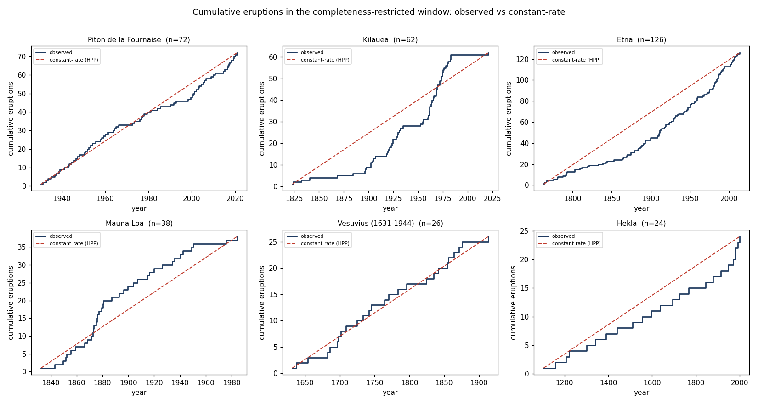
Figure 1. Cumulative eruptions vs. a constant-rate (HPP) expectation in each volcano’s completeness-restricted window. Fournaise and Vesuvius track the straight line; Kilauea and Etna bend clearly above it (accelerating); Hekla is unusually regular.
In the completeness window, the verdict splits — and by volcano type. Key statistics (completeness window):
Volcano | Type | n | KS p | Laplace U (p) | CV | best fit | β [95% CI] | Verdict
Piton de la Fournaise | open shield | 72 | 0.60 | 0.5 (0.63) | 0.87 | frechet | 0.99 [0.77–1.23] | Constant rate OK
Mauna Loa | open shield | 38 | 0.07 | −1.7 (0.09) | 1.09 | exponential | 1.05 [0.74–1.42] | Largely OK
Vesuvius (1631–1944) | strato | 26 | 0.22 | −0.1 (0.89) | 0.81 | gamma | 0.98 [0.64–1.40] | OK (low power)
Hekla | strato | 24 | 0.39 | 1.9 (0.06) | 0.55 | weibull | 1.41 [0.89–2.04] | Quasi-periodic (CV<1)
Kilauea | open shield | 62 | <0.001 | 2.6 (0.009) | 2.06 | loglogistic | 1.34 [1.03–1.70] | REJECTS — real
Etna | open strato | 126 | <0.001 | 4.8 (<0.001) | 1.21 | loglogistic | 1.31 [1.09–1.55] | REJECTS — accelerating

Piton de la Fournaise is the clean Poisson case (curve hugs the line, CV≈1, all tests non-significant). Kilauea and Etna genuinely reject constant rate even after restriction — a real century-scale acceleration (β significantly >1), the opposite of the common assumption that open-conduit systems are Poissonian. Hekla departs the other way (CV = 0.55, more regular than random). Vesuvius and Mauna Loa cannot reject, but with n = 26–38 that is partly low power, not proof.

6. Results II — global screen with FDR control
Constant rate is rejected for the majority of testable volcanoes. In the primary 1900–2021 window (104 volcanoes), 55% reject constant rate (KS-uniform or Laplace trend, FDR < 0.05): 53% fail KS-uniform, 32% show a significant trend (21 increasing, 12 decreasing). The median CV is 1.21 and median β is 1.15 — both above the Poisson value of 1, so the typical volcano is mildly clustered and mildly accelerating. Of 26 volcanoes with CV significantly ≠ 1, all 26 are clustered (CV > 1); none are quasi-periodic.
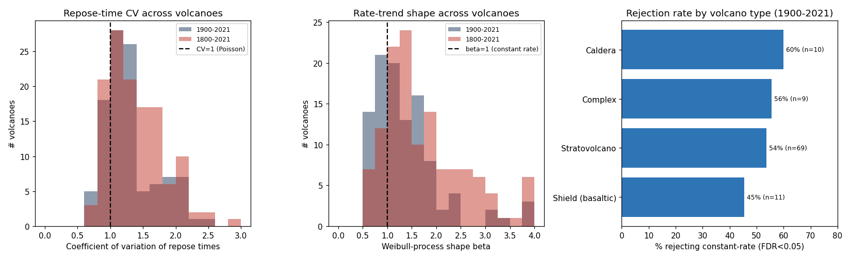
Figure 2. Global screen. Left: repose-time CV clusters just above 1 (Poisson). Centre: Weibull-process β clusters just above 1 (mild acceleration). Right: rejection rate by volcano type — calderas highest, basaltic shields lowest.
Departure scales with volcano type (1900–2021):
Volcano type | n | % reject constant-rate (FDR<0.05) | median CV | median β
Caldera | 10 | 60% | 1.43 | 1.04
Complex | 9 | 56% | 1.19 | 1.07
Stratovolcano | 69 | 54% | 1.21 | 1.30
Shield (basaltic) | 11 | 45% | 1.07 | 1.10

Sensitivity (1800–2021) confirms direction and exposes the confound. Extending to 1800 raises rejection to 76% and makes trends overwhelmingly increasing (70 of 75 vs. 21 of 33). That jump is the under-recording fingerprint: the deeper the window, the more apparent “acceleration” is improving detection. The 1900 window is the more honest test — and a majority still reject.
Answer to the core question. The homogeneous-Poisson constant-rate assumption is the exception, not the rule. ~55% of well-recorded volcanoes reject it in the cleanest modern window; the typical volcano is mildly clustered and accelerating; and the departure scales with system type exactly as open/closed-conduit theory predicts. Where it survives (~45% of shields; Fournaise) it is a defensible approximation; as a blanket default it is not.

7. Caveats and limits
- Low power is real. “Fail to reject” for the ~45% includes genuine low power at n = 12–40; this is a lower bound on departures, not proof of Poisson for the rest.
- Residual recording bias. Even within 1900–2021, detection improved over time, inflating the increasing-trend count. The trend component is therefore an upper bound; the clustering component (CV) is robust to it.
- Coarse inputs. VEI is a coarse, sometimes default-filled proxy; onset definitions and phase-lumping affect the repose series. Date-uncertainty Monte Carlo and change-point localisation are the natural next hardening steps.
- Catalogue version. GVP v4.10.3 (2021). Qualitative verdicts are stable, but cite the live version for publication.

8. Implications for the terminology paper and forecasting
- Do not assume Poisson by default. For most volcanoes a constant rate is wrong; report a model suite and propagate model-choice uncertainty.
- Probability tiers must stay relative and be explicit about which probability. Short-term conditional (monitoring-based, e.g. the 12.6% Steamboat figure) and long-term unconditional (recurrence-based) are different quantities; status tiers should say which they encode.
- Match the model to system type. Shields tolerate near-Poisson; calderas and complexes need clustered/time-varying models; few-event calderas should lean on monitoring and system-size normalisation (Giordano & Caricchi 2022) rather than repose statistics.
- Always correct for completeness before claiming a trend, and control for multiple comparisons (FDR) when screening many volcanoes.

