Indic Speech-to-Response Pipeline
Evaluation and an ASR-bottleneck improvement for Hindi and Malayalam
Speech Input → Speech Encoder / ASR → Language Model → Text Response
30 October 2026

1. Summary
We built a reproducible pipeline that takes Hindi or Malayalam speech and returns a text response in the same language and script, using open-source pretrained models, and wrote our own evaluation infrastructure around it. The system was evaluated on 720 test items (240 utterances × 3 acoustic conditions), plus 400 assistant replies, 720 language-ID decisions and 48 blind native-speaker ratings.
Measure | Baseline | Improved | Change
ASR CER, Hindi (all conditions) | 101.2% | 34.8% | −66.4 pts
ASR CER, Malayalam (all conditions) | 139.0% | 27.9% | −111.1 pts
Restatement judged correct, Hindi / Malayalam | 18.9% / 6.4% | 44.4% / 67.2% | +25.6 / +60.8 pts
Reply judged acceptable, clean Hindi / Malayalam | 32.5% / 7.5% | 77.5% / 57.5% | +45.0 / +50.0 pts
Native speaker: good response / on-topic | 12% / 12% | 42% / 46% | +29 / +33 pts
ASR real-time factor, Hindi / Malayalam (mean) | 0.239 / 0.234 | 0.042 / 0.169 | 5.7× / 1.4× faster

All baseline-vs-improved differences above are significant (paired bootstrap, p ≤ 0.002). The research extension identified ASR as the measurable bottleneck (with a perfect transcript, 99.2% of responses are correct) and replaced it with language-adapted Whisper served on faster-whisper, improving both accuracy and speed.

2. Models used
All models are open-source and used as pretrained checkpoints; none were trained or fine-tuned by us.
Role | Model | How it is used
Language identification | openai/whisper-medium | One decoder step; probability over the <|hi|> and <|ml|> tokens only
ASR, baseline (both languages) | openai/whisper-small (244M) | Hugging Face transformers, fp16, greedy, language forced
ASR, improved, Hindi | vasista22/whisper-hindi-small (244M) | Fine-tuned on Hindi corpora; safetensors revision pinned (e760aba8); faster-whisper
ASR, improved, Malayalam | vrclc/Whisper-medium-Malayalam (769M) | Fine-tuned on Malayalam corpora, never saw FLEURS; faster-whisper
ASR, size control (ablation) | openai/whisper-medium (769M) | Stock model, to separate fine-tuning gains from model-size gains
Language model | Qwen/Qwen3-4B-Instruct-2507 | bitsandbytes 4-bit NF4, greedy (deterministic)
LLM judge (evaluation only) | Qwen/Qwen2.5-7B-Instruct | 4-bit, including the output layer, to fit 6 GB
Meaning similarity (evaluation only) | sentence-transformers/LaBSE | Cross-lingual sentence embeddings

Hardware: a laptop with an NVIDIA RTX 3060 (6 GB VRAM), Windows 11. Models are loaded one at a time; PyTorch 2.5.1 + CUDA 12.1 throughout, so every run was timed on the same software stack.

3. Dataset
- Source: Google FLEURS test split, Hindi (hi_in) and Malayalam (ml_in). Each recording has a human native-script transcript; through the FLoRes benchmark each sentence also has a professional English translation, used as the meaning reference.
- Sample: 120 distinct sentences per language, fixed random seed, gender-stratified for Hindi (60/60). The Malayalam test speakers are all female.
- Acoustic conditions: clean, 10 dB and 0 dB SNR. The noise is babble from 4 other speakers plus white noise, mixed at exactly the target SNR (verified: 10.00 dB and 0.00 dB). Each utterance gets the same noise at both levels, so only the loudness changes.
- Evaluation sets: 720 items for ASR and restatement; 160 items per system for reply mode (40 utterances per language at clean and 0 dB) plus 80 with gold transcripts; 720 for language ID; 48 replies for native-speaker rating.

4. Architecture
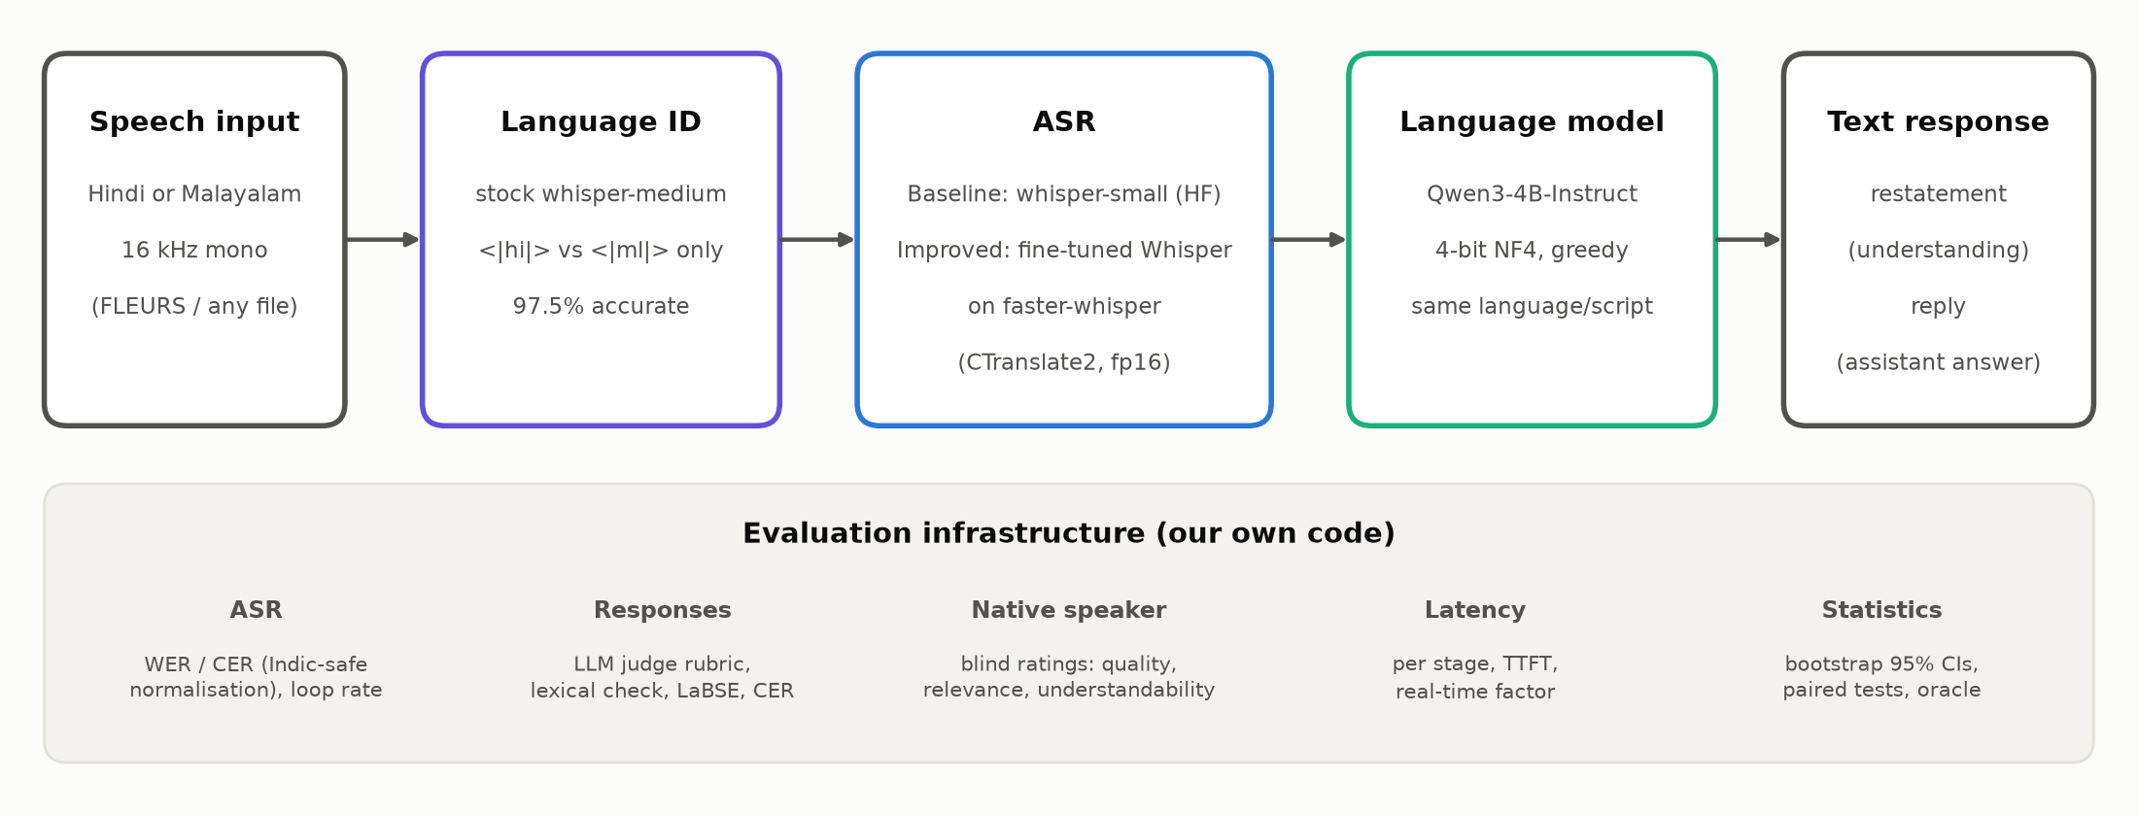
Figure 1. Pipeline and evaluation infrastructure.
- Language ID picks Hindi or Malayalam from the audio and routes it to the matching ASR model.
- ASR transcribes the audio with greedy decoding, the language token forced and a single 30-second window. Baseline and improved runs differ only in model weights and inference engine.
- Language model turns the transcript into a response in the same language and script, in one of two modes: restatement or reply (Section 6).
- Runner: ASR runs on all items, then the LLM, because both don't fit in 6 GB together. Every result is saved item by item, so interrupted runs resume where they stopped. A single-file demo (scripts/demo.py) runs the full chain on any recording.

5. Baseline vs improved
 | Baseline | Improved
Hindi ASR | openai/whisper-small | vasista22/whisper-hindi-small (fine-tuned, same size)
Malayalam ASR | openai/whisper-small | vrclc/Whisper-medium-Malayalam (fine-tuned)
ASR engine | Hugging Face transformers | faster-whisper (CTranslate2), with a decoding-limit fix
Language model | Qwen3-4B-Instruct, 4-bit | Same (unchanged, so the comparison isolates ASR)
Language selection | Given | Automatic language ID (stock whisper-medium)

What is in the improved system
- Language-adapted ASR. Whisper checkpoints fine-tuned on Hindi and Malayalam speech replace the stock multilingual model, which mostly failed on Malayalam: repetition loops, English translations instead of transcripts, or Hindi-script output.
- A faster inference engine. faster-whisper (CTranslate2) runs the same weights about 3× faster. We found and fixed a bug in its decoder: CTranslate2 4.8.4 returns only half the requested number of tokens, which cut long Malayalam transcripts in half. After the fix, the accuracy of the two engines matches.
- Automatic language identification, so a user doesn't need to say which language they are speaking (97.5% accurate; 100% on clean speech).

6. Why both a reply and a restatement
The language model runs in two modes, and both are evaluated, because a spoken assistant must get two different things right:
- Restatement (did it understand?) The model restates faithfully what the user said, in clean Hindi or Malayalam, repairing misrecognised words without adding anything. This has a gold answer (what was actually said), so understanding can be measured objectively: correctness against two references, character error rate, and an oracle comparison that proves where errors come from.
- Reply (did it respond well?) The model answers the user as an assistant would, in 1–3 sentences. This is the user-facing response the brief asks for. A reply has no single gold answer, so it is measured with a grounded rubric and with native-speaker ratings.
Neither mode is enough on its own. A reply metric alone can't tell "misheard the user" apart from "responded badly"; the restatement can. The restatement alone doesn't show whether the user gets a useful answer; the reply does. Both modes use the same ASR transcripts, so their results can be compared directly.

7. Results against the requirements
Every metric is reported by language and acoustic condition with bootstrap 95% confidence intervals (2,000 resamples of whole utterances). Baseline-vs-improved comparisons use paired tests on the same items.

7.1 ASR word and character error rate
Both sides are normalised identically before scoring: Unicode NFC, an Indic script normaliser, punctuation including the danda (।) removed. Whisper's built-in English normaliser deletes Indic vowel signs and was deliberately not used. CER is the primary metric for Malayalam, which is agglutinative: one wrong suffix makes a whole long word wrong, so WER exaggerates the damage. Rates above 100% come from repetition loops, which insert far more text than the reference contains.
Language | Condition | WER baseline | WER improved | CER baseline | CER improved | Loops baseline | Loops improved
Hindi | clean | 79.4% | 14.2% | 45.9% | 5.8% | 7.5% | 0.0%
Hindi | 10 dB | 105.8% | 27.6% | 75.4% | 16.2% | 15.8% | 0.0%
Hindi | 0 dB | 182.8% | 95.8% | 182.3% | 82.3% | 63.3% | 10.0%
Malayalam | clean | 280.3% | 36.9% | 160.9% | 12.8% | 41.7% | 0.8%
Malayalam | 10 dB | 158.7% | 49.7% | 121.7% | 18.2% | 52.5% | 0.0%
Malayalam | 0 dB | 159.8% | 91.1% | 134.5% | 52.8% | 70.8% | 7.5%
Table: ASR error rates (n = 120 per row). "Loops" = share of transcripts that are repetition loops or runaway output.
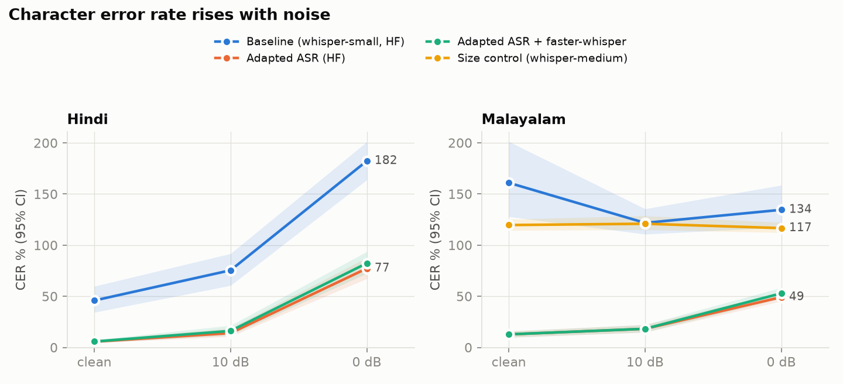
Figure 2. Character error rate by noise level, with 95% CIs. The size-control line is stock whisper-medium.

7.2 Response correctness and hallucination: criteria
Each criterion has a written definition, applied by an LLM judge (Qwen2.5-7B) and, for replies, checked against a native speaker.
Mode | Criterion | Definition
Restatement | Correct | In the right language and conveys every key element of what was said (who, what, entities, numbers, places, times); paraphrase allowed
Restatement | Partial / incorrect | Main idea kept but a key element missing or wrong / main idea wrong, unrelated, empty or wrong language
Restatement | Hallucination | States a specific detail (name, number, event, place) that was not said. Omissions and garbled words are not hallucination
Restatement | Lexical check | Judge-free cross-check: numbers in the response that appear in neither reference
Reply | Relevance | On-topic: engages with what was actually said / partial / off-topic
Reply | Misattribution | Says or implies the user said something they didn't, changing the meaning (paraphrase is fine)
Reply | Factual hallucination | Asserts a specific claim that is false or contradicts what was said (correct background knowledge is fine)
Reply | Acceptable | On-topic, no misattribution, no factual hallucination, and in the right script
Both | Off-script | Less than 80% of letters in the target script (e.g. an English answer)

Reply criteria are judged against what the user actually said (the gold transcript and its English translation). The judge never sees the ASR transcript, so a reply built on a misrecognition counts as a failure.

7.2 (continued) Response correctness and hallucination: results
Language | Condition | Restatement correct (base → improved) | Restatement hallucination (base → improved) | Reply acceptable (base → improved)
Hindi | clean | 37.5% → 80.0% | 10.8% → 0.8% | 32.5% → 77.5%
Hindi | 10 dB | 16.7% → 50.0% | 19.2% → 9.2% | not run
Hindi | 0 dB | 2.5% → 3.3% | 4.2% → 39.2% | 10.0% → 12.5%
Malayalam | clean | 7.5% → 93.3% | 11.7% → 0.0% | 7.5% → 57.5%
Malayalam | 10 dB | 6.7% → 79.2% | 15.0% → 6.7% | not run
Malayalam | 0 dB | 5.0% → 29.2% | 5.0% → 23.3% | 2.5% → 22.5%
Table: restatement n = 120 per row; reply n = 40 per row (the reply subset covers clean and 0 dB).
- On clean and 10 dB speech, correct responses rise sharply and hallucination falls to ≤ 1% on clean audio.
- At 0 dB, better ASR increases hallucination (Hindi 4.2% → 39.2%). The baseline's 0 dB transcripts were loops that the LLM copied back (wrong, but not invented). The improved ASR gives partially correct transcripts, and the LLM, asked to repair misrecognised words, fills the gaps with invented content.
- In reply mode, the improved system on clean Hindi reaches the gold-transcript ceiling (77.5%, the same as with a perfect transcript). The remaining errors come from the language model: even with a perfect transcript it asks the user to repeat in 22.5% of Hindi replies.
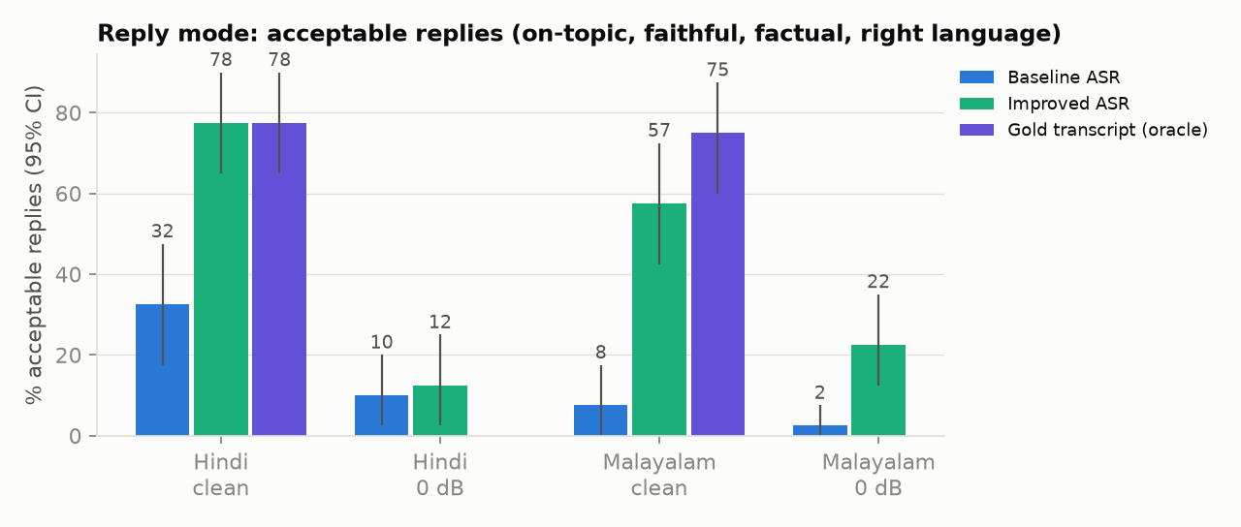
Figure 3. Acceptable replies by condition, with the gold-transcript (oracle) ceiling.

7.3 Processing latency and real-time factor
Each stage is timed separately (GPU synchronised before each clock read; 3 warm-up items excluded per group). Real-time factor (RTF) = processing time ÷ audio duration; below 1 is faster than real time. Medians (p50) are shown.
System | Language | ASR (s) | LLM first token (s) | LLM total (s) | End-to-end (s) | End-to-end RTF | ASR RTF (mean)
Baseline | Hindi | 1.58 | 0.19 | 9.39 | 10.98 | 1.01 | 0.239
Baseline | Malayalam | 4.88 | 0.21 | 23.64 | 28.35 | 2.45 | 0.234
Improved | Hindi | 0.42 | 0.18 | 7.84 | 8.25 | 0.82 | 0.042
Improved | Malayalam | 2.21 | 0.22 | 14.72 | 16.97 | 1.25 | 0.169
Table: restatement mode, n = 351 timed items per language. Language ID adds about 0.10 s (RTF 0.008).
- Speech recognition is now fast: RTF 0.042 for Hindi and 0.169 for Malayalam.
- The language model is now the latency bottleneck (85–95% of the time per utterance). The first token arrives in ~0.2 s, but 4-bit decoding runs at ~12 tokens per second on this GPU, and Malayalam text needs ~14 tokens per second of speech against ~10 for Hindi.
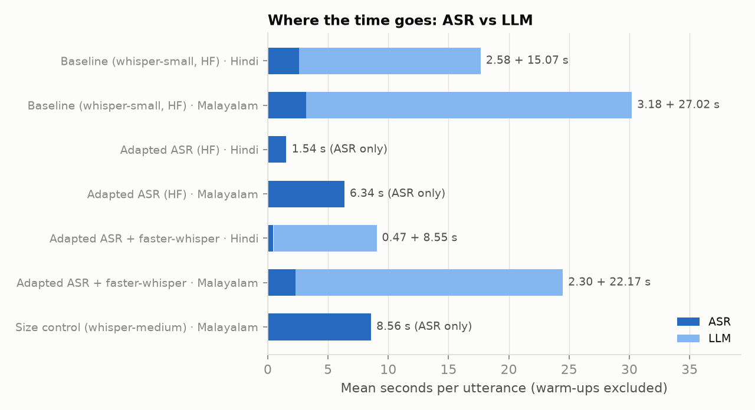
Figure 4. Mean time per utterance, split into ASR and LLM.

7.4 Performance across linguistic and acoustic conditions
Condition | Finding
Linguistic: Hindi vs Malayalam | Stock Whisper is far worse on Malayalam (CER 139% vs 101%) and mostly cannot transcribe it. After adaptation Malayalam is on par with or better than Hindi (CER 27.9% vs 34.8%). Malayalam remains costlier for the LLM (more tokens per sentence) and harder for the LLM judge.
Acoustic: clean → 10 dB | Moderate degradation: improved CER goes 5.8% → 16.2% (Hindi) and 12.8% → 18.2% (Malayalam); restatement correctness stays useful (50% and 79%).
Acoustic: 0 dB | The hardest condition for every system: improved CER 82.3% (Hindi) and 52.8% (Malayalam); correct responses collapse, and hallucination rises as the LLM over-repairs partial transcripts. Language ID also drops to 86.7% for Malayalam.

8. Evaluation strategy: native-speaker judge vs LLM judge
Automatic LLM judges are convenient but untested on Indian languages. Because I am a fluent native speaker of both Hindi and Malayalam, I rated a sample of replies myself and used those ratings both as a human evaluation and as a check on the LLM judge.

Method
- Blind and paired: 24 utterances (6 per language × clean / 0 dB), each with its baseline and its improved reply = 48 replies, shuffled, with no indication of which system wrote which.
- Criteria: response quality (is this a good, correct response? non-answers such as "I didn't understand, please repeat" count as incorrect), relevance (on-topic / partial / off-topic), and understandability to a native reader (1–5).
- Agreement: Cohen's κ between my ratings and the LLM judge, overall and per language.

Results
 | Baseline | Improved | Paired difference
Good responses | 12% | 42% | +29 pts, p < 0.001
On-topic | 12% | 46% | +33 pts, p = 0.002
Understandability (1–5) | 4.29 | 3.79 | −0.50, not significant

Agreement with the LLM judge (Cohen's κ) | All | Hindi | Malayalam
Relevance | 0.52 | 0.53 | 0.50
Response quality (human "correct" vs judge "acceptable") | 0.46 | 0.57 | 0.25

- The human ratings independently confirm the improvement, so the result doesn't rest on the LLM judge.
- The LLM judge is only a moderate proxy for a native speaker (κ 0.46–0.52), and is much weaker on Malayalam (κ = 0.25 on response quality vs 0.57 for Hindi). A model judge misses quality problems that a native speaker sees; for example, it accepted a reply containing invented scientific terms.
- Understandability drops where the improved system engages with very noisy Malayalam: it copies garbled non-words from the transcript into its reply. The baseline's replies there were fluent but useless requests to repeat.

Why this strengthens the evaluation
Adding a native-speaker judge is an improvement to the evaluation methodology (separate from the system improvement in Section 9). It gives a ground truth that the LLM judge cannot provide for Indian languages, measures how far the automatic judge can be trusted in each language, and adds a criterion (understandability to a native reader) that an automatic judge cannot assess reliably. Limitations: a single annotator, who is also the project author (the ratings were blind to the system), and 6 items per condition.

9. Research extension: bottleneck and improvement

Identifying the bottleneck
An oracle ablation fed the gold transcript straight to the language model. With a perfect transcript, 99.2% of restatements are judged correct in both languages, and 99–100% of the baseline's failures and 100% of its hallucinations disappear. Errors therefore come almost entirely from ASR, which is a measurable bottleneck: baseline CER is 101% (Hindi) and 139% (Malayalam), with 29–55% of transcripts being repetition loops.

The improvement and the comparison
We replaced the stock ASR with language-adapted Whisper checkpoints served on faster-whisper, keeping everything else fixed, and isolated each effect with ablations:
Run (only the ASR changes) | Hindi CER | Malayalam CER | Hindi ASR RTF | Malayalam ASR RTF
Baseline: whisper-small, HF engine | 101.2% | 139.0% | 0.239 | 0.234
Size control: stock whisper-medium, HF engine | — | 119.0% | — | 0.663
Adapted ASR, HF engine | 32.3% | 26.7% | 0.137 | 0.462
Improved: adapted ASR + faster-whisper | 34.8% | 27.9% | 0.042 | 0.169

- Accuracy comes from adaptation, not size. Scaling stock Whisper from small to medium cuts Malayalam CER by only 20 points and nearly triples its time; the adapted model cuts a further 91 points.
- Speed comes from the engine. On the same adapted weights, faster-whisper is 3.3× (Hindi) and 2.7× (Malayalam) faster, with CER within 1–2.5 points.
- Effect on responses: restatement correctness +25.6 pts (Hindi) and +60.8 pts (Malayalam); reply acceptability +45 to +50 pts on clean speech; native-speaker good responses +29 pts. All p ≤ 0.002.

What the improvement revealed
- The new bottleneck is the language model: it now dominates latency, and its reply behaviour (needless requests to repeat, occasional misstatements) sets the quality ceiling.
- Very noisy speech (0 dB) remains unsolved and exposes a hallucination risk when the LLM repairs partial transcripts.

10. Deliverables
Deliverable | Where
Working code | src/ (pipeline, ASR, LLM, language ID, metrics, statistics), scripts/ (data preparation, runs, evaluation, report, demo), configs/ (one file per run); 19 unit tests for the evaluation code
Evaluation results | results/<run>/ per-item outputs and scores for every run; results/summary.md (all tables with confidence intervals); results/figures/; results/human_eval/ (blind ratings and analysis); results/lid/
Ablation analysis | Oracle (ASR vs LLM attribution), size control (adaptation vs model size), engine comparison (HF vs faster-whisper), noise levels, languages, restatement vs reply
Full technical report | REPORT.md (methods, all results, limitations); README.md (setup and one-command reproduction)

11. Limitations
- Human evaluation uses one annotator (the project author, rating blind) and 48 replies; a second annotator would allow inter-annotator agreement to be measured.
- The LLM judge's hallucination labels were not separately rated by a human, and they probably under-count hallucination.
- Whisper's decoder holds at most ~200 Malayalam characters per 30-second window, so the longest Malayalam sentences cannot be fully transcribed by any Whisper model; audio longer than 30 s is truncated.
- FLEURS is read speech; conversational or code-mixed speech would be harder. The Hindi adapted model was trained on FLEURS train+dev (no test overlap). Multi-step instruction following was not evaluated.

12. Conclusion
The pipeline meets every requirement of the brief: speech in Hindi or Malayalam goes through ASR and a language model to a text response in the same language, evaluated with our own infrastructure on 720 items across two linguistic and three acoustic conditions. ASR WER/CER, response correctness and hallucination under written criteria, latency and real-time factor are all reported with confidence intervals.
The research extension found a clear, measurable bottleneck, speech recognition, and fixed it with language-adapted Whisper on faster-whisper: Malayalam CER fell from 139% to 28%, correct responses rose by 26–61 points, and ASR became up to 5.7× faster. Ablations show the accuracy gain comes from language adaptation rather than model size, and the speed gain from the inference engine. Blind native-speaker ratings confirm the improvement independently and show that an LLM judge is only a moderate stand-in for a native speaker, especially in Malayalam. The next bottleneck is the language model itself: its latency, and its reply behaviour on noisy input.

