MALTA TAX & CUSTOMS ADMINISTRATION
Debt Management Building Block
Installation Requirements Specification
Proof-of-Concept environment on MITA infrastructure
Requirements for MITA to provision and host a single proof-of-concept
environment that makes the DMBB accessible to MTCA Debt Management unit users.

Document control
Field | Detail
Document | DMBB Installation Requirements Specification — Proof of Concept (MITA)
Version | 1.0
Date | June 2026
Status | For MITA review and provisioning
Prepared for | MITA — Malta Information Technology Agency (infrastructure & platform team)
Prepared by | MTCA Debt Management digitalisation project
Audience | MITA platform/infrastructure engineers; MTCA project and DM unit

Related documents
- Solution Architecture Document (SAD) — Joget-based Debt Management Solution.
- Development Environment Runbook (ENVIRONMENT.md) and Deployment Process (DEPLOYMENT.md).
- DMBB User Guide for Debt-Collection Officers.

Contents
Document control 2
Related documents 2
Contents 3
1. Introduction 5
1.1 Purpose 5
1.2 Scope 5
1.3 Out of scope 5
1.4 Definitions 5
2. Solution overview 6
3. PoC objectives and assumptions 7
3.1 Objectives 7
3.2 Assumptions 7
4. Target deployment architecture 8
5. Infrastructure requirements 9
5.1 Compute and storage 9
5.2 Operating system 9
5.3 Container runtime 9
5.4 Install-time connectivity 9
6. Software prerequisites 10
6.1 Application artefacts (supplied by the project) 10
7. Joget platform requirements 11
7.1 Edition and licence 11
7.2 Java runtime 11
7.3 Database schema precondition (important) 11
7.4 Directory and accounts 11
7.5 Data API key 11
8. Database requirements 12
8.1 Joget application database — PostgreSQL 16 12
8.2 STA data product — ClickHouse 24.8 12
8.3 Mayan database — PostgreSQL 14 12
9. Document management (Mayan EDMS) 13
10. Network and connectivity 14
10.1 User access 14
10.2 Internal service ports 14
10.3 Firewall and TLS 14
11. Security requirements 15
12. Operations 16
12.1 Storage and capacity 16
12.2 Backup and recovery 16
12.3 Monitoring and logging 16
13. Installation and deployment process 17
13.1 Responsibilities 17
13.2 Artefact import order 17
14. Non-functional expectations (PoC) 18
15. Dependencies, assumptions and exclusions 19
15.1 MITA must provide 19
15.2 Key dependencies and risks 19
16. Readiness and acceptance checklist 20

1. Introduction

1.1 Purpose
This document specifies everything MITA needs to provision and host a single proof-of-concept (PoC) environment for the Debt Management Building Block (DMBB), so that Malta Tax & Customs Administration (MTCA) Debt Management unit users can access and exercise the system. It states the infrastructure, software, database, network, security and operational requirements, and divides responsibilities between MITA, the delivery project and MTCA.

1.2 Scope
The scope is a single, MITA-hosted, non-production environment treated as a proof of concept:
- One environment (development / PoC tier) — no separate staging or production tiers, and no high-availability or disaster-recovery clustering.
- The DMBB and its supporting platform components installed and made reachable to DM unit users over the MITA network.
- Seed (synthetic) test data only — the system runs against a seeded copy of the taxpayer data product, not a live data feed.

1.3 Out of scope
The following are explicitly excluded from this PoC and are addressed in later phases:
- Production hosting, high availability, load balancing and disaster recovery.
- A live connection to the MTCA Data Platform / Single Taxpayer Account (the real STA feed) — the PoC uses seeded data.
- Live external integrations — email/SMS dispatch, bank, court and registry connectors, and SAS VIYA risk scoring are stubbed.
- Single sign-on (Keycloak / Active Directory) — the PoC uses local application accounts.
- Any real taxpayer data — no production personal or financial data is loaded into the PoC.

1.4 Definitions
Term | Meaning
DMBB | Debt Management Building Block — the debt-management application.
CMBB | Case Management Building Block — the shared case fabric the DMBB is built on.
STA / sta_v1 | Single Taxpayer Account data product — the published views the DMBB reads over JDBC.
OSGi bundle | The packaged Java plugin (cmbb-plugins) carrying the DMBB processing engines.
Seed data | Synthetic, deterministic test data loaded for the PoC.

2. Solution overview
The DMBB automates the tax-debt lifecycle — identification, reminders, demands, escalation, enforcement, instalment agreements, write-off and closure. It is delivered as two applications on the Joget DX low-code platform: CMBB (the shared case fabric) and DMBB (the debt module), backed by a single Java plugin bundle that carries the processing engines and reports.
At runtime the DMBB:
- reads taxpayer debt and accounting figures from the STA data product (sta_v1) over JDBC — in the PoC this is a seeded copy;
- stores its own case, action, instalment and write-off records in the Joget application database (PostgreSQL);
- files documents (notices, agreements, letters) in Mayan EDMS over its REST API;
- produces dashboards and reports using the platform's native charting and Jasper reporting (Joget Enterprise features).

3. PoC objectives and assumptions

3.1 Objectives
- Make the DMBB available to MTCA DM unit users on MITA infrastructure for hands-on evaluation.
- Demonstrate the full debt lifecycle end to end against representative seed data.
- Establish the installation pattern and validate the platform on MITA's environment ahead of any future production build.

3.2 Assumptions
- MITA provides and operates the host(s), operating system, network, database and platform; the project supplies and installs the DMBB application artefacts.
- A small number of named DM unit users will use the environment (indicatively 5–15).
- Modest, business-hours availability is acceptable; no HA or formal SLA applies to the PoC.
- Joget Enterprise edition and licence are available to MITA (required — see Section 6).

4. Target deployment architecture
The PoC is a single MITA-hosted environment. A reverse proxy terminates TLS and routes DM unit browsers to the Joget application server; Joget runs the CMBB and DMBB apps and the plugin bundle, and connects to PostgreSQL (its own data), ClickHouse (the seeded STA product, read-only) and the Mayan EDMS stack (documents). External integrations are designed but not connected.
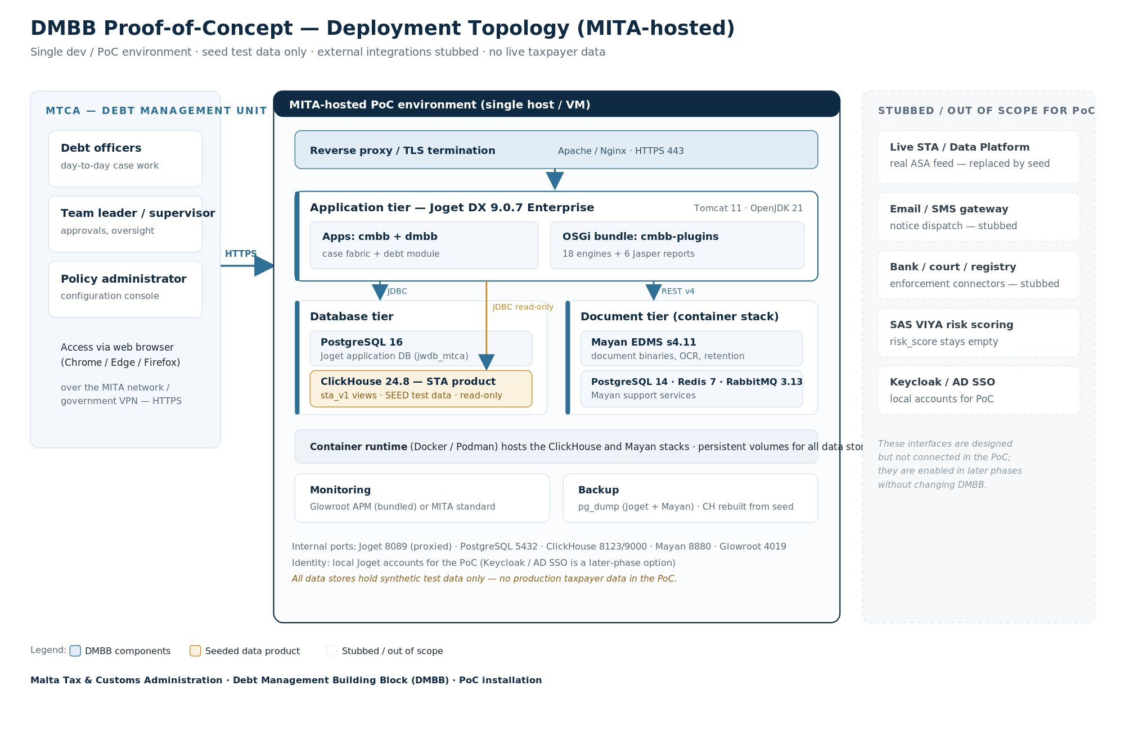
Figure — DMBB proof-of-concept deployment topology on MITA infrastructure.
All components may run on a single host for the PoC, or be split across two hosts (application vs. data/services) at MITA's discretion. The container-based components (ClickHouse and the Mayan stack) run under a container runtime with persistent volumes.

5. Infrastructure requirements

5.1 Compute and storage
The environment can be hosted on a single virtual machine. The sizing below is for the whole stack on one VM; if split across two VMs, divide the resources accordingly (application vs. data/services).
Resource | Minimum | Recommended
vCPU | 4 | 8
Memory (RAM) | 16 GB | 32 GB
Disk (SSD) | 100 GB | 200 GB
Operating system | Ubuntu Server 26.04 LTS (64-bit) | Ubuntu Server 26.04 LTS (64-bit)

Indicative memory split: JVM heap for Joget/Tomcat ~6 GB; PostgreSQL 16 ~2 GB; ClickHouse ~2–4 GB; the Mayan stack (Mayan + PostgreSQL 14 + Redis + RabbitMQ) ~3–4 GB; OS and headroom the remainder.

5.2 Operating system
- Ubuntu Server 26.04 LTS (64-bit), provisioned and maintained to MITA's server standards.
- Hardened to MITA's server baseline; SSH/administrative access restricted to authorised staff.
- NTP time synchronisation enabled (the system relies on accurate timestamps for the audit trail and escalation timing).

5.3 Container runtime
- Docker Engine 24+ (with the Compose plugin) or Podman 4+ with compose support, to run the ClickHouse and Mayan EDMS stacks.
- Persistent named volumes for all data stores; the stacks must never be torn down with their volumes during the PoC.

5.4 Install-time connectivity
During installation the host needs to obtain the platform binaries and container images (Joget DX9 Enterprise package, OpenJDK, the ClickHouse, Mayan, PostgreSQL, Redis and RabbitMQ images). MITA may allow temporary outbound access to the relevant repositories/registries, or provide the binaries and images through an internal mirror for an air-gapped install.

6. Software prerequisites
The following components and versions make up the platform MITA provides. Versions are the validated baseline; patch-level updates within the same series are acceptable.
Component | Version | Role
Joget DX (Enterprise) | 9.0.7 Enterprise | Low-code platform and application server; hosts the CMBB/DMBB apps. Enterprise licence required.
Apache Tomcat | 11.0.x (bundled) | Servlet container shipped with Joget DX9.
OpenJDK | 21 (LTS) | Java runtime for Joget/Tomcat. Pinned — see Section 7.2.
PostgreSQL | 16 | Joget application database (jwdb_mtca).
ClickHouse | 24.8 | Hosts the STA data product (sta_v1) with seed data; read by the DMBB over JDBC.
Mayan EDMS | s4.11 | Document management — binaries, versions, OCR, retention.
PostgreSQL | 14 | Mayan metadata database (part of the Mayan stack).
Redis | 7 | Mayan cache and lock manager.
RabbitMQ | 3.13 | Mayan background-task broker.
Reverse proxy | Apache httpd 2.4 / Nginx 1.24+ | TLS termination and routing to Joget.
APM (optional) | Glowroot (bundled) | Performance monitoring; may be replaced by MITA's standard tooling.

6.1 Application artefacts (supplied by the project)
These are delivered and installed by the project team onto the platform MITA provides:
- The CMBB and DMBB Joget application definitions (44 forms, 51 lists, the console userview, the 6 Jasper reports).
- The cmbb-plugins OSGi bundle (a single JAR carrying the 18 processing engines).
- Master-data seed (CSV) and the ClickHouse seed dataset (deterministic synthetic data).

7. Joget platform requirements

7.1 Edition and licence
Joget DX 9.0.7 Enterprise is required. The DMBB dashboards and reports use Enterprise-only features (the native SQL chart menu and the Jasper reports menu); these are not available in the Community edition. MITA must hold a valid Enterprise licence for the environment.

7.2 Java runtime
The runtime must be OpenJDK 21. Joget/Tomcat is started with Java pinned to JDK 21 and the -Dwflow.ignite=true flag; later JDKs are not validated for the Joget workflow engine.

7.3 Database schema precondition (important)
Critical install step — Joget PostgreSQL schema
Joget auto-creates most of its tables on first start, but on PostgreSQL the workflow-engine (Shark) tables — 67 tables prefixed shk — are NOT auto-created (the product ships only a MySQL initialisation script).
Before first start, the PostgreSQL structure (including the shk tables and the base directory/user tables) must be loaded into the Joget database. The project supplies this structure script. Skipping it leaves the workflow engine non-functional.

7.4 Directory and accounts
- An administrative Joget account is created for installation and configuration.
- DM unit user accounts and roles are created locally for the PoC (officer, supervisor, policy administrator).

7.5 Data API key
Seed and test data are loaded through Joget's data API using a per-app API key (bound to the API id, a DX9 requirement). The project configures these keys during installation.

8. Database requirements

8.1 Joget application database — PostgreSQL 16
- A dedicated database (for example jwdb_mtca) and an application database user with full rights on it.
- The structure precondition in Section 7.3 must be loaded before first boot.
- Holds all DMBB/CMBB case data; included in backups (Section 12).

8.2 STA data product — ClickHouse 24.8
- Hosts the published sta_v1 views plus the underlying mtca_ors schema, loaded with the deterministic seed dataset.
- A read-only role sta_reader the DMBB uses to query the product (SELECT only); a separate restricted identity for outcome writeback.
- Disposable for the PoC — it can be rebuilt at any time from the schema and seed scripts; no backup required.

8.3 Mayan database — PostgreSQL 14
- Internal to the Mayan stack; provisioned automatically as part of the Mayan container deployment.

9. Document management (Mayan EDMS)
- Mayan EDMS s4.11 with its support services (PostgreSQL 14, Redis 7, RabbitMQ 3.13), deployed as a container stack with persistent volumes.
- The DMBB integrates with Mayan over its REST API (v4) using a token; the project configures the connector during installation.
- A persistent volume for document binaries; modest for the PoC (seed documents only).

10. Network and connectivity

10.1 User access
- DM unit users reach the console from their workstations over the MITA network (or government VPN) using a standard web browser (Chrome, Edge or Firefox).
- Access is over HTTPS to a hostname resolved by MITA DNS (for example dmbb-poc.mita.internal), terminated at the reverse proxy.

10.2 Internal service ports
Port | Service | Exposure
443 (HTTPS) | Reverse proxy — user access | Exposed to DM unit users
8089 | Joget HTTP (behind the proxy) | Internal only
8019 | Tomcat shutdown | Localhost only
5432 | PostgreSQL 16 (Joget) | Internal only
8123 / 9000 | ClickHouse HTTP / native (JDBC) | Internal only
8880 | Mayan EDMS HTTP / REST | Internal / admin
6379 / 5672 | Redis / RabbitMQ (Mayan stack) | Internal to the stack
4019 | Glowroot APM (optional) | Internal / admin

10.3 Firewall and TLS
- Only the reverse proxy's HTTPS port is exposed to users; all platform and data ports remain on the internal network or localhost.
- A MITA-issued TLS certificate for the console hostname is installed on the reverse proxy.

11. Security requirements
The PoC perimeter is relaxed relative to production, but the application security baseline is non-negotiable:
- Transport security. All user traffic over HTTPS/TLS; internal service traffic confined to the host/internal network.
- Authentication. Local Joget accounts for the PoC, with per-user credentials. Single sign-on (Keycloak / Active Directory via OIDC) is a later-phase option and requires no DMBB change.
- Authorisation. Role- and row-level permissions are enforced in the application; author and approver duties (for example write-off approval) are segregated.
- Secrets. Database passwords, API keys and service credentials are held in environment/instance configuration, not in source or artefacts.
- Data access. All data writes go through the application API and server-side validators; no direct writes to application tables.
- Data protection. Synthetic test data only — no production taxpayer data is loaded, so the PoC carries no live personal-data exposure.
- Host hardening. OS and platform hardened to MITA's baseline; administrative access limited to authorised staff.

12. Operations

12.1 Storage and capacity
Capacity needs are modest because the dataset is a fixed seed. The recommended 200 GB SSD comfortably covers the operating system, the Joget platform, all databases and document storage for the PoC, with headroom for logs and backups.

12.2 Backup and recovery
- Joget application database (PostgreSQL 16): regular logical backup (pg_dump) on MITA's standard schedule.
- Mayan database and document volume: pg_dump plus a volume snapshot/archive.
- ClickHouse STA product: no backup needed — rebuilt on demand from the schema and seed scripts.
- Recovery objectives are modest for a PoC; a same-day restore from the latest backup is sufficient.

12.3 Monitoring and logging
- Application/JVM performance via the bundled Glowroot APM, or MITA's standard monitoring.
- Tomcat logs (catalina.out) and container logs retained per MITA policy.
- Health check: GET /jw/web/login returns HTTP 200 when the platform is up.

13. Installation and deployment process

13.1 Responsibilities
Activity | Responsible
Provision host(s), OS, network, DNS, TLS certificate, reverse proxy | MITA
Install Joget DX9 Enterprise (+ licence), OpenJDK 21, PostgreSQL 16 | MITA
Deploy the ClickHouse and Mayan container stacks | MITA (with project guidance)
Load the Joget schema precondition; create databases and roles | MITA + project
Deploy CMBB/DMBB apps, the OSGi plugin bundle, reports | Project
Load master-data seed and the ClickHouse seed dataset | Project
Configure connectors (STA JDBC, Mayan REST) and API keys | Project
Create DM unit user accounts and roles | Project + MTCA
Acceptance testing and sign-off | MTCA DM unit
Backups, monitoring, ongoing host operation | MITA

13.2 Artefact import order
The project installs the application artefacts in this dependency order:
- Master-data seed (categories, instruments, strategies, fee schedules, policies).
- Forms, then datalists, then the userview (console navigation).
- Workflow package.
- The OSGi plugin bundle (engines).
- Jasper reports.
- The ClickHouse STA seed dataset.

14. Non-functional expectations (PoC)
Aspect | PoC expectation
Performance | Single-taxpayer lookups in a few seconds; portfolio lists and dashboards within a few seconds on the recommended sizing. Best-effort, not contractual.
Availability | Business-hours availability on a single instance; no high availability or formal SLA.
Concurrency | A small group of DM unit users (indicatively 5–15) using the system concurrently.
Auditability | Every case action is recorded in an immutable, time-stamped history (retained in the Joget database).
Recoverability | Same-day restore from the latest backup; ClickHouse rebuildable from seed.

15. Dependencies, assumptions and exclusions

15.1 MITA must provide
- The host(s), operating system, network access for DM unit users, DNS entry and TLS certificate.
- Joget DX9 Enterprise software and a valid Enterprise licence.
- PostgreSQL 16, a container runtime, and a reverse proxy.
- Administrative access for the project team to install the application artefacts (or a joint installation session).

15.2 Key dependencies and risks
Item | Note
Joget Enterprise licence | Required for dashboards and reports; the PoC cannot deliver these on Community edition.
Schema precondition | The PostgreSQL Shark schema must be loaded before first boot, or the workflow engine will not function.
Seed data only | The PoC does not connect to the live STA; figures are representative, not real.
Stubbed integrations | Notices, enforcement connectors and risk scoring are simulated; no external messages are sent.

16. Readiness and acceptance checklist
The environment is ready for DM unit users when all of the following pass:
# | Check
1 | Joget responds (login page returns HTTP 200) and an administrator can sign in.
2 | The CMBB and DMBB apps are published and the DMBB Console is reachable over HTTPS.
3 | ClickHouse holds the seeded sta_v1 product and the DMBB can read a known taxpayer profile.
4 | Mayan is reachable and a test document can be filed and retrieved.
5 | The management dashboard renders all four charts with data.
6 | The debtors list, a debt case, an instalment, an enforcement action and a write-off screen all render.
7 | At least one Jasper report renders and exports to PDF.
8 | DM unit accounts are created and each user can log in with the correct role.
9 | Backups are configured for the Joget and Mayan databases.

In summary
MITA provides a single Linux host (8 vCPU / 32 GB / 200 GB recommended) running Joget DX9 Enterprise on OpenJDK 21 with PostgreSQL 16, a container runtime for the ClickHouse and Mayan stacks, and a TLS reverse proxy on the MITA network.
The project installs the DMBB applications, the engine bundle and the seed data, and validates the environment against the checklist above. The DM unit then accesses the console over HTTPS to evaluate the system.

