MALTA TAX & CUSTOMS ADMINISTRATION
Debt Management
Building Block (DMBB)
User Guide for Debt-Collection Officers
How to find debtors, work cases, agree instalments,
take enforcement action, and run your reports.
Version 1.0 · June 2026 · DMBB Console

Contents
Contents 2
1. Introduction 4
1.1 What the Debt Management system is 4
1.2 Who this guide is for 4
1.3 What the system does for you 4
1.4 Key terms 4
2. Getting started 6
2.1 Opening the console 6
2.2 The console at a glance 6
2.3 Working with lists — search, filter, sort, export 6
3. The management dashboard 7
4. Finding the debtors you need to work 8
4.1 The debtors list 8
4.2 Debt categories (C1–C6) 8
4.3 The enforcement stage 9
5. Working a debt case 10
5.1 Opening a case 10
5.2 What is on a case 10
5.3 Creating a case manually 10
6. Instalment agreements 12
6.1 Creating an agreement 12
6.2 While an agreement is active 12
7. Enforcement actions 14
7.1 Proportional enforcement 14
7.2 Initiating an action 14
7.3 What the system checks before it acts 15
7.4 Charges, agents and publication 15
8. Write-offs 16
8.1 Submitting a write-off for approval 16
8.2 Approval delegation 16
8.3 Automatic write-offs 17
9. Default assessments 18
10. Reports and analytics 19
10.1 Formal reports 19
10.2 Management-information lists 19
11. How automation supports you 21
12. Quick reference 22
12.1 A typical working day 22
12.2 Glossary 22
12.3 Getting help 22

1. Introduction

1.1 What the Debt Management system is
The Debt Management Building Block — the DMBB — is the system the Malta Tax & Customs Administration uses to recover outstanding tax debt. It takes a tax debt from the moment it is identified, through reminders and formal demands, into enforcement, instalment arrangements or write-off, and finally to closure — keeping a complete, time-stamped history at every step.
You work in the DMBB through a single web application called the DMBB Console. Everything in this guide happens in that one place: there is nothing to install on your computer beyond a web browser.

1.2 Who this guide is for
This guide is written for debt-collection officers — the people who work cases day to day. It focuses on the tasks you do: finding the debtors who need attention, opening and understanding a case, agreeing instalment plans, initiating enforcement, preparing write-offs, and running reports. Configuration of the system (categories, strategies, fee schedules and policies) is performed by administrators and is outside the scope of this guide.

1.3 What the system does for you
A great deal of the routine work happens automatically, so that your time goes to the cases that need judgement:
- It identifies debtors automatically from the taxpayer account and opens a debt case for each one above the collection threshold.
- It escalates ageing debt on its own — sending reminders, then demand notices, then final demands — and records every notice.
- It enforces the rules of proportionality, so the actions available to you always match the size and category of the debt.
- It monitors instalment agreements and flags or cancels those that fall into default.
- It keeps an unbroken audit trail for every case and produces the reports and dashboards you and your managers need.

1.4 Key terms
Term | What it means
Debt case | A single file for one taxpayer's consolidated debt. Identified by a case reference such as DM-000002.
TIN | Tax Identification Number — the taxpayer the case belongs to.
Debt category (C1–C6) | A size band for the total debt, from C1 (smallest) to C6 (largest). It governs how the debt is handled.
Enforcement stage | Where the case sits on the escalation ladder: Identified, Reminder, Demand, Final demand, then enforcement / Recovery.
Enforceable amount | The amount that may be enforced: the balance minus any open dispute.
Instrument | An enforcement tool — bank garnishment, property seizure, agent appointment, publication, and so on.

2. Getting started

2.1 Opening the console
Open your web browser and go to the DMBB Console address provided by your administrator (for example, http://<server>/jw/web/userview/dmbb/dmbbConsole). Sign in with your MTCA credentials. If you do not have access, contact your supervisor or the IT service desk.

2.2 The console at a glance
The console has a dark navigation panel on the left and your working area on the right. The navigation is organised into four areas, so you can always find what you need by what you are trying to do:
Area | What you will find there
Dashboards | At-a-glance charts of the whole debt portfolio — stock, ageing, recovery and instalment compliance.
Operations | Your day-to-day work: debt cases, debtors list, instalments, enforcement actions, write-offs, reports.
Automation | The scheduled jobs the system runs for you. You normally only look here to confirm a run has happened.
Admin | Configuration — categories, instruments, strategies, fees, templates and policies. Maintained by administrators.
As an officer you will spend almost all of your time in the Operations area, with the Dashboards for an overview.

2.3 Working with lists — search, filter, sort, export
Most screens in Operations are lists. They all behave the same way, so once you learn one you know them all:
- Filter using the boxes above the list (for example debt category, tax type, or TIN), then press Show.
- Sort by clicking a column heading; click again to reverse the order.
- Page through results, or raise the rows-per-page count, using the controls at the top of the list.
- Export the list to Excel or CSV where an export control is offered — useful for offline work or sharing.
- Open a record by clicking its action link (for example Edit, or the Open-case link on the debtors list).

3. The management dashboard
The dashboard is the quickest way to understand the state of the debt portfolio. Open it from Dashboards ▸ Management dashboard. It shows four charts on one page.
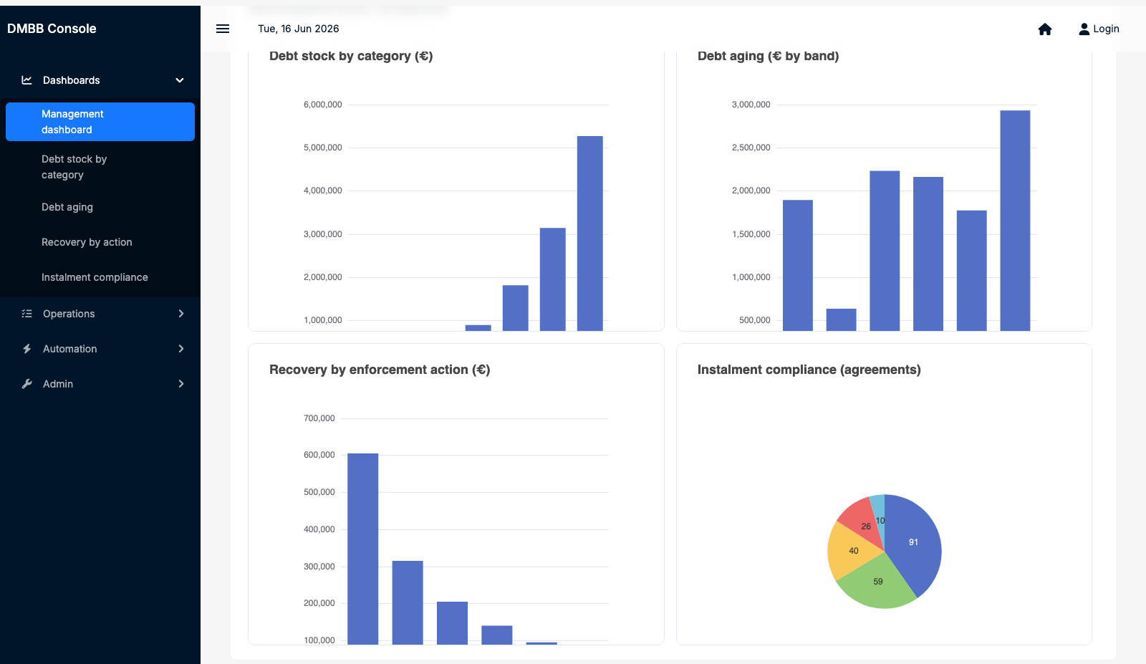
Figure — The management dashboard — debt by category, ageing, recovery by action, and instalment compliance.
- Debt stock by category — how much debt sits in each size band C1–C6. Most value typically concentrates in the larger categories.
- Debt aging — how much debt sits in each age band, from 0–30 days to over a year. Older debt is harder to recover and deserves attention.
- Recovery by enforcement action — how much has been recovered through each instrument, so you can see what is working.
- Instalment compliance — the mix of agreements that are active, completed, cancelled, rejected or in default.
Tip
The figures refresh each time the page loads — use the Reload control to get the latest picture before a meeting.

4. Finding the debtors you need to work

4.1 The debtors list
Open Operations ▸ Debtors list (outstanding). This is your primary worklist: every taxpayer with outstanding, enforceable debt, excluding cases that have been written off or closed.
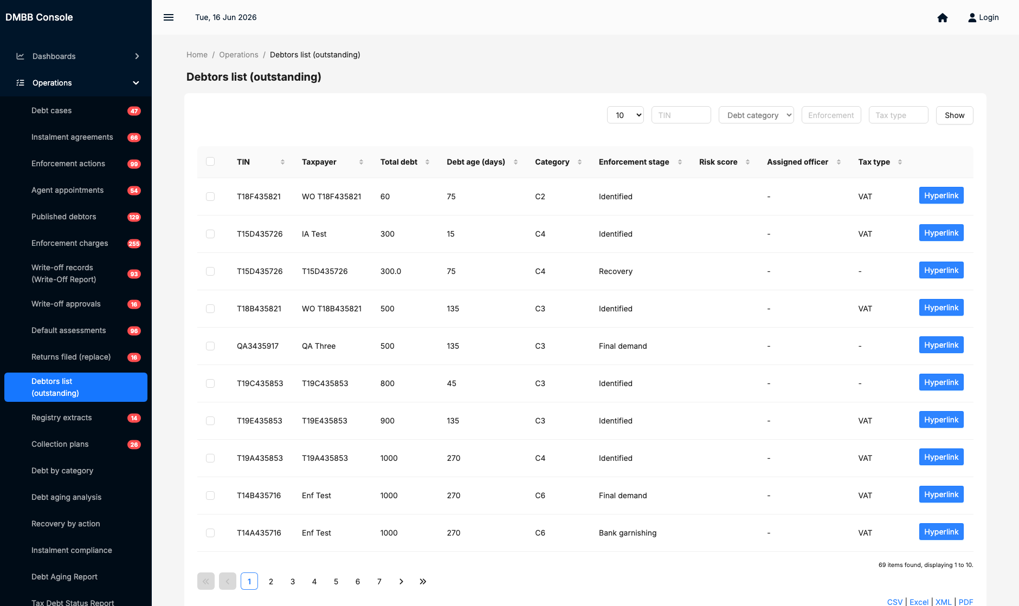
Figure — The debtors list — every outstanding debtor, with filters and a link through to the case.
Each row shows the taxpayer (TIN and name), the total debt, the debt age in days, the category, the current enforcement stage, the risk score, the assigned officer and the tax type. To narrow the list:
- Choose a Debt category, Tax type, or type a TIN in the filter boxes at the top.
- Press Show to apply the filters.
- Click a column heading to sort — for example by Total debt to work the largest first, or by Debt age to chase the oldest.
- Click the link at the end of a row to open that taxpayer's debt case.
Note
You can filter on one criterion at a time on this list and combine it with sorting. To work the highest-value cases, sort by Total debt (descending); to chase ageing debt, sort by Debt age.

4.2 Debt categories (C1–C6)
Every debt is placed in a size band based on the taxpayer's total consolidated debt. The category drives how the debt is treated and which enforcement instruments become available.
Category | Indicative size band | Typical handling
C1 | Up to €30 | Smallest balances. Usually cleared by automatic write-off rather than active pursuit.
C2 | €30 – €100 | Small. Reminders and passive collection (such as refund interception).
C3 | €100 – €1,000 | Moderate. Demand notices, instalment offers, first-line enforcement, may be published.
C4 | €1,000 – €20,000 | Significant. Instalments, garnishment and collection agents become available.
C5 | €20,000 – €200,000 | Large. Full enforcement, agents and publication.
C6 | Over €200,000 | Largest. Full enforcement including judicial action; closely monitored.
Band boundaries are configured by administrators; the figures above are indicative.

4.3 The enforcement stage
A case moves along an escalation ladder. The stage tells you what has already happened and what comes next:
- Identified — the debt has been found and a case opened; no notice sent yet.
- Reminder — a first, informal reminder has issued.
- Demand — a formal demand notice has issued.
- Final demand — the last notice before enforcement.
- Enforcement / Recovery — enforcement instruments are now in play and recovery is under way.
The system advances these stages automatically as the debt ages (see Section 11). You act when a case reaches the enforcement stage, or when a taxpayer contacts you to arrange payment.

5. Working a debt case

5.1 Opening a case
Open Operations ▸ Debt cases for the full list of cases, or follow the link from the debtors list. Each case carries a case reference (for example DM-000002), the TIN, the tax type, the debt category, the amount at stake, the current state and the assigned officer.
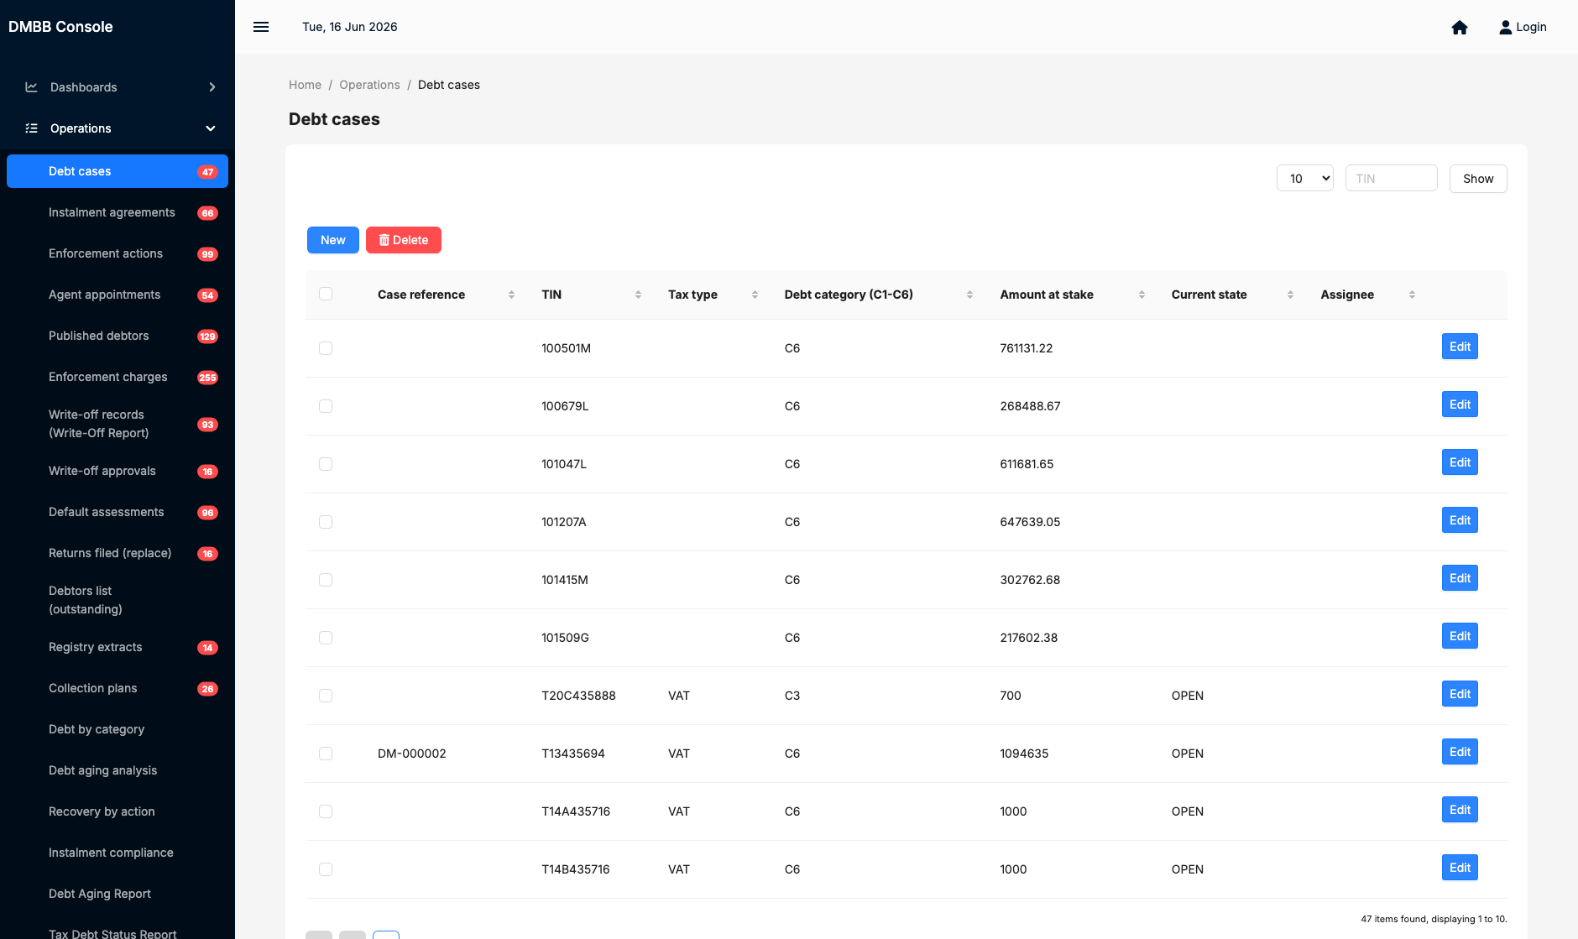
Figure — The Debt cases list — open any case with Edit, or start a manual case with New.

5.2 What is on a case
Open a case with Edit to see its full detail:
- The debt summary — the consolidated amount owed, the enforceable amount, and the category.
- The debt lines — the individual amounts that make up the debt, broken down by tax type and year, each with its disputed and enforceable amounts.
- The current state and stage — where the case sits in its lifecycle.
- The history — a complete, time-stamped record of every notice, action and change. This audit trail cannot be altered.

5.3 Creating a case manually
Most cases are created automatically. Occasionally you may need to open one by hand — for example for a debt referred from another team. To do so:
- In Operations ▸ Debt cases, click New.
- Enter the taxpayer's TIN and the debt details.
- Save. The system will not create a duplicate if an open case already exists for that taxpayer.

6. Instalment agreements
When a taxpayer cannot pay in full but is willing to pay over time, you can set up an instalment agreement. Open Operations ▸ Instalment agreements.
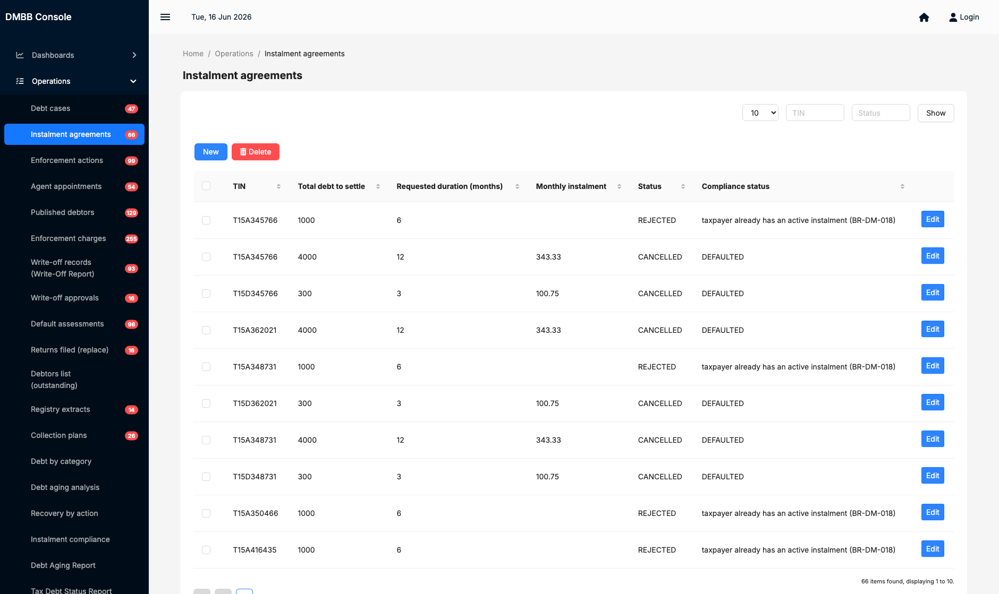
Figure — Instalment agreements — payment plans and their compliance status.

6.1 Creating an agreement
- Click New and select the debt case.
- Enter the proposed terms (number and frequency of instalments).
- Save. The system builds the payment schedule and calculates the projected interest at the reduced relief rate.
The system checks eligibility automatically and will reject an agreement that breaks the rules — for example, a taxpayer who already has an active plan, an instalment below the minimum allowed, or a debt in a category that is not eligible for relief. Within the approved parameters, eligible plans are approved automatically.

6.2 While an agreement is active
- Enforcement is held. An active plan suppresses enforcement on the case, so the taxpayer is protected while they keep to the arrangement.
- Compliance is monitored. The system watches for missed instalments. A missed payment within the grace period is flagged; once the agreed number of consecutive payments is missed, the plan is cancelled automatically, the enforcement hold is released, and a recovery case is opened.
What this means for you
You do not have to police every payment by hand — the system raises the cases that have fallen into default. Your job is to act on those, and to handle taxpayers who contact you to renegotiate before they default.

7. Enforcement actions
When reminders and demands have not produced payment, and no instalment plan or dispute is protecting the debt, you can take enforcement action. Open Operations ▸ Enforcement actions.
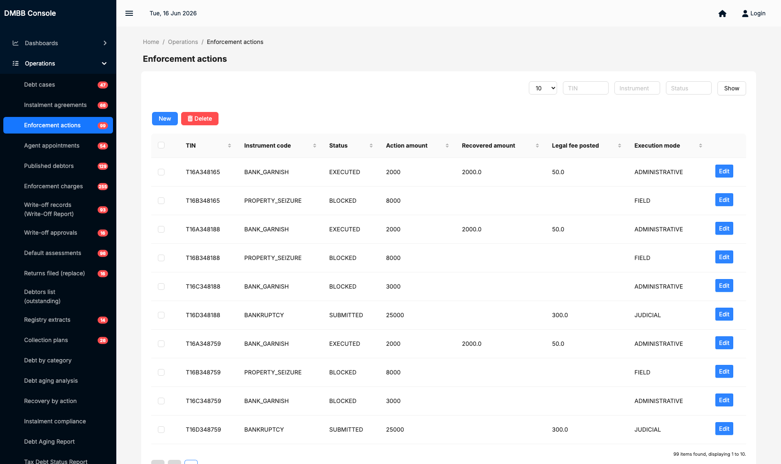
Figure — Enforcement actions — initiate and track garnishment, seizure, agents, publication and more.

7.1 Proportional enforcement
The system enforces proportionality: the instruments available to you depend on the debt's category and amount. Heavier instruments unlock only at higher categories, so the response always matches the size of the debt.
Instrument | What it does | Typically available
Bank garnishment | Instructs the bank to pay funds from the taxpayer's account toward the debt. | Mid and higher categories
Property seizure | Seizes and, if needed, auctions assets to recover the debt. | Higher categories
Agent appointment | Appoints an external collection agent who earns commission on what they recover. | C4 – C5
Debtor publication | Publishes the defaulter on the official register. | C3 and above, past final demand
Judicial action | Refers the case to court — for example bankruptcy proceedings. | Largest debts

7.2 Initiating an action
- Open the relevant case, or start from Enforcement actions and select the case.
- Choose the instrument. Only instruments allowed for the case's category and amount are offered.
- Confirm the details and submit. The system records the action, sends any instruction (for example to the bank), and tracks the response and any amount recovered.

7.3 What the system checks before it acts
Before an enforcement action proceeds, the system verifies that it is allowed. An action is blocked if any of the following is true:
- The instrument is too heavy for the debt's category or amount (the proportionality rule).
- The full amount is under dispute (an open objection covering the whole debt).
- An active instalment agreement is protecting the case.
If an action is blocked, the system tells you why. Resolve the underlying reason — for example wait for a dispute to close — before trying again.

7.4 Charges, agents and publication
- Charges. Where an instrument carries a cost (a legal or agent fee), the system raises a separate charge against the case. You can review these under Operations ▸ Enforcement charges.
- Agents. Appointed agents and their reports and commission are tracked under Agent appointments. The system alerts you if an agent has not reported within the expected interval.
- Publication. Published defaulters appear under Published debtors. When a debt is resolved, the taxpayer is removed from the published set.

8. Write-offs
When a debt cannot realistically be collected — it is uncollectible, or time-barred — it can be written off. Open Operations ▸ Write-off records. A write-off never deletes the case: the case, the debt and its full history are preserved, with the status marked written-off.
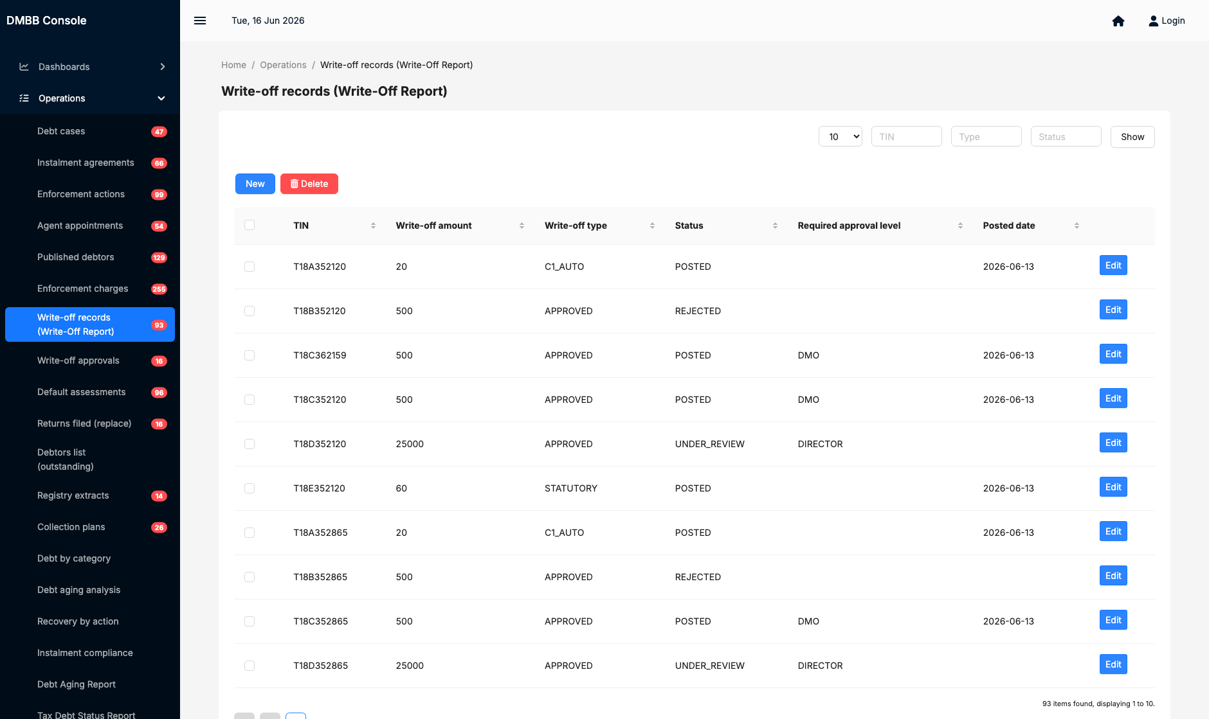
Figure — Write-off records — the write-off register, which is also the Write-Off Report.

8.1 Submitting a write-off for approval
- Open the case and start a write-off request, choosing the ground (the reason).
- Attach the required evidence: a summary of enforcement history, the supporting evidence, and your rationale. The system rejects a request that is missing this.
- Submit. The request is routed for approval according to its amount.

8.2 Approval delegation
Who must approve a write-off depends on the amount, so that larger write-offs receive more senior sign-off:
Amount | Approver
Below €1,000 | Debt Management Officer (DMO)
€1,000 – €20,000 | Senior Debt Officer (SDO)
€20,000 and above | Director
Approvers act under Operations ▸ Write-off approvals: approving posts the write-off and closes the case; rejecting returns the case to you. Thresholds are configurable by administrators.

8.3 Automatic write-offs
Some write-offs need no manual request. The system clears the smallest balances (category C1) automatically, and performs statutory bulk write-offs of debts that have passed the statutory age limit. You do not need to do anything for these; they appear in the write-off register for the record.

9. Default assessments
Where a taxpayer has not filed a return, the system can raise a default assessment — an estimate of the tax due — so that the debt can be pursued. Open Operations ▸ Default assessments.
- Estimation. The system estimates the amount using the best available basis (the prior year, an industry average, or a fixed amount) and records the method it used.
- Reasonableness. An estimate that is much larger than the prior year is held for justification before it is confirmed.
- Replacement. When the taxpayer later files the real return, record it under Returns filed (replace); the estimate is replaced and the difference noted.
- Escalation. If no return is filed within the grace period, the assessed amount becomes a categorised debt case and follows the normal collection path.

10. Reports and analytics
The Operations area includes a set of formal reports and a set of management-information (MI) lists. Both are useful for your own planning and for answering questions from managers.

10.1 Formal reports
Six ready-made reports render as titled, totalled documents that you can export to PDF or Excel: Debt Aging, Tax Debt Status, Recovery by Action, Instalment Compliance, Write-Off, and Debtors List. Open one — for example the Debt Aging Report — from its entry in the Operations list.
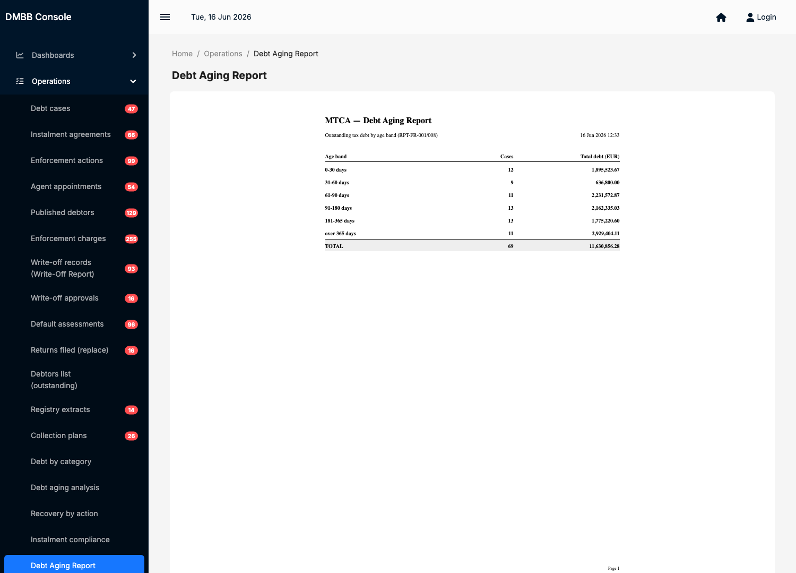
Figure — The Debt Aging Report — a typeset, totalled report ready to export to PDF or Excel.

10.2 Management-information lists
Four MI lists let you slice the portfolio interactively — Debt by category, Debt aging analysis, Recovery by action, and Instalment compliance. Each can be filtered, sorted and exported, and several let you drill from a summary figure down to the underlying debtors.
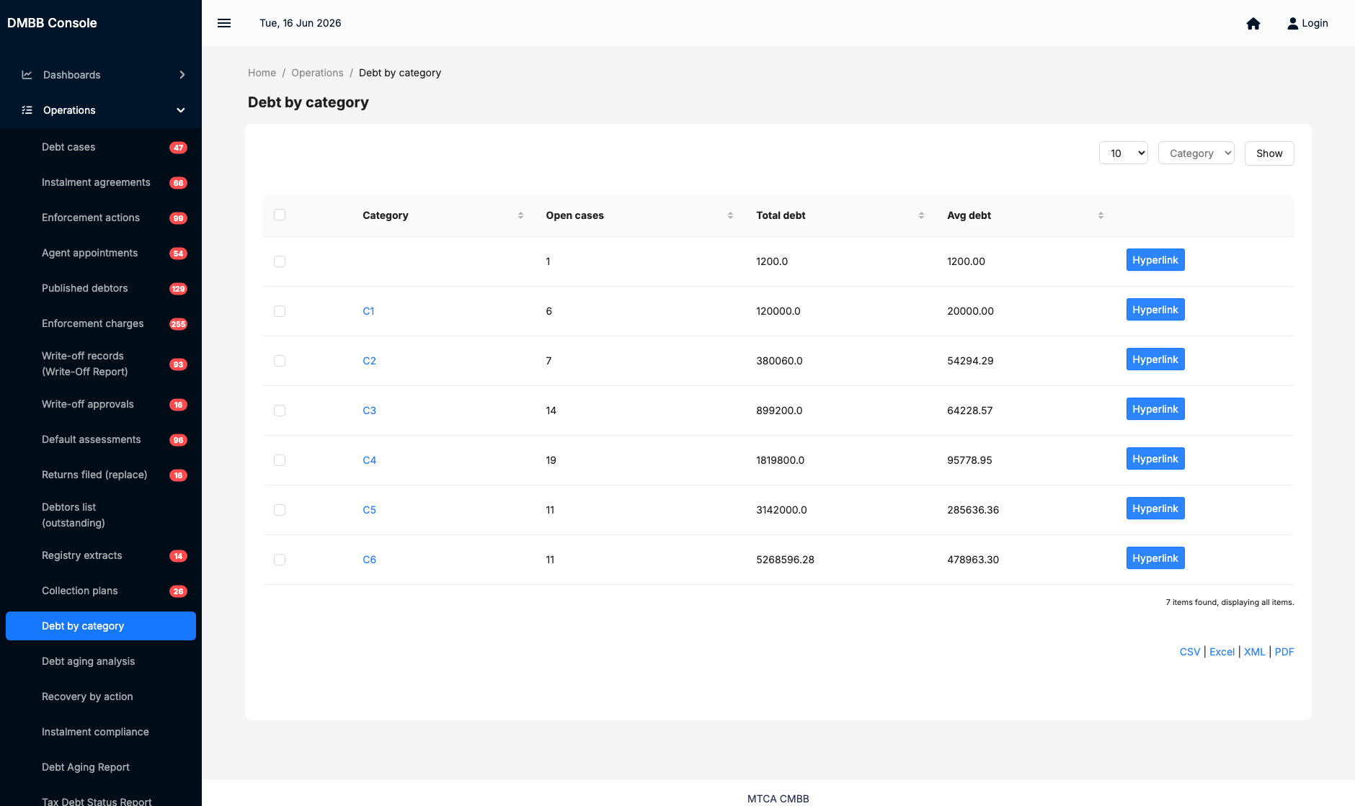
Figure — The Debt-by-category MI list — filter, sort, export, and drill down to the debtors behind a figure.

11. How automation supports you
The Automation area lists the scheduled jobs the system runs on its own. You do not normally start these — they run on a timetable set by administrators — but it helps to know what they do, because their results are the cases and notices that arrive in your worklist.
Automated job | What it does for you
Identification run | Finds new debtors and opens a debt case for each one above the threshold.
Escalation sweep | Advances ageing cases along the reminder ▸ demand ▸ final-demand ladder and issues the notices.
Instalment compliance sweep | Detects missed instalments, cancels defaulted plans, and opens recovery cases.
Enforcement sweep | Publishes and releases debtors and runs agent alerts.
Write-off sweep | Performs automatic C1 and statutory write-offs.
Default-assessment escalation | Turns un-filed assessments into categorised debt cases after the grace period.
Collection MI run | Refreshes the management-information figures behind the dashboards and reports.
In short: the system continuously finds, escalates and tidies cases, and hands you the ones that need a person. If you ever need to confirm that a run has happened, you can check it here.

12. Quick reference

12.1 A typical working day
- Open the dashboard for the overall picture.
- Go to the debtors list; sort by value or age to set your priorities.
- Open each priority case, review the debt and history.
- Act: agree an instalment plan, initiate a proportionate enforcement action, or prepare a write-off.
- Work the cases the automation has handed you — defaulted instalments, newly escalated cases.
- Run a report at the end of the day or week to track your recovery.

12.2 Glossary
Term | Meaning
Consolidated debt | All of a taxpayer's enforceable debt brought together into one case.
Enforceable amount | Balance minus any open dispute — the amount that may be enforced.
Dispute / objection | A formal challenge to the debt. An open full-amount dispute blocks enforcement.
Hold | A protection on a case (for example from an active instalment plan) that suppresses enforcement.
Instrument | An enforcement tool — garnishment, seizure, agent, publication, judicial action.
Write-off ground | The reason a debt is written off (for example uncollectible, or statute-barred).
Default assessment | An estimated assessment raised when a return has not been filed.

12.3 Getting help
If a screen does not behave as described, or you believe a figure is wrong, do not adjust configuration yourself — note the case reference and what you expected, and contact your supervisor or the IT service desk. Configuration changes (categories, fees, strategies and policies) are made by administrators.

A note on the figures in this guide
The screenshots show a test environment with representative data, so the names and amounts are illustrative. Your live console will show real taxpayers and balances, but every screen and step works exactly as shown here.

