Installing the Lesotho Farmers Registry on Kubernetes
For: the ITU system administrator who installs it · Version: 4 October 2026 · Package: lst-fr-itu-package
This guide takes you from an empty Kubernetes namespace to a working copy of the Lesotho Farmers Registry, with its demonstration data, reachable over HTTPS. You do not need to know Joget: every Joget step is spelled out, and every Joget word is explained the first time it appears. Every command below was run, in this order, on a test cluster on 3 October 2026 (the two restores of section 10 on 2 October 2026); the text under each command is what it printed there. Step 12 was added on 4 October 2026, when the package was installed again from nothing and checked; its output is from that run. Allow about 45 minutes.

1. What you will end up with
- One namespace, farmers-registry, holding everything.
- PostgreSQL 16 (a StatefulSet, one replica, a 10 GiB volume) holding the registry's database.
- Joget DX 9.0.5 Enterprise (a Deployment, one replica, a 5 GiB volume) running the Farmers Registry.
- An Ingress that publishes it at https://<your hostname>/ with your certificate.
- The demonstration content: the Farmers Registry application with all its forms, reports, menus, plugins and code lists, 110 farmer records (107 complete registrations), 195 parcels, and three user accounts.
Every person in the package is generated. Before the package was made, the national ID number, every name, the telephone numbers, the e-mail addresses, the home village, the cooperative's name and the signature of every farmer, household member, applicant and contact person were replaced by invented values, and every date of birth was moved to another day of the same year. Sex, district, resource centre, crops, livestock and parcels were kept, so the reports show the same figures as the project's test system. No real person's data is in the package.

2. Words used in this guide
Word | Meaning
Joget | Joget DX, a low-code platform: a Java web application (Tomcat) that runs applications defined as data in its database. The Farmers Registry is such an application.
App | One application inside Joget. Here: farmersPortal, shown to users as "Farmers Registration".
Form | A data-entry screen of an app (for example the farmer registration wizard). Each form stores its records in its own database table, named app_fd_<something>.
Report / list | A table screen of an app (Joget calls it a datalist). The four reports you check in section 7 are lists.
Portal / menu | The navigation of an app with its menus (Joget calls it a userview). Its address is /jw/web/userview/farmersPortal/v.
Plugin | A Java .jar file that adds elements to Joget (a map widget, a search box, report filters). The package carries 17.
wflow folder | Joget's data folder (/opt/joget/wflow in the container): its database connection settings, the plugins and a few app files. It lives on its own volume.
Console | Joget's administration pages, under /jw/web/console/.
System Key | The identifier Joget computes for one installation. A Joget licence is issued for one System Key.

3. What you need from ITU before starting
- A workstation with kubectl (1.30 or later), sha256sum, openssl, base64 and curl, and the package folder unpacked on it.
- Access to a Kubernetes cluster (tested on Kubernetes 1.34) with the right to create a namespace and, inside it, Deployments, StatefulSets, Jobs, Services, Secrets, ConfigMaps, PersistentVolumeClaims, an Ingress, a ServiceAccount, a Role and a RoleBinding.
- Worker nodes that run linux/amd64 images. Joget publishes its image for amd64 only.
- Persistent storage: a storage class that can give two ReadWriteOnce volumes, 10 GiB and 5 GiB. If the cluster has a default storage class, nothing needs changing; if not, put its name in the two lines marked storageClassName in k8s/02-postgres.yaml and k8s/04-restore-job.yaml.
- Pulling from Docker Hub: the nodes pull postgres:16.13 and jogetworkflow/joget-enterprise:9.0.5.
- A hostname and its TLS certificate (two files: the certificate and its private key), and the name of the cluster's Ingress class (for example nginx or traefik).
- Resources: about 1 CPU and 3.5 GiB of memory for the two pods.
- The Joget licence, if more than three people must log in. Without one, Joget Enterprise lets the first three user names in alphabetical order log in, which here are exactly the three demonstration accounts. Section 8 explains how to obtain and enter a licence.

4. What is in the package
Path | What it is
FR-ITU-Kubernetes-Install-Guide.docx / .md, images/ | This guide and its pictures.
README.txt | A short note on the package.
k8s/00-namespace.yaml | The namespace farmers-registry.
k8s/01-secret.template.yaml | A template of the Secret with the three passwords (placeholders only).
k8s/02-postgres.yaml | PostgreSQL: Service and StatefulSet with its volume.
k8s/03-joget-tomcat-config.yaml | Joget's web server settings (Tomcat server.xml), with two limits raised so large forms can be saved.
k8s/04-restore-job.yaml | The wflow volume, and a one-time Job that restores the database and prepares the wflow folder.
k8s/05-joget.yaml | Joget: ServiceAccount and Role (for the licence), Service and Deployment with probes.
k8s/06-ingress.yaml | The HTTPS address (two placeholders to fill).
db/fr-jwdb.dump | The database (PostgreSQL custom format, pg_dump -Fc), 2.1 MB.
wflow/app_plugins/*.jar | The 17 plugins.
wflow/app_resources/, wflow/app_pwa/ | The app's logo, icon and mobile settings.
app-export/APP_farmersPortal-1-20261004.jwa | The application exported by Joget itself: a spare copy of the app's definitions (forms, reports, menus), without data. You do not need it to install.
SHA256SUMS | A checksum of every other file of the package.
proof/ | Screenshots and the recorded output of the test installation.

The package holds no password, key or credential: you choose the three passwords in step 4, and they live only in your cluster's Secret.

5. Install, step by step
Open a terminal in the package folder (the folder that holds SHA256SUMS) and run the steps in order. Every command names the namespace explicitly, so it does not matter which namespace your kubectl context points at.

Step 1 — Check the tools and the cluster
kubectl version; kubectl get nodes; kubectl get storageclass
It prints the client and server versions, your nodes in state Ready, and the storage classes. One should be marked (default); if none is, see section 3, item 4. On the test cluster:
Server Version: v1.34.3
NAME STATUS ROLES AGE VERSION
desktop-control-plane Ready control-plane 114d v1.34.3
NAME PROVISIONER RECLAIMPOLICY VOLUMEBINDINGMODE ALLOWVOLUMEEXPANSION AGE
hostpath rancher.io/local-path Delete WaitForFirstConsumer false 114d
standard (default) rancher.io/local-path Delete WaitForFirstConsumer false 114d

Step 2 — Check the package files
sha256sum -c SHA256SUMS
It checks every file of the package, this guide included. Every line must end in OK. A line ending in FAILED means the file was damaged in transfer: get the package again.
FR-ITU-Kubernetes-Install-Guide.docx: OK
FR-ITU-Kubernetes-Install-Guide.md: OK
README.txt: OK
app-export/APP_farmersPortal-1-20261004.jwa: OK
db/fr-jwdb.dump: OK
...
wflow/app_resources/farmersPortal/1/lesotho_farmers_registry_logo_120.png: OK

Step 3 — Create the namespace
kubectl apply -f k8s/00-namespace.yaml
namespace/farmers-registry created

Step 4 — Create the three passwords
This makes three random passwords and stores them in the Secret fr-secrets. Nothing is printed and nothing is written to disk; you read the administrator's password back in section 6.
PG_PW=$(openssl rand -hex 16); ADMIN_PW=$(openssl rand -hex 12); DEMO_PW=$(openssl rand -hex 12)
kubectl -n farmers-registry create secret generic fr-secrets --from-literal=postgres-password="$PG_PW" --from-literal=joget-admin-password="$ADMIN_PW" --from-literal=demo-user-password="$DEMO_PW"
secret/fr-secrets created
The three keys are: postgres-password (the database user joget), joget-admin-password (the Joget administrator admin) and demo-user-password (the two demonstration users cat and clark). If you prefer to choose them yourself, use k8s/01-secret.template.yaml instead.

Step 5 — Start PostgreSQL
kubectl apply -f k8s/02-postgres.yaml && kubectl -n farmers-registry rollout status statefulset/fr-postgres --timeout=300s
service/fr-postgres created
statefulset.apps/fr-postgres created
Waiting for 1 pods to be ready...
partitioned roll out complete: 1 new pods have been updated...

Step 6 — Start the restore Job
The Job starts, then waits for you to copy the package's files into it (step 7).
kubectl apply -f k8s/03-joget-tomcat-config.yaml -f k8s/04-restore-job.yaml && kubectl -n farmers-registry wait --for=condition=Ready pod -l job-name=fr-restore --timeout=300s
configmap/fr-joget-tomcat created
persistentvolumeclaim/fr-wflow created
configmap/fr-restore-script created
job.batch/fr-restore created
pod/fr-restore-z6wcm condition met

Step 7 — Copy the database and the wflow files into the Job
POD=$(kubectl -n farmers-registry get pod -l job-name=fr-restore -o jsonpath="{.items[0].metadata.name}")
kubectl -n farmers-registry cp SHA256SUMS $POD:/package/SHA256SUMS
kubectl -n farmers-registry cp db $POD:/package/db
kubectl -n farmers-registry cp wflow $POD:/package/wflow
kubectl -n farmers-registry exec $POD -- touch /package/UPLOAD_COMPLETE
echo "uploaded to $POD"
uploaded to fr-restore-z6wcm
(The pod name ends in five random characters; yours will differ.)

Step 8 — Wait for the restore and read its result
kubectl -n farmers-registry wait --for=condition=complete job/fr-restore --timeout=900s; kubectl -n farmers-registry logs job/fr-restore
job.batch/fr-restore condition met
[1/6] Waiting for the package files (the guide's 'kubectl cp' step) ...
[2/6] Checking the files against their checksums ...
all 21 files match
[3/6] Waiting for PostgreSQL ...
[4/6] Restoring the database (a minute or two) ...
application: farmersPortal (farmersPortal version 1)
users: admin, cat, clark
farmer records: 110
[5/6] Preparing Joget's data folder ...
plugins installed: 17
[6/6] Done. Start Joget now (05-joget.yaml).
The Job refuses to run on a database that already holds a Joget installation; see section 11 if it says so.

Step 9 — Start Joget
kubectl apply -f k8s/05-joget.yaml && kubectl -n farmers-registry rollout status deployment/fr-joget --timeout=900s
serviceaccount/fr-joget created
role.rbac.authorization.k8s.io/fr-joget-deployment-info created
rolebinding.rbac.authorization.k8s.io/fr-joget-deployment-info created
service/fr-joget created
deployment.apps/fr-joget created
Waiting for deployment "fr-joget" rollout to finish: 0 of 1 updated replicas are available...
deployment "fr-joget" successfully rolled out
Joget took 71 seconds to become ready on the test cluster; the probes allow it ten minutes. "Successfully rolled out" means its login page answers. Check all pods:
kubectl -n farmers-registry get pods,pvc,svc
NAME READY STATUS RESTARTS AGE
pod/fr-joget-f5cf45685-r72xp 1/1 Running 0 71s
pod/fr-postgres-0 1/1 Running 0 98s
pod/fr-restore-z6wcm 0/1 Completed 0 83s
NAME STATUS ... CAPACITY ACCESS MODES
persistentvolumeclaim/data-fr-postgres-0 Bound ... 10Gi RWO
persistentvolumeclaim/fr-wflow Bound ... 5Gi RWO
NAME TYPE CLUSTER-IP PORT(S)
service/fr-joget ClusterIP 10.96.72.78 8080/TCP,9090/TCP
service/fr-postgres ClusterIP None 5432/TCP

Step 10 — A first look, before the public address exists
This forwards port 8080 of your workstation to Joget. Leave it running in its own terminal.
kubectl -n farmers-registry port-forward service/fr-joget 8080:8080
Forwarding from 127.0.0.1:8080 -> 8080
Open http://localhost:8080/jw/ in a browser on the same workstation; you will see Joget's login page. Section 6 says how to log in. (A port-forward follows one pod: after Joget restarts, stop it with Ctrl-C and start it again.)

Step 11 — Publish it over HTTPS
- Store your certificate and key in the cluster (use your own two files' names):
kubectl -n farmers-registry create secret tls fr-tls --cert=fr.crt --key=fr.key
- Open k8s/06-ingress.yaml in an editor and replace fr.example.itu.int with your hostname in all three places it appears: the comment at the top, under tls and under rules. If your cluster's Ingress class is not nginx, change ingressClassName too. The two nginx.ingress… annotations raise the upload size and the time-out on NGINX-based controllers; other controllers ignore them.
- Apply it:
kubectl apply -f k8s/06-ingress.yaml
kubectl -n farmers-registry get ingress fr-joget
ingress.networking.k8s.io/fr-joget created
NAME CLASS HOSTS ADDRESS PORTS AGE
fr-joget nginx fr.example.itu.int 80, 443 0s
- Check it from your workstation (replace the hostname):
curl -s -o /dev/null -w "%{http_code} -> %{redirect_url}\n" https://fr.example.itu.int/
302 -> https://fr.example.itu.int/jw/
The Ingress sends traffic to Joget's port 9090, which knows it sits behind HTTPS and writes https:// addresses. On the test cluster the address worked end to end: login, the portal and the reports over HTTPS (proof/14-https-via-ingress-crops.png). The test used a self-signed certificate for fr.example.itu.int.

Step 12 — Enter ITU's own notification addresses
The registry can send notices by e-mail and by text message. As delivered it is in test mode: every notice goes to one test e-mail address and one test telephone number instead of to the person it concerns, so that nothing can reach a citizen by accident. This package carries no address and no number: both are empty, so a notice has nowhere to go until ITU enters its own. Joget reads the two values from the Java properties regbb.notif.testEmail and regbb.notif.testPhone; on Kubernetes you set them in the Deployment, as below.
- Set both values. The address and the number shown are placeholders: replace them with ITU's own mailbox and telephone number, written without spaces.
kubectl -n farmers-registry set env deployment/fr-joget \
CATALINA_OPTS="-Dregbb.notif.testEmail=notices@fr.example.itu.int -Dregbb.notif.testPhone=+00000000000"
deployment.apps/fr-joget env updated
- Joget restarts by itself (it took 80 seconds on the test cluster). Wait for it:
kubectl -n farmers-registry rollout status deployment/fr-joget --timeout=900s
Waiting for deployment "fr-joget" rollout to finish: 0 out of 1 new replicas have been updated...
Waiting for deployment "fr-joget" rollout to finish: 0 out of 1 new replicas have been updated...
Waiting for deployment "fr-joget" rollout to finish: 0 out of 1 new replicas have been updated...
Waiting for deployment "fr-joget" rollout to finish: 0 of 1 updated replicas are available...
deployment "fr-joget" successfully rolled out
- Check that Joget has both values:
kubectl -n farmers-registry exec deployment/fr-joget -c joget -- cat /proc/1/cmdline | tr "\0" "\n" | grep regbb
-Dregbb.notif.testEmail=notices@fr.example.itu.int
-Dregbb.notif.testPhone=+00000000000
- Joget restarted, so a port-forward from step 10 must be started again: stop it with Ctrl-C and run the same command.
Leave regbb.notif.testMode alone. Its default is Y, test mode; N would send notices to the people they concern, which needs the mail server and the SMS gateway that this installation does not include (section 12). Until those exist nothing is delivered, whatever you enter here. The command updates the Deployment; it does not re-create it, which section 8 says you must never do.

6. Logging in the first time, and changing the administrator's password
- Read the administrator's password from the Secret:
kubectl -n farmers-registry get secret fr-secrets -o jsonpath="{.data.joget-admin-password}" | base64 -d; echo
It prints the 24-character password made in step 4.
- Open https://<your hostname>/jw/web/login (or http://localhost:8080/jw/web/login through step 10). Log in as admin with that password. You land on the Farmers Registry's Executive Overview: tiles reading Farmers registered 107 across 10 districts and Parcels captured 195, and a menu on the left (Dashboard, Registration Forms, MOA Office, Budget, Inputs Management, Reports, MM - Configuration, Admin, Master Data).
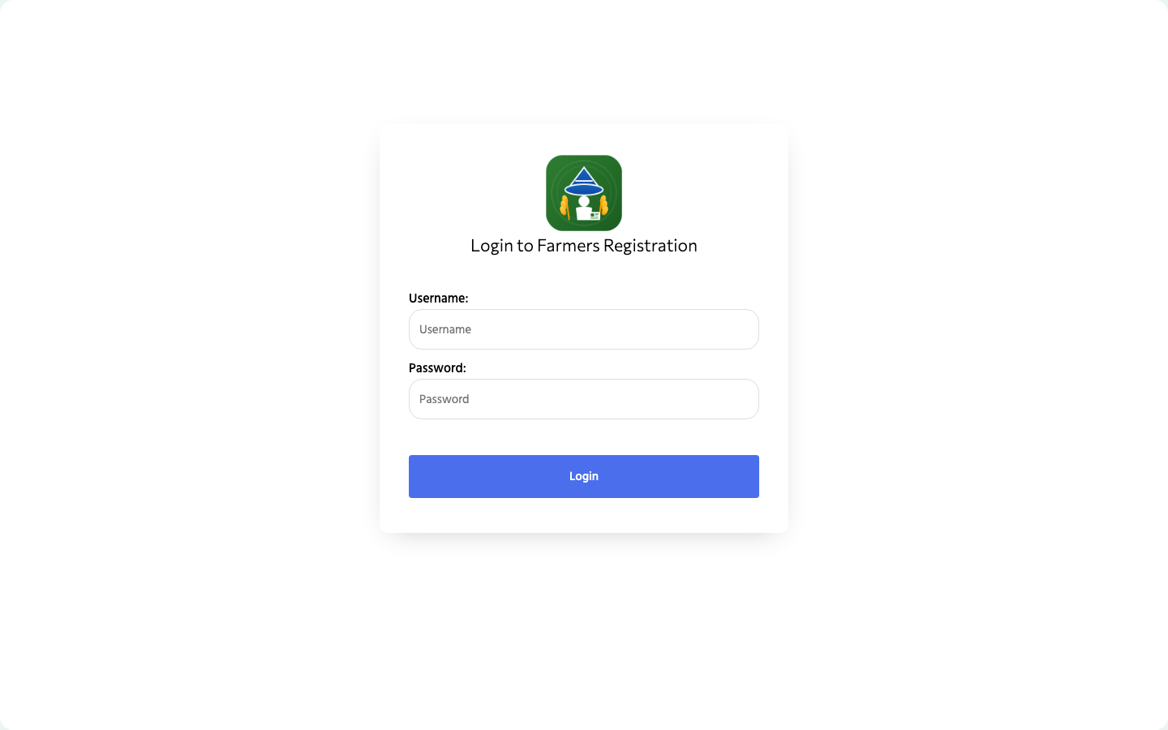
Joget's login page
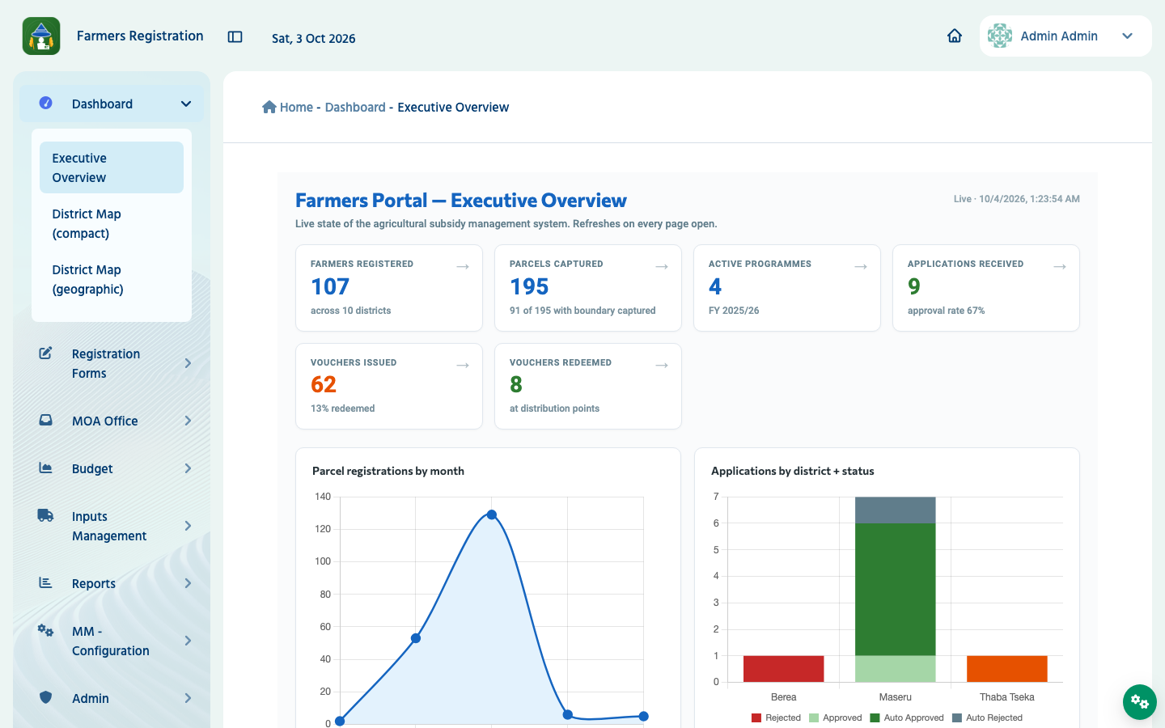
The Farmers Registry after logging in as admin
- Change the password. Open https://<your hostname>/jw/web/console/home (Joget's Console). At the top right, click Profile (admin). In the dialog User Profile, fill Password and Confirm Password with the new password, fill Current Password with the one from the Secret, and click Save. On the test installation the new password then worked and the old one no longer did.
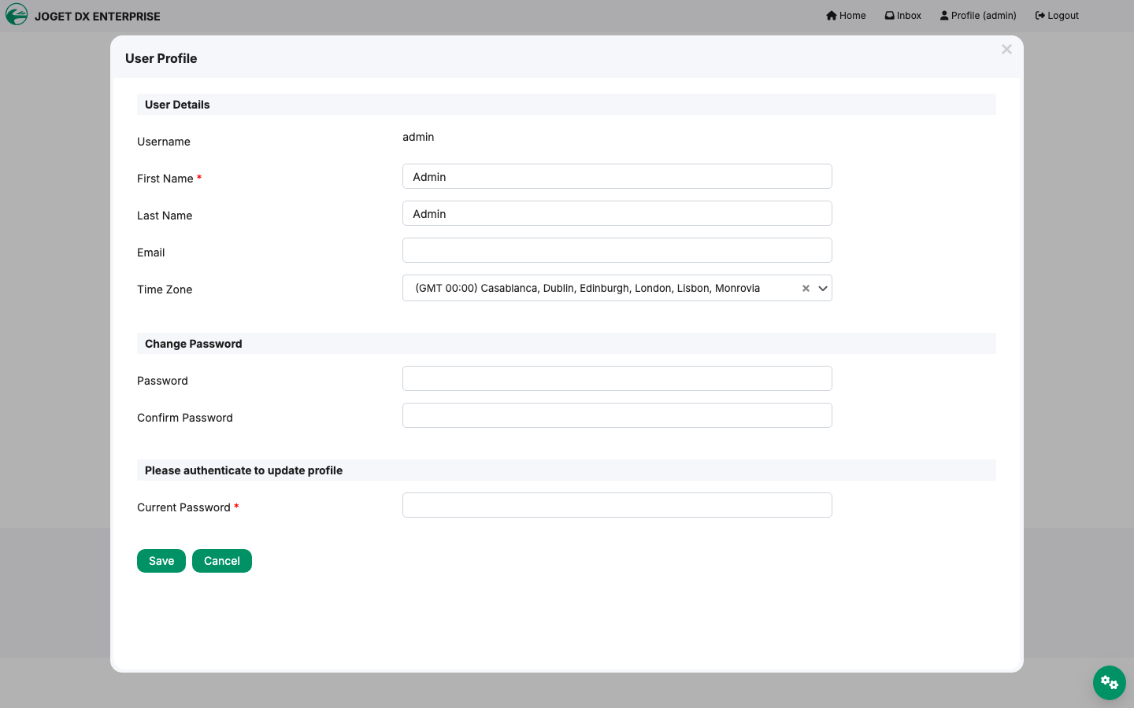
The User Profile dialog where the password is changed
- Write the new password down where ITU keeps such things. The Secret still holds the first one; it is only used by the restore Job, so it does no harm, but it no longer opens Joget.
The two demonstration users are cat (Cat Grant, District Supervisor) and clark (Clark Kent, Field Officer); their first password is the Secret's demo-user-password. Each sees the menus of their role. They can change their passwords the same way, from the user menu at the top right of the portal.

7. Checking that the installation works
Log in as admin and check four things. The figures are those of the source system on 3 October 2026, and the test installation showed every one of them; a program compared every cell of the four reports with the source system and found them all equal (proof/captures/20-compare-reports.txt).
- The portal opens: https://<your hostname>/jw/ shows the Executive Overview with Farmers registered 107.
- A registration opens: menu Registration Forms → 01 - Farmer Registration Form lists 107 farmers; click Edit on any row. The farmer's record opens with the tabs General, Residency, Activities, Household Members, Livestock, Income & Programs, Declaration and Parcels.
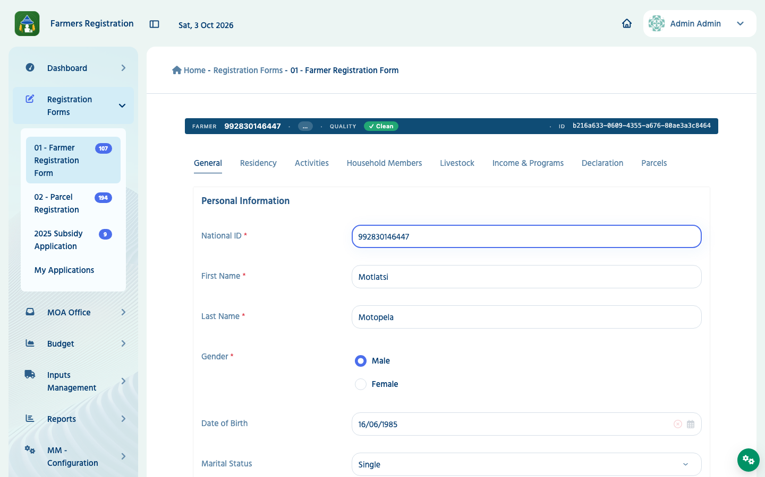
A farmer registration opened for editing
- The reports show these national totals: menu Reports. Each report lists districts and resource centres, with a DISTRICT TOTAL line per district and NATIONAL TOTAL lines at the end. Set the page size (the box showing 20 above the table) to 500 and click Show to see them all on one page.
Livestock farmers — 123 lines. The first national line, Any livestock:
Farmers holding | Registered farmers | Active livestock farmers | Share (%) | Cooperative members
55 | 107 | 82 | 51.4 | 27

Livestock production — 32 lines. National totals:
Product | Unit | Farmers reporting | Quantity per year
Eggs | Number of eggs | 3 | 1560.00
Hides and skins | Number of pieces | 2 | 5.00
Meat | Kilograms | 2 | 190.00
Milk | Litres | 4 | 1560.00
Mohair | Kilograms | 1 | 8.00
Wool | Kilograms | 2 | 35.00

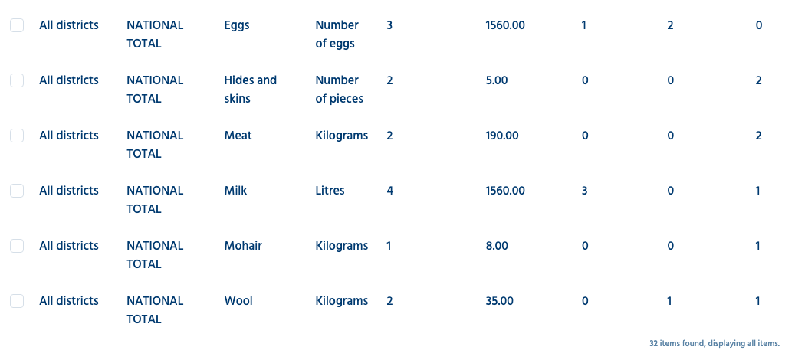
The national totals of the Livestock production report on the test installation
Crops — 152 lines. National totals, first line and three crops:
Crop | Farmers growing | Parcels | Area cultivated (ha) | 50 kg bags harvested
All crops | 46 | 86 | 695.60 | 22424
Maize | 34 | 46 | 187.54 | 5729
Mixed Beans | 18 | 20 | 180.51 | 1063
Pumpkin | 11 | 11 | 117.29 | 2810

Farmers by sex and age — 84 lines. National totals:
Sex | Registered farmers | Under 18 | 18 to 35 | 36 to 59 | 60 and over | Age not known
All | 107 | 30 | 16 | 45 | 8 | 8
Female | 45 | 12 | 11 | 17 | 4 | 1
Male | 62 | 18 | 5 | 28 | 4 | 7

Ages are counted on the day you look, so a test farmer's birthday can move one person between age groups. Many farmers are "under 18" because the records were typed with birth dates in 2026; that is a property of the demonstration data, not a fault.
- The demonstration users log in: log out (user menu, top right), log in as cat, then as clark, with the demo-user-password.

8. The Joget licence
Joget Enterprise needs a licence issued for the installation's System Key. Without one it runs as a free installation: the page footer and Settings → General read Licensed To: Free · Licensed Users: 3 and also Node License Exceeded. Everything works, but only the first three user names in alphabetical order can log in. Here those are admin, cat and clark, so the demonstration is complete without a licence. Do not create a fourth user name that sorts before clark (for example bob): it would lock out clark, or, if it sorts before admin, lock out the administrator. Anonymous pages need no licence.
To find the System Key: Console (/jw/web/console/home) → Settings → General → click the licence line Joget DX Enterprise 9 (with the pencil). The dialog shows System Key EE-K8S-….
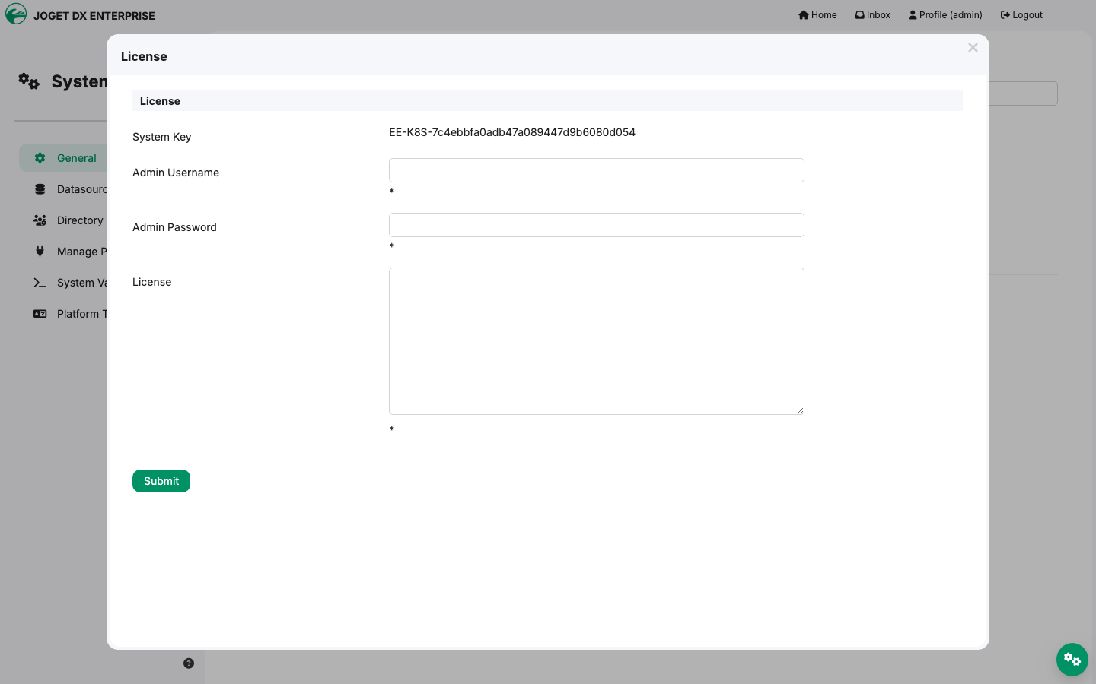
The licence dialog with the System Key
On Kubernetes, the System Key comes from the Joget Deployment's UID. For Joget to read it, the pod needs read access to pods and replicasets in its namespace; k8s/05-joget.yaml gives it (ServiceAccount fr-joget and Role fr-joget-deployment-info), following Joget's own Kubernetes documentation. On the test cluster the System Key stayed the same across a restart of Joget (proof/captures/28-system-key-before-restart.txt and proof/captures/30-system-key-after-restart.txt).
Never delete and re-create the Deployment fr-joget. A new Deployment has a new UID, so a new System Key, and the licence would no longer match. To restart Joget use kubectl -n farmers-registry rollout restart deployment/fr-joget; to stop it, scale it to 0.
To activate a licence: obtain one from Joget (through the licence holder's Joget account, quoting the System Key and the version, Joget DX 9 Enterprise), then in the same dialog fill Admin Username admin, Admin Password, paste the licence text into License, and click Submit. A licence for Joget 8 does not work on Joget 9. The production Farmers Registry in Lesotho runs under a licence of the World Food Programme for the Ministry's own server; that licence belongs to that server and does not cover this installation.

9. Everyday operations
What | Command
See the pods | kubectl -n farmers-registry get pods
Joget's log | kubectl -n farmers-registry logs deployment/fr-joget -c joget --tail=200
Restart Joget | kubectl -n farmers-registry rollout restart deployment/fr-joget
Stop / start Joget | kubectl -n farmers-registry scale deployment/fr-joget --replicas=0 (or =1)
Open a database prompt | kubectl -n farmers-registry exec -it fr-postgres-0 -- psql -U joget -d jwdb

Keep Joget at one replica: its volume is ReadWriteOnce and this setup is not a Joget cluster.

10. Backup and restore
Back up (from any folder; it writes two files there):
kubectl -n farmers-registry exec fr-postgres-0 -- pg_dump -Fc -U joget jwdb > fr-db-backup-$(date +%F).dump
kubectl -n farmers-registry exec deployment/fr-joget -c joget -- tar czf - -C /opt/joget/wflow . > fr-wflow-backup-$(date +%F).tgz
ls -l fr-*-backup-*
-rw-r--r-- 1 admin staff 2219541 Oct 4 01:28 fr-db-backup-2026-10-04.dump
-rw-r--r-- 1 admin staff 9357547 Oct 4 01:28 fr-wflow-backup-2026-10-04.tgz
The database file holds everything users enter. The wflow file holds the plugins, the connection settings and Joget's caches; take it after any change of plugins. Keep backups where ITU keeps confidential files: the database backup contains password hashes.
Restore the database (replace the date with your backup's). Joget is stopped first, so nobody writes while the database is replaced; users are logged out. This restore was tested on 2 October 2026; the lines below are what it printed there.
kubectl -n farmers-registry scale deployment/fr-joget --replicas=0 && kubectl -n farmers-registry wait --for=delete pod -l app=fr-joget --timeout=300s
kubectl -n farmers-registry exec fr-postgres-0 -- psql -U joget -d postgres -c "DROP DATABASE jwdb WITH (FORCE);" -c "CREATE DATABASE jwdb OWNER joget;"
kubectl -n farmers-registry exec -i fr-postgres-0 -- pg_restore --no-owner --no-privileges --exit-on-error -U joget -d jwdb < fr-db-backup-2026-10-02.dump
kubectl -n farmers-registry exec fr-postgres-0 -- psql -U joget -d jwdb -tAc "select count(*) from app_fd_farmerbasicinfo"
kubectl -n farmers-registry scale deployment/fr-joget --replicas=1 && kubectl -n farmers-registry rollout status deployment/fr-joget --timeout=900s
deployment.apps/fr-joget scaled
pod/fr-joget-f5cf45685-pwk8z condition met
DROP DATABASE
CREATE DATABASE
110
deployment.apps/fr-joget scaled
deployment "fr-joget" successfully rolled out
The 110 is the number of farmer records in the restored database. Passwords are those of the moment of the backup.
Restore the wflow folder (only after losing the wflow volume): with Joget running,
kubectl -n farmers-registry exec -i deployment/fr-joget -c joget -- tar xzf - -C /opt/joget/wflow < fr-wflow-backup-2026-10-02.tgz
kubectl -n farmers-registry rollout restart deployment/fr-joget
On the test installation of 2 October 2026 these two commands printed nothing but the restart lines, and Joget came back.
If the wflow volume is lost entirely, Joget cannot start (the volume holds its database settings). The simplest way back is to install again from the package into a new namespace (steps 3 to 9, which recreate the wflow folder), then restore your latest database backup into it as above. A new namespace means a new Deployment, so a licence, if one was entered, must be issued again for the new System Key (section 8).

11. When something goes wrong
What you see | What it means and what to do
sha256sum: WARNING: 1 computed checksum did NOT match (step 2) | A file was damaged in transfer. Get the package again.
Pods stay Pending; kubectl -n farmers-registry describe pvc says no storage class | The cluster has no default storage class. Set storageClassName (section 3, item 4), delete the namespace and start again.
ImagePullBackOff | The nodes cannot reach Docker Hub, or a proxy blocks it. Mirror the two images into ITU's registry and change the two image: lines (keep the versions).
exec format error in Joget's log | The node is ARM. Joget's image is amd64 only; schedule Joget on amd64 nodes.
Pods refused with violates PodSecurity "restricted" | The namespace enforces the restricted policy. PostgreSQL's official image starts as root and the restore Job changes file owners; label the namespace pod-security.kubernetes.io/enforce=baseline.
Restore Job log ends with STOP: the database already holds a Joget installation | You are re-running the install on a used database. To start from nothing: kubectl delete namespace farmers-registry, wait until it is gone, and begin again at step 3.
Restore Job log stops at [1/6] Waiting for the package files | Step 7 was not run, or not completely. Run it again; the last command (touch …/UPLOAD_COMPLETE) releases the Job.
deployment "fr-joget" never becomes ready; the init container log says The restore Job has not prepared the data folder yet | Joget was started before the restore Job finished. Finish steps 7–8; Joget then starts by itself.
Joget's log shows Unable to retrieve Deployment UID ... ApiException | Joget cannot read its own Deployment; the System Key is then not stable. Check that the ServiceAccount, Role and RoleBinding of k8s/05-joget.yaml exist.
The login page says Login restricted, license not activated for this system | More than three user names exist and this one is not among the first three alphabetically, or a licence for another System Key was entered. See section 8.
The browser is sent to http:// addresses, or loops | The Ingress points at port 8080 instead of 9090. Use k8s/06-ingress.yaml unchanged except for the hostname and class.
Saving a farmer registration fails with an error about too many parts | The Tomcat settings of k8s/03-joget-tomcat-config.yaml are not mounted. Check that the ConfigMap exists, then restart Joget.
kubectl port-forward stops answering | Joget restarted; stop the port-forward and start it again.
Joget restarts by itself; kubectl -n farmers-registry describe pod -l app=fr-joget shows OOMKilled | Joget ran out of memory. The limit in k8s/05-joget.yaml is 3 GiB; raise limits and requests together by 1 GiB, apply the file again and wait for the rollout. On a computer with an ARM processor that runs Joget's amd64 image through emulation (for example Docker Desktop on an Apple Mac), Joget's memory keeps growing under use and this happens whatever the limit; use amd64 nodes (section 3, item 3).
Joget's log shows Cannot save config file … jgit | Harmless if it appears once; k8s/05-joget.yaml gives the container a writable home folder to prevent it.

12. What this installation does not include
- Real data. Every person in the package is generated (section 1).
- API keys. The source system's API credentials were removed, and the one key written inside a form was emptied. Two things therefore need a new key before they work: the map's check for overlapping parcels in the parcel registration, and the interface the developers' tools use to change the app (form-creator-api). Setting that up is a task for a Joget developer of the project; neither is needed for the demonstration.
- E-mail and SMS. No mail server or SMS gateway is configured; notifications are not sent. The test address and test number the registry would use are empty; step 12 says where ITU enters its own.
- Other applications. The source Joget held other, unrelated applications; only the Farmers Registry was carried over, with three of its users.

13. Removing everything
kubectl delete namespace farmers-registry
This deletes the pods, the Secret and both volumes with all their data. Take a backup first if you need one.

Appendix A — Versions and images
Component | Version | Image
Joget DX Enterprise | 9.0.5 (Tomcat 11.0.13, OpenJDK 21) | jogetworkflow/joget-enterprise:9.0.5@sha256:432ce2efe7333dceb7e401d4cdcf46087c0051eed606fd0f10980c328c8df3f3 (linux/amd64)
PostgreSQL | 16.13 | postgres:16.13@sha256:5d143123fdf80462d1778cd4f24b9f7ca13c87174bca19141fb194c5a1ebca59 (multi-architecture)
Farmers Registry app | farmersPortal version 1, as on 3 October 2026 | in the database dump

The source system runs Joget DX Enterprise 9.0.5 on PostgreSQL 16.13; the package installs the same versions.

Appendix B — Resources
Pod | CPU request | Memory request / limit | Volume
fr-joget | 0.5 | 2 GiB / 3 GiB (Java uses up to 70 % of the limit) | fr-wflow, 5 GiB
fr-postgres-0 | 0.25 | 512 MiB / 1 GiB | data-fr-postgres-0, 10 GiB
fr-restore (once) | 0.25 | 256 MiB / 1 GiB | —

The database is 40 MB and the wflow folder about 12 MB after installation; the volumes leave room for years of demonstration use.

