LESOTHO FARMERS PORTAL
Data Quality Framework
Design for approval

Ministry of Agriculture, Food Security and Nutrition
Agricultural subsidy registry — ecitizen.gov.ls
Version 1.0 · 26 August 2026 · Status: design, awaiting approval
Nothing described in this document has been built. It is a design put forward for approval; implementation begins only once the decisions in Section 12 are settled.

Contents
1. | Executive summary | 3
2. | Why this framework is needed | 4
3. | How the framework is structured | 5
4. | Counting correctly: the two populations | 6
5. | Layer 1 — checks on the records | 7
6. | Layer 2 — configuration integrity | 9
7. | Layer 3 — history, severity and alerting | 10
8. | Quality by officer | 11
9. | Coverage: what would now be caught | 12
10. | What this framework cannot do | 13
11. | Delivery | 14
12. | Decisions requested | 15
Figures
Figure 1 Three layers of assurance, sharing one daily record · p5
Figure 2 Real records and abandoned drafts · p6
Figure 3 How an unannounced change becomes visible · p9
Figure 4 The severity ladder · p10
Figure 5 Four gated stages from build to live operation · p14

1. Executive summary
The Farmers Portal went live on 24 August 2026 and is now in daily public use. In its first week of operation, a series of data and configuration faults were found — each by accident, during unrelated work, and in one case only six hours after it occurred. None was found by a monitor, because no monitor existed to find them.
This document sets out a framework to change that. Its purpose is not to describe data quality in the abstract, but to make a specific list of known failures impossible to miss again, and to catch the next one on the morning it happens rather than by chance weeks later.
The commitment in one sentence
Every morning, one scheduled run checks the registry, checks the system's own configuration, records what it found, and shows anything that needs attention on a single page — reading only, never altering a citizen's record.

Three points deserve the reader's attention before the detail:
- The framework is built from evidence, not theory. Every check exists because a real fault of that shape occurred on this system between 21 and 26 August 2026. Section 9 traces each one to the check that now catches it — and states honestly which faults no check can catch.
- It watches the system as well as the data. The most costly failures of the first week were changes made to the system's own configuration outside the release process. A daily configuration fingerprint makes the next one visible the following morning.
- It never repairs anything. Every check is a read. The framework reports; a person decides. A monitoring system that silently corrects records is more dangerous than the faults it hides.

2. Why this framework is needed
The following faults were all observed on the live or test systems during the week of 21–26 August 2026. They are listed here because they define what the framework must be able to see.
What was found | Why it matters
Eight of twenty-eight income records pointed to a farmer registration that does not exist | The link between a farmer and their recorded income had broken silently. The condition was chronic, spread over several days, and nobody knew.
A parcel boundary of 177,055 hectares, drawn with three points, roughly 100 km from its district | Larger than the district that contains it. Existing checks asked only whether an area was missing, never whether it was possible.
A resource centre marked inactive is erased from any record that referenced it, on the next save | Reproduced deliberately on the test system: a save that changed nothing destroyed the stored value. One live parcel is exposed to exactly this.
Three form definitions changed directly on the live system, outside any release | One introduced a fault that silently discarded the answers officers were entering. Unnoticed for six hours; found only by chance.
A published figure of 5 registrations against 60 rows in the underlying table | Two different populations were being counted as one. No quality percentage could be trusted while this was unresolved.
Registrations older than seven days can no longer be saved at all | The save is refused with no message on screen. No live record is affected yet; the earliest crosses that threshold on 28 August.

The pattern
Every one of these was discovered by a person doing something else. None was announced by the system.
The cost is not only the fault itself — it is the days between the fault occurring and anyone noticing.

3. How the framework is structured
The framework has three layers. Each answers a different question, and all three write to one shared daily record so that history — and therefore direction of travel — is preserved.
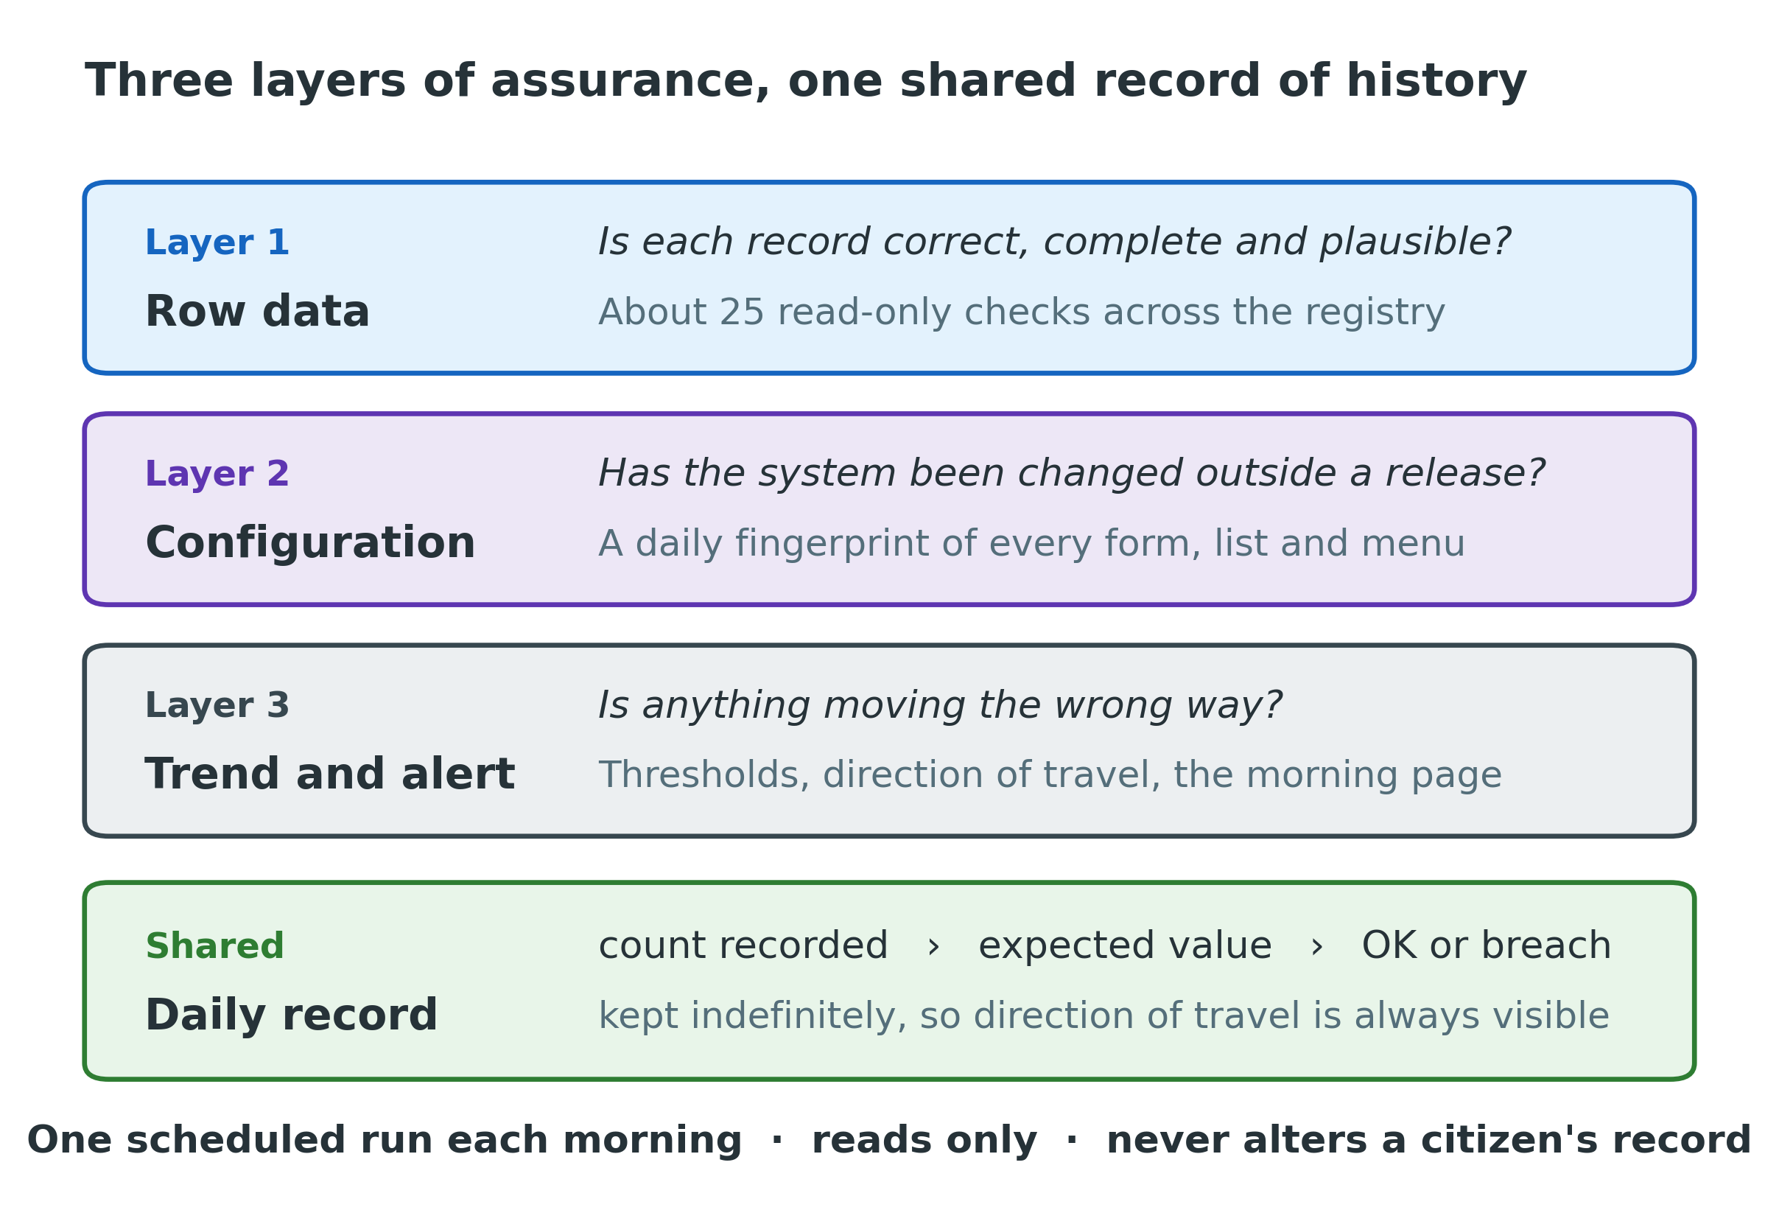
Figure 1 — Three layers of assurance, sharing one daily record

What each layer is for
Layer 1 — Row data. About twenty-five checks over the registry itself: is each record complete, internally consistent, plausible, and does it reference master data that still exists? This layer extends the nine checks already in the system rather than replacing them.
Layer 2 — Configuration. A daily fingerprint of every form, list and menu definition, compared against the state recorded when the last release closed. Anything that changed, appeared or disappeared in between is reported by name.
Layer 3 — Trend and alert. Each run stores its counts. That turns a snapshot into a series: whether a number is rising, and whether it crossed a threshold that warrants telling somebody.

Operating principles
- Read-only. Every check is a query. The only thing the framework writes is its own record of what it found.
- One run a day, before office hours, so it never competes with officers entering registrations.
- No automatic repair, ever. The framework reports; a person decides what to do.
- False positives are treated as defects. A check that cries wolf is worse than no check, because it teaches people to stop reading the page.

4. Counting correctly: the two populations
Before any quality measure can mean anything, one ambiguity has to be resolved. The registry tables contain two quite different kinds of row, and until now every published count has added them together.
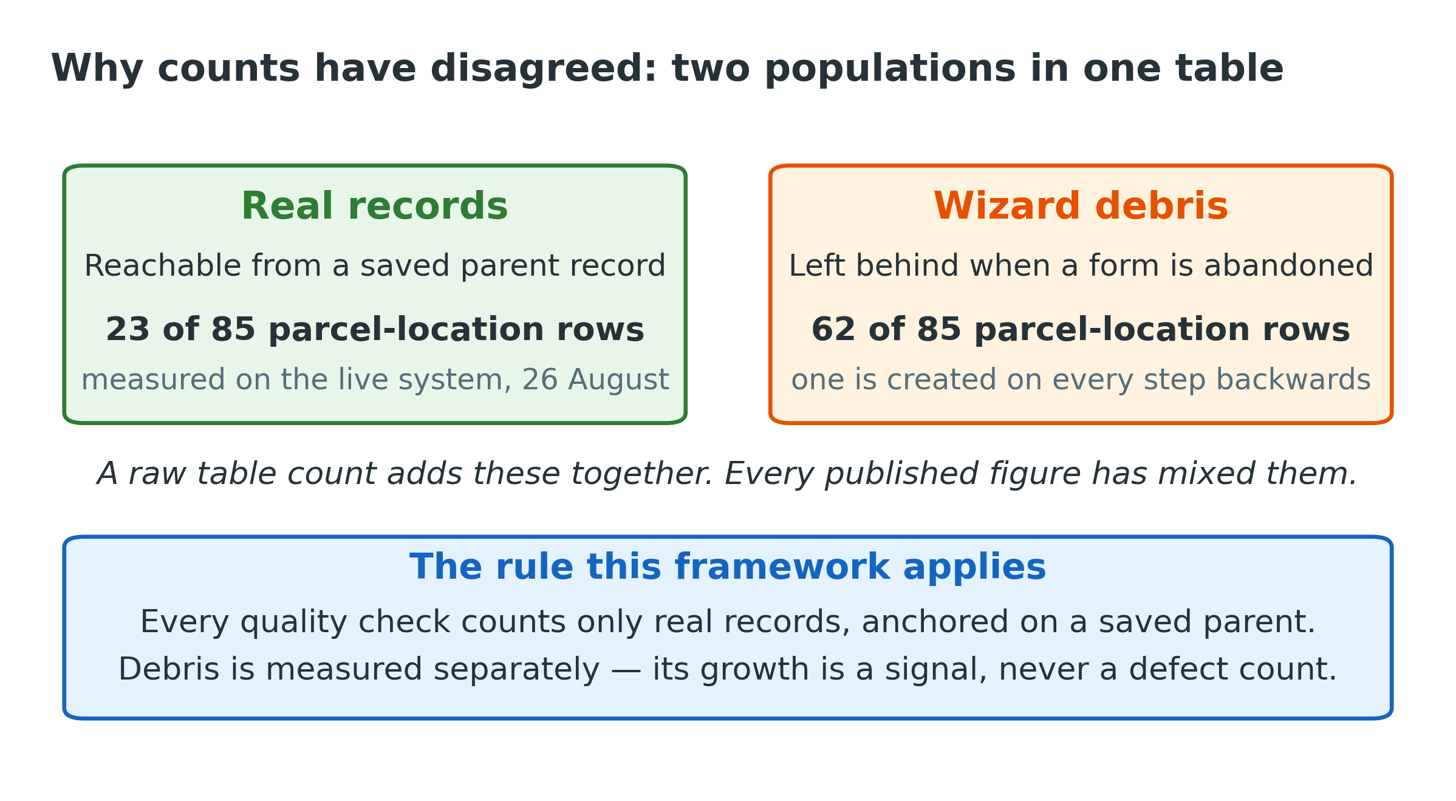
Figure 2 — Real records and abandoned drafts, measured on the live system, 26 August 2026
When an officer steps backwards through a multi-page form, the system leaves behind a partial row. These are a normal by-product of how the forms work, not a fault. But they are indistinguishable from real records in a simple count — which is why a dashboard could report five registrations while the underlying table held sixty rows.
Two definitions, written once and used everywhere
A complete registration is a registration record that resolves to a signed, dated declaration.
A complete parcel is a parcel record that has both a location and a boundary, and identifies its farmer.
The same definitions are used by the executive dashboard and by every quality check, so the two can never again disagree.

Abandoned drafts are not ignored. They are counted separately, and their rate of growth is reported as context — never as a defect count.

5. Layer 1 — checks on the records
Nine checks already exist in the Portal and are retained; three have their definitions corrected so they count real records rather than abandoned drafts. Around sixteen new checks are added, in four groups.

5.1 Broken links between records
The registry is a set of linked records: a registration, its declaration, its household, its income, its parcels. When a link breaks, both halves survive but the connection is lost — invisibly.
Check | Severity | What it finds
Orphaned income records | CRITICAL | Income records whose farmer registration does not exist — eight on the live system today
Orphaned declarations | HIGH | A declaration with no registration, or a registration pointing at a declaration that is gone
Orphaned household members | HIGH | Household member rows with no household record
Orphaned residency records | HIGH | Residency details with no registration to belong to
Orphaned agriculture records | HIGH | The same break in the farming-activity records

5.2 Values that are possible but not plausible
A boundary can be a valid shape and still be obviously wrong. These checks apply the judgement a person would apply at a glance.
Check | Severity | What it finds
Implausible parcel area | CRITICAL | A parcel larger than 1,000 hectares — one exists on the live system today
Large parcel review list | MEDIUM | Between 50 and 1,000 hectares: large but conceivable, listed for review
Too few boundary points | HIGH | A boundary drawn with fewer than four points
Boundary outside its district | HIGH | The centre of a parcel falling outside the district it is recorded in
Coordinates outside Lesotho | HIGH | Any coordinate outside the national bounding box
Parcel larger than declared holding | MEDIUM | A parcel far exceeding the land the farmer declared, with wide tolerance

5.3 References to master data
This group contains the single most valuable check in the framework.
Why this one matters most
When a resource centre is withdrawn, any record still pointing at it displays as blank — and the stored value is destroyed the next time anyone saves that record, without warning or error.
This check names the exposed records before that save happens. It is what makes withdrawing a centre a safe operation rather than a silent one.

Check | Severity | What it finds
Reference to a withdrawn centre | CRITICAL | Any parcel or residency record pointing at a resource centre that is inactive or gone
Stored code not in its list | HIGH | A stored value that is not a valid code — for example a label saved where a code belongs
Master data flag hygiene | HIGH | An active/inactive flag holding anything other than Yes or No — a single stray space removes an option from every dropdown nationally
Missing district and zone pairs | MEDIUM | Combinations the forms offer that have no matching reference entry

5.4 Completeness and the declaration window
Check | Severity | What it finds
Stuck incomplete registrations | HIGH | Registrations more than a day old that never reached a complete state
Signature integrity | CRITICAL | A declaration whose signature is missing, truncated, or stored as the literal word "undefined"
Declaration window exposure | HIGH | Registrations that can no longer be saved because their declaration date has aged past the permitted window — zero today, rising from 28 August

6. Layer 2 — configuration integrity
The costliest failures of the first week were not bad data. They were changes to the system itself, made outside the release process, that nobody was told about.
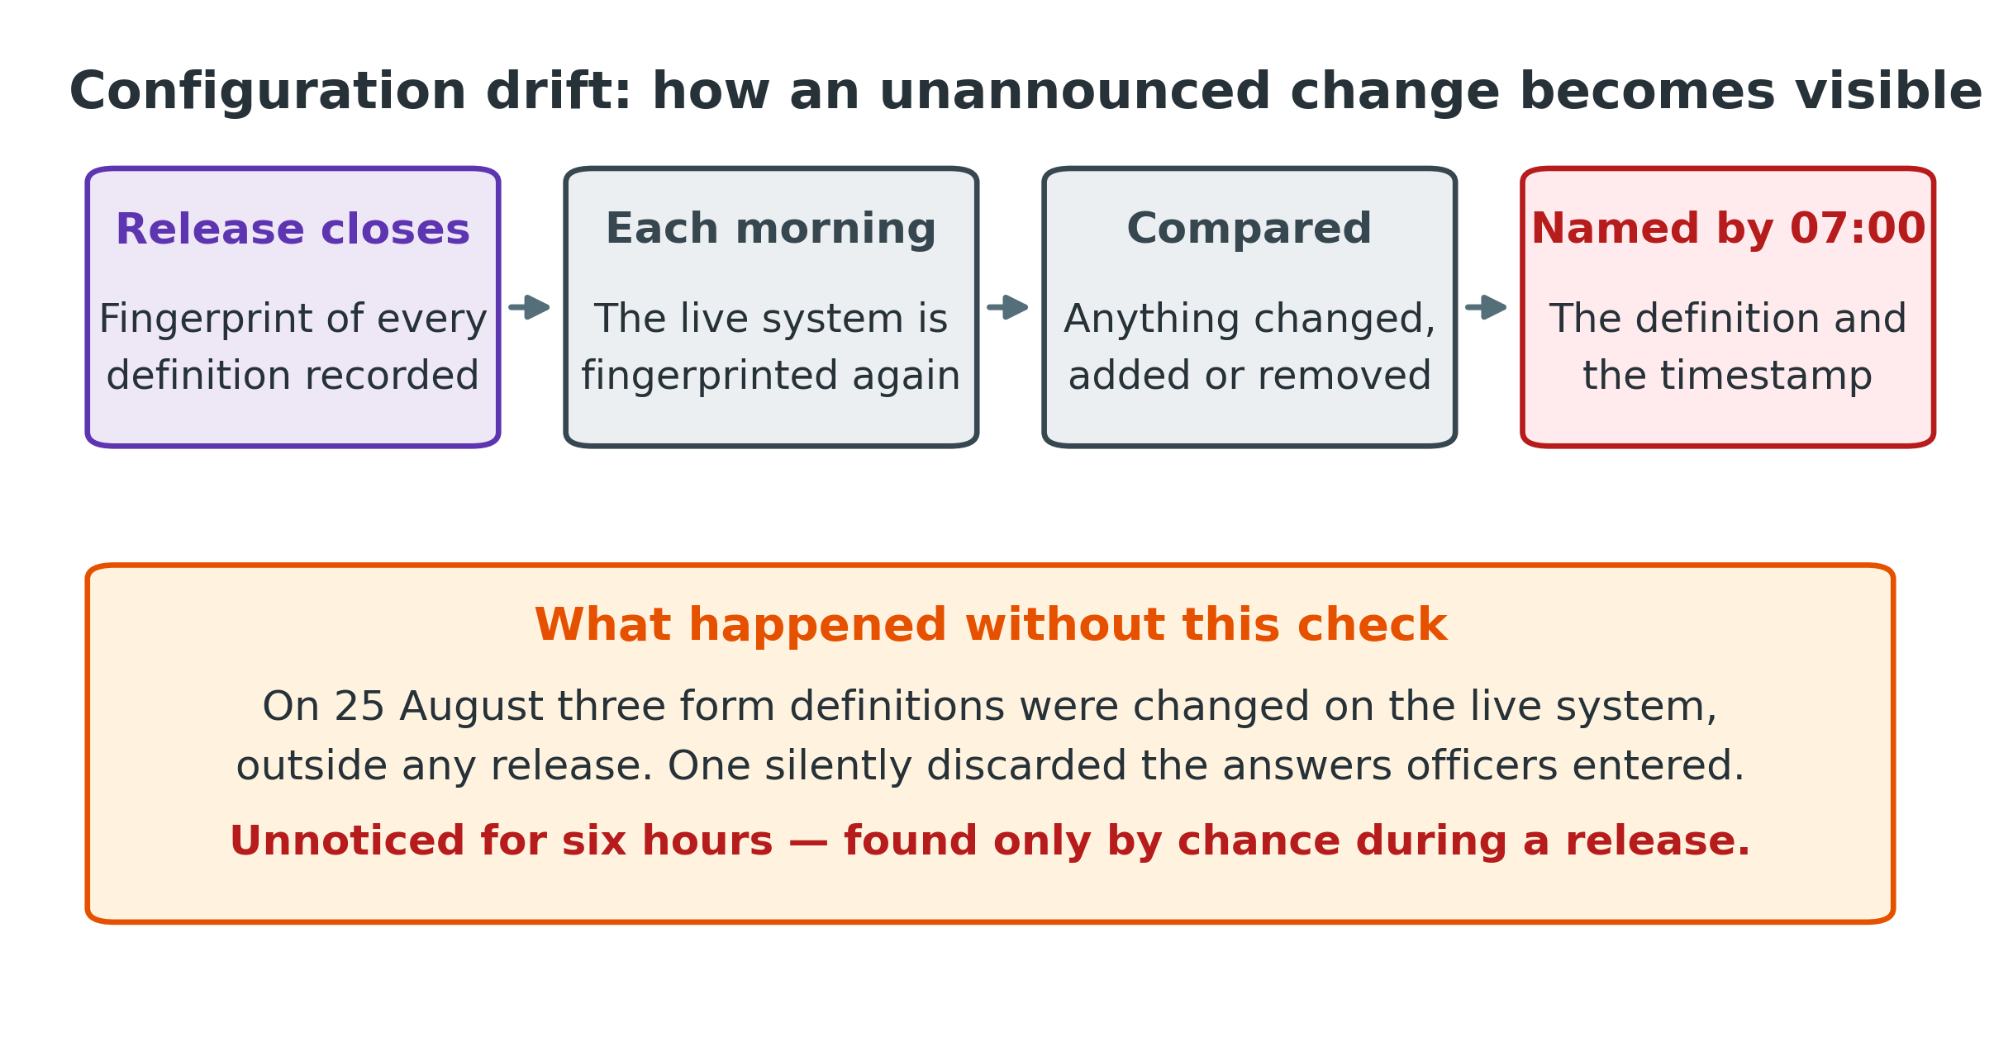
Figure 3 — How an unannounced change becomes visible the following morning
At the close of every release, a fingerprint of each form, list and menu definition is recorded. Each morning the live system is fingerprinted again and the two compared. Between releases the expected difference is none; anything else is named, with the time it changed.
Check | Severity | What it finds
Configuration drift | CRITICAL | Any definition changed, added or removed since the last release closed
Duplicate field identifiers | CRITICAL | Two fields sharing one identifier — the fault that silently discarded officers' answers. One exists today, across 220 definitions
Obsolete embedded values | HIGH | Definitions still carrying a known dead configuration value
Unexpected embedded credentials | HIGH | A credential appearing in a definition outside the one documented, accepted exception
Credential inventory | HIGH | The set of registered service credentials no longer matching what is expected

Two limits are stated deliberately. The framework does not fingerprint server or network configuration, because doing so would require widening the access the daily run holds — an increase in risk that is not justified. Nor does it verify installed software components; that remains a separate operational concern.

7. Layer 3 — history, severity and alerting
Each run appends one row per check to a small internal record: the count found, the count expected, whether that constitutes a breach, and any detail worth keeping. Roughly forty rows a day. This is what turns a report into a trend, and it is what makes the morning after a release informative rather than reassuring.

7.1 Severity means a response time
Severity in this framework is defined by what the reader must do, not by how serious the fault sounds. This keeps the top of the list short enough to be believed.
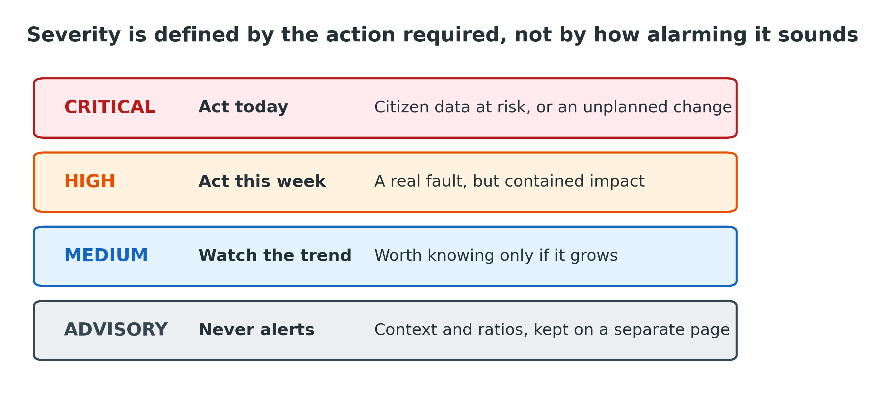
Figure 4 — The severity ladder

7.2 The morning page
One page, five sections, ordered so that a clean day takes ten seconds to confirm:
- Today — every check with its current count and severity.
- Drift — configuration changed outside a release, named with timestamps.
- Officers — quality by operator account, over a rolling thirty days.
- Trend — direction of travel for the headline measures.
- Advisory — context and ratios, deliberately separated so it cannot drown the signal.

7.3 Alerting
The page is the channel at launch. Email escalation for critical findings is specified but deliberately not switched on until the thresholds have run quietly against real data — the proposal is fourteen consecutive days without a false positive. Alerting that arrives before it is trustworthy trains people to ignore it.

8. Quality by officer
Every record carries the account that created it. Aggregating quality measures by account, over a rolling thirty days, shows where support or training would help — well before it shows in aggregate national figures.
The reported measures are: complete registrations, complete parcels, abandoned drafts left behind, records failing any plausibility check, and the rate of missing optional details. All are counted against complete records only, so that abandoned drafts never distort an individual's numbers.
A boundary stated plainly
The framework reports facts per account against the same thresholds that apply system-wide. It does not rank people and it does not score them.
What the Ministry does with an individual officer's numbers is a management matter outside this system. The intent of this surface is to direct support, not to support sanction.

9. Coverage: what would now be caught
The test of this framework is not how many checks it contains, but whether it would have caught what actually happened. Each fault from Section 2 is traced below to the check that now detects it, and to when.
Fault observed | Now detected by | When
Orphaned income records | Broken-link check | Next morning, as critical
177,055-hectare three-point boundary | Three independent plausibility checks | Next morning
Records pointing at a withdrawn centre | Master-data reference check | Before the save that would destroy the value
Stray space in an active/inactive flag | Flag hygiene check | Next morning
Published counts disagreeing with the tables | Shared definitions of complete records | Removed at source
Three definitions changed outside a release | Configuration drift check | Next morning, named
Duplicate field identifier | Duplicate identifier scan | Next morning
Ageing declarations that can no longer be saved | Declaration window exposure | Counted daily as it grows
Signature replaced with the word "undefined" | Signature integrity — partial only | After the event, not before

10. What this framework cannot do
Stating the limits precisely is part of the design. A framework whose boundaries are vague invites false confidence, which is the failure mode it exists to prevent.
- Faults that occur in the browser before anything is saved are invisible to it. The signature that was replaced with the word "undefined" is the example: the framework can detect the damage afterwards, but only fixing the underlying fault prevents it.
- Answers that are wrong but plausible — a mistyped yet valid telephone number, an area that is incorrect but reasonable — cannot be distinguished from correct ones.
- Failures that occur and clear between two daily runs are not seen. The cadence is daily by design; continuous monitoring is a different and more expensive undertaking.
- Server, network and infrastructure configuration are out of scope, as is the health of other applications sharing the same environment.
- Boundary checks use rectangular district bounds, not exact district shapes. A point just outside a district but inside its rectangle will pass.
- Where several people share one administrative account, the framework can report what was done but not reliably by whom. Individual accounts are a prerequisite for attribution, and that is a process change rather than a technical one.
- Nothing is repaired automatically, by deliberate choice. Every finding requires a human decision.

11. Delivery
Implementation proceeds in four stages. Each has a gate that must pass before the next begins, and nothing reaches the live service until the final approval.
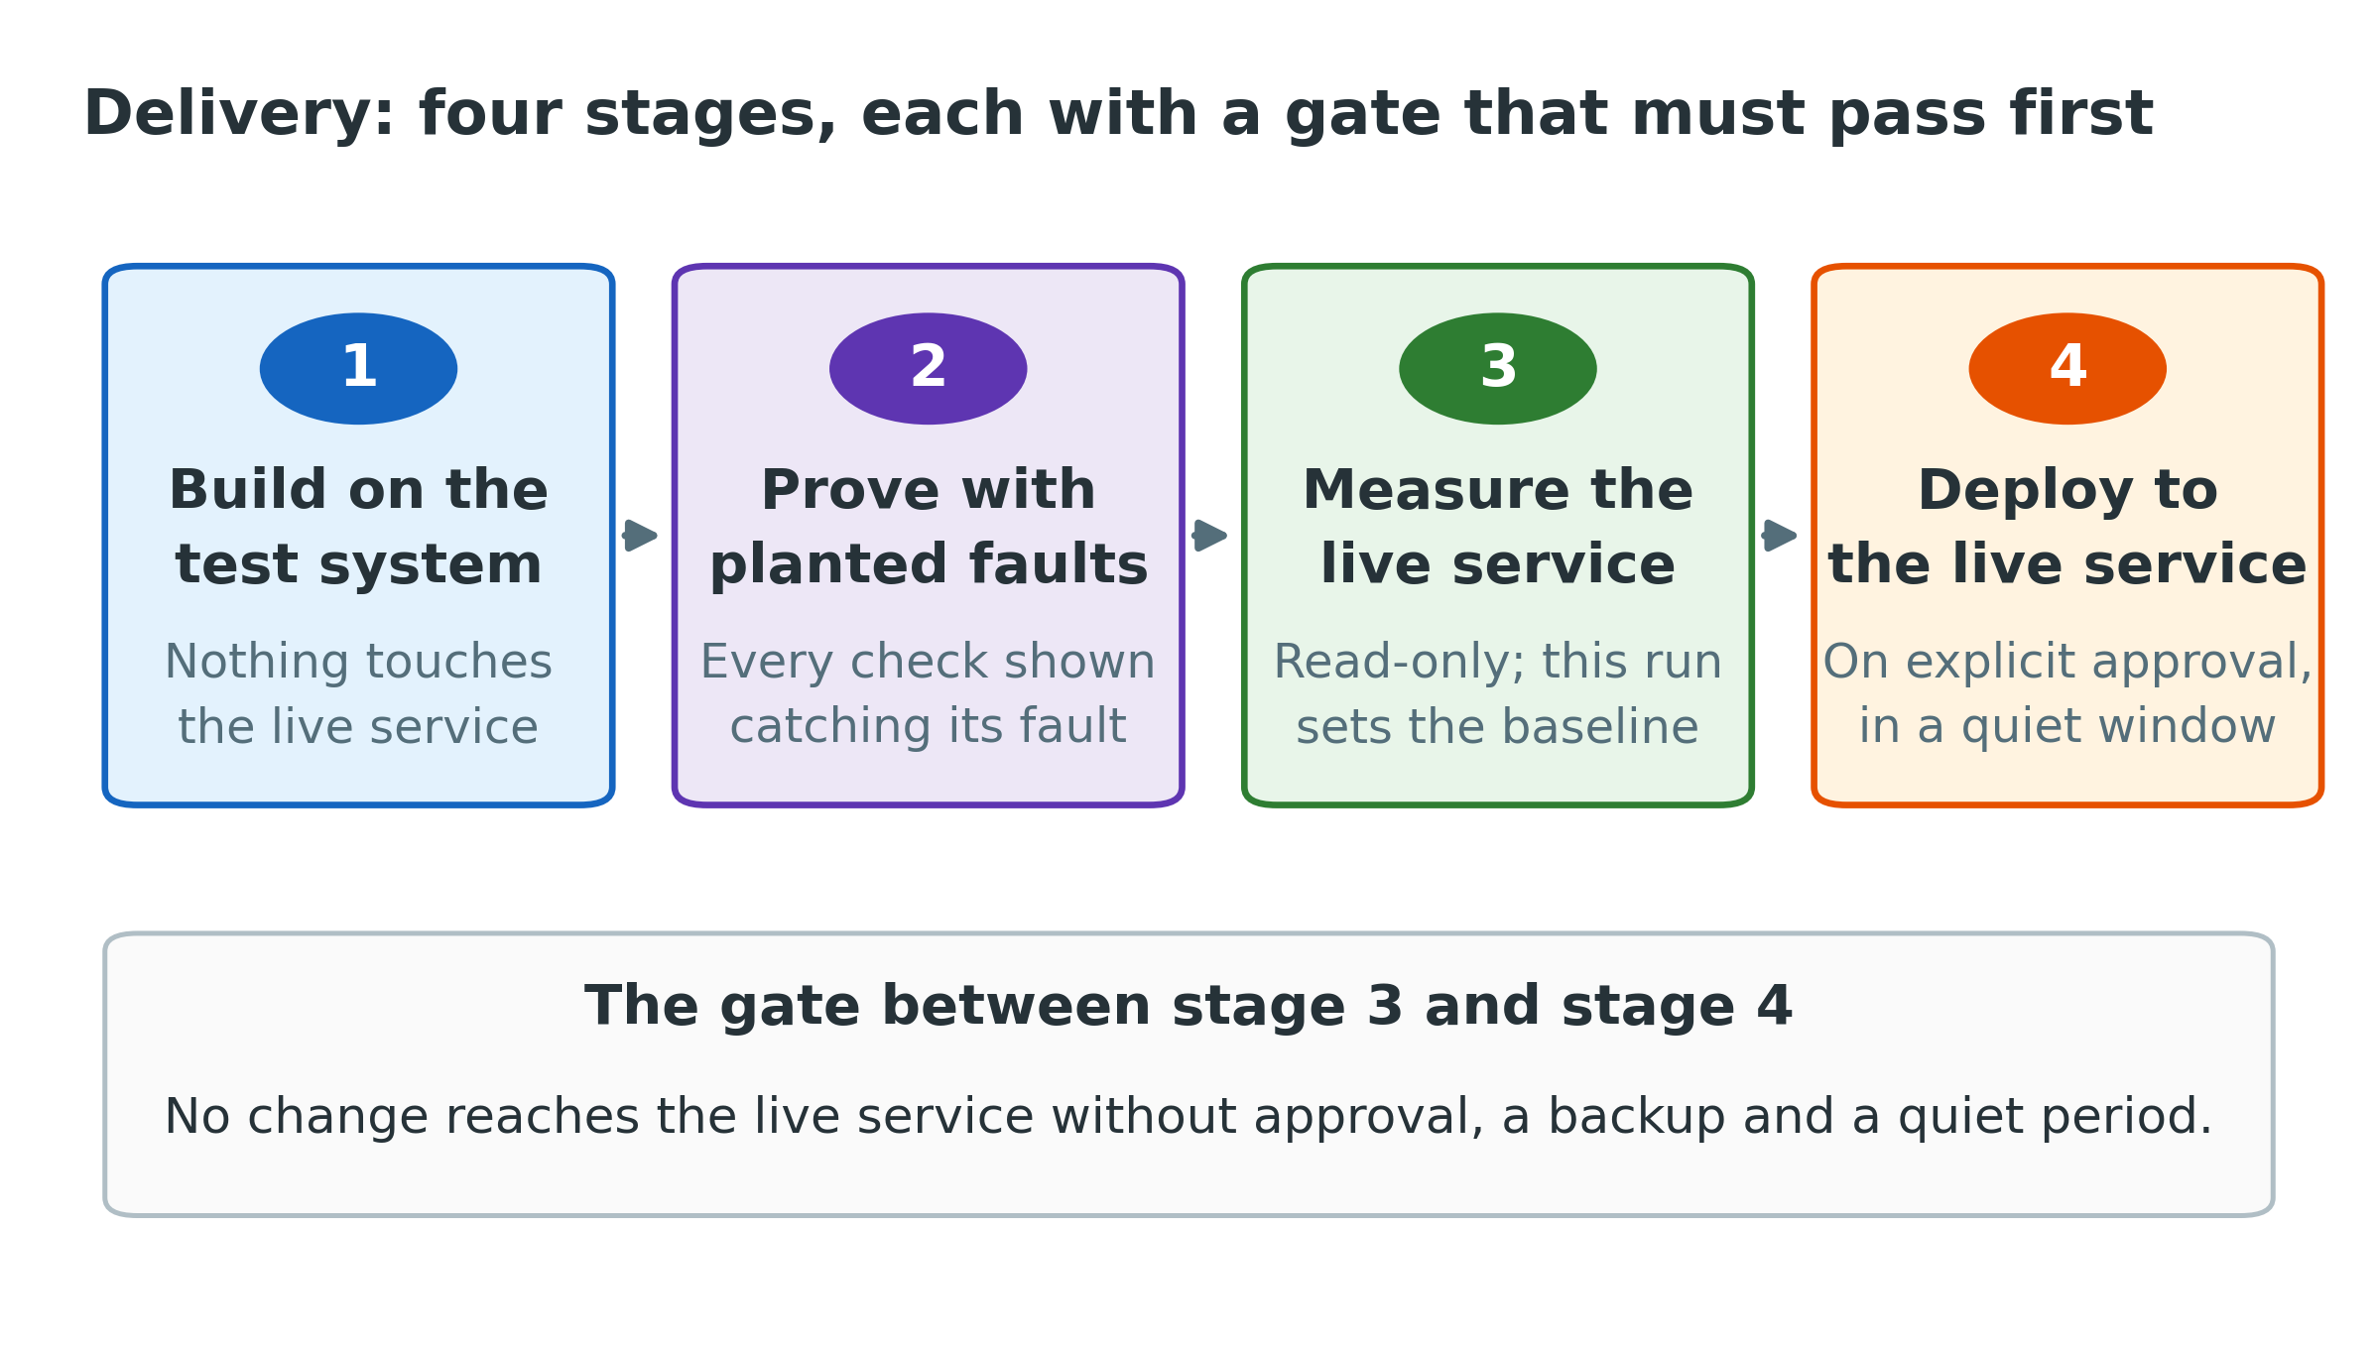
Figure 5 — Four gated stages from build to live operation
Stage | What happens | Gate before proceeding
1. Build | Everything is built and configured on the test system | The existing automated test suite still passes in full
2. Prove | A fault of each kind is deliberately created on the test system | Every check demonstrably catches its own fault; the test system is restored exactly
3. Measure | The full set of checks runs against the live service, reading only | Results reviewed; this run establishes the baseline the thresholds start from
4. Deploy | The checks, the page and the daily schedule go to the live service | Explicit approval, a fresh backup, and a confirmed quiet period

Stage 2 deserves emphasis. It is not enough for a check to be written correctly; it must be shown catching a real instance of the fault it targets. A check that has never fired is an assumption, not a control.

12. Decisions requested
The following decisions are needed before implementation begins. The first is the most consequential: everything downstream depends on it.
# | Decision | Recommendation
1 | The definition of a complete registration | A registration that resolves to a signed, dated declaration. Adopted by the dashboard and every check alike
2 | How the shared definitions are implemented | As database views, so that one definition serves every consumer and cannot drift between copies
3 | When alerting by email is switched on | After fourteen consecutive days with no false positive, not at launch
4 | Whether quality by officer is included from the start | Yes — included from day one, reported as facts against common thresholds
5 | How long the daily history is kept | Indefinitely; the volume is negligible. Review at twelve months
6 | Where the first measurement run is recorded | Requires one small addition to the live service ahead of full deployment, or the run is recorded on the test system instead

On approval
Implementation begins on the test system, with the planted-fault validation of stage 2 as its acceptance gate.
Nothing reaches the live service until stage 4, and stage 4 requires a separate, explicit approval on the day.

