The Joget Platform-Plugins Vision
A shared runtime-extension library for spec-to-code-on-Joget development
Why plugins become a platform, what that platform is, and how it works.
repo joget-platform-plugins
3 July 2026 · draft for discussion

Executive summary
Reusable Joget plugins have been built again and again inside individual projects, then copied when the next project needed them. This document sets out a different model: treat a plugin as an extension of the Joget development platform, not a component of any one project. A single version-controlled library holds every reusable plugin; projects — and the spec-to-code engine jkit — consume them by pinning a version, never by copying. The library serves any spec-to-code-on-Joget development; GovStack Building Blocks are one lens over it, not its boundary.

1. Why — the problem, and the goal

The problem: scatter, duplication, and trapped capability
Across three production Joget engagements, reusable plugins ended up scattered across six-plus homes — separate project folders, a shared-plugins directory, and a monolithic case-management bundle. Two failure modes followed. First, duplication: with no single home and no versioning, the only way to reuse a plugin was to copy its source into the next project, where the two copies then diverged. Second, and worse, trapped capability: genuinely generic building blocks — an approval service, a state machine, a hash-chained event log — were built inside a case-management application, so nothing else could reach them without dragging the whole case project along.
That last point is the crux. An approval service is not a case-management feature; it is a horizontal capability that merely happened to be written in a case app. The scatter is an accident of where code was first needed, not a statement about what the code is.

The goal: reuse without duplication
The objective is a developer-experience one: make the loop of building a new Joget application fast, trustworthy and fearless by giving every reusable plugin a single, versioned, project-neutral home. When a second project needs a plugin, it should pin a version — not fork a copy. New capability is added once, to the platform, and is immediately available to every project and to the spec-to-code engine.

2. What — the vision
The platform is a single repository, joget-platform-plugins, that holds reusable Joget OSGi plugins as versioned artifacts. It sits between the author-time tools that produce Joget applications and the run-time applications that consume them.
The invariant A plugin here never depends on a consuming project. Projects (and jkit) depend on the platform; the arrow only points one way. A plugin that imports project code is disqualified until it is genericised.

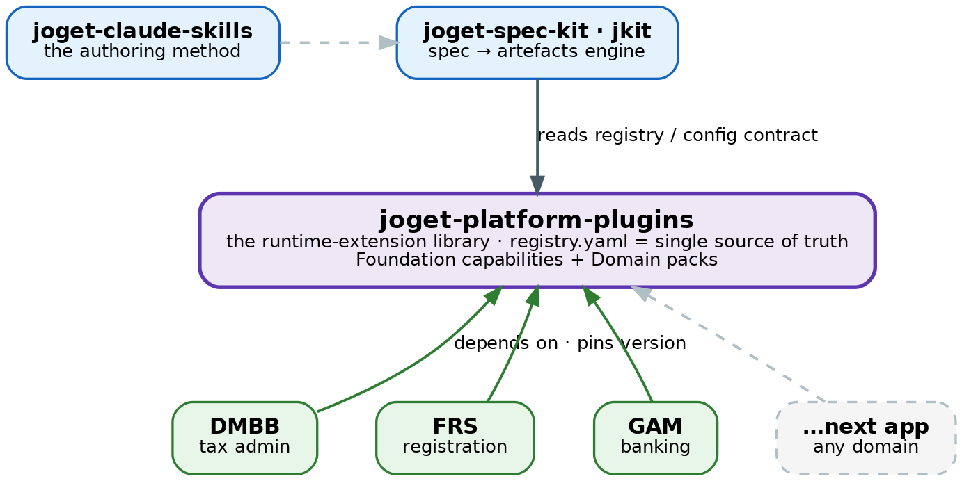
Figure 1. The platform sits between author-time tooling and run-time apps; every app depends on it by version pin, and jkit generates against its registry.
The engine jkit reads the platform's registry to know which plugins exist and how to configure them, then generates application artefacts against that contract without ever compiling the plugins. Any number of applications — tax administration, registration, banking, whatever is next — draw from the same shelf.

Two tiers: Foundation, and Domain packs
Plugins are organised by capability, not by the project they came from:
- Foundation — horizontal, domain-agnostic capability that works for any Joget app. This is where the three plugins being freed from the case app belong: an approval service, a state machine and an integrity log are foundation capabilities, not case-management ones.
- Domain packs — capability aligned to a domain (pack:registration, pack:payments, …). A pack that maps to a GovStack Building Block also carries a govstack_bb tag — a tagging overlay, not the organising axis.
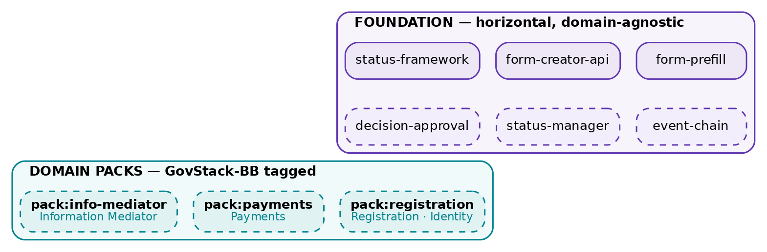
Figure 2. The capability taxonomy. Solid = shipped and active; dashed = planned or being extracted. GovStack BB names tag the packs that align to one.

3. How — the mechanism

Promote and pin, never vendor
Each plugin builds to a versioned OSGi JAR and is published as an artifact. Projects consume it the way any library is consumed — by declaring a coordinate and version — so the deploy step drops the pinned JAR into the instance. The governing rule: when a second project needs a plugin, it is promoted into the platform and pinned, never pasted into the second project. One plugin, one home, many consumers.

The registry is the single source of truth
A single registry.yaml lists every plugin, its coordinates, its tier and category, and — most importantly — its config contract: the element and property keys it exposes. That contract is the plugin's public API, and it is exactly what jkit generates against. Because the kit reads the contract rather than the Java, the two repositories stay decoupled: changing a contract key is a breaking (major) version change; the Java implementation can evolve freely underneath it.

Governance keeps it from rotting back into scatter
- Reuse tiers decide fate. Generic code is promoted as-is; pattern-reusable code is genericised first; project-specific code stays in its project.
- Provenance scrub before promotion. No client or project names in shipped code, comments or samples.
- Drift check. Continuous integration asserts the registry and the built modules stay in step, so the catalogue never lies.
- Definition of done per plugin. Builds green with tests; namespace scrubbed; registry entry with contract; consuming project re-pointed and its copy retired.

The roadmap
The work runs in phases, easy wins first to prove the build-publish-pin loop cheaply, then the higher-risk extraction of the foundation capabilities trapped in the case app, then the domain packs and remote publishing.
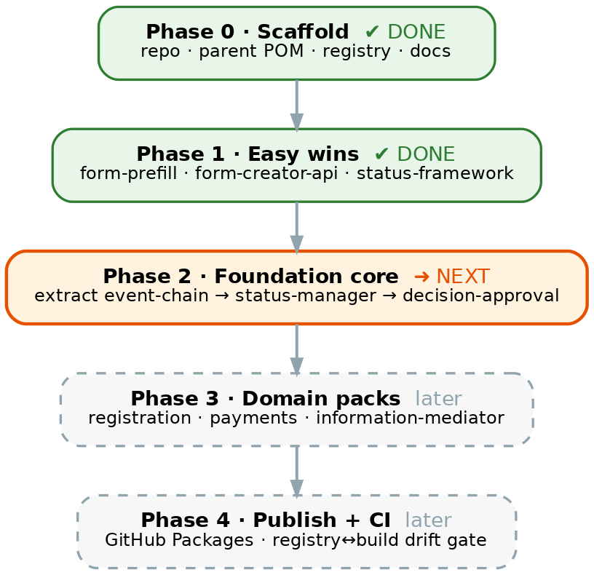
Figure 3. Phased roadmap. Phases 0–1 are complete (three plugins consolidated); Phase 2 — reclaiming the foundation capabilities — is next.

4. What this gives us
A new building block no longer starts from a blank generator and a folder of copied plugins. It starts from a shelf of versioned, contract-documented capabilities that jkit already knows how to wire in. Reuse becomes a one-line version pin; a fix or an improvement is made once and flows to every consumer on their next bump; and the catalogue is honest because CI keeps it so. The platform is domain-neutral, so the same shelf serves a tax system, a registration portal, a bank back-office, or the next GovStack service equally.

5. Status and naming
Three plugins are already consolidated and the reactor builds green. Names are confirmed: the repository is joget-platform-plugins, alongside joget-spec-kit (jkit) and joget-claude-skills.
Plugin | Category | How | State
joget-form-prefill | foundation | promoted (module 1) | active · 12 tests
form-creator-api | foundation | promoted (module 2) | active
joget-status-framework | foundation | registered in place | active · pinned
joget-event-chain | foundation | planned — Phase 2 | extracting
joget-status-manager | foundation | planned — Phase 2 | extracting
joget-decision-approval | foundation | planned — Phase 2 | extracting

The living technical detail — the per-plugin migration backlog, the approval-service extraction design, and the phased plan — is maintained in the repository under docs/ (CONSOLIDATION-PLAN, MIGRATION-BACKLOG, DAS-EXTRACTION-PLAN).

