Final Project: Final Report

David Aarhus

4/23/2020

Libraries

library("tidyverse")

## ── Attaching packages ──────────────────────────────────── tidyverse 1.3.0 ──

## ✓ ggplot2 3.2.1 ✓ purrr 0.3.3  
## ✓ tibble 2.1.3 ✓ dplyr 0.8.3  
## ✓ tidyr 1.0.0 ✓ stringr 1.4.0  
## ✓ readr 1.3.1 ✓ forcats 0.5.0

## ── Conflicts ─────────────────────────────────────── tidyverse_conflicts() ──  
## x dplyr::filter() masks stats::filter()  
## x dplyr::lag() masks stats::lag()

library("ggplot2")  
library("caret")

## Loading required package: lattice

##   
## Attaching package: 'caret'

## The following object is masked from 'package:purrr':  
##   
## lift

library("doBy")  
library("glmnet")

## Loading required package: Matrix

##   
## Attaching package: 'Matrix'

## The following objects are masked from 'package:tidyr':  
##   
## expand, pack, unpack

## Loaded glmnet 3.0-2

library("glmnetUtils")

##   
## Attaching package: 'glmnetUtils'

## The following objects are masked from 'package:glmnet':  
##   
## cv.glmnet, glmnet

library("leaps")  
library("plotROC")  
library("coefplot")

rm(list = ls()) #removing all variables

Loads in Data

suicide <- read.csv("/Users/DavidAarhus/Documents/310 R/Datasets/suicide.csv")  
names(suicide)

## [1] "country" "year" "sex"   
## [4] "age" "suicides_no" "population"   
## [7] "suicides.100k.pop" "country.year" "HDI.for.year"   
## [10] "gdp_for_year...." "gdp_per_capita...." "generation"

Data Transformation

#remove meaning less columns (HDI.for.year)  
suicide$HDI.for.year <- NULL  
suicide$country.year <- NULL  
#create new column (gdpM, gdpB, suicide_hvy)  
suicide$gdpM <- suicide$gdp_for_year..../1e+6  
suicide$gdpB <- suicide$gdp_for_year..../1e+9  
suicide$pop100000 <- suicide$population*1e-5  
suicide$suicide_rate_per100000capita <- suicide$pop100000/suicide$suicides_no  
  
#identified whether a country was suicide heavy or not by first running summary statistics on the dataset to find the average suicide rate for each country. This then allowed me to identify the average suicide rate for the dataset. After finding this I used a suicide rate just a tad higher than the average to identify whether a country was suicide heavy (in relation to the worldwide average)  
suicide$suicide_hvy <- ifelse(suicide$suicide_rate_per100000capita > 0.56, 1, 0)  
  
  
NaRV.omit <- function(x){  
 ## Author: Rene Locher  
 ## Version: 2005-10-17  
  
 if (is.vector(x)) {  
 if (is.numeric(x)) x <- na.omit(x[is.finite(x)]) else  
 x <- na.omit(x)  
 } else if (is.factor(x)) {  
 x <- na.omit(x)  
 } else if (is.data.frame(x)) {  
 x.num <- as.matrix(x[,sapply(x, is.numeric)])  
 ri <- (!apply(x.num, MARGIN = 1,  
 function(x) sum(is.infinite(x))>0) &  
 !apply(x, MARGIN = 1, function(x) sum(is.na(x))>0))  
 x <- x[ri,,drop=FALSE]  
 ## class omit is incompatible with class data.frame  
 ## attributes(x) <- c(attributes(x),list(na.action=which(!ri),class="omit"))  
 } else if (is.matrix(x)) {  
 if(is.numeric(x)) {  
 ri <- !apply(x, MARGIN = 1,  
 function(x) {sum(is.na(x)|is.infinite(x))>0})  
 x <- x[ri,,drop=FALSE]  
 attributes(x) <- c(attributes(x),list(na.action=which(!ri),class="omit"))  
 } else x <- na.omit(x)  
 } else {  
 warning("'x' is neither a vector, nor a factor, nor a data.frame nor a matrix. \n'x' is returned unchanged\n")  
 return(x)  
 }  
 return(x)  
}## NaRV.omit  
  
suicide <- NaRV.omit(suicide)

Summary tables

summary(suicide)

## country year sex age   
## Netherlands: 378 Min. :1985 female:11253 15-24 years:4131   
## Austria : 373 1st Qu.:1995 male :12286 25-34 years:4191   
## Argentina : 372 Median :2002 35-54 years:4272   
## Brazil : 372 Mean :2001 5-14 years :3142   
## Ecuador : 372 3rd Qu.:2009 55-74 years:4083   
## Japan : 372 Max. :2016 75+ years :3720   
## (Other) :21300   
## suicides_no population suicides.100k.pop gdp_for_year....   
## Min. : 1.0 Min. : 889 Min. : 0.02 Min. :4.692e+07   
## 1st Qu.: 8.0 1st Qu.: 238722 1st Qu.: 2.78 1st Qu.:1.597e+10   
## Median : 42.0 Median : 588430 Median : 8.26 Median :7.622e+10   
## Mean : 286.7 Mean : 2161400 Mean : 15.15 Mean :5.220e+11   
## 3rd Qu.: 175.0 3rd Qu.: 2107592 3rd Qu.: 19.56 3rd Qu.:3.233e+11   
## Max. :22338.0 Max. :43805214 Max. :224.97 Max. :1.812e+13   
##   
## gdp_per_capita.... generation gdpM   
## Min. : 251 Boomers :4568 Min. : 47   
## 1st Qu.: 3293 G.I. Generation:2251 1st Qu.: 15969   
## Median : 9667 Generation X :5638 Median : 76216   
## Mean : 17230 Generation Z : 984 Mean : 522025   
## 3rd Qu.: 25735 Millenials :4716 3rd Qu.: 323320   
## Max. :126352 Silent :5382 Max. :18120700   
##   
## gdpB pop100000 suicide_rate_per100000capita  
## Min. : 0.047 Min. : 0.0089 Min. : 0.00444   
## 1st Qu.: 15.969 1st Qu.: 2.3872 1st Qu.: 0.05113   
## Median : 76.216 Median : 5.8843 Median : 0.12112   
## Mean : 522.025 Mean : 21.6140 Mean : 0.55723   
## 3rd Qu.: 323.320 3rd Qu.: 21.0759 3rd Qu.: 0.35913   
## Max. :18120.700 Max. :438.0521 Max. :58.21000   
##   
## suicide_hvy   
## Min. :0.0000   
## 1st Qu.:0.0000   
## Median :0.0000   
## Mean :0.1856   
## 3rd Qu.:0.0000   
## Max. :1.0000   
##

summaryBy(suicides_no ~ country, suicide, FUN = mean)

## country suicides_no.mean  
## 1 Albania 9.563107  
## 2 Antigua and Barbuda 1.100000  
## 3 Argentina 221.018817  
## 4 Armenia 7.559524  
## 5 Aruba 1.942308  
## 6 Australia 196.389356  
## 7 Austria 134.243968  
## 8 Azerbaijan 10.036364  
## 9 Bahamas 1.430769  
## 10 Bahrain 4.367925  
## 11 Barbados 2.212500  
## 12 Belarus 237.666667  
## 13 Belgium 171.947945  
## 14 Belize 2.503597  
## 15 Bosnia and Herzegovina 22.714286  
## 16 Brazil 609.174731  
## 17 Bulgaria 103.375000  
## 18 Cabo Verde 4.666667  
## 19 Canada 309.083333  
## 20 Chile 110.826558  
## 21 Colombia 143.459459  
## 22 Costa Rica 20.770642  
## 23 Croatia 72.841897  
## 24 Cuba 144.818182  
## 25 Cyprus 4.204082  
## 26 Czech Republic 138.688889  
## 27 Denmark 62.692623  
## 28 Ecuador 55.537634  
## 29 El Salvador 41.137324  
## 30 Estonia 30.318966  
## 31 Fiji 3.268817  
## 32 Finland 101.132132  
## 33 France 914.241667  
## 34 Georgia 13.777778  
## 35 Germany 933.532051  
## 36 Greece 37.365559  
## 37 Grenada 1.266667  
## 38 Guatemala 24.325373  
## 39 Guyana 13.076336  
## 40 Hungary 245.485050  
## 41 Iceland 4.196970  
## 42 Ireland 37.422619  
## 43 Israel 32.085227  
## 44 Italy 355.956873  
## 45 Jamaica 2.967742  
## 46 Japan 2169.091398  
## 47 Kazakhstan 325.467949  
## 48 Kiribati 1.558824  
## 49 Kuwait 5.715976  
## 50 Kyrgyzstan 42.090032  
## 51 Latvia 54.572650  
## 52 Lithuania 108.258687  
## 53 Luxembourg 6.570470  
## 54 Macau 3.000000  
## 55 Maldives 1.176471  
## 56 Malta 3.078947  
## 57 Mauritius 11.944785  
## 58 Mexico 298.760753  
## 59 Mongolia 42.300000  
## 60 Montenegro 11.238095  
## 61 Netherlands 134.478836  
## 62 New Zealand 42.302941  
## 63 Nicaragua 29.602941  
## 64 Norway 49.109827  
## 65 Oman 3.000000  
## 66 Panama 13.044944  
## 67 Paraguay 15.943333  
## 68 Philippines 121.193182  
## 69 Poland 482.979167  
## 70 Portugal 78.374593  
## 71 Puerto Rico 26.833828  
## 72 Qatar 7.000000  
## 73 Republic of Korea 703.575269  
## 74 Romania 218.549550  
## 75 Russian Federation 3733.771605  
## 76 Saint Lucia 1.811024  
## 77 Saint Vincent and Grenadines 1.722222  
## 78 San Marino 1.000000  
## 79 Serbia 122.116162  
## 80 Seychelles 1.633333  
## 81 Singapore 28.661932  
## 82 Slovakia 59.986607  
## 83 Slovenia 45.952381  
## 84 South Africa 31.021186  
## 85 Spain 270.816216  
## 86 Sri Lanka 421.522727  
## 87 Suriname 7.443299  
## 88 Sweden 107.678063  
## 89 Switzerland 107.446721  
## 90 Thailand 337.326220  
## 91 Trinidad and Tobago 13.927586  
## 92 Turkey 120.607143  
## 93 Turkmenistan 25.975904  
## 94 Ukraine 952.232143  
## 95 United Arab Emirates 13.234043  
## 96 United Kingdom 370.745257  
## 97 United States 2779.604839  
## 98 Uruguay 40.300613  
## 99 Uzbekistan 131.829545

summaryBy(gdpB ~ country, suicide, FUN = mean)

## country gdpB.mean  
## 1 Albania 4.648709e+00  
## 2 Antigua and Barbuda 8.826761e-01  
## 3 Argentina 2.742565e+02  
## 4 Armenia 5.485033e+00  
## 5 Aruba 2.231247e+00  
## 6 Australia 6.335728e+02  
## 7 Austria 2.656939e+02  
## 8 Azerbaijan 7.459842e+00  
## 9 Bahamas 8.285369e+00  
## 10 Bahrain 1.727900e+01  
## 11 Barbados 2.353033e+00  
## 12 Belarus 3.067641e+01  
## 13 Belgium 3.182275e+02  
## 14 Belize 1.085627e+00  
## 15 Bosnia and Herzegovina 1.857685e+01  
## 16 Brazil 1.022560e+03  
## 17 Bulgaria 2.673242e+01  
## 18 Cabo Verde 1.864824e+00  
## 19 Canada 9.131880e+02  
## 20 Chile 1.118403e+02  
## 21 Colombia 1.449995e+02  
## 22 Costa Rica 1.975445e+01  
## 23 Croatia 4.304783e+01  
## 24 Cuba 4.589732e+01  
## 25 Cyprus 2.287242e+01  
## 26 Czech Republic 1.218473e+02  
## 27 Denmark 2.544138e+02  
## 28 Ecuador 3.960131e+01  
## 29 El Salvador 1.354635e+01  
## 30 Estonia 1.431887e+01  
## 31 Fiji 2.928943e+00  
## 32 Finland 1.746144e+02  
## 33 France 1.781195e+03  
## 34 Georgia 7.872178e+00  
## 35 Germany 2.742234e+03  
## 36 Greece 1.750806e+02  
## 37 Grenada 4.941695e-01  
## 38 Guatemala 2.561343e+01  
## 39 Guyana 1.164074e+00  
## 40 Hungary 8.889633e+01  
## 41 Iceland 1.082616e+01  
## 42 Ireland 1.332056e+02  
## 43 Israel 1.408492e+02  
## 44 Italy 1.480509e+03  
## 45 Jamaica 9.053891e+00  
## 46 Japan 4.339220e+03  
## 47 Kazakhstan 7.868729e+01  
## 48 Kiribati 5.514045e-02  
## 49 Kuwait 7.820154e+01  
## 50 Kyrgyzstan 3.304067e+00  
## 51 Latvia 1.804614e+01  
## 52 Lithuania 2.763685e+01  
## 53 Luxembourg 3.036920e+01  
## 54 Macau 6.265844e+00  
## 55 Maldives 1.494499e+00  
## 56 Malta 5.788061e+00  
## 57 Mauritius 6.064692e+00  
## 58 Mexico 6.803078e+02  
## 59 Mongolia 1.118346e+01  
## 60 Montenegro 3.693664e+00  
## 61 Netherlands 5.427702e+02  
## 62 New Zealand 8.282233e+01  
## 63 Nicaragua 1.076980e+01  
## 64 Norway 2.522220e+02  
## 65 Oman 6.103208e+01  
## 66 Panama 2.007308e+01  
## 67 Paraguay 1.189702e+01  
## 68 Philippines 1.150493e+02  
## 69 Poland 2.944583e+02  
## 70 Portugal 1.368790e+02  
## 71 Puerto Rico 6.309963e+01  
## 72 Qatar 1.198388e+02  
## 73 Republic of Korea 6.734205e+02  
## 74 Romania 9.625033e+01  
## 75 Russian Federation 8.843230e+02  
## 76 Saint Lucia 8.364877e-01  
## 77 Saint Vincent and Grenadines 5.093509e-01  
## 78 San Marino 1.372973e+00  
## 79 Serbia 3.078407e+01  
## 80 Seychelles 8.999832e-01  
## 81 Singapore 1.250928e+02  
## 82 Slovakia 5.049306e+01  
## 83 Slovenia 3.536011e+01  
## 84 South Africa 2.512605e+02  
## 85 Spain 8.556179e+02  
## 86 Sri Lanka 1.532645e+01  
## 87 Suriname 2.038817e+00  
## 88 Sweden 3.566500e+02  
## 89 Switzerland 4.568137e+02  
## 90 Thailand 2.105542e+02  
## 91 Trinidad and Tobago 1.038646e+01  
## 92 Turkey 8.382300e+02  
## 93 Turkmenistan 1.071667e+01  
## 94 Ukraine 8.389108e+01  
## 95 United Arab Emirates 2.542419e+02  
## 96 United Kingdom 1.820855e+03  
## 97 United States 1.051071e+04  
## 98 Uruguay 2.343104e+01  
## 99 Uzbekistan 2.286003e+01

summaryBy(suicides_no ~ sex, suicide, FUN = mean)

## sex suicides_no.mean  
## 1 female 138.5862  
## 2 male 422.3433

GGPLOTS

ggplot(suicide, aes(generation)) +  
 geom_bar(aes(fill = sex)) +  
 labs(x = " ", y = "Count", title = "Suicide Totals vs Generations")

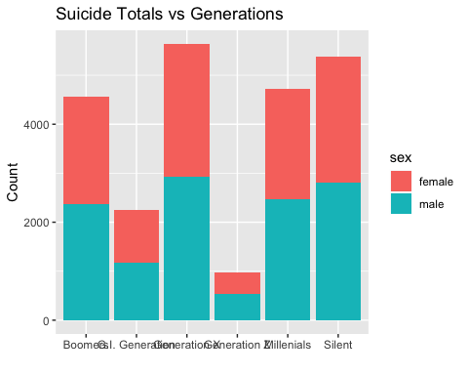

ggplot(suicide, aes(suicides.100k.pop, gdpB)) +  
 geom_point(aes(color = age)) +  
 labs(x = "Suicides per 100k pop ", y = "GDP (Billions)", title = "GDP (Billions) vs Suicides per 100k pop")

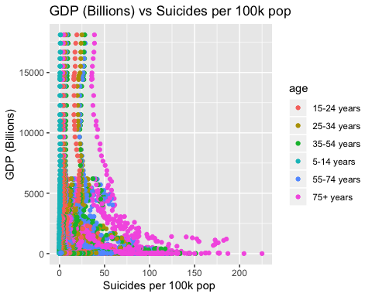

ggplot(suicide, aes(year, suicides_no)) +  
 geom_point(aes(color = sex)) +  
 labs(x = "Year", y = "Suicide Count", title = "Suicides vs Year")

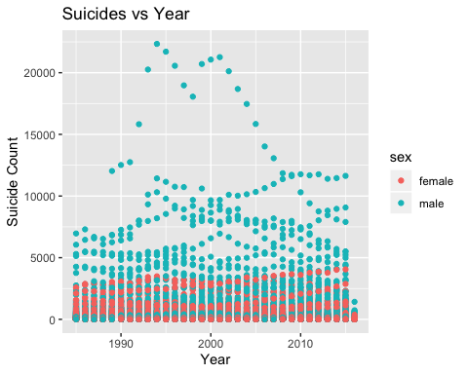

ggplot(suicide, aes(population, suicides.100k.pop )) +  
 geom_point(aes(color = generation)) +  
 labs(x = "Population", y = "Suicides per 100k pop", title = "Suicides per 100k pop Vs Population")

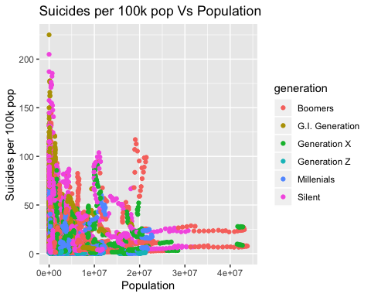

ggplot(suicide, aes(year, suicides.100k.pop)) +  
 geom_point(aes(color = generation)) +  
 labs(x = "Year", y = "Suicides per 100k pop", title = "Suicides per 100k pop Vs Year")

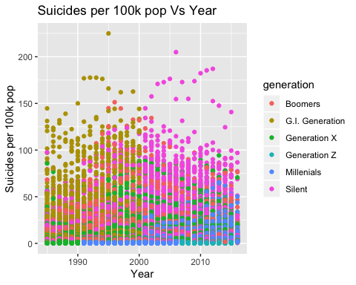

Training Split

set.seed(310)  
train_indx <- sample(1:nrow(suicide), 0.70 * nrow(suicide), replace=FALSE)  
suicide_train <- suicide[train_indx, ]  
suicide_test <- suicide[-train_indx, ]

Linear Regression

# We are using a linear model to see the affect of certain variables on the number of suicides in different countries  
Linear_mod <- lm(suicide_rate_per100000capita ~ ., suicide_train)  
summary(Linear_mod)

##   
## Call:  
## lm(formula = suicide_rate_per100000capita ~ ., data = suicide_train)  
##   
## Residuals:  
## Min 1Q Median 3Q Max   
## -3.807 -0.182 0.048 0.215 55.096   
##   
## Coefficients: (3 not defined because of singularities)  
## Estimate Std. Error t value Pr(>|t|)   
## (Intercept) 1.372e+01 5.675e+00 2.418 0.015631 *   
## countryAntigua and Barbuda 2.620e-02 5.098e-01 0.051 0.959013   
## countryArgentina -2.048e-01 1.491e-01 -1.374 0.169487   
## countryArmenia 2.703e-01 1.617e-01 1.671 0.094657 .   
## countryAruba -2.597e-01 2.602e-01 -0.998 0.318219   
## countryAustralia -7.570e-02 1.576e-01 -0.480 0.630939   
## countryAustria -4.197e-01 1.586e-01 -2.647 0.008138 **   
## countryAzerbaijan 6.603e-01 1.799e-01 3.671 0.000242 ***  
## countryBahamas 1.349e-01 2.399e-01 0.562 0.574032   
## countryBahrain 3.731e-02 2.087e-01 0.179 0.858136   
## countryBarbados -2.498e-02 2.238e-01 -0.112 0.911142   
## countryBelarus -4.608e-01 1.637e-01 -2.815 0.004887 **   
## countryBelgium -3.652e-01 1.575e-01 -2.319 0.020422 *   
## countryBelize -5.945e-02 1.810e-01 -0.328 0.742636   
## countryBosnia and Herzegovina 5.056e-01 4.227e-01 1.196 0.231673   
## countryBrazil 3.380e-01 1.703e-01 1.985 0.047181 *   
## countryBulgaria -3.230e-01 1.505e-01 -2.146 0.031899 *   
## countryCabo Verde -1.897e-01 5.432e-01 -0.349 0.726897   
## countryCanada -4.252e-01 1.577e-01 -2.696 0.007024 **   
## countryChile -8.350e-02 1.490e-01 -0.561 0.575103   
## countryColombia -9.389e-02 1.499e-01 -0.626 0.531000   
## countryCosta Rica -8.345e-02 1.528e-01 -0.546 0.585018   
## countryCroatia -3.378e-01 1.605e-01 -2.105 0.035341 *   
## countryCuba -1.006e-01 1.610e-01 -0.625 0.532015   
## countryCyprus 3.749e-02 2.039e-01 0.184 0.854071   
## countryCzech Republic -1.691e-01 1.554e-01 -1.088 0.276484   
## countryDenmark -2.996e-01 1.741e-01 -1.721 0.085277 .   
## countryEcuador -1.934e-01 1.482e-01 -1.305 0.191784   
## countryEl Salvador -1.298e-01 1.573e-01 -0.825 0.409298   
## countryEstonia -3.838e-01 1.639e-01 -2.341 0.019237 *   
## countryFiji -9.562e-02 2.142e-01 -0.446 0.655283   
## countryFinland -4.739e-01 1.606e-01 -2.951 0.003167 **   
## countryFrance -1.978e-01 1.609e-01 -1.230 0.218821   
## countryGeorgia 2.705e-01 1.645e-01 1.645 0.100084   
## countryGermany -8.807e-02 1.692e-01 -0.521 0.602645   
## countryGreece 1.656e-01 1.543e-01 1.073 0.283369   
## countryGrenada -1.449e-01 3.358e-01 -0.432 0.666048   
## countryGuatemala 4.335e-01 1.511e-01 2.870 0.004110 **   
## countryGuyana -4.862e-01 1.590e-01 -3.057 0.002240 **   
## countryHungary -2.993e-01 1.583e-01 -1.891 0.058631 .   
## countryIceland -3.351e-01 1.682e-01 -1.992 0.046360 *   
## countryIreland -2.715e-01 1.605e-01 -1.691 0.090878 .   
## countryIsrael 6.104e-02 1.537e-01 0.397 0.691316   
## countryItaly 6.826e-01 1.576e-01 4.330 1.50e-05 ***  
## countryJamaica 6.481e-01 2.424e-01 2.673 0.007517 **   
## countryJapan -3.871e-01 1.828e-01 -2.117 0.034255 *   
## countryKazakhstan -5.260e-01 1.548e-01 -3.398 0.000680 ***  
## countryKiribati -5.043e-01 2.800e-01 -1.801 0.071701 .   
## countryKuwait 4.046e-02 1.831e-01 0.221 0.825181   
## countryKyrgyzstan -2.627e-01 1.530e-01 -1.717 0.086089 .   
## countryLatvia -4.335e-01 1.630e-01 -2.660 0.007819 **   
## countryLithuania -6.171e-01 1.651e-01 -3.738 0.000186 ***  
## countryLuxembourg -4.706e-01 1.851e-01 -2.542 0.011031 *   
## countryMacau -2.102e-01 5.850e-01 -0.359 0.719375   
## countryMaldives -1.438e-01 4.069e-01 -0.353 0.723840   
## countryMalta 7.777e-03 1.720e-01 0.045 0.963939   
## countryMauritius -2.891e-01 1.534e-01 -1.885 0.059487 .   
## countryMexico 9.543e-02 1.572e-01 0.607 0.543745   
## countryMongolia 4.868e-02 5.436e-01 0.090 0.928649   
## countryMontenegro -2.447e-01 2.921e-01 -0.838 0.402308   
## countryNetherlands 7.503e-03 1.555e-01 0.048 0.961524   
## countryNew Zealand -4.151e-01 1.526e-01 -2.720 0.006542 **   
## countryNicaragua 2.590e-02 2.351e-01 0.110 0.912274   
## countryNorway -5.092e-01 1.729e-01 -2.944 0.003243 **   
## countryOman 6.555e-01 5.115e-01 1.281 0.200046   
## countryPanama -3.067e-02 1.611e-01 -0.190 0.849025   
## countryParaguay -3.979e-02 1.537e-01 -0.259 0.795668   
## countryPhilippines 8.679e-01 1.811e-01 4.791 1.67e-06 ***  
## countryPoland -1.347e-01 1.569e-01 -0.858 0.390742   
## countryPortugal 6.787e-02 1.554e-01 0.437 0.662242   
## countryPuerto Rico -8.101e-02 1.548e-01 -0.523 0.600819   
## countryQatar -7.690e-02 2.374e-01 -0.324 0.745990   
## countryRepublic of Korea -4.306e-01 1.532e-01 -2.810 0.004952 **   
## countryRomania -9.970e-02 1.513e-01 -0.659 0.510085   
## countryRussian Federation -5.879e-01 1.700e-01 -3.458 0.000546 ***  
## countrySaint Lucia -1.069e-01 1.900e-01 -0.563 0.573760   
## countrySaint Vincent and Grenadines -1.111e-01 2.326e-01 -0.478 0.632803   
## countrySan Marino -3.530e-01 7.146e-01 -0.494 0.621299   
## countrySerbia -1.908e-01 1.722e-01 -1.108 0.267793   
## countrySeychelles -9.737e-02 2.610e-01 -0.373 0.709138   
## countrySingapore -4.648e-01 1.596e-01 -2.913 0.003587 **   
## countrySlovakia -1.718e-01 1.656e-01 -1.037 0.299634   
## countrySlovenia -4.254e-01 1.679e-01 -2.533 0.011314 *   
## countrySouth Africa 3.584e+00 1.680e-01 21.340 < 2e-16 ***  
## countrySpain 8.119e-01 1.542e-01 5.264 1.43e-07 ***  
## countrySri Lanka -6.692e-01 1.910e-01 -3.504 0.000460 ***  
## countrySuriname -3.990e-01 1.561e-01 -2.556 0.010596 *   
## countrySweden -2.988e-01 1.606e-01 -1.860 0.062860 .   
## countrySwitzerland -4.628e-01 1.845e-01 -2.509 0.012115 *   
## countryThailand 3.342e-01 1.553e-01 2.152 0.031400 *   
## countryTrinidad and Tobago -3.406e-01 1.548e-01 -2.201 0.027785 *   
## countryTurkey 2.730e-01 2.227e-01 1.226 0.220279   
## countryTurkmenistan -1.036e-01 1.521e-01 -0.682 0.495518   
## countryUkraine -4.208e-01 1.533e-01 -2.746 0.006044 **   
## countryUnited Arab Emirates 1.252e-01 2.741e-01 0.457 0.647792   
## countryUnited Kingdom 1.387e+00 1.608e-01 8.622 < 2e-16 ***  
## countryUnited States -3.424e-01 2.755e-01 -1.243 0.213932   
## countryUruguay -3.284e-01 1.521e-01 -2.159 0.030845 *   
## countryUzbekistan -6.410e-02 1.595e-01 -0.402 0.687846   
## year -6.698e-03 2.858e-03 -2.344 0.019104 *   
## sexmale -4.558e-01 2.689e-02 -16.951 < 2e-16 ***  
## age25-34 years -4.614e-02 4.464e-02 -1.034 0.301335   
## age35-54 years -5.852e-02 7.024e-02 -0.833 0.404804   
## age5-14 years 2.094e+00 6.395e-02 32.748 < 2e-16 ***  
## age55-74 years -5.420e-02 1.049e-01 -0.517 0.605390   
## age75+ years -1.527e-01 1.242e-01 -1.229 0.219055   
## suicides_no 1.709e-05 1.718e-05 0.995 0.319774   
## population -8.648e-09 6.778e-09 -1.276 0.202053   
## suicides.100k.pop 8.831e-03 8.505e-04 10.383 < 2e-16 ***  
## gdp_for_year.... 3.113e-15 2.043e-14 0.152 0.878878   
## gdp_per_capita.... 4.794e-06 1.542e-06 3.109 0.001882 **   
## generationG.I. Generation -1.027e-01 9.326e-02 -1.101 0.270713   
## generationGeneration X 5.684e-02 5.312e-02 1.070 0.284577   
## generationGeneration Z -2.860e-01 1.238e-01 -2.311 0.020825 *   
## generationMillenials 5.487e-02 8.301e-02 0.661 0.508634   
## generationSilent -2.709e-02 5.963e-02 -0.454 0.649675   
## gdpM NA NA NA NA   
## gdpB NA NA NA NA   
## pop100000 NA NA NA NA   
## suicide_hvy 7.592e-01 4.725e-02 16.068 < 2e-16 ***  
## ---  
## Signif. codes: 0 '***' 0.001 '**' 0.01 '*' 0.05 '.' 0.1 ' ' 1  
##   
## Residual standard error: 1.399 on 16360 degrees of freedom  
## Multiple R-squared: 0.3643, Adjusted R-squared: 0.3598   
## F-statistic: 80.82 on 116 and 16360 DF, p-value: < 2.2e-16

#This linear model helps point out the factors other than countries that play a key role in the amount of suicides  
Linear_mod_noCountries <- lm(suicide_rate_per100000capita ~ year + sex   
 + age + generation  
 + gdpB + gdpM, suicide_train)  
summary(Linear_mod_noCountries)

##   
## Call:  
## lm(formula = suicide_rate_per100000capita ~ year + sex + age +   
## generation + gdpB + gdpM, data = suicide_train)  
##   
## Residuals:  
## Min 1Q Median 3Q Max   
## -2.975 -0.269 -0.009 0.069 55.529   
##   
## Coefficients: (1 not defined because of singularities)  
## Estimate Std. Error t value Pr(>|t|)   
## (Intercept) 3.950e+00 5.361e+00 0.737 0.4612   
## year -1.774e-03 2.704e-03 -0.656 0.5117   
## sexmale -3.906e-01 2.352e-02 -16.609 <2e-16 ***  
## age25-34 years -1.308e-02 4.785e-02 -0.273 0.7846   
## age35-54 years 7.276e-03 7.471e-02 0.097 0.9224   
## age5-14 years 2.602e+00 5.373e-02 48.438 <2e-16 ***  
## age55-74 years 4.016e-02 1.123e-01 0.358 0.7207   
## age75+ years 1.886e-02 1.318e-01 0.143 0.8862   
## generationG.I. Generation -1.038e-01 1.001e-01 -1.037 0.2997   
## generationGeneration X 6.897e-02 5.710e-02 1.208 0.2271   
## generationGeneration Z -2.413e-01 1.328e-01 -1.816 0.0694 .   
## generationMillenials 5.644e-02 8.924e-02 0.632 0.5271   
## generationSilent -4.238e-02 6.400e-02 -0.662 0.5079   
## gdpB 4.099e-06 7.669e-06 0.534 0.5930   
## gdpM NA NA NA NA   
## ---  
## Signif. codes: 0 '***' 0.001 '**' 0.01 '*' 0.05 '.' 0.1 ' ' 1  
##   
## Residual standard error: 1.508 on 16463 degrees of freedom  
## Multiple R-squared: 0.2573, Adjusted R-squared: 0.2567   
## F-statistic: 438.7 on 13 and 16463 DF, p-value: < 2.2e-16

Linear Regression Predictions (Linear_mod_noCountries)

preds_train1 <- predict(Linear_mod_noCountries, newdata = suicide_train)

## Warning in predict.lm(Linear_mod_noCountries, newdata = suicide_train):  
## prediction from a rank-deficient fit may be misleading

preds_test1 <- predict(Linear_mod_noCountries, newdata = suicide_test)

## Warning in predict.lm(Linear_mod_noCountries, newdata = suicide_test):  
## prediction from a rank-deficient fit may be misleading

preds_train1_df <- data.frame(true = suicide_train$suicide_rate_per100000capita,  
 pred = predict(Linear_mod_noCountries, newdata = suicide_train),  
 resid = suicide_train$suicide_rate_per100000capita - predict(Linear_mod_noCountries, newdata = suicide_train))

## Warning in predict.lm(Linear_mod_noCountries, newdata = suicide_train):  
## prediction from a rank-deficient fit may be misleading  
  
## Warning in predict.lm(Linear_mod_noCountries, newdata = suicide_train):  
## prediction from a rank-deficient fit may be misleading

preds_test1_df <- data.frame(true = suicide_test$suicide_rate_per100000capita,  
 pred = predict(Linear_mod_noCountries, newdata = suicide_test),  
 resid = suicide_test$suicide_rate_per100000capita - predict(Linear_mod_noCountries, newdata = suicide_test))

## Warning in predict.lm(Linear_mod_noCountries, newdata = suicide_test):  
## prediction from a rank-deficient fit may be misleading

## Warning in predict.lm(Linear_mod_noCountries, newdata = suicide_test):  
## prediction from a rank-deficient fit may be misleading

Linear Regression Predictions (Linear_mod)

preds_train2 <- predict(Linear_mod, newdata = suicide_train)

## Warning in predict.lm(Linear_mod, newdata = suicide_train): prediction from a  
## rank-deficient fit may be misleading

preds_test2 <- predict(Linear_mod, newdata = suicide_test)

## Warning in predict.lm(Linear_mod, newdata = suicide_test): prediction from a  
## rank-deficient fit may be misleading

preds_train2_df <- data.frame(true = suicide_train$suicide_rate_per100000capita,  
 pred = predict(Linear_mod, newdata = suicide_train),  
 resid = suicide_train$suicide_rate_per100000capita - predict(Linear_mod, newdata = suicide_train))

## Warning in predict.lm(Linear_mod, newdata = suicide_train): prediction from a  
## rank-deficient fit may be misleading  
  
## Warning in predict.lm(Linear_mod, newdata = suicide_train): prediction from a  
## rank-deficient fit may be misleading

preds_test2_df <- data.frame(true = suicide_test$suicide_rate_per100000capita,  
 pred = predict(Linear_mod, newdata = suicide_test),  
 resid = suicide_test$suicide_rate_per100000capita - predict(Linear_mod, newdata = suicide_test))

## Warning in predict.lm(Linear_mod, newdata = suicide_test): prediction from a  
## rank-deficient fit may be misleading

## Warning in predict.lm(Linear_mod, newdata = suicide_test): prediction from a  
## rank-deficient fit may be misleading

Plot predictions (linear_mod_noCountries)

ggplot(preds_train1_df, aes(x=pred, y=resid)) +  
 geom_point() +   
 geom_smooth(se=FALSE)

## `geom_smooth()` using method = 'gam' and formula 'y ~ s(x, bs = "cs")'

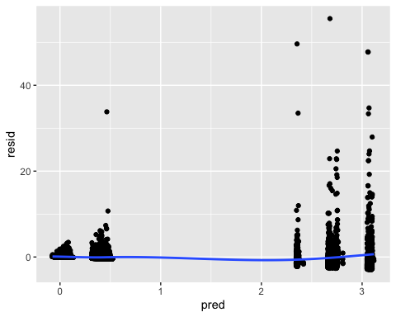

ggplot(preds_test1_df, aes(x=pred, y=resid)) +  
 geom_point() +   
 geom_smooth(se=FALSE)

## `geom_smooth()` using method = 'gam' and formula 'y ~ s(x, bs = "cs")'

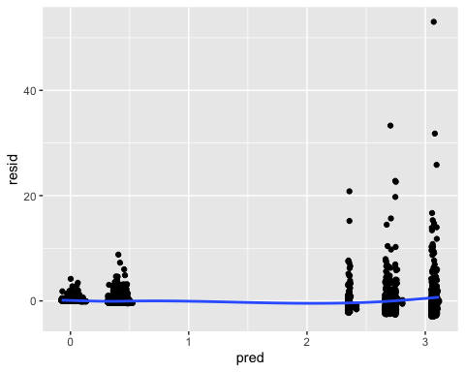

Plot predictions (linear_mod)

ggplot(preds_train2_df, aes(x=pred, y=resid)) +  
 geom_point() +   
 geom_smooth(se=FALSE)

## `geom_smooth()` using method = 'gam' and formula 'y ~ s(x, bs = "cs")'

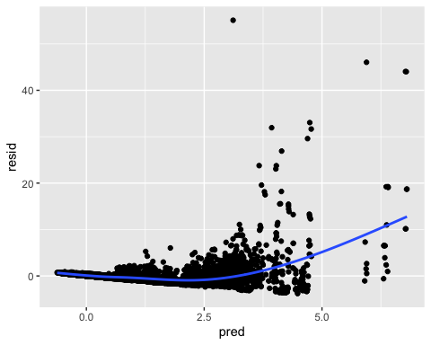

ggplot(preds_test2_df, aes(x=pred, y=resid)) +  
 geom_point() +   
 geom_smooth(se=FALSE)

## `geom_smooth()` using method = 'gam' and formula 'y ~ s(x, bs = "cs")'

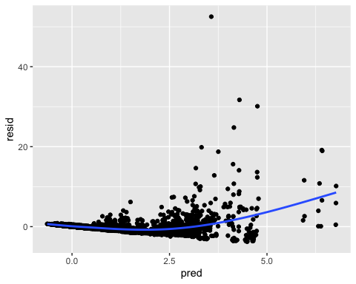

MSE for train and test (linear_mod_noCountries)

RMSE(preds_train1_df$pred, preds_train1_df$true)

## [1] 1.506979

RMSE(preds_test1_df$pred, preds_test1_df$true)

## [1] 1.481042

MSE for train and test (linear_mod)

RMSE(preds_train2_df$pred, preds_train2_df$true)

## [1] 1.394213

RMSE(preds_test2_df$pred, preds_test2_df$true)

## [1] 1.377826

Logistic Regression

logit_fit <- glm(suicide_hvy ~ year + sex + age + generation + country + gdp_per_capita...., family = binomial, suicide_train)  
summary(logit_fit)

##   
## Call:  
## glm(formula = suicide_hvy ~ year + sex + age + generation + country +   
## gdp_per_capita...., family = binomial, data = suicide_train)  
##   
## Deviance Residuals:   
## Min 1Q Median 3Q Max   
## -4.0132 -0.2010 -0.0521 -0.0001 4.0284   
##   
## Coefficients:  
## Estimate Std. Error z value Pr(>|z|)   
## (Intercept) 2.148e+01 1.981e+01 1.084 0.278369   
## year -1.144e-02 9.984e-03 -1.145 0.252026   
## sexmale -3.137e+00 1.157e-01 -27.116 < 2e-16 ***  
## age25-34 years -4.292e-01 1.582e-01 -2.714 0.006654 **   
## age35-54 years -1.728e-01 2.449e-01 -0.706 0.480382   
## age5-14 years 8.939e+00 2.370e-01 37.721 < 2e-16 ***  
## age55-74 years 3.782e-02 3.688e-01 0.103 0.918338   
## age75+ years -5.138e-01 4.428e-01 -1.160 0.245889   
## generationG.I. Generation -6.716e-01 3.453e-01 -1.945 0.051756 .   
## generationGeneration X -1.315e-01 1.893e-01 -0.694 0.487463   
## generationGeneration Z -4.342e-01 4.321e-01 -1.005 0.314925   
## generationMillenials -1.140e-01 2.940e-01 -0.388 0.698190   
## generationSilent -2.830e-01 2.065e-01 -1.371 0.170438   
## countryAntigua and Barbuda -1.643e+01 3.383e+03 -0.005 0.996125   
## countryArgentina -2.220e+00 5.812e-01 -3.821 0.000133 ***  
## countryArmenia 2.591e+00 4.172e-01 6.211 5.27e-10 ***  
## countryAruba -1.717e+01 1.555e+03 -0.011 0.991193   
## countryAustralia -3.181e+00 6.349e-01 -5.009 5.47e-07 ***  
## countryAustria -2.974e+00 6.282e-01 -4.733 2.21e-06 ***  
## countryAzerbaijan 3.692e+00 4.444e-01 8.307 < 2e-16 ***  
## countryBahamas -2.065e+01 1.277e+03 -0.016 0.987101   
## countryBahrain 8.931e-01 5.159e-01 1.731 0.083396 .   
## countryBarbados -1.984e+01 1.172e+03 -0.017 0.986490   
## countryBelarus -4.180e+00 6.471e-01 -6.459 1.05e-10 ***  
## countryBelgium -3.216e+00 6.477e-01 -4.966 6.84e-07 ***  
## countryBelize -2.175e+01 8.094e+02 -0.027 0.978567   
## countryBosnia and Herzegovina 3.322e+00 8.764e-01 3.791 0.000150 ***  
## countryBrazil -2.325e+00 6.181e-01 -3.762 0.000168 ***  
## countryBulgaria -2.737e+00 6.102e-01 -4.485 7.31e-06 ***  
## countryCabo Verde -2.114e+01 3.212e+03 -0.007 0.994748   
## countryCanada -3.413e+00 6.603e-01 -5.169 2.36e-07 ***  
## countryChile -4.501e-01 4.586e-01 -0.982 0.326332   
## countryColombia 1.875e+00 3.974e-01 4.717 2.39e-06 ***  
## countryCosta Rica 5.660e-01 4.280e-01 1.323 0.185960   
## countryCroatia -2.525e+00 6.827e-01 -3.699 0.000216 ***  
## countryCuba -1.735e+00 6.453e-01 -2.689 0.007168 **   
## countryCyprus 3.171e-01 5.240e-01 0.605 0.545124   
## countryCzech Republic -2.444e+00 6.359e-01 -3.843 0.000122 ***  
## countryDenmark -3.209e+00 7.176e-01 -4.472 7.75e-06 ***  
## countryEcuador -4.625e-02 4.361e-01 -0.106 0.915533   
## countryEl Salvador -9.430e-01 5.470e-01 -1.724 0.084690 .   
## countryEstonia -3.973e+00 7.364e-01 -5.395 6.84e-08 ***  
## countryFiji 5.510e-01 5.623e-01 0.980 0.327086   
## countryFinland -3.326e+00 6.709e-01 -4.958 7.12e-07 ***  
## countryFrance -3.165e+00 6.430e-01 -4.922 8.56e-07 ***  
## countryGeorgia 1.842e+00 4.183e-01 4.403 1.07e-05 ***  
## countryGermany -3.197e+00 6.629e-01 -4.823 1.42e-06 ***  
## countryGreece 1.298e+00 4.132e-01 3.140 0.001688 **   
## countryGrenada -2.063e+01 1.930e+03 -0.011 0.991468   
## countryGuatemala 2.288e+00 4.043e-01 5.658 1.54e-08 ***  
## countryGuyana -6.240e+00 6.263e-01 -9.964 < 2e-16 ***  
## countryHungary -2.387e+00 6.510e-01 -3.667 0.000246 ***  
## countryIceland -2.259e+01 6.321e+02 -0.036 0.971491   
## countryIreland -2.699e+00 6.405e-01 -4.215 2.50e-05 ***  
## countryIsrael -1.200e+00 4.960e-01 -2.419 0.015558 *   
## countryItaly -9.458e-01 4.880e-01 -1.938 0.052595 .   
## countryJamaica 4.908e+00 5.297e-01 9.265 < 2e-16 ***  
## countryJapan -3.206e+00 6.530e-01 -4.910 9.10e-07 ***  
## countryKazakhstan -6.993e+00 6.085e-01 -11.492 < 2e-16 ***  
## countryKiribati -2.316e+01 1.414e+03 -0.016 0.986938   
## countryKuwait 2.543e+00 4.761e-01 5.341 9.24e-08 ***  
## countryKyrgyzstan -5.339e+00 5.872e-01 -9.093 < 2e-16 ***  
## countryLatvia -3.922e+00 6.865e-01 -5.712 1.11e-08 ***  
## countryLithuania -4.347e+00 6.077e-01 -7.154 8.46e-13 ***  
## countryLuxembourg -2.306e+01 6.034e+02 -0.038 0.969518   
## countryMacau -1.761e+01 4.064e+03 -0.004 0.996543   
## countryMaldives -2.149e+01 2.364e+03 -0.009 0.992748   
## countryMalta -3.815e+00 1.411e+00 -2.703 0.006868 **   
## countryMauritius -4.186e+00 6.621e-01 -6.323 2.57e-10 ***  
## countryMexico 2.297e+00 4.009e-01 5.730 1.00e-08 ***  
## countryMongolia 8.353e-01 1.251e+00 0.668 0.504385   
## countryMontenegro -1.997e+01 1.659e+03 -0.012 0.990395   
## countryNetherlands -3.526e+00 6.632e-01 -5.316 1.06e-07 ***  
## countryNew Zealand -4.048e+00 5.946e-01 -6.807 9.96e-12 ***  
## countryNicaragua 5.437e-01 6.692e-01 0.812 0.416560   
## countryNorway -5.250e+00 6.981e-01 -7.521 5.44e-14 ***  
## countryOman 6.328e+00 1.141e+00 5.543 2.97e-08 ***  
## countryPanama 1.485e+00 4.219e-01 3.519 0.000433 ***  
## countryParaguay 6.165e-01 4.275e-01 1.442 0.149288   
## countryPhilippines 3.094e+00 4.418e-01 7.003 2.50e-12 ***  
## countryPoland -2.335e+00 6.338e-01 -3.685 0.000229 ***  
## countryPortugal -9.720e-02 4.469e-01 -0.218 0.827799   
## countryPuerto Rico 9.549e-01 4.226e-01 2.260 0.023852 *   
## countryQatar -1.541e-01 6.993e-01 -0.220 0.825556   
## countryRepublic of Korea -2.646e+00 6.140e-01 -4.310 1.63e-05 ***  
## countryRomania -1.961e+00 5.904e-01 -3.322 0.000893 ***  
## countryRussian Federation -5.361e+00 5.578e-01 -9.611 < 2e-16 ***  
## countrySaint Lucia -2.237e+01 9.183e+02 -0.024 0.980563   
## countrySaint Vincent and Grenadines -2.255e+01 1.313e+03 -0.017 0.986298   
## countrySan Marino -1.653e+01 5.333e+03 -0.003 0.997527   
## countrySerbia -1.536e+00 6.731e-01 -2.283 0.022442 *   
## countrySeychelles -1.569e+01 1.646e+03 -0.010 0.992395   
## countrySingapore -3.731e+00 6.559e-01 -5.689 1.28e-08 ***  
## countrySlovakia 2.629e-01 4.540e-01 0.579 0.562485   
## countrySlovenia -3.076e+00 7.747e-01 -3.970 7.19e-05 ***  
## countrySouth Africa 5.313e+00 4.412e-01 12.042 < 2e-16 ***  
## countrySpain -1.156e+00 4.983e-01 -2.319 0.020396 *   
## countrySri Lanka -5.992e+00 7.572e-01 -7.913 2.51e-15 ***  
## countrySuriname -2.376e+01 5.498e+02 -0.043 0.965522   
## countrySweden -3.660e+00 6.805e-01 -5.379 7.48e-08 ***  
## countrySwitzerland -4.395e+00 8.264e-01 -5.318 1.05e-07 ***  
## countryThailand -1.701e+00 6.122e-01 -2.778 0.005464 **   
## countryTrinidad and Tobago -4.201e+00 6.580e-01 -6.384 1.72e-10 ***  
## countryTurkey 2.634e+00 5.268e-01 5.001 5.71e-07 ***  
## countryTurkmenistan -5.579e-01 4.894e-01 -1.140 0.254356   
## countryUkraine -3.746e+00 5.659e-01 -6.619 3.62e-11 ***  
## countryUnited Arab Emirates 1.395e+00 6.397e-01 2.182 0.029136 *   
## countryUnited Kingdom -3.278e+00 6.595e-01 -4.971 6.66e-07 ***  
## countryUnited States -3.346e+00 6.472e-01 -5.170 2.34e-07 ***  
## countryUruguay -2.548e+00 6.677e-01 -3.816 0.000136 ***  
## countryUzbekistan -1.914e+00 6.767e-01 -2.828 0.004678 **   
## gdp_per_capita.... 3.332e-05 7.236e-06 4.605 4.13e-06 ***  
## ---  
## Signif. codes: 0 '***' 0.001 '**' 0.01 '*' 0.05 '.' 0.1 ' ' 1  
##   
## (Dispersion parameter for binomial family taken to be 1)  
##   
## Null deviance: 15691.3 on 16476 degrees of freedom  
## Residual deviance: 4552.5 on 16365 degrees of freedom  
## AIC: 4776.5  
##   
## Number of Fisher Scoring iterations: 18

Logistic Regression Predictions

preds_train <- data.frame(scores = predict(logit_fit, type = "response"), suicide_train)  
preds_train <- data.frame(class_preds05 = ifelse(preds_train$scores > 0.5, 1, 0), preds_train)  
  
preds_test <- data.frame(scores = predict(logit_fit, newdata = suicide_test, type = "response"), suicide_test)  
preds_test <- data.frame(class_preds05 = ifelse(preds_test$scores > 0.5, 1, 0), preds_test)

Train confusion matrix

table(preds_train$suicide_hvy,preds_train$class_preds05)

##   
## 0 1  
## 0 13054 405  
## 1 486 2532

# Sensitivity = 0.9641  
# Specificity = 0.8621

Test confusion matrix

table(preds_test$suicide_hvy, preds_test$class_preds05)

##   
## 0 1  
## 0 5535 177  
## 1 220 1130

# Sensitivity = 0.9618  
# Specificity = 0.8646

Train ROC Plot

train_ROC <- ggplot(preds_train, aes(m = scores, d = suicide_hvy)) +  
 geom_roc(cutoffs.at = 0.56)  
train_ROC

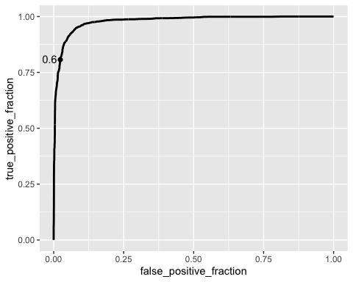

Test ROC Plot

test_ROC <- ggplot(preds_test, aes(m = scores, d = suicide_hvy)) +  
 geom_roc(cutoffs.at = 0.56)  
test_ROC

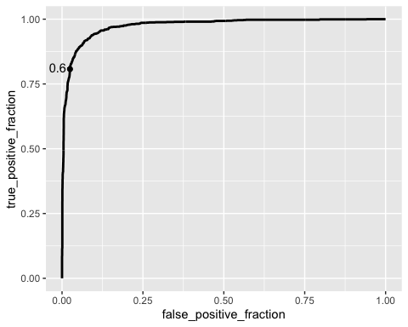

Train AUC score

calc_auc(train_ROC)

## PANEL group AUC  
## 1 1 -1 0.9793738

Test AUC score

calc_auc(test_ROC)

## PANEL group AUC  
## 1 1 -1 0.9753269

Lasso Regression

# estimate Lasso mod   
lasso_mod <- cv.glmnet(suicide_rate_per100000capita ~ .,  
 data = suicide_train,  
 alpha = 1)

# print the coefficients for lambda.min and lambda.1se  
lasso_mod$lambda.min

## [1] 0.0004262016

lasso_mod$lambda.1se

## [1] 0.2615133

# put in a matrix  
coef(lasso_mod, s = lasso_mod$lambda.min)

## 126 x 1 sparse Matrix of class "dgCMatrix"  
## 1  
## (Intercept) 1.207695e+01  
## countryAlbania 1.513081e-01  
## countryAntigua and Barbuda 1.697743e-01  
## countryArgentina -4.158516e-02  
## countryArmenia 4.160886e-01  
## countryAruba -7.471754e-02  
## countryAustralia 1.020548e-01  
## countryAustria -2.311515e-01  
## countryAzerbaijan 8.065446e-01  
## countryBahamas 2.971037e-01  
## countryBahrain 1.945119e-01  
## countryBarbados 1.341155e-01  
## countryBelarus -2.913926e-01  
## countryBelgium -1.785737e-01  
## countryBelize 9.283709e-02  
## countryBosnia and Herzegovina 6.340962e-01  
## countryBrazil 4.811368e-01  
## countryBulgaria -1.576119e-01  
## countryCabo Verde -1.684398e-02  
## countryCanada -2.413033e-01  
## countryChile 7.395549e-02  
## countryColombia 5.501357e-02  
## countryCosta Rica 7.139858e-02  
## countryCroatia -1.697906e-01  
## countryCuba 5.510815e-02  
## countryCyprus 1.982611e-01  
## countryCzech Republic -2.418239e-05  
## countryDenmark -1.051586e-01  
## countryDominica .   
## countryEcuador -3.348537e-02  
## countryEl Salvador 2.282325e-02  
## countryEstonia -2.127385e-01  
## countryFiji 5.132483e-02  
## countryFinland -2.852392e-01  
## countryFrance -1.006398e-02  
## countryGeorgia 4.175708e-01  
## countryGermany 9.193692e-02  
## countryGreece 3.255062e-01  
## countryGrenada 4.342589e-03  
## countryGuatemala 5.824701e-01  
## countryGuyana -3.195884e-01  
## countryHungary -1.281397e-01  
## countryIceland -1.451030e-01  
## countryIreland -8.608972e-02  
## countryIsrael 2.296371e-01  
## countryItaly 8.528164e-01  
## countryJamaica 7.900812e-01  
## countryJapan -1.927329e-01  
## countryKazakhstan -3.574060e-01  
## countryKiribati -3.267309e-01  
## countryKuwait 2.050617e-01  
## countryKyrgyzstan -1.019707e-01  
## countryLatvia -2.632820e-01  
## countryLithuania -4.439189e-01  
## countryLuxembourg -2.594537e-01  
## countryMacau -1.393157e-02  
## countryMaldives .   
## countryMalta 1.674603e-01  
## countryMauritius -1.239141e-01  
## countryMexico 2.421655e-01  
## countryMongolia 1.776256e-01  
## countryMontenegro -7.211020e-02  
## countryNetherlands 1.863523e-01  
## countryNew Zealand -2.368080e-01  
## countryNicaragua 1.641366e-01  
## countryNorway -3.069289e-01  
## countryOman 7.853678e-01  
## countryPanama 1.220322e-01  
## countryParaguay 1.117383e-01  
## countryPhilippines 1.005895e+00  
## countryPoland 2.123938e-02  
## countryPortugal 2.305234e-01  
## countryPuerto Rico 8.313178e-02  
## countryQatar 1.110704e-01  
## countryRepublic of Korea -2.560955e-01  
## countryRomania 5.426856e-02  
## countryRussian Federation -4.201534e-01  
## countrySaint Kitts and Nevis .   
## countrySaint Lucia 4.894627e-02  
## countrySaint Vincent and Grenadines 4.134924e-02  
## countrySan Marino -1.291973e-01  
## countrySerbia -2.771594e-02  
## countrySeychelles 5.716563e-02  
## countrySingapore -2.749324e-01  
## countrySlovakia -4.986695e-03  
## countrySlovenia -2.496408e-01  
## countrySouth Africa 3.723788e+00  
## countrySpain 9.783719e-01  
## countrySri Lanka -4.965826e-01  
## countrySuriname -2.310711e-01  
## countrySweden -1.080137e-01  
## countrySwitzerland -2.560102e-01  
## countryThailand 4.829853e-01  
## countryTrinidad and Tobago -1.707602e-01  
## countryTurkey 4.117741e-01  
## countryTurkmenistan 4.981450e-02  
## countryUkraine -2.570201e-01  
## countryUnited Arab Emirates 2.920608e-01  
## countryUnited Kingdom 1.562196e+00  
## countryUnited States -1.439628e-01  
## countryUruguay -1.598627e-01  
## countryUzbekistan 8.573058e-02  
## year -6.205378e-03  
## sexfemale 4.477017e-01  
## sexmale -7.439698e-14  
## age15-24 years 4.187516e-02  
## age25-34 years .   
## age35-54 years -7.848072e-03  
## age5-14 years 2.120969e+00  
## age55-74 years -8.549733e-05  
## age75+ years -9.362917e-02  
## suicides_no 1.472236e-05  
## population -6.888872e-09  
## suicides.100k.pop 8.551849e-03  
## gdp_for_year.... 2.277274e-17  
## gdp_per_capita.... 4.104069e-06  
## generationBoomers .   
## generationG.I. Generation -1.042099e-01  
## generationGeneration X 6.128764e-02  
## generationGeneration Z -2.691260e-01  
## generationMillenials 6.293651e-02  
## generationSilent -2.845528e-02  
## gdpM .   
## gdpB .   
## pop100000 -4.345678e-05  
## suicide_hvy 7.683397e-01

coef(lasso_mod, s = lasso_mod$lambda.1se)

## 126 x 1 sparse Matrix of class "dgCMatrix"  
## 1  
## (Intercept) 0.2353705  
## countryAlbania .   
## countryAntigua and Barbuda .   
## countryArgentina .   
## countryArmenia .   
## countryAruba .   
## countryAustralia .   
## countryAustria .   
## countryAzerbaijan .   
## countryBahamas .   
## countryBahrain .   
## countryBarbados .   
## countryBelarus .   
## countryBelgium .   
## countryBelize .   
## countryBosnia and Herzegovina .   
## countryBrazil .   
## countryBulgaria .   
## countryCabo Verde .   
## countryCanada .   
## countryChile .   
## countryColombia .   
## countryCosta Rica .   
## countryCroatia .   
## countryCuba .   
## countryCyprus .   
## countryCzech Republic .   
## countryDenmark .   
## countryDominica .   
## countryEcuador .   
## countryEl Salvador .   
## countryEstonia .   
## countryFiji .   
## countryFinland .   
## countryFrance .   
## countryGeorgia .   
## countryGermany .   
## countryGreece .   
## countryGrenada .   
## countryGuatemala .   
## countryGuyana .   
## countryHungary .   
## countryIceland .   
## countryIreland .   
## countryIsrael .   
## countryItaly .   
## countryJamaica .   
## countryJapan .   
## countryKazakhstan .   
## countryKiribati .   
## countryKuwait .   
## countryKyrgyzstan .   
## countryLatvia .   
## countryLithuania .   
## countryLuxembourg .   
## countryMacau .   
## countryMaldives .   
## countryMalta .   
## countryMauritius .   
## countryMexico .   
## countryMongolia .   
## countryMontenegro .   
## countryNetherlands .   
## countryNew Zealand .   
## countryNicaragua .   
## countryNorway .   
## countryOman .   
## countryPanama .   
## countryParaguay .   
## countryPhilippines .   
## countryPoland .   
## countryPortugal .   
## countryPuerto Rico .   
## countryQatar .   
## countryRepublic of Korea .   
## countryRomania .   
## countryRussian Federation .   
## countrySaint Kitts and Nevis .   
## countrySaint Lucia .   
## countrySaint Vincent and Grenadines .   
## countrySan Marino .   
## countrySerbia .   
## countrySeychelles .   
## countrySingapore .   
## countrySlovakia .   
## countrySlovenia .   
## countrySouth Africa 0.7472674  
## countrySpain .   
## countrySri Lanka .   
## countrySuriname .   
## countrySweden .   
## countrySwitzerland .   
## countryThailand .   
## countryTrinidad and Tobago .   
## countryTurkey .   
## countryTurkmenistan .   
## countryUkraine .   
## countryUnited Arab Emirates .   
## countryUnited Kingdom .   
## countryUnited States .   
## countryUruguay .   
## countryUzbekistan .   
## year .   
## sexfemale .   
## sexmale .   
## age15-24 years .   
## age25-34 years .   
## age35-54 years .   
## age5-14 years 1.0332336  
## age55-74 years .   
## age75+ years .   
## suicides_no .   
## population .   
## suicides.100k.pop .   
## gdp_for_year.... .   
## gdp_per_capita.... .   
## generationBoomers .   
## generationG.I. Generation .   
## generationGeneration X .   
## generationGeneration Z .   
## generationMillenials .   
## generationSilent .   
## gdpM .   
## gdpB .   
## pop100000 .   
## suicide_hvy 0.9225455

# plot lasso mse for different values of lambda  
plot(lasso_mod)

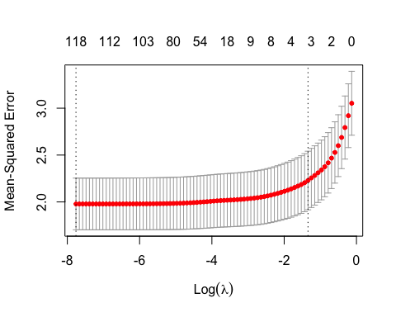

# explore how coefficients   
# change as we change lambda  
coefpath(lasso_mod)