Experiment: 9
Massive MIMO Capacity vs SNR and Gain Using MATLAB
Aim
To analyze the performance of a Massive MIMO system by studying channel capacity, signal-to-noise ratio (SNR), and antenna gain using MATLAB.
Objectives
Objective – 1: Analyze Channel Capacity (bps/Hz)
Analyze the channel capacity of a Massive MIMO system for different signal-to-noise ratio (SNR) values using MATLAB. Observe how channel capacity increases with improving signal quality based on the Shannon capacity principle.
Objective – 2: Compare Signal-to-Noise Ratio (SNR) (dB)
Compare the signal-to-noise ratio for different communication scenarios using MATLAB. Analyze the effect of SNR on the quality and reliability of wireless communication in Massive MIMO systems.
Objective – 3: Analyze Antenna Gain (dB)
Analyze the antenna gain achieved by varying the number of antenna elements in a Massive MIMO system using MATLAB. Observe how increasing the antenna array size improves directional gain and enhances communication performance.

Software Required
• MATLAB

Theory
Massive MIMO employs a large number of antennas at the base station to simultaneously serve multiple users. The increased spatial diversity and beamforming capability significantly improve channel capacity, signal quality, and antenna gain. Channel capacity is influenced by the signalto-noise ratio (SNR), while antenna gain increases with the number of antenna elements. These parameters are fundamental to achieving the high throughput and spectral efficiency required in 5G and beyond wireless communication systems.
Objective – 1 Plot of Channel Capacity (bps/Hz) versus SNR (dB).
MATLAB Code:
clc;
clear;
close all;

% SNR range (dB)
snr = 0:5:30;

% Convert SNR from dB to linear scale
snr_linear = 10.^(snr/10);

% Shannon channel capacity
capacity = log2(1 + snr_linear);

figure;

% Plot Channel Capacity vs SNR
plot(snr, capacity, '-o', 'LineWidth', 2, 'MarkerSize', 6);

grid on;

xlabel('SNR (dB)');
ylabel('Channel Capacity (bps/Hz)');
title('192512102 Channel Capacity vs SNR');

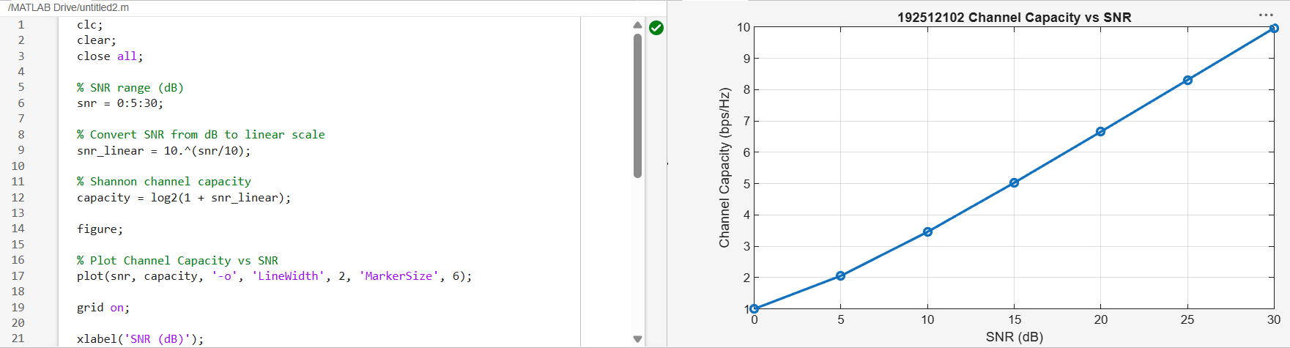

Objective – 2 Bar graph comparing SNR values under different communication scenarios.
Analyze the channel capacity of a Massive MIMO system for different signal-to-noise ratio (SNR) values using MATLAB. Observe how channel capacity increases with improving signal quality based on the Shannon capacity principle.
clc;
clear;
close all;

% SNR range (dB)
snr = 0:5:30;

% Convert SNR from dB to linear scale
snr_linear = 10.^(snr/10);

% Channel capacity using Shannon's formula
capacity = log2(1 + snr_linear);

figure;

% Plot Channel Capacity vs SNR
plot(snr, capacity, '-o', 'LineWidth', 2, 'MarkerSize', 6);

grid on;

xlabel('SNR (dB)');
ylabel('Channel Capacity (bps/Hz)');
title('192512102 Channel Capacity vs SNR');

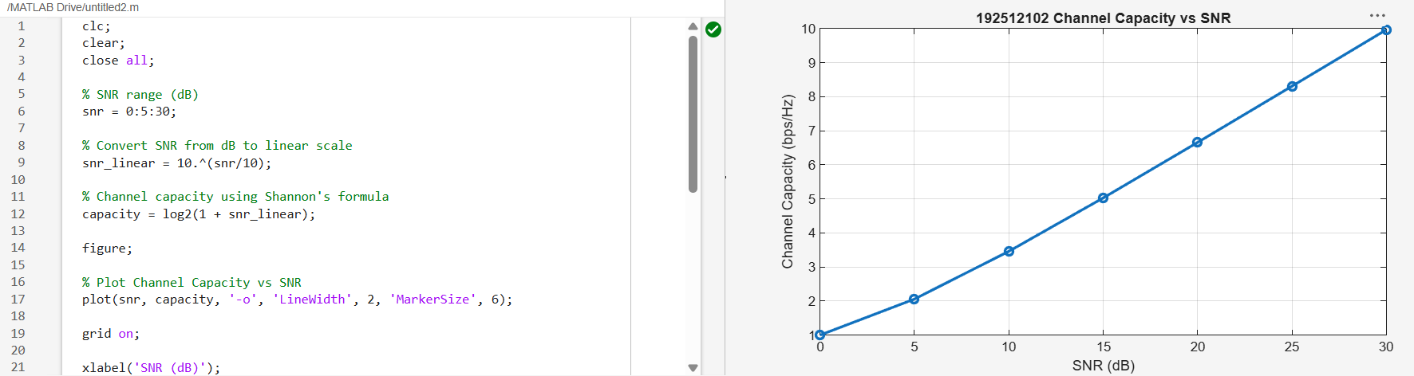
Objective – 3 Bar graph showing Antenna Gain for different antenna array sizes.
clc;
clear;
close all;

% Number of Antenna Elements
antennas = [4 8 16 32 64];

% Antenna Gain (dB)
gain = 10 * log10(antennas);

figure;

% Bar graph
bar(antennas, gain);

grid on;

xlabel('Number of Antenna Elements');
ylabel('Antenna Gain (dB)');
title('Antenna Gain for Different Antenna Array Sizes');

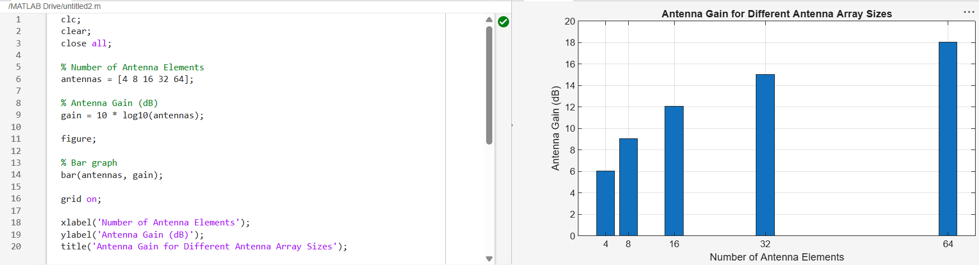
Result
The MATLAB analysis successfully demonstrated the relationship between channel capacity, signal-to-noise ratio, and antenna gain in a Massive MIMO system. The results showed that higher SNR and larger antenna arrays improve communication performance by increasing channel capacity and directional gain.
Discussion
Massive MIMO technology significantly enhances wireless communication performance by using a large number of antenna elements at the base station to improve channel capacity, signal-tonoise ratio (SNR), and antenna gain. The MATLAB analysis clearly demonstrates how these parameters interact to improve overall system efficiency in modern 5G networks.
From the results, it is observed that channel capacity increases logarithmically with SNR, following the Shannon capacity principle. As SNR improves, the system is able to support higher data rates per unit bandwidth, thereby increasing spectral efficiency. This highlights the importance of maintaining a high-quality signal environment in Massive MIMO systems.
It is also observed that SNR plays a critical role in determining communication performance. Higher SNR values indicate reduced noise impact and improved signal reliability, which directly contributes to better link quality and reduced error rates in wireless transmission.
Further, antenna gain increases with the number of antenna elements in the array. This improvement is due to the constructive combination of signals in the desired direction, which strengthens the received signal and enhances coverage. This makes Massive MIMO highly effective for dense urban and high-capacity 5G deployments.

