10.5G Network Slicing Environment Using MATLAB
Aim
To analyze the performance of a 5G Network Slicing environment by studying the number of network slices, slice utilization, and end-to-end latency using MATLAB.
Objectives
Objective – 1: Analyze the Number of Network Slices
Analyze the creation and allocation of multiple network slices in a 5G network using MATLAB. Observe how different slices can be configured to support diverse service requirements and applications.
Objective – 2: Compare Slice Utilization (%)
Compare the utilization of different network slices using MATLAB. Analyze how efficiently network resources are allocated and utilized across multiple slices.
Objective – 3: Analyze End-to-End Latency (ms)
Analyze the end-to-end latency of different network slices using MATLAB. Compare the latency values to understand the Quality of Service (QoS) requirements of various 5G applications.
Software Required
• MATLAB
Theory
Network slicing is a key feature of 5G that enables a single physical network infrastructure to be partitioned into multiple logical networks called slices. Each slice is optimized for a specific service category, such as enhanced Mobile Broadband (eMBB), Ultra-Reliable Low-Latency Communications (URLLC), or massive Machine-Type Communications (mMTC). By dynamically allocating network resources, network slicing improves flexibility, resource utilization, and Quality of Service (QoS) while supporting diverse application requirements.
Objective – 1
Analyze the Number of Network Slices
Generate and visualize multiple network slices using MATLAB. Observe how a 5G network can be logically partitioned into independent slices for different communication services.
clc;
clear;
close all;

% Network slice types
slices = {'eMBB', 'URLLC', 'mMTC', 'Private', 'IoT'};

% One instance of each network slice
count = [1 1 1 1 1];

figure;

% Bar graph
bar(count);

grid on;

% X-axis settings
set(gca, 'XTick', 1:5);
set(gca, 'XTickLabel', slices);

xlabel('Network Slice Type');
ylabel('Number of Network Slices');
title('Number of Configured 5G Network Slices');

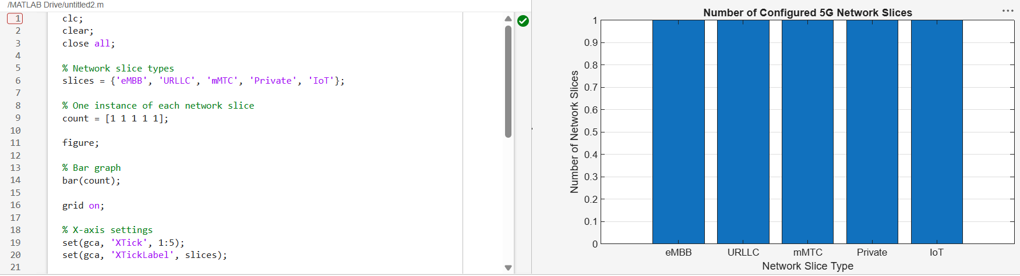

Objective – 2
Compare Slice Utilization (%)
Analyze the utilization percentage of different network slices using MATLAB. Compare the resource usage of each slice to evaluate network efficiency.
clc;
clear;
close all;

% Network slice types
slices = categorical({'eMBB', 'URLLC', 'mMTC', 'Private', 'IoT'});

% Slice utilization (%)
utilization = [85 70 60 75 50];

figure;

% Bar graph
bar(slices, utilization);

grid on;

xlabel('Network Slice Type');
ylabel('Slice Utilization (%)');

title('192512102 Slice Utilization in 5G Network Slicing');

ylim([0 100]);

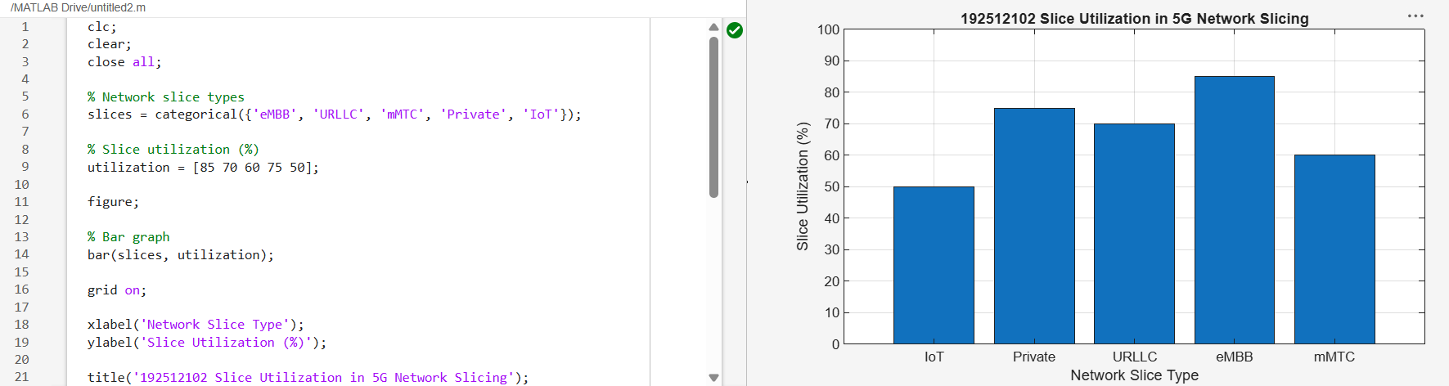
Objective – 3
Analyze End-to-End Latency (ms)
Compare the end-to-end latency of different network slices using MATLAB. Observe how latency varies depending on the service requirements of each slice.
clc;
clear;
close all;

% Network slice numbers
slices = [1 2 3 4 5];

% End-to-End Latency (ms)
latency = [25 5 40 15 60];

figure;

% Plot latency
plot(slices, latency, '-o', 'LineWidth', 2, 'MarkerSize', 8);

grid on;

% X-axis settings
xticks(slices);
xticklabels({'eMBB', 'URLLC', 'mMTC', 'Private', 'IoT'});

xlabel('Network Slice Type');
ylabel('End-to-End Latency (ms)');

title('192512102 5G Network Slicing: End-to-End Latency');

ylim([0 70]);

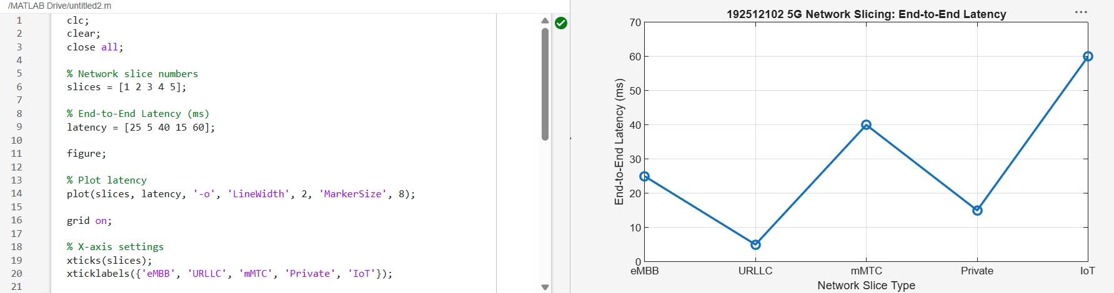
Result
The MATLAB analysis successfully demonstrated the characteristics of a 5G Network Slicing environment. The results showed that multiple network slices can coexist while exhibiting different utilization levels and latency characteristics based on their intended services.

