Experiment: 7
Analog Beamforming Analysis Using MATLAB
Aim
To analyze the performance of analog beamforming by studying beamforming gain, beam width, and main lobe direction using MATLAB.
Objectives
- To analyze the beamforming gain achieved by varying the number of antenna elements in an analog beamforming system using MATLAB.
- To compare the beam width of an antenna array for different beamforming configurations using MATLAB.
- To analyze the main lobe direction by steering the antenna array beam to different angles using MATLAB.
Software Required
• MATLAB
Theory
Analog beamforming is a beam steering technique in which a single RF chain drives multiple antenna elements through adjustable phase shifters. By controlling the phase of the transmitted or received signals, the antenna array forms a directional beam toward the intended user, thereby improving signal strength, coverage, and spectral efficiency. Analog beamforming is widely employed in millimeter-wave (mmWave) communication systems due to its reduced hardware complexity and lower power consumption.
Objective – 1
Analyze Beamforming Gain (dB)
Generate beamforming gain values for different antenna array sizes using MATLAB. Compare how increasing the number of antenna elements improves the beamforming gain and enhances signal strength.
clc;
clear;
close all;

% Number of Antenna Elements
antennas = [2 4 8 16 32];

% Beamforming Gain (dB)
gain = 10 * log10(antennas);

figure;

% Bar graph
bar(antennas, gain);

grid on;

xlabel('Number of Antenna Elements');
ylabel('Beamforming Gain (dB)');
title('192512102 Beamforming Gain for Different Antenna Array Sizes');

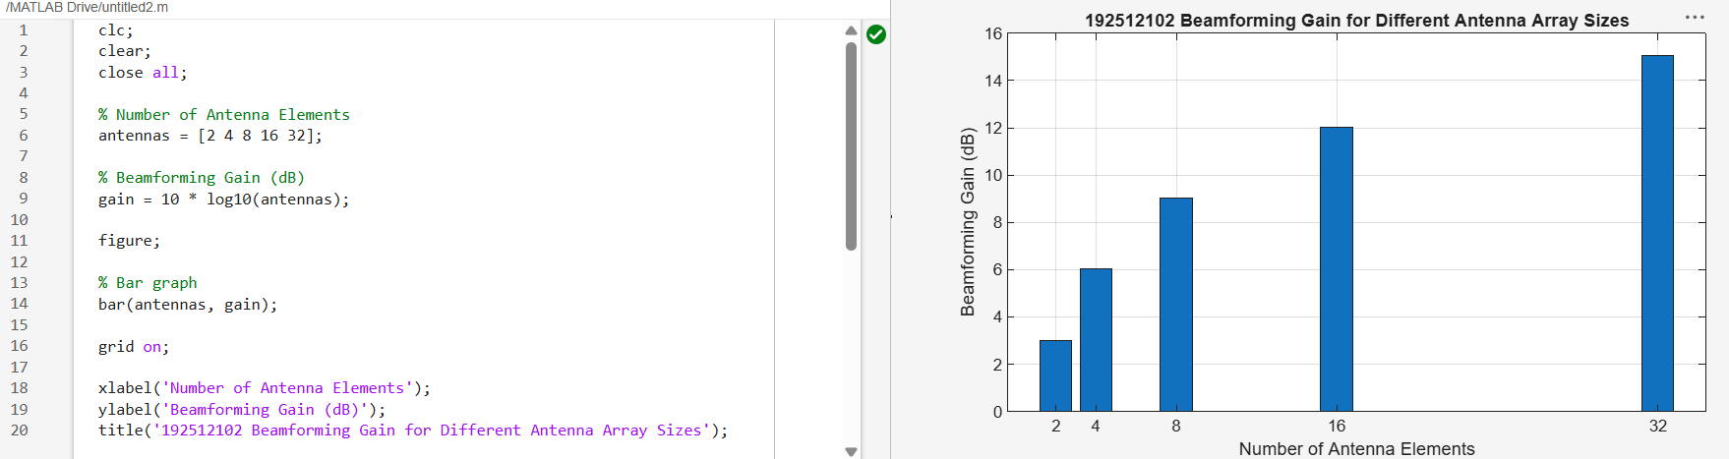
Objective – 2
Compare Beam Width (Degrees)
Analyze the beam width corresponding to different antenna array sizes using MATLAB. Observe how increasing the number of antenna elements results in a narrower beam, thereby improving spatial resolution.
clc;
clear;
close all;

% Number of Antenna Elements
antennas = [2 4 8 16 32];

% Beam Width (degrees)
beamwidth = [90 45 22.5 11.25 5.625];

figure;

% Plot beam width
plot(antennas, beamwidth, 'o-', 'LineWidth', 2);

grid on;

xlabel('Number of Antenna Elements');
ylabel('Beam Width (Degrees)');
title('192512102 Beam Width for Different Antenna Array Sizes');

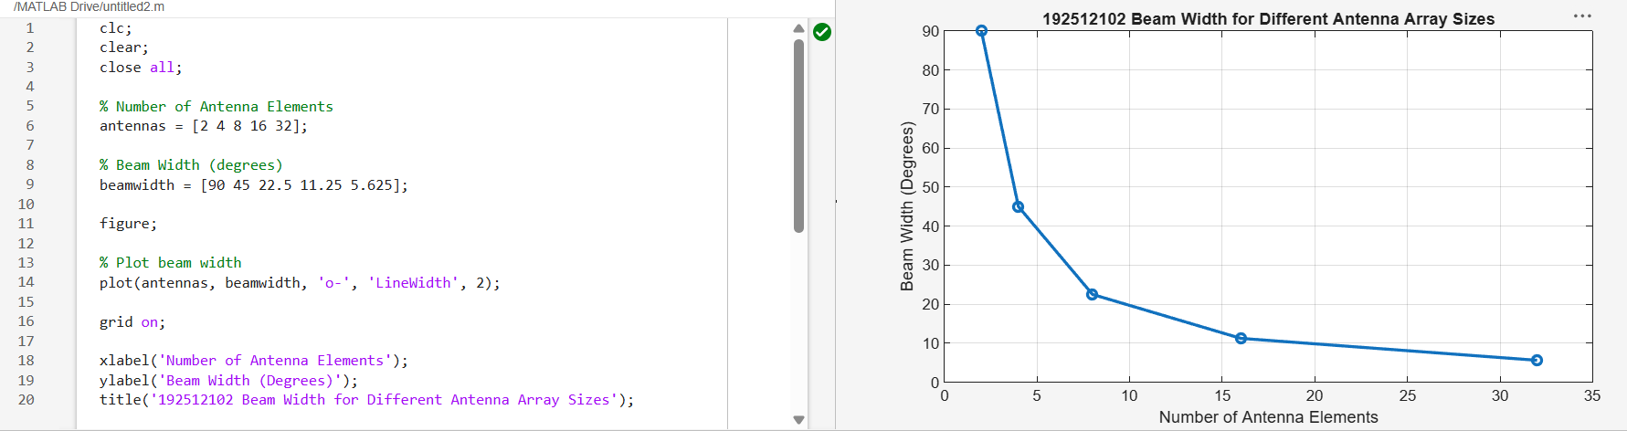
Objective – 3
Analyze Main Lobe Direction (Degrees)
Simulate beam steering by varying the steering angle of the antenna array using MATLAB. Observe the change in the main lobe direction and understand how analog beamforming directs energy toward the intended user.
clc;
clear;
close all;

% Main Lobe Direction (degrees)
theta = [-60 -30 0 30 60];

% Constant normalized gain
gain = [1 1 1 1 1];

figure;

% Polar plot
polarplot(deg2rad(theta), gain, 'o', 'LineWidth', 2);

title('192512102 Main Lobe Direction in Analog Beamforming');

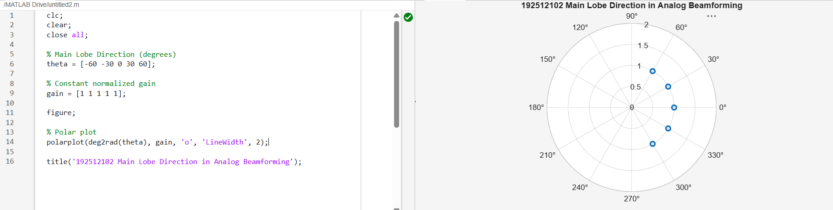
Result
The MATLAB analysis successfully demonstrated the characteristics of analog beamforming. The results showed that increasing the number of antenna elements improves beamforming gain and reduces beam width, while phase adjustment enables the main lobe to be steered toward different directions.
Discussion:
Analog beamforming plays a key role in 5G mmWave communication by enabling directional transmission using antenna arrays with phase shifters. The MATLAB analysis demonstrates how beamforming performance varies with antenna array configuration and steering of the transmitted signal.
From the results, it is observed that the beamforming gain increases with the number of antenna elements. This is because more antenna elements allow constructive combination of signals in the desired direction, leading to improved signal strength and coverage.
It is also observed that increasing the number of antenna elements results in a narrower beam width. A reduced beam width improves spatial resolution and reduces interference from unwanted directions, thereby enhancing communication reliability and system efficiency.
Further, the main lobe direction analysis shows that the beam can be steered toward different angles by adjusting the phase of antenna elements. This beam steering capability enables efficient targeting of users in different spatial locations, which is essential for modern 5G beam management techniques.

