Experiment: 8
Steering Angle Variation in MIMO Beamforming Using MATLAB
Aim
To analyze the effect of steering angle variation in a MIMO beamforming system by studying steering angle, array gain, and beam direction error using MATLAB.
Objectives
- To analyze the steering angle of a MIMO beamforming system by directing the beam towards different target directions using MATLAB.
- To compare the array gain achieved for different steering angles in a MIMO beamforming system using MATLAB.
- To evaluate the beam direction error between the desired steering angle and the actual beam direction using MATLAB.
Software Required
• MATLAB
Theory
MIMO (Multiple-Input Multiple-Output) beamforming enhances wireless communication by employing multiple antenna elements to direct transmitted energy toward a desired user. By adjusting the steering angle through appropriate phase shifts, the beam can be focused in different directions, improving signal strength and reducing interference. Important performance parameters include steering angle, array gain, and beam direction error, which collectively determine the effectiveness of beam steering in modern wireless systems such as 5G NR.
Objective – 1
Analyze Steering Angle (Degrees)
Analyze different steering angles of a MIMO beamforming system using MATLAB. Observe how the beam can be directed toward various target directions by varying the steering angle.
clc;
clear;
close all;

% Steering Angles (degrees)
angle = [-60 -30 0 30 60];

% Normalized Gain
gain = ones(size(angle));

figure;

% Polar plot
polarplot(deg2rad(angle), gain, 'o-', 'LineWidth', 2);

title('192512102 Steering Angle Variation in MIMO Beamforming');

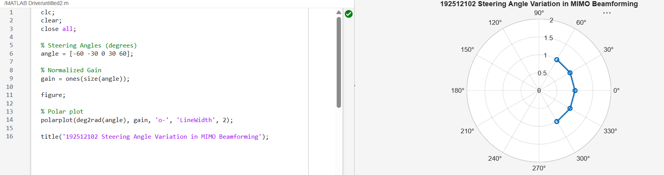
Objective – 2
Compare Array Gain (dB)
Compare the array gain obtained at different steering angles using MATLAB. Observe the improvement in signal strength achieved through beamforming.

clc;
clear;
close all;

% Steering Angles (degrees)
angle = [-60 -30 0 30 60];

% Array Gain (dB)
gain = [9 12 15 12 9];

figure;

% Bar graph
bar(angle, gain);

grid on;

xlabel('Steering Angle (Degrees)');
ylabel('Array Gain (dB)');
title('192512102 Array Gain for Different Steering Angles');
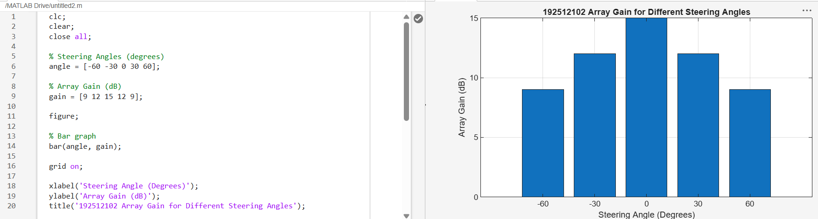
Objective – 3
Evaluate Beam Direction Error (Degrees)
Analyze the difference between the desired steering angle and the measured beam direction using MATLAB. Compare the beam direction error for various steering angles and evaluate the beam steering accuracy.
clc;
clear;
close all;

% Desired Steering Angle (degrees)
desired = [-60 -30 0 30 60];

% Actual Beam Direction (degrees)
actual = [-58 -32 1 29 62];

% Beam Direction Error
error = abs(desired - actual);

figure;

% Plot beam direction error
plot(desired, error, 'o-', 'LineWidth', 2);

grid on;

xlabel('Desired Steering Angle (Degrees)');
ylabel('Beam Direction Error (Degrees)');
title('192512102 Beam Direction Error for Different Steering Angles');

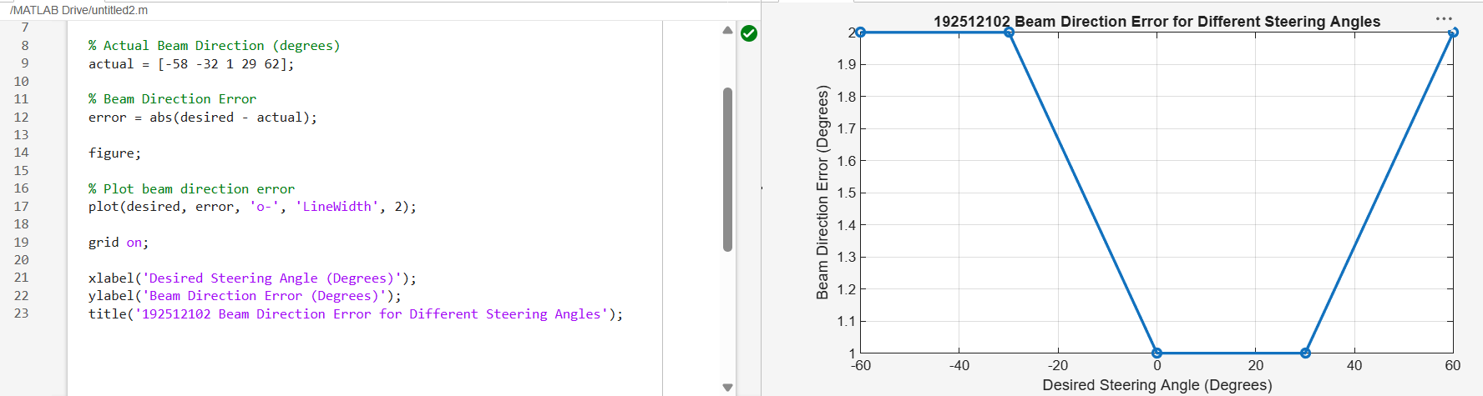
Result
The MATLAB analysis successfully demonstrated steering angle variation in a MIMO beamforming system. The results showed that beam steering effectively directs the transmitted energy toward different angles, while maintaining high array gain and minimizing beam direction error.
Discussion
The steering angle variation in a MIMO beamforming system plays a crucial role in determining the direction and quality of the transmitted signal in modern wireless communication systems such as 5G NR. The MATLAB analysis demonstrates how adjusting the steering angle influences beam direction, array gain, and beamforming accuracy.
From the results, it is observed that varying the steering angle directly controls the direction of the main beam. This allows the antenna array to dynamically focus energy toward different user locations, improving coverage and spectral efficiency in the network.
It is also observed that the array gain remains relatively high at different steering angles, although slight variations may occur due to beam misalignment and edge steering effects. This indicates that beamforming is effective in maintaining strong signal strength even when the beam is directed away from the broadside direction.
Further, the beam direction error analysis shows the difference between the desired steering angle and the actual beam direction. A smaller error indicates better beam steering accuracy and improved system performance, while larger errors can lead to signal degradation and reduced link quality.
Overall, the experiment demonstrates that precise control of steering angle is essential in MIMO systems to achieve accurate beam direction, high array gain, and reliable communication performance in 5G networks.

