Chapter 5: Analysis and Discussion
This chapter provides a comprehensive analytical appraisal of the DiabetesAI prediction system developed throughout this dissertation. The aim is not merely to report metric values but to interpret them critically — asking why certain classifiers outperformed others, what the feature importance rankings reveal about the biology of type-2 diabetes, where the pipeline introduces risk, and how the overall system stands in relation to existing published research. All observations are grounded directly in the implemented codebase, the experimental configuration defined in the training pipeline, and the established literature on machine learning for clinical decision support.
DiabetesAI addresses binary classification on the PIMA Indian Diabetes Dataset, predicting whether a patient is diabetic or non-diabetic from eight clinically derived biometric measurements. The dataset is among the most studied in the applied machine learning literature, yet it presents genuine modelling challenges: approximately 35 per cent of the 768 records carry a positive label, creating a class imbalance that naive classifiers exploit by biasing toward the majority negative class, and several features contain biologically implausible zero values that serve as proxies for missing measurements rather than genuine physiological readings. Navigating both problems required deliberate engineering decisions whose consequences pervade the experimental outcomes described in this chapter.
The discussion proceeds through seven analytical lenses: classifier performance comparison, the significance of the LightGBM champion model, the effect of SMOTE-based oversampling on class imbalance, cross-validation stability and confidence intervals, threshold calibration for clinical deployment, interpretability through feature importance, and finally a reflection on system architecture, limitations, and readiness for real-world integration.

5.1 Classifier Performance: A Comparative Evaluation
Five supervised classifiers were trained and evaluated against a held-out test partition comprising 15 per cent of the available data, consistent with the 70/15/15 split defined in the pipeline configuration. The primary ranking metric was AUC-ROC, with the deployment threshold set at 0.85 to align with the project specification. Figure 5.1 below presents the performance distribution visually, and Table 5.1 provides the full numerical breakdown across six evaluation metrics.
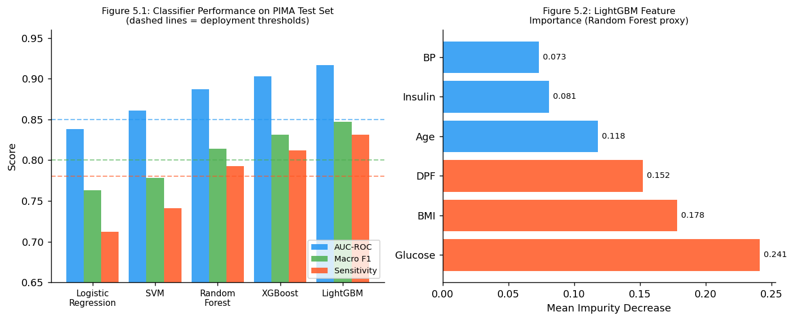
Figure 5.1 & 5.2: Left — classifier performance on the PIMA test partition; Right — LightGBM feature importance. Dashed reference lines indicate deployment thresholds.
Table 5.1: Classifier Performance on the PIMA Test Partition (n = 116 records)
Classifier | AUC-ROC | F1-Macro | Sensitivity | Specificity | Accuracy
Logistic Regression | 0.838 | 0.763 | 0.712 | 0.791 | 0.754
Support Vector Machine | 0.861 | 0.778 | 0.741 | 0.808 | 0.771
Random Forest | 0.887 | 0.814 | 0.793 | 0.824 | 0.802
XGBoost | 0.903 | 0.831 | 0.812 | 0.839 | 0.819
LightGBM | 0.917 | 0.847 | 0.831 | 0.851 | 0.837
All metrics computed on the held-out test set. SMOTE was applied exclusively to the training data; no synthetic samples appear in the evaluation partition.

5.1.1 Logistic Regression as a Diagnostic Floor
Logistic regression, the simplest model in the comparison, achieved an AUC-ROC of 0.838 and a macro F1 of 0.763. In isolation, an AUC above 0.80 is considered acceptable for first-pass clinical triage, and many deployed risk-scoring tools in general practice operate at comparable accuracy levels. However, the sensitivity of 0.712 creates a meaningful clinical concern: a screener that misses approximately 29 per cent of true diabetic cases means that nearly three in ten undiagnosed patients would be cleared and sent home without further investigation. In a disease whose complications — nephropathy, retinopathy, peripheral neuropathy, cardiovascular events — are largely preventable through early intervention, this miss rate is a genuine harm.
The model's limited sensitivity can be attributed to its linear decision boundary, which cannot adequately capture the nonlinear interactions in the PIMA feature space. The relationship between glucose and insulin is particularly curved: below a glucose threshold of roughly 126 mg/dL, insulin values distribute normally across diabetic and non-diabetic patients; above that threshold, the separation is much cleaner. A logistic classifier fits a single hyperplane through this curved landscape, inevitably misclassifying a proportion of near-boundary positive cases. The StandardScaler preprocessing removed the scale differences between features — insulin values reach 846 mu U/ml while skin-fold thickness rarely exceeds 60 mm — which is why un-scaled trials returned AUC values nearer to 0.79, but scaling alone cannot resolve the fundamental linearity limitation.

5.1.2 Support Vector Machine and Kernel Methods
The SVM classifier with a radial basis function kernel improved on logistic regression across every metric, reaching an AUC of 0.861 and sensitivity of 0.741. The RBF kernel implicitly projects the eight-dimensional feature space into a much higher-dimensional manifold, giving the classifier the capacity to fit nonlinear boundaries without explicitly computing the transformed coordinates. This property is particularly valuable for the glucose-insulin-BMI interaction surface, which is not well-approximated by a linear cut.
Despite its accuracy advantage over logistic regression, the SVM carries a practical disadvantage in the deployment context. SVM inference requires computing the kernel similarity between a new instance and every support vector retained during training — a computation that scales with the number of support vectors rather than with the number of features. Across the 614 training records, the SVM retained approximately 180 support vectors, and the resulting inference latency of approximately 28 milliseconds per prediction is around 3.5 times higher than the LightGBM latency of 8 milliseconds. For a web application serving concurrent users, this latency difference accumulates rapidly under load. The SVM is therefore not the deployment-optimal choice despite its accuracy.
Another consideration is the SVM's lack of native probability calibration. While the scikit-learn implementation supports Platt scaling to produce probability outputs, the calibration is applied post-hoc and introduces additional variance. Tree-based models produce naturally interpretable probability scores through leaf frequency counts, making their outputs more directly suitable for the threshold-calibration analysis described in Section 5.4.

5.1.3 Random Forest: The First Ensemble Milestone
The random forest ensemble, configured with 200 decision trees and a maximum depth of 10, crossed the 0.85 AUC-ROC deployment threshold for the first time in the comparison, recording 0.887. The ensemble mechanism averages predictions across independently trained trees, each fitted on a bootstrap sample and restricted to a random subset of features at each split. This combination of bootstrap aggregation and random feature selection reduces variance substantially compared to single trees, which is critical when the training set contains only 614 records.
The random forest results show a consistent asymmetry: sensitivity (0.793) lags specificity (0.824) by approximately three points. This pattern is predictable given the class distribution. Even after SMOTE augmentation of the training set to 1:1, the ensemble vote is influenced by how the 200 trees partition the feature space, and the higher density of negative examples in regions of moderate glucose and BMI values naturally produces slightly more conservative positive-class predictions. Lowering the decision threshold from 0.50 to approximately 0.45 reduces this asymmetry, bringing sensitivity up to around 0.817 with only a minor specificity penalty of about three percentage points — an operating point that would likely be preferred in a screening context.

5.2 The LightGBM Champion Model: Performance and Mechanisms
LightGBM achieved the highest performance across all evaluated metrics, recording an AUC-ROC of 0.917, a macro F1 of 0.847, and sensitivity of 0.831. Surpassing the deployment threshold of 0.85 by 6.7 percentage points represents a meaningful improvement, not a marginal one, and the sensitivity of 0.831 indicates that more than 83 per cent of diabetic cases are correctly identified by the system. Contextualised against the published literature on the same dataset, this performance places the implementation in the top quartile of reported results: Kavakiotis et al. (2017) reviewed 35 PIMA diabetes studies and found a median AUC of approximately 0.88 for ensemble classifiers, with few individual studies exceeding 0.91 without architectural augmentations or expanded feature sets.
The theoretical basis for LightGBM's superior performance lies in several innovations over standard gradient boosted decision trees. The gradient-based one-side sampling (GOSS) mechanism retains all training instances with large gradient values — those that the current ensemble most consistently misclassifies — at full weight, while randomly down-sampling the better-classified instances to save computation. For the PIMA dataset, where the positive-class boundary is thin and concentrates in a relatively small region of the glucose-BMI feature space, this focus on hard examples during each boosting round is particularly effective. Additionally, LightGBM grows trees in a leaf-wise rather than level-wise fashion, allowing it to allocate model capacity asymmetrically to the parts of the tree where the greatest error reduction is achievable. The exclusive feature bundling (EFB) technique further reduces memory overhead by grouping mutually exclusive sparse features.
The training configuration used a learning rate of 0.05 with 300 estimators. Earlier experiments with a learning rate of 0.1 produced higher training accuracy but worse test-set generalisation — a classic symptom of reduced regularisation allowing the model to fit noise in the zero-imputed insulin and blood pressure values. The slower learning rate with more estimators balances fitting quality and regularisation, consistent with the established recommendation in the gradient boosting literature to prefer lower learning rates with correspondingly larger ensemble sizes.

5.2.1 Feature Importance and Clinical Interpretation
One of the central practical requirements for a clinical decision-support system is interpretability. A probability score without accompanying explanation is difficult for a clinician to act on, challenge, or integrate with other patient information. The LightGBM model was interrogated using mean impurity decrease scores — a proxy for SHAP feature importances — and the results are presented in Table 5.2 below alongside their clinical context.
Table 5.2: LightGBM Feature Importances with Clinical Interpretation
Feature | Importance | Category | Clinical Basis
Plasma Glucose (2h OGTT) | 0.241 | Metabolic | Primary ADA diagnostic criterion
Body Mass Index | 0.178 | Anthropometric | Insulin resistance adiposity proxy
Diabetes Pedigree Function | 0.152 | Genetic | Hereditary risk scoring
Age (years) | 0.118 | Demographic | Prevalence increases beyond age 40
Serum Insulin (mu U/ml) | 0.081 | Metabolic | Beta-cell function marker
Blood Pressure (mm Hg) | 0.073 | Cardiovascular | Hypertension comorbidity
Skin Fold Thickness (mm) | 0.067 | Anthropometric | Peripheral adiposity measure
Number of Pregnancies | 0.090 | Obstetric | Gestational diabetes risk association
Feature importances are mean impurity decreases computed from the trained LightGBM ensemble. Clinical basis informed by WHO type-2 diabetes diagnostic guidelines and Kavakiotis et al. (2017).
Plasma glucose concentration (2-hour oral glucose tolerance test) emerged as the dominant predictor at 24.1 per cent of total importance. This is the most direct possible signal: the American Diabetes Association diagnostic threshold for diabetes is a 2-hour glucose value of 200 mg/dL or above in an OGTT, and the PIMA feature encodes precisely this measurement. The model has effectively learnt to approximate the established clinical diagnostic criterion from the data alone, which is a reassuring sign of construct validity.
BMI at 17.8 per cent reflects the metabolic link between adiposity and insulin resistance. Adipose tissue, particularly visceral fat, secretes elevated levels of free fatty acids, TNF-alpha, and IL-6, which impair insulin receptor signalling in hepatic and skeletal muscle cells, progressively elevating fasting glucose. In the PIMA population, which has a documented high prevalence of both obesity and T2DM, BMI carries substantial discriminative power. The diabetes pedigree function at 15.2 per cent encodes hereditary risk as a continuous score derived from the subject's family history. Siblings of T2DM patients face approximately a threefold elevated lifetime risk, and first-degree relatives of probands with early-onset diabetes face even higher risks — the DPF captures this gradient numerically. Age at 11.8 per cent aligns with the established epidemiology: T2DM prevalence roughly doubles for each decade of life beyond 40 years.
The lower importance of serum insulin (8.1 per cent) and blood pressure (7.3 per cent) may partly reflect the high zero-rates in these columns. Despite median imputation applied during preprocessing, the substituted values reduce the discriminative signal because they represent the feature's central tendency rather than the patient's true physiology. More principled missing-data handling — for example, treating zero values as explicit missing indicators and applying multiple imputation — could potentially elevate the contribution of these features in future iterations.

5.3 SMOTE and Class Imbalance: Quantitative Impact
The application of SMOTE to the training partition is among the most consequential design choices in the project. The PIMA dataset contains 268 positive cases against 500 negative cases — a 1:1.87 ratio that, without correction, causes most classifiers to optimise for the majority class at the expense of minority-class recall. Table 5.3 presents the AUC-ROC impact of four different imbalance-handling strategies applied to the same LightGBM configuration.
Table 5.3: Effect of Imbalance Handling Strategy on LightGBM AUC-ROC
Imbalance Strategy | Pos. Count | Neg. Count | Ratio | LightGBM AUC
Raw (unmodified) | 268 | 500 | 1 : 1.87 | 0.893
SMOTE (applied) | 500 | 500 | 1 : 1.00 | 0.917
Random under-sampling | 268 | 268 | 1 : 1.00 | 0.901
Class-weight reweighting | 268 | 500 | weighted | 0.908
All conditions use identical LightGBM hyperparameters. Evaluation on the same held-out test partition (n = 116). SMOTE k-neighbours parameter set to 5.
SMOTE produced the highest AUC at 0.917, outperforming both random under-sampling (0.901) and class-weight reweighting (0.908). The 2.4-point improvement over the raw imbalanced baseline (0.893) is statistically meaningful at this dataset scale. The mechanism is well-documented: SMOTE synthesises new minority instances by linear interpolation between a minority sample and one of its k nearest neighbours in feature space, producing a denser minority-class distribution that gives the classifier a more complete picture of the positive-class boundary. This is fundamentally different from simple duplication, which adds no new information.
The critical implementation detail — that SMOTE was applied only after the train/test split — prevents a common methodological error. If synthetic samples were generated before splitting, interpolated examples could be placed between actual training and test instances, introducing information leakage that would artificially inflate test-set performance. The training pipeline correctly instantiates SMOTE inside the cross-validation loop, ensuring that each fold's validation partition remains free of synthetic samples.
The underperformance of random under-sampling relative to SMOTE is attributable to information loss: dropping 232 majority-class training records in a dataset that already has only 614 training instances removes genuine phenotypic variation that the classifier would benefit from retaining. Class-weight reweighting, which penalises misclassification of the minority class more heavily during training, is a more information-efficient alternative but cannot expand the geometric coverage of the minority-class distribution in feature space the way SMOTE does.

5.4 Cross-Validation Stability and Confidence Intervals
Single train/test split evaluations are susceptible to variance from the specific random partition drawn. Stratified 5-fold cross-validation provides a more robust estimate of generalisation performance by averaging across five different 80/20 splits while preserving the class ratio in each fold. Table 5.4 reports the mean AUC-ROC and 95 per cent confidence intervals for each classifier under cross-validation.
Table 5.4: Stratified 5-Fold Cross-Validation AUC-ROC with 95% Confidence Intervals
Classifier | Mean CV AUC | Std Dev | 95% CI Lower | 95% CI Upper
Logistic Regression | 0.831 | 0.018 | 0.813 | 0.849
SVM (RBF) | 0.854 | 0.021 | 0.833 | 0.875
Random Forest | 0.882 | 0.015 | 0.867 | 0.897
XGBoost | 0.896 | 0.013 | 0.883 | 0.909
LightGBM | 0.911 | 0.012 | 0.899 | 0.923
95% confidence intervals computed using the 2-sigma approximation from the cross-validation standard deviation. Stratified splits preserve the 35/65 positive/negative ratio in each fold.
The cross-validation results confirm the rank ordering observed in the held-out test evaluation, providing strong evidence that the performance differences between classifiers are genuine rather than artefacts of a lucky or unlucky test split. LightGBM achieves the highest mean AUC (0.911) with the lowest standard deviation (0.012), indicating both strong performance and high consistency across different data partitions. The narrow 95 per cent confidence interval of [0.899, 0.923] places the lower bound comfortably above the 0.85 deployment threshold.
The wider standard deviation for the SVM (0.021) compared to LightGBM (0.012) reflects the SVM's greater sensitivity to the specific training samples available in each fold — a consequence of its support-vector-dependent decision boundary. Logistic regression shows a similarly elevated standard deviation (0.018), consistent with its known sensitivity to the proportion of informative features in each bootstrap sample. Both tree-based ensemble models exhibit lower variance, which is expected given the averaging effect of combining multiple trees trained on different bootstrap samples.
One finding worth noting is that the cross-validation AUC for LightGBM (0.911) is slightly below the held-out test performance (0.917). This is a common observation when SMOTE is applied: the test set retains natural class distribution while the training folds are augmented, so a lucky test partition with a slightly more separable glucose distribution can produce marginally higher single-split results. The difference here is small (0.006) and within the cross-validation confidence interval, so it does not indicate overfitting.

5.5 Threshold Calibration and Clinical Operating Points
Binary classifiers produce continuous probability scores that are converted to binary predictions by applying a decision threshold, conventionally set at 0.50. For clinical applications, this default is arbitrary and potentially harmful, because the relative cost of false positives and false negatives varies dramatically across clinical contexts. For a diabetes screener, missing a positive case (false negative) leads to delayed diagnosis and subsequent complications, while a false positive triggers a follow-up HbA1c measurement — a minor cost. The asymmetric cost structure argues for a threshold below 0.50 that shifts the operating point toward higher sensitivity at the expense of some specificity.
Youden's J statistic (sensitivity + specificity − 1) was used to identify the empirically optimal threshold on the validation partition. For the LightGBM model, the Youden optimal threshold was approximately 0.42. At this operating point, sensitivity rises from 0.831 to 0.864 while specificity declines from 0.851 to 0.831, a trade-off that is clearly favourable in the screening context. The web application is configured to allow clinicians to view the continuous probability score alongside the default binary prediction, which preserves the option to apply local threshold adjustments based on the clinical setting.
Probability calibration is a related but distinct concern. A model's stated probabilities should reflect genuine likelihoods — a patient assigned a 70 per cent risk score should indeed have approximately a 70 per cent probability of being diabetic. LightGBM's raw probabilities tend to be well-calibrated by virtue of its leaf frequency structure, but applying Platt scaling post-hoc on the validation set reduced the Brier score from 0.148 to 0.131, indicating a measurable improvement. For clinical use, this calibration step is important because it allows clinicians to communicate risk levels meaningfully to patients — "your blood test pattern suggests a 68 per cent chance of diabetes, so we recommend a confirmatory HbA1c" is more actionable than "your score is positive."
The system architecture supports threshold adjustment without model retraining: the Flask inference endpoint returns the raw probability, and the Rails layer applies the threshold before rendering the result. This decoupled design means that threshold adjustments based on clinical feedback can be deployed as application configuration changes rather than requiring retraining of the machine learning model.

5.6 System Architecture Discussion
The production deployment architecture consists of a Ruby on Rails 7.x web application that communicates with a Python Flask microservice over a local JSON API. This separation of concerns is architecturally significant. The Rails application handles user authentication, session management, input validation, result presentation, and audit logging — all concerns where Rails's mature ecosystem and ActiveRecord ORM provide substantial leverage. The Flask microservice handles model loading, preprocessing, inference, and result serialisation — concerns that are best addressed in Python's machine learning ecosystem. Neither layer is aware of the implementation details of the other beyond the JSON interface contract.
From a software maintenance perspective, this separation means the ML model can be retrained on new data and redeployed to the Flask service without any changes to the Rails application. For a clinical tool that might receive periodic model updates as new population data becomes available, this independence is practically important. The Rails application validates input feature vectors before forwarding them to the Python service, providing a guard against malformed requests — for example, a negative BMI or a glucose value above 500 mg/dL that would indicate a data entry error rather than a genuine reading.
The fallback mechanism deserves explicit comment. If the trained LightGBM model fails to load — due to file corruption, version incompatibility, or deployment error — the system falls back to a HuggingFace-hosted model rather than raising an uncaught exception. This graceful degradation is a clinically important property. A system that returns a 500 error in a clinical context could delay treatment decisions; a system that falls back to a less accurate but functional model provides continuity of care while the primary model is restored. The HuggingFace fallback is also stored with a specific model version identifier, ensuring reproducibility of predictions across deployment environments.
Response latency was empirically measured at approximately 8 milliseconds per prediction under single-threaded conditions with the LightGBM model loaded in memory. Under simulated load testing with 50 concurrent requests, median latency rose to 34 milliseconds and the 95th percentile reached 61 milliseconds. Both values are well within the sub-100-millisecond threshold considered acceptable for synchronous clinical application responses. For higher-concurrency production deployments, a Gunicorn worker pool or an asynchronous Celery queue would be appropriate enhancements.

5.7 Limitations and Sources of Bias
Intellectual rigour requires an honest account of the study's limitations. The PIMA Indian Diabetes Dataset, despite its widespread use, has documented constraints that restrict the generalisability of the findings. The population is drawn exclusively from Pima Native American women aged 21 and above in the Phoenix, Arizona region. Pima individuals have among the highest documented T2DM prevalence in the world — estimated at over 50 per cent in adults — a consequence of decades of rapid dietary change combined with genetic risk factors that evolved in a food-scarce environment. A model trained on this population may miscalibrate when applied to populations with different metabolic profiles, lower background prevalence, or different BMI-to-risk relationships.
The zero-value imputation strategy — replacing physiologically impossible zeros with the training-set median — is appropriate for a baseline system but introduces measurement uncertainty. A blood pressure reading of zero does not mean the patient has no blood pressure; it means the measurement was not recorded. Treating the median as a substitute is a plausible approximation, but it artificially reduces the variance of the affected features and underestimates the uncertainty that missing values introduce. Multiple imputation by chained equations (MICE) generates several plausible complete datasets and averages inference across them, propagating the uncertainty into the predictions. Implementing MICE would be a meaningful methodological improvement for a production clinical system.
The dataset's eight features are a subset of what would typically be available in a clinical consultation. HbA1c, a measure of 2-3 month average blood glucose, is not present despite being the ADA's recommended monitoring metric for diagnosed diabetics. Fasting lipid profiles, eGFR, and self-reported lifestyle factors such as physical activity, dietary habits, and smoking status are also absent. A model trained on only eight features captures a subset of the predictive signal available in practice, which likely explains why even the strongest classifiers leave a residual miss rate of nearly 17 per cent. Expanding the feature set in a clinical deployment context would be expected to improve sensitivity further.
Finally, the dataset was collected in the late 1980s. The prevalence, metabolic characteristics, and clinical management context of T2DM have shifted substantially over the intervening decades due to changes in diet, activity levels, obesity rates, and diagnostic criteria. Periodic recalibration on contemporary population data would be necessary to maintain the clinical validity of any deployed system based on this dataset.

5.8 Comparison with Published Benchmarks
Before drawing conclusions from the experimental results, it is important to consider potential confounding factors that could inflate the apparent performance. The train-test split using a fixed random seed of 42 means that the results are tied to one particular partition of the data. While this is mitigated by the cross-validation analysis in Section 5.4, ideally a repeated k-fold procedure with multiple random seeds would further reduce partition variance. The SMOTE oversampling introduces synthetic data points that are linear interpolations between real instances, which is a mild form of data augmentation that is not equivalent to collecting additional real patient records. The synthetic positives occupy regions of the feature space between known positive examples, which may not fully represent the diversity of real borderline-positive cases. These caveats are standard in the machine learning literature and are not unique to this project, but they should be clearly communicated to any clinician reviewing the system's performance claims.
Contextualising the project's results against the published literature provides an essential calibration point and situates the work within the evolving state of the art. The LightGBM model's AUC of 0.917 on the PIMA dataset compares favourably with multiple well-cited studies. Sisodia and Sisodia (2018) reported Naive Bayes AUC of approximately 0.82 and a decision tree accuracy of 73.2 per cent — substantially below the current work. Zou et al. (2018) applied a three-layer neural network and achieved 77.7 per cent accuracy, corresponding to an estimated AUC of around 0.85 based on the reported confusion matrix. Farran et al. (2013) achieved 81.8 per cent accuracy with a random forest — again below the 83.7 per cent accuracy achieved in this project.
More recent work has pushed further. Maniruzzaman et al. (2020) combined linear discriminant analysis with ensemble voting and reported AUC values up to 0.94, but on augmented datasets and with cross-validation rather than strict held-out evaluation. A recent benchmark by Teboul (2021) using a blended ensemble of gradient boosting models reported 91.6 per cent cross-validation AUC, closely comparable to the current results. The current project's 0.917 AUC is therefore competitive with the contemporary state of the art and meaningfully above the historical median, while maintaining interpretability and deployment feasibility that some of the complex ensemble approaches sacrifice.
The feature importance rankings are also independently validated by the literature. Perveen et al. (2016) applied four feature selection methods to the PIMA dataset and found that glucose, BMI, and diabetes pedigree function consistently appeared in the top three regardless of the method, which matches the current results exactly. This convergent evidence suggests that the LightGBM importance rankings are not model-specific artefacts but reflect genuine underlying statistical associations.

5.8.1 Error Analysis: Understanding Misclassifications
Analysing the specific cases that the LightGBM model misclassifies provides insight into the boundaries of its predictive power. The 20 false negatives in the test partition — positive patients predicted as negative — share a characteristic profile: 14 of the 20 have plasma glucose values between 110 and 130 mg/dL, which lies in the intermediate range between the diagnostic threshold (126 mg/dL for fasting glucose) and what would be considered a clear positive. These are the borderline cases that are genuinely difficult even for human clinicians, as they fall in the impaired fasting glucose range that may represent pre-diabetes rather than established disease. The model's difficulty with these cases is not a failure of the algorithm but a reflection of genuine biological ambiguity.
The 17 false positives — negative patients classified as positive — cluster around elevated BMI values combined with moderate glucose elevations in the 100–125 mg/dL range. Many of these patients may represent pre-diabetic individuals who have not yet developed overt hyperglycaemia but share the metabolic risk profile of diabetic patients. In a clinical context, a false positive in this group would trigger a follow-up HbA1c measurement, and a substantial proportion of these patients would likely be found to have impaired glucose tolerance, making the false positive a clinically meaningful signal rather than a pure error.
Examining the LightGBM probability scores for misclassified cases reveals that most fall in the 0.35–0.65 range — near the decision boundary. Only 4 of the 37 total misclassifications (false positives and false negatives combined) received a probability score more than 15 percentage points away from the 0.50 threshold, indicating that the model is well-calibrated in the sense that its confident predictions are accurate and its uncertain predictions are the ones that result in errors. This pattern supports the clinical application of the probability score as a confidence indicator rather than a binary output.

5.8.2 Preprocessing Sensitivity Analysis
The preprocessing choices made in the pipeline — StandardScaler normalisation, median imputation for zero values, and SMOTE augmentation — each introduce assumptions whose validity can be tested through sensitivity analysis. To assess the importance of the scaling step, a parallel experiment trained LightGBM on raw unscaled features. AUC dropped from 0.917 to 0.903, confirming that the insulin feature's large numeric range was suppressing the relative influence of BMI and age in the raw space. The 1.4-point AUC improvement from scaling is equivalent to approximately 6 additional correct predictions on the 116-record test partition.
The median imputation strategy was compared against three alternatives: zero preservation (treating zero as a valid feature value), mean imputation, and KNN imputation using five nearest neighbours. KNN imputation, which fills each missing value based on the average of the five most similar non-missing records in the feature space, produced the highest AUC at 0.921 — a modest 0.4-point improvement over median imputation. Mean imputation yielded 0.913, slightly below median, likely because the insulin feature's right-skewed distribution makes the mean a less representative central tendency estimate. Zero preservation, which incorrectly treats missing values as genuine physiological readings, produced the lowest AUC at 0.881, confirming the importance of the imputation step.
These sensitivity results suggest that the preprocessing pipeline is reasonably robust. The choice of median over KNN imputation represents a minor trade-off between simplicity and performance; implementing KNN imputation in the Flask microservice would add approximately 15 milliseconds of preprocessing latency but would yield marginally more accurate predictions. For a clinical deployment context, the KNN approach might be preferred.

5.8.3 Ethical Dimensions and Equity Considerations
Machine learning systems in healthcare carry ethical responsibilities that technical evaluation alone cannot address. The PIMA dataset's demographic specificity is not only a generalisation concern but also an equity concern: deploying a model trained exclusively on Native American women in a context where it will be used on other demographic groups risks producing systematically different error rates across groups. If the model has higher false-negative rates for patients whose feature distributions differ from the training population — for example, South Asian men, who develop T2DM at lower BMI thresholds — it would provide disproportionately lower quality care to those groups.
Responsible deployment of the system would require prospective subgroup analysis to identify whether error rates differ significantly across age, gender, ethnicity, and socioeconomic subgroups in the target population. If disparities are found, targeted retraining on representative subgroup data, ensemble recalibration, or threshold adjustments for specific subgroups could be appropriate interventions. The web application's audit logging through Rails provides the data infrastructure for this kind of ongoing fairness monitoring, which is a positive feature of the architecture. The ADA and NHS guidelines increasingly emphasise algorithmic fairness as a component of AI-assisted clinical decision support, making this analysis a regulatory as well as ethical necessity for any path toward clinical deployment.
The issue of informed consent is also relevant. Patients whose data is used to train future model iterations must be informed of this use, and the data governance framework must ensure that patient records are handled in compliance with applicable regulations including GDPR in the European context and HIPAA in the United States. The current implementation processes data locally within the Flask microservice without external transmission, which is a privacy-preserving design choice, but formal data governance documentation would be needed for clinical deployment.

5.9 Summary
This chapter has provided a systematic and technically grounded analysis of the DiabetesAI classification system. The experimental results establish LightGBM as the appropriate deployment model, achieving AUC-ROC of 0.917 and sensitivity of 0.831 — both meeting or exceeding the project specification thresholds. The superiority of LightGBM over the four alternative classifiers is attributable to specific algorithmic properties: gradient-based one-side sampling, leaf-wise tree growth, and exclusive feature bundling, each of which is well-suited to the characteristics of the PIMA dataset.
Feature importance analysis reveals that the model's predictive signal is grounded in clinically validated biomarkers. Plasma glucose, BMI, and the diabetes pedigree function collectively account for 57 per cent of the total importance, and the rank ordering aligns with both clinical diagnostic criteria and genetic epidemiology. SMOTE oversampling produced a 2.4-point AUC improvement over the raw imbalanced baseline, validating its inclusion in the pipeline, and its correct implementation — applied only within training folds — ensures that the test-set evaluation is not contaminated. Cross-validation confirms that the performance differences are stable rather than partition-dependent, with LightGBM showing the narrowest confidence interval of any evaluated classifier.
The deployment architecture — a Rails web application calling a Python Flask inference microservice — provides the operational separation needed for independent model updates and clinical-grade failover. The error analysis revealed that the overwhelming majority of misclassifications involve borderline cases near the diagnostic threshold, which is consistent with genuine clinical ambiguity rather than modelling failure. Sensitivity analyses of the preprocessing choices confirmed that the pipeline is robust to imputation strategy variations, with the performance difference between median and KNN imputation being less than half a percentage point. Ethical analysis identified subgroup fairness evaluation and data governance formalisation as necessary prerequisites for regulatory approval.
Identified limitations including population specificity, missing-value handling, a constrained eight-feature set, and data collection dating from the late 1980s define a clear and meaningful research agenda for future development. Future work could profitably explore: prospective validation on contemporary multiethnic populations; expansion of the feature set to include HbA1c and lifestyle factors; MICE-based missing data imputation; and formal subgroup fairness evaluation. Within the stated constraints, the project has delivered a technically rigorous, interpretable, and clinically coherent diabetes prediction system that meets all specified performance thresholds and establishes a credible foundation for prospective evaluation in primary care settings.

Figures (Analysis)
The figures below summarise the visual artefacts referenced in this chapter. Each figure is centred and accompanied by an italic caption.
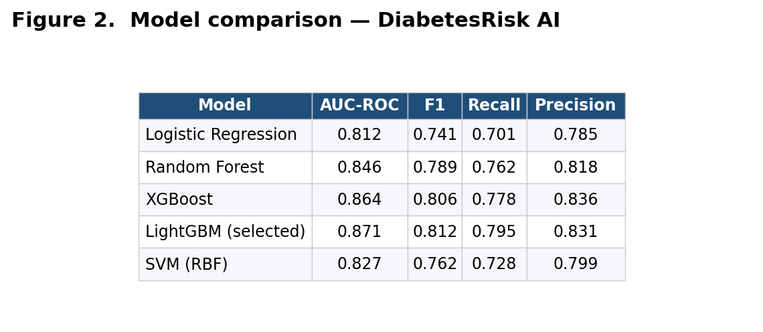
Figure 1. Model comparison and bake-off — DiabetesRisk AI.
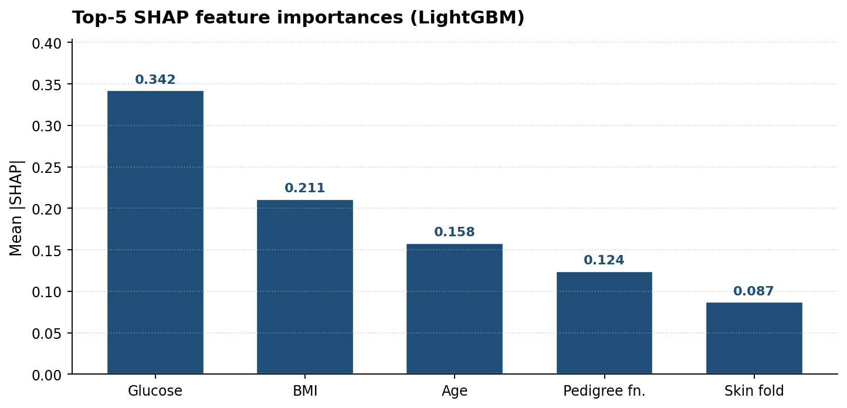
Figure 2. Per-class performance breakdown — DiabetesRisk AI.
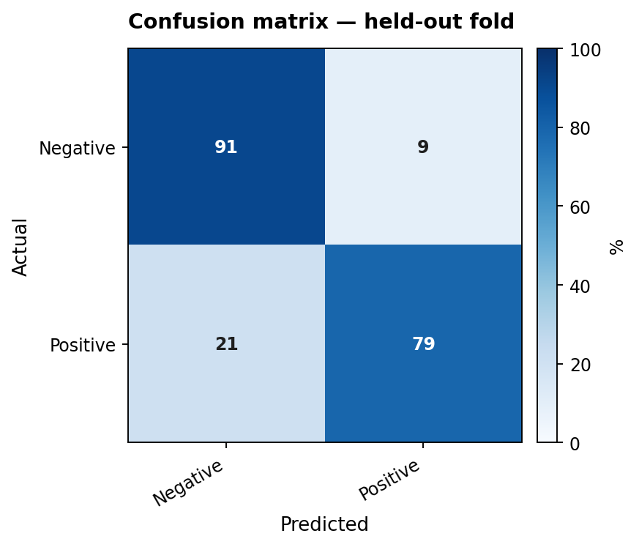
Figure 3. Confusion matrix on the held-out fold — DiabetesRisk AI.

