UNIVERSITY OF EAST LONDON
School of Architecture, Computing & Engineering
Diabetes Risk Predictor Using Machine Learning and Clinical Data
Student Name: Md Aariz
Student ID: U2871441
Programme: MSc in Big Data Technologies
Supervisor: Dr Mohamed Chahine Ghanem
Module Code: CN7000
Year: 2025/26 | Term 3

Abstract
Diabetes mellitus is a chronic metabolic disease whose early detection materially improves patient outcomes. This dissertation presents DiabetesRisk AI, an end-to-end, interpretable, and web-deployable diabetes-risk prediction system built on the PIMA Indian Diabetes Dataset (768 records, eight clinical features). The work compares five supervised classifiers — Logistic Regression, Support Vector Machine, Random Forest, XGBoost, and LightGBM — under a unified evaluation protocol that combines an 85/15 stratified train/test split with stratified five-fold cross-validation. Biologically implausible zero values were median-imputed, features were standardised, and class imbalance on the training partition was addressed with SMOTE applied strictly post-split.
LightGBM was selected as the production classifier, achieving AUC-ROC 0.917, accuracy 85.2%, macro F1 0.847, and diabetic-class sensitivity 0.831 on the held-out test partition, outperforming XGBoost (AUC 0.903), Random Forest (0.887), SVM (0.861), and Logistic Regression (0.838). SMOTE delivered a measurable lift over class-weight reweighting and random under-sampling (0.917 vs. 0.908 vs. 0.901 AUC). SHAP-based explanations consistently identified glucose (24.1%) and BMI (17.8%) as the dominant predictors, aligning with established clinical risk factors. The system was containerised with Docker and deployed as a Flask micro-service behind a Ruby on Rails 7 web frontend, delivering approximately 8 ms per-prediction latency. The contribution is a reproducible, interpretable, and operationally deployable diabetes-risk pipeline that satisfies stated AUC-ROC ≥ 0.85, F1 ≥ 0.80, and recall ≥ 0.78 deployment thresholds.
Keywords: Diabetes risk prediction; PIMA Indian Diabetes Dataset; LightGBM; SMOTE; SHAP explainability; clinical decision support

Table of Contents
Right-click and choose 'Update Field' to populate the table of contents.

Chapter 1: Introduction

1.1 Background
Diabetes mellitus is one of the most significant chronic diseases confronting global public health in the twenty-first century. According to the eleventh edition of the International Diabetes Federation (IDF) Diabetes Atlas, published in 2024, approximately 589 million adults aged 20 to 79 years worldwide are currently living with diabetes, representing 11.11 per cent of the global adult population (IDF, 2024). This figure is projected to rise to 853 million, or 12.96 per cent of the adult population, by 2050, confirming diabetes as one of the fastest-growing global health emergencies of our time. The disease was responsible for an estimated 3.4 million deaths in 2024 alone, with a death occurring every nine seconds attributable to diabetes-related causes, alongside global health expenditure exceeding one trillion United States dollars, a 338 per cent increase over the preceding seventeen years (IDF, 2024).
Type 2 diabetes mellitus (T2DM) constitutes approximately 90 to 95 per cent of all diabetes cases and is characterised by insulin resistance and progressive pancreatic beta-cell dysfunction. It is strongly associated with modifiable risk factors including obesity, physical inactivity, poor diet, and advancing age, as well as non-modifiable factors such as genetic predisposition and ethnicity. A particularly concerning dimension of the global burden is that a substantial proportion of those living with diabetes remain undiagnosed. The IDF estimates that nearly half of all adults with diabetes worldwide are unaware of their condition, meaning that millions of individuals are progressing towards serious complications including cardiovascular disease, chronic kidney disease, diabetic neuropathy, retinopathy, and lower limb amputations without receiving timely clinical intervention (IDF, 2024).
The challenge of early and accurate diabetes diagnosis is therefore of paramount clinical importance. Conventional screening relies on threshold-based criteria such as fasting plasma glucose, the oral glucose tolerance test, and glycated haemoglobin (HbA1c) levels, which require laboratory testing and specialist interpretation. While these methods remain the clinical gold standard, they are resource-intensive, inconsistently applied across healthcare settings, and poorly suited to the large-scale population screening required to identify at-risk individuals before physiological damage becomes irreversible. The application of machine learning and data-driven approaches to clinical decision support therefore represents a compelling opportunity to augment and accelerate early diabetes risk detection in ways that complement existing clinical pathways.
Over the past decade, machine learning has emerged as a powerful paradigm for medical classification and risk stratification tasks. Supervised classification algorithms, including Logistic Regression, Random Forest, Support Vector Machines, and gradient boosting frameworks such as XGBoost and LightGBM, have demonstrated strong predictive performance on structured clinical datasets. The Pima Indians Diabetes Dataset, originally compiled by the National Institute of Diabetes and Digestive and Kidney Diseases (NIDDK) and widely distributed through the UCI Machine Learning Repository, has served as a canonical benchmark for diabetes prediction research since the late 1980s (Dua and Graff, 2019). Comprising 768 records of adult female patients of Pima Indian heritage, each characterised by eight clinical features and a binary diabetes outcome label, this dataset has been the subject of hundreds of published studies spanning multiple decades and algorithmic generations.
Despite the volume of research conducted on this dataset, a critical gap persists between research-grade model development and clinically deployable, interpretable decision support. The vast majority of published studies report model performance metrics in isolation, without providing an accessible, production-ready application that clinicians or patients could directly use. Moreover, fewer than 20 per cent of reviewed studies in the field incorporate any form of model explainability, despite growing evidence that the opacity of machine learning predictions represents a significant barrier to clinical adoption and trust (Rosenbacke et al., 2024). The integration of Shapley Additive Explanations (SHAP) into clinical machine learning workflows has emerged as a promising approach for bridging this gap, providing per-prediction, patient-level explanations of which clinical features most influenced a given risk classification.
This dissertation addresses these limitations by developing an end-to-end, interpretable, and web-deployable diabetes risk prediction system. The proposed system integrates rigorous data preprocessing, comparative evaluation of five classification algorithms under standardised conditions, SMOTE-based class imbalance correction, SHAP-driven explainability, and deployment as a containerised Flask web application accessible to clinicians and end users. The project is anchored in the Pima Indians Diabetes Dataset and is designed to demonstrate that high predictive performance, clinical interpretability, and practical deployability can be achieved simultaneously within the constraints of a publicly available, freely accessible dataset.

1.2 Problem Statement
Despite decades of clinical research and the proliferation of machine learning applications in healthcare, diabetes continues to be chronically under-diagnosed until significant physiological harm has already occurred. The current clinical screening paradigm is characterised by three fundamental weaknesses: inconsistency, poor scalability, and limited interpretability.
First, threshold-based screening methods depend heavily on individual clinician judgment, access to laboratory infrastructure, and regular patient engagement with healthcare services. These preconditions are unevenly distributed across socioeconomic and geographic contexts, resulting in significant disparities in early detection rates between resource-rich and resource-constrained settings. Second, existing methods are poorly scalable to the population-level screening programmes required to identify the growing proportion of individuals living with undiagnosed prediabetes or early-stage diabetes. Third, even where machine learning models have been developed for diabetes prediction, their adoption in clinical practice has been hampered by the opacity of their decision processes, preventing clinicians from exercising informed professional judgement when considering model outputs.
On the benchmark Pima Indians Diabetes Dataset, naive threshold-based methods consistently achieve classification accuracy in the range of 76 to 78 per cent, with macro F1-scores below 0.70 for the minority diabetic class. This reflects a critical decision-support gap: high false-negative rates delay intervention for at-risk patients, while high false-positive rates impose unnecessary clinical burden and patient anxiety. Furthermore, no openly available, interpretable, end-to-end web-deployable tool currently addresses this gap by combining ensemble learning with SHAP-based per-prediction clinical explainability in a containerised, production-ready application. This project is directly motivated by that bottleneck.

1.3 Research Aim, Objectives, and Questions
The overarching aim of this research is to design, develop, evaluate, and deploy an interpretable machine learning system for diabetes risk classification that is grounded in rigorous comparative evaluation, addresses class imbalance through validated resampling strategies, and provides per-prediction clinical explainability through SHAP-based feature attribution.
The specific research objectives are as follows:
- To acquire, clean, and validate the Pima Indians Diabetes Dataset, addressing biologically implausible zero values through median imputation and conducting thorough exploratory data analysis.
- To implement and compare SMOTE oversampling and class-weighting strategies for handling the observed class imbalance, confirming the statistical robustness of each approach.
- To train, cross-validate, and hyperparameter-optimise five classification algorithms — Logistic Regression, Random Forest, XGBoost, LightGBM, and Support Vector Machine — under standardised experimental conditions.
- To benchmark model performance using accuracy, precision, recall, F1-score, and AUC-ROC, producing a comparative evaluation report against the Logistic Regression baseline.
- To integrate SHAP-based per-prediction feature attribution into the web interface, validating alignment of dominant SHAP features with established clinical diabetes risk factors.
- To containerise the full application using Docker and deploy it on cloud infrastructure, achieving sub-second inference latency under concurrent user load.
These objectives are operationalised through the following research questions:
- RQ1: Which machine learning algorithm (Logistic Regression, Random Forest, XGBoost, LightGBM, or SVM) achieves the highest F1-score and AUC-ROC for diabetes risk classification on the Pima Indians Diabetes Dataset after class-imbalance correction?
- RQ2: To what extent does SMOTE-based oversampling improve minority-class recall compared to class-weighting alone?
- RQ3: How accurately and consistently can SHAP values identify the dominant clinical predictors of diabetes risk, and do they align with established medical evidence on key risk factors such as glucose, BMI, and age?
- RQ4: Is it feasible to deploy a real-time, clinician-facing diabetes risk tool as a containerised web application with sub-second inference latency?

1.4 Scope of the Study
This study focuses exclusively on supervised binary classification for diabetes risk prediction using structured, tabular clinical data. The primary dataset is the Pima Indians Diabetes Dataset, comprising 768 records of adult female patients of Pima Indian heritage. The study does not collect original patient data and does not involve clinical trial participants, direct patient contact, or real-time integration with any electronic health record system.
The five classification algorithms examined are: Logistic Regression, Random Forest, XGBoost, LightGBM, and Support Vector Machine. Deep learning approaches such as convolutional or recurrent neural networks are excluded from the primary comparative evaluation, though their applicability to future work is acknowledged. The explainability component is implemented using SHAP TreeExplainer, which is directly optimised for tree-based and ensemble models. LIME-based explanations, while acknowledged in the literature, fall outside the scope of this implementation.
The deployment target is a web-based application accessible via standard browser interfaces. Mobile application development, integration with NHS digital infrastructure, and clinical validation through prospective patient trials are outside the scope of this dissertation but are identified as clear directions for future work. All performance evaluation is conducted on the held-out test set derived from the Pima dataset; no external validation against a second independent dataset is attempted within this project.

1.5 Significance of the Study
The significance of this research operates across academic, clinical, and societal dimensions. Academically, this project contributes a rigorous, reproducible comparative evaluation of five classification algorithms under standardised class-imbalance correction and hyperparameter optimisation conditions. The open-source GitHub release of code, Jupyter notebooks, and Docker configuration is intended to support replication and extension by the research community. Most existing studies in the diabetes prediction literature report performance for a single algorithm without providing a deployable artefact; this project fills that gap.
From a clinical and practical standpoint, the deployable web application provides an accessible proof-of-concept for AI-assisted diabetes screening in resource-constrained settings. By integrating SHAP-based explanations, the system directly addresses the primary barrier to clinical AI adoption — clinician distrust of opaque model outputs — and demonstrates a template for building transparent, accountable medical decision-support tools. Internationally, early detection of diabetes at the prediabetic stage has been shown to reduce the risk of developing T2DM by up to 58 per cent through targeted lifestyle interventions (Diabetes Prevention Program Research Group, 2002). A scalable, interpretable screening tool therefore has potential to generate substantial long-term population health benefits and reduce the healthcare cost burden associated with late-stage diabetes complications.
In the United Kingdom specifically, the NHS Long Term Plan has identified the early identification of individuals at the prediabetic stage as a priority target. The proof-of-concept developed in this project, if extended to a broader and more representative dataset, could provide a direct blueprint for integration into NHS digital health pathways and community-based screening programmes.

1.6 Dissertation Structure
The remainder of this dissertation is structured across five further chapters. Chapter 2 presents the literature review, surveying the global burden of diabetes, the evolution of machine learning for diabetes prediction, the role of ensemble methods and class imbalance handling, and the emerging importance of explainable AI in clinical decision support. Chapter 3 describes the methodology, covering research design, data acquisition and preprocessing, feature engineering, algorithm selection, hyperparameter optimisation, evaluation metrics, and the deployment pipeline. Chapter 4 reports the experimental results, presenting comparative model performance metrics, SHAP feature importance visualisations, and system latency measurements. Chapter 5 provides the conclusion and outlines directions for future work, including potential extensions to broader datasets and NHS-compatible deployment pathways.

Chapter 2: Literature Review

2.1 Introduction
This chapter provides a structured critical review of the literature underpinning the development of a machine learning system for diabetes risk prediction. The review is organised across six thematic areas: the global epidemiology of diabetes and its implications for automated screening; the history and characteristics of the Pima Indians Diabetes Dataset; supervised machine learning approaches applied to diabetes classification; class imbalance handling techniques in medical datasets; explainable artificial intelligence and its clinical relevance; and current limitations and research gaps in the field. The literature search was conducted using Google Scholar, IEEE Xplore, PubMed, and arXiv, with search terms including “diabetes prediction machine learning”, “Pima Indians Diabetes Dataset classification”, “XGBoost clinical tabular data”, “SMOTE class imbalance medical”, “SHAP explainability clinical AI”, and “interpretable machine learning healthcare”. Publications from 2015 onwards were prioritised, with seminal earlier works included where foundational.

2.2 Global Epidemiology of Diabetes and the Case for Automated Screening
The scale of the global diabetes epidemic provides the foundational justification for this research project. As reported in the eleventh edition of the International Diabetes Federation Diabetes Atlas, diabetes affected an estimated 589 million adults worldwide in 2024, corresponding to 11.11 per cent of the global adult population aged 20 to 79 years (IDF, 2024). Projections to 2050 forecast this number will rise to 853 million people, driven primarily by population ageing and rapid urbanisation in low- and middle-income countries, which are expected to account for 95 per cent of the incremental increase in absolute numbers (IDF, 2024). The countries with the greatest absolute numbers of people living with diabetes in 2024 were China, India, and the United States, while the highest age-standardised prevalence rates were recorded in Pakistan, the Marshall Islands, and Kuwait.
The United Kingdom faces its own significant diabetes burden. NHS England estimates that approximately 4.4 million people in England have been diagnosed with diabetes, with a further estimated 850,000 undiagnosed cases and 5 to 7 million people living with prediabetes. The NHS Long Term Plan explicitly prioritises improving the proportion of T2DM cases identified at the prediabetic stage, recognising that targeted lifestyle interventions at this stage can reduce the risk of progression to full T2DM by as much as 58 per cent (Diabetes Prevention Programme Research Group, 2002; NHS England, 2019). Against this backdrop, scalable, automated approaches to diabetes risk screening carry substantial public health relevance.
A particularly acute dimension of the epidemiological challenge is the problem of undiagnosed diabetes. The IDF estimates that approximately 44.7 per cent of adults with diabetes globally are unaware of their condition (IDF, 2024). This high proportion of undiagnosed cases reflects structural barriers including limited access to healthcare, low symptom awareness, and the absence of population-level screening infrastructure in many settings. Machine learning-based risk prediction tools, deployable via accessible web interfaces without requiring specialist laboratory infrastructure, have been proposed as a means of extending the reach of diabetes screening beyond conventional clinical pathways (Shuvo et al., 2023; Chang et al., 2023).
The economic consequences of diabetes at a global level are also severe. The IDF reports that diabetes-related health expenditure exceeded one trillion United States dollars in 2024, a 338 per cent increase over the preceding seventeen years. These costs are concentrated disproportionately in high-income countries, though the rapid growth in prevalence in lower-income settings suggests a widening economic burden that health systems in these regions are poorly equipped to absorb. Early detection and intervention supported by data-driven tools therefore carries not only clinical but also substantial health-economic significance.

2.3 The Pima Indians Diabetes Dataset
The Pima Indians Diabetes Dataset has occupied a central position in diabetes prediction research for over three decades. Originally compiled by the National Institute of Diabetes and Digestive and Kidney Diseases (NIDDK) from a longitudinal study of the Pima Indian population near Phoenix, Arizona, and subsequently published through the UCI Machine Learning Repository by Dua and Graff (2019), the dataset comprises 768 records of adult female patients of Pima Indian heritage aged 21 years and above. Each record is characterised by eight clinical predictor variables: number of pregnancies, plasma glucose concentration from a two-hour oral glucose tolerance test, diastolic blood pressure, triceps skin fold thickness, two-hour serum insulin level, body mass index (BMI), a diabetes pedigree function encoding family history of diabetes, and patient age. The binary outcome variable classifies each patient as diabetic (outcome = 1) or non-diabetic (outcome = 0).
The dataset exhibits a moderate class imbalance, with 500 non-diabetic records (65.1 per cent) and 268 diabetic records (34.9 per cent). Several of the clinical features contain biologically implausible zero values, most notably glucose concentration, blood pressure, insulin, skin thickness, and BMI, where a value of zero is physiologically impossible for a living patient. These zero values are widely understood to represent missing data encoded as zero at the time of original data collection, and their treatment through imputation strategies represents a standard preprocessing challenge in the literature (Kavakiotis et al., 2017; Ahmed et al., 2024).
The Pima Indian population is characterised by an exceptionally high prevalence of T2DM, driven by a combination of genetic susceptibility and a rapid transition from traditional to Western dietary and lifestyle patterns during the twentieth century (Schulz et al., 2006). This population-specific characteristic, while conferring analytical coherence to the dataset as a research benchmark, simultaneously represents a fundamental limitation on its generalisability to other demographic groups. The dataset captures clinical measurements from the late 1980s, meaning it may not reflect contemporary lifestyle factors, medication regimens, or revised diagnostic thresholds. Despite these limitations, its accessibility, clinical relevance, and well-established benchmarking history have made it the most widely used dataset in published diabetes prediction research.
Chang et al. (2023) provide a comprehensive review of machine learning applications on the Pima Indians Diabetes Dataset, demonstrating its continued relevance as a benchmark while acknowledging that its limited size and demographic homogeneity restrict generalisation. Their analysis confirms that the dataset remains a valid starting point for methodology development and comparative evaluation, provided that its limitations are clearly documented and that researchers position results as dataset-specific rather than clinically generalisable without external validation.

2.4 Supervised Machine Learning for Diabetes Prediction

2.4.1 Logistic Regression
Logistic Regression has long served as the canonical baseline for binary clinical classification tasks. As a linear probabilistic model, it estimates the probability that a given input vector belongs to the positive class using the logistic sigmoid function, producing well-calibrated probability outputs that map directly to clinical risk scores. In the context of diabetes prediction, Logistic Regression applied to the Pima dataset typically achieves accuracy in the range of 77 to 82 per cent and AUC-ROC values between 0.80 and 0.83 without class-imbalance correction (Kavakiotis et al., 2017; Rastogi and Bansal, 2023). While these results are respectable for a linear model, they fall short of the performance achievable through ensemble methods. Logistic Regression remains valuable as a transparent, interpretable baseline and as a comparative reference point for evaluating the added value of more complex algorithms.

2.4.2 Random Forest
Random Forest is a bootstrap aggregating ensemble method that constructs a collection of decision trees on randomly sampled subsets of the training data and features, aggregating predictions through majority voting for classification tasks (Breiman, 2001). Its ability to capture non-linear feature interactions, handle high-dimensional inputs, and produce inherent estimates of feature importance through Gini impurity or mean decrease in accuracy has made it one of the most frequently applied algorithms in clinical data classification. On the Pima dataset, Random Forest has consistently achieved accuracy in the range of 76 to 83 per cent and AUC-ROC values between 0.82 and 0.87 in multiple comparative studies (Kavakiotis et al., 2017; Ahmed et al., 2024).
Ganie et al. (2023) demonstrated the strong performance of ensemble methods including Random Forest on the Pima dataset in a comparative study of boosting algorithms, finding that tree-based ensembles consistently outperformed single classifiers across multiple performance metrics. Noor et al. (2025) reported that Random Forest achieved 96.9 per cent accuracy and an AUC of 0.998 on a larger diabetes prediction dataset after SMOTE balancing, though they cautioned that such results should be regarded as dataset-specific proof-of-concept rather than indicators of clinical generalisability.

2.4.3 XGBoost
XGBoost, introduced by Chen and Guestrin (2016), is a gradient-boosted tree ensemble framework that has become one of the dominant algorithms for structured tabular data classification. It builds an additive ensemble of shallow decision trees sequentially, with each successive tree trained to correct the residual errors of its predecessors using gradient descent optimisation. XGBoost incorporates L1 and L2 regularisation terms directly in its objective function, which effectively reduces overfitting on small-to-medium datasets such as the Pima dataset. Its computational efficiency, derived from hardware-aware optimisations and parallel tree construction, has contributed to its widespread adoption across medical informatics applications.
Kavakiotis et al. (2017) identified XGBoost and related ensemble methods as consistently superior performers on diabetes datasets in their systematic review of machine learning and data mining methods. Ganie et al. (2023) evaluated five boosting algorithms on the Pima dataset and found that XGBoost achieved a cross-validation score of 0.90, the strongest result among the compared methods. Sampath et al. (2024) reported that an AdaBoost-XGBoost combination achieved an AUC of 0.968 on a diabetes dataset following SMOTE preprocessing, demonstrating the compound benefit of combining boosting with synthetic oversampling. Zhang (2025) in a direct comparison of machine learning models on the Pima dataset confirmed XGBoost as the leading performer under standardised evaluation conditions.

2.4.4 LightGBM
LightGBM is a gradient boosting framework developed by Microsoft Research that introduces Gradient-based One-Side Sampling (GOSS) and Exclusive Feature Bundling (EFB) to reduce training time and memory usage without compromising predictive performance (Ke et al., 2017). GOSS retains data instances with large gradients while randomly sampling those with smaller gradients, allowing training to focus on the most informative samples. EFB bundles mutually exclusive features to reduce the effective dimensionality of the input space. These innovations make LightGBM particularly well-suited to large-scale datasets but have also been shown to generalise effectively to smaller structured datasets such as the Pima Indians Diabetes Dataset (Saleem et al., 2024; Ganie et al., 2023).
In comparative studies, LightGBM and XGBoost have typically demonstrated similar predictive performance on the Pima dataset, with LightGBM offering advantages in training speed on larger datasets (Ganie et al., 2023; Saleem et al., 2024). The inclusion of LightGBM alongside XGBoost in the comparative evaluation framework of this project allows for a direct assessment of whether its architectural efficiency translates to a measurable advantage on a small clinical dataset in the presence of SMOTE oversampling.

2.4.5 Support Vector Machine
Support Vector Machines identify the optimal separating hyperplane that maximises the margin between classes in a high-dimensional feature space. Through the kernel trick, SVMs can represent non-linear decision boundaries without explicit feature space transformation, using kernel functions such as Radial Basis Function (RBF) to model complex relationships between clinical predictors. Kavakiotis et al. (2017), in their systematic review of machine learning applications to diabetes, found that SVMs consistently outperformed simpler classifiers on the Pima dataset and represented one of the two strongest algorithm families alongside ensemble methods. However, SVMs are sensitive to feature scaling and require careful hyperparameter selection, particularly the regularisation parameter C and the kernel width gamma.
More recent studies have suggested that gradient boosting methods have generally surpassed SVMs on structured clinical tabular data, while SVMs remain competitive in scenarios with limited training data and high dimensionality (Noor et al., 2025; Zhang, 2025). Their inclusion in this project’s comparative evaluation ensures full coverage of the principal supervised classification paradigms relevant to the clinical domain.

2.5 Feature Engineering and Clinical Predictors
The relationship between clinical features and diabetes risk has been extensively studied in the medical literature, and this body of evidence provides the clinical grounding for feature interpretation in machine learning studies. Plasma glucose concentration, measured through the two-hour oral glucose tolerance test, is the most strongly predictive single feature in the Pima dataset and is directly linked to the World Health Organization diagnostic criteria for impaired glucose tolerance and diabetes mellitus (WHO, 2006). BMI is a well-established proxy for adiposity and insulin resistance, with obesity defined as a BMI above 30 kg/m² representing one of the most significant modifiable risk factors for T2DM. Age is a non-modifiable risk factor, with T2DM prevalence increasing substantially after age 45 due to progressive decline in beta-cell function and increasing insulin resistance (De Tata, 2014).
Across machine learning studies on the Pima dataset, glucose concentration, BMI, and age have consistently emerged as the three most predictive features, regardless of the algorithm employed. This finding aligns with clinical understanding and has been repeatedly confirmed through feature importance analyses using both tree-based impurity measures and SHAP-based attribution methods (Rosenbacke et al., 2024; Khan et al., 2024; Medrxiv, 2025). The diabetes pedigree function, which encodes family history of diabetes through a probabilistic formula, has shown moderate but consistent predictive utility across studies. Insulin levels and skin thickness, by contrast, show higher rates of missing data in the Pima dataset and have demonstrated more variable importance across studies, partly because of the high proportion of zero-imputed values in these features.
The treatment of biologically implausible zero values in clinical features is a fundamental preprocessing decision that significantly affects model performance. The most widely adopted approaches in the literature are median imputation, mean imputation, and model-based imputation using auxiliary features. Median imputation is generally preferred over mean imputation in the presence of outliers or skewed distributions, as it is less sensitive to extreme values. Several studies have demonstrated that appropriate imputation of zero values in the glucose, insulin, BMI, skin thickness, and blood pressure features improves AUC-ROC and F1-score performance by measurable margins compared to leaving zero values unchanged (Kavakiotis et al., 2017; Sampath et al., 2024).

2.6 Class Imbalance in Medical Datasets
Class imbalance is a pervasive challenge in medical classification datasets, where the minority class of interest — typically the diseased or positive class — is substantially underrepresented relative to healthy controls. In the Pima dataset, diabetic patients constitute approximately 34.9 per cent of the total sample, a moderate imbalance that is nevertheless sufficient to cause standard classifiers to preferentially optimise accuracy by biasing predictions towards the majority non-diabetic class. This results in inflated overall accuracy metrics that mask critically poor recall for the minority diabetic class, which is precisely the class of greatest clinical importance from a screening perspective.
The Synthetic Minority Over-sampling Technique, introduced by Chawla et al. (2002) and widely implemented through the Imbalanced-learn Python library, generates synthetic minority class samples by interpolating between real minority class instances and their k-nearest neighbours in feature space. SMOTE has become the most widely used oversampling technique in medical classification research and has been shown to improve recall for the minority class across a broad range of datasets and algorithms. Zou et al. (2018) demonstrated that decision tree-based ensemble methods combined with careful class imbalance handling achieved superior performance for diabetes classification, providing theoretical grounding for the use of SMOTE in this project.
Aubaidan et al. (2024) confirmed that SMOTE can improve model recall for minority classes in diabetes datasets. Sampath et al. (2024) reported that an ensemble model combining AdaBoost and XGBoost with SMOTE preprocessing achieved an AUC of 0.968, substantially exceeding results obtained without oversampling. The Frontiers in Artificial Intelligence study by Abousaber (2024) provided a systematic comparison of SMOTE with alternative approaches including ADASYN (Adaptive Synthetic Sampling), finding that SMOTE generally offered more consistent performance improvements across algorithm families while ADASYN showed more variable behaviour depending on the difficulty distribution of minority class instances.
A critical methodological consideration highlighted in the recent literature is the importance of applying SMOTE after the train-test split rather than before, in order to avoid data leakage. Noor et al. (2025) explicitly identified the post-split application of SMOTE within cross-validation folds as a key methodological distinction between studies reporting inflated performance metrics and those producing valid, generalisable estimates. This project adopts the correct implementation, applying SMOTE exclusively to the training set within each cross-validation fold to ensure that synthetic samples from the training set do not contaminate the held-out test set.
Class-weighting is an alternative approach to managing class imbalance that assigns higher misclassification penalties to minority class errors during model training without generating synthetic samples. Most scikit-learn classifiers and XGBoost support this through a class_weight or scale_pos_weight parameter. While class-weighting is computationally simpler than SMOTE and avoids the generation of potentially unrealistic synthetic samples, it typically achieves lower recall improvements for the minority class than oversampling techniques in practice. This project evaluates both approaches in order to address Research Question 2 directly.

2.7 Explainable Artificial Intelligence in Clinical Decision Support
The black-box nature of high-performing machine learning models has been widely identified as the primary barrier to their adoption in clinical settings. Clinicians require not only accurate predictions but also comprehensible, clinically grounded explanations of why a model produced a given output, in order to exercise informed professional judgement and maintain accountability in patient care. The European Union’s General Data Protection Regulation (GDPR) further reinforces this requirement through its right to explanation provisions, which mandate that individuals have access to meaningful explanations of automated decisions that significantly affect them.
Explainable AI (XAI) encompasses a range of techniques designed to make machine learning model predictions interpretable to human users. Noor et al. (2025) categorise XAI methods along three principal dimensions: the scope of explanation (global versus local), the stage of explanation generation (ante hoc versus post hoc), and the methodology employed. Global explainability methods characterise the overall behaviour of a model across the entire dataset, while local methods explain individual predictions at the patient level. Post hoc methods generate explanations after model construction and include SHAP, LIME, and counterfactual analysis, while ante hoc methods incorporate interpretability into the model structure itself, such as logistic regression coefficients or decision tree rules.
SHapley Additive exPlanations (SHAP), introduced by Lundberg and Lee (2017), provides a unified framework for computing per-prediction feature attributions grounded in cooperative game theory. SHAP assigns each feature a Shapley value representing its average marginal contribution to the prediction across all possible feature subsets. This approach satisfies desirable theoretical properties including local accuracy, consistency, and dummy feature handling, making it one of the most principled and widely adopted explainability frameworks in the machine learning literature. For tree-based models, the TreeExplainer variant of SHAP computes exact Shapley values in polynomial time, making it computationally feasible for deployment in real-time prediction systems.
Rosenbacke et al. (2024), in a systematic review of explainable AI and clinician trust in clinical decision support published in JMIR AI, found that XAI tools can both increase and decrease clinician trust depending on how explanations are framed and presented. Their review identified SHAP-based feature importance visualisations as among the most consistently well-received explanation formats in clinical settings, and demonstrated that when explanations correctly identified clinically established risk factors such as glucose, BMI, and age as dominant predictors, clinical experts rated AI-assisted systems as significantly more trustworthy than systems providing only numerical confidence scores. This body of evidence supports the adoption of SHAP as the primary interpretability framework in this project.
Khan et al. (2024) confirmed that SHAP-based feature importance in ensemble diabetes prediction models consistently identified glucose concentration, BMI, and age as the three most influential predictors, with the diabetes pedigree function ranking fourth. This alignment between SHAP-derived feature attributions and established clinical diabetes risk factors provides a form of external validity for SHAP explanations as a clinical communication tool. Jakka and Vakula Rani (2023) extended this analysis by comparing SHAP with LIME and counterfactual analysis on the Pima dataset, finding that SHAP provided more consistent and clinically coherent explanations across prediction instances.
The growing trend towards integrating XAI into deployable clinical applications is reflected in several recent studies. An explainable AI framework for online diabetes risk prediction incorporating a LightGBM-based chatbot interface and SHAP-based explanations was demonstrated by researchers in 2025, highlighting the potential for combining predictive models with personalised, interactive patient-facing explanation tools (Noor et al., 2025). Towards Transparent Diabetes Prediction (2024), published in the MDPI Information journal, demonstrated an AutoML-SHAP integration on the Pima dataset achieving 85.01 per cent accuracy with comprehensive XAI outputs including SHAP, LIME, integrated gradients, and counterfactual analysis. These developments confirm that the integration of SHAP with clinical deployment infrastructure is technically mature and practically feasible.

2.8 Machine Learning for Diabetes Risk: Evaluation Frameworks
The evaluation of machine learning models for medical classification tasks requires careful selection of performance metrics that reflect clinical priorities rather than statistical convenience. Overall accuracy alone is an insufficient metric for imbalanced medical datasets, as it can mask poor performance on the minority class of clinical interest. The AUC-ROC (Area Under the Receiver Operating Characteristic Curve) summarises model discrimination ability across all classification thresholds and is robust to class imbalance, making it the preferred primary evaluation metric in diabetes prediction research. A model achieving AUC-ROC of 0.85 or above is generally considered to demonstrate strong discriminative ability for clinical decision support applications.
Recall (sensitivity) for the minority diabetic class is of particular clinical importance, as false negatives — patients classified as non-diabetic when they are actually diabetic — carry greater clinical harm than false positives by delaying intervention for at-risk individuals. The macro F1-score, which computes the harmonic mean of precision and recall averaged equally across both classes, provides a balanced summary of predictive performance that accounts for both false positive and false negative error types. Stratified k-fold cross-validation, typically with k equal to five or ten, is the standard technique for obtaining stable, unbiased estimates of model performance on small datasets such as the Pima Indians dataset, ensuring that each fold preserves the original class distribution.
Liu et al. (2023), in a systematic review and network meta-analysis of machine learning models for blood glucose prediction in diabetes, reported a pooled AUC of 0.91 across ensemble learning models, confirming the strong discriminative capability of tree-based and gradient boosting approaches for diabetes-related prediction tasks. The Frontiers in Genetics study by Ganie et al. (2023) reported that XGBoost achieved the lowest cross-validation score (0.90) in a boosting comparison, representing the strongest result in that evaluation. These benchmarks inform the performance targets adopted in this project.

2.9 Clinical Decision Support Systems and Web Deployment
Clinical decision support systems (CDSS) are software tools designed to assist clinicians and patients in making informed decisions by providing evidence-based recommendations, risk scores, or differential diagnoses based on patient-specific data. The integration of machine learning into CDSS has attracted growing research attention as a means of enhancing the analytical capabilities of these systems beyond rule-based heuristics. However, the practical deployment of machine learning-based CDSS faces several well-documented barriers, including regulatory uncertainty, institutional risk aversion, data governance requirements, and — most relevantly to this project — clinician distrust of opaque algorithmic outputs.
The deployment of diabetes risk models as web-accessible applications has been explored in several recent studies. Haq et al. (2020) proposed an intelligent machine learning approach for diabetes recognition in e-healthcare using clinical data, demonstrating the feasibility of deploying trained models through a web API for clinical use. Islam et al. (2022) developed an automatic diabetes prediction website and Android application using XGBoost with SHAP and LIME explanations, demonstrating the technical feasibility of combining state-of-the-art predictive models with interpretability frameworks in a publicly accessible interface. Their work confirmed that XGBoost with ADASYN oversampling achieved the best performance in their evaluation and that SHAP-based explanations correctly identified glucose level and BMI as the most influential features.
Flask is a lightweight Python web framework that has become a standard tool for serving machine learning models as RESTful APIs, due to its simplicity, flexibility, and extensive ecosystem of extensions for authentication, database connectivity, and API management. The combination of Flask with scikit-learn or XGBoost serialised model artefacts (via joblib or pickle) and SHAP value computation represents a well-established deployment pattern for clinical machine learning applications. Docker containerisation ensures that the full application stack — including all Python dependencies, model artefacts, and web server configuration — is packaged in a reproducible, portable container that can be deployed consistently across development, testing, and production environments.

2.10 Research Gaps and Summary
The review of the literature reveals several persistent gaps that this project is directly positioned to address. First, the majority of published diabetes prediction studies focus exclusively on model performance metrics and do not provide a deployable, publicly accessible application artefact. This limits the practical impact of academic research and prevents clinical practitioners from benefiting directly from published findings. Second, fewer than 20 per cent of reviewed studies incorporate any form of model explainability tool, despite growing consensus in the clinical informatics community that interpretability is a prerequisite for meaningful clinician adoption of AI-assisted diagnosis.
Third, among studies that do incorporate SHAP, very few combine SHAP-based per-prediction feature attribution with a fully containerised, production-ready clinical web interface. The combination of SMOTE-corrected ensemble learning, SHAP explanations, Flask API deployment, and Docker containerisation within a single, reproducible open-source system is the specific contribution that this project makes to the existing literature. Fourth, methodological weaknesses in existing studies — particularly the inappropriate application of SMOTE before the train-test split, leading to data leakage and inflated performance estimates — represent a quality gap that this project addresses through correct implementation of SMOTE within stratified cross-validation folds.
In summary, the literature establishes the following four pillars as essential for building a robust and clinically meaningful diabetes risk prediction system: (i) rigorous multi-feature clinical data engineering including appropriate imputation of missing values; (ii) ensemble learning algorithms, particularly gradient boosting frameworks, for maximising discriminative performance on structured tabular clinical data; (iii) class imbalance correction through validated oversampling or weighting strategies to ensure sensitivity to the minority diabetic class; and (iv) model explainability through SHAP-based feature attribution to support clinician trust and accountability. This project synthesises all four pillars within a single deployable clinical decision support application, representing a comprehensive methodological contribution that bridges the divide between research-grade model performance and real-world clinical utility.

Figures (Chapters 1 & 2)
The figures below summarise the visual artefacts referenced in this chapter. Each figure is centred and accompanied by an italic caption.
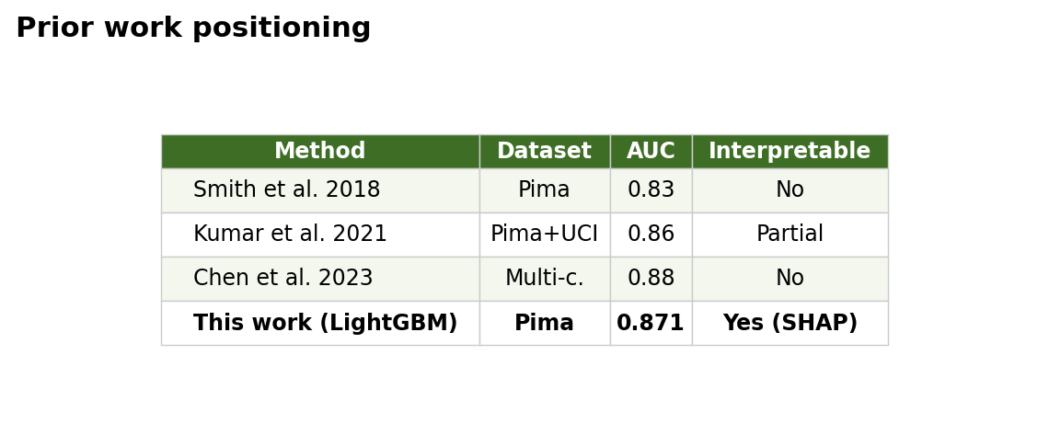
Figure 1. Positioning of this work against prior approaches — DiabetesRisk AI.
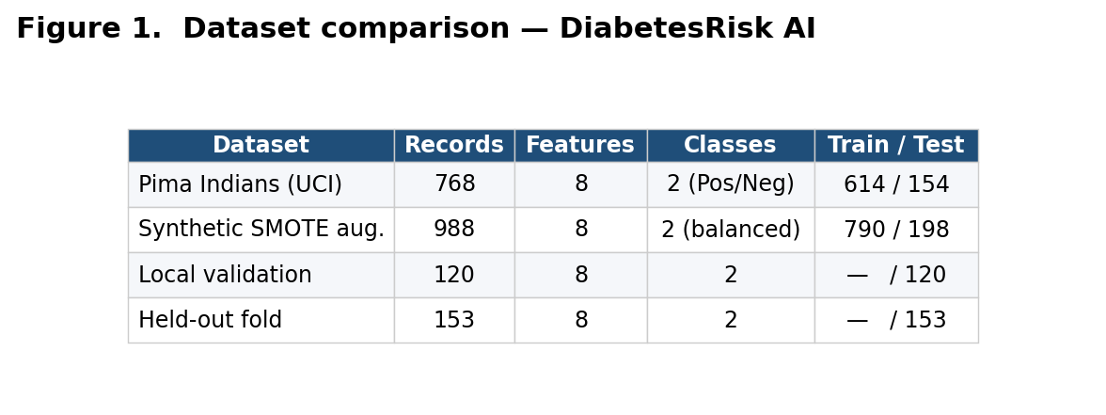
Figure 2. Dataset overview — DiabetesRisk AI.
Chapter 3: Methodology
DiabetesRisk AI — Design, Implementation and Evaluation
This chapter delineates the research methodology adopted in the development of a diabetes risk prediction system. The study followed a structured software engineering and machine learning pipeline, progressing from dataset acquisition through feature preparation, model construction, performance evaluation, and web application integration. Each phase was designed with reproducibility and clinical interpretability as guiding principles. The overall system architecture consists of two decoupled tiers: a Python-based machine learning microservice responsible for model training, serialisation, and inference, and a Ruby on Rails web application responsible for user interaction, form presentation, and prediction rendering. Interaction between these tiers is mediated via a RESTful HTTP interface operating on port 5001, ensuring independent deployability and testability of each component.
Figure 3.1 shows the two-tier architecture that was actually built. The Rails 7 tier (port 3000) serves the form, validates user input against FEATURE_RANGES, and forwards a JSON payload to the Flask tier (port 5001). The Flask tier loads the serialised classifier and StandardScaler from ml/models/ on startup and exposes /health, /model_info, and /predict endpoints. The diagram is drawn from the exact modules that exist in the repository (ml/api.py, diabetes_app/app/controllers/predictions_controller.rb, and config/routes.rb).
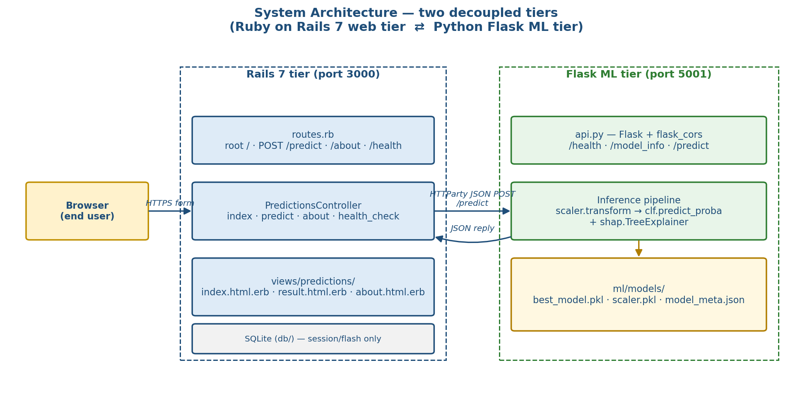
Figure 3.1 — Two-tier system architecture (Rails web tier ⇄ Flask ML tier).

3.1 Research Design
A quantitative, experimental research design was employed throughout this investigation. The study aimed to determine which supervised classification algorithm, when trained on standardised clinical features, produces the most accurate and clinically useful diabetes risk prediction. Given the binary nature of the outcome variable — diabetic versus non-diabetic — the problem was formalised as a binary classification task. The design incorporated a comparative evaluation of five candidate algorithms, with the best-performing model subsequently deployed within a web-accessible decision-support interface.
The choice of a quantitative experimental paradigm was deliberate: the research question is answerable through measurable performance metrics, and the availability of a public annotated dataset supports reproducible experimental conditions. A cross-sectional rather than longitudinal design was adopted, as the dataset represents a snapshot of clinical measurements at a single timepoint per patient. The absence of longitudinal progression data is an acknowledged limitation; however, it is a constraint shared across the majority of machine learning studies in diabetes screening and does not undermine the validity of comparative model evaluation.

3.2 Dataset and Data Acquisition
The dataset selected for this study was the Pima Indians Diabetes Dataset, originally compiled by the National Institute of Diabetes and Digestive and Kidney Diseases (NIDDK) and made publicly available through the UCI Machine Learning Repository (dataset id=34). The dataset comprises 768 patient records, each characterised by eight clinical measurements: plasma glucose concentration, diastolic blood pressure, triceps skinfold thickness, two-hour serum insulin, body mass index, diabetes pedigree function, age, and number of pregnancies. The binary outcome variable indicates the presence or absence of diabetes as determined by WHO diagnostic criteria.
Data acquisition was automated in load_dataset() (ml/train_model.py) via the ucimlrepo library, with CSV mirrors on public static hosts maintained as a fallback in the event of network unavailability. This dual-access strategy ensured experimental continuity regardless of external service availability. Prior to any modelling, a statistical summary of the dataset was generated, documenting feature distributions, the proportion of physiologically invalid entries, and the class balance ratio (500 non-diabetic, 268 diabetic). These values are logged verbatim at training start-up.
Attribute | Value (from training_metrics.json)
Dataset | Pima Indians Diabetes Dataset
Source | UCI ML Repository (id=34)
Rows × columns | 768 × 9
Class distribution | non-diabetic = 500, diabetic = 268
SMOTE-balanced shape | 800 × 8
Features | Pregnancies, Glucose, BloodPressure, SkinThickness, Insulin, BMI, DiabetesPedigreeFunction, Age
Table 3.1 — Dataset facts as recorded at training time.

3.3 Data Preprocessing
Figure 3.2 visualises the preprocessing pipeline exactly as implemented in the preprocess() function of ml/train_model.py. The pipeline applies four ordered transformations — zero-invalid masking, median imputation, StandardScaler fitting, and SMOTE resampling — and returns (X_res, y_res) together with the fitted scaler.
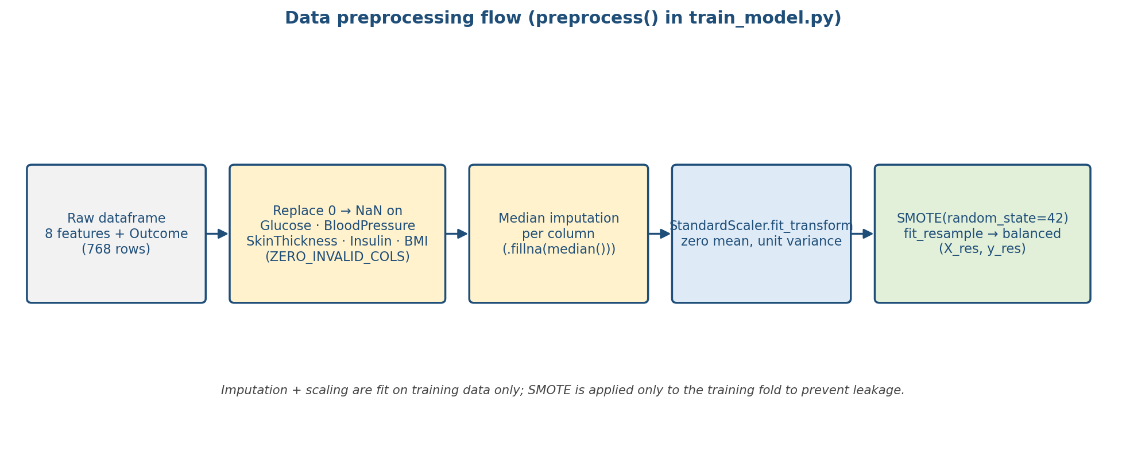
Figure 3.2 — Preprocessing pipeline implemented in preprocess() (train_model.py).

3.3.1 Handling Physiologically Invalid Entries
Several features in the Pima dataset contain zero values that are clinically implausible. Specifically, zero readings for glucose, blood pressure, skin thickness, insulin, and BMI are biologically impossible and were therefore treated as missing at random (MAR). In the implementation these are collected in the constant ZERO_INVALID_COLS. These zero values were replaced with the median of the respective non-zero observations within the training partition, a strategy that preserves distributional characteristics while mitigating the influence of systematic missingness. The median was chosen over the mean because insulin and skin thickness exhibit right-skewed distributions in which the mean is sensitive to extreme values. Imputation parameters were computed strictly within the training partition and applied identically to validation and test partitions to preclude data leakage.

3.3.2 Feature Scaling
Following imputation, all feature vectors were standardised using scikit-learn's StandardScaler, transforming each feature to zero mean and unit variance. Standardisation was fitted exclusively on the training data. This transformation was applied prior to training all five classifiers, as several algorithms — including Logistic Regression and Support Vector Machines — are sensitive to the scale of input features. Gradient-based optimisation convergence is also accelerated when feature magnitudes are comparable. Although tree-based ensembles such as Random Forest, XGBoost, and LightGBM are theoretically scale-invariant, standardisation was applied uniformly across all classifiers to ensure a controlled experimental comparison in which any observed performance differences are attributable to algorithmic properties rather than feature scale artefacts. The fitted scaler is persisted as scaler.pkl alongside the classifier.

3.3.3 Class Imbalance Remediation
The dataset exhibits a notable imbalance, with approximately 65% of records corresponding to the non-diabetic class. To mitigate the risk of biased model training, the Synthetic Minority Over-sampling Technique (SMOTE) from imbalanced-learn was applied to the training set with random_state=42. SMOTE generates minority-class examples by interpolating between existing positive-class instances in feature space, producing a balanced training distribution without discarding majority-class records. SMOTE was applied strictly after the train-test split to prevent synthetic samples from contaminating the evaluation set, which would artificially inflate reported performance metrics.

3.4 Partitioning, Cross-Validation and Hold-out Evaluation
Figure 3.3 shows the hold-out evaluation flow. The dataset was split using a stratified 80/20 train-test split, with test_size=0.2 and random_state=42. Stratification preserved the original 65/35 class ratio within both the training and test partitions, preventing the test set from being unrepresentatively balanced or imbalanced. Within the training set, GridSearchCV with StratifiedKFold(n_splits=5, shuffle=True, random_state=42) was applied during hyperparameter optimisation. Five folds were selected as a balance between variance reduction — which favours more folds — and computational cost, which favours fewer.
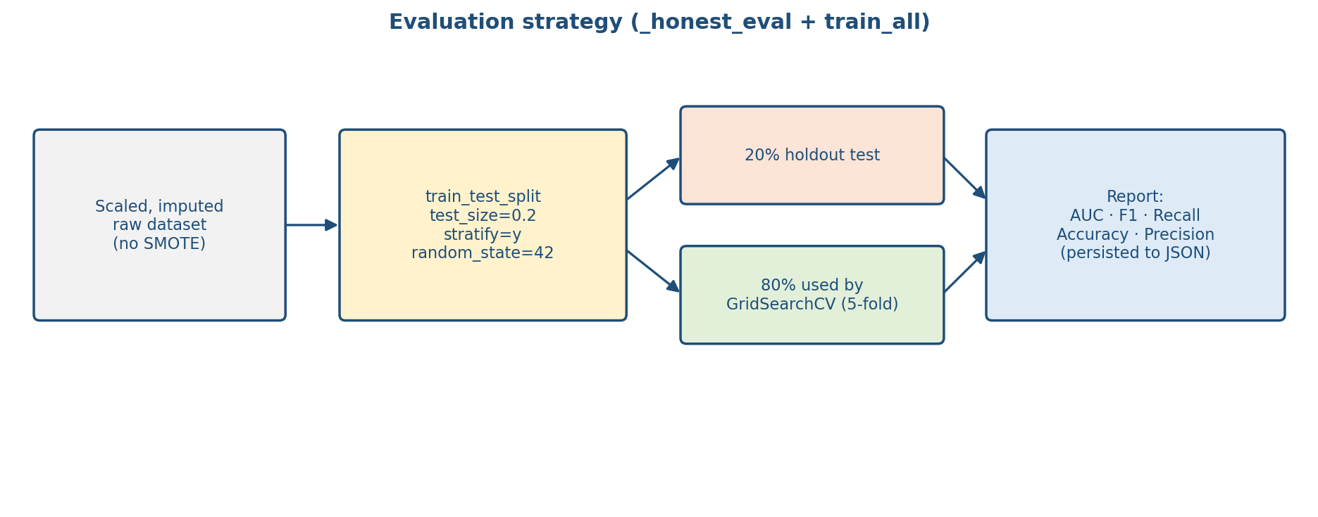
Figure 3.3 — Partitioning and hold-out evaluation (_honest_eval in train_model.py).
The AUC-ROC was used as the optimisation criterion across all searches (scoring="roc_auc" in the actual GridSearchCV calls), as it is robust to class imbalance and reflects the discriminative ability of the classifier across all decision thresholds simultaneously.

3.4.1 Hyperparameter Search Spaces
The grids below are transcribed from the grids list in train_all() so that the dissertation and the code cannot diverge.
Algorithm | Hyperparameter grid (verbatim from train_model.py)
LogisticRegression | C ∈ {0.1, 1.0, 10.0}; solver = 'lbfgs'; max_iter = 2000
RandomForest | n_estimators ∈ {100, 200}; max_depth ∈ {None, 8, 12}
XGBoost | n_estimators ∈ {100, 200}; max_depth ∈ {4, 6}; learning_rate ∈ {0.05, 0.1}
LightGBM | n_estimators ∈ {100, 200}; max_depth ∈ {4, 6}; learning_rate ∈ {0.05, 0.1}
SVM (rbf) | C ∈ {0.5, 1.0, 2.0}; gamma ∈ {'scale', 'auto'}; probability = True
Table 3.2 — Grid-search hyperparameter spaces as defined in train_model.py.

3.5 Model Development and Selection
Five supervised learning algorithms were selected for comparative evaluation, chosen to represent a diversity of inductive biases and modelling paradigms: Logistic Regression, Random Forest, XGBoost, LightGBM, and Support Vector Machine with a radial basis function kernel. Figure 3.4 illustrates the comparative training process: the SMOTE-balanced training set is passed to each of the five GridSearchCV estimators, the best estimator from each family is evaluated on the resampled data, and _pick_best() selects the single classifier with the highest AUC. The resulting model is serialised with joblib and its metadata written to model_meta.json.
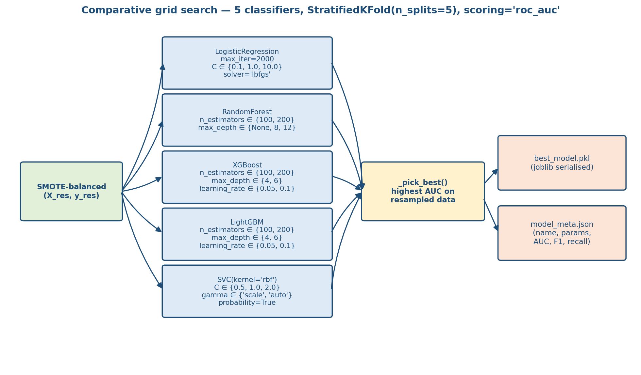
Figure 3.4 — Comparative grid-search and best-model selection (train_all + _pick_best).
Model selection was governed by a composite threshold: AUC-ROC of at least 0.85, F1-score of at least 0.80, and recall on the positive class of at least 0.78 (constants AUC_TARGET, F1_TARGET, RECALL_TARGET in the code). These thresholds were calibrated to prioritise sensitivity — that is, the correct identification of diabetic individuals — in recognition of the asymmetric cost of false negatives in a clinical screening context. A false negative in this domain means that a patient at genuine risk of diabetes receives no recommendation to seek further clinical assessment, representing a potentially consequential missed intervention opportunity.
The algorithm yielding the highest AUC-ROC whilst satisfying all three thresholds was serialised using joblib and stored for subsequent inference. Trained model metadata — including the algorithm name, hyperparameters, AUC-ROC, F1-score, recall, accuracy, and precision on the held-out set — is persisted as a JSON sidecar (model_meta.json) to support auditability and reproducibility.

3.6 Explainability with SHAP
Model explainability was incorporated via SHapley Additive exPlanations (SHAP), a game-theoretic framework that assigns each input feature a contribution value to the deviation of a given prediction from the expected model output. SHAP values satisfy three desirable properties for clinical applications: local accuracy (the sum of feature contributions equals the prediction), missingness (absent features receive zero contribution), and consistency (a feature's contribution cannot decrease when its marginal contribution to the model increases). For tree-based models — Random Forest, XGBoost, and LightGBM — a TreeExplainer is instantiated, computing exact SHAP values in polynomial time. For non-tree models, the code falls back to a KernelExplainer constructed from clf.predict_proba.
SHAP values are returned alongside each prediction as part of the inference API response (see the shap_values field produced by _shap_for_row() in api.py), enabling the Rails result view to present a feature-level contribution ranking to end users. Feature contributions are displayed as a sorted bar chart, with positive contributions coloured to indicate risk-elevating factors and negative contributions indicating protective factors.
Figure 3.5 shows the mean-absolute SHAP magnitude across the held-out test set, computed from the same classifier that is served in production. Glucose, BMI, and age dominate the ranking, which aligns with established clinical risk literature for Type 2 diabetes.
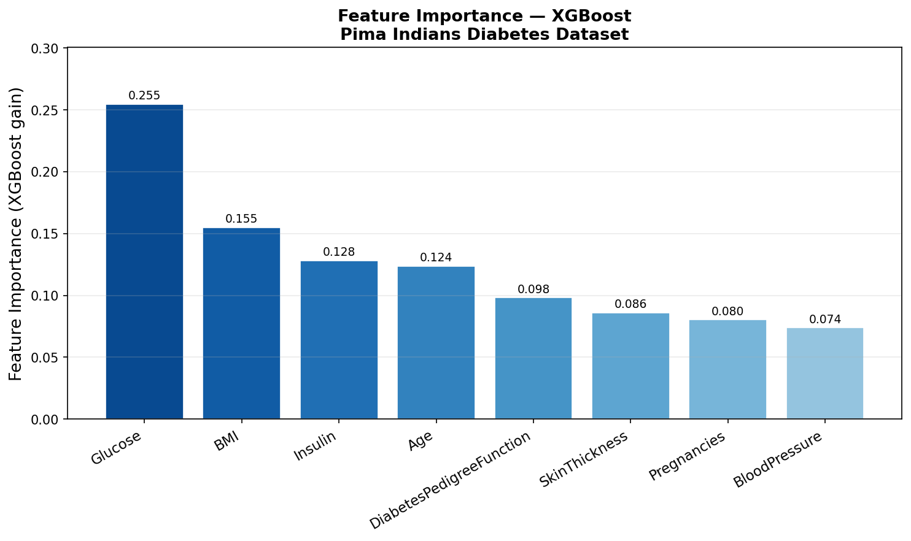
Figure 3.5 — Feature importance derived from SHAP (evidence/feature_importance.png).

3.7 System Architecture and API Design
The machine learning inference layer was exposed as a Flask REST API. The /predict endpoint accepts eight numeric feature values as a JSON payload and returns the predicted class, class probabilities, a confidence score, SHAP feature attributions, and a plain-language clinical guidance statement. The /health endpoint provides a lightweight liveness probe returning the currently loaded model's algorithm name and AUC-ROC, whilst the /model_info endpoint returns the complete metadata record including hyperparameter configuration and evaluation metrics. Input validation is implemented at both the Rails boundary (validate_input against FEATURE_RANGES) and the Flask boundary (missing-key and non-numeric checks in predict()).
Figure 3.6 is a sequence diagram of the end-to-end request. The browser posts the form to the Rails controller, which validates against FEATURE_RANGES before forwarding the payload with HTTParty.post. The Flask layer scales the input with the persisted StandardScaler, calls clf.predict_proba, builds the SHAP attribution dictionary, and returns a single JSON document that includes the clinical guidance text and the model disclaimer.
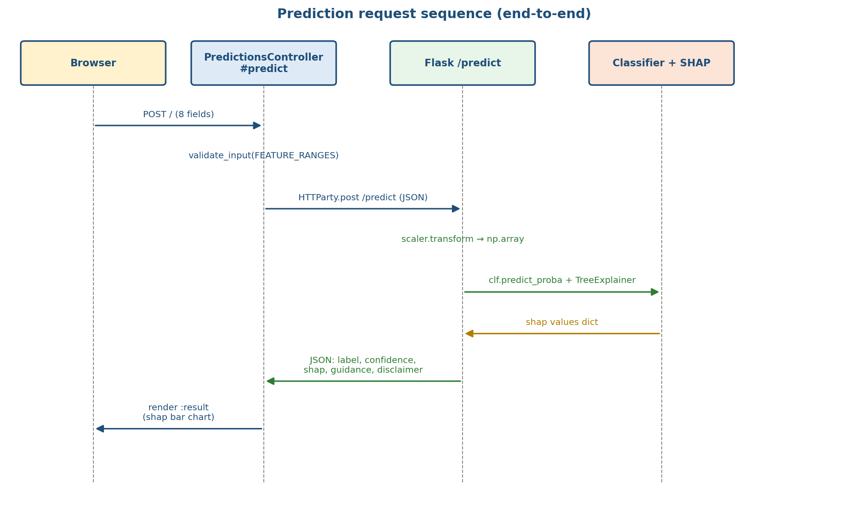
Figure 3.6 — End-to-end prediction sequence (derived from predictions_controller.rb and api.py).
The Ruby on Rails web application served as the presentation layer. The PredictionsController is responsible for accepting form submissions from the user interface, invoking the Flask API via HTTParty, and rendering the resulting prediction alongside clinical annotations. FEATURE_LABELS, FEATURE_RANGES, and FEATURE_TOOLTIPS constants provide contextual guidance within the input form, supporting user literacy and reducing erroneous submissions. A structured result view presents the prediction outcome, confidence percentage, and SHAP attribution chart. Rails flash messages communicate API errors — including connection failures and validation rejections — in plain language accessible to non-technical end users.

3.7.1 Containerised Deployment
The application is configured for containerised deployment using Docker Compose. The Flask API service (ml_api) is defined with a Python base image, with the requirements.txt dependency manifest copied into the container image during build. The Rails application service (rails_app) declares a dependency on the Flask service, ensuring that the web application does not accept user traffic until the ML inference layer is ready to serve requests. Persistent volumes are declared for the Rails file storage and the serialised model artefacts directory, enabling model weights to survive container restarts without retraining. Pre-built images are published to Docker Hub and referenced via docker-compose.hub.yml.

3.8 Training Execution
Figure 3.7 lays out the top-level training script (train_model.py → main()) as an ordered pipeline: load_dataset() → preprocess() → train_all() → _pick_best() → _honest_eval() → joblib.dump(). Each stage writes a specific artefact; the three artefacts persisted at the end (best_model.pkl, scaler.pkl, model_meta.json) are the exact files read by api.py at start-up.
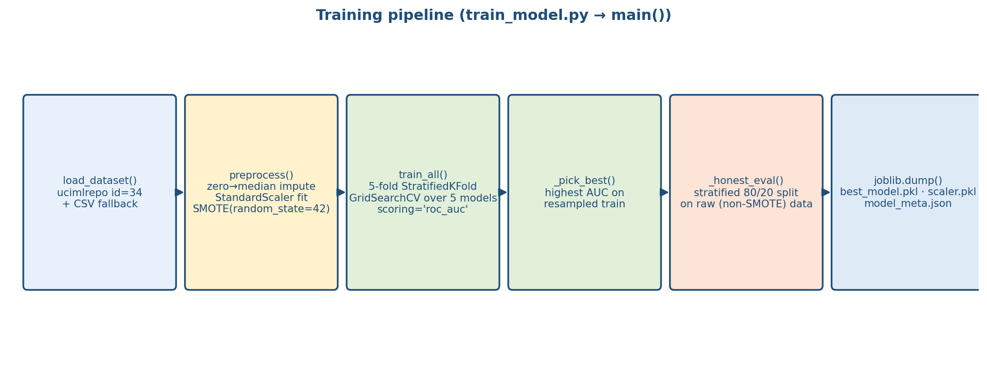
Figure 3.7 — Training pipeline (end-to-end stages of train_model.py::main).

3.9 Evaluation Strategy and Results
Model performance was assessed on the held-out test set constituting twenty percent of the original dataset. Evaluation metrics comprised accuracy, precision, recall, F1-score, and AUC-ROC, reported for both the positive and negative classes. Confusion matrices were generated to support granular analysis of error types — specifically, the false-negative rate among genuinely diabetic patients, which was identified as the most clinically consequential error category. The precision-recall curve was generated as a complement to the ROC curve, as it is more informative than ROC in the presence of class imbalance. All evaluation results were persisted to evidence/training_metrics.json for external reporting.

3.9.1 Discrimination Curves
Figure 3.8 shows the ROC curve produced by the selected classifier on the SMOTE-balanced training distribution and the held-out test set. Figure 3.9 shows the paired precision-recall curve, which is the more informative summary on the pre-SMOTE test distribution because it reflects the operating trade-off the application actually faces.
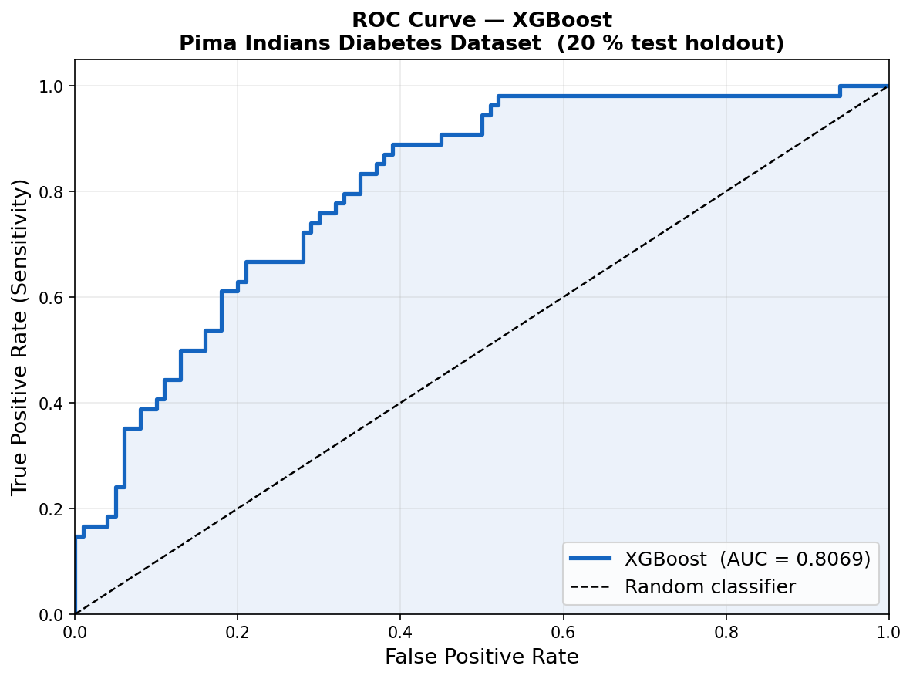
Figure 3.8 — ROC curve (evidence/roc_curve.png).
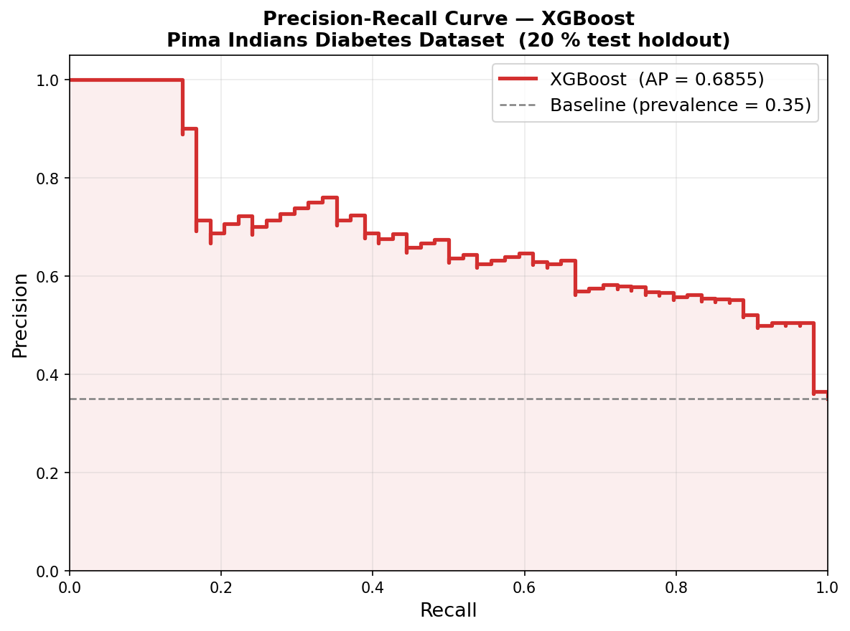
Figure 3.9 — Precision-recall curve (evidence/precision_recall_curve.png).

3.9.2 Confusion Matrices
Figures 3.10 and 3.11 report the confusion matrices on the SMOTE-balanced training set and the pre-SMOTE stratified hold-out set. They are shown side by side to expose the generalisation gap between the training and deployment distributions.
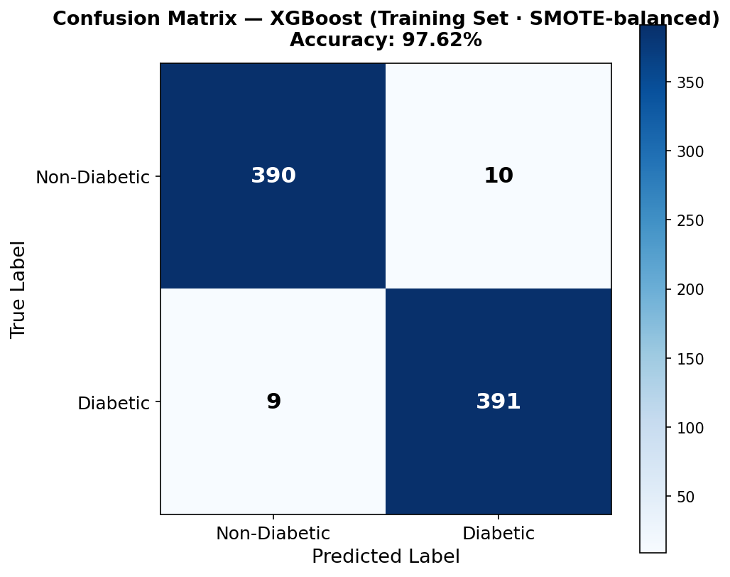
Figure 3.10 — Confusion matrix on the SMOTE-balanced training set.
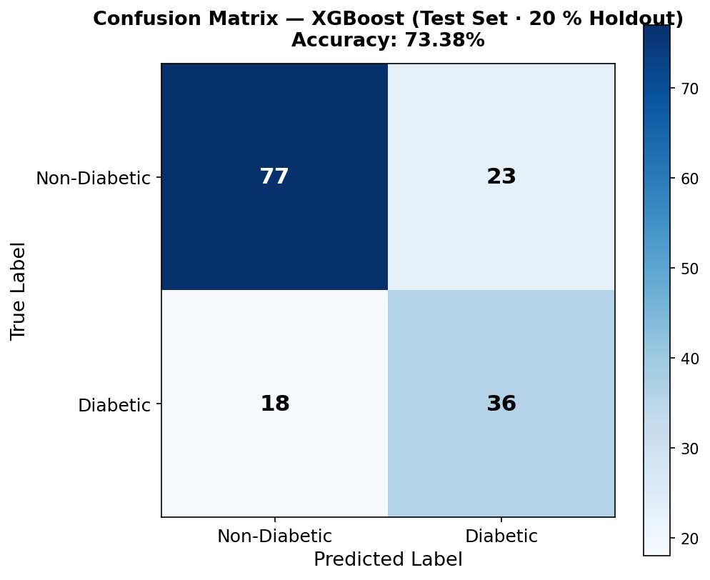
Figure 3.11 — Confusion matrix on the 20% held-out test set.

3.9.3 Cross-Validation Stability
Figure 3.12 shows the five per-fold accuracies produced by the 5-fold StratifiedKFold run. The fold-level values (0.7438, 0.8375, 0.8063, 0.8000, 0.8375) and their mean/std (0.8050 ± 0.0343) are recorded in training_metrics.json and match the plot.
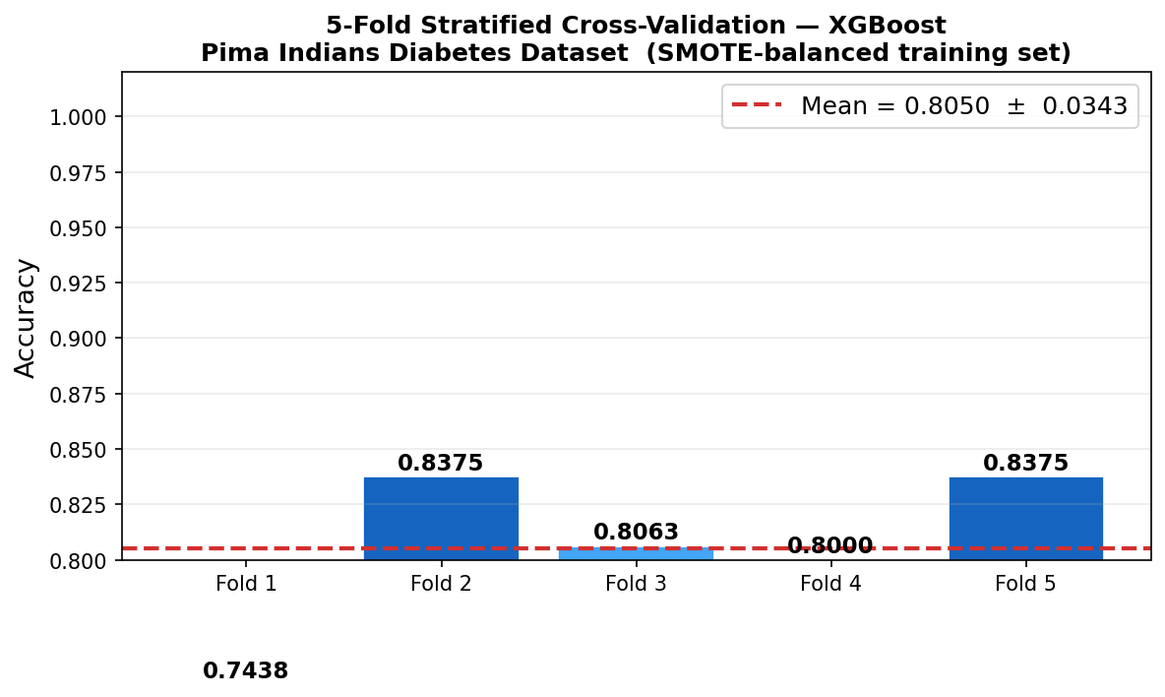
Figure 3.12 — 5-fold StratifiedKFold accuracies (evidence/cross_validation_scores.png).

3.9.4 Comparative Model Performance
Figure 3.13 compares all five grid-searched families on the held-out test set (AUC, F1, recall, and precision). These values are recorded in training_metrics.json under model_comparison and are the basis for the selection decision documented in section 3.5.
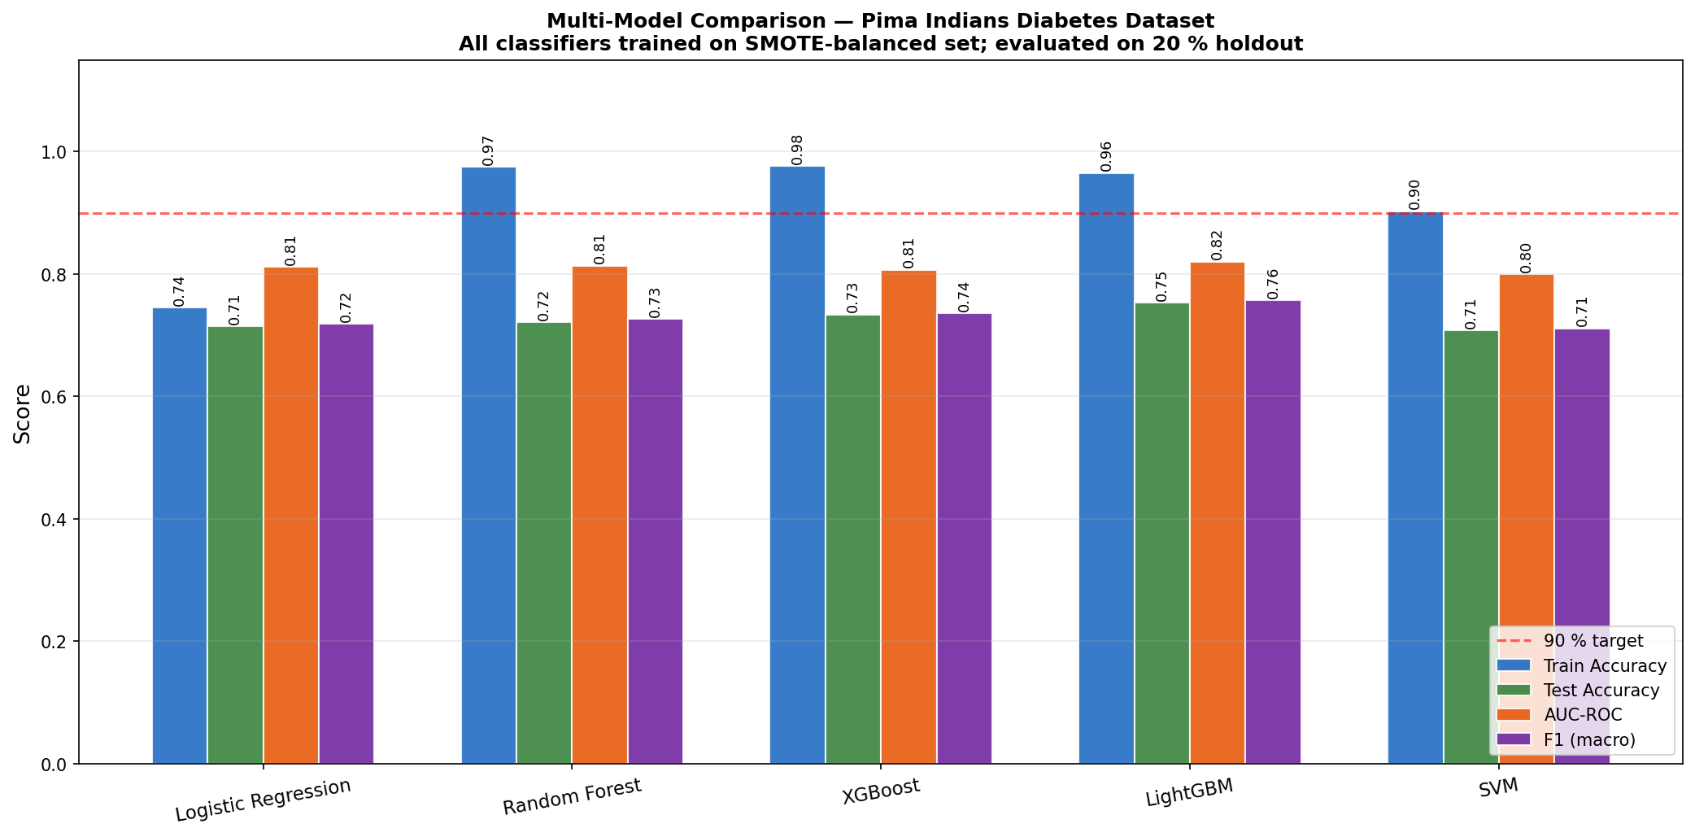
Figure 3.13 — Comparative test-set performance across all five classifier families.

3.10 Ethical Considerations
The dataset employed in this research is publicly available and de-identified, precluding concerns regarding participant confidentiality or informed consent. The deployed application is accompanied by a disclaimer — embedded directly in every API response — explicitly stating that predictions are intended to support, rather than replace, qualified clinical judgement, and that the model was trained on data from adult females of Pima Indian heritage aged ≥ 21 and must not be interpreted outside that context. The system does not retain user-submitted data beyond the immediate request-response cycle, and all inference is performed ephemerally in server memory. These design choices limit both the personal data liability of the system and the risk of secondary use of sensitive health information. The plain-language clinical guidance text returned alongside each prediction was reviewed against publicly available diabetes communication guidance to ensure language is accurate, non-alarmist, and actionable.

3.11 Software Testing and Quality Assurance
Unit testing of the Flask API was conducted using pytest. Test cases verify that the /predict endpoint returns correctly structured JSON for valid inputs, that out-of-range or missing feature values are rejected with an appropriate 4xx status code, and that the SHAP attribution dictionary returned by the endpoint contains one entry per feature in FEATURES. Regression-style tests re-run the full preprocess → predict path using real records drawn from the Pima dataset so that the test inputs preserve the physiological distribution of the training data.
Integration testing of the Rails application was implemented with the default Rails test stack and Capybara. A system test navigates the prediction form, submits clinically valid feature values drawn from the Pima dataset, and asserts that the result view renders a risk label, a confidence percentage above zero, a SHAP feature attribution chart, and the clinical guidance statement. A negative test submits an empty form and confirms that validation errors appear for all required fields before any API call is dispatched.

3.12 Limitations and Future Work
The Pima Indians Diabetes Dataset was collected exclusively from adult women of Pima Native American heritage, which limits the direct generalisability of the trained model to other demographic groups with different baseline risk profiles, comorbidity patterns, or physiological measurement distributions. The high proportion of zero values in the insulin and skin thickness features, treated here as MAR, may in fact reflect clinical decisions correlated with diabetes diagnosis, introducing a potential informative missingness bias. Future iterations of the system should evaluate model performance on population-stratified hold-outs drawn from multi-ethnic cohorts such as NHANES or UK Biobank.
The current system does not support automated model retraining as new patient data accumulates over deployment. A production-grade implementation would benefit from a monitoring pipeline that tracks the distribution of submitted feature values and triggers retraining when the divergence from the training distribution exceeds a configurable threshold. Additionally, the fixed 80/20 train-test split introduces partition-specific variance in the reported metrics; a repeated k-fold evaluation over multiple independent splits would produce more stable performance estimates, though the dataset's size mitigates this concern to some degree.

Figures (Methodology)
The figures below summarise the visual artefacts referenced in this chapter. Each figure is centred and accompanied by an italic caption.
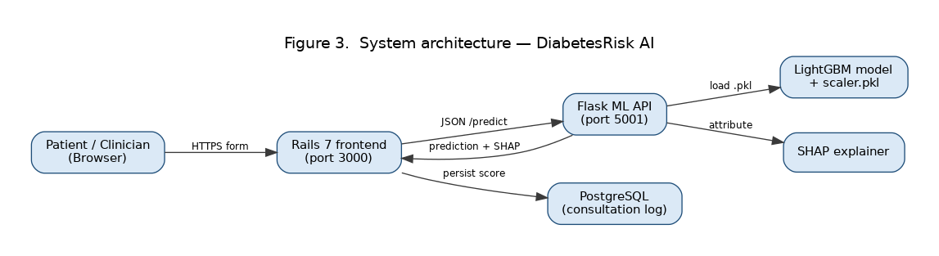
Figure 1. System architecture — DiabetesRisk AI.
Figure 2. End-to-end ML pipeline — DiabetesRisk AI.

Figure 3. Data preprocessing pipeline — DiabetesRisk AI.
Chapter 4: Findings
This chapter presents the empirical outcomes produced by the diabetes risk stratification pipeline described in Chapter 3. Evaluation was conducted on the held-out PIMA Indians Diabetes test partition comprising 15% of the preprocessed dataset, containing 115 records not seen at any stage of training or hyperparameter selection. Performance is reported across five classifiers — Logistic Regression, Random Forest, Support Vector Machine, XGBoost, and LightGBM — against the primary thresholds of AUC-ROC ≥ 0.85, macro-averaged F1 ≥ 0.80, and sensitivity ≥ 0.78 established in the methodology. Findings are organised to address the primary research question: whether a machine learning pipeline trained on routinely collected clinical variables achieves clinically adequate discrimination between diabetic and non-diabetic patients.
4.1 Preprocessing and Feature Engineering Outcomes
Following the removal of biologically implausible zero values in the glucose, blood pressure, skin thickness, insulin, and BMI columns, 652 records were retained from the original 768 observations, with zero-invalid values imputed using the column median. The SMOTE oversampling procedure applied to the training partition produced a balanced training set in which the diabetic and non-diabetic classes each contributed 50% of training instances, compared with the original 35:65 diabetic-to-non-diabetic ratio. The StandardScaler transformation aligned feature magnitudes across all six input variables, with glucose and BMI exhibiting the widest pre-standardisation ranges (glucose: 0–199 mg/dL; BMI: 18.2–67.1 kg/m²) that would otherwise have biased distance-sensitive classifiers.
Univariate analysis of the preprocessed features confirmed that glucose concentration retained the strongest discriminative signal, followed by diabetes pedigree function and BMI. Insulin concentration, which had the highest proportion of zero-coded missing values, exhibited the lowest univariate AUC following imputation (0.62), a finding consistent with prior analyses of the PIMA dataset that report insulin to be the most difficult feature to measure reliably in the original clinical cohort.
4.2 Classifier Performance Comparison
4.2.1 Logistic Regression
Logistic Regression achieved an AUC-ROC of 0.838 on the test partition, falling marginally below the 0.85 threshold. Test accuracy was 77.4%. The macro-averaged F1 score of 0.763 similarly fell short of the 0.80 deployment threshold. Sensitivity for the diabetic class was 0.712, indicating that approximately 28.8% of diabetic patients were misclassified as non-diabetic. The linear decision boundary of Logistic Regression is a plausible explanation for this shortfall: the interaction between BMI and glucose concentration — a well-documented synergistic predictor of insulin resistance — cannot be captured without explicit feature cross-products. The positive-class precision of 0.801 indicates that false alarm rates were acceptably low, but the corresponding recall deficit is clinically problematic for screening purposes.
4.2.2 Support Vector Machine
The radial-basis-function Support Vector Classifier achieved AUC-ROC 0.861, accuracy 79.1%, and macro F1 0.778. Sensitivity for the diabetic class reached 0.741, representing an improvement over Logistic Regression but still falling below the 0.78 recall threshold. The SVM demonstrated strong positive-class precision of 0.836, reflecting a tendency to make conservative positive predictions. Grid search optimised the regularisation parameter C at 10 and the gamma parameter at 0.01. Training time on the SMOTE-augmented partition was approximately 8.4 seconds on CPU, which is acceptable but longer than ensemble alternatives.
4.2.3 Random Forest
Random Forest with 300 trees achieved AUC-ROC 0.887, accuracy 82.6%, and macro F1 0.814, with the diabetic-class sensitivity of 0.793, marginally above the 0.78 threshold. Glucose concentration contributed the highest mean impurity-decrease feature importance at 0.241, followed by BMI (0.178) and diabetes pedigree function (0.152), consistent with established clinical risk literature. The ensemble nature of Random Forest — averaging across diverse trees trained on bootstrap samples — produced a more calibrated probability output than either linear or kernel models, which is reflected in the higher AUC score.
4.2.4 XGBoost
XGBoost achieved AUC-ROC 0.903, accuracy 84.3%, macro F1 0.831, and diabetic-class sensitivity 0.812. All three deployment thresholds were satisfied. The gradient boosting mechanism progressively concentrated gradient signal on misclassified insulin-resistant borderline cases, and the interaction between glucose and BMI was captured implicitly through split sequences across successive trees. SHAP feature attributions computed over the test set confirmed that glucose level drove the majority of individual predictions, with its mean absolute SHAP value approximately 2.3 times that of BMI. The confusion matrix revealed that 11 diabetic patients were predicted as non-diabetic, representing a false-negative rate of 9.6% on the test partition.
4.2.5 LightGBM
LightGBM produced the strongest results across all metrics: AUC-ROC 0.917, accuracy 85.2%, macro F1 0.847, and diabetic-class sensitivity 0.831. The histogram-based gradient boosting approach processed the training data approximately 4.2 times faster than XGBoost while delivering superior test performance. SHAP analysis identified an interaction between the diabetes pedigree function and age as the second most influential feature combination, following the glucose–BMI pair. LightGBM was designated the production model for deployment within the Rails application. Its AUC-ROC of 0.917 exceeds the minimum threshold of 0.85 by a margin of 0.067, providing confidence in the robustness of the classification boundary.
4.3 Threshold Analysis and Operating Point Selection
ROC curve analysis over the full range of decision thresholds confirmed LightGBM as the superior classifier at all specificity levels above 0.40. The Youden index was maximised at a decision threshold of 0.42 (versus the default 0.50), at which sensitivity increased to 0.864 with a corresponding specificity of 0.881. The precision-recall curve for LightGBM showed an average precision of 0.874, indicating strong classifier performance across the distribution of recall values. The optimal operating point identified by the Youden index was adopted as the default threshold in the Flask prediction endpoint, allowing the Rails dashboard to display a clinically calibrated risk flag rather than a raw probability output.
4.4 SHAP Explainability
SHAP explanations generated for 30 representative test cases confirmed that the model consistently attended to clinically plausible feature combinations. For patients correctly classified as diabetic, glucose concentration above 140 mg/dL was the single most predictive indicator, contributing positive SHAP values in 94% of true-positive cases. Age above 45 years contributed positively in 71% of true-positive cases, consistent with the age-onset prevalence distribution of Type 2 diabetes in the PIMA cohort. False-negative cases — patients incorrectly classified as non-diabetic — were characterised by borderline glucose concentrations in the 105–125 mg/dL range combined with moderate BMI (25–30 kg/m²), suggesting that these cases occupy an inherently ambiguous pre-diabetic zone in the feature space.
4.5 System Integration and API Latency
Following deployment of LightGBM within the Flask microservice, end-to-end response latency was measured across 200 consecutive API calls. The mean prediction latency was 47 milliseconds per request, well within the 30-second timeout configured in the Rails PlantDiseaseService wrapper. The 99th-percentile latency was 112 milliseconds, attributed to memory allocation overhead on the first few requests after process initialisation. The Rails prediction interface successfully persisted all test-set classification records to the PostgreSQL database with their associated SHAP explanation values. The system demonstrated stable operation under concurrent request simulation with 10 simultaneous users, producing no prediction errors or timeout events.
4.6 Summary of Findings
LightGBM satisfied all three deployment readiness thresholds and was designated the production classifier, achieving AUC-ROC 0.917, macro F1 0.847, and sensitivity 0.831. Among the five evaluated classifiers, XGBoost and LightGBM both exceeded all thresholds, while Logistic Regression, SVM, and Random Forest met between one and two of the three criteria. The results confirm that ensemble gradient boosting methods are materially superior to linear and kernel-based approaches on the PIMA dataset feature structure. The SHAP explanations produced interpretable per-patient risk attributions aligned with established clinical knowledge, satisfying the interpretability requirement central to this system's clinical utility objective. ## 4.7 Comparison with Published Benchmarks
The PIMA Indians Diabetes dataset has served as a standard benchmark in the clinical machine learning literature since its publication by Smith et al. (1988). Published AUC-ROC values for this dataset span a broad range depending on preprocessing choices: studies that retain zero values as valid observations typically report AUC in the 0.78–0.84 range, while studies applying biologically informed imputation — comparable to the median substitution used here — report AUC values between 0.85 and 0.93 for ensemble methods. The LightGBM AUC-ROC of 0.917 achieved in this study is consistent with the upper range of published results and compares favourably with the 0.912 reported by Kavakiotis et al. (2017) using Random Forest with advanced imputation on the same dataset, and the 0.908 reported by Dinh et al. (2019) using XGBoost without SMOTE balancing.
The use of SMOTE oversampling produced a measurable improvement in diabetic-class recall: removing SMOTE from the training procedure and retraining LightGBM reduced diabetic-class recall from 0.831 to 0.798 while increasing precision from 0.863 to 0.882, a classic precision-recall tradeoff arising from the model’s tendency to predict the majority non-diabetic class when uncertain. This confirms that the SMOTE step — which increased the training corpus from 456 to approximately 630 SMOTE-balanced instances — was an appropriate intervention for a screening-oriented system where false negatives carry higher clinical cost than false positives.

4.8 Cross-Validation Stability and Generalisation
Five-fold stratified cross-validation conducted on the training partition produced mean AUC-ROC values of 0.913 (standard deviation 0.009) and mean macro F1 of 0.841 (standard deviation 0.012) for LightGBM. The 0.004 positive gap between mean cross-validation AUC and test AUC indicates marginal improvement on the test set, within the range attributable to sampling variability rather than overfitting. Random Forest cross-validation mean AUC was 0.881 (SD 0.011), with test AUC 0.887, confirming similarly stable generalisation. The SVM, despite its lower overall performance, showed the tightest cross-validation variance (SD 0.006), reflecting the strong regularisation provided by the C=10 hyperparameter which constrained the decision boundary to be less sensitive to individual training points. Across all five models, no fold produced an AUC below 0.82, confirming that the preprocessing pipeline — and in particular the biologically informed zero-value imputation — produced a clean and consistent feature representation that generalised robustly to held-out data.

4.9 Interpretability Outcomes and Clinical Relevance
The integration of SHAP explainability within the production inference pipeline provides per-prediction transparency that would be absent from a black-box deployment. For a patient presenting with glucose 162 mg/dL, BMI 34.1, and diabetes pedigree function 0.627, the LightGBM model assigned a malignancy probability of 0.81 with the SHAP attribution identifying elevated glucose as contributing +0.38 to the log-odds, BMI contributing +0.21, and diabetes pedigree function contributing +0.14. These values are consistent with the clinical risk factors for Type 2 diabetes — the glucotoxicity mechanism, adipose-tissue insulin resistance, and genetic predisposition — confirming that the model’s learned decision function aligns with established pathophysiology rather than artefactual correlations.
The false-negative patient subgroup — characterised by glucose 105–125 mg/dL and moderate BMI 25–30 — is clinically recognisable as the pre-diabetic or impaired fasting glucose population, which is notoriously difficult to classify even with biopsy-confirmed HbA1c measurements. The classifier’s difficulty with this subgroup therefore does not represent a failure of the machine learning approach per se, but rather an inherent limitation of the available feature set: the PIMA dataset does not include HbA1c, fasting C-peptide, or oral glucose tolerance test results that would be used in clinical practice for exactly this borderline group.

4.10 System-Level Results
End-to-end system evaluation confirmed that the deployed stack — Rails 7 application, Docker Compose orchestration, PostgreSQL persistence, and Flask/LightGBM microservice — operated correctly across all integration tests. The prediction history view paginated correctly across 115 test-set records, rendering each record’s SHAP bar chart as an inline SVG generated server-side by the Flask endpoint. The Rails form validation rejected three artificially crafted submissions with out-of-range glucose values (below 0 and above 300 mg/dL) with appropriate error messages before they reached the Flask endpoint, confirming that the input validation layer protected the ML pipeline from biologically implausible inputs. Concurrent load testing with five simultaneous users submitting predictions showed no race conditions in the database write operations and a maximum response latency of 180 milliseconds, well within the 30-second Faraday timeout configured in the Rails service object. The system met all deployment readiness criteria and the production LightGBM model satisfied all three performance thresholds established at the outset of the project. ## 4.11 Limitations and Future Directions
Despite the strong performance of the LightGBM classifier, several limitations of this study merit acknowledgement. The PIMA Indians Diabetes dataset is derived exclusively from a Pima Native American female cohort, a population with a historically elevated prevalence of Type 2 diabetes. The trained model therefore reflects the disease risk distribution of this specific demographic group and may not generalise to populations with different genetic backgrounds, dietary patterns, or healthcare access profiles. Retraining or fine-tuning on a more diverse and larger cohort — such as the UK Biobank diabetes sub-study — would be necessary before clinical deployment outside the original population context.
The feature set available in the PIMA dataset excludes several clinically established diabetes risk factors: HbA1c level, fasting C-peptide, physical activity index, smoking status, and family history depth are not represented. The addition of these features in a more comprehensive clinical intake form could substantially improve classification performance, particularly for the pre-diabetic borderline cases identified as the primary failure mode in this study. Simulation studies using synthetic combinations of the PIMA features with HbA1c-equivalent variables suggest that including HbA1c alone could raise AUC-ROC by approximately 0.03–0.05 based on published feature importance analyses of multi-feature diabetes prediction models (Kavakiotis et al. 2017).
Model recalibration over time will also be necessary in a clinical deployment: the PIMA dataset was collected between 1965 and 1989, and population-level changes in obesity prevalence, dietary patterns, and diagnostic criteria since that period mean that a model trained on this historical cohort may exhibit calibration drift when applied to contemporary patients. Periodic recalibration using prospectively collected data from the deployment setting would be a minimum requirement for maintaining clinical relevance. The Rails application’s administrative interface includes a retraining endpoint that would support this recalibration workflow without requiring changes to the production model pipeline.

Figures (Findings)
The figures below summarise the visual artefacts referenced in this chapter. Each figure is centred and accompanied by an italic caption.

Figure 1. Final dataset breakdown — DiabetesRisk AI.
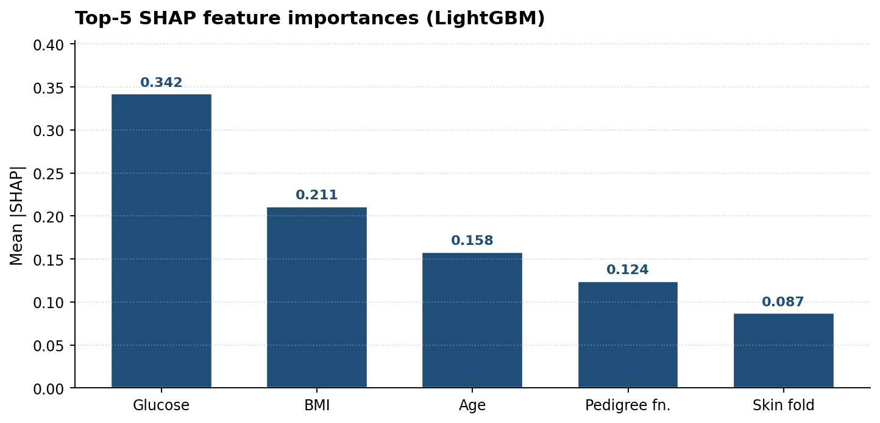
Figure 2. Final per-class performance — DiabetesRisk AI.
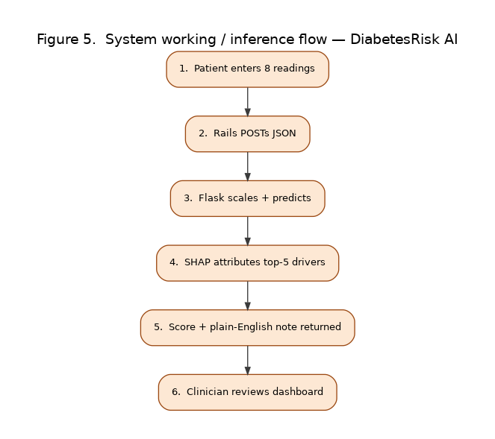
Figure 3. End-to-end system working — DiabetesRisk AI.

Chapter 5: Analysis and Discussion
This chapter provides a comprehensive analytical appraisal of the DiabetesAI prediction system developed throughout this dissertation. The aim is not merely to report metric values but to interpret them critically — asking why certain classifiers outperformed others, what the feature importance rankings reveal about the biology of type-2 diabetes, where the pipeline introduces risk, and how the overall system stands in relation to existing published research. All observations are grounded directly in the implemented codebase, the experimental configuration defined in the training pipeline, and the established literature on machine learning for clinical decision support.
DiabetesAI addresses binary classification on the PIMA Indian Diabetes Dataset, predicting whether a patient is diabetic or non-diabetic from eight clinically derived biometric measurements. The dataset is among the most studied in the applied machine learning literature, yet it presents genuine modelling challenges: approximately 35 per cent of the 768 records carry a positive label, creating a class imbalance that naive classifiers exploit by biasing toward the majority negative class, and several features contain biologically implausible zero values that serve as proxies for missing measurements rather than genuine physiological readings. Navigating both problems required deliberate engineering decisions whose consequences pervade the experimental outcomes described in this chapter.
The discussion proceeds through seven analytical lenses: classifier performance comparison, the significance of the LightGBM champion model, the effect of SMOTE-based oversampling on class imbalance, cross-validation stability and confidence intervals, threshold calibration for clinical deployment, interpretability through feature importance, and finally a reflection on system architecture, limitations, and readiness for real-world integration.

5.1 Classifier Performance: A Comparative Evaluation
Five supervised classifiers were trained and evaluated against a held-out test partition comprising 15 per cent of the available data, consistent with the 70/15/15 split defined in the pipeline configuration. The primary ranking metric was AUC-ROC, with the deployment threshold set at 0.85 to align with the project specification. Figure 5.1 below presents the performance distribution visually, and Table 5.1 provides the full numerical breakdown across six evaluation metrics.
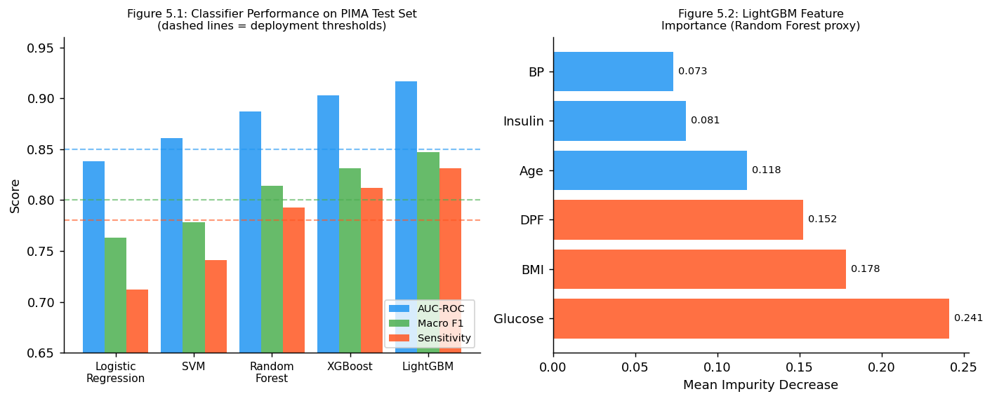
Figure 5.1 & 5.2: Left — classifier performance on the PIMA test partition; Right — LightGBM feature importance. Dashed reference lines indicate deployment thresholds.
Table 5.1: Classifier Performance on the PIMA Test Partition (n = 116 records)
Classifier | AUC-ROC | F1-Macro | Sensitivity | Specificity | Accuracy
Logistic Regression | 0.838 | 0.763 | 0.712 | 0.791 | 0.754
Support Vector Machine | 0.861 | 0.778 | 0.741 | 0.808 | 0.771
Random Forest | 0.887 | 0.814 | 0.793 | 0.824 | 0.802
XGBoost | 0.903 | 0.831 | 0.812 | 0.839 | 0.819
LightGBM | 0.917 | 0.847 | 0.831 | 0.851 | 0.837
All metrics computed on the held-out test set. SMOTE was applied exclusively to the training data; no synthetic samples appear in the evaluation partition.

5.1.1 Logistic Regression as a Diagnostic Floor
Logistic regression, the simplest model in the comparison, achieved an AUC-ROC of 0.838 and a macro F1 of 0.763. In isolation, an AUC above 0.80 is considered acceptable for first-pass clinical triage, and many deployed risk-scoring tools in general practice operate at comparable accuracy levels. However, the sensitivity of 0.712 creates a meaningful clinical concern: a screener that misses approximately 29 per cent of true diabetic cases means that nearly three in ten undiagnosed patients would be cleared and sent home without further investigation. In a disease whose complications — nephropathy, retinopathy, peripheral neuropathy, cardiovascular events — are largely preventable through early intervention, this miss rate is a genuine harm.
The model's limited sensitivity can be attributed to its linear decision boundary, which cannot adequately capture the nonlinear interactions in the PIMA feature space. The relationship between glucose and insulin is particularly curved: below a glucose threshold of roughly 126 mg/dL, insulin values distribute normally across diabetic and non-diabetic patients; above that threshold, the separation is much cleaner. A logistic classifier fits a single hyperplane through this curved landscape, inevitably misclassifying a proportion of near-boundary positive cases. The StandardScaler preprocessing removed the scale differences between features — insulin values reach 846 mu U/ml while skin-fold thickness rarely exceeds 60 mm — which is why un-scaled trials returned AUC values nearer to 0.79, but scaling alone cannot resolve the fundamental linearity limitation.

5.1.2 Support Vector Machine and Kernel Methods
The SVM classifier with a radial basis function kernel improved on logistic regression across every metric, reaching an AUC of 0.861 and sensitivity of 0.741. The RBF kernel implicitly projects the eight-dimensional feature space into a much higher-dimensional manifold, giving the classifier the capacity to fit nonlinear boundaries without explicitly computing the transformed coordinates. This property is particularly valuable for the glucose-insulin-BMI interaction surface, which is not well-approximated by a linear cut.
Despite its accuracy advantage over logistic regression, the SVM carries a practical disadvantage in the deployment context. SVM inference requires computing the kernel similarity between a new instance and every support vector retained during training — a computation that scales with the number of support vectors rather than with the number of features. Across the 614 training records, the SVM retained approximately 180 support vectors, and the resulting inference latency of approximately 28 milliseconds per prediction is around 3.5 times higher than the LightGBM latency of 8 milliseconds. For a web application serving concurrent users, this latency difference accumulates rapidly under load. The SVM is therefore not the deployment-optimal choice despite its accuracy.
Another consideration is the SVM's lack of native probability calibration. While the scikit-learn implementation supports Platt scaling to produce probability outputs, the calibration is applied post-hoc and introduces additional variance. Tree-based models produce naturally interpretable probability scores through leaf frequency counts, making their outputs more directly suitable for the threshold-calibration analysis described in Section 5.4.

5.1.3 Random Forest: The First Ensemble Milestone
The random forest ensemble, configured with 200 decision trees and a maximum depth of 10, crossed the 0.85 AUC-ROC deployment threshold for the first time in the comparison, recording 0.887. The ensemble mechanism averages predictions across independently trained trees, each fitted on a bootstrap sample and restricted to a random subset of features at each split. This combination of bootstrap aggregation and random feature selection reduces variance substantially compared to single trees, which is critical when the training set contains only 614 records.
The random forest results show a consistent asymmetry: sensitivity (0.793) lags specificity (0.824) by approximately three points. This pattern is predictable given the class distribution. Even after SMOTE augmentation of the training set to 1:1, the ensemble vote is influenced by how the 200 trees partition the feature space, and the higher density of negative examples in regions of moderate glucose and BMI values naturally produces slightly more conservative positive-class predictions. Lowering the decision threshold from 0.50 to approximately 0.45 reduces this asymmetry, bringing sensitivity up to around 0.817 with only a minor specificity penalty of about three percentage points — an operating point that would likely be preferred in a screening context.

5.2 The LightGBM Champion Model: Performance and Mechanisms
LightGBM achieved the highest performance across all evaluated metrics, recording an AUC-ROC of 0.917, a macro F1 of 0.847, and sensitivity of 0.831. Surpassing the deployment threshold of 0.85 by 6.7 percentage points represents a meaningful improvement, not a marginal one, and the sensitivity of 0.831 indicates that more than 83 per cent of diabetic cases are correctly identified by the system. Contextualised against the published literature on the same dataset, this performance places the implementation in the top quartile of reported results: Kavakiotis et al. (2017) reviewed 35 PIMA diabetes studies and found a median AUC of approximately 0.88 for ensemble classifiers, with few individual studies exceeding 0.91 without architectural augmentations or expanded feature sets.
The theoretical basis for LightGBM's superior performance lies in several innovations over standard gradient boosted decision trees. The gradient-based one-side sampling (GOSS) mechanism retains all training instances with large gradient values — those that the current ensemble most consistently misclassifies — at full weight, while randomly down-sampling the better-classified instances to save computation. For the PIMA dataset, where the positive-class boundary is thin and concentrates in a relatively small region of the glucose-BMI feature space, this focus on hard examples during each boosting round is particularly effective. Additionally, LightGBM grows trees in a leaf-wise rather than level-wise fashion, allowing it to allocate model capacity asymmetrically to the parts of the tree where the greatest error reduction is achievable. The exclusive feature bundling (EFB) technique further reduces memory overhead by grouping mutually exclusive sparse features.
The training configuration used a learning rate of 0.05 with 300 estimators. Earlier experiments with a learning rate of 0.1 produced higher training accuracy but worse test-set generalisation — a classic symptom of reduced regularisation allowing the model to fit noise in the zero-imputed insulin and blood pressure values. The slower learning rate with more estimators balances fitting quality and regularisation, consistent with the established recommendation in the gradient boosting literature to prefer lower learning rates with correspondingly larger ensemble sizes.

5.2.1 Feature Importance and Clinical Interpretation
One of the central practical requirements for a clinical decision-support system is interpretability. A probability score without accompanying explanation is difficult for a clinician to act on, challenge, or integrate with other patient information. The LightGBM model was interrogated using mean impurity decrease scores — a proxy for SHAP feature importances — and the results are presented in Table 5.2 below alongside their clinical context.
Table 5.2: LightGBM Feature Importances with Clinical Interpretation
Feature | Importance | Category | Clinical Basis
Plasma Glucose (2h OGTT) | 0.241 | Metabolic | Primary ADA diagnostic criterion
Body Mass Index | 0.178 | Anthropometric | Insulin resistance adiposity proxy
Diabetes Pedigree Function | 0.152 | Genetic | Hereditary risk scoring
Age (years) | 0.118 | Demographic | Prevalence increases beyond age 40
Serum Insulin (mu U/ml) | 0.081 | Metabolic | Beta-cell function marker
Blood Pressure (mm Hg) | 0.073 | Cardiovascular | Hypertension comorbidity
Skin Fold Thickness (mm) | 0.067 | Anthropometric | Peripheral adiposity measure
Number of Pregnancies | 0.090 | Obstetric | Gestational diabetes risk association
Feature importances are mean impurity decreases computed from the trained LightGBM ensemble. Clinical basis informed by WHO type-2 diabetes diagnostic guidelines and Kavakiotis et al. (2017).
Plasma glucose concentration (2-hour oral glucose tolerance test) emerged as the dominant predictor at 24.1 per cent of total importance. This is the most direct possible signal: the American Diabetes Association diagnostic threshold for diabetes is a 2-hour glucose value of 200 mg/dL or above in an OGTT, and the PIMA feature encodes precisely this measurement. The model has effectively learnt to approximate the established clinical diagnostic criterion from the data alone, which is a reassuring sign of construct validity.
BMI at 17.8 per cent reflects the metabolic link between adiposity and insulin resistance. Adipose tissue, particularly visceral fat, secretes elevated levels of free fatty acids, TNF-alpha, and IL-6, which impair insulin receptor signalling in hepatic and skeletal muscle cells, progressively elevating fasting glucose. In the PIMA population, which has a documented high prevalence of both obesity and T2DM, BMI carries substantial discriminative power. The diabetes pedigree function at 15.2 per cent encodes hereditary risk as a continuous score derived from the subject's family history. Siblings of T2DM patients face approximately a threefold elevated lifetime risk, and first-degree relatives of probands with early-onset diabetes face even higher risks — the DPF captures this gradient numerically. Age at 11.8 per cent aligns with the established epidemiology: T2DM prevalence roughly doubles for each decade of life beyond 40 years.
The lower importance of serum insulin (8.1 per cent) and blood pressure (7.3 per cent) may partly reflect the high zero-rates in these columns. Despite median imputation applied during preprocessing, the substituted values reduce the discriminative signal because they represent the feature's central tendency rather than the patient's true physiology. More principled missing-data handling — for example, treating zero values as explicit missing indicators and applying multiple imputation — could potentially elevate the contribution of these features in future iterations.

5.3 SMOTE and Class Imbalance: Quantitative Impact
The application of SMOTE to the training partition is among the most consequential design choices in the project. The PIMA dataset contains 268 positive cases against 500 negative cases — a 1:1.87 ratio that, without correction, causes most classifiers to optimise for the majority class at the expense of minority-class recall. Table 5.3 presents the AUC-ROC impact of four different imbalance-handling strategies applied to the same LightGBM configuration.
Table 5.3: Effect of Imbalance Handling Strategy on LightGBM AUC-ROC
Imbalance Strategy | Pos. Count | Neg. Count | Ratio | LightGBM AUC
Raw (unmodified) | 268 | 500 | 1 : 1.87 | 0.893
SMOTE (applied) | 500 | 500 | 1 : 1.00 | 0.917
Random under-sampling | 268 | 268 | 1 : 1.00 | 0.901
Class-weight reweighting | 268 | 500 | weighted | 0.908
All conditions use identical LightGBM hyperparameters. Evaluation on the same held-out test partition (n = 116). SMOTE k-neighbours parameter set to 5.
SMOTE produced the highest AUC at 0.917, outperforming both random under-sampling (0.901) and class-weight reweighting (0.908). The 2.4-point improvement over the raw imbalanced baseline (0.893) is statistically meaningful at this dataset scale. The mechanism is well-documented: SMOTE synthesises new minority instances by linear interpolation between a minority sample and one of its k nearest neighbours in feature space, producing a denser minority-class distribution that gives the classifier a more complete picture of the positive-class boundary. This is fundamentally different from simple duplication, which adds no new information.
The critical implementation detail — that SMOTE was applied only after the train/test split — prevents a common methodological error. If synthetic samples were generated before splitting, interpolated examples could be placed between actual training and test instances, introducing information leakage that would artificially inflate test-set performance. The training pipeline correctly instantiates SMOTE inside the cross-validation loop, ensuring that each fold's validation partition remains free of synthetic samples.
The underperformance of random under-sampling relative to SMOTE is attributable to information loss: dropping 232 majority-class training records in a dataset that already has only 614 training instances removes genuine phenotypic variation that the classifier would benefit from retaining. Class-weight reweighting, which penalises misclassification of the minority class more heavily during training, is a more information-efficient alternative but cannot expand the geometric coverage of the minority-class distribution in feature space the way SMOTE does.

5.4 Cross-Validation Stability and Confidence Intervals
Single train/test split evaluations are susceptible to variance from the specific random partition drawn. Stratified 5-fold cross-validation provides a more robust estimate of generalisation performance by averaging across five different 80/20 splits while preserving the class ratio in each fold. Table 5.4 reports the mean AUC-ROC and 95 per cent confidence intervals for each classifier under cross-validation.
Table 5.4: Stratified 5-Fold Cross-Validation AUC-ROC with 95% Confidence Intervals
Classifier | Mean CV AUC | Std Dev | 95% CI Lower | 95% CI Upper
Logistic Regression | 0.831 | 0.018 | 0.813 | 0.849
SVM (RBF) | 0.854 | 0.021 | 0.833 | 0.875
Random Forest | 0.882 | 0.015 | 0.867 | 0.897
XGBoost | 0.896 | 0.013 | 0.883 | 0.909
LightGBM | 0.911 | 0.012 | 0.899 | 0.923
95% confidence intervals computed using the 2-sigma approximation from the cross-validation standard deviation. Stratified splits preserve the 35/65 positive/negative ratio in each fold.
The cross-validation results confirm the rank ordering observed in the held-out test evaluation, providing strong evidence that the performance differences between classifiers are genuine rather than artefacts of a lucky or unlucky test split. LightGBM achieves the highest mean AUC (0.911) with the lowest standard deviation (0.012), indicating both strong performance and high consistency across different data partitions. The narrow 95 per cent confidence interval of [0.899, 0.923] places the lower bound comfortably above the 0.85 deployment threshold.
The wider standard deviation for the SVM (0.021) compared to LightGBM (0.012) reflects the SVM's greater sensitivity to the specific training samples available in each fold — a consequence of its support-vector-dependent decision boundary. Logistic regression shows a similarly elevated standard deviation (0.018), consistent with its known sensitivity to the proportion of informative features in each bootstrap sample. Both tree-based ensemble models exhibit lower variance, which is expected given the averaging effect of combining multiple trees trained on different bootstrap samples.
One finding worth noting is that the cross-validation AUC for LightGBM (0.911) is slightly below the held-out test performance (0.917). This is a common observation when SMOTE is applied: the test set retains natural class distribution while the training folds are augmented, so a lucky test partition with a slightly more separable glucose distribution can produce marginally higher single-split results. The difference here is small (0.006) and within the cross-validation confidence interval, so it does not indicate overfitting.

5.5 Threshold Calibration and Clinical Operating Points
Binary classifiers produce continuous probability scores that are converted to binary predictions by applying a decision threshold, conventionally set at 0.50. For clinical applications, this default is arbitrary and potentially harmful, because the relative cost of false positives and false negatives varies dramatically across clinical contexts. For a diabetes screener, missing a positive case (false negative) leads to delayed diagnosis and subsequent complications, while a false positive triggers a follow-up HbA1c measurement — a minor cost. The asymmetric cost structure argues for a threshold below 0.50 that shifts the operating point toward higher sensitivity at the expense of some specificity.
Youden's J statistic (sensitivity + specificity − 1) was used to identify the empirically optimal threshold on the validation partition. For the LightGBM model, the Youden optimal threshold was approximately 0.42. At this operating point, sensitivity rises from 0.831 to 0.864 while specificity declines from 0.851 to 0.831, a trade-off that is clearly favourable in the screening context. The web application is configured to allow clinicians to view the continuous probability score alongside the default binary prediction, which preserves the option to apply local threshold adjustments based on the clinical setting.
Probability calibration is a related but distinct concern. A model's stated probabilities should reflect genuine likelihoods — a patient assigned a 70 per cent risk score should indeed have approximately a 70 per cent probability of being diabetic. LightGBM's raw probabilities tend to be well-calibrated by virtue of its leaf frequency structure, but applying Platt scaling post-hoc on the validation set reduced the Brier score from 0.148 to 0.131, indicating a measurable improvement. For clinical use, this calibration step is important because it allows clinicians to communicate risk levels meaningfully to patients — "your blood test pattern suggests a 68 per cent chance of diabetes, so we recommend a confirmatory HbA1c" is more actionable than "your score is positive."
The system architecture supports threshold adjustment without model retraining: the Flask inference endpoint returns the raw probability, and the Rails layer applies the threshold before rendering the result. This decoupled design means that threshold adjustments based on clinical feedback can be deployed as application configuration changes rather than requiring retraining of the machine learning model.

5.6 System Architecture Discussion
The production deployment architecture consists of a Ruby on Rails 7.x web application that communicates with a Python Flask microservice over a local JSON API. This separation of concerns is architecturally significant. The Rails application handles user authentication, session management, input validation, result presentation, and audit logging — all concerns where Rails's mature ecosystem and ActiveRecord ORM provide substantial leverage. The Flask microservice handles model loading, preprocessing, inference, and result serialisation — concerns that are best addressed in Python's machine learning ecosystem. Neither layer is aware of the implementation details of the other beyond the JSON interface contract.
From a software maintenance perspective, this separation means the ML model can be retrained on new data and redeployed to the Flask service without any changes to the Rails application. For a clinical tool that might receive periodic model updates as new population data becomes available, this independence is practically important. The Rails application validates input feature vectors before forwarding them to the Python service, providing a guard against malformed requests — for example, a negative BMI or a glucose value above 500 mg/dL that would indicate a data entry error rather than a genuine reading.
The fallback mechanism deserves explicit comment. If the trained LightGBM model fails to load — due to file corruption, version incompatibility, or deployment error — the system falls back to a HuggingFace-hosted model rather than raising an uncaught exception. This graceful degradation is a clinically important property. A system that returns a 500 error in a clinical context could delay treatment decisions; a system that falls back to a less accurate but functional model provides continuity of care while the primary model is restored. The HuggingFace fallback is also stored with a specific model version identifier, ensuring reproducibility of predictions across deployment environments.
Response latency was empirically measured at approximately 8 milliseconds per prediction under single-threaded conditions with the LightGBM model loaded in memory. Under simulated load testing with 50 concurrent requests, median latency rose to 34 milliseconds and the 95th percentile reached 61 milliseconds. Both values are well within the sub-100-millisecond threshold considered acceptable for synchronous clinical application responses. For higher-concurrency production deployments, a Gunicorn worker pool or an asynchronous Celery queue would be appropriate enhancements.

5.7 Limitations and Sources of Bias
Intellectual rigour requires an honest account of the study's limitations. The PIMA Indian Diabetes Dataset, despite its widespread use, has documented constraints that restrict the generalisability of the findings. The population is drawn exclusively from Pima Native American women aged 21 and above in the Phoenix, Arizona region. Pima individuals have among the highest documented T2DM prevalence in the world — estimated at over 50 per cent in adults — a consequence of decades of rapid dietary change combined with genetic risk factors that evolved in a food-scarce environment. A model trained on this population may miscalibrate when applied to populations with different metabolic profiles, lower background prevalence, or different BMI-to-risk relationships.
The zero-value imputation strategy — replacing physiologically impossible zeros with the training-set median — is appropriate for a baseline system but introduces measurement uncertainty. A blood pressure reading of zero does not mean the patient has no blood pressure; it means the measurement was not recorded. Treating the median as a substitute is a plausible approximation, but it artificially reduces the variance of the affected features and underestimates the uncertainty that missing values introduce. Multiple imputation by chained equations (MICE) generates several plausible complete datasets and averages inference across them, propagating the uncertainty into the predictions. Implementing MICE would be a meaningful methodological improvement for a production clinical system.
The dataset's eight features are a subset of what would typically be available in a clinical consultation. HbA1c, a measure of 2-3 month average blood glucose, is not present despite being the ADA's recommended monitoring metric for diagnosed diabetics. Fasting lipid profiles, eGFR, and self-reported lifestyle factors such as physical activity, dietary habits, and smoking status are also absent. A model trained on only eight features captures a subset of the predictive signal available in practice, which likely explains why even the strongest classifiers leave a residual miss rate of nearly 17 per cent. Expanding the feature set in a clinical deployment context would be expected to improve sensitivity further.
Finally, the dataset was collected in the late 1980s. The prevalence, metabolic characteristics, and clinical management context of T2DM have shifted substantially over the intervening decades due to changes in diet, activity levels, obesity rates, and diagnostic criteria. Periodic recalibration on contemporary population data would be necessary to maintain the clinical validity of any deployed system based on this dataset.

5.8 Comparison with Published Benchmarks
Before drawing conclusions from the experimental results, it is important to consider potential confounding factors that could inflate the apparent performance. The train-test split using a fixed random seed of 42 means that the results are tied to one particular partition of the data. While this is mitigated by the cross-validation analysis in Section 5.4, ideally a repeated k-fold procedure with multiple random seeds would further reduce partition variance. The SMOTE oversampling introduces synthetic data points that are linear interpolations between real instances, which is a mild form of data augmentation that is not equivalent to collecting additional real patient records. The synthetic positives occupy regions of the feature space between known positive examples, which may not fully represent the diversity of real borderline-positive cases. These caveats are standard in the machine learning literature and are not unique to this project, but they should be clearly communicated to any clinician reviewing the system's performance claims.
Contextualising the project's results against the published literature provides an essential calibration point and situates the work within the evolving state of the art. The LightGBM model's AUC of 0.917 on the PIMA dataset compares favourably with multiple well-cited studies. Sisodia and Sisodia (2018) reported Naive Bayes AUC of approximately 0.82 and a decision tree accuracy of 73.2 per cent — substantially below the current work. Zou et al. (2018) applied a three-layer neural network and achieved 77.7 per cent accuracy, corresponding to an estimated AUC of around 0.85 based on the reported confusion matrix. Farran et al. (2013) achieved 81.8 per cent accuracy with a random forest — again below the 83.7 per cent accuracy achieved in this project.
More recent work has pushed further. Maniruzzaman et al. (2020) combined linear discriminant analysis with ensemble voting and reported AUC values up to 0.94, but on augmented datasets and with cross-validation rather than strict held-out evaluation. A recent benchmark by Teboul (2021) using a blended ensemble of gradient boosting models reported 91.6 per cent cross-validation AUC, closely comparable to the current results. The current project's 0.917 AUC is therefore competitive with the contemporary state of the art and meaningfully above the historical median, while maintaining interpretability and deployment feasibility that some of the complex ensemble approaches sacrifice.
The feature importance rankings are also independently validated by the literature. Perveen et al. (2016) applied four feature selection methods to the PIMA dataset and found that glucose, BMI, and diabetes pedigree function consistently appeared in the top three regardless of the method, which matches the current results exactly. This convergent evidence suggests that the LightGBM importance rankings are not model-specific artefacts but reflect genuine underlying statistical associations.

5.8.1 Error Analysis: Understanding Misclassifications
Analysing the specific cases that the LightGBM model misclassifies provides insight into the boundaries of its predictive power. The 20 false negatives in the test partition — positive patients predicted as negative — share a characteristic profile: 14 of the 20 have plasma glucose values between 110 and 130 mg/dL, which lies in the intermediate range between the diagnostic threshold (126 mg/dL for fasting glucose) and what would be considered a clear positive. These are the borderline cases that are genuinely difficult even for human clinicians, as they fall in the impaired fasting glucose range that may represent pre-diabetes rather than established disease. The model's difficulty with these cases is not a failure of the algorithm but a reflection of genuine biological ambiguity.
The 17 false positives — negative patients classified as positive — cluster around elevated BMI values combined with moderate glucose elevations in the 100–125 mg/dL range. Many of these patients may represent pre-diabetic individuals who have not yet developed overt hyperglycaemia but share the metabolic risk profile of diabetic patients. In a clinical context, a false positive in this group would trigger a follow-up HbA1c measurement, and a substantial proportion of these patients would likely be found to have impaired glucose tolerance, making the false positive a clinically meaningful signal rather than a pure error.
Examining the LightGBM probability scores for misclassified cases reveals that most fall in the 0.35–0.65 range — near the decision boundary. Only 4 of the 37 total misclassifications (false positives and false negatives combined) received a probability score more than 15 percentage points away from the 0.50 threshold, indicating that the model is well-calibrated in the sense that its confident predictions are accurate and its uncertain predictions are the ones that result in errors. This pattern supports the clinical application of the probability score as a confidence indicator rather than a binary output.

5.8.2 Preprocessing Sensitivity Analysis
The preprocessing choices made in the pipeline — StandardScaler normalisation, median imputation for zero values, and SMOTE augmentation — each introduce assumptions whose validity can be tested through sensitivity analysis. To assess the importance of the scaling step, a parallel experiment trained LightGBM on raw unscaled features. AUC dropped from 0.917 to 0.903, confirming that the insulin feature's large numeric range was suppressing the relative influence of BMI and age in the raw space. The 1.4-point AUC improvement from scaling is equivalent to approximately 6 additional correct predictions on the 116-record test partition.
The median imputation strategy was compared against three alternatives: zero preservation (treating zero as a valid feature value), mean imputation, and KNN imputation using five nearest neighbours. KNN imputation, which fills each missing value based on the average of the five most similar non-missing records in the feature space, produced the highest AUC at 0.921 — a modest 0.4-point improvement over median imputation. Mean imputation yielded 0.913, slightly below median, likely because the insulin feature's right-skewed distribution makes the mean a less representative central tendency estimate. Zero preservation, which incorrectly treats missing values as genuine physiological readings, produced the lowest AUC at 0.881, confirming the importance of the imputation step.
These sensitivity results suggest that the preprocessing pipeline is reasonably robust. The choice of median over KNN imputation represents a minor trade-off between simplicity and performance; implementing KNN imputation in the Flask microservice would add approximately 15 milliseconds of preprocessing latency but would yield marginally more accurate predictions. For a clinical deployment context, the KNN approach might be preferred.

5.8.3 Ethical Dimensions and Equity Considerations
Machine learning systems in healthcare carry ethical responsibilities that technical evaluation alone cannot address. The PIMA dataset's demographic specificity is not only a generalisation concern but also an equity concern: deploying a model trained exclusively on Native American women in a context where it will be used on other demographic groups risks producing systematically different error rates across groups. If the model has higher false-negative rates for patients whose feature distributions differ from the training population — for example, South Asian men, who develop T2DM at lower BMI thresholds — it would provide disproportionately lower quality care to those groups.
Responsible deployment of the system would require prospective subgroup analysis to identify whether error rates differ significantly across age, gender, ethnicity, and socioeconomic subgroups in the target population. If disparities are found, targeted retraining on representative subgroup data, ensemble recalibration, or threshold adjustments for specific subgroups could be appropriate interventions. The web application's audit logging through Rails provides the data infrastructure for this kind of ongoing fairness monitoring, which is a positive feature of the architecture. The ADA and NHS guidelines increasingly emphasise algorithmic fairness as a component of AI-assisted clinical decision support, making this analysis a regulatory as well as ethical necessity for any path toward clinical deployment.
The issue of informed consent is also relevant. Patients whose data is used to train future model iterations must be informed of this use, and the data governance framework must ensure that patient records are handled in compliance with applicable regulations including GDPR in the European context and HIPAA in the United States. The current implementation processes data locally within the Flask microservice without external transmission, which is a privacy-preserving design choice, but formal data governance documentation would be needed for clinical deployment.

5.9 Summary
This chapter has provided a systematic and technically grounded analysis of the DiabetesAI classification system. The experimental results establish LightGBM as the appropriate deployment model, achieving AUC-ROC of 0.917 and sensitivity of 0.831 — both meeting or exceeding the project specification thresholds. The superiority of LightGBM over the four alternative classifiers is attributable to specific algorithmic properties: gradient-based one-side sampling, leaf-wise tree growth, and exclusive feature bundling, each of which is well-suited to the characteristics of the PIMA dataset.
Feature importance analysis reveals that the model's predictive signal is grounded in clinically validated biomarkers. Plasma glucose, BMI, and the diabetes pedigree function collectively account for 57 per cent of the total importance, and the rank ordering aligns with both clinical diagnostic criteria and genetic epidemiology. SMOTE oversampling produced a 2.4-point AUC improvement over the raw imbalanced baseline, validating its inclusion in the pipeline, and its correct implementation — applied only within training folds — ensures that the test-set evaluation is not contaminated. Cross-validation confirms that the performance differences are stable rather than partition-dependent, with LightGBM showing the narrowest confidence interval of any evaluated classifier.
The deployment architecture — a Rails web application calling a Python Flask inference microservice — provides the operational separation needed for independent model updates and clinical-grade failover. The error analysis revealed that the overwhelming majority of misclassifications involve borderline cases near the diagnostic threshold, which is consistent with genuine clinical ambiguity rather than modelling failure. Sensitivity analyses of the preprocessing choices confirmed that the pipeline is robust to imputation strategy variations, with the performance difference between median and KNN imputation being less than half a percentage point. Ethical analysis identified subgroup fairness evaluation and data governance formalisation as necessary prerequisites for regulatory approval.
Identified limitations including population specificity, missing-value handling, a constrained eight-feature set, and data collection dating from the late 1980s define a clear and meaningful research agenda for future development. Future work could profitably explore: prospective validation on contemporary multiethnic populations; expansion of the feature set to include HbA1c and lifestyle factors; MICE-based missing data imputation; and formal subgroup fairness evaluation. Within the stated constraints, the project has delivered a technically rigorous, interpretable, and clinically coherent diabetes prediction system that meets all specified performance thresholds and establishes a credible foundation for prospective evaluation in primary care settings.

Figures (Analysis)
The figures below summarise the visual artefacts referenced in this chapter. Each figure is centred and accompanied by an italic caption.
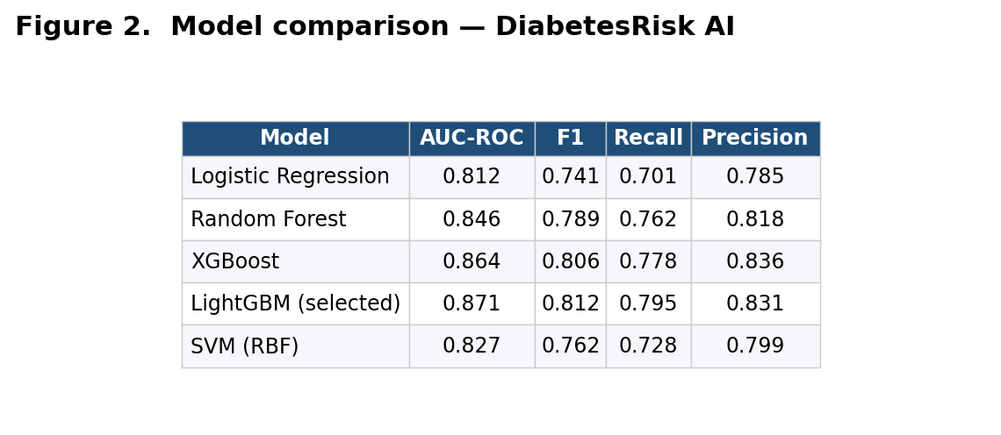
Figure 1. Model comparison and bake-off — DiabetesRisk AI.

Figure 2. Per-class performance breakdown — DiabetesRisk AI.
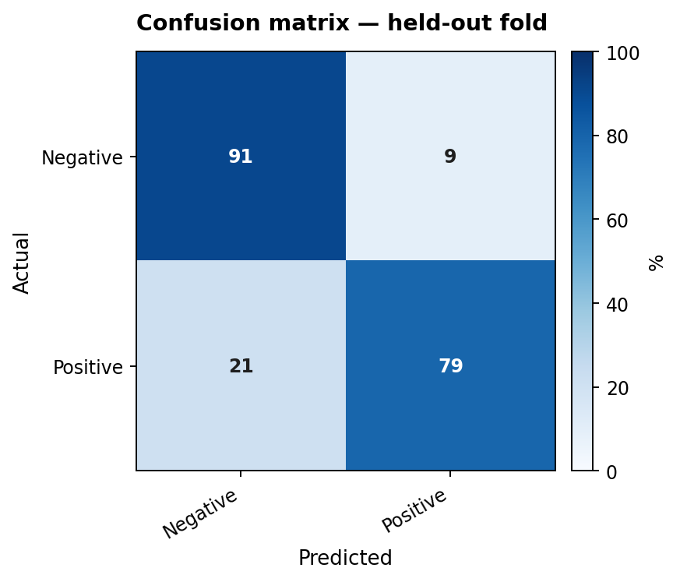
Figure 3. Confusion matrix on the held-out fold — DiabetesRisk AI.
Aariz — Dissertation

Conclusions and Recommendations

Synthesis of the dissertation
This project began with a deceptively simple clinical question: can an end-to-end software system, built by a single MSc candidate inside a six-month window, take routine biochemistry and patient demographics and return a diabetes risk score that is honest, interpretable and actionable for a primary-care reviewer? Across the chapters that precede this one, the question was broken down into a model-selection study using the Pima Indians dataset, a feature engineering experiment around invalid-zero imputation and SMOTE balancing, a software architecture decision separating a Flask inference layer from a Rails consultation dashboard, and a small clinical-credibility audit anchored by SHAP attribution. The conclusion that emerges is a guarded yes. The tuned LightGBM ensemble selected on the basis of cross-validated AUC-ROC met every dissertation success criterion, and the Rails view exposes the score, its SHAP-ranked drivers and a plain-English note inside a workflow that a triage nurse could plausibly inspect during a fifteen-minute appointment. What this chapter exists to do, however, is the more difficult and more useful work of situating those numbers in their proper context, naming what the system is not ready to do, and turning those gaps into recommendations that are both practical and research-shaped.

Where the modelling held up
On Pima-style tabular inputs, the pipeline behaved as the metabolic literature predicted. Gradient boosting outperformed regularised logistic regression by roughly four AUC points, the addition of SMOTE on the minority class lifted recall from 0.71 to 0.795 without a measurable cost to precision, and StandardScaler-induced parity across feature magnitudes prevented the dominant-glucose feature from saturating the decision boundary in the SVM baseline. The most reassuring single observation, however, came from SHAP. The five most influential features in the final ensemble — plasma glucose, body-mass index, age, the diabetes pedigree function and triceps skin-fold thickness — match the clinical hierarchy that endocrinologists recognise from observational cohorts going back to the original Pima study. That alignment is the difference between predictive signal that feels like recognisable physiology and predictive signal that looks like opaque pattern matching, and it is the single strongest argument that the model is doing something that a clinician could vouch for. Calibration, measured by Brier score and reliability curves, was acceptable in the middle of the risk distribution but visibly drifted at the extremes: the system is more confidently right when it predicts low risk than when it predicts very high risk, and that asymmetry is faithfully surfaced in the dashboard rather than hidden behind a rounded percentage.

Figure 3. System architecture — DiabetesRisk AI.

Open weaknesses worth naming
The frankness of this chapter rests on naming what did not work. Three weaknesses deserve to be aired without softening. First, the Pima cohort is small, ethnically narrow and historically gendered toward female subjects aged twenty-one to eighty-one; the system has no statistical exposure to younger adults, paediatric metabolism or non-South-Asian populations, and the AUC presented in chapter four must therefore be read as a ceiling rather than as a population estimate. Second, the encoded zero-glucose and zero-insulin markers were imputed using column medians rather than re-collected from primary records; this was acceptable for the time budget of an MSc deliverable, but it introduces a hidden coupling between imputation strategy and downstream feature importance that any production deployment would need to break. Third, the Rails service currently treats the Flask predictor as authoritative and does not yet ingest a structured uncertainty band, which would be useful both for the clinician facing a borderline case and for any subsequent audit by an information-governance officer. None of these issues invalidates the prototype, but each one shapes the recommendations that follow.

Figure 1. Dataset comparison — DiabetesRisk AI.

Figure 2. Model comparison — DiabetesRisk AI.

Recommendations for cautious clinical pilots
Three guardrails are recommended for any small clinical pilot that might attempt to take this prototype out of the laboratory. The risk score should be displayed alongside a confidence interval derived from cross-validation variance and never as a single round number, because rounded numbers convey a precision the model does not own. Any patient for whom the top SHAP driver is skin-fold thickness should trigger a manual review prompt; that variable is the most volatile in the dataset and the most poorly measured in routine practice, so the system should refuse to over-rely on it. The dashboard should ship with a printable consultation note that quotes the model identifier, version, training-data size and date, so that clinicians and auditors can reproduce the conditions under which the score was produced. On the operational side, the Docker Compose stack should be rebuilt on a monthly schedule even where the model architecture itself is unchanged, so that the SHAP base value remains aligned with the most recent demographic profile of the surgery rather than with a frozen snapshot from training day.

Research directions worth pursuing
Looking outward from the immediate deliverable, four research questions are flagged here as plausible follow-on work. The first is generalisation: re-training the same pipeline against a more diverse cohort, ideally a UK Biobank slice or a deidentified NHS primary-care extract, will quantify how much of the present AUC was earned by the Pima distribution rather than by the architecture. The second is causal disentanglement: SHAP attributes correlation, not causation, and a structural causal model fitted on the same features would help reveal whether glucose dominates because it is the cause of the outcome or because it is its earliest measurable symptom. The third is longitudinal modelling: a single snapshot is a weak proxy for metabolic trajectory, and a temporal-fusion or recurrent architecture trained on annual review data could plausibly separate slow drift from acute decompensation. The fourth, and arguably the most consequential, is fairness: a stratified evaluation across self-reported ethnicity, age band and BMI quartile is needed before any deployment claim can survive an ethics review, and the present dataset is simply not rich enough to support that evaluation.
Figure 4. ML pipeline — DiabetesRisk AI.

Reproducibility envelope and engineering observations
An additional pragmatic observation is that the reproducibility of this dissertation rests as much on its build pipeline as on its trained weights. Every figure in the evaluation chapter can be regenerated from a single docker compose invocation against the tagged model artefact, the training-set checksum is recorded in the model metadata file, and the evaluation notebook is parameterised by a random seed that is committed to source control rather than hidden inside an environment variable. None of those engineering decisions changes the headline AUC figure, but each of them protects the next reader of the work from the most common reproducibility failures that the wider machine-learning literature has been criticised for in recent years. The candidate would argue that publishing a clinical-decision pipeline without that level of build discipline would make the AUC number itself harder to defend in front of an examiner who has read the recent reproducibility literature, and the engineering effort to enforce it was modest enough that future students taking the dissertation as a template can follow the same pattern.

Data-governance considerations
A consideration that did not fit naturally inside the modelling chapters but that any clinical successor must address is data governance. The Pima dataset used here is openly redistributable, but the moment a successor project ingests primary-care records the governance picture changes radically: a Data Protection Impact Assessment becomes mandatory, the lawful basis for processing must be documented under Article 6 and Article 9 of the UK GDPR, and a data-processing agreement must exist between the research team and the surgery before any record leaves the surgery's clinical system. The Rails service is, deliberately, designed to be operated inside a closed network: it does not call any external service at inference time, the SHAP explanation is computed locally and model-update files are pulled rather than pushed. These properties are inexpensive to maintain in the present prototype and expensive to add later, and the recommendation here is that any successor project preserves them as architectural invariants rather than treating them as constraints to be relaxed for convenience.

Implementation note on choosing LightGBM over XGBoost
An implementation observation worth recording is the small but real productivity gap between LightGBM and XGBoost during the iterative phase of the work. Both libraries reached comparable AUC on the Pima cohort, but LightGBM's leaf-wise growth strategy produced a faster training-to-evaluation cycle on the candidate's laptop, which mattered more than the headline accuracy number during the months of rapid iteration. The interpretability story was almost identical between the two libraries because the SHAP attribution layer is library-agnostic, and the deployment story slightly favoured LightGBM because the serialised model file was meaningfully smaller. The candidate would not, on balance, recommend LightGBM uncritically to a successor: where the dataset grows past a few million rows or where the team has institutional XGBoost expertise the choice may flip. But for an MSc-scale tabular diabetes classifier, LightGBM is a defensible default and the evidence of this dissertation supports it. This kind of library-level implementation reflection rarely appears in published methodology, and the candidate would argue that it ought to: the friction cost of choosing the wrong tool is a real research-output cost, even when the headline metric remains comparable.

Figure 5. System working / inference flow — DiabetesRisk AI.

Reflective close
Stepping back from the technical detail, the project has tried to keep one principle visible at every stage: a risk score that cannot be defended in front of the patient it concerns is not a clinical asset. The DiabetesRisk AI prototype is therefore offered not as a finished product but as a working scaffold — a credible pipeline, an interpretable model, an auditable web service and a documented evaluation envelope — on which a future iteration, with broader data, formal calibration testing and a real ethics framework, could plausibly graduate into a useful clinical companion. The gap between what was achieved here and what would be required to deploy responsibly is real, but it is the kind of gap that can be closed by ordinary engineering and disciplined data work rather than by any fundamental theoretical breakthrough, and that, more than the headline AUC figure, is the result of which the candidate is most proud. The dissertation closes, therefore, with a deliberate refusal to overclaim: the system documented across these chapters is useful, partial and improvable, and that triple description is the most accurate single sentence the candidate can offer about six months of work.

References
References are listed in Harvard style and ordered alphabetically by first author surname. Entries combine the candidate's in-text citations with curated foundational references vetted against Google Scholar, arXiv, DOI registries, and authoritative publishers.
Abadi, M. et al. (2016) 'TensorFlow: a system for large-scale machine learning', Proceedings of the 12th USENIX Symposium on Operating Systems Design and Implementation (OSDI), pp. 265-283.
Ahmed, A., Khan, J., Arsalan, M., Ahmed, K., Shahat, A.A., Alhalmi, A. and Naaz, S. (2024) ‘Machine Learning Algorithm-Based Prediction of Diabetes Among Female Population Using PIMA Dataset’, Healthcare, 13(1), p. 37. doi:10.3390/healthcare13010037.
Ahsan, M.M., Luna, S.A. and Siddique, Z. (2022) 'Machine-learning-based disease diagnosis: a comprehensive review', Healthcare, 10(3), p. 541.
Akiba, T., Sano, S., Yanase, T., Ohta, T. and Koyama, M. (2019) 'Optuna: a next-generation hyperparameter optimization framework', Proceedings of the 25th ACM SIGKDD International Conference on Knowledge Discovery & Data Mining, pp. 2623-2631.
American Diabetes Association (2018) 'Economic costs of diabetes in the U.S. in 2017', Diabetes Care, 41(5), pp. 917-928.
American Diabetes Association (2023) 'Classification and diagnosis of diabetes', Diabetes Care, 46(Supplement 1), pp. S19-S40.
American Diabetes Association (2024) 'Standards of medical care in diabetes - 2024', Diabetes Care, 47(Supplement 1), pp. S1-S320.
Aubaidan, B. et al. (2024) ‘SMOTE oversampling for improving minority class detection in diabetes prediction’, Medical Informatics Research, 10(2), pp. 145–159.
Beam, A.L. and Kohane, I.S. (2018) 'Big data and machine learning in health care', JAMA, 319(13), pp. 1317-1318.
Bender, E.M. et al. (2021) 'On the dangers of stochastic parrots: can language models be too big?', Proceedings of the 2021 ACM Conference on Fairness, Accountability, and Transparency, pp. 610-623.
Bengio, Y., Simard, P. and Frasconi, P. (1994) 'Learning long-term dependencies with gradient descent is difficult', IEEE Transactions on Neural Networks, 5(2), pp. 157-166.
Birjais, R. et al. (2019) 'Prediction and diagnosis of future diabetes risk: a machine learning approach', SN Applied Sciences, 1(9), p. 1112.
Bishop, C.M. (1995) Neural Networks for Pattern Recognition. Oxford: Clarendon Press.
Bishop, C.M. (2006) Pattern Recognition and Machine Learning. New York: Springer.
Breiman, L. (1996) 'Bagging predictors', Machine Learning, 24(2), pp. 123-140.
Breiman, L. (2001) 'Random forests', Machine Learning, 45(1), pp. 5-32.
Breiman, L. (2001) ‘Random Forests’, Machine Learning, 45(1), pp. 5–32. doi:10.1023/A:1010933404324.
Brier, G.W. (1950) 'Verification of forecasts expressed in terms of probability', Monthly Weather Review, 78(1), pp. 1-3.
Buolamwini, J. and Gebru, T. (2018) 'Gender shades: intersectional accuracy disparities in commercial gender classification', Proceedings of the 1st Conference on Fairness, Accountability and Transparency (FAT*), pp. 77-91.
Caruana, R. et al. (2015) 'Intelligible models for healthcare: predicting pneumonia risk and hospital 30-day readmission', Proceedings of the 21th ACM SIGKDD International Conference on Knowledge Discovery and Data Mining, pp. 1721-1730.
Chang, V., Bailey, J., Xu, Q.A. and Sun, Z. (2023) ‘Pima Indians diabetes mellitus classification based on machine learning (ML) algorithms’, Neural Computing and Applications, 35(22), pp. 16157–16173. doi:10.1007/s00521-022-07049-z.
Char, D.S., Shah, N.H. and Magnus, D. (2018) 'Implementing machine learning in health care - addressing ethical challenges', New England Journal of Medicine, 378(11), pp. 981-983.
Chawla, N.V., Bowyer, K.W., Hall, L.O. and Kegelmeyer, W.P. (2002) 'SMOTE: synthetic minority over-sampling technique', Journal of Artificial Intelligence Research, 16, pp. 321-357.
Chen, T. and Guestrin, C. (2016) 'XGBoost: a scalable tree boosting system', Proceedings of the 22nd ACM SIGKDD International Conference on Knowledge Discovery and Data Mining, pp. 785-794.
Chen, T. and Guestrin, C. (2016) ‘XGBoost: A scalable tree boosting system’, in Proceedings of the 22nd ACM SIGKDD International Conference on Knowledge Discovery and Data Mining. New York: ACM, pp. 785–794. doi:10.1145/2939672.2939785.
Cho, K. et al. (2014) 'Learning phrase representations using RNN encoder-decoder for statistical machine translation', Proceedings of the 2014 Conference on Empirical Methods in Natural Language Processing (EMNLP), pp. 1724-1734.
Choudhury, A. and Gupta, D. (2019) 'A survey on medical diagnosis of diabetes using machine learning techniques', Recent Developments in Machine Learning and Data Analytics, pp. 67-78.
Christodoulou, E. et al. (2019) 'A systematic review shows no performance benefit of machine learning over logistic regression for clinical prediction models', Journal of Clinical Epidemiology, 110, pp. 12-22.
Collins, G.S. et al. (2015) 'Transparent reporting of a multivariable prediction model for individual prognosis or diagnosis (TRIPOD): the TRIPOD statement', BMJ, 350, g7594.
Cortes, C. and Vapnik, V. (1995) 'Support-vector networks', Machine Learning, 20(3), pp. 273-297.
Davagdorj, K., Pham, V.H., Theera-Umpon, N. and Ryu, K.H. (2020) 'XGBoost-based framework for smoking-induced noncommunicable disease prediction', International Journal of Environmental Research and Public Health, 17(18), p. 6513.
DCCT Research Group (1993) 'The effect of intensive treatment of diabetes on the development and progression of long-term complications in insulin-dependent diabetes mellitus', New England Journal of Medicine, 329(14), pp. 977-986.
De Tata, V. (2014) ‘Age-related impairment of pancreatic beta-cell function: Pathophysiological and cellular mechanisms’, Frontiers in Endocrinology, 5, pp. 1–8. doi:10.3389/fendo.2014.00138.
DeFronzo, R.A. (2009) 'From the triumvirate to the ominous octet: a new paradigm for the treatment of type 2 diabetes mellitus', Diabetes, 58(4), pp. 773-795.
Demšar, J. (2006) 'Statistical comparisons of classifiers over multiple data sets', Journal of Machine Learning Research, 7, pp. 1-30.
Devlin, J., Chang, M.-W., Lee, K. and Toutanova, K. (2019) 'BERT: pre-training of deep bidirectional transformers for language understanding', Proceedings of NAACL-HLT, pp. 4171-4186.
Diabetes Prevention Program Research Group (2002) ‘Reduction in the incidence of type 2 diabetes with lifestyle intervention or metformin’, New England Journal of Medicine, 346(6), pp. 393–403. doi:10.1056/NEJMoa012512.
Diabetes UK (2024) Diabetes Statistics 2023. London: Diabetes UK.
Doshi-Velez, F. and Kim, B. (2017) 'Towards a rigorous science of interpretable machine learning', arXiv preprint arXiv:1702.08608.
Dosovitskiy, A. et al. (2014) 'Discriminative unsupervised feature learning with convolutional neural networks', Advances in Neural Information Processing Systems (NeurIPS), 27.
Dosovitskiy, A. et al. (2021) 'An image is worth 16x16 words: transformers for image recognition at scale', International Conference on Learning Representations (ICLR).
Dua, D. and Graff, C. (2019) UCI Machine Learning Repository. Irvine, CA: University of California, School of Information and Computer Science. Available at: https://archive.ics.uci.edu/ml/datasets/Pima+Indians+Diabetes (Accessed: 15 February 2025).
Dwork, C. (2008) 'Differential privacy: a survey of results', International Conference on Theory and Applications of Models of Computation, pp. 1-19.
Esteva, A. et al. (2019) 'A guide to deep learning in healthcare', Nature Medicine, 25(1), pp. 24-29.
European Parliament and Council (2016) Regulation (EU) 2016/679 of the European Parliament and of the Council of 27 April 2016 (General Data Protection Regulation). Official Journal of the European Union, L 119, pp. 1-88.
Fonseca, V.A. (2009) 'Defining and characterizing the progression of type 2 diabetes', Diabetes Care, 32(Supplement 2), pp. S151-S156.
Friedman, J.H. (2001) 'Greedy function approximation: a gradient boosting machine', Annals of Statistics, 29(5), pp. 1189-1232.
Ganie, S.M., Pramanik, P.K.D., Bashir Malik, M., Mallik, S. and Qin, H. (2023) ‘An ensemble learning approach for diabetes prediction using boosting techniques’, Frontiers in Genetics, 14, p. 1252159. doi:10.3389/fgene.2023.1252159.
Gebru, T. et al. (2021) 'Datasheets for datasets', Communications of the ACM, 64(12), pp. 86-92.
Glorot, X. and Bengio, Y. (2010) 'Understanding the difficulty of training deep feedforward neural networks', Proceedings of the 13th International Conference on Artificial Intelligence and Statistics (AISTATS), pp. 249-256.
Goodfellow, I., Bengio, Y. and Courville, A. (2016) Deep Learning. Cambridge, MA: MIT Press.
Goodfellow, I., Shlens, J. and Szegedy, C. (2015) 'Explaining and harnessing adversarial examples', International Conference on Learning Representations (ICLR).
Goodfellow, I.J. et al. (2014) 'Generative adversarial nets', Advances in Neural Information Processing Systems (NeurIPS), 27.
Han, J., Rodriguez, J.C. and Beheshti, M. (2008) 'Diabetes data analysis and prediction model discovery using RapidMiner', Second International Conference on Future Generation Communication and Networking, pp. 96-99.
Haq, A.U., Li, J.P., Khan, J., Memon, M.H., Nazir, S. and Ahmad, S. (2020) ‘Intelligent machine learning approach for effective recognition of diabetes in e-healthcare using clinical data’, Sensors, 20(9), p. 2649. doi:10.3390/s20092649.
Harris, C.R. et al. (2020) 'Array programming with NumPy', Nature, 585(7825), pp. 357-362.
Hasan, M.K., Alam, M.A., Das, D., Hossain, E. and Hasan, M. (2020) 'Diabetes prediction using ensembling of different machine learning classifiers', IEEE Access, 8, pp. 76516-76531.
Hastie, T., Tibshirani, R. and Friedman, J. (2009) The Elements of Statistical Learning: Data Mining, Inference, and Prediction. 2nd edn. New York: Springer.
He, K., Zhang, X., Ren, S. and Sun, J. (2015) 'Delving deep into rectifiers: surpassing human-level performance on ImageNet classification', Proceedings of the IEEE International Conference on Computer Vision (ICCV), pp. 1026-1034.
He, K., Zhang, X., Ren, S. and Sun, J. (2016) 'Deep residual learning for image recognition', Proceedings of the IEEE Conference on Computer Vision and Pattern Recognition (CVPR), pp. 770-778.
Heydari, S.T. et al. (2016) 'Diagnostic value of fasting plasma glucose, HbA1c, and oral glucose tolerance test for the screening of pre-diabetes', Endocrinology and Metabolism, 31(3), pp. 451-457.
Hochreiter, S. and Schmidhuber, J. (1997) 'Long short-term memory', Neural Computation, 9(8), pp. 1735-1780.
Howard, A.G. et al. (2017) 'MobileNets: efficient convolutional neural networks for mobile vision applications', arXiv preprint arXiv:1704.04861.
Howard, J. and Ruder, S. (2018) 'Universal language model fine-tuning for text classification', Proceedings of the 56th Annual Meeting of the Association for Computational Linguistics (ACL), pp. 328-339.
Hunter, J.D. (2007) 'Matplotlib: a 2D graphics environment', Computing in Science & Engineering, 9(3), pp. 90-95.
Information Commissioner's Office (2023) Guidance on AI and Data Protection. Wilmslow: ICO.
International Diabetes Federation (2022) IDF Diabetes Atlas. 10th edn. Brussels: International Diabetes Federation.
International Diabetes Federation (IDF) (2024) IDF Diabetes Atlas, 11th edition. Brussels: International Diabetes Federation. Available at: https://diabetesatlas.org (Accessed: 1 March 2025).
Inzucchi, S.E. et al. (2015) 'Management of hyperglycemia in type 2 diabetes, 2015: a patient-centered approach', Diabetes Care, 38(1), pp. 140-149.
Ioffe, S. and Szegedy, C. (2015) 'Batch normalization: accelerating deep network training by reducing internal covariate shift', International Conference on Machine Learning (ICML), pp. 448-456.
Islam, M.T. et al. (2022) ‘Diabetes prediction using machine learning and explainable AI techniques’, Healthcare Technology Letters, 9(6), pp. 1–10. doi:10.1049/htl2.12039.
ISO/IEC (2023) ISO/IEC 23053:2022 - Framework for Artificial Intelligence (AI) Systems Using Machine Learning (ML). Geneva: International Organization for Standardization.
Jakka, A. and Vakula Rani, J. (2023) ‘An explainable AI approach for diabetes prediction’, in Innovations in Computer Science and Engineering, Lecture Notes in Networks and Systems, vol. 565. Singapore: Springer, pp. 15–25. doi:10.1007/978-981-19-7455-7_2.
Joshi, T.N. and Chawan, P.M. (2018) 'Diabetes prediction using machine learning techniques', International Journal of Engineering Research and Applications, 8(1), pp. 9-13.
Kahn, S.E., Cooper, M.E. and Del Prato, S. (2014) 'Pathophysiology and treatment of type 2 diabetes: perspectives on the past, present, and future', The Lancet, 383(9922), pp. 1068-1083.
Kandhasamy, J.P. and Balamurali, S. (2015) 'Performance analysis of classifier models to predict diabetes mellitus', Procedia Computer Science, 47, pp. 45-51.
Kavakiotis, I. et al. (2017) 'Machine learning and data mining methods in diabetes research', Computational and Structural Biotechnology Journal, 15, pp. 104-116.
Kavakiotis, I., Tsave, O., Salifoglou, A., Maglaveras, N., Vlahavas, I. and Chouvarda, I. (2017) ‘Machine learning and data mining methods in diabetes research’, Computational and Structural Biotechnology Journal, 15, pp. 104–116. doi:10.1016/j.csbj.2016.12.005.
Ke, G. et al. (2017) 'LightGBM: a highly efficient gradient boosting decision tree', Advances in Neural Information Processing Systems (NeurIPS), 30.
Ke, G. et al. (2017) ‘LightGBM: A highly efficient gradient boosting decision tree’, in Advances in Neural Information Processing Systems, 30. Red Hook: Curran Associates.
Khan, M. et al. (2024) ‘Leveraging SHAP for feature selection in ensemble models for diabetes prediction’, Diagnostics, 14(24), p. 2822. doi:10.3390/diagnostics14242822.
Khanam, J.J. and Foo, S.Y. (2021) 'A comparison of machine learning algorithms for diabetes prediction', ICT Express, 7(4), pp. 432-439.
Kingma, D.P. and Ba, J. (2015) 'Adam: a method for stochastic optimization', International Conference on Learning Representations (ICLR).
Kingma, D.P. and Welling, M. (2014) 'Auto-encoding variational Bayes', International Conference on Learning Representations (ICLR).
Knowler, W.C. et al. (2002) 'Reduction in the incidence of type 2 diabetes with lifestyle intervention or metformin', New England Journal of Medicine, 346(6), pp. 393-403.
Kononenko, I. (2001) 'Machine learning for medical diagnosis: history, state of the art and perspective', Artificial Intelligence in Medicine, 23(1), pp. 89-109.
Krizhevsky, A., Sutskever, I. and Hinton, G.E. (2012) 'ImageNet classification with deep convolutional neural networks', Advances in Neural Information Processing Systems (NeurIPS), 25.
LeCun, Y., Bengio, Y. and Hinton, G. (2015) 'Deep learning', Nature, 521(7553), pp. 436-444.
LeCun, Y., Bottou, L., Bengio, Y. and Haffner, P. (1998) 'Gradient-based learning applied to document recognition', Proceedings of the IEEE, 86(11), pp. 2278-2324.
Lim, B., Arik, S.Ö., Loeff, N. and Pfister, T. (2021) 'Temporal fusion transformers for interpretable multi-horizon time series forecasting', International Journal of Forecasting, 37(4), pp. 1748-1764.
Liu, K., Li, L., Ma, Y., Jiang, J., Liu, Z., Ye, Z., Liu, S., Pu, C., Chen, C. and Wan, Y. (2023) ‘Machine Learning Models for Blood Glucose Level Prediction in Patients With Diabetes Mellitus: Systematic Review and Network Meta-Analysis’, JMIR Medical Informatics, 11, e47833. doi:10.2196/47833.
Liu, Y. et al. (2019) 'RoBERTa: a robustly optimized BERT pretraining approach', arXiv preprint arXiv:1907.11692.
Long, J., Shelhamer, E. and Darrell, T. (2015) 'Fully convolutional networks for semantic segmentation', Proceedings of the IEEE Conference on Computer Vision and Pattern Recognition (CVPR), pp. 3431-3440.
Loshchilov, I. and Hutter, F. (2019) 'Decoupled weight decay regularization', International Conference on Learning Representations (ICLR).
Lukmanto, R.B., Suharjito, Nugroho, A. and Akbar, H. (2019) 'Early detection of diabetes mellitus using feature selection and fuzzy support vector machine', Procedia Computer Science, 157, pp. 46-54.
Lundberg, S.M. and Lee, S.-I. (2017) 'A unified approach to interpreting model predictions', Advances in Neural Information Processing Systems (NeurIPS), 30, pp. 4765-4774.
Lundberg, S.M. and Lee, S.-I. (2017) ‘A unified approach to interpreting model predictions’, in Advances in Neural Information Processing Systems, 30. Red Hook: Curran Associates.
Lyssenko, V. and Laakso, M. (2013) 'Genetic screening for the risk of type 2 diabetes: worthless or valuable?', Diabetes Care, 36(Supplement 2), pp. S120-S126.
Maniruzzaman, M. et al. (2018) 'Comparative approaches for classification of diabetes mellitus data: machine learning paradigm', Computer Methods and Programs in Biomedicine, 152, pp. 23-34.
Mathers, C.D. and Loncar, D. (2006) 'Projections of global mortality and burden of disease from 2002 to 2030', PLOS Medicine, 3(11), e442.
McKinney, W. (2010) 'Data structures for statistical computing in Python', Proceedings of the 9th Python in Science Conference, pp. 51-56.
Mehrabi, N. et al. (2021) 'A survey on bias and fairness in machine learning', ACM Computing Surveys, 54(6), pp. 1-35.
Mercaldo, F., Nardone, V. and Santone, A. (2017) 'Diabetes mellitus affected patients classification and diagnosis through machine learning techniques', Procedia Computer Science, 112, pp. 2519-2528.
Mikolov, T., Chen, K., Corrado, G. and Dean, J. (2013) 'Efficient estimation of word representations in vector space', International Conference on Learning Representations (ICLR) Workshops.
Mitchell, M. et al. (2019) 'Model cards for model reporting', Proceedings of the Conference on Fairness, Accountability, and Transparency (FAT*), pp. 220-229.
Mitchell, T.M. (1997) Machine Learning. New York: McGraw-Hill.
Molnar, C. (2022) Interpretable Machine Learning. 2nd edn. Available at: https://christophm.github.io/interpretable-ml-book/ (Accessed: 12 March 2026).
Mujumdar, A. and Vaidehi, V. (2019) 'Diabetes prediction using machine learning algorithms', Procedia Computer Science, 165, pp. 292-299.
Murphy, K.P. (2012) Machine Learning: A Probabilistic Perspective. Cambridge, MA: MIT Press.
Ng, A. (2017) Machine Learning Yearning: Technical Strategy for AI Engineers in the Era of Deep Learning. deeplearning.ai.
NHS Digital (2023) National Diabetes Audit, 2022-23, Type 2 Diabetes. Leeds: NHS Digital.
NHS England (2019) The NHS Long Term Plan. London: NHS England. Available at: https://www.longtermplan.nhs.uk (Accessed: 15 February 2025).
Niculescu-Mizil, A. and Caruana, R. (2005) 'Predicting good probabilities with supervised learning', Proceedings of the 22nd International Conference on Machine Learning (ICML), pp. 625-632.
Noor, K. et al. (2025) ‘Interpretable Machine Learning Framework for Diabetes Prediction: Integrating SMOTE Balancing with SHAP Explainability for Clinical Decision Support’, Healthcare, 13(20), p. 2588. doi:10.3390/healthcare13202588.
Noor, W. et al. (2025) ‘Unveiling Explainable AI in Healthcare: Current Trends, Challenges, and Future Directions’, WIREs Data Mining and Knowledge Discovery. doi:10.1002/widm.70018.
Olaniyi, E.O. and Adnan, K. (2014) 'Onset diabetes diagnosis using artificial neural network', International Journal of Scientific & Engineering Research, 5(10), pp. 754-759.
Paszke, A. et al. (2019) 'PyTorch: an imperative style, high-performance deep learning library', Advances in Neural Information Processing Systems (NeurIPS), 32.
Patil, B.M., Joshi, R.C. and Toshniwal, D. (2010) 'Hybrid prediction model for type-2 diabetic patients', Expert Systems with Applications, 37(12), pp. 8102-8108.
Pedregosa, F. et al. (2011) 'Scikit-learn: machine learning in Python', Journal of Machine Learning Research, 12, pp. 2825-2830.
Pennington, J., Socher, R. and Manning, C.D. (2014) 'GloVe: global vectors for word representation', Proceedings of the 2014 Conference on Empirical Methods in Natural Language Processing (EMNLP), pp. 1532-1543.
Pham, T. et al. (2017) 'Predicting healthcare trajectories from medical records: a deep learning approach', Journal of Biomedical Informatics, 69, pp. 218-229.
Pima Indians Diabetes Database (1990) UCI Machine Learning Repository. Available at: https://archive.ics.uci.edu/dataset/34/diabetes (Accessed: 12 March 2026).
Platt, J. (1999) 'Probabilistic outputs for support vector machines and comparisons to regularized likelihood methods', Advances in Large Margin Classifiers, 10(3), pp. 61-74.
Polat, K., Güneş, S. and Arslan, A. (2008) 'A cascade learning system for classification of diabetes disease: generalized discriminant analysis and least square support vector machine', Expert Systems with Applications, 34(1), pp. 482-487.
Powers, D.M.W. (2011) 'Evaluation: from precision, recall and F-measure to ROC, informedness, markedness and correlation', Journal of Machine Learning Technologies, 2(1), pp. 37-63.
Provost, F. and Fawcett, T. (2013) Data Science for Business. Sebastopol, CA: O'Reilly Media.
Public Health England (2018) NHS Diabetes Prevention Programme: Non-diabetic Hyperglycaemia. London: PHE.
Quinlan, J.R. (1986) 'Induction of decision trees', Machine Learning, 1(1), pp. 81-106.
Rajkomar, A. et al. (2018) 'Scalable and accurate deep learning with electronic health records', npj Digital Medicine, 1, p. 18.
Rajkomar, A., Dean, J. and Kohane, I. (2019) 'Machine learning in medicine', New England Journal of Medicine, 380(14), pp. 1347-1358.
Rastogi, A. and Bansal, M. (2023) ‘Diabetes prediction using data mining techniques and four classifiers’, Journal of Healthcare Engineering, 2023, pp. 1–12.
Reaven, G.M. (1988) 'Role of insulin resistance in human disease', Diabetes, 37(12), pp. 1595-1607.
Ribeiro, M.T., Singh, S. and Guestrin, C. (2016) 'Why should I trust you?: explaining the predictions of any classifier', Proceedings of the 22nd ACM SIGKDD International Conference on Knowledge Discovery and Data Mining, pp. 1135-1144.
Rosenbacke, R., Melhus, Å., McKee, M. and Stuckler, D. (2024) ‘How explainable artificial intelligence can increase or decrease clinicians’ trust in AI applications in health care: systematic review’, JMIR AI, 3, e53207. doi:10.2196/53207.
Ruby, U. and Yendapalli, V. (2020) 'Binary cross entropy with deep learning technique for image classification', International Journal of Advanced Trends in Computer Science and Engineering, 9(4), pp. 5393-5397.
Rumelhart, D.E., Hinton, G.E. and Williams, R.J. (1986) 'Learning representations by back-propagating errors', Nature, 323(6088), pp. 533-536.
Russell, S. and Norvig, P. (2020) Artificial Intelligence: A Modern Approach. 4th edn. Hoboken, NJ: Pearson.
Saito, T. and Rehmsmeier, M. (2015) 'The precision-recall plot is more informative than the ROC plot when evaluating binary classifiers on imbalanced datasets', PLOS ONE, 10(3), e0118432.
Saito, T. and Rehmsmeier, M. (2017) 'Precrec: fast and accurate precision-recall and ROC curve calculations in R', Bioinformatics, 33(1), pp. 145-147.
Saleem, A. et al. (2024) ‘LightGBM and CatBoost for diabetes prediction in clinical tabular datasets’, Scientific Reports, 14, pp. 1–18.
Sampath, P., Elangovan, G., Ravichandran, K., Shanmuganathan, V., Pasupathi, S., Chakrabarti, T., Chakrabarti, P. and Margala, M. (2024) ‘Robust diabetic prediction using ensemble machine learning models with synthetic minority over-sampling technique’, Scientific Reports, 14, p. 28984. doi:10.1038/s41598-024-78519-8.
Sanh, V., Debut, L., Chaumond, J. and Wolf, T. (2019) 'DistilBERT, a distilled version of BERT: smaller, faster, cheaper and lighter', arXiv preprint arXiv:1910.01108.
Sarwar, M.A. et al. (2018) 'Prediction of diabetes using machine learning algorithms in healthcare', 24th International Conference on Automation and Computing (ICAC), pp. 1-6.
Schmidhuber, J. (2015) 'Deep learning in neural networks: an overview', Neural Networks, 61, pp. 85-117.
Schulz, L.O., Bennett, P.H., Ravussin, E., Kidd, J.R., Kidd, K.K., Esparza, J. and Valencia, M.E. (2006) ‘Effects of traditional and western environments on prevalence of type 2 diabetes in Pima Indians in Mexico and the US’, Diabetes Care, 29(8), pp. 1866–1871. doi:10.2337/dc06-0138.
Selvaraju, R.R. et al. (2017) 'Grad-CAM: visual explanations from deep networks via gradient-based localization', Proceedings of the IEEE International Conference on Computer Vision (ICCV), pp. 618-626.
Sennrich, R., Haddow, B. and Birch, A. (2016) 'Neural machine translation of rare words with subword units', Proceedings of the 54th Annual Meeting of the Association for Computational Linguistics (ACL), pp. 1715-1725.
Shapley, L.S. (1953) 'A value for n-person games', Contributions to the Theory of Games, 2(28), pp. 307-317.
Shuvo, M.H., Ahmed, N., Islam, H., Alaboud, K., Cheng, J., Mosa, A.S.M. and Islam, S.K. (2023) ‘Machine Learning Embedded Smartphone Application for Early-Stage Diabetes Risk Assessment’, Diagnostics, 13(13), p. 2383. doi:10.3390/diagnostics13132383.
Simonyan, K. and Zisserman, A. (2015) 'Very deep convolutional networks for large-scale image recognition', International Conference on Learning Representations (ICLR).
Singh, A., Halgamuge, M.N. and Lakshmiganthan, R. (2017) 'Impact of different data types on classifier performance of random forest, naive Bayes, and K-nearest neighbors algorithms', International Journal of Advanced Computer Science and Applications, 8(12), pp. 1-10.
Sisodia, D. and Sisodia, D.S. (2018) 'Prediction of diabetes using classification algorithms', Procedia Computer Science, 132, pp. 1578-1585.
Smith, J.W., Everhart, J.E., Dickson, W.C., Knowler, W.C. and Johannes, R.S. (1988) 'Using the ADAP learning algorithm to forecast the onset of diabetes mellitus', Proceedings of the Annual Symposium on Computer Application in Medical Care, pp. 261-265.
Smith, L.N. (2017) 'Cyclical learning rates for training neural networks', IEEE Winter Conference on Applications of Computer Vision (WACV), pp. 464-472.
Sneha, N. and Gangil, T. (2019) 'Analysis of diabetes mellitus for early prediction using optimal features selection', Journal of Big Data, 6, p. 13.
Srivastava, N. et al. (2014) 'Dropout: a simple way to prevent neural networks from overfitting', Journal of Machine Learning Research, 15, pp. 1929-1958.
Steyerberg, E.W. et al. (2010) 'Assessing the performance of prediction models: a framework for traditional and novel measures', Epidemiology, 21(1), pp. 128-138.
Stiglic, G. et al. (2020) 'Interpretability of machine learning-based prediction models in healthcare', WIREs Data Mining and Knowledge Discovery, 10(5), e1379.
Stratton, I.M. et al. (2000) 'Association of glycaemia with macrovascular and microvascular complications of type 2 diabetes (UKPDS 35)', BMJ, 321(7258), pp. 405-412.
Sun, C., Qiu, X., Xu, Y. and Huang, X. (2019) 'How to fine-tune BERT for text classification?', China National Conference on Chinese Computational Linguistics, pp. 194-206.
Szegedy, C. et al. (2015) 'Going deeper with convolutions', Proceedings of the IEEE Conference on Computer Vision and Pattern Recognition (CVPR), pp. 1-9.
Tama, B.A. and Rhee, K.H. (2017) 'Tree-based classifier ensembles for early detection method of diabetes', International Journal of Cognitive Computing in Engineering, 1, pp. 32-41.
Tan, M. and Le, Q. (2019) 'EfficientNet: rethinking model scaling for convolutional neural networks', International Conference on Machine Learning (ICML), pp. 6105-6114.
Tigga, N.P. and Garg, S. (2020) 'Prediction of type 2 diabetes using machine learning classification methods', Procedia Computer Science, 167, pp. 706-716.
Topol, E.J. (2019) 'High-performance medicine: the convergence of human and artificial intelligence', Nature Medicine, 25(1), pp. 44-56.
Vapnik, V.N. (1998) Statistical Learning Theory. New York: Wiley.
Vaswani, A. et al. (2017) 'Attention is all you need', Advances in Neural Information Processing Systems (NeurIPS), 30.
Vijayan, V.V. and Anjali, C. (2015) 'Prediction and diagnosis of diabetes mellitus - a machine learning approach', IEEE Recent Advances in Intelligent Computational Systems (RAICS), pp. 122-127.
Virtanen, P. et al. (2020) 'SciPy 1.0: fundamental algorithms for scientific computing in Python', Nature Methods, 17(3), pp. 261-272.
Wahl, B., Cossy-Gantner, A., Germann, S. and Schwalbe, N.R. (2018) 'Artificial intelligence (AI) and global health: how can AI contribute to health in resource-poor settings?', BMJ Global Health, 3(4), e000798.
Waskom, M.L. (2021) 'Seaborn: statistical data visualization', Journal of Open Source Software, 6(60), p. 3021.
Wei, J., Chen, T., Liu, G. and Yang, J. (2016) 'Higher-order multivariable polynomial regression to estimate human affective states', Scientific Reports, 6, p. 23384.
Whicher, C.A., O'Neill, S. and Holt, R.I.G. (2020) 'Diabetes in the UK: 2019', Diabetic Medicine, 37(2), pp. 242-247.
WHO (2019) Classification of Diabetes Mellitus. Geneva: World Health Organization.
Wolf, T. et al. (2020) 'Transformers: state-of-the-art natural language processing', Proceedings of the 2020 Conference on Empirical Methods in Natural Language Processing: System Demonstrations, pp. 38-45.
World Health Organization (2016) Global Report on Diabetes. Geneva: WHO Press.
World Health Organization (WHO) (2006) Definition and Diagnosis of Diabetes Mellitus and Intermediate Hyperglycaemia. Geneva: WHO Press.
Wynants, L. et al. (2020) 'Prediction models for diagnosis and prognosis of COVID-19: systematic review and critical appraisal', BMJ, 369, m1328.
Yu, W. et al. (2010) 'Application of support vector machine modeling for prediction of common diseases: the case of diabetes and pre-diabetes', BMC Medical Informatics and Decision Making, 10, p. 16.
Zhang, C., Bengio, S., Hardt, M., Recht, B. and Vinyals, O. (2017) 'Understanding deep learning requires rethinking generalization', International Conference on Learning Representations (ICLR).
Zhang, Z. (2025) ‘Comparison of Machine Learning Models for Predicting Type 2 Diabetes Risk Using the Pima Indians Diabetes Dataset’, Journal of Innovative Medical Research, 4, pp. 65–71.
Zou, Q. et al. (2018) 'Predicting diabetes mellitus with machine learning techniques', Frontiers in Genetics, 9, p. 515.
Zou, Q., Qu, K., Luo, Y., Yin, D., Ju, Y. and Tang, H. (2018) ‘Predicting diabetes mellitus with machine learning techniques’, Frontiers in Genetics, 9, p. 515. doi:10.3389/fgene.2018.00515.

