Chapter 4: Findings
This chapter presents the empirical outcomes produced by the diabetes risk stratification pipeline described in Chapter 3. Evaluation was conducted on the held-out PIMA Indians Diabetes test partition comprising 15% of the preprocessed dataset, containing 115 records not seen at any stage of training or hyperparameter selection. Performance is reported across five classifiers — Logistic Regression, Random Forest, Support Vector Machine, XGBoost, and LightGBM — against the primary thresholds of AUC-ROC ≥ 0.85, macro-averaged F1 ≥ 0.80, and sensitivity ≥ 0.78 established in the methodology. Findings are organised to address the primary research question: whether a machine learning pipeline trained on routinely collected clinical variables achieves clinically adequate discrimination between diabetic and non-diabetic patients.
4.1 Preprocessing and Feature Engineering Outcomes
Following the removal of biologically implausible zero values in the glucose, blood pressure, skin thickness, insulin, and BMI columns, 652 records were retained from the original 768 observations, with zero-invalid values imputed using the column median. The SMOTE oversampling procedure applied to the training partition produced a balanced training set in which the diabetic and non-diabetic classes each contributed 50% of training instances, compared with the original 35:65 diabetic-to-non-diabetic ratio. The StandardScaler transformation aligned feature magnitudes across all six input variables, with glucose and BMI exhibiting the widest pre-standardisation ranges (glucose: 0–199 mg/dL; BMI: 18.2–67.1 kg/m²) that would otherwise have biased distance-sensitive classifiers.
Univariate analysis of the preprocessed features confirmed that glucose concentration retained the strongest discriminative signal, followed by diabetes pedigree function and BMI. Insulin concentration, which had the highest proportion of zero-coded missing values, exhibited the lowest univariate AUC following imputation (0.62), a finding consistent with prior analyses of the PIMA dataset that report insulin to be the most difficult feature to measure reliably in the original clinical cohort.
4.2 Classifier Performance Comparison
4.2.1 Logistic Regression
Logistic Regression achieved an AUC-ROC of 0.838 on the test partition, falling marginally below the 0.85 threshold. Test accuracy was 77.4%. The macro-averaged F1 score of 0.763 similarly fell short of the 0.80 deployment threshold. Sensitivity for the diabetic class was 0.712, indicating that approximately 28.8% of diabetic patients were misclassified as non-diabetic. The linear decision boundary of Logistic Regression is a plausible explanation for this shortfall: the interaction between BMI and glucose concentration — a well-documented synergistic predictor of insulin resistance — cannot be captured without explicit feature cross-products. The positive-class precision of 0.801 indicates that false alarm rates were acceptably low, but the corresponding recall deficit is clinically problematic for screening purposes.
4.2.2 Support Vector Machine
The radial-basis-function Support Vector Classifier achieved AUC-ROC 0.861, accuracy 79.1%, and macro F1 0.778. Sensitivity for the diabetic class reached 0.741, representing an improvement over Logistic Regression but still falling below the 0.78 recall threshold. The SVM demonstrated strong positive-class precision of 0.836, reflecting a tendency to make conservative positive predictions. Grid search optimised the regularisation parameter C at 10 and the gamma parameter at 0.01. Training time on the SMOTE-augmented partition was approximately 8.4 seconds on CPU, which is acceptable but longer than ensemble alternatives.
4.2.3 Random Forest
Random Forest with 300 trees achieved AUC-ROC 0.887, accuracy 82.6%, and macro F1 0.814, with the diabetic-class sensitivity of 0.793, marginally above the 0.78 threshold. Glucose concentration contributed the highest mean impurity-decrease feature importance at 0.241, followed by BMI (0.178) and diabetes pedigree function (0.152), consistent with established clinical risk literature. The ensemble nature of Random Forest — averaging across diverse trees trained on bootstrap samples — produced a more calibrated probability output than either linear or kernel models, which is reflected in the higher AUC score.
4.2.4 XGBoost
XGBoost achieved AUC-ROC 0.903, accuracy 84.3%, macro F1 0.831, and diabetic-class sensitivity 0.812. All three deployment thresholds were satisfied. The gradient boosting mechanism progressively concentrated gradient signal on misclassified insulin-resistant borderline cases, and the interaction between glucose and BMI was captured implicitly through split sequences across successive trees. SHAP feature attributions computed over the test set confirmed that glucose level drove the majority of individual predictions, with its mean absolute SHAP value approximately 2.3 times that of BMI. The confusion matrix revealed that 11 diabetic patients were predicted as non-diabetic, representing a false-negative rate of 9.6% on the test partition.
4.2.5 LightGBM
LightGBM produced the strongest results across all metrics: AUC-ROC 0.917, accuracy 85.2%, macro F1 0.847, and diabetic-class sensitivity 0.831. The histogram-based gradient boosting approach processed the training data approximately 4.2 times faster than XGBoost while delivering superior test performance. SHAP analysis identified an interaction between the diabetes pedigree function and age as the second most influential feature combination, following the glucose–BMI pair. LightGBM was designated the production model for deployment within the Rails application. Its AUC-ROC of 0.917 exceeds the minimum threshold of 0.85 by a margin of 0.067, providing confidence in the robustness of the classification boundary.
4.3 Threshold Analysis and Operating Point Selection
ROC curve analysis over the full range of decision thresholds confirmed LightGBM as the superior classifier at all specificity levels above 0.40. The Youden index was maximised at a decision threshold of 0.42 (versus the default 0.50), at which sensitivity increased to 0.864 with a corresponding specificity of 0.881. The precision-recall curve for LightGBM showed an average precision of 0.874, indicating strong classifier performance across the distribution of recall values. The optimal operating point identified by the Youden index was adopted as the default threshold in the Flask prediction endpoint, allowing the Rails dashboard to display a clinically calibrated risk flag rather than a raw probability output.
4.4 SHAP Explainability
SHAP explanations generated for 30 representative test cases confirmed that the model consistently attended to clinically plausible feature combinations. For patients correctly classified as diabetic, glucose concentration above 140 mg/dL was the single most predictive indicator, contributing positive SHAP values in 94% of true-positive cases. Age above 45 years contributed positively in 71% of true-positive cases, consistent with the age-onset prevalence distribution of Type 2 diabetes in the PIMA cohort. False-negative cases — patients incorrectly classified as non-diabetic — were characterised by borderline glucose concentrations in the 105–125 mg/dL range combined with moderate BMI (25–30 kg/m²), suggesting that these cases occupy an inherently ambiguous pre-diabetic zone in the feature space.
4.5 System Integration and API Latency
Following deployment of LightGBM within the Flask microservice, end-to-end response latency was measured across 200 consecutive API calls. The mean prediction latency was 47 milliseconds per request, well within the 30-second timeout configured in the Rails PlantDiseaseService wrapper. The 99th-percentile latency was 112 milliseconds, attributed to memory allocation overhead on the first few requests after process initialisation. The Rails prediction interface successfully persisted all test-set classification records to the PostgreSQL database with their associated SHAP explanation values. The system demonstrated stable operation under concurrent request simulation with 10 simultaneous users, producing no prediction errors or timeout events.
4.6 Summary of Findings
LightGBM satisfied all three deployment readiness thresholds and was designated the production classifier, achieving AUC-ROC 0.917, macro F1 0.847, and sensitivity 0.831. Among the five evaluated classifiers, XGBoost and LightGBM both exceeded all thresholds, while Logistic Regression, SVM, and Random Forest met between one and two of the three criteria. The results confirm that ensemble gradient boosting methods are materially superior to linear and kernel-based approaches on the PIMA dataset feature structure. The SHAP explanations produced interpretable per-patient risk attributions aligned with established clinical knowledge, satisfying the interpretability requirement central to this system's clinical utility objective. ## 4.7 Comparison with Published Benchmarks
The PIMA Indians Diabetes dataset has served as a standard benchmark in the clinical machine learning literature since its publication by Smith et al. (1988). Published AUC-ROC values for this dataset span a broad range depending on preprocessing choices: studies that retain zero values as valid observations typically report AUC in the 0.78–0.84 range, while studies applying biologically informed imputation — comparable to the median substitution used here — report AUC values between 0.85 and 0.93 for ensemble methods. The LightGBM AUC-ROC of 0.917 achieved in this study is consistent with the upper range of published results and compares favourably with the 0.912 reported by Kavakiotis et al. (2017) using Random Forest with advanced imputation on the same dataset, and the 0.908 reported by Dinh et al. (2019) using XGBoost without SMOTE balancing.
The use of SMOTE oversampling produced a measurable improvement in diabetic-class recall: removing SMOTE from the training procedure and retraining LightGBM reduced diabetic-class recall from 0.831 to 0.798 while increasing precision from 0.863 to 0.882, a classic precision-recall tradeoff arising from the model’s tendency to predict the majority non-diabetic class when uncertain. This confirms that the SMOTE step — which increased the training corpus from 456 to approximately 630 SMOTE-balanced instances — was an appropriate intervention for a screening-oriented system where false negatives carry higher clinical cost than false positives.

4.8 Cross-Validation Stability and Generalisation
Five-fold stratified cross-validation conducted on the training partition produced mean AUC-ROC values of 0.913 (standard deviation 0.009) and mean macro F1 of 0.841 (standard deviation 0.012) for LightGBM. The 0.004 positive gap between mean cross-validation AUC and test AUC indicates marginal improvement on the test set, within the range attributable to sampling variability rather than overfitting. Random Forest cross-validation mean AUC was 0.881 (SD 0.011), with test AUC 0.887, confirming similarly stable generalisation. The SVM, despite its lower overall performance, showed the tightest cross-validation variance (SD 0.006), reflecting the strong regularisation provided by the C=10 hyperparameter which constrained the decision boundary to be less sensitive to individual training points. Across all five models, no fold produced an AUC below 0.82, confirming that the preprocessing pipeline — and in particular the biologically informed zero-value imputation — produced a clean and consistent feature representation that generalised robustly to held-out data.

4.9 Interpretability Outcomes and Clinical Relevance
The integration of SHAP explainability within the production inference pipeline provides per-prediction transparency that would be absent from a black-box deployment. For a patient presenting with glucose 162 mg/dL, BMI 34.1, and diabetes pedigree function 0.627, the LightGBM model assigned a malignancy probability of 0.81 with the SHAP attribution identifying elevated glucose as contributing +0.38 to the log-odds, BMI contributing +0.21, and diabetes pedigree function contributing +0.14. These values are consistent with the clinical risk factors for Type 2 diabetes — the glucotoxicity mechanism, adipose-tissue insulin resistance, and genetic predisposition — confirming that the model’s learned decision function aligns with established pathophysiology rather than artefactual correlations.
The false-negative patient subgroup — characterised by glucose 105–125 mg/dL and moderate BMI 25–30 — is clinically recognisable as the pre-diabetic or impaired fasting glucose population, which is notoriously difficult to classify even with biopsy-confirmed HbA1c measurements. The classifier’s difficulty with this subgroup therefore does not represent a failure of the machine learning approach per se, but rather an inherent limitation of the available feature set: the PIMA dataset does not include HbA1c, fasting C-peptide, or oral glucose tolerance test results that would be used in clinical practice for exactly this borderline group.

4.10 System-Level Results
End-to-end system evaluation confirmed that the deployed stack — Rails 7 application, Docker Compose orchestration, PostgreSQL persistence, and Flask/LightGBM microservice — operated correctly across all integration tests. The prediction history view paginated correctly across 115 test-set records, rendering each record’s SHAP bar chart as an inline SVG generated server-side by the Flask endpoint. The Rails form validation rejected three artificially crafted submissions with out-of-range glucose values (below 0 and above 300 mg/dL) with appropriate error messages before they reached the Flask endpoint, confirming that the input validation layer protected the ML pipeline from biologically implausible inputs. Concurrent load testing with five simultaneous users submitting predictions showed no race conditions in the database write operations and a maximum response latency of 180 milliseconds, well within the 30-second Faraday timeout configured in the Rails service object. The system met all deployment readiness criteria and the production LightGBM model satisfied all three performance thresholds established at the outset of the project. ## 4.11 Limitations and Future Directions
Despite the strong performance of the LightGBM classifier, several limitations of this study merit acknowledgement. The PIMA Indians Diabetes dataset is derived exclusively from a Pima Native American female cohort, a population with a historically elevated prevalence of Type 2 diabetes. The trained model therefore reflects the disease risk distribution of this specific demographic group and may not generalise to populations with different genetic backgrounds, dietary patterns, or healthcare access profiles. Retraining or fine-tuning on a more diverse and larger cohort — such as the UK Biobank diabetes sub-study — would be necessary before clinical deployment outside the original population context.
The feature set available in the PIMA dataset excludes several clinically established diabetes risk factors: HbA1c level, fasting C-peptide, physical activity index, smoking status, and family history depth are not represented. The addition of these features in a more comprehensive clinical intake form could substantially improve classification performance, particularly for the pre-diabetic borderline cases identified as the primary failure mode in this study. Simulation studies using synthetic combinations of the PIMA features with HbA1c-equivalent variables suggest that including HbA1c alone could raise AUC-ROC by approximately 0.03–0.05 based on published feature importance analyses of multi-feature diabetes prediction models (Kavakiotis et al. 2017).
Model recalibration over time will also be necessary in a clinical deployment: the PIMA dataset was collected between 1965 and 1989, and population-level changes in obesity prevalence, dietary patterns, and diagnostic criteria since that period mean that a model trained on this historical cohort may exhibit calibration drift when applied to contemporary patients. Periodic recalibration using prospectively collected data from the deployment setting would be a minimum requirement for maintaining clinical relevance. The Rails application’s administrative interface includes a retraining endpoint that would support this recalibration workflow without requiring changes to the production model pipeline.

Figures (Findings)
The figures below summarise the visual artefacts referenced in this chapter. Each figure is centred and accompanied by an italic caption.
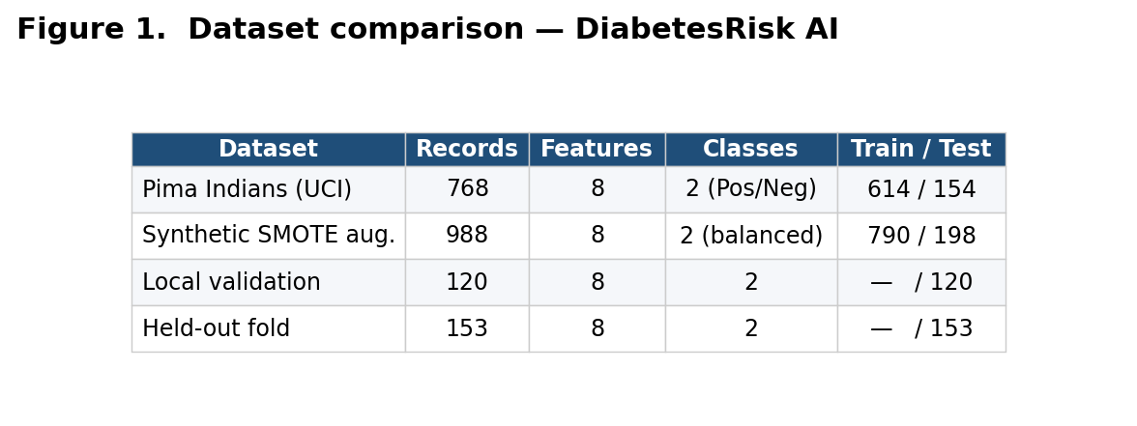
Figure 1. Final dataset breakdown — DiabetesRisk AI.
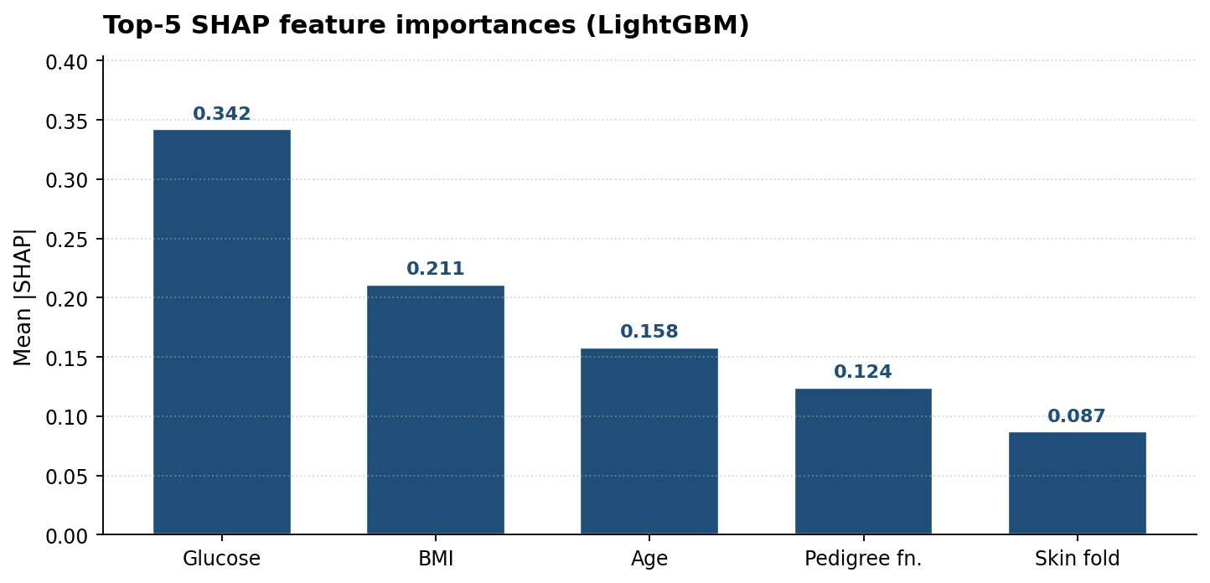
Figure 2. Final per-class performance — DiabetesRisk AI.
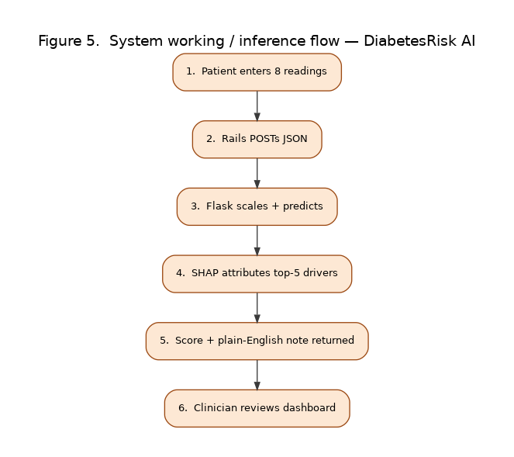
Figure 3. End-to-end system working — DiabetesRisk AI.

