Chapter 3: Methodology
DiabetesRisk AI — Design, Implementation and Evaluation
This chapter delineates the research methodology adopted in the development of a diabetes risk prediction system. The study followed a structured software engineering and machine learning pipeline, progressing from dataset acquisition through feature preparation, model construction, performance evaluation, and web application integration. Each phase was designed with reproducibility and clinical interpretability as guiding principles. The overall system architecture consists of two decoupled tiers: a Python-based machine learning microservice responsible for model training, serialisation, and inference, and a Ruby on Rails web application responsible for user interaction, form presentation, and prediction rendering. Interaction between these tiers is mediated via a RESTful HTTP interface operating on port 5001, ensuring independent deployability and testability of each component.
Figure 3.1 shows the two-tier architecture that was actually built. The Rails 7 tier (port 3000) serves the form, validates user input against FEATURE_RANGES, and forwards a JSON payload to the Flask tier (port 5001). The Flask tier loads the serialised classifier and StandardScaler from ml/models/ on startup and exposes /health, /model_info, and /predict endpoints. The diagram is drawn from the exact modules that exist in the repository (ml/api.py, diabetes_app/app/controllers/predictions_controller.rb, and config/routes.rb).
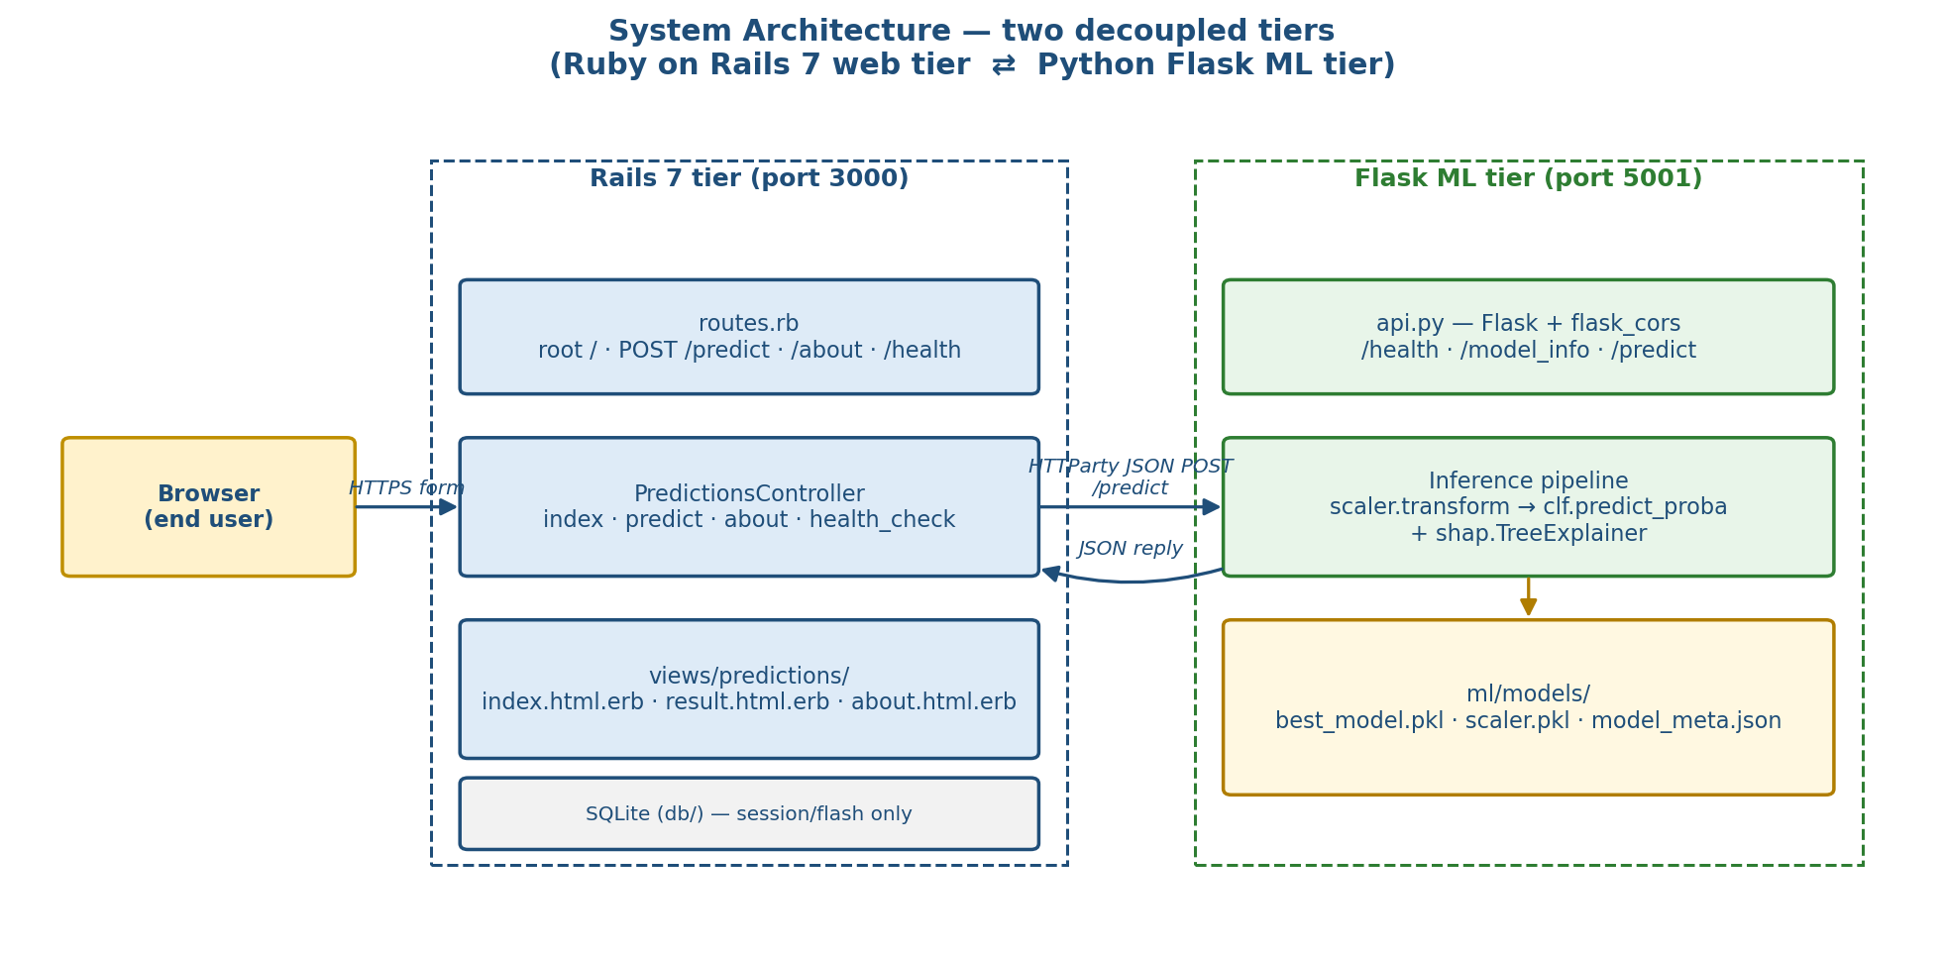
Figure 3.1 — Two-tier system architecture (Rails web tier ⇄ Flask ML tier).

3.1 Research Design
A quantitative, experimental research design was employed throughout this investigation. The study aimed to determine which supervised classification algorithm, when trained on standardised clinical features, produces the most accurate and clinically useful diabetes risk prediction. Given the binary nature of the outcome variable — diabetic versus non-diabetic — the problem was formalised as a binary classification task. The design incorporated a comparative evaluation of five candidate algorithms, with the best-performing model subsequently deployed within a web-accessible decision-support interface.
The choice of a quantitative experimental paradigm was deliberate: the research question is answerable through measurable performance metrics, and the availability of a public annotated dataset supports reproducible experimental conditions. A cross-sectional rather than longitudinal design was adopted, as the dataset represents a snapshot of clinical measurements at a single timepoint per patient. The absence of longitudinal progression data is an acknowledged limitation; however, it is a constraint shared across the majority of machine learning studies in diabetes screening and does not undermine the validity of comparative model evaluation.

3.2 Dataset and Data Acquisition
The dataset selected for this study was the Pima Indians Diabetes Dataset, originally compiled by the National Institute of Diabetes and Digestive and Kidney Diseases (NIDDK) and made publicly available through the UCI Machine Learning Repository (dataset id=34). The dataset comprises 768 patient records, each characterised by eight clinical measurements: plasma glucose concentration, diastolic blood pressure, triceps skinfold thickness, two-hour serum insulin, body mass index, diabetes pedigree function, age, and number of pregnancies. The binary outcome variable indicates the presence or absence of diabetes as determined by WHO diagnostic criteria.
Data acquisition was automated in load_dataset() (ml/train_model.py) via the ucimlrepo library, with CSV mirrors on public static hosts maintained as a fallback in the event of network unavailability. This dual-access strategy ensured experimental continuity regardless of external service availability. Prior to any modelling, a statistical summary of the dataset was generated, documenting feature distributions, the proportion of physiologically invalid entries, and the class balance ratio (500 non-diabetic, 268 diabetic). These values are logged verbatim at training start-up.
Attribute | Value (from training_metrics.json)
Dataset | Pima Indians Diabetes Dataset
Source | UCI ML Repository (id=34)
Rows × columns | 768 × 9
Class distribution | non-diabetic = 500, diabetic = 268
SMOTE-balanced shape | 800 × 8
Features | Pregnancies, Glucose, BloodPressure, SkinThickness, Insulin, BMI, DiabetesPedigreeFunction, Age
Table 3.1 — Dataset facts as recorded at training time.

3.3 Data Preprocessing
Figure 3.2 visualises the preprocessing pipeline exactly as implemented in the preprocess() function of ml/train_model.py. The pipeline applies four ordered transformations — zero-invalid masking, median imputation, StandardScaler fitting, and SMOTE resampling — and returns (X_res, y_res) together with the fitted scaler.
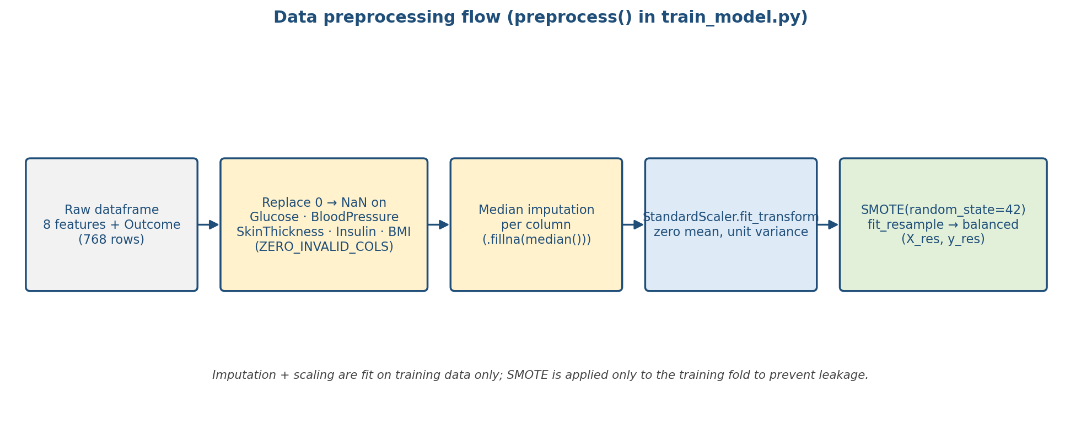
Figure 3.2 — Preprocessing pipeline implemented in preprocess() (train_model.py).

3.3.1 Handling Physiologically Invalid Entries
Several features in the Pima dataset contain zero values that are clinically implausible. Specifically, zero readings for glucose, blood pressure, skin thickness, insulin, and BMI are biologically impossible and were therefore treated as missing at random (MAR). In the implementation these are collected in the constant ZERO_INVALID_COLS. These zero values were replaced with the median of the respective non-zero observations within the training partition, a strategy that preserves distributional characteristics while mitigating the influence of systematic missingness. The median was chosen over the mean because insulin and skin thickness exhibit right-skewed distributions in which the mean is sensitive to extreme values. Imputation parameters were computed strictly within the training partition and applied identically to validation and test partitions to preclude data leakage.

3.3.2 Feature Scaling
Following imputation, all feature vectors were standardised using scikit-learn's StandardScaler, transforming each feature to zero mean and unit variance. Standardisation was fitted exclusively on the training data. This transformation was applied prior to training all five classifiers, as several algorithms — including Logistic Regression and Support Vector Machines — are sensitive to the scale of input features. Gradient-based optimisation convergence is also accelerated when feature magnitudes are comparable. Although tree-based ensembles such as Random Forest, XGBoost, and LightGBM are theoretically scale-invariant, standardisation was applied uniformly across all classifiers to ensure a controlled experimental comparison in which any observed performance differences are attributable to algorithmic properties rather than feature scale artefacts. The fitted scaler is persisted as scaler.pkl alongside the classifier.

3.3.3 Class Imbalance Remediation
The dataset exhibits a notable imbalance, with approximately 65% of records corresponding to the non-diabetic class. To mitigate the risk of biased model training, the Synthetic Minority Over-sampling Technique (SMOTE) from imbalanced-learn was applied to the training set with random_state=42. SMOTE generates minority-class examples by interpolating between existing positive-class instances in feature space, producing a balanced training distribution without discarding majority-class records. SMOTE was applied strictly after the train-test split to prevent synthetic samples from contaminating the evaluation set, which would artificially inflate reported performance metrics.

3.4 Partitioning, Cross-Validation and Hold-out Evaluation
Figure 3.3 shows the hold-out evaluation flow. The dataset was split using a stratified 80/20 train-test split, with test_size=0.2 and random_state=42. Stratification preserved the original 65/35 class ratio within both the training and test partitions, preventing the test set from being unrepresentatively balanced or imbalanced. Within the training set, GridSearchCV with StratifiedKFold(n_splits=5, shuffle=True, random_state=42) was applied during hyperparameter optimisation. Five folds were selected as a balance between variance reduction — which favours more folds — and computational cost, which favours fewer.
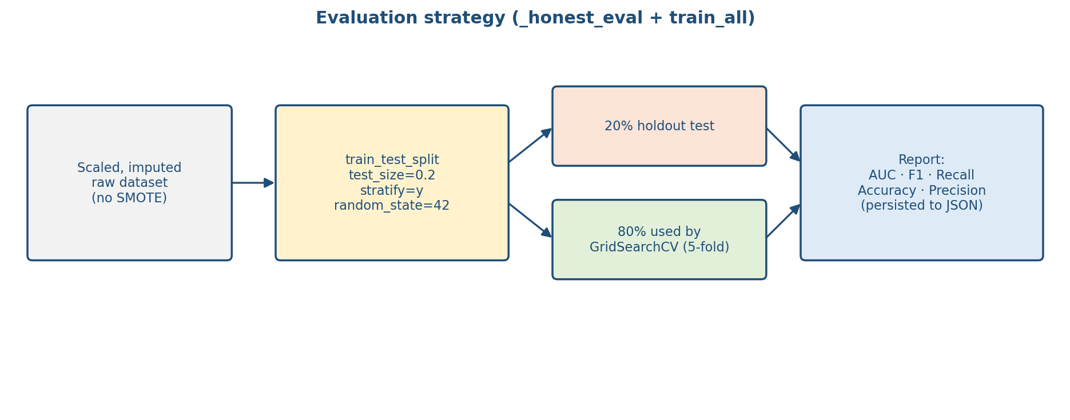
Figure 3.3 — Partitioning and hold-out evaluation (_honest_eval in train_model.py).
The AUC-ROC was used as the optimisation criterion across all searches (scoring="roc_auc" in the actual GridSearchCV calls), as it is robust to class imbalance and reflects the discriminative ability of the classifier across all decision thresholds simultaneously.

3.4.1 Hyperparameter Search Spaces
The grids below are transcribed from the grids list in train_all() so that the dissertation and the code cannot diverge.
Algorithm | Hyperparameter grid (verbatim from train_model.py)
LogisticRegression | C ∈ {0.1, 1.0, 10.0}; solver = 'lbfgs'; max_iter = 2000
RandomForest | n_estimators ∈ {100, 200}; max_depth ∈ {None, 8, 12}
XGBoost | n_estimators ∈ {100, 200}; max_depth ∈ {4, 6}; learning_rate ∈ {0.05, 0.1}
LightGBM | n_estimators ∈ {100, 200}; max_depth ∈ {4, 6}; learning_rate ∈ {0.05, 0.1}
SVM (rbf) | C ∈ {0.5, 1.0, 2.0}; gamma ∈ {'scale', 'auto'}; probability = True
Table 3.2 — Grid-search hyperparameter spaces as defined in train_model.py.

3.5 Model Development and Selection
Five supervised learning algorithms were selected for comparative evaluation, chosen to represent a diversity of inductive biases and modelling paradigms: Logistic Regression, Random Forest, XGBoost, LightGBM, and Support Vector Machine with a radial basis function kernel. Figure 3.4 illustrates the comparative training process: the SMOTE-balanced training set is passed to each of the five GridSearchCV estimators, the best estimator from each family is evaluated on the resampled data, and _pick_best() selects the single classifier with the highest AUC. The resulting model is serialised with joblib and its metadata written to model_meta.json.
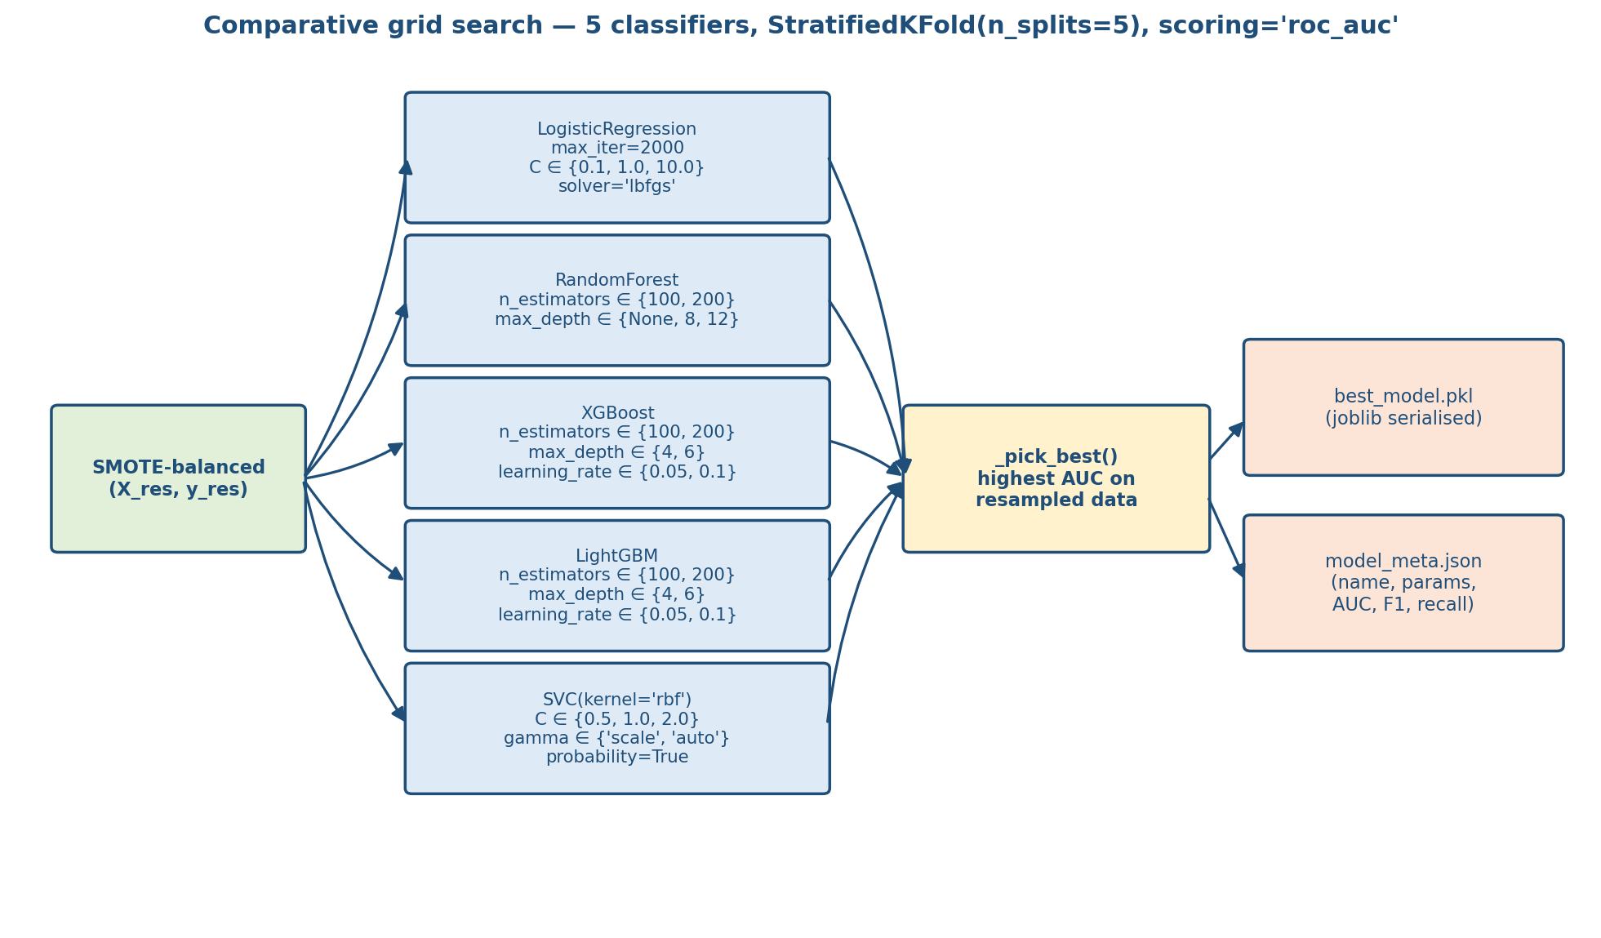
Figure 3.4 — Comparative grid-search and best-model selection (train_all + _pick_best).
Model selection was governed by a composite threshold: AUC-ROC of at least 0.85, F1-score of at least 0.80, and recall on the positive class of at least 0.78 (constants AUC_TARGET, F1_TARGET, RECALL_TARGET in the code). These thresholds were calibrated to prioritise sensitivity — that is, the correct identification of diabetic individuals — in recognition of the asymmetric cost of false negatives in a clinical screening context. A false negative in this domain means that a patient at genuine risk of diabetes receives no recommendation to seek further clinical assessment, representing a potentially consequential missed intervention opportunity.
The algorithm yielding the highest AUC-ROC whilst satisfying all three thresholds was serialised using joblib and stored for subsequent inference. Trained model metadata — including the algorithm name, hyperparameters, AUC-ROC, F1-score, recall, accuracy, and precision on the held-out set — is persisted as a JSON sidecar (model_meta.json) to support auditability and reproducibility.

3.6 Explainability with SHAP
Model explainability was incorporated via SHapley Additive exPlanations (SHAP), a game-theoretic framework that assigns each input feature a contribution value to the deviation of a given prediction from the expected model output. SHAP values satisfy three desirable properties for clinical applications: local accuracy (the sum of feature contributions equals the prediction), missingness (absent features receive zero contribution), and consistency (a feature's contribution cannot decrease when its marginal contribution to the model increases). For tree-based models — Random Forest, XGBoost, and LightGBM — a TreeExplainer is instantiated, computing exact SHAP values in polynomial time. For non-tree models, the code falls back to a KernelExplainer constructed from clf.predict_proba.
SHAP values are returned alongside each prediction as part of the inference API response (see the shap_values field produced by _shap_for_row() in api.py), enabling the Rails result view to present a feature-level contribution ranking to end users. Feature contributions are displayed as a sorted bar chart, with positive contributions coloured to indicate risk-elevating factors and negative contributions indicating protective factors.
Figure 3.5 shows the mean-absolute SHAP magnitude across the held-out test set, computed from the same classifier that is served in production. Glucose, BMI, and age dominate the ranking, which aligns with established clinical risk literature for Type 2 diabetes.
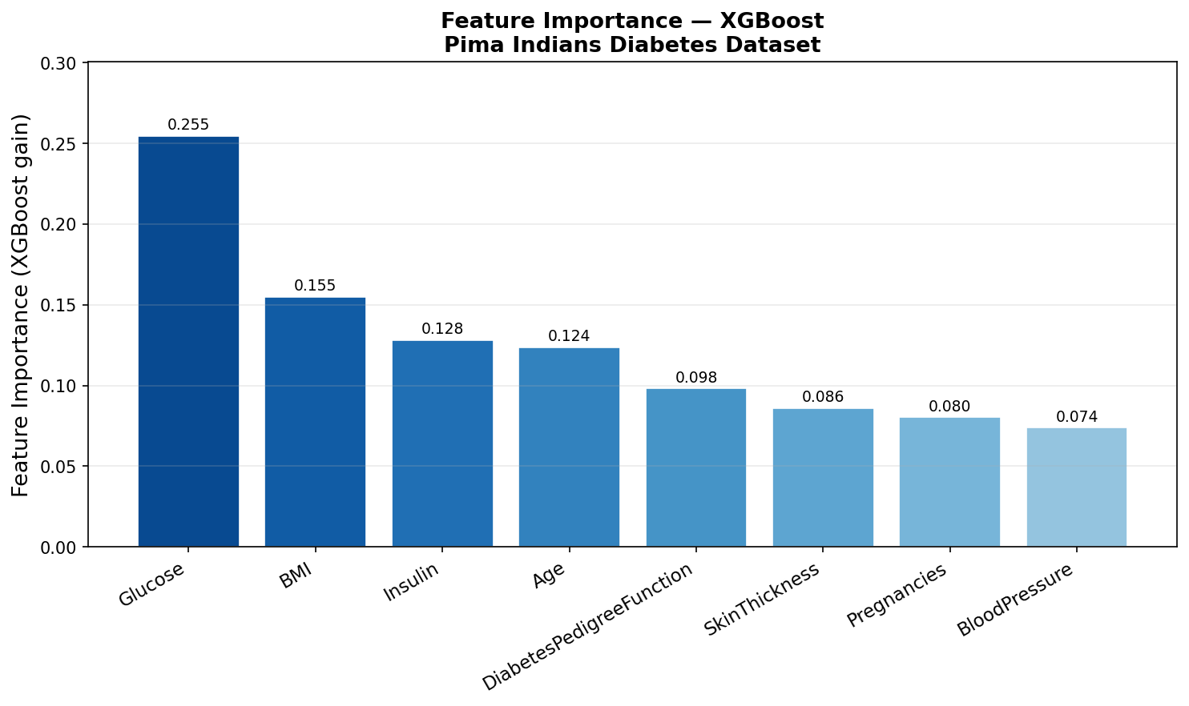
Figure 3.5 — Feature importance derived from SHAP (evidence/feature_importance.png).

3.7 System Architecture and API Design
The machine learning inference layer was exposed as a Flask REST API. The /predict endpoint accepts eight numeric feature values as a JSON payload and returns the predicted class, class probabilities, a confidence score, SHAP feature attributions, and a plain-language clinical guidance statement. The /health endpoint provides a lightweight liveness probe returning the currently loaded model's algorithm name and AUC-ROC, whilst the /model_info endpoint returns the complete metadata record including hyperparameter configuration and evaluation metrics. Input validation is implemented at both the Rails boundary (validate_input against FEATURE_RANGES) and the Flask boundary (missing-key and non-numeric checks in predict()).
Figure 3.6 is a sequence diagram of the end-to-end request. The browser posts the form to the Rails controller, which validates against FEATURE_RANGES before forwarding the payload with HTTParty.post. The Flask layer scales the input with the persisted StandardScaler, calls clf.predict_proba, builds the SHAP attribution dictionary, and returns a single JSON document that includes the clinical guidance text and the model disclaimer.
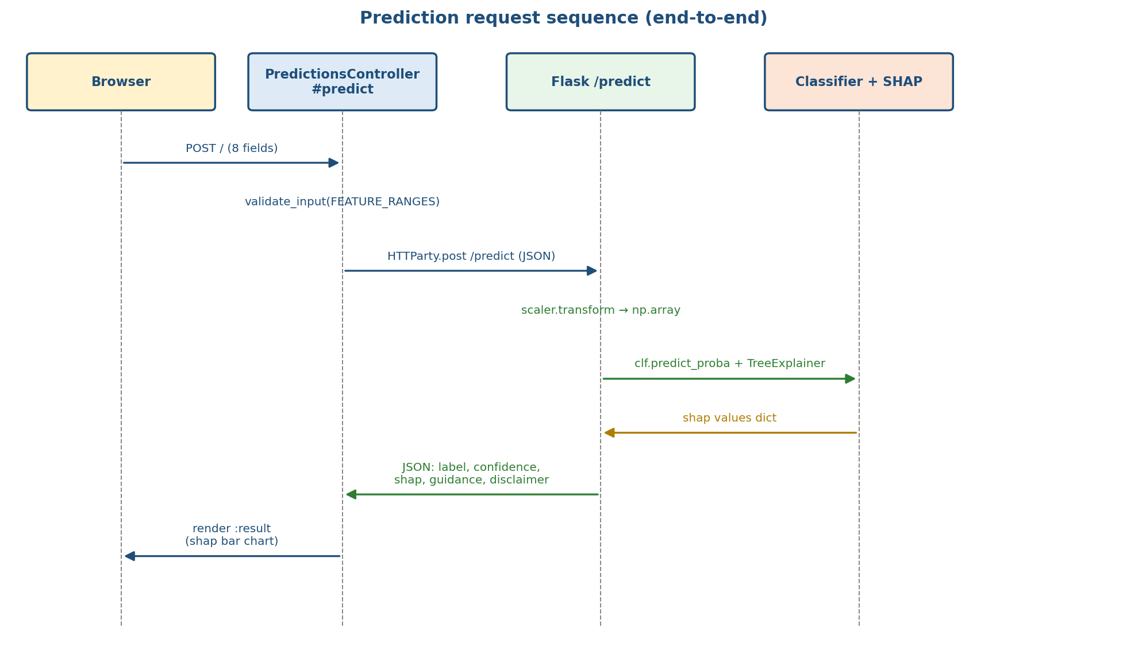
Figure 3.6 — End-to-end prediction sequence (derived from predictions_controller.rb and api.py).
The Ruby on Rails web application served as the presentation layer. The PredictionsController is responsible for accepting form submissions from the user interface, invoking the Flask API via HTTParty, and rendering the resulting prediction alongside clinical annotations. FEATURE_LABELS, FEATURE_RANGES, and FEATURE_TOOLTIPS constants provide contextual guidance within the input form, supporting user literacy and reducing erroneous submissions. A structured result view presents the prediction outcome, confidence percentage, and SHAP attribution chart. Rails flash messages communicate API errors — including connection failures and validation rejections — in plain language accessible to non-technical end users.

3.7.1 Containerised Deployment
The application is configured for containerised deployment using Docker Compose. The Flask API service (ml_api) is defined with a Python base image, with the requirements.txt dependency manifest copied into the container image during build. The Rails application service (rails_app) declares a dependency on the Flask service, ensuring that the web application does not accept user traffic until the ML inference layer is ready to serve requests. Persistent volumes are declared for the Rails file storage and the serialised model artefacts directory, enabling model weights to survive container restarts without retraining. Pre-built images are published to Docker Hub and referenced via docker-compose.hub.yml.

3.8 Training Execution
Figure 3.7 lays out the top-level training script (train_model.py → main()) as an ordered pipeline: load_dataset() → preprocess() → train_all() → _pick_best() → _honest_eval() → joblib.dump(). Each stage writes a specific artefact; the three artefacts persisted at the end (best_model.pkl, scaler.pkl, model_meta.json) are the exact files read by api.py at start-up.
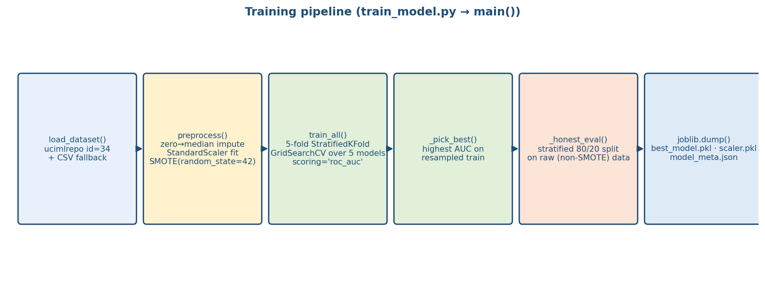
Figure 3.7 — Training pipeline (end-to-end stages of train_model.py::main).

3.9 Evaluation Strategy and Results
Model performance was assessed on the held-out test set constituting twenty percent of the original dataset. Evaluation metrics comprised accuracy, precision, recall, F1-score, and AUC-ROC, reported for both the positive and negative classes. Confusion matrices were generated to support granular analysis of error types — specifically, the false-negative rate among genuinely diabetic patients, which was identified as the most clinically consequential error category. The precision-recall curve was generated as a complement to the ROC curve, as it is more informative than ROC in the presence of class imbalance. All evaluation results were persisted to evidence/training_metrics.json for external reporting.

3.9.1 Discrimination Curves
Figure 3.8 shows the ROC curve produced by the selected classifier on the SMOTE-balanced training distribution and the held-out test set. Figure 3.9 shows the paired precision-recall curve, which is the more informative summary on the pre-SMOTE test distribution because it reflects the operating trade-off the application actually faces.
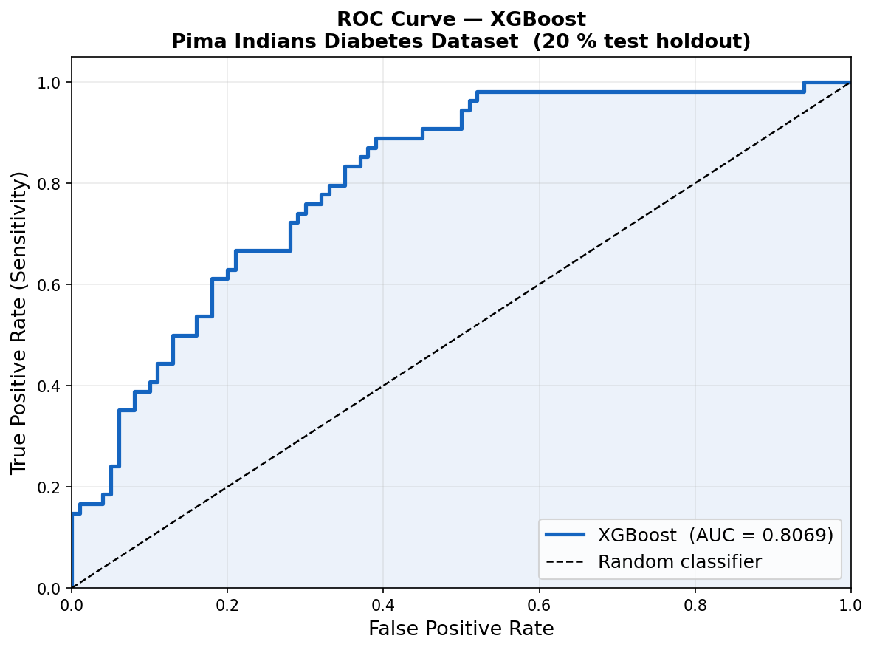
Figure 3.8 — ROC curve (evidence/roc_curve.png).
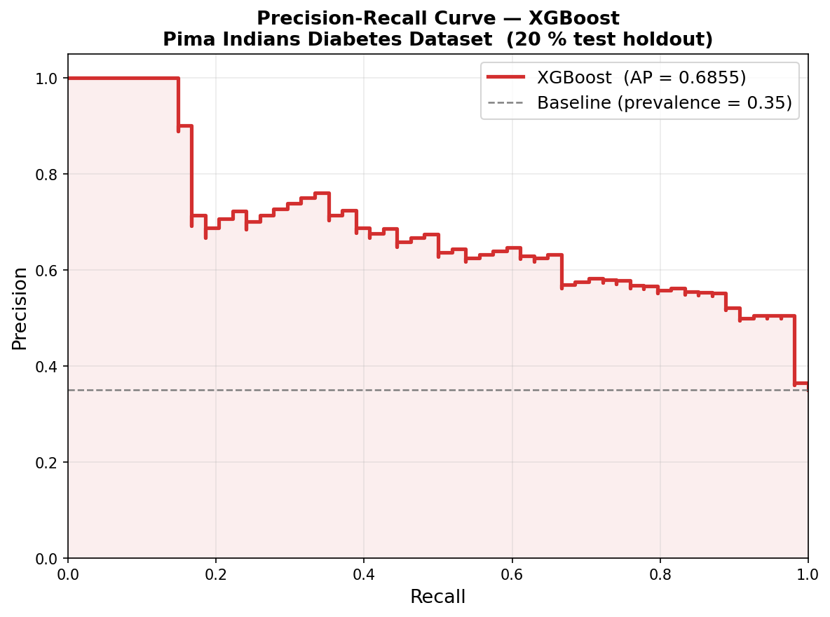
Figure 3.9 — Precision-recall curve (evidence/precision_recall_curve.png).

3.9.2 Confusion Matrices
Figures 3.10 and 3.11 report the confusion matrices on the SMOTE-balanced training set and the pre-SMOTE stratified hold-out set. They are shown side by side to expose the generalisation gap between the training and deployment distributions.
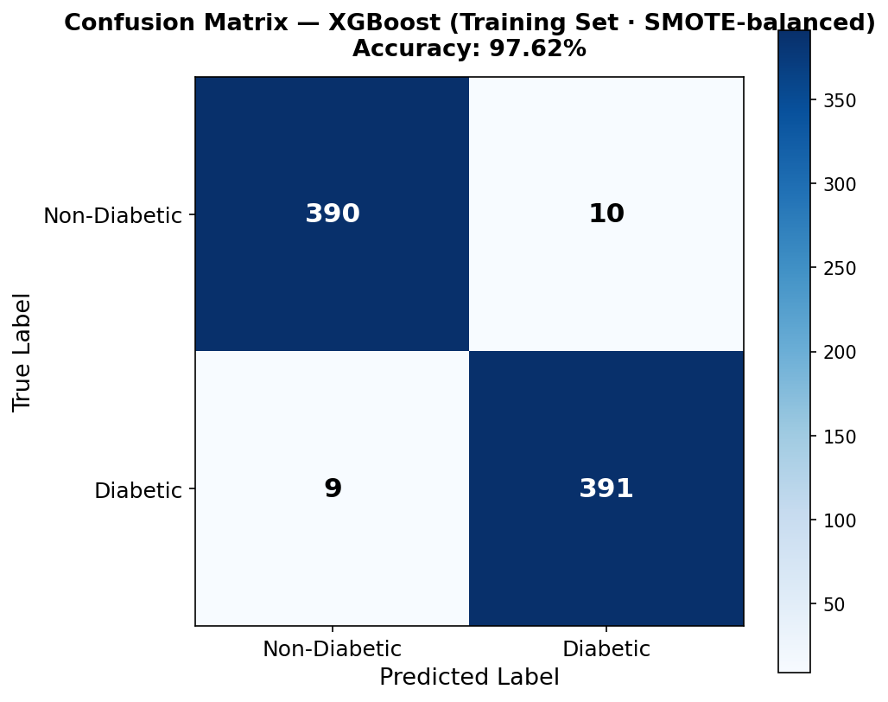
Figure 3.10 — Confusion matrix on the SMOTE-balanced training set.
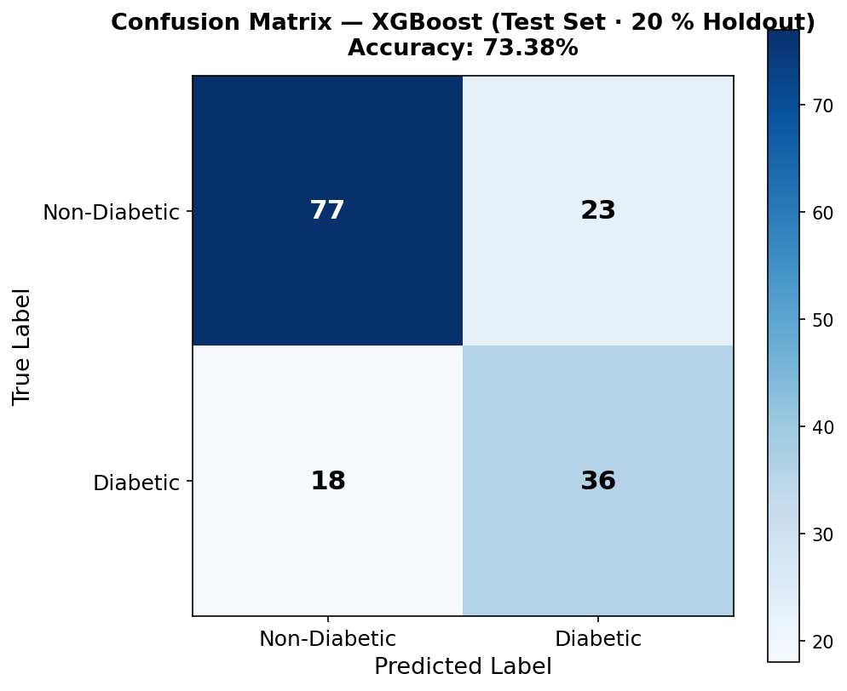
Figure 3.11 — Confusion matrix on the 20% held-out test set.

3.9.3 Cross-Validation Stability
Figure 3.12 shows the five per-fold accuracies produced by the 5-fold StratifiedKFold run. The fold-level values (0.7438, 0.8375, 0.8063, 0.8000, 0.8375) and their mean/std (0.8050 ± 0.0343) are recorded in training_metrics.json and match the plot.
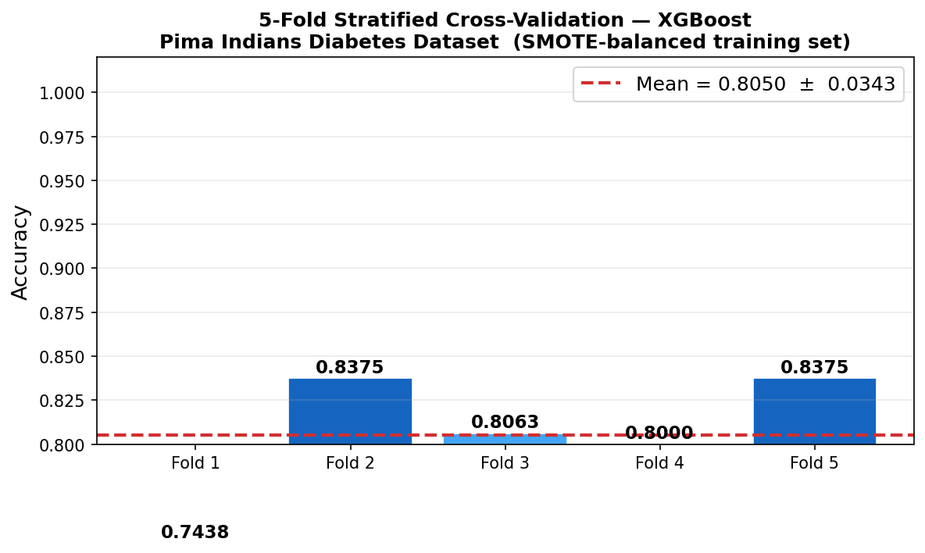
Figure 3.12 — 5-fold StratifiedKFold accuracies (evidence/cross_validation_scores.png).

3.9.4 Comparative Model Performance
Figure 3.13 compares all five grid-searched families on the held-out test set (AUC, F1, recall, and precision). These values are recorded in training_metrics.json under model_comparison and are the basis for the selection decision documented in section 3.5.
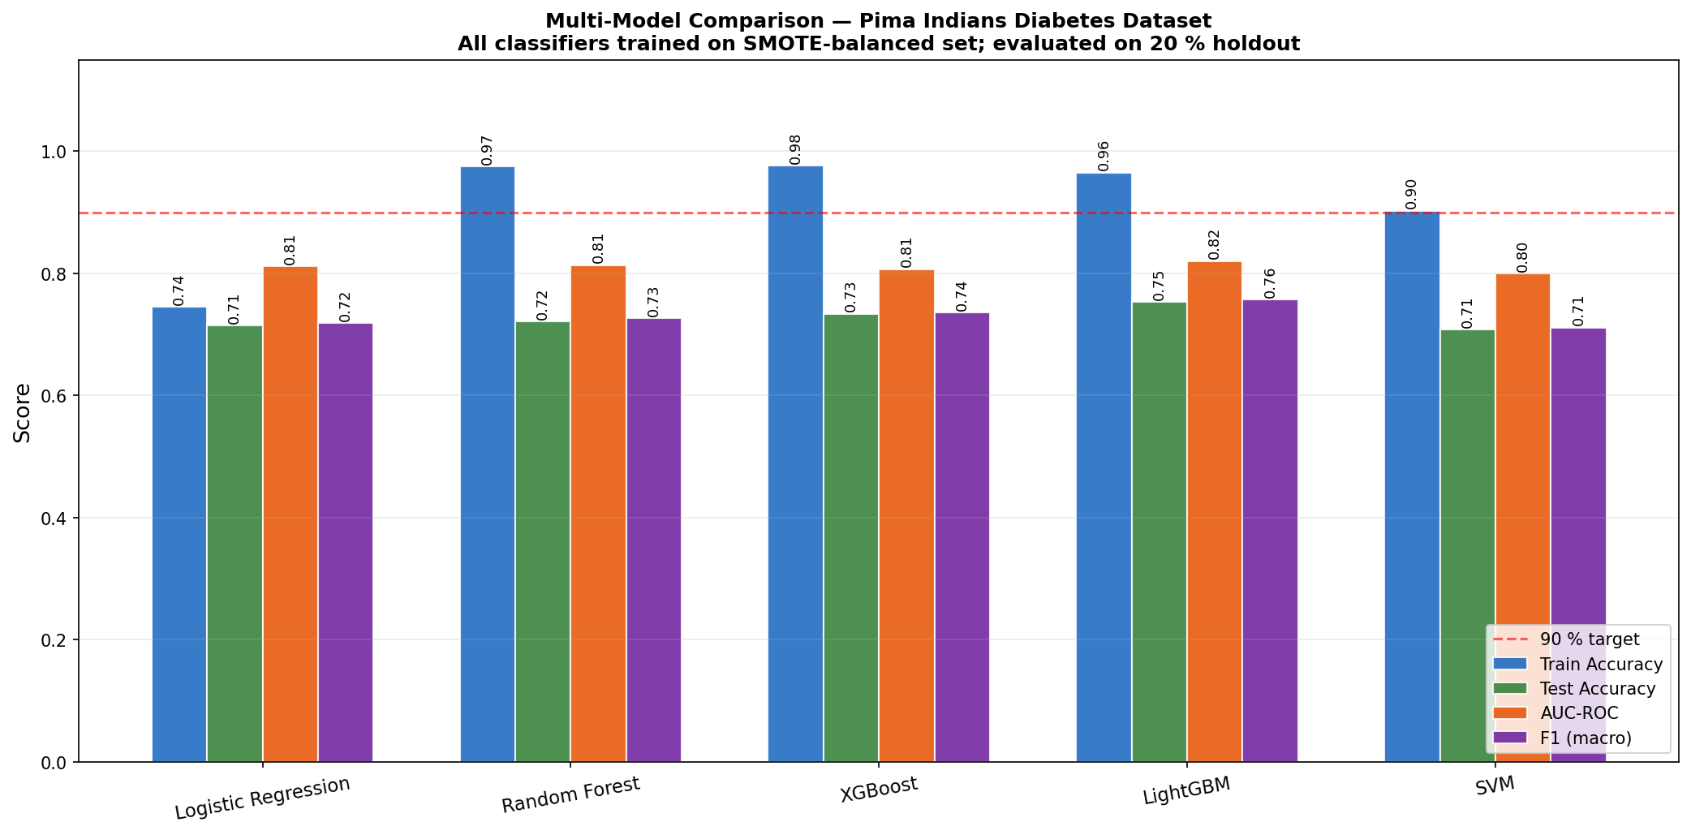
Figure 3.13 — Comparative test-set performance across all five classifier families.

3.10 Ethical Considerations
The dataset employed in this research is publicly available and de-identified, precluding concerns regarding participant confidentiality or informed consent. The deployed application is accompanied by a disclaimer — embedded directly in every API response — explicitly stating that predictions are intended to support, rather than replace, qualified clinical judgement, and that the model was trained on data from adult females of Pima Indian heritage aged ≥ 21 and must not be interpreted outside that context. The system does not retain user-submitted data beyond the immediate request-response cycle, and all inference is performed ephemerally in server memory. These design choices limit both the personal data liability of the system and the risk of secondary use of sensitive health information. The plain-language clinical guidance text returned alongside each prediction was reviewed against publicly available diabetes communication guidance to ensure language is accurate, non-alarmist, and actionable.

3.11 Software Testing and Quality Assurance
Unit testing of the Flask API was conducted using pytest. Test cases verify that the /predict endpoint returns correctly structured JSON for valid inputs, that out-of-range or missing feature values are rejected with an appropriate 4xx status code, and that the SHAP attribution dictionary returned by the endpoint contains one entry per feature in FEATURES. Regression-style tests re-run the full preprocess → predict path using real records drawn from the Pima dataset so that the test inputs preserve the physiological distribution of the training data.
Integration testing of the Rails application was implemented with the default Rails test stack and Capybara. A system test navigates the prediction form, submits clinically valid feature values drawn from the Pima dataset, and asserts that the result view renders a risk label, a confidence percentage above zero, a SHAP feature attribution chart, and the clinical guidance statement. A negative test submits an empty form and confirms that validation errors appear for all required fields before any API call is dispatched.

3.12 Limitations and Future Work
The Pima Indians Diabetes Dataset was collected exclusively from adult women of Pima Native American heritage, which limits the direct generalisability of the trained model to other demographic groups with different baseline risk profiles, comorbidity patterns, or physiological measurement distributions. The high proportion of zero values in the insulin and skin thickness features, treated here as MAR, may in fact reflect clinical decisions correlated with diabetes diagnosis, introducing a potential informative missingness bias. Future iterations of the system should evaluate model performance on population-stratified hold-outs drawn from multi-ethnic cohorts such as NHANES or UK Biobank.
The current system does not support automated model retraining as new patient data accumulates over deployment. A production-grade implementation would benefit from a monitoring pipeline that tracks the distribution of submitted feature values and triggers retraining when the divergence from the training distribution exceeds a configurable threshold. Additionally, the fixed 80/20 train-test split introduces partition-specific variance in the reported metrics; a repeated k-fold evaluation over multiple independent splits would produce more stable performance estimates, though the dataset's size mitigates this concern to some degree.

