SUMMER INTERNSHIP PROJECT (SIP) REPORT
Course: Summer Project Evaluation

Course Code: H0513B

Name: Aarish Master

URN: 2024-B-24092006

Project Title: TrailPilot – Rider’s Travel Planner

1. Introduction
TrailPilot is a static web-based travel planning system designed for long-distance riders, bikers, daily commuters, and explorers who depend on accurate routing, weather forecasting, and essential travel recommendations. The project emphasizes the practical use of web technologies such as HTML, CSS, JavaScript, and third‑party APIs. The aim was to build a lightweight solution that provides the exact information riders need without the heaviness and complexity of mainstream navigation platforms.

2. Problem Statement
Long‑distance riders frequently struggle with fragmented information—routes, weather, nearby accommodation, and terrain conditions exist across multiple apps and platforms. Heavy apps like Google Maps overwhelm riders with unnecessary features, leading to distraction and reduced usability. Riders lack a dedicated tool optimized specifically for long‑distance travel, route clarity, and real‑time conditions. TrailPilot solves these gaps by providing a clean, focused travel planner built purely for bikers and commuters.

3. Objectives of the Project
• Build a static and responsive travel‑planning web application.
• Provide an elegant, rider‑centric UI.
• Integrate routing, weather, and hotel APIs.
• Implement autocomplete search.
• Allow saving routes locally.
• Maintain fast performance and simple interaction.

4. Technology Stack Used
HTML5, CSS3, JavaScript (ES6+), Geoapify Routing API, Nominatim Geocoding, OpenWeather API, LocalStorage, Leaflet.js

5. System Architecture
TrailPilot uses a pure client-side architecture. All operations such as data fetching, routing, and rendering occur in-browser. User Input → Geocode API → Routing API → Weather API → Map Display → Optional Save

6. Methodology
UI Design → Map Integration → Routing → Weather → Hotels → Autocomplete → Saved Routes → Testing

7. Screenshots

Landing Page:
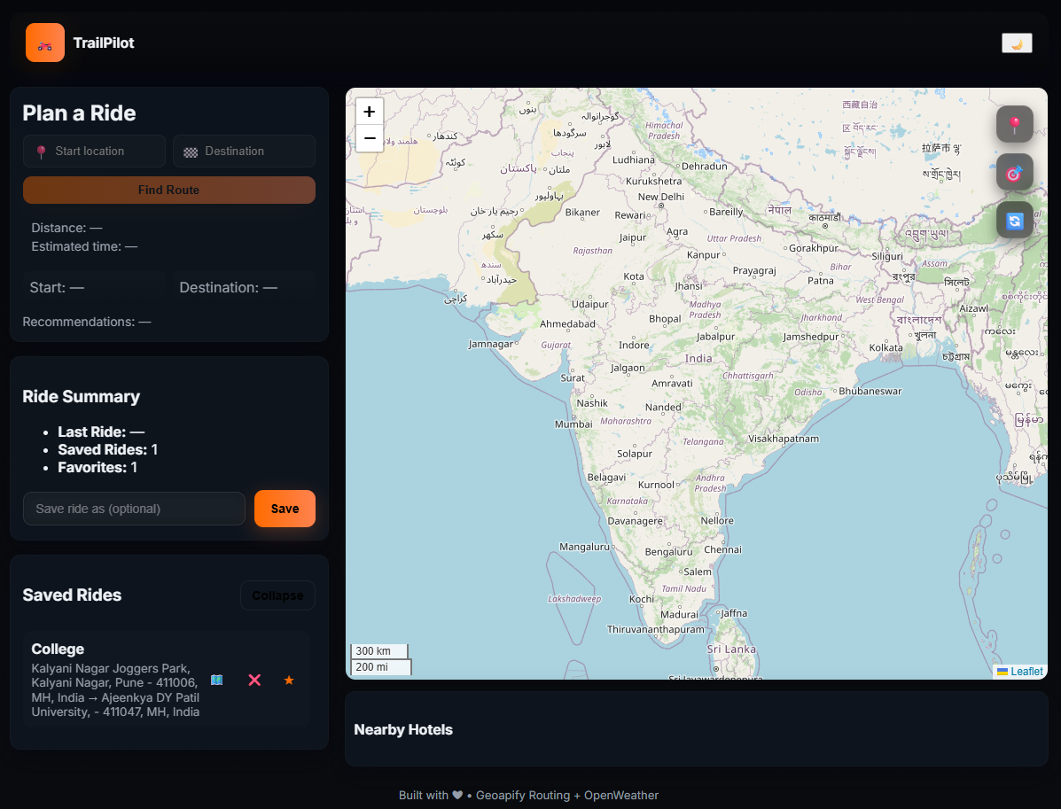
Plan A Ride:
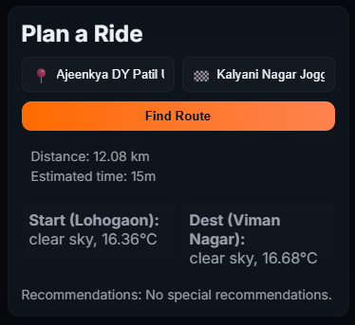
Ride Summary/Save Rides:
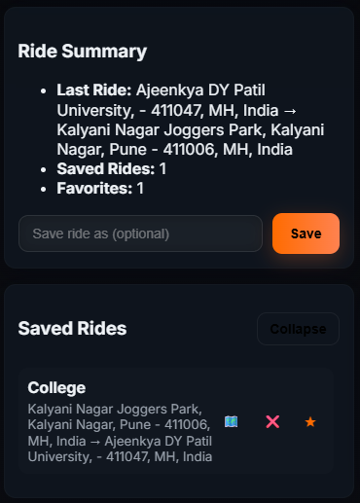
Map/Nearby Hotels:
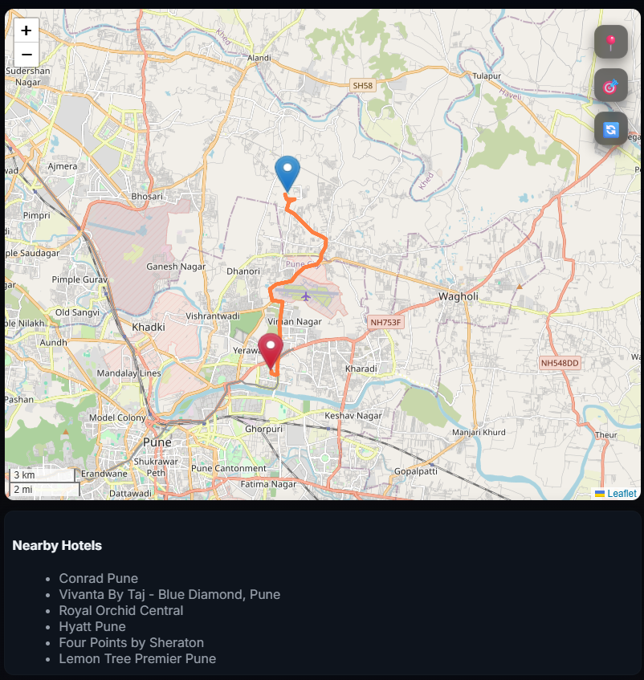

Demo Run:
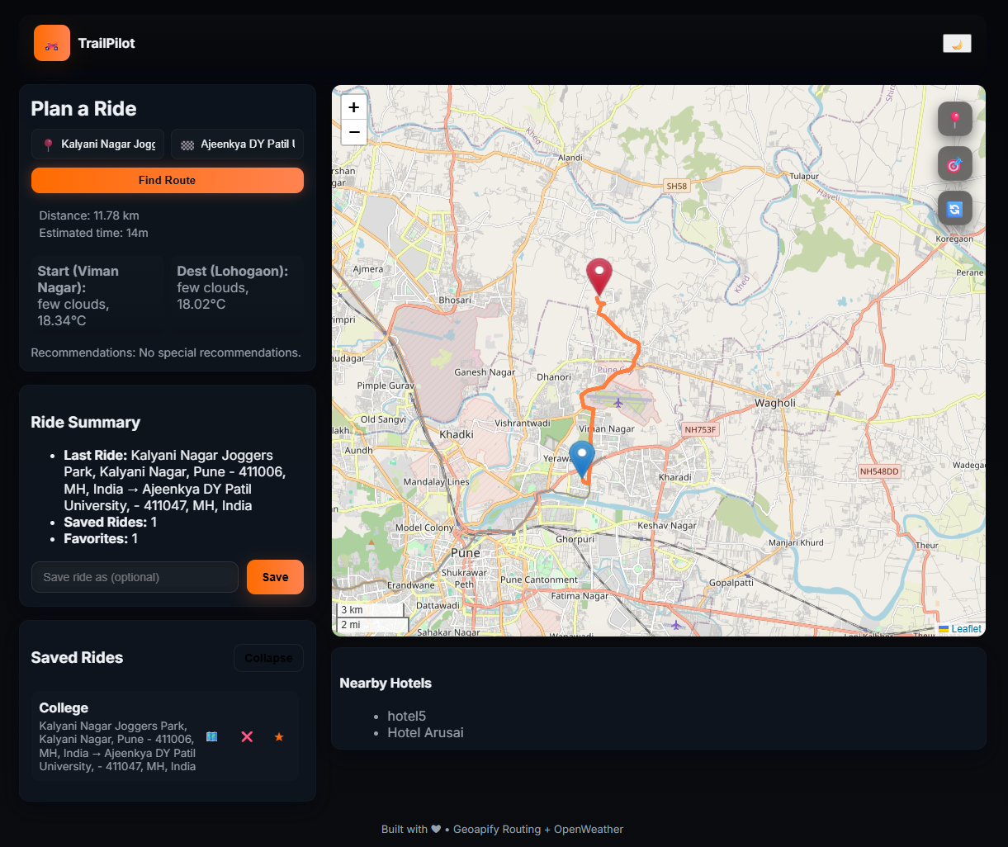

8. Challenges Faced
API limits, inconsistent results, overlapping events, CSS responsiveness, error handling, mobile testing issues.

9. Conclusion
TrailPilot successfully demonstrates a modern client-side travel planner integrating multiple APIs and offering smooth routing, weather updates, and hotel suggestions.

10. Future Scope
Backend integration, authentication, terrain view, GPX export, traffic data, mobile application development.

11. Requirement Analysis
Functional Requirements: Autocomplete, Routing, Weather, Hotels, Saved Routes.
Non‑Functional Requirements: Speed, responsive UI, error handling, maintainability.

12. Implementation Details
Modules: Homepage, Routing, Weather, Hotels, Saved Routes. JS functions handle API calls, DOM updates, and map rendering.

13. Testing
Functional tests, edge-case tests, invalid input tests, UI responsiveness tests, cross‑device testing.

14. Results / Outputs
Accurate distance & duration, working weather output, rendered route, hotel listing, functional saved routes.

15. Annexure

GitHub Repo URL: https://github.com/aarishhh/TrailPilot.git
Deployment Link: https://aarishhh.github.io/TrailPilot/

