EXPERIMENT 3: SURVEY REPORT ON EMERGING TRENDS IN LOW-CODE APPLICATION DEVELOPMENT
Topic: Library Book Issue Request Form
Roll Number: 240701316
NAME: Mohamed Aaris P
1. AIM
To conduct a survey on the emerging trends in low-code application development and to design a functional Library Book Issue Request Form using modern low-code development methodologies.
2. TRADITIONAL APPLICATION DEVELOPMENT VS. EMERGING TRENDS IN LOW-CODE APPLICATION DEVELOPMENT
Traditionally, developing a library request management system required separate development of the user interface, database, backend logic, and validation mechanisms. Low-code development changes this approach by providing visual form builders, pre-built components, database integration, and workflow automation.
Feature | Traditional Application Development | Emerging Trends in Low-Code Development
Development Speed | Slow; requires considerable manual coding for UI, backend, database, and validation. | Faster; functional forms and workflows can be created within hours or days.
Skill Requirement | High; requires knowledge of programming languages, databases, APIs, and frameworks. | Moderate to Low; visual development tools allow users with limited coding experience to build applications.
Maintenance & Updates | Complex; developers need to modify, test, and maintain the application code manually. | Simplified; many infrastructure and platform-level updates are managed by the low-code provider.
Integration | External services generally require custom APIs and integration code. | Pre-built connectors and integrations simplify connections with databases, email services, and other applications.

3. BENEFITS AND CHALLENGES IN LOW-CODE
Benefits
- Accelerated Development: Library forms, validation rules, reports, and workflows can be created quickly using visual development tools.
- Cost Efficiency: Reduces the amount of manual coding required and allows organizations to develop applications with fewer development resources.
- Easy Data Management: Submitted book requests can be automatically stored and displayed through reports for library staff.
- Workflow Automation: Actions such as confirmation emails can be triggered automatically after a successful form submission.
- Cross-Platform Accessibility: Applications created using low-code platforms can be accessed through web-based interfaces across different devices.
- Built-in Features: Form validation, field types, reports, and workflow components are available within the platform.
Challenges
- Vendor Lock-in: Applications and workflows created on a particular low-code platform may be difficult to migrate to another platform.
- Customization Limitations: Highly complex application requirements may require custom scripting or may not be fully supported by visual development features.
- Platform Dependency: Application functionality depends on the features, availability, and limitations of the selected low-code platform.
- Data Governance: Proper access control and management are required when storing member information and library records.
4. COMPARISON OF EXISTING PLATFORMS
The following comparison presents commonly used low-code platforms that can be used to develop applications such as a Library Book Issue Request Form.
Criteria | Microsoft Power Apps | OutSystems | Mendix | Zoho Creator
Target Audience | Enterprise users and organizations using Microsoft services | Enterprise development teams | Businesses and professional development teams | Businesses, educational institutions, and citizen developers
UI Development | Canvas and model-driven application development | Visual application development with extensive customization | Visual development and design tools | Drag-and-drop form and application builder
Database Capability | Dataverse and multiple external connectors | Relational databases and external databases | Built-in data management and external integrations | Built-in application database and external integrations
Workflow & Automation | Power Automate integration | Visual workflows and business processes | Workflow and business-process automation | Built-in workflows and automation
Extensibility | Power Fx, connectors, and custom integrations | Supports custom development and integrations | Supports custom logic and extensions | Deluge scripting, integrations, and custom functions

Screenshots
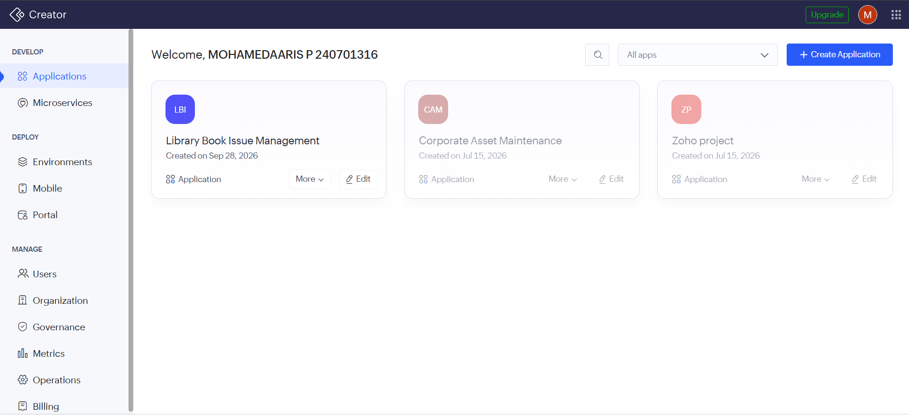

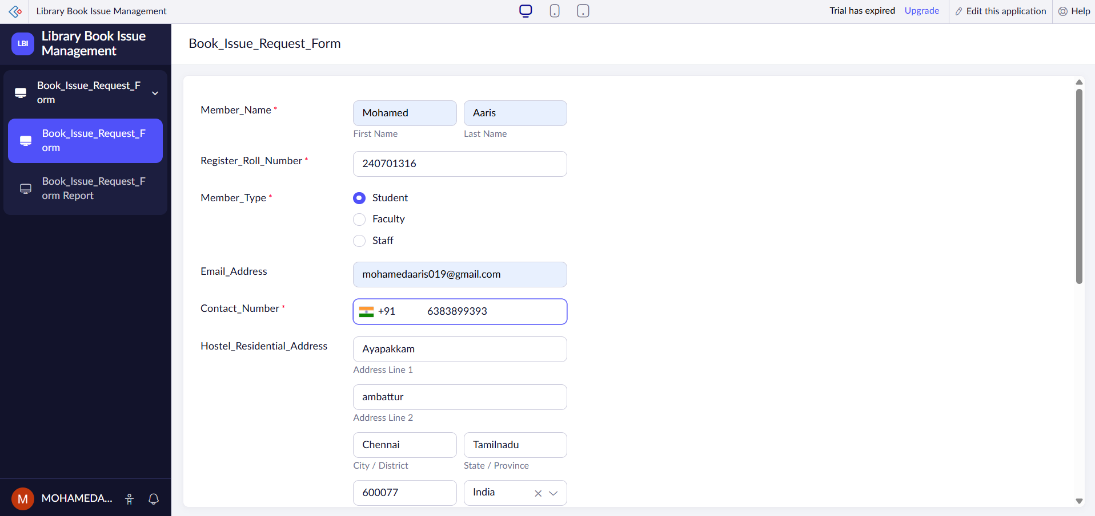

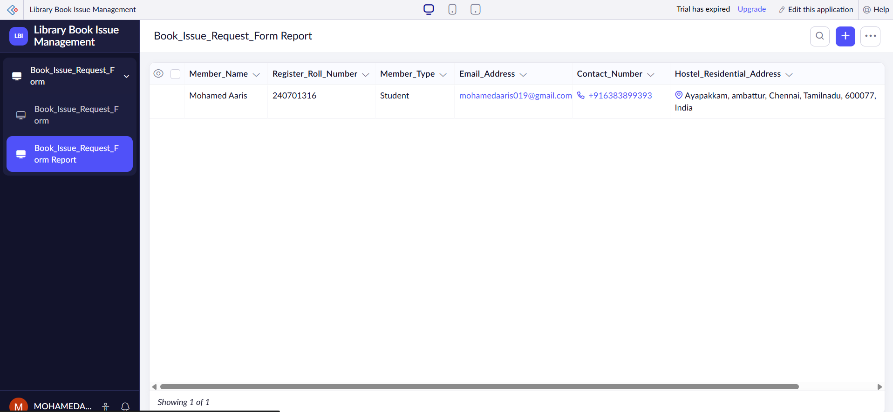

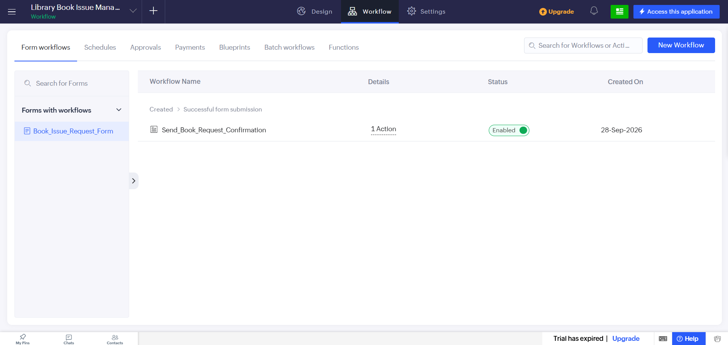

5. RESULT
The survey on emerging trends in low-code application development was successfully completed. The study shows how low-code platforms simplify application development by providing visual form builders, data management, validation, reporting, and workflow automation.
A Library Book Issue Request Form can therefore be developed efficiently using a low-code platform such as Zoho Creator. The application provides a structured method for collecting member details, book-request information, preferred collection schedules, and acknowledgement of library rules while allowing library staff to manage submitted requests through reports and automated workflows.

