1.Comparative study of low-code development versus traditional application development approaches.

1. Aim
To compare low-code development with traditional application development, examining how each approach structures its stages and workflow, and identifying the key technical differences between them.
2. Introduction to Traditional Approach
Traditional software development is built around writing code by hand, line by line, using text editors and IDEs. Developers are directly responsible for designing database schemas, wiring up API integrations, and managing deployment to servers. Because nearly every part of the process depends on hands-on technical skill — typically in languages such as Java, Python, or C++ — this approach demands genuine engineering expertise. In exchange, it gives complete flexibility and full control over the codebase and system architecture, though usually at the cost of longer development timelines, larger budgets, and more thorough testing cycles.
3. Introduction to Low-Code Approach
Low-Code Application Platforms (LCAPs) take a different route: instead of writing code from scratch, developers assemble applications visually, using cloud-based tools with drag-and-drop components, ready-made templates, and automated deployment. This significantly lowers the barrier to entry, making it possible for "citizen developers" — people with little or no formal programming background — to build working applications. Because so much of the repetitive coding work is automated, low-code shortens time-to-market and reduces upfront development costs, though it comes with trade-offs in how deeply the application can be customized and how tied it becomes to the chosen platform.

4. Diagram for Stages in Traditional Approach
The traditional Software Development Life Cycle (SDLC) is a linear or iterative pipeline requiring specialized engineering intervention at every stage:

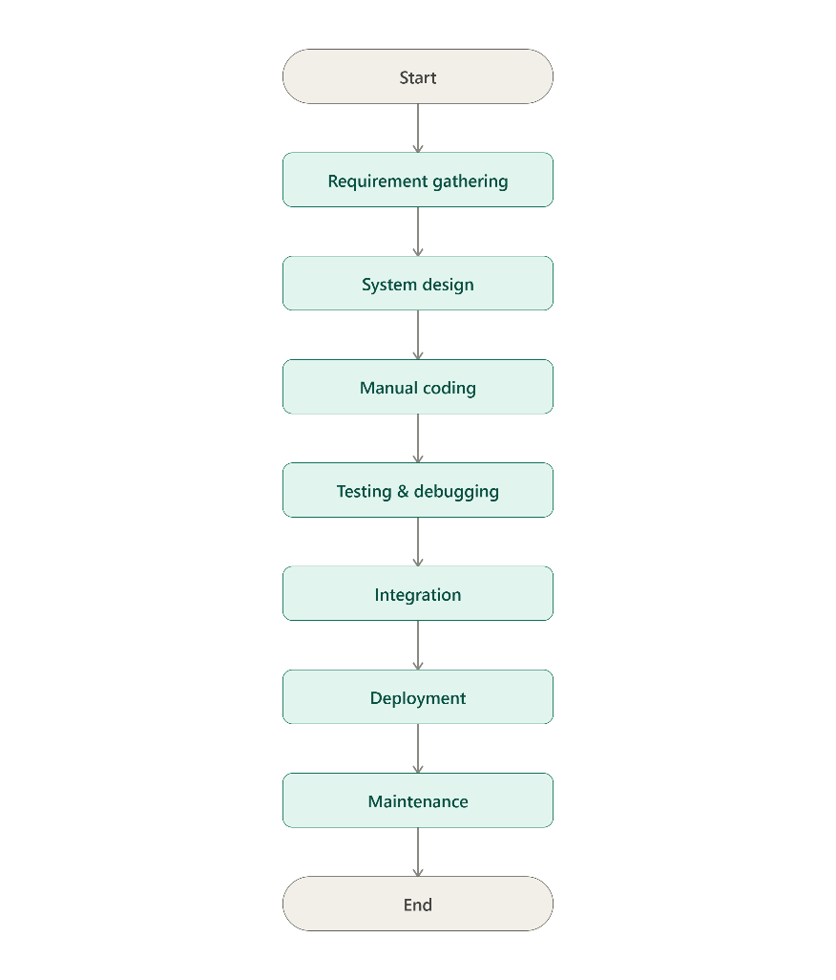
6. Comparative Analysis (Tabulation)
Feature | Traditional Development | Low-Code Development
Development Speed | Slow; requires hand-coding everything from scratch. | Fast; reduces time by up to 50% to 70% using pre-built modules.
Skill Required | High; requires skilled software engineers/developers. | Low; enables "citizen development" with drag-and-drop tools.
Customization | Infinite; developer has total control over every line of code. | Limited; restricted to the capabilities and components offered by the platform.
Cost | Higher initial setup, developer salaries, and long-term maintenance. | Lower upfront costs, but involves ongoing platform licensing or subscription fees.
Maintenance & Updates | Laborious; each bug fix and update must be manually coded and tested. | Simplified; updates are centrally managed and deployed by the platform provider.
Vendor Lock-in | None; the business has 100% ownership of the source code. | High; the application depends on the specific vendor's infrastructure and ecosystem.
Best Use Cases | Complex, high-performance, or highly secured enterprise-level systems. | Prototyping, workflow automation, and internal business tools.

7. Result
This comparative study shows that traditional development remains the stronger choice when a project needs maximum flexibility, fine-grained control, and the ability to scale in highly specific ways — the kind of demands typical of mission-critical enterprise systems. Low-code development, on the other hand, offers a faster, more affordable path to building, deploying, and maintaining applications, particularly where speed and iteration matter more than deep customization. In practice, many organizations land on a hybrid strategy: using low-code tools to move quickly on front-end interfaces and routine workflow automation, while relying on traditional development for the complex, custom logic that sits in the back end.

