Name: MOHAMED AARIS P Roll no: 240701316
EXPERIMENT – 2
Setting up a Zoho Creator account and exploring the platform
architecture and interface
Aim
To develop a sample application using Zoho Creator by creating a form, report, and dashboard, and to understand the Develop, Deploy, and Manage sections of the Zoho Creator platform.
1. Setting Up Zoho Creator
I. Creating the Sample Application
Procedure:
- Log in to the Zoho Creator platform.
- Select the Create New Application option.
- Choose the From Scratch option.
- Enter Sample Application as the application name.
- Click Create to generate the application.
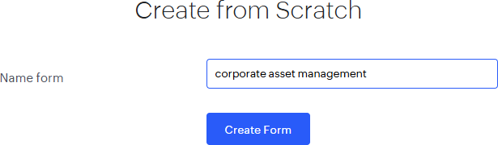
2. Creating a Form
Procedure:
- Select Create and then choose Form.
- Provide Student Details as the name of the form.
- Add the required fields, including Name, Roll Number, Department, Email, and Phone Number.
- Save the completed form.

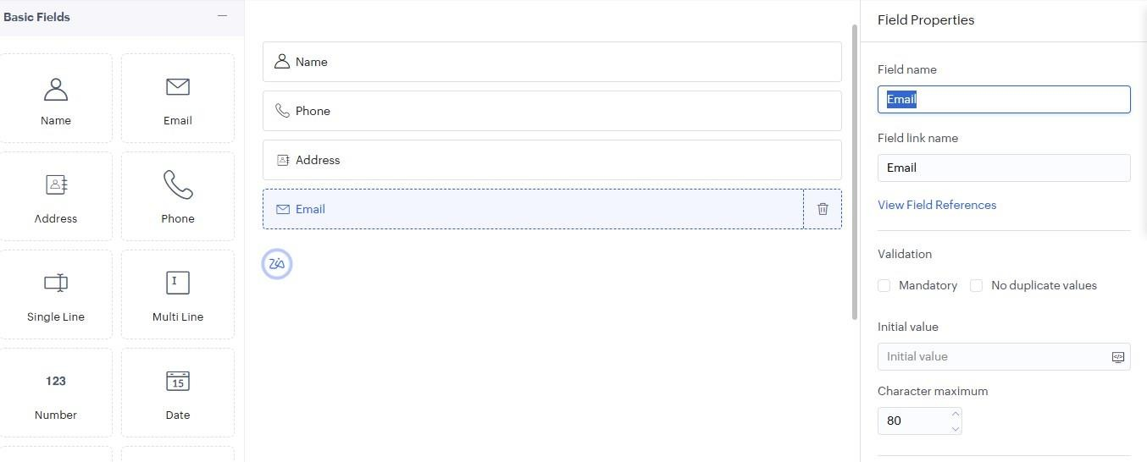
Explanation:
A form is used to collect information from users through different input fields. When users submit the form, the entered information is stored in the application's database.
3. Creating a Report
Procedure:
- Select Create and choose Report.
- Choose the Student Details form as the data source.
- Create the report and save it.

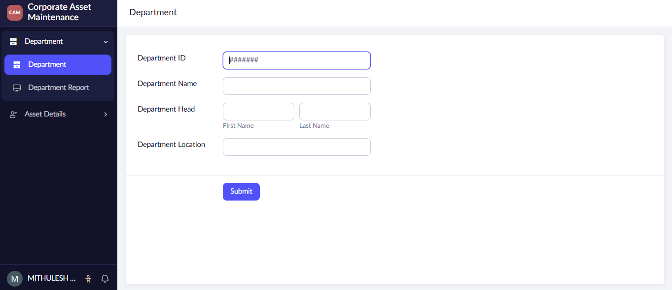
Explanation:
A report presents the records submitted through a form. It allows users to view, search, sort, filter, and manage the stored information in an organized manner.
4. Creating a Dashboard
Procedure:
- Select Create and then choose Dashboard.
- Add suitable report and chart components to the dashboard.
- Save the dashboard.

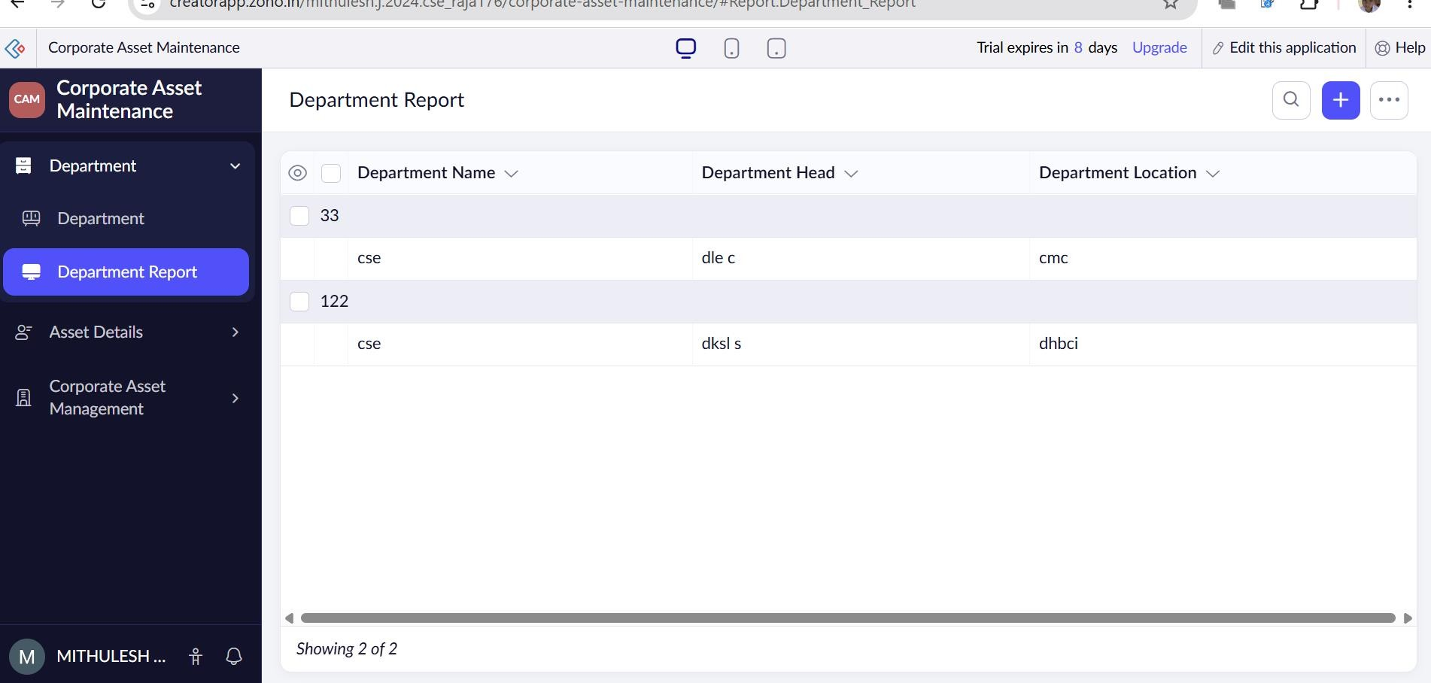
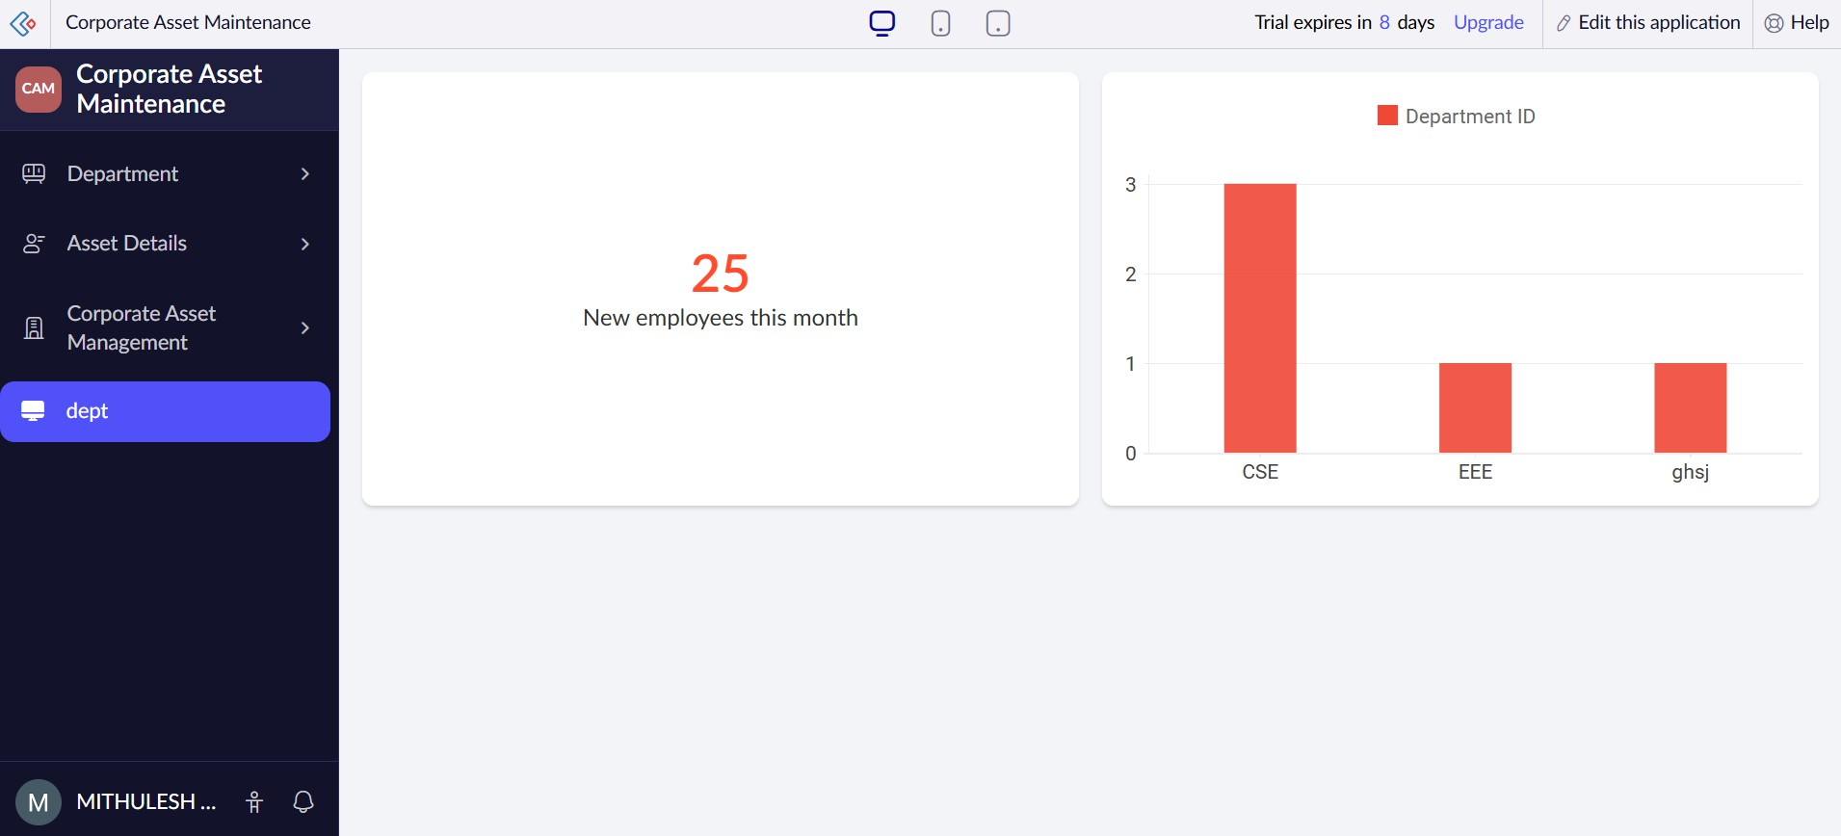
Explanation:
A dashboard provides a visual summary of application data. It combines reports, charts, and other components on a single screen, making it easier to understand and analyze information quickly.
5. Exploring the Zoho Creator Platform Architecture and Interface
Develop – Application Creation and Customization
- Provides built-in drag-and-drop builders for creating forms and reports.
- Includes the Deluge scripting engine for implementing complex business logic.
- Supports low-code workflow automation for processes such as multi-stage approvals.
- Allows custom HTML and CSS pages for creating personalized user interfaces.
- Provides data validation and conditional user-interface formatting.
- Offers sandbox environments for development and testing without affecting the live application.
Deploy – Application Distribution and Governance
- Supports publishing applications across web, iOS, and Android platforms.
- Provides role-based access control (RBAC) for managing field-level security.
- Allows customer portals to be created for external users and stakeholders.
- Provides version management to track changes and restore earlier versions when required.
- Supports custom domain mapping for white-labeled applications.
- Provides Single Sign-On (SSO) integration through SAML and Active Directory.
Manage – Administration and Operations
- Provides centralized user provisioning and license administration.
- Supports scheduled data backups and point-in-time recovery.
- Provides integration dashboards for monitoring APIs and webhooks.
- Maintains audit logs to track user activities and data changes.
- Offers real-time performance analytics and system health monitoring.
- Supports management of data encryption keys to improve cloud security.
6. Result
The Zoho Creator environment was successfully configured and a sample application was created. The application included a form for collecting student information, a report for displaying and managing submitted records, and a dashboard for presenting data visually. The Develop, Deploy, and Manage sections of the Zoho Creator platform were also explored successfully.

