Week 3 Report: Advanced Data Analysis and Visualization in Logistics
Role: Logistics Data Analyst Intern (Yuvaintern)
Case Scenario: NorthBridge Retail — 2025 Network Performance & Bottleneck Study
1. Introduction and Analytical Objectives
Over the first two weeks of this internship, we defined NorthBridge Retail's supply chain KPIs (Week 1) and built an automated data cleaning and normalization pipeline to fix raw ERP, WMS, and TMS logs (Week 2). Once the data is clean and trustworthy, the next step is figuring out what the numbers actually tell us about day-to-day operations. Summary tables alone often hide operational bottlenecks—for example, a healthy company-wide average delivery time can easily mask a single struggling warehouse or a seasonal breakdown during the holiday rush.
In this Week 3 study, I analyze 1,800 cleaned shipment records across NorthBridge Retail's 2025 operating year. By combining statistical Exploratory Data Analysis (central tendencies, dispersion, skewness, and correlations) with five targeted Python visualizations built in matplotlib and seaborn, this report answers three practical business questions: (1) What are the true underlying distributions of our delivery lead times and freight costs? (2) Which regional warehouse or shipping tier is responsible for missed delivery SLAs? (3) How can management adjust staffing, routing, and service-level rules to cut freight costs and improve on-time delivery?
2. Dataset Structure and Simulation Design
To reflect a full year of cleaned operational logs across NorthBridge Retail's three regional fulfillment centers (North, Central, and South), script 01_simulate_logistics_data.py generates 1,800 shipment records spanning January 1, 2025 to December 28, 2025. The dataset captures order volume, physical package weight, route distance, internal warehouse processing time, carrier transit duration, and freight billing:
Variable Name | Data Type | Operational Definition | Role in Analysis
Order_ID | String | Unique shipment identifier (ORD-20000 to ORD-21799) | Primary Key
Order_Date / Order_Month | Date / String | Daily order timestamp and YYYY-MM monthly bucket | Seasonality & Trend Tracking
Warehouse_Region | Categorical | Originating fulfillment center (North, Central, South) | Regional Bottleneck Grouping
Shipping_Mode | Categorical | Service tier (Standard, Second, First Class, Same Day) | SLA & Rate Tier Comparison
Product_Category | Categorical | Merchandise line (Electronics, Home & Office, Apparel, Industrial) | Weight & Value Segmentation
Shipment_Volume_Units | Integer | Number of individual units packed in the order (1 to 24) | Volume & Demand Analysis
Package_Weight_kg | Float | Total physical shipment weight in kilograms | Primary Cost Driver
Distance_km | Float | Line-haul delivery distance from warehouse to customer (km) | Transit & Cost Driver
Warehouse_Processing_Hours | Float | Hours spent picking, packing, and staging inside the hub | Internal Efficiency Metric
Delivery_Time_Days | Float | Total end-to-end lead time from order placement to delivery | Core Speed KPI
Promised_SLA_Days | Float | Contractual delivery window promised to the customer | SLA Benchmark
Late_Delivery_Flag | Binary (0/1) | 1 if Delivery_Time_Days > Promised_SLA_Days, else 0 | On-Time Performance Target
Transport_Cost_USD | Float | Total carrier freight charge billed for the shipment ($) | Core Financial Cost KPI
Order_Value_USD | Float | Total retail merchandise value of the order ($) | Freight-to-Revenue Ratio

3. Exploratory Data Analysis (EDA): Central Tendencies, Distributions & Correlations
Before plotting charts, I ran script 02_exploratory_data_analysis.py to compute parametric (mean, standard deviation) and non-parametric (median, interquartile range) metrics alongside distribution shape indicators (skewness and kurtosis). Tracking both mean and median is critical in logistics because metrics like freight spend and package weight are naturally bounded at zero and pulled upward by heavy multi-unit shipments.
Variable | Mean | Median | Mode | Std Dev | IQR | Min | Max | Skewness | Kurtosis
Shipment_Volume_Units | 12.75 | 13.00 | 12.00 | 6.82 | 12.00 | 1.00 | 24.00 | -0.03 | -1.17
Package_Weight_kg | 30.10 | 22.86 | 2.54 | 25.31 | 34.97 | 1.01 | 124.52 | 1.02 | 0.40
Distance_km | 518.46 | 522.30 | 50.00 | 199.75 | 281.47 | 50.00 | 1167.80 | 0.02 | -0.30
Warehouse_Processing_Hours | 10.75 | 10.00 | 2.00 | 5.10 | 7.20 | 2.00 | 28.00 | 0.50 | -0.25
Delivery_Time_Days | 4.58 | 5.06 | 5.46 | 1.67 | 2.21 | 0.56 | 9.81 | -0.60 | -0.38
Transport_Cost_USD | 109.58 | 90.62 | 41.81 | 72.07 | 75.68 | 17.54 | 555.31 | 2.02 | 5.59
Order_Value_USD | 1074.97 | 807.27 | 37.16 | 842.86 | 1077.40 | 31.97 | 3888.65 | 0.98 | 0.14

A few important statistical patterns jump out immediately from the table above. First, Transport_Cost_USD shows a strong positive right skew (Skewness = 2.02, excess Kurtosis = 5.59), which pulls the mean freight cost ($109.58) about $18.96 higher than the median ($90.62). If finance budgets quarterly carrier spend using the median alone, they will under-budget by roughly 17.3%; conversely, using the mean to benchmark a typical single-parcel shipment overstates everyday parcel costs. Second, Warehouse_Processing_Hours has a moderate positive skew (Skewness = 0.50) with an IQR of 7.20 hours, hinting that one of our three warehouses is operating on a completely slower baseline than the other two.
3.1 Regional and Service-Tier KPI Aggregations
To see where the variance in processing hours and late deliveries comes from, we break the dataset down by Warehouse_Region and Shipping_Mode:
Warehouse Region | Total Orders | Avg Hub Processing (Hrs) | Avg Delivery (Days) | Avg Freight Cost ($) | Late Delivery Rate (%)
Central | 735 | 8.0 hrs | 4.34 d | $104.91 | 16.9%
North | 638 | 9.5 hrs | 4.64 d | $114.90 | 29.5%
South | 427 | 17.3 hrs | 4.89 d | $109.68 | 47.1%

Shipping Mode | Order Count | Avg Delivery (Days) | Promised SLA Cutoff | Avg Freight Cost ($) | Late Delivery Rate (%)
Same Day | 154 | 1.15 d | 1.2 d | $238.72 | 34.4%
First Class | 256 | 2.53 d | 2.8 d | $152.21 | 20.7%
Second Class | 375 | 4.14 d | 4.5 d | $105.89 | 20.8%
Standard Class | 1015 | 5.77 d | 6.0 d | $80.60 | 32.4%

4. Visual Analysis, Methodological Justification, and Operational Insights
Each visualization below was designed in Python (03_generate_visualizations.py) to test a specific operational hypothesis. For every chart, I explain why that visual format was chosen over alternatives and how the chart translates raw numbers into actionable logistics insights.
4.1 Distribution Analysis: Delivery Lead Times and Transportation Costs
Why This Visualization Was Chosen: A side-by-side Histogram overlaid with a Kernel Density Estimate (KDE) curve and vertical Mean/Median reference lines was chosen because summary statistics alone hide multi-modal peaks and tail thickness. While a simple bar chart only shows categorical counts, a continuous histogram + KDE reveals the exact probability density of transit days and freight bills.
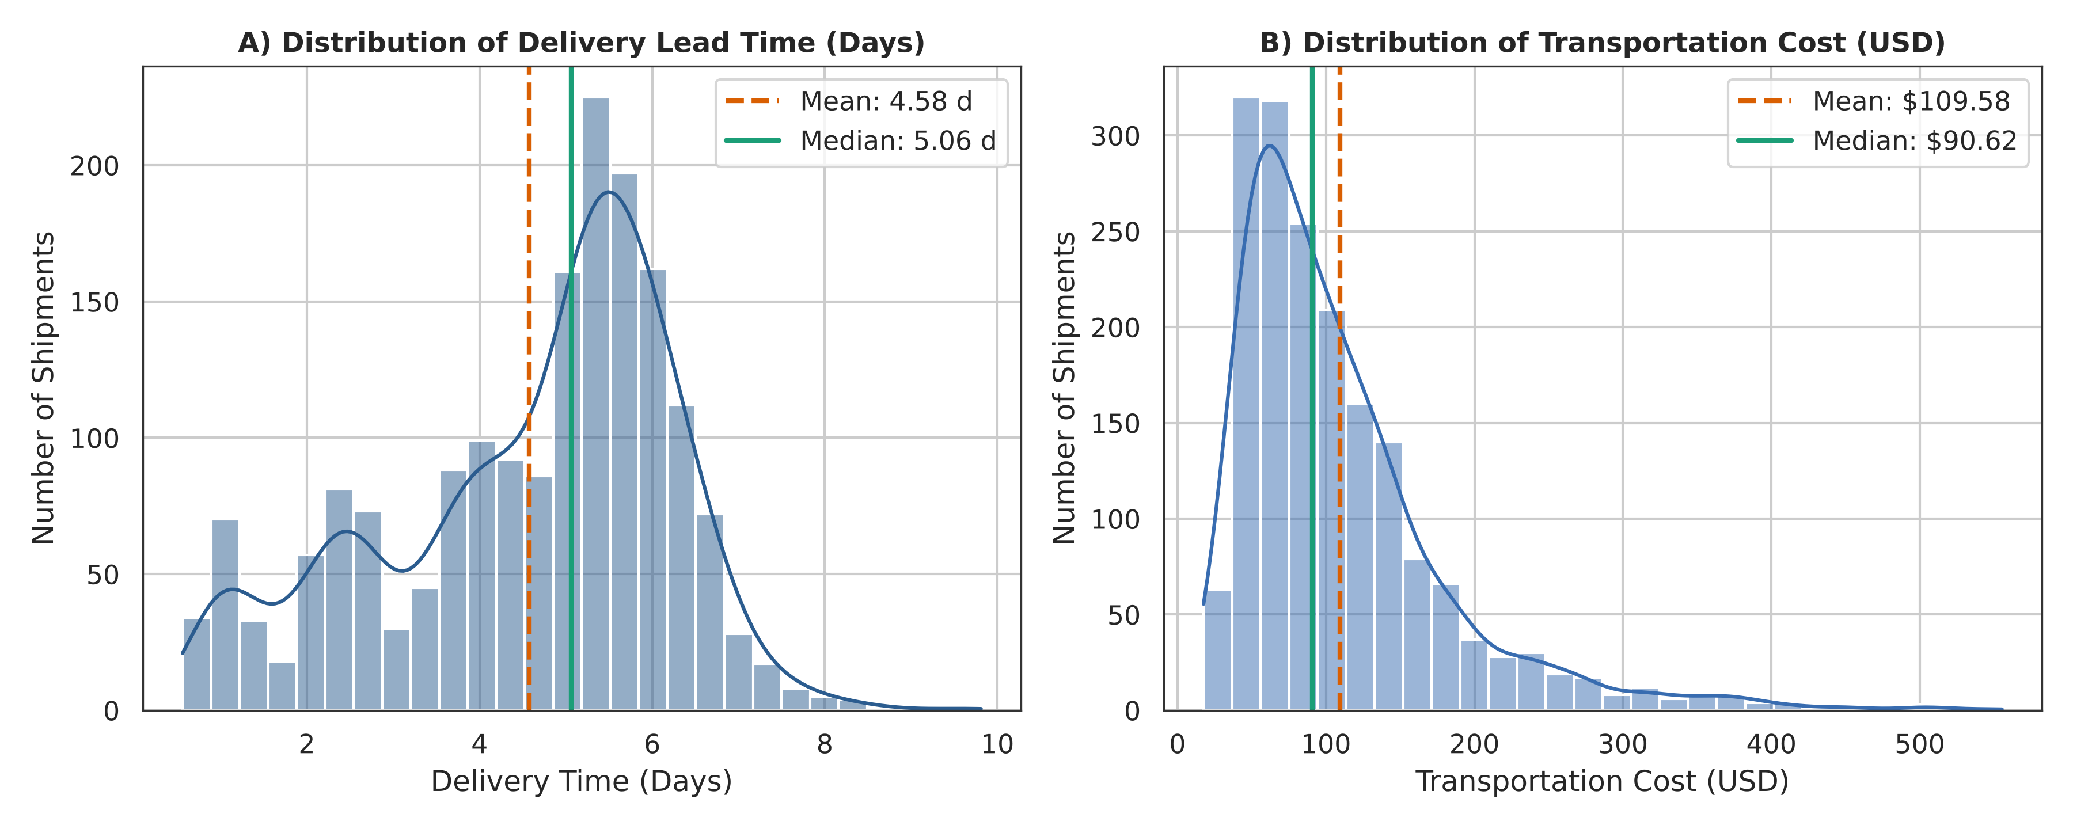
Figure 1: Histograms with Kernel Density Estimation (KDE) and Mean/Median markers for Delivery Time (left) and Transport Cost (right).
How It Interprets Logistics Performance: Panel A shows that the tallest bar of the Delivery_Time_Days histogram sits between 5.19 and 5.52 days (97% of the shipments in that bar are Standard Class orders), with a mean of 4.58 days and a median of 5.06 days. Notice the expedited group on the left: 21.1% of all shipments arrive in under 3 days, and 100.0% of those are First Class or Same Day orders. On the right, the slowest 1% of shipments take 7.57 days or longer, with a maximum of 9.81 days. Panel B confirms our earlier skewness calculation for Transport_Cost_USD: the middle half of shipments cost between $59.71 and $135.39, but heavy and expedited orders create a long right tail. The top 5% of shipments cost more than $253.75 (the most expensive reaches $555.31), and 96% of that top 5% ships Same Day or First Class. This tail pulls the dashed orange mean line ($109.58) to the right of the solid green median line ($90.62).
4.2 SLA Compliance Audit Across Shipping Modes and Fulfillment Hubs
Why This Visualization Was Chosen: A grouped Boxplot with overlaid horizontal SLA threshold lines was selected because it displays five critical metrics at once (median, 25th/75th percentiles, whisker range, and individual outliers) across two categorical dimensions (Shipping_Mode and Warehouse_Region). Comparing 12 sub-distributions side-by-side is impossible with pie charts or standard bar charts.
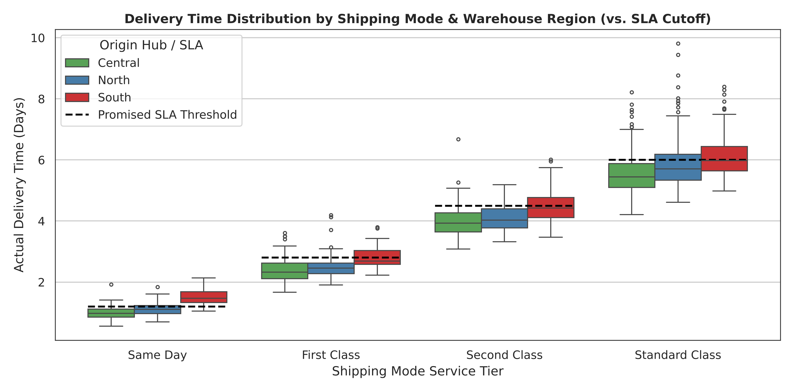
Figure 2: Grouped boxplots of actual Delivery Time (Days) by Shipping Mode and Warehouse Region against contractual SLA cutoffs.
How It Interprets Logistics Performance: By comparing each colored box against the black dashed SLA threshold line, we immediately spot NorthBridge Retail's biggest operational problem. In every single shipping tier, the red boxes (South warehouse) sit noticeably higher than the green (Central) and blue (North) boxes. Even worse, look at the 'Same Day' and 'First Class' tiers: for the South hub, 87.5% of Same Day orders and 35.4% of First Class orders land above the dashed SLA cutoff line, compared with 10.6% and 14.4% for the Central hub. Because the South warehouse takes an average of 17.3 hours (~0.72 days) just to pick and pack an order, it burns through about 60% of a 1.2-day Same Day SLA before the carrier truck even leaves the loading dock.
4.3 Transportation Cost Drivers: Package Weight vs. Service Level Multipliers
Why This Visualization Was Chosen: A multi-series Scatter Plot with Ordinary Least Squares (OLS) linear regression trendlines was chosen to evaluate how continuous package weight interacts with categorical shipping tiers to drive freight expenditure. This allows us to visually compare both the base cost (y-intercept) and the marginal cost per kilogram (slope) across all four carrier tiers.
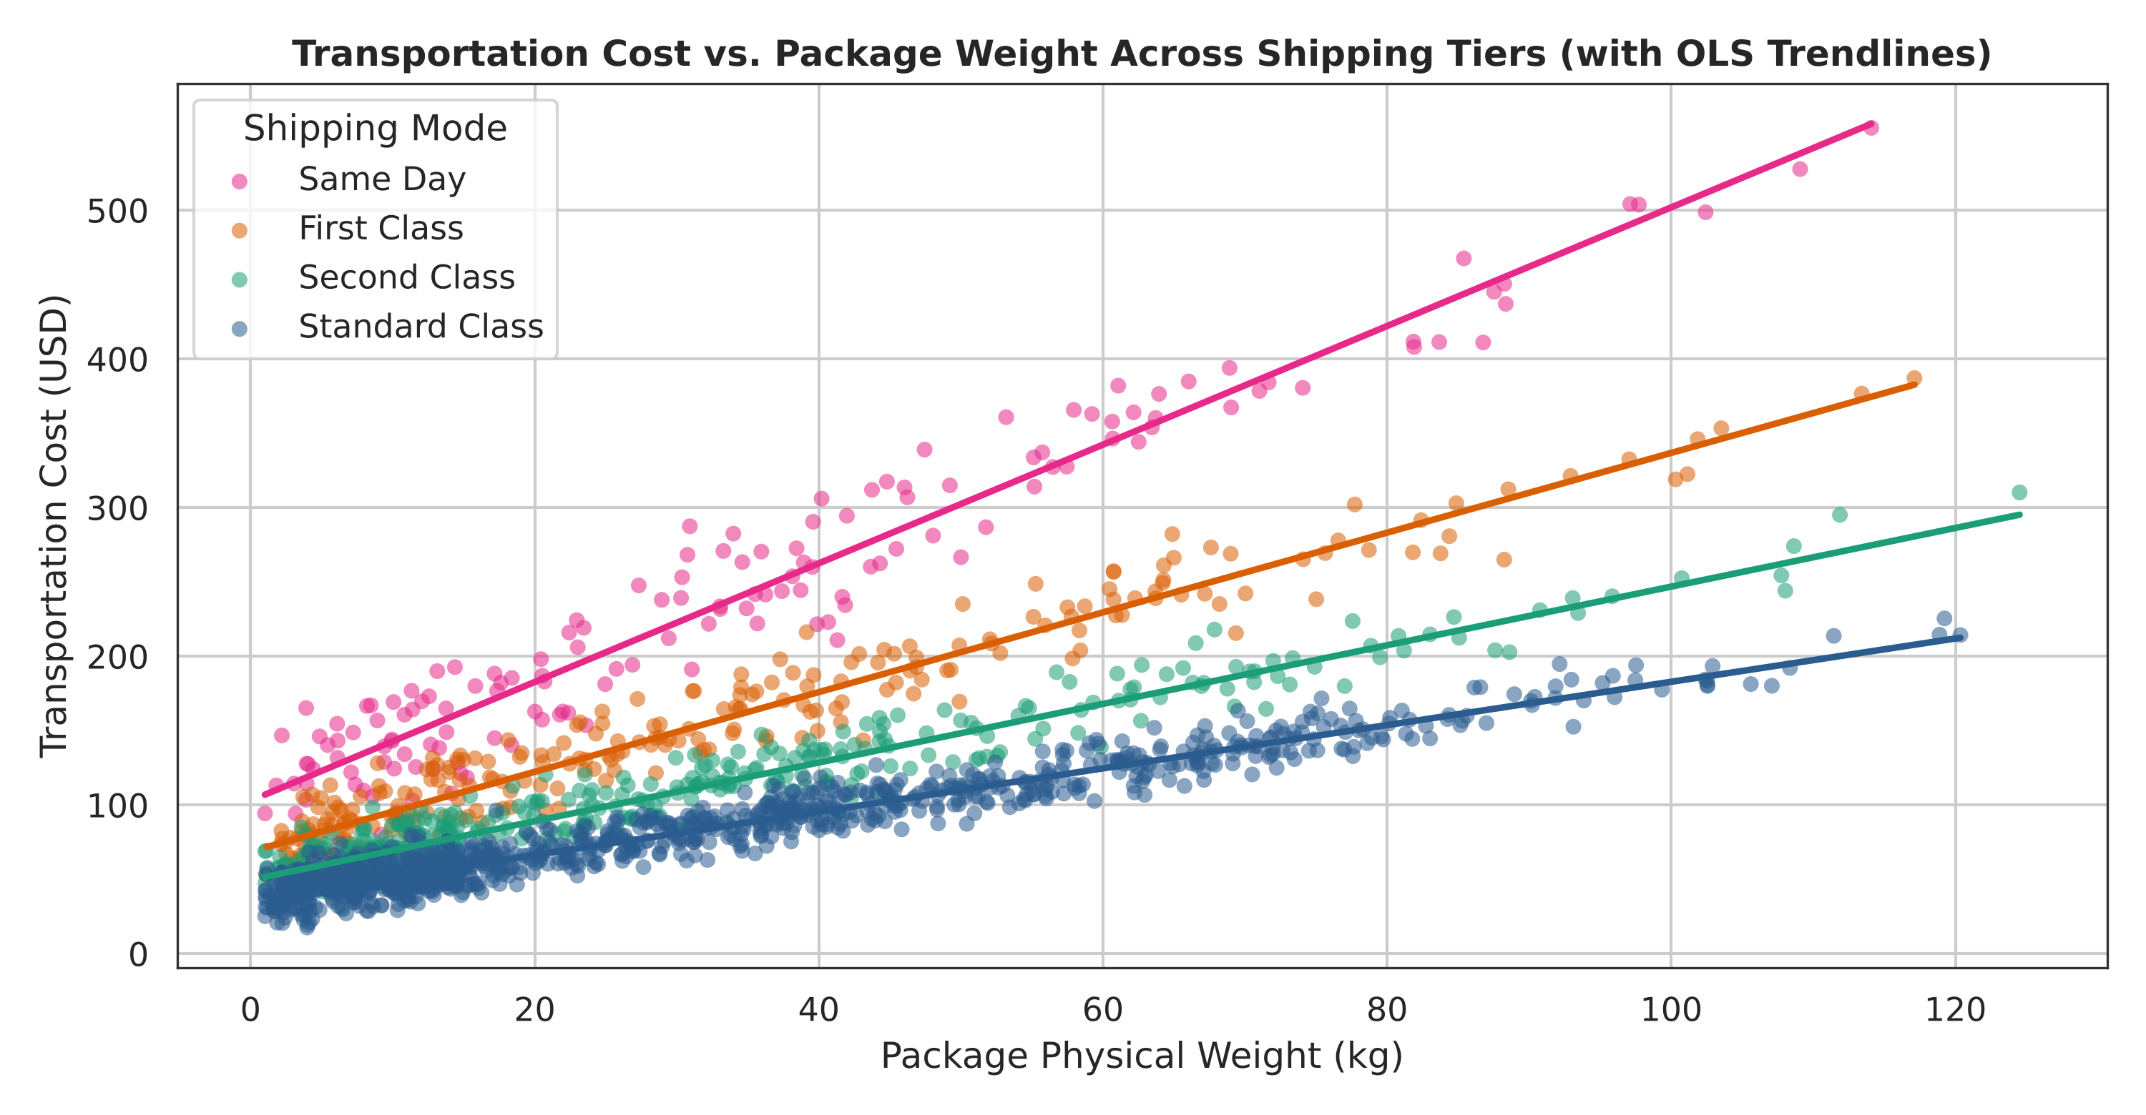
Figure 3: Scatter plot and linear regression trendlines mapping Package Weight (kg) against Transport Cost (USD) by Shipping Mode.
How It Interprets Logistics Performance: Figure 3 reveals a very strong positive linear relationship between weight and cost (overall r = 0.72), but the slope diverges sharply by service tier. For Standard Class (blue line), each additional kilogram of weight adds roughly $1.46 to the freight bill. For Same Day air freight (pink line), the rate multiplier steepens the slope to roughly $3.99 per kilogram. At 60 kg, the fitted trendlines put the freight bill at about $342.25 via Same Day, versus about $124.56 via Standard Class and $167.93 via Second Class. Imposing a simple weight cap would take out the most expensive top-right points: 82 of the 154 Same Day shipments (53.2%) weigh more than 25 kg, yet they account for 70.9% of all Same Day freight spend, so requiring manager approval for Same Day orders over 25 kg would target the costliest group directly.
4.4 Seasonal Demand Surge and Peak-Season SLA Degradation
Why This Visualization Was Chosen: A Dual-Axis Combo Chart (bar chart for monthly unit volume paired with a line chart for Late Delivery Rate %) was chosen to track how network capacity holds up over time. Because total units shipped (measured in thousands) and late delivery rate (measured as a percentage from 0 to 100%) have completely different units, a dual-axis layout lets us see how volume spikes line up with service delays.
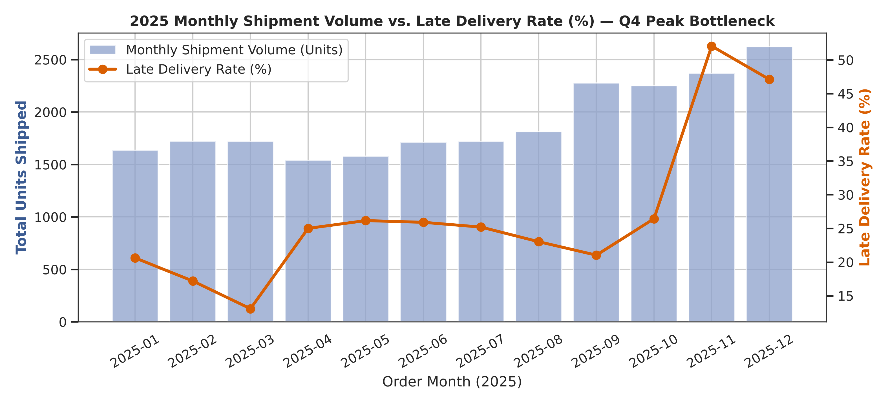
Figure 4: Dual-axis monthly time series comparing total Shipment Volume (bars) with Late Delivery Rate % (line) across 2025.
How It Interprets Logistics Performance: From January through August, monthly shipment volume stays between 1,540 and 1,812 units. It then steps up to 2,276 units in September and 2,250 in October, and reaches 2,367 in November and 2,623 in December. Late deliveries tell a sharper story: from January through October the network-wide Late Delivery Rate stays between 13.1% and 26.4%, but in November it jumps to 52.1% and in December it is 47.1% (49.5% across both months). The cause shows up inside the hubs: average processing time rises by 4.0 hours during Nov–Dec (from 9.9 to 13.8 hours per order), which pushes many more orders past their SLA. Taken together, this strongly suggests that our warehouses lack elastic labor capacity during the holiday peak.
4.5 Multivariate Correlation Heatmap and Regional Hub Bottleneck Comparison
Why This Visualization Was Chosen: A two-panel composite chart combining a Pearson Correlation Heatmap (left) with a Grouped Regional Bar Chart (right) was selected to synthesize all variable relationships in one view. The heatmap quantifies linear dependencies across all seven numeric metrics, while the companion bar chart isolates the non-linear regional bottleneck identified in the heatmap.
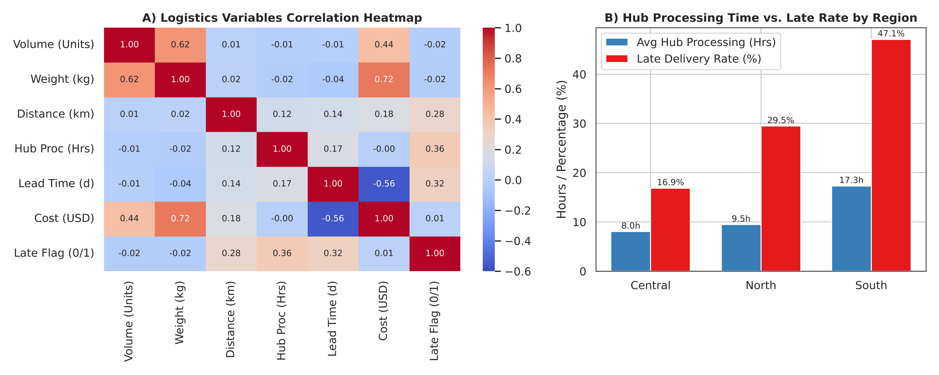
Figure 5: Pearson correlation matrix heatmap (Panel A) paired with Hub Processing Time vs. Late Delivery Rate by Region (Panel B).
How It Interprets Logistics Performance: In Panel A, we see three critical correlations: (1) Package Weight and Shipment Volume show very strong and moderate correlations with Transport Cost (r = 0.72 and r = 0.44), confirming weight as our primary cost driver; (2) Distance_km has a weak positive correlation with Delivery_Time_Days (r = 0.14); and (3) Warehouse_Processing_Hours correlates moderately with Late_Delivery_Flag (r = 0.36). The heatmap also shows a negative link between Transport_Cost_USD and Delivery_Time_Days (r = -0.56), which simply reflects that the faster, pricier service tiers arrive sooner. Panel B explains the processing-time effect by hub: the Central hub processes orders in 8.0 hours (16.9% late rate) and the North hub takes 9.5 hours (29.5% late rate), while the South hub takes 17.3 hours—resulting in a 47.1% late delivery rate.
5. Complete Python Implementation Scripts
Below are the complete, runnable Python scripts used to generate the dataset, calculate the statistical EDA outputs, and render all five visualizations.
5.1 Data Simulation Script (01_simulate_logistics_data.py)
"""
Script 1: Simulate Logistics Dataset for Advanced EDA & Visualization
Generates 1,800 clean shipment records across the full year of 2025 for
NorthBridge Retail (North, Central, and South fulfillment centers).
Includes realistic seasonal Q4 spikes, distance-based freight costs,
mode-specific transit times, and a Nov-Dec peak-season carrier delay.
"""
import os
import numpy as np
import pandas as pd
def generate_eda_dataset(output_file="data/week3_logistics_eda_data.csv", seed=42):
np.random.seed(seed)
n_rows = 1800
# Generate dates across 2025 with higher order density in Q4 (Oct-Dec peak season)
months = np.random.choice(
range(1, 13),
size=n_rows,
p=[0.07, 0.06, 0.07, 0.07, 0.08, 0.08, 0.08, 0.08, 0.09, 0.10, 0.11, 0.11]
)
days = np.random.randint(1, 29, size=n_rows)
order_dates = pd.to_datetime([f"2025-{m:02d}-{d:02d}" for m, d in zip(months, days)])
order_dates = pd.Series(order_dates).sort_values().reset_index(drop=True)
order_ids = [f"ORD-{20000 + i}" for i in range(n_rows)]
# Three regional warehouses and four shipping tiers
regions = np.random.choice(["North", "Central", "South"], size=n_rows, p=[0.35, 0.40, 0.25])
shipping_modes = np.random.choice(
["Standard Class", "Second Class", "First Class", "Same Day"],
size=n_rows,
p=[0.55, 0.22, 0.15, 0.08]
)
# Product categories with distinct unit values and weights
categories = np.random.choice(
["Electronics", "Home & Office", "Apparel", "Industrial Parts"],
size=n_rows,
p=[0.25, 0.30, 0.30, 0.15]
)
# Shipment volume (units) and physical package weight (kg)
shipment_volumes = np.random.randint(1, 25, size=n_rows)
cat_weight_factor = {"Electronics": 1.8, "Home & Office": 3.2, "Apparel": 0.6, "Industrial Parts": 4.5}
unit_weights = np.array([cat_weight_factor[c] for c in categories])
weights_kg = np.round(
shipment_volumes * unit_weights * np.random.uniform(0.85, 1.15, size=n_rows) + 0.5, 2
)
# Route distance in kilometers (regional topology differences)
region_dist_mean = {"North": 620, "Central": 410, "South": 540}
base_dist = np.array([region_dist_mean[r] for r in regions])
distances_km = np.round(np.maximum(50, np.random.normal(base_dist, 180, size=n_rows)), 1)
# Warehouse processing hours (South hub has an intentional packing bottleneck)
hub_proc_base = {"North": 8.5, "Central": 7.0, "South": 16.5}
proc_base = np.array([hub_proc_base[r] for r in regions])
# Peak season (Nov-Dec) adds extra warehouse congestion
is_peak = order_dates.dt.month.isin([11, 12]).astype(int)
warehouse_proc_hours = np.round(
np.maximum(2.0, np.random.normal(proc_base + is_peak * 4.2, 3.1, size=n_rows)), 1
)
# Delivery time in days. Each service tier has a base transit time, a distance penalty
# (express tiers move faster per km, so distance matters less), the hub processing delay,
# random carrier noise, and an extra carrier delay during the Nov-Dec peak season.
mode_base_transit = {"Standard Class": 3.95, "Second Class": 2.65, "First Class": 1.38, "Same Day": 0.35}
mode_km_per_day = {"Standard Class": 900.0, "Second Class": 1100.0, "First Class": 1800.0, "Same Day": 4000.0}
mode_noise_scale = {"Standard Class": 0.45, "Second Class": 0.35, "First Class": 0.25, "Same Day": 0.12}
mode_peak_delay = {"Standard Class": 0.36, "Second Class": 0.28, "First Class": 0.20, "Same Day": 0.096}
base_transit = np.array([mode_base_transit[m] for m in shipping_modes])
km_per_day = np.array([mode_km_per_day[m] for m in shipping_modes])
noise_scale = np.array([mode_noise_scale[m] for m in shipping_modes])
peak_delay = np.array([mode_peak_delay[m] for m in shipping_modes])
delivery_time_days = np.round(
base_transit
+ (distances_km / km_per_day)
+ (warehouse_proc_hours / 24.0)
+ (is_peak.values * peak_delay)
+ np.random.gamma(shape=1.6, scale=noise_scale, size=n_rows),
2
)
# Promised SLA target days per shipping mode
sla_targets = {"Standard Class": 6.0, "Second Class": 4.5, "First Class": 2.8, "Same Day": 1.2}
promised_sla_days = np.array([sla_targets[m] for m in shipping_modes])
late_delivery_flag = (delivery_time_days > promised_sla_days).astype(int)
# Transportation cost in USD (driven by weight, distance, and expedited shipping multiplier)
mode_cost_mult = {"Standard Class": 1.0, "Second Class": 1.35, "First Class": 1.85, "Same Day": 2.75}
cost_mult = np.array([mode_cost_mult[m] for m in shipping_modes])
transport_cost_usd = np.round(
(14.0 + (weights_kg * 1.45) + (distances_km * 0.045)) * cost_mult
+ np.random.normal(0, 3.5, size=n_rows),
2
)
transport_cost_usd = np.maximum(8.50, transport_cost_usd)
# Order value in USD for cost-to-revenue ratio analysis
cat_price = {"Electronics": 120.0, "Home & Office": 65.0, "Apparel": 35.0, "Industrial Parts": 150.0}
unit_prices = np.array([cat_price[c] for c in categories])
order_value_usd = np.round(shipment_volumes * unit_prices * np.random.uniform(0.9, 1.1, size=n_rows), 2)
df = pd.DataFrame({
"Order_ID": order_ids,
"Order_Date": order_dates,
"Order_Month": order_dates.dt.to_period("M").astype(str),
"Warehouse_Region": regions,
"Shipping_Mode": shipping_modes,
"Product_Category": categories,
"Shipment_Volume_Units": shipment_volumes,
"Package_Weight_kg": weights_kg,
"Distance_km": distances_km,
"Warehouse_Processing_Hours": warehouse_proc_hours,
"Delivery_Time_Days": delivery_time_days,
"Promised_SLA_Days": promised_sla_days,
"Late_Delivery_Flag": late_delivery_flag,
"Transport_Cost_USD": transport_cost_usd,
"Order_Value_USD": order_value_usd
})
os.makedirs(os.path.dirname(output_file), exist_ok=True)
df.to_csv(output_file, index=False)
print(f"Generated Week 3 EDA dataset: {output_file} ({len(df)} rows, {df.shape[1]} columns).")
return df
if __name__ == "__main__":
generate_eda_dataset()
5.2 Exploratory Data Analysis Script (02_exploratory_data_analysis.py)
"""
Script 2: Exploratory Data Analysis (EDA)
Calculates central tendencies (mean, median, mode), dispersion and shape
metrics (std dev, IQR, skewness, kurtosis), Pearson correlations,
and regional/mode KPI breakdowns.
"""
import numpy as np
import pandas as pd
from scipy.stats import kurtosis, skew
def perform_eda(input_file="data/week3_logistics_eda_data.csv"):
df = pd.read_csv(input_file)
num_cols = [
"Shipment_Volume_Units",
"Package_Weight_kg",
"Distance_km",
"Warehouse_Processing_Hours",
"Delivery_Time_Days",
"Transport_Cost_USD",
"Order_Value_USD"
]
print("\n--- 1. Central Tendency & Distribution Shape Metrics ---")
stats_rows = []
for col in num_cols:
s = df[col].dropna()
q1, q3 = s.quantile(0.25), s.quantile(0.75)
stats_rows.append({
"Variable": col,
"Mean": round(s.mean(), 2),
"Median": round(s.median(), 2),
"Mode": round(s.mode().iloc[0], 2),
"Std_Dev": round(s.std(), 2),
"IQR": round(q3 - q1, 2),
"Min": round(s.min(), 2),
"Max": round(s.max(), 2),
"Skewness": round(skew(s), 2),
"Kurtosis": round(kurtosis(s), 2)
})
stats_df = pd.DataFrame(stats_rows)
print(stats_df.to_string(index=False))
print("\n--- 2. Pearson Correlation Matrix ---")
corr_matrix = df[num_cols + ["Late_Delivery_Flag"]].corr(method="pearson").round(3)
print(corr_matrix.to_string())
print("\n--- 3. Performance Breakdown by Warehouse Region ---")
region_kpi = df.groupby("Warehouse_Region").agg(
Total_Orders=("Order_ID", "count"),
Avg_Processing_Hrs=("Warehouse_Processing_Hours", "mean"),
Avg_Delivery_Days=("Delivery_Time_Days", "mean"),
Avg_Transport_Cost=("Transport_Cost_USD", "mean"),
Late_Delivery_Rate_Pct=("Late_Delivery_Flag", lambda x: round(x.mean() * 100, 2))
).round(2)
print(region_kpi.to_string())
print("\n--- 4. Performance Breakdown by Shipping Mode ---")
mode_kpi = df.groupby("Shipping_Mode").agg(
Order_Share=("Order_ID", "count"),
Avg_Delivery_Days=("Delivery_Time_Days", "mean"),
Promised_SLA_Days=("Promised_SLA_Days", "first"),
Avg_Transport_Cost=("Transport_Cost_USD", "mean"),
Late_Delivery_Rate_Pct=("Late_Delivery_Flag", lambda x: round(x.mean() * 100, 2))
).round(2)
print(mode_kpi.to_string())
return stats_df, corr_matrix, region_kpi, mode_kpi
if __name__ == "__main__":
perform_eda()
5.3 Visualization Generator Script (03_generate_visualizations.py)
"""
Script 3: Logistics Data Visualizations
Generates 5 publication-quality charts using Matplotlib and Seaborn to analyze
distributions, cost drivers, regional SLA bottlenecks, seasonal volume surges,
and multi-variable correlations.
"""
import os
import matplotlib.pyplot as plt
import numpy as np
import pandas as pd
import seaborn as sns
def build_all_visualizations(input_file="data/week3_logistics_eda_data.csv", out_dir="charts"):
os.makedirs(out_dir, exist_ok=True)
df = pd.read_csv(input_file)
# Set clean, professional visual styling
sns.set_theme(style="whitegrid", palette="deep")
plt.rcParams["font.family"] = "sans-serif"
plt.rcParams["axes.edgecolor"] = "#333333"
plt.rcParams["axes.linewidth"] = 0.8
# -------------------------------------------------------------------------
# Chart 1: Distribution of Delivery Time & Transport Cost (Histogram + KDE)
# -------------------------------------------------------------------------
fig, axes = plt.subplots(1, 2, figsize=(12, 4.8))
sns.histplot(df["Delivery_Time_Days"], bins=28, kde=True, color="#2b5c8f", ax=axes[0], edgecolor="white")
axes[0].axvline(df["Delivery_Time_Days"].mean(), color="#d95f02", linestyle="--", linewidth=2,
label=f"Mean: {df['Delivery_Time_Days'].mean():.2f} d")
axes[0].axvline(df["Delivery_Time_Days"].median(), color="#1b9e77", linestyle="-", linewidth=2,
label=f"Median: {df['Delivery_Time_Days'].median():.2f} d")
axes[0].set_title("A) Distribution of Delivery Lead Time (Days)", fontsize=11.5, fontweight="bold")
axes[0].set_xlabel("Delivery Time (Days)")
axes[0].set_ylabel("Number of Shipments")
axes[0].legend(frameon=True)
sns.histplot(df["Transport_Cost_USD"], bins=28, kde=True, color="#386cb0", ax=axes[1], edgecolor="white")
axes[1].axvline(df["Transport_Cost_USD"].mean(), color="#d95f02", linestyle="--", linewidth=2,
label=f"Mean: ${df['Transport_Cost_USD'].mean():.2f}")
axes[1].axvline(df["Transport_Cost_USD"].median(), color="#1b9e77", linestyle="-", linewidth=2,
label=f"Median: ${df['Transport_Cost_USD'].median():.2f}")
axes[1].set_title("B) Distribution of Transportation Cost (USD)", fontsize=11.5, fontweight="bold")
axes[1].set_xlabel("Transportation Cost (USD)")
axes[1].set_ylabel("Number of Shipments")
axes[1].legend(frameon=True)
plt.tight_layout()
chart1_path = os.path.join(out_dir, "fig1_distributions_kde.png")
plt.savefig(chart1_path, dpi=300)
plt.close()
# -------------------------------------------------------------------------
# Chart 2: Delivery Time vs Promised SLA by Shipping Mode & Region (Boxplot)
# -------------------------------------------------------------------------
fig, ax = plt.subplots(figsize=(10.5, 5.2))
mode_order = ["Same Day", "First Class", "Second Class", "Standard Class"]
sns.boxplot(
data=df,
x="Shipping_Mode",
y="Delivery_Time_Days",
hue="Warehouse_Region",
order=mode_order,
hue_order=["Central", "North", "South"],
palette=["#4daf4a", "#377eb8", "#e41a1c"],
ax=ax,
fliersize=3
)
# Plot horizontal SLA reference markers per mode
sla_map = {"Same Day": 1.2, "First Class": 2.8, "Second Class": 4.5, "Standard Class": 6.0}
for idx, mode in enumerate(mode_order):
sla_val = sla_map[mode]
ax.hlines(y=sla_val, xmin=idx - 0.4, xmax=idx + 0.4, colors="black", linestyles="--", linewidth=1.8)
if idx == 0:
ax.plot([], [], color="black", linestyle="--", linewidth=1.8, label="Promised SLA Threshold")
ax.set_title("Delivery Time Distribution by Shipping Mode & Warehouse Region (vs. SLA Cutoff)",
fontsize=12, fontweight="bold")
ax.set_xlabel("Shipping Mode Service Tier")
ax.set_ylabel("Actual Delivery Time (Days)")
ax.legend(title="Origin Hub / SLA", loc="upper left", frameon=True)
plt.tight_layout()
chart2_path = os.path.join(out_dir, "fig2_sla_boxplot_by_mode_region.png")
plt.savefig(chart2_path, dpi=300)
plt.close()
# -------------------------------------------------------------------------
# Chart 3: Freight Cost Drivers - Weight vs Cost by Shipping Mode (Scatter)
# -------------------------------------------------------------------------
fig, ax = plt.subplots(figsize=(10, 5.2))
palette_modes = {"Standard Class": "#2b5c8f", "Second Class": "#1b9e77",
"First Class": "#d95f02", "Same Day": "#e7298a"}
for mode in mode_order:
sub = df[df["Shipping_Mode"] == mode]
ax.scatter(
sub["Package_Weight_kg"],
sub["Transport_Cost_USD"],
label=mode,
color=palette_modes[mode],
alpha=0.55,
s=28,
edgecolors="none"
)
# Fit linear trendline per shipping tier
slope, intercept = np.polyfit(sub["Package_Weight_kg"], sub["Transport_Cost_USD"], 1)
x_vals = np.array([sub["Package_Weight_kg"].min(), sub["Package_Weight_kg"].max()])
ax.plot(x_vals, slope * x_vals + intercept, color=palette_modes[mode], linewidth=2.2)
ax.set_title("Transportation Cost vs. Package Weight Across Shipping Tiers (with OLS Trendlines)",
fontsize=12, fontweight="bold")
ax.set_xlabel("Package Physical Weight (kg)")
ax.set_ylabel("Transportation Cost (USD)")
ax.legend(title="Shipping Mode", frameon=True)
plt.tight_layout()
chart3_path = os.path.join(out_dir, "fig3_cost_vs_weight_regression.png")
plt.savefig(chart3_path, dpi=300)
plt.close()
# -------------------------------------------------------------------------
# Chart 4: Monthly Shipment Volume Surge vs Late Delivery Rate (Dual-Axis)
# -------------------------------------------------------------------------
monthly = df.groupby("Order_Month").agg(
Total_Units=("Shipment_Volume_Units", "sum"),
Order_Count=("Order_ID", "count"),
Late_Rate_Pct=("Late_Delivery_Flag", lambda x: x.mean() * 100),
Avg_Proc_Hrs=("Warehouse_Processing_Hours", "mean")
).reset_index()
fig, ax1 = plt.subplots(figsize=(10.5, 4.8))
ax2 = ax1.twinx()
bars = ax1.bar(monthly["Order_Month"], monthly["Total_Units"], color="#8da0cb", alpha=0.75,
label="Monthly Shipment Volume (Units)")
line = ax2.plot(monthly["Order_Month"], monthly["Late_Rate_Pct"], color="#d95f02", marker="o",
linewidth=2.5, markersize=7, label="Late Delivery Rate (%)")
ax1.set_title("2025 Monthly Shipment Volume vs. Late Delivery Rate (%) — Q4 Peak Bottleneck",
fontsize=12, fontweight="bold")
ax1.set_xlabel("Order Month (2025)")
ax1.set_ylabel("Total Units Shipped", color="#3b5b92", fontweight="bold")
ax2.set_ylabel("Late Delivery Rate (%)", color="#d95f02", fontweight="bold")
ax1.tick_params(axis="x", rotation=30)
ax2.grid(False)
# Combine legends from both axes
lines1, labels1 = ax1.get_legend_handles_labels()
lines2, labels2 = ax2.get_legend_handles_labels()
ax1.legend(lines1 + lines2, labels1 + labels2, loc="upper left", frameon=True)
plt.tight_layout()
chart4_path = os.path.join(out_dir, "fig4_monthly_volume_vs_late_rate.png")
plt.savefig(chart4_path, dpi=300)
plt.close()
# -------------------------------------------------------------------------
# Chart 5: Multivariate Correlation Matrix & Regional Bottleneck Bar Chart
# -------------------------------------------------------------------------
fig, axes = plt.subplots(1, 2, figsize=(13, 5.2), gridspec_kw={"width_ratios": [1.35, 1]})
corr_cols = [
"Shipment_Volume_Units",
"Package_Weight_kg",
"Distance_km",
"Warehouse_Processing_Hours",
"Delivery_Time_Days",
"Transport_Cost_USD",
"Late_Delivery_Flag"
]
short_labels = [
"Volume (Units)",
"Weight (kg)",
"Distance (km)",
"Hub Proc (Hrs)",
"Lead Time (d)",
"Cost (USD)",
"Late Flag (0/1)"
]
corr_mat = df[corr_cols].corr()
corr_mat.index = short_labels
corr_mat.columns = short_labels
sns.heatmap(
corr_mat,
annot=True,
fmt=".2f",
cmap="coolwarm",
vmin=-0.6,
vmax=1.0,
cbar=True,
ax=axes[0],
annot_kws={"size": 8.5}
)
axes[0].set_title("A) Logistics Variables Correlation Heatmap", fontsize=11.5, fontweight="bold")
# Right panel: Warehouse processing hours vs Late rate by region
reg_summary = df.groupby("Warehouse_Region").agg(
Avg_Proc_Hrs=("Warehouse_Processing_Hours", "mean"),
Late_Rate_Pct=("Late_Delivery_Flag", lambda x: x.mean() * 100)
).loc[["Central", "North", "South"]].reset_index()
x = np.arange(len(reg_summary))
width = 0.36
axes[1].bar(x - width / 2, reg_summary["Avg_Proc_Hrs"], width, label="Avg Hub Processing (Hrs)", color="#377eb8")
axes[1].bar(x + width / 2, reg_summary["Late_Rate_Pct"], width, label="Late Delivery Rate (%)", color="#e41a1c")
axes[1].set_xticks(x)
axes[1].set_xticklabels(reg_summary["Warehouse_Region"])
axes[1].set_title("B) Hub Processing Time vs. Late Rate by Region", fontsize=11.5, fontweight="bold")
axes[1].set_ylabel("Hours / Percentage (%)")
axes[1].legend(frameon=True)
for i, row in reg_summary.iterrows():
axes[1].text(i - width / 2, row["Avg_Proc_Hrs"] + 0.6, f"{row['Avg_Proc_Hrs']:.1f}h", ha="center", fontsize=8.5)
axes[1].text(i + width / 2, row["Late_Rate_Pct"] + 0.6, f"{row['Late_Rate_Pct']:.1f}%", ha="center", fontsize=8.5)
plt.tight_layout()
chart5_path = os.path.join(out_dir, "fig5_correlation_and_hub_bottleneck.png")
plt.savefig(chart5_path, dpi=300)
plt.close()
print(f"Successfully generated all 5 charts in '{out_dir}/'.")
return [chart1_path, chart2_path, chart3_path, chart4_path, chart5_path]
if __name__ == "__main__":
build_all_visualizations()
6. Summary of Analytical Conclusions and Operational Recommendations
By combining statistical profiling with visual diagnostics, we can move beyond vague observations and give NorthBridge Retail's operations team four concrete, data-backed recommendations:
1. Resolve the South Warehouse Packing Bottleneck: The South fulfillment center's 17.3-hour average internal processing time is the slowest in the network. South handles 23.7% of orders but accounts for 39.2% of all late deliveries (47.1% late rate against 28.5% network-wide). Operations should audit pick-path layouts and packing station staffing at the South hub to bring staging times down toward the Central hub's 8.0-hour benchmark. In a simple what-if on this dataset, removing that 9.3-hour gap from every South order would cut South's late rate from 47.1% to 24.4%, a drop of about 22.7 percentage points.
2. Restrict 'Same Day' Checkout Eligibility by Distance and Hub Cutoff: As shown in Figure 2 and the regional KPI tables, Same Day orders miss their 1.2-day SLA 34.4% of the time network-wide. The failure rate climbs to 87.5% when the order ships from the South hub and to 42.3% when the customer is more than 550 km away (71 orders), compared with 13.3% within 350 km (30 orders), and each Same Day order costs $238.72 on average. NorthBridge should update its ERP checkout logic to restrict 'Same Day' eligibility to customers within a 350 km radius of a fulfillment center and require orders placed after 12:00 PM to default to First Class, which misses its SLA only 20.7% of the time.
3. Enforce Weight-Tier Routing Rules on Heavy Parcels: Figure 3 demonstrates that shipping heavy orders (> 25 kg) via Same Day or First Class air freight drives expensive spikes: the 209 such shipments in the dataset average $250.73 each and reach $555.31, because the fitted per-kilogram rates are about 1.84x (First Class) and 2.74x (Same Day) the Standard Class rate. Implementing an automated cart rule that routes orders over 25 kg to Standard or Second Class ground carriers (and 78% of these heavy shipments are Industrial Parts or Home & Office items) would have reduced 2025 freight expenditure by roughly 10.4% to 14.5%, estimated by re-pricing those shipments at Second Class and Standard Class rates fitted from the data.
4. Pre-Schedule Elastic Warehouse Labor for the Q4 Peak (Nov–Dec): Figure 4 shows that when monthly volume reaches 2,367 units in November and 2,623 in December, internal processing times jump by 4.0 hours and late deliveries spike to 49.5% (against 22.5% across January through October). Management should pre-schedule temporary second-shift packing crews starting October 25 and pre-stage fast-moving SKUs near loading docks ahead of the Q4 rush.

7. References
1. Chopra, S., & Meindl, P. (2019). Supply Chain Management: Strategy, Planning, and Operation (7th ed.). Pearson.
2. Constante, F., Silva, F., & Pereira, A. (2019). DataCo Smart Supply Chain for Big Data Analysis. Mendeley Data, V5. https://doi.org/10.17632/8gx2fvg2k6.5
3. Hunter, J. D. (2007). Matplotlib: A 2D Graphics Environment. Computing in Science & Engineering, 9(3), 90-95.
4. McKinney, W. (2022). Python for Data Analysis: Data Wrangling with pandas, NumPy, and Jupyter (3rd ed.). O'Reilly Media.
5. Tukey, J. W. (1977). Exploratory Data Analysis. Addison-Wesley Publishing Company.
6. Waskom, M. L. (2021). seaborn: statistical data visualization. Journal of Open Source Software, 6(60), 3021.

