GOLDEN HOUR
Product + Visual Design Brief
Premium public entry point → separate multi-page Cyber Fraud Action Room
Architecture reset • implemented V2 • visual approval and handoff
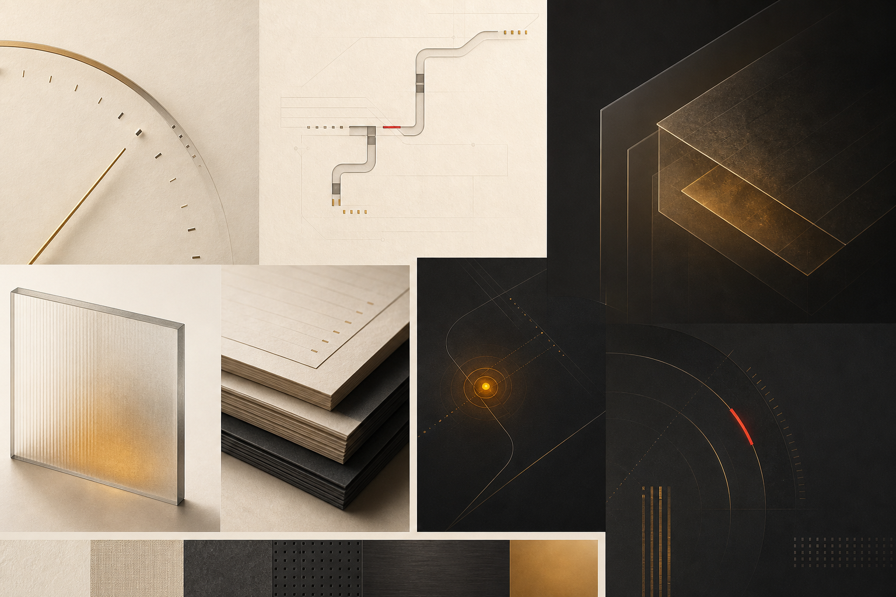
North-star material language: warm evidence surface, interrupted transaction path, focused graphite command surface.
Prepared for Aariz • 25 August 2026
Independent OpenAI hackathon prototype • no government or bank affiliation

DECISION SUMMARY

The product is now an application, not a long landing page
ARCHITECTURE DECISION
Short public entry. Deep operational workspace.
The landing page communicates the promise and routes the situation. Every response job lives on a fresh page inside the Action Room, so urgent guidance never competes with marketing content.

What changed
- The earlier eight-section landing-led concept is superseded as the primary information architecture.
- The public page now has four purposeful bands: emergency utility, product hero, situation routing, and a concise product/prototype boundary.
- The Action Room is a separate graphite application shell with dedicated pages for triage, urgent actions, money trail, evidence, complaint drafting, recovery tracking, and frozen accounts.
- All original working capabilities were ported into the V2 folder and verified end to end.
- The original repository root remains unchanged; V2 is isolated under /v2.

Approval position
This brief documents the implemented direction. The core architecture, visual system, and functionality are working; remaining work is product polish, legal review, and deployment choice rather than rebuilding the concept.

INFORMATION ARCHITECTURE

One job per page
The route map is deliberately explicit. A hackathon judge can understand the product quickly, while a distressed user can enter a task without scanning a marketing page.
Surface | Route | Single job
Public | / | Explain the product and route the situation
Overview | /action-room | Resume or choose a workspace
Triage | /action-room/intake | Create the local case
Urgent actions | /action-room/what-to-do | Prioritized first-hour guidance
Case | /action-room/case | Run and log the original action sequence
Money trail | /action-room/money-trail | Visual layer model and assumptions
Evidence | /action-room/evidence | Preservation checklist
Complaint | /action-room/complaint | OpenAI chronology + bank notice
Recovery | /action-room/recovery | Local actions and simulated stages
Frozen | /action-room/frozen | Separate account-restraint workflow
Methodology | /methodology | Sources, privacy, real vs. simulated

Compatibility
Legacy routes /act, /case, /frozen, and /how-it-works redirect to their V2 equivalents. Existing demo links therefore continue to work.

CAPABILITY PARITY

Original functionality, reorganized and preserved
The architecture changed; the product capabilities did not disappear. This matrix is the implementation contract used for the end-to-end test.
Capability | Status | V2 route | Notes
Four-question triage | Preserved | /action-room/intake | Amount, route, time, authorisation
Urgent action sequence | Preserved | /action-room/case | 1930, freeze, bank, evidence, FIR
Recovery clock + layer model | Preserved + relabeled | /action-room/money-trail | Illustrative model, not personal probability
English/Hindi call script | Preserved | /action-room/case | Bilingual 1930 guidance
OpenAI chronology | Preserved + verified | /action-room/complaint | Server key plus deterministic fallback
Evidence checklist | Preserved + promoted | /action-room/evidence | Dedicated page
Recovery-stage machine | Preserved + promoted | /action-room/recovery | Dedicated page
Frozen-account test | Preserved | /action-room/frozen | Position, bank letter, RTI
Real vs. mocked | Updated | /methodology | Current primary sources

EXPERIENCE MODEL

Two surfaces with different jobs

Public surface
Warm ivory, editorial typography, calm explanation, one generated hero asset, and strong situation routing. This surface earns trust and gets out of the way.

Action Room surface
Deep graphite, amber task focus, persistent emergency access, local-case status, and dedicated navigation. This surface is a tool, not a campaign.

Victim path
- Triage. Answer amount, payment route, time window, and authorisation.
- Act. Call 1930, prepare the freeze request, notify the bank, preserve evidence, and prepare FIR information.
- Document. Use evidence to build an editable complaint chronology and written bank notice.
- Track. Log actions, references, simulated stages, and next follow-up.

Frozen-account path
- Diagnose. Capture state, duration, balance held, disputed amount, legal section, scope, notice, and Magistrate information.
- Understand. Show the strength and limits of the position using sourced rules.
- Respond. Generate a bank letter and RTI draft without pretending to provide legal representation.
- Escalate. Preserve the written record and track review points.

VISUAL SYSTEM

Calm emergency intelligence
PALETTE
Ivory → graphite, with amber as the operational signal
Public: Ivory #F5F0E6, Ink #171A1C, warm paper grain. App: Graphite #101416, warm white #F5F0E6, Amber #E9A23B. Red is reserved for destructive or overdue states.

Typography
- DM Serif Display carries public headlines and app page titles as an editorial signal.
- Manrope carries controls, navigation, forms, and operational copy.
- JetBrains Mono carries case IDs, timing, stage metadata, and numeric values.
- Noto Sans Devanagari supports Hindi guidance without substituting person imagery or flags.

Component language
- Rounded task cards with precise borders and shallow depth; selective glass only where focus or hierarchy benefits.
- Thin Phosphor icons for clocks, paths, documents, banks, phones, calendars, exports, and evidence. No shield/padlock identity and no person icon.
- Progress rails, audit timelines, transaction paths, status chips, evidence checklists, and generated-document panes replace long explanatory text.
- Motion is limited to transform and opacity, supports reduced motion, and never delays an urgent action.

Implemented public landing
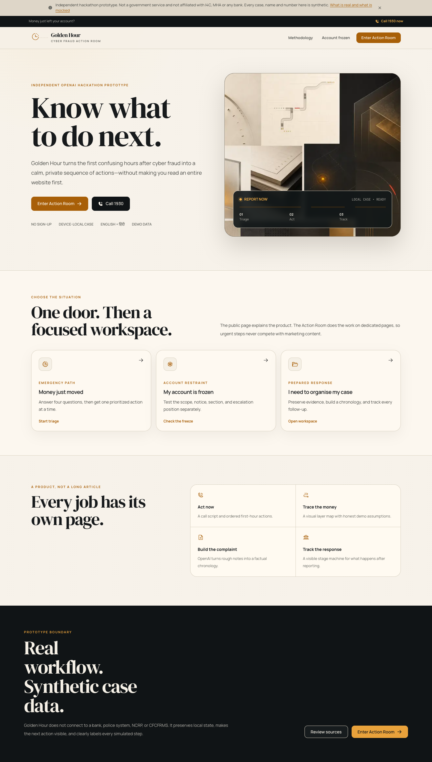
Live V2 desktop landing capture.

Implemented Action Room
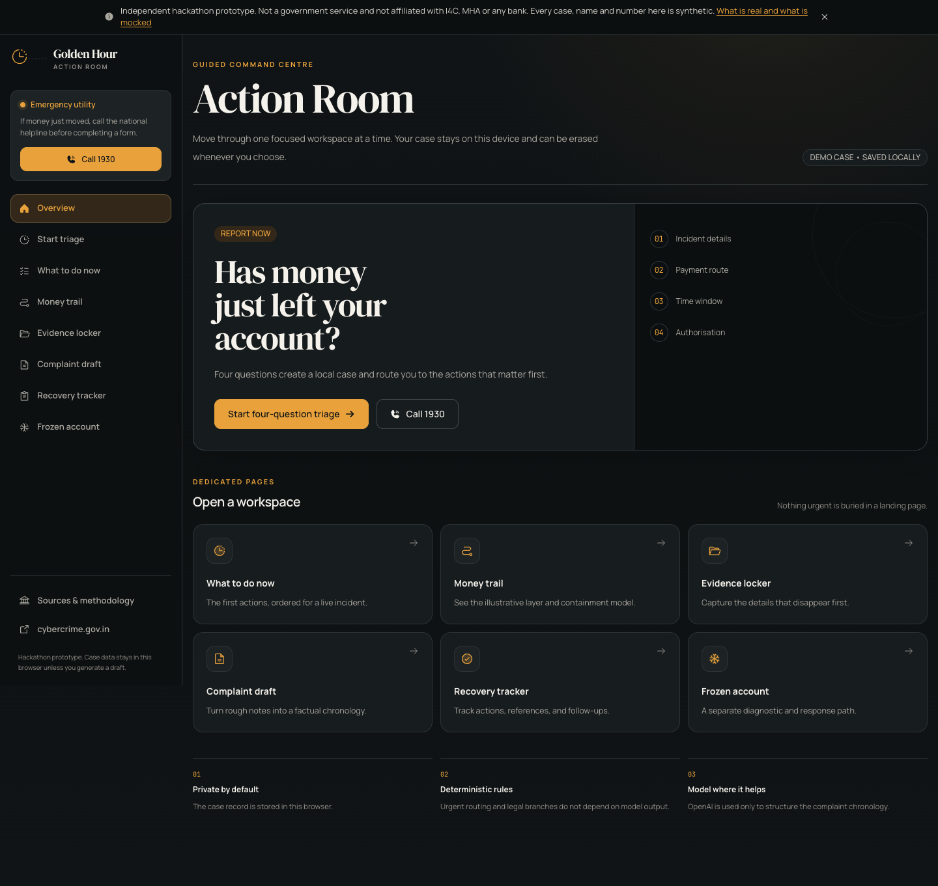
Live V2 desktop Action Room overview capture.
The public/app transition is not a theme toggle. It is a deliberate context switch from explanation to operation.

Implemented case workflow
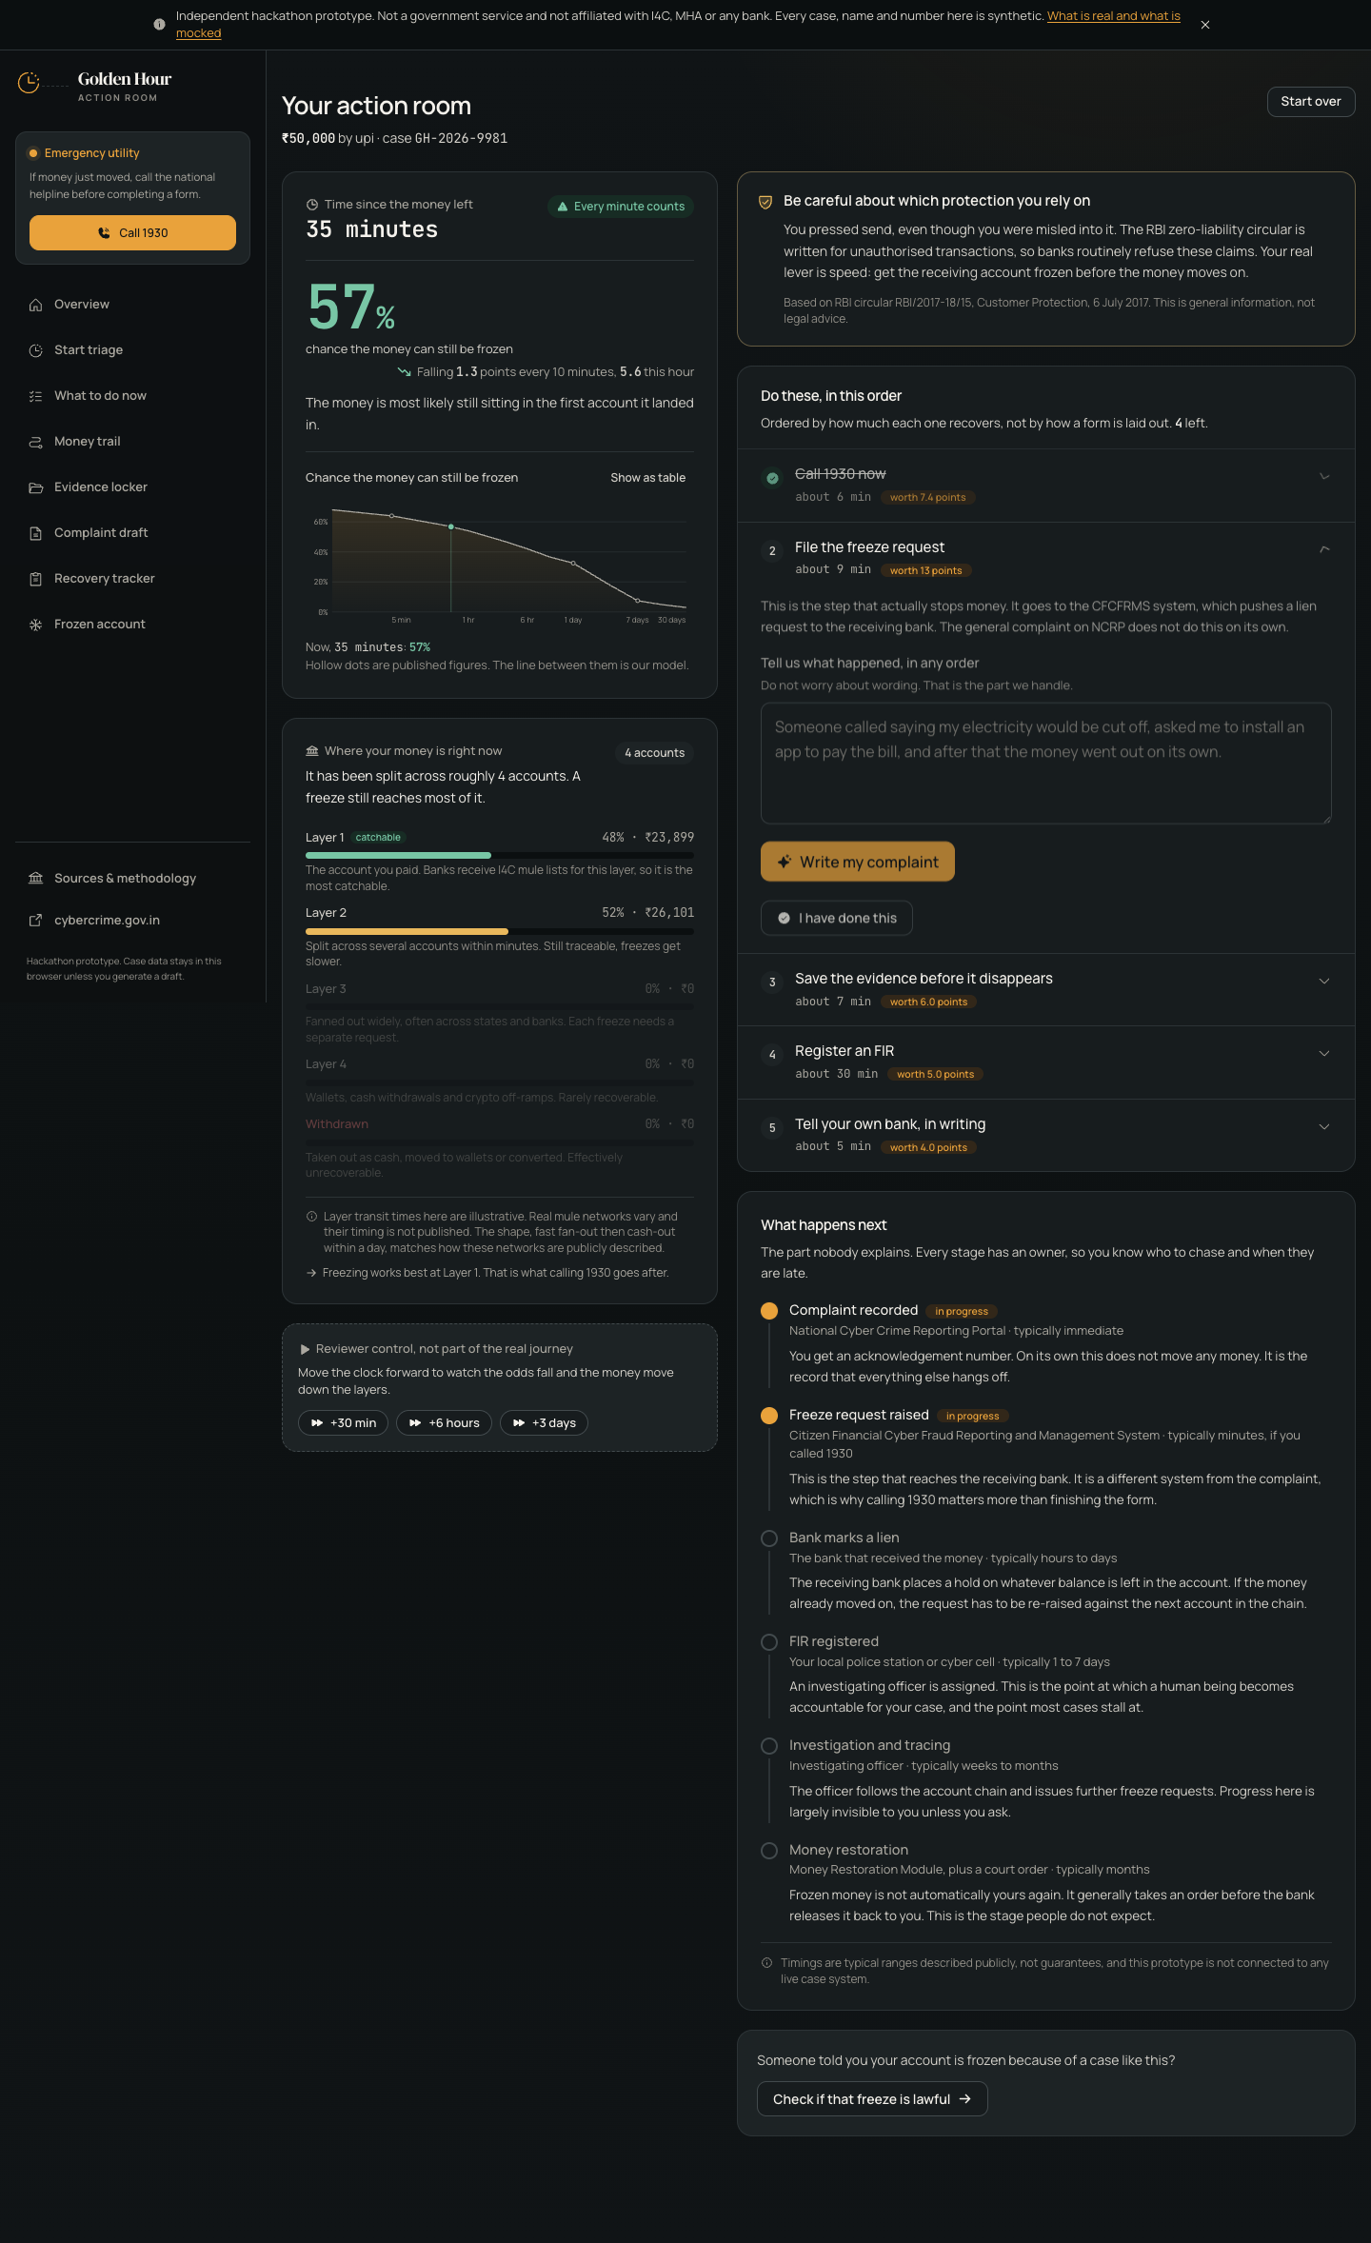
Live V2 case screen after triage.

Implemented mobile surfaces
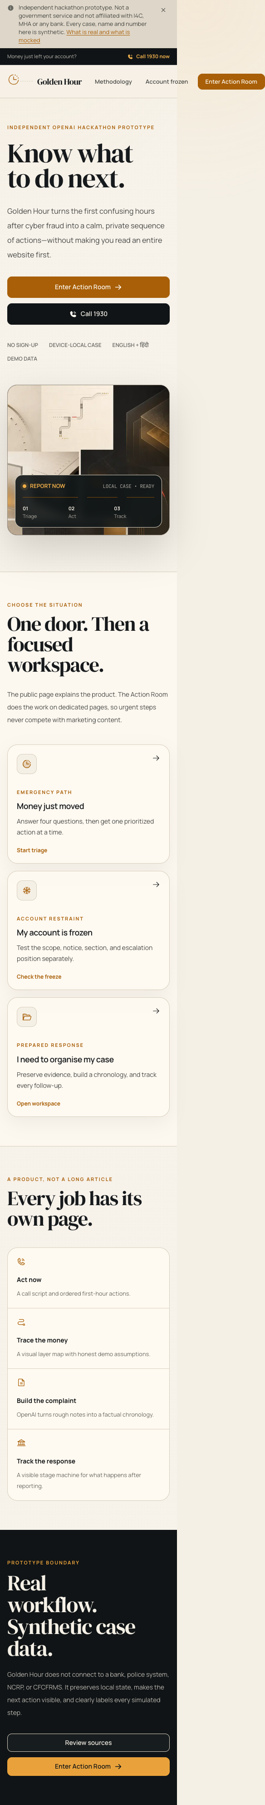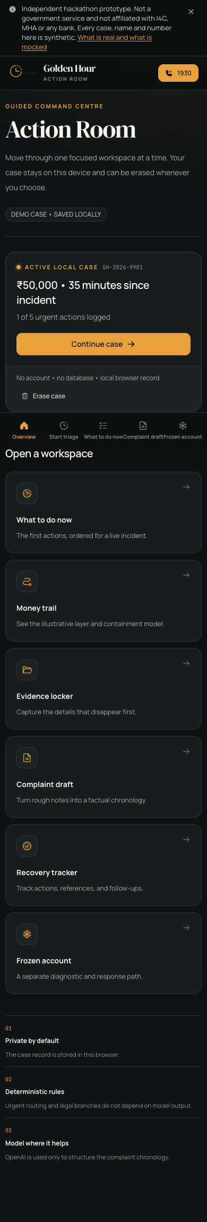
Live mobile captures: public landing (left) and separate Action Room application (right).

GENERATED VISUAL DIRECTION

North star and operational concepts
The image-generation work established the material language before implementation: clocks, interrupted transaction paths, evidence documents, bank/process objects, and graphite containment surfaces. It deliberately excludes people, faces, hands, silhouettes, avatars, shields, and padlocks.
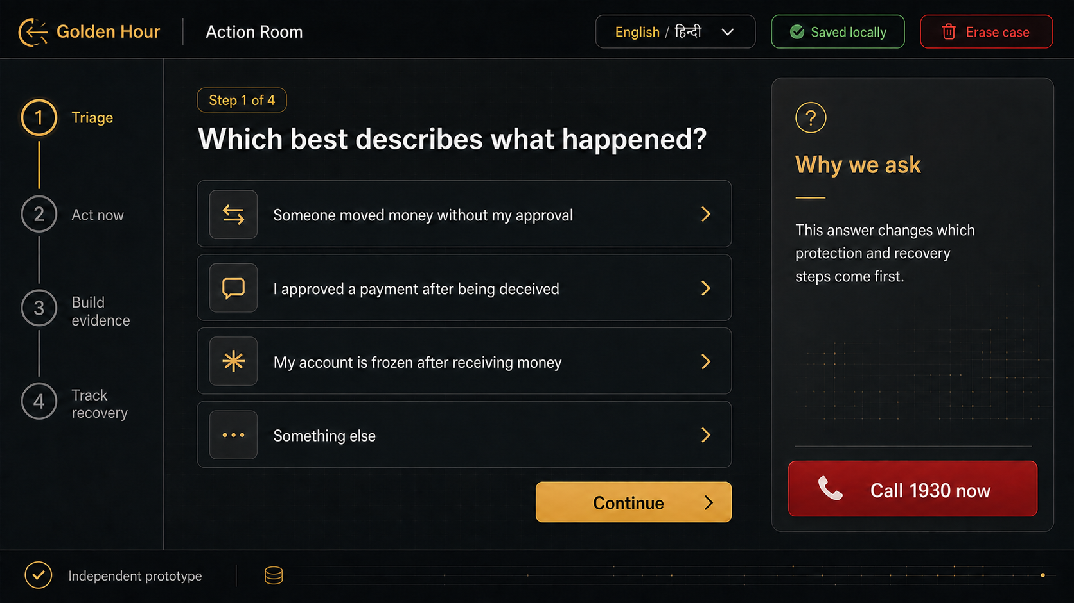
Generated desktop Action Room concept used to set hierarchy and task density.

Victim flow concepts
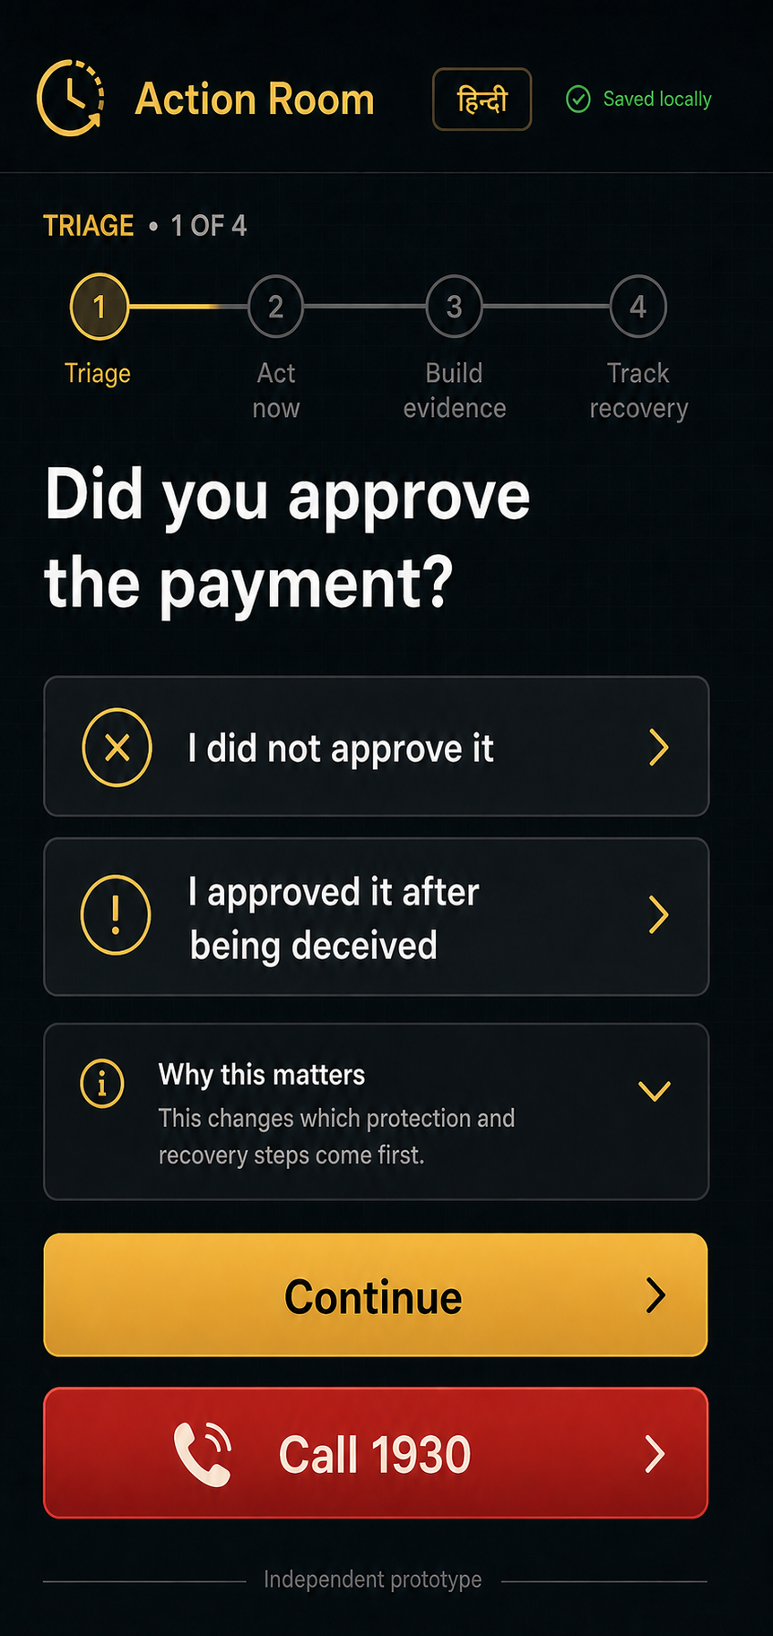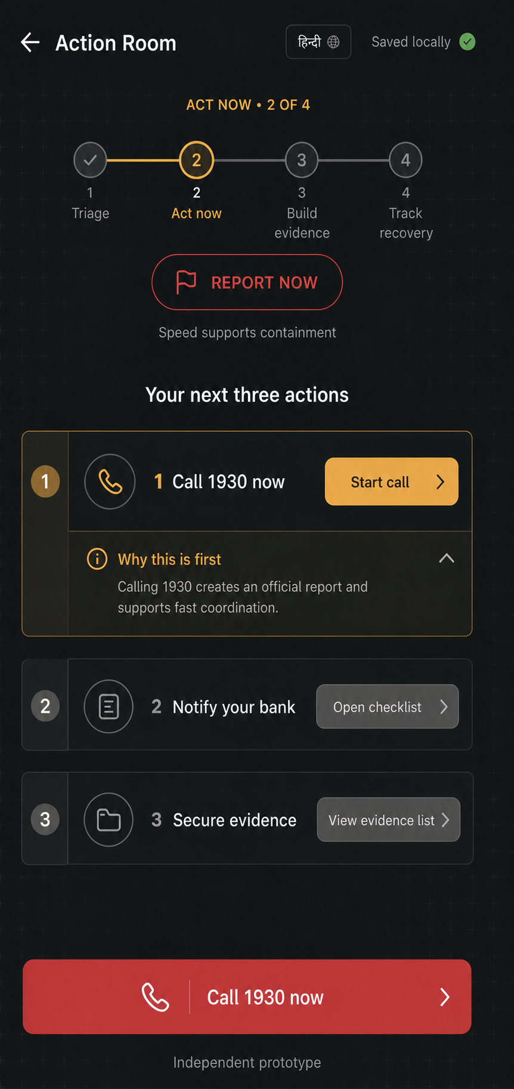
Generated victim path: triage and act-now stages.

Victim flow concepts — continued
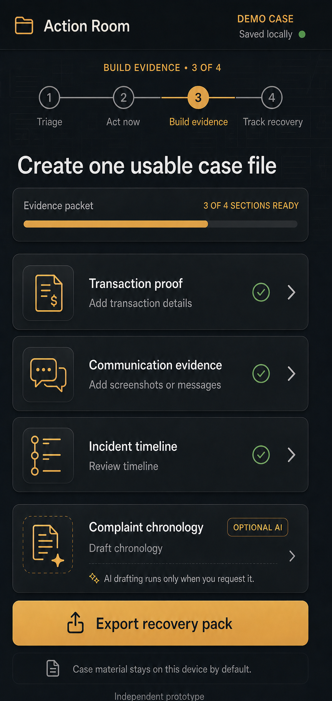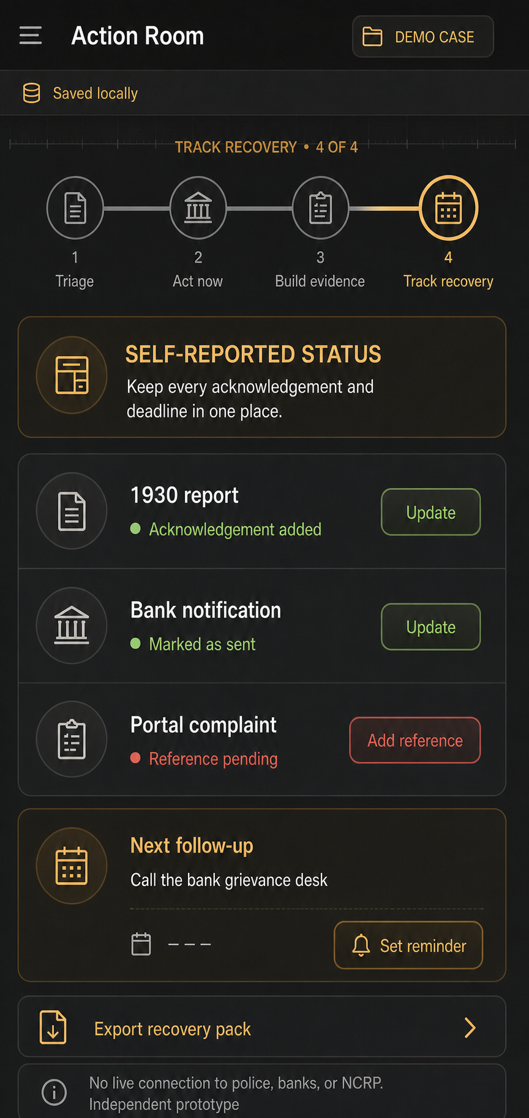
Generated victim path: evidence and recovery tracking stages.

Frozen-account concepts
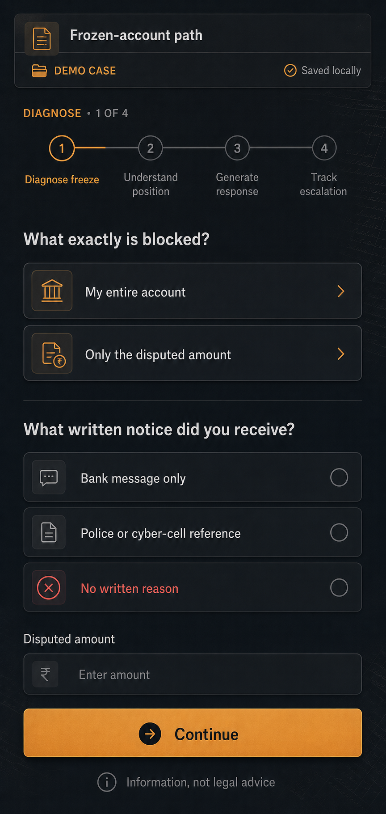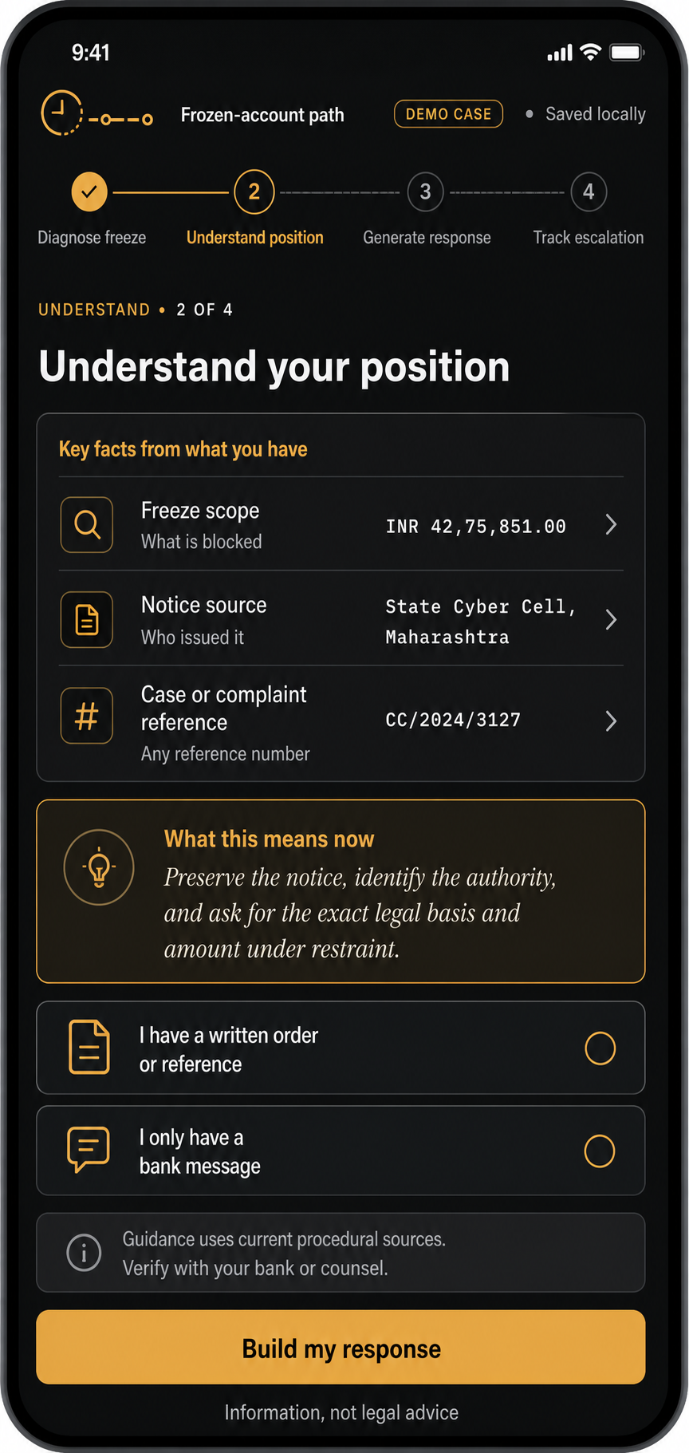
Generated frozen-account path: diagnose and understand stages.

Frozen-account concepts — continued
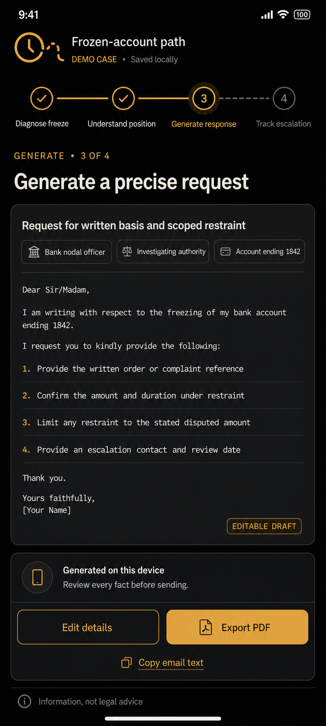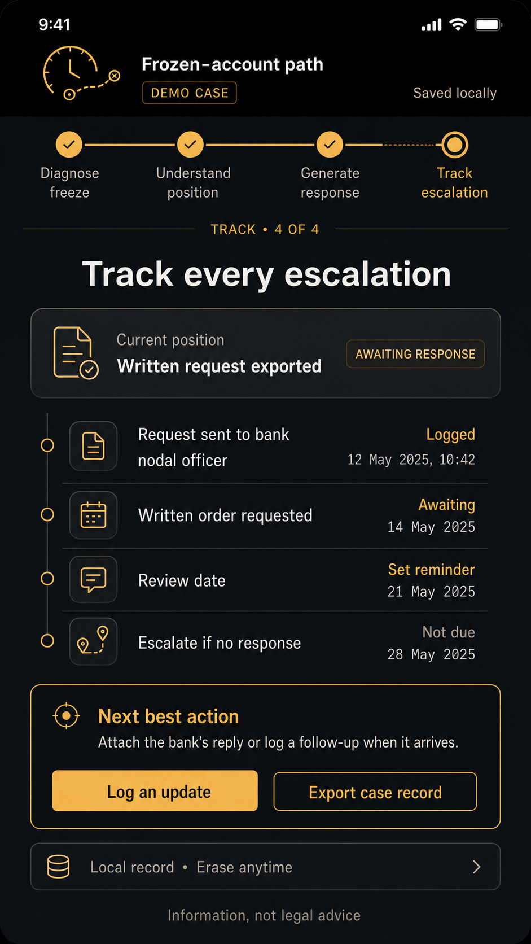
Generated frozen-account path: response drafting and escalation tracking.

MODEL, PRIVACY, AND SAFETY

The model is bounded; the emergency workflow is deterministic

OpenAI use
- Only the complaint chronology uses the OpenAI API.
- The key is read server-side from OPENAI_API_KEY or the existing local OPENAI_KEY variable; it is never exposed through NEXT_PUBLIC_.
- The system prompt forbids invented identifiers, preserves the authorisation branch, and requires missing-detail placeholders.
- A deterministic template completes the workflow if the model is unavailable, rejected, or returns empty content.
- The production smoke test returned a real model-generated draft during verification.

Local data
- No sign-up, database, or case analytics.
- The case record is versioned in browser local storage and can be erased from the Action Room.
- Only an explicit drafting action sends the narrative and minimal incident context to the server.
- The UI repeatedly warns against Aadhaar, PAN, OTP, PIN, passwords, and full card details.

Public-safety language
- The product says REPORT NOW and explains why speed supports containment; it does not publish a personal recovery probability.
- 1930 and cybercrime.gov.in are presented as official channels.
- Frozen-account outputs say general information, not legal advice, and distinguish sourced rules from case-specific review.
- All synthetic references and simulated stages are labeled at the point of use.

PRIMARY SOURCES

Current procedural and factual references
Ministry of Home Affairs parliamentary answer, 24 March 2026
Official reporting workflow and national channels.
https://www.mha.gov.in/MHA1/Par2017/pdfs/par2026-pdfs/LS24032026/5124.pdf
Press Information Bureau release, 21 August 2026
As of 30 June 2026, Rs 11,158 crore saved across 32.80 lakh complaints; an aggregate, not a personal probability.
https://www.pib.gov.in/PressReleasePage.aspx?PRID=2301973&lang=2&reg=48
RBI customer-protection circular RBI/2017-18/15
Unauthorised electronic-banking liability and notification timelines.
https://www.rbi.org.in/commonman/English/scripts/Notification.aspx?Id=2623
Bharatiya Nagarik Suraksha Sanhita, 2023
Official text for sections 94, 106, and 107.
https://www.indiacode.nic.in/bitstream/123456789/21920/1/the_bharatiya_nagarik_suraksha_sanhita%2C_2023.pdf
Delhi High Court judgment, 2026
Discussion of debit-freeze power under section 106 and the separate section 107 process.
https://delhihighcourt.nic.in/app/showlogo/1769248155_eb87a6191c1f9386_596_41982025.pdf/2026

VERIFICATION AND HANDOFF

Implementation acceptance checklist
- PASS — Production build passes across 19 routes.
- PASS — ESLint passes with zero warnings.
- PASS — Desktop and mobile landing surfaces render without overlays or missing assets.
- PASS — Action Room navigation works across dedicated pages.
- PASS — Four-question triage creates and persists a local case.
- PASS — English and Hindi 1930 call guidance works.
- PASS — Evidence selection and urgent-action logging work.
- PASS — OpenAI draft generation works with the server-side key; fallback remains available.
- PASS — Recovery tracker responds to local actions.
- PASS — Frozen-account diagnostic produces position, bank letter, and RTI output.
- PASS — Legacy route redirects work.
- PASS — No people, faces, hands, silhouettes, avatars, or person icons appear in project visuals.
- PASS — Original root prototype files remain untouched.
HANDOFF
The architecture reset is complete
The next product decisions are deployment target, legal review ownership, and whether the full interface should receive a complete Hindi localization beyond the preserved bilingual emergency script.

